
MINISTRY OF EDUCATION, CULTURE AND RESEARCH
OF THE REPUBLIC OF MOLDOVA
Technical University of Moldova
Faculty of Computers, Informatics and Microelectronics
Department of Software Engineering and Automation
Pleșu Dinu FAF-241
Report
Laboratory Work No. 8
Operating Systems
Topic: A Simple Shell Runner and Process Communication
Checked by: Reitman Patricia, university assistant
Chișinău – 2026

Contents
1. Purpose of the Work
2. Part 1 – run
3. Part 2 – pingpong
4. Conclusion

1. Purpose of the Work
Repeat the Lab 7 process and pipe experiments inside xv6, using its smaller system-call interface.

2. Part 1 – run
run.c uses getpid(), fork(), exec(), wait(), and exit(). The Linux Lab 7 version uses getpid(), fork(), execlp(), and waitpid(). The core operations match: create a child, replace its program, then wait for it. The API details differ because xv6 has its own small user library and no glibc/PATH search.
The text hello from the child is printed by the echo program after exec() replaces the child. In the missing-program experiment, xv6's sample child explicitly calls exit(1) after failed exec, while the Linux program calls exit(127); the parent reports the child's chosen status.
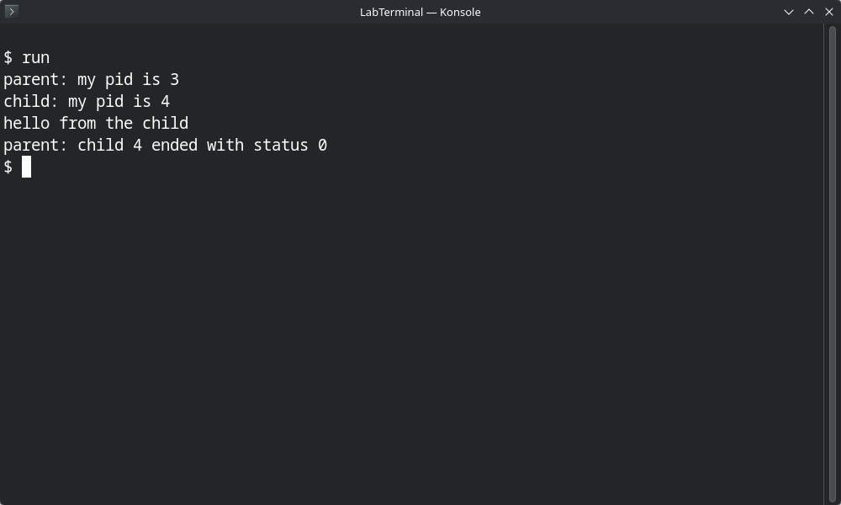
Figure 1.1 – xv6: run forks a child that execs echo and the parent reports its status

3. Part 2 – pingpong
pingpong.c creates two pipes because each pipe carries bytes in one direction: one parent-to-child and one child-to-parent. The parent blocks in read() until the child writes a byte to the response pipe; wait() then ensures the child has terminated before the parent exits. The child prints received ping before returning the byte, so it appears before received pong.
Build and test in ~/xv6-riscv after adding $U/_run\ and $U/_pingpong\ to UPROGS:
Commands / Output
$ run
parent: my pid is 3
child: my pid is 4
hello from the child
parent: child 4 ended with status 0
$ pingpong
10: received ping
9: received pong

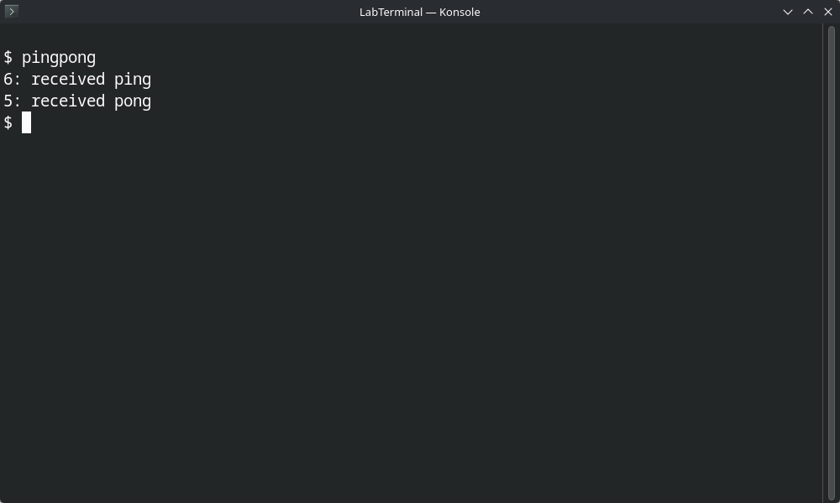
Figure 2.1 – xv6: pingpong over two pipes (ping is received before pong)
PIDs vary between runs. The Makefile entry is included in UPROGS.txt.

4. Conclusion
The same process and pipe concepts work in xv6 as on Linux, but xv6 exposes a smaller system-call interface. fork() and exec() separate process creation from program replacement; pipes and disciplined descriptor closing provide one-way communication, and two pipes enable a request/reply exchange.

