
MINISTRY OF EDUCATION, CULTURE AND RESEARCH
OF THE REPUBLIC OF MOLDOVA
Technical University of Moldova
Faculty of Computers, Informatics and Microelectronics
Department of Software Engineering and Automation
Pleșu Dinu FAF-241
Report
Laboratory Work No. 6
Operating Systems
Topic: Inside the xv6 File System
Checked by: Reitman Patricia, university assistant
Chișinău – 2026

Contents
1. Purpose of the Work
2. Part 1 – Read what xv6 shows you
3. Part 2 – Write mystat
4. Part 3 – Measure the limits
5. Part 4 – Write find
6. Conclusion

1. Purpose of the Work
The purpose of this laboratory is to read what the xv6 file system shows about its own objects, write my own stat program, measure the limits written in kernel/fs.h, and write find, which walks the directory tree recursively. Every session below was run on QEMU with the code in this folder (user/mystat.c, user/find.c and the Makefile with the UPROGS lines $U/_mystat and $U/_find).
make clean ; make CPUS=1 # builds kernel + fs.img with mystat and find
make qemu CPUS=1 # boot xv6; exit QEMU with Ctrl-A then X
The build completed with exit status 0 on this machine, so both programs compile against the current xv6 tree.

2. Part 1 – Read what xv6 shows you
Each ls line is: name, type, inode number, size in bytes. The type field is decoded from kernel/stat.h.
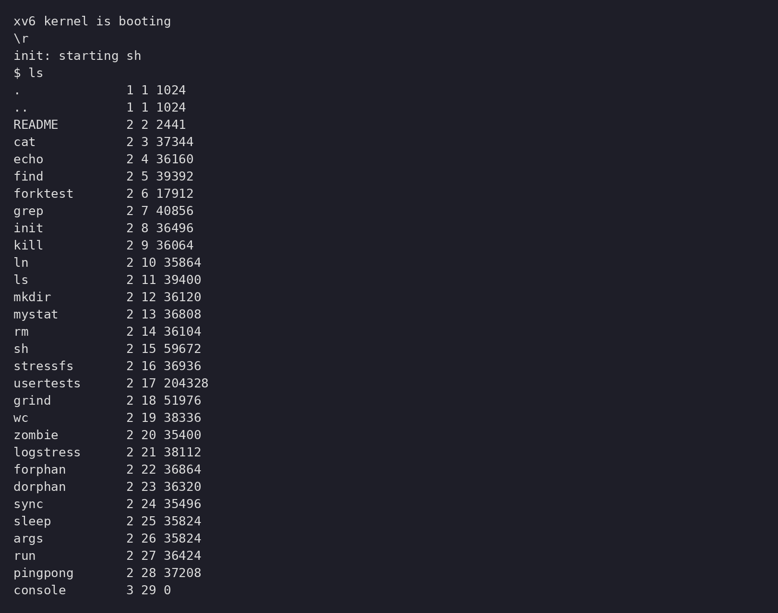
Figure 1.1 – The root directory as xv6 shows it: name, type, inode, size
mkdir a
ls a
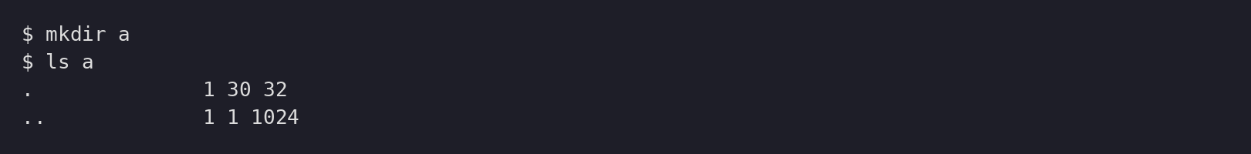
Figure 1.2 – The empty directory a: two entries, size 32

2.1. Observations
1. In kernel/stat.h, type 1 is T_DIR (directory), type 2 is T_FILE (regular file) and type 3 is T_DEVICE (device file) — visible in Figure 1.1 as README = 2, console = 3.
2. The root directory has inode number 1 because kernel/fs.h defines ROOTINO as 1. In the root, . and .. are the same because the parent of the root is the root itself.
3. The empty directory a has size 32. One directory entry is 16 bytes: a 2-byte inode number plus a 14-byte name (DIRSIZ). The two entries are . (points to itself, inode 30) and .. (points to the parent, inode 1), as Figure 1.2 shows.

3. Part 2 – Write mystat
user/mystat.c fills struct stat through the stat() library call and prints the name, type, inode, link count and size for every argument.
#include "kernel/types.h"
#include "kernel/stat.h"
#include "user/user.h"
char *
typename(int t)
{
switch (t) {
case T_DIR:
return "directory";
case T_FILE:
return "file";
case T_DEVICE:
return "device";
default:
return "?";
}
}
int
main(int argc, char *argv[])
{
struct stat st;
int i;
for (i = 1; i < argc; i++) {
if (stat(argv[i], &st) < 0) {
fprintf(2, "mystat: cannot stat %s\n", argv[i]);
continue;
}
printf("%s: %s, inode %d, links %d, size %d bytes\n",
argv[i], typename(st.type), st.ino, st.nlink, (int)st.size);
}
exit(0);
}
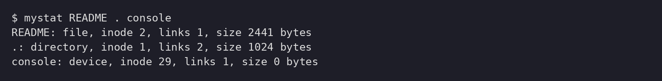
Figure 2.1 – mystat README . console on the fresh disk
ln README r2
mystat README r2
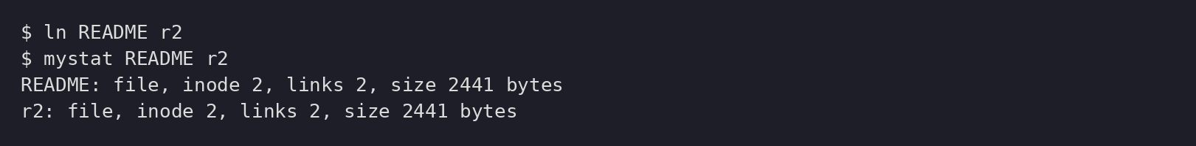
Figure 2.2 – After ln: both names share inode 2, link count 2
rm README
mystat r2
cat r2 | wc
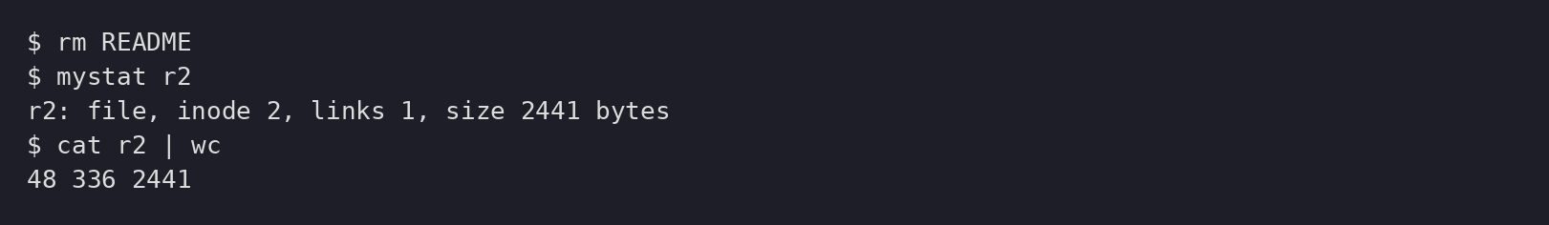
Figure 2.3 – After rm: the inode survives with link count 1; the data is unchanged

3.1. Observations
1. After ln, both README and r2 reported inode 2 with links 2: two names, one inode. After rm, r2 still reported inode 2 with size 2441 bytes, but links 1 — only the name was removed; what changed was the link count, what did not change were the inode number and the data (cat r2 | wc still printed the full content).
2. kernel/sysfile.c decrements the count inside sys_unlink with `ip->nlink--;` followed by `iupdate(ip);`. The data blocks are not freed at that moment: they are released only when the last link disappears and the inode is reclaimed (itrunc/bfree), so an open reader keeps working.
3. struct dinode in kernel/fs.h holds: short type, short major, short minor, short nlink, uint size and uint addrs[NDIRECT + 1] — type, device numbers, link count, length and block pointers. There is no symlink flag and no permission bits, which is why xv6 has neither symbolic links nor permissions.

4. Part 3 – Measure the limits
grep -n "define BSIZE\|define NDIRECT\|define NINDIRECT\|define DIRSIZ" kernel/fs.h
make clean ; make fs.img # mkfs prints the nmeta line
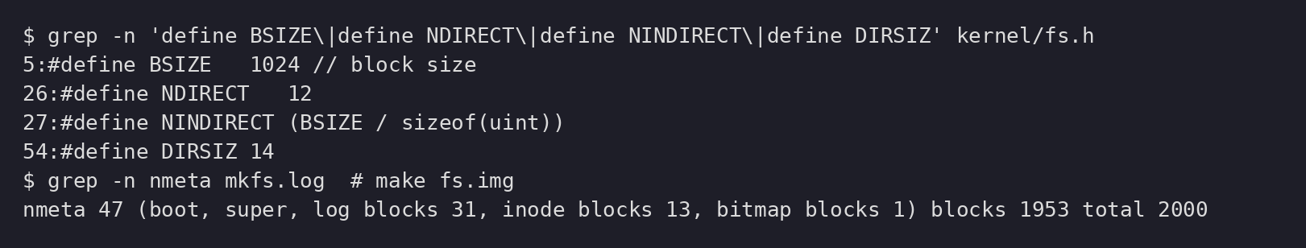
Figure 3.1 – The constants in kernel/fs.h and the nmeta line of the build
mkdir averyveryverylongname
ls
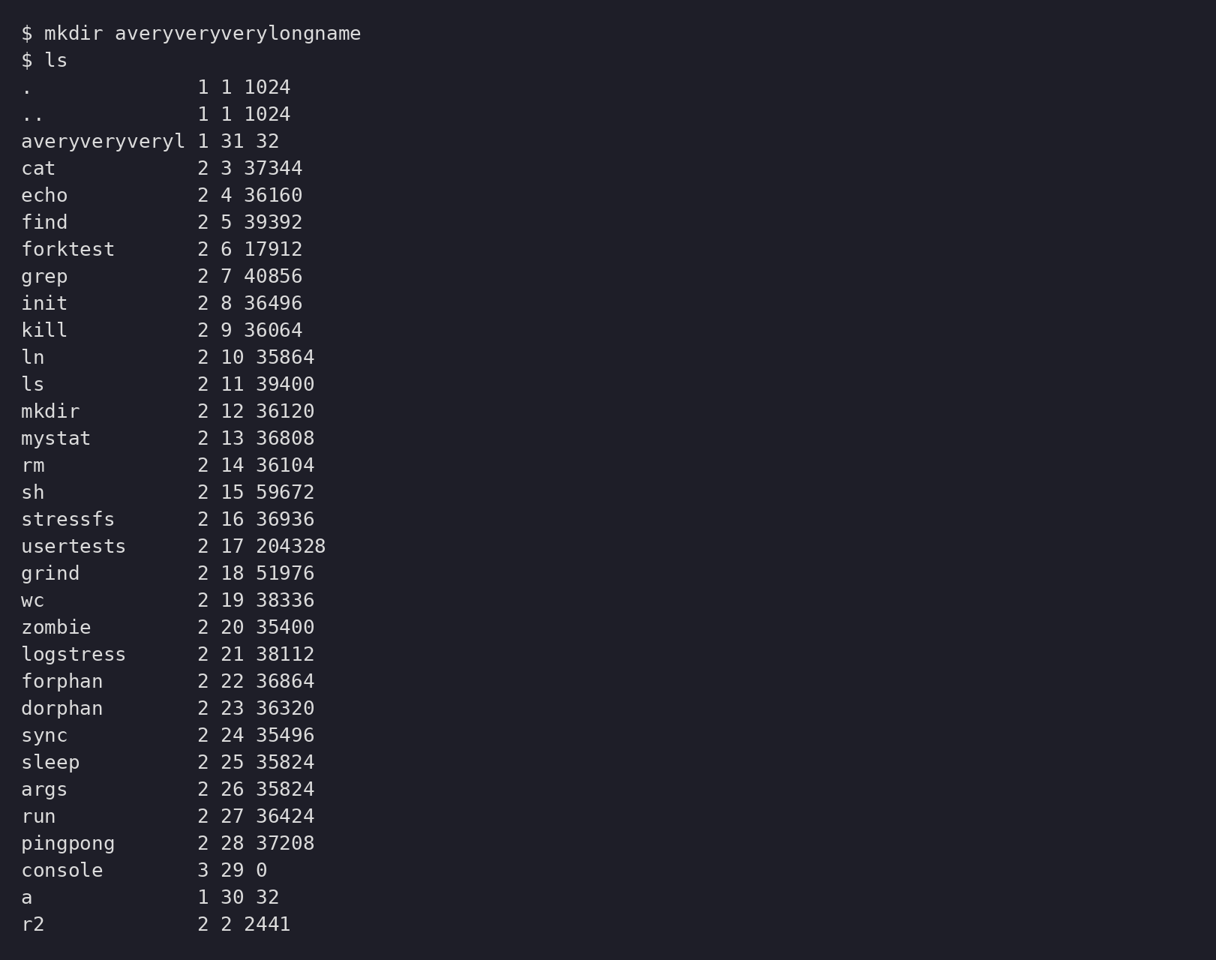
Figure 3.2 – The long name is truncated to DIRSIZ = 14 characters

4.1. Observations
1. ls shows the directory as averyveryveryl: a directory entry keeps only DIRSIZ = 14 characters of the name, so the rest is cut off (Figure 3.2).
2. The largest file is 12 direct blocks plus one indirect block: 12 × 1024 + (1024 / 4) × 1024 = 12 288 + 262 144 = 274 432 bytes, i.e. (NDIRECT + NINDIRECT) × BSIZE with NDIRECT = 12 and NINDIRECT = BSIZE / 4 = 256.
3. The nmeta line says: nmeta 47 (boot, super, log blocks 31, inode blocks 13, bitmap blocks 1) blocks 1953 total 2000. So the whole disk is 2000 blocks: 31 for the log, 13 for inodes, 1 for the bitmap (plus boot and superblock make 47 metadata), and 1953 blocks are available for data.

5. Part 4 – Write find
find <dir> <name> prints every path under <dir> whose last component is <name>. It opens a directory, reads struct dirent entries one by one, skips inum == 0, never recurses into . and .., compares names with strcmp, and closes every directory it opens (only 16 open files per process).
#include "kernel/types.h"
#include "kernel/stat.h"
#include "kernel/fs.h"
#include "user/user.h"
static char *
basename_of(char *path)
{
char *p;
for (p = path + strlen(path); p >= path && *p != '/'; p--)
;
return p + 1;
}
static void
find(char *path, char *name)
{
char buf[512], *p;
int fd;
struct dirent de;
struct stat st;
if ((fd = open(path, 0)) < 0) {
fprintf(2, "find: cannot open %s\n", path);
return;
}
if (fstat(fd, &st) < 0) {
fprintf(2, "find: cannot stat %s\n", path);
close(fd);
return;
}
if (st.type == T_DIR) {
if (strlen(path) + 1 + DIRSIZ + 1 > sizeof(buf)) {
printf("find: path too long\n");
close(fd);
return;
}
strcpy(buf, path);
p = buf + strlen(buf);
*p++ = '/';
while (read(fd, &de, sizeof(de)) == sizeof(de)) {
if (de.inum == 0)
continue;
if (strcmp(de.name, ".") == 0 || strcmp(de.name, "..") == 0)
continue;
memmove(p, de.name, DIRSIZ);
p[DIRSIZ] = 0;
if (stat(buf, &st) < 0) {
fprintf(2, "find: cannot stat %s\n", buf);
continue;
}
if (strcmp(basename_of(buf), name) == 0)
printf("%s\n", buf);
if (st.type == T_DIR)
find(buf, name);
}
close(fd);
return;
}
if (strcmp(basename_of(path), name) == 0)
printf("%s\n", path);
close(fd);
}
int
main(int argc, char *argv[])
{
if (argc != 3) {
fprintf(2, "usage: find <dir> <name>\n");
exit(1);
}
find(argv[1], argv[2]);
exit(0);
}
Run on a fresh disk (make fs.img then make qemu), exactly as the assignment prescribes:
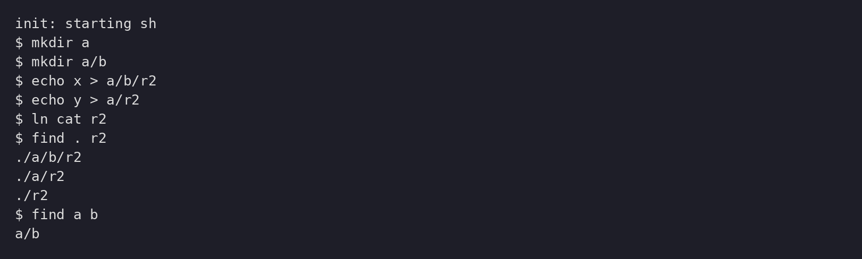
Figure 4.1 – find . r2 and find a b on a fresh disk

5.1. Observations
1. The walk found all three files named r2: ./a/b/r2, ./a/r2 and ./r2, in the order the directories are read. find a b printed a/b because only a/b matches the name b.
The recursion is the same idea behind real filesystem tools: open, read entries, build a path, stat it, recurse, close — respecting the per-process open-file limit.

6. Conclusion
The xv6 file system is small but instructive: directories are just files containing 16-byte dirent records, names are capped at DIRSIZ = 14, and inodes carry the metadata that manages size, hard links and block addresses (12 direct + 256 indirect = 274 432 bytes maximum). A hard link shares one inode; data blocks are reclaimed only when the last link disappears, which sys_unlink implements with a single nlink decrement. Writing mystat and find showed how the library calls map onto the kernel syscalls, and running both inside QEMU confirmed they compile and behave on the current xv6 tree.

