
MINISTRY OF EDUCATION, CULTURE AND RESEARCH
OF THE REPUBLIC OF MOLDOVA
Technical University of Moldova
Faculty of Computers, Informatics and Microelectronics
Department of Software Engineering and Automation
Pleșu Dinu FAF-241
Report
Laboratory Work No. 2
Operating Systems
Topic: Inside the xv6 Source Tree
Checked by: Reitman Patricia, university assistant
Chișinău – 2026

Contents
1. Purpose of the Work
2. Part 1 – Build and boot
3. Part 2 – Use xv6
4. Part 3 – Read the source
5. Part 4 – First xv6 program
6. Conclusion

1. Purpose of the Work
Build and boot xv6, use its shell and programs, read the source of a small user program and the system-call layer, and add a first user program (sleep).

2. Part 1 – Build and boot
The xv6 tree is in ~/xv6-riscv. I built and launched it with make qemu; QEMU prints the xv6 boot message and starts the shell. I exited QEMU with Ctrl-A followed by X.

3. Part 2 – Use xv6
1. Three programs shipped with xv6 are echo, cat, and ls.
2. A pipe requires process creation so both commands can run, and inter-process communication through a kernel-managed pipe buffer and file descriptors.
3. The xv6 shell supports basic command execution, pipes, and redirection, while Linux Bash adds richer scripting, expansion, history, completion, and job control.

4. Part 3 – Read the source
user/cat.c uses open() to open a named file, read() to obtain bytes from a file descriptor (or standard input when no filename is supplied), write() to send bytes to standard output, close() to release a file descriptor, and exit() to finish. In this checkout, sys_read is implemented in kernel/sysfile.c at line 69. user/user.h declares the user-visible system-call interface.
kernel/ contains privileged operating-system implementation code. user/ contains ordinary programs that request kernel services through system calls.
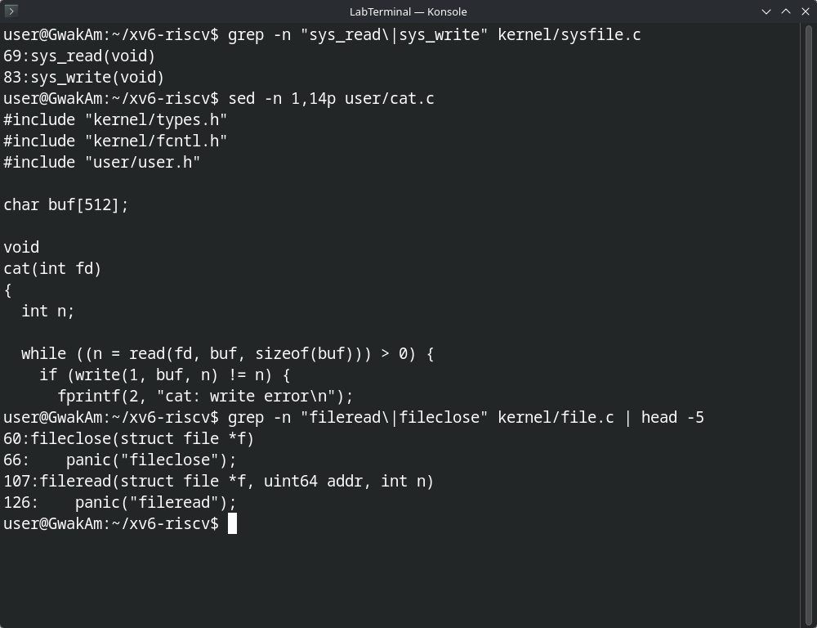
Figure 3.1 – Locating sys_read and sys_write, the start of user/cat.c, and fileread in the kernel

5. Part 4 – First xv6 program
The current xv6 checkout declares pause(int) instead of sleep(int). The working program is sleep.c, and the Makefile entry ($U/_sleep\) is recorded in UPROGS.txt. I built and booted xv6 with make qemu CPUS=1, then tested the shell tools and sleep:
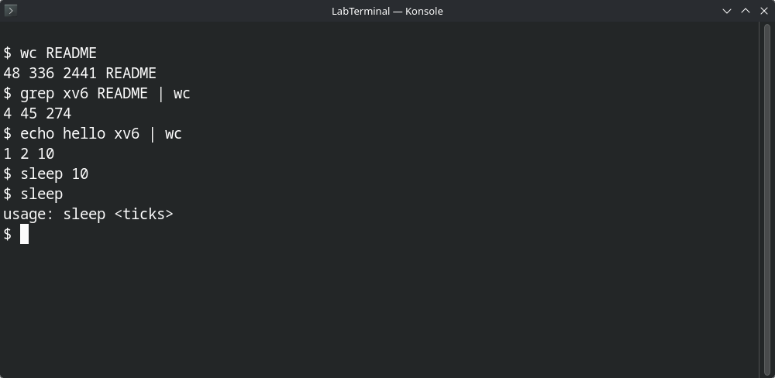
Figure 4.1 – xv6 session: wc, a pipe, and sleep with and without an argument
The valid call waited and returned to the shell; the invalid call printed the expected usage message.

6. Conclusion
Building xv6 made the relationship between user programs and kernel services concrete. A user program invokes system calls, and the kernel performs the privileged work. The sleep utility is a small example of that boundary.

