
MINISTRY OF EDUCATION, CULTURE AND RESEARCH
OF THE REPUBLIC OF MOLDOVA
Technical University of Moldova
Faculty of Computers, Informatics and Microelectronics
Department of Software Engineering and Automation
Pleșu Dinu FAF-241
Report
Laboratory Work No. 3
Operating Systems
Topic: The Command Line: Shell, Pipes and Text Filters
Checked by: Reitman Patricia, university assistant
Chișinău – 2026

Contents
1 Purpose of the Work 3
2 Initial Setup 3
3 Part 1 – Move Fast, Find Help 3
4 Part 2 – What the Shell Does to Your Line 4
5 Part 3 – Redirection, Chaining, and Jobs 5
6 Part 4 – One-Liners 6
7 Part 5 – First Script 7
8 Conclusion 8

1. Purpose of the Work
Practice Bash command lookup, shell expansion, quoting, redirection, pipelines, process control, and small scripts. Use filters to answer questions about a generated access log.

2. Initial Setup
The laboratory uses an artificial web access log with 500 entries, generated in ~/os-lab3 and checked before running the one-liners.
Commands / Output
mkdir -p ~/os-lab3 && cd ~/os-lab3
for i in $(seq 1 500); do
echo "2026-10-05 10:$(printf %02d $((i % 60))) user$((i % 7)) $([ $((i % 5)) -eq 0 ] && echo FAIL || echo OK) /page$((i % 4))"
done > access.log
head -3 access.log; wc -l access.log

3. Part 1 – Move Fast, Find Help
Tab completes a unique path prefix, such as /et to /etc. If several entries match, pressing Tab twice displays the candidates. Ctrl+R starts reverse history search; typing part of a previous command finds it, and Enter runs the selected command.
cd is a Bash builtin because it must change the current shell process's working directory. ls is an external program found through PATH; echo is normally a Bash builtin, though external implementations also exist. which ls reports the executable found on PATH. PATH is a colon-separated list of directories, and tr ':' '\n' displays one directory per line. Bash returns status 127 when a command cannot be found. The ls option that sorts by modification time is -t (-lt combines this order with long format).
Observed on this host: cd and echo are Bash builtins; ls resolves to /usr/bin/ls. The inherited PATH contains 16 directory entries (some repeat). A missing command returned 127. ls -t sorts by modification time, newest first.
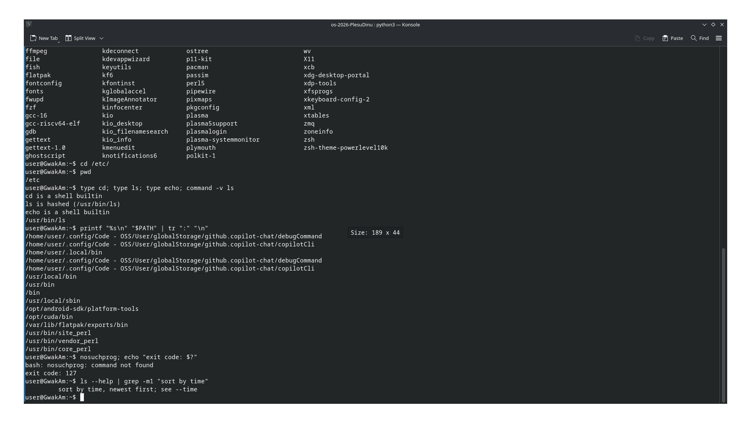
Figure 1.1 – Part 1: command lookup, PATH, missing-command status, and the ls time option

4. Part 2 – What the Shell Does to Your Line
Run the commands in the assignment after creating the six files. The table records the expected output on Bash; the weekday and account name depend on the computer. Add your own prediction before running each command and note any differences.
Command | Expected output | Explanation
echo *.c | a.c b.c | Bash expands the wildcard before starting echo.
echo file?.txt | file1.txt file2.txt | ? matches exactly one character.
echo [a-b]* | a.c alfa beta.txt b.c | The bracket expression matches names beginning with a or b; the name containing a space remains one argument.
echo *.xyz | *.xyz | With default Bash settings, an unmatched glob remains literal.
ls alfa beta.txt | Error: neither separate path exists | The shell passes two arguments, alfa and beta.txt.
ls "alfa beta.txt" | Lists alfa beta.txt | Quoting preserves the embedded space as part of one argument.
echo '$HOME' "$HOME" \$HOME | $HOME <home-directory> $HOME | Single quotes and backslash suppress expansion; double quotes allow parameter expansion.
echo {1..5} ; echo $((7 * 6)) | 1 2 3 4 5, then 42 | Bash performs brace and arithmetic expansion before echo.
echo "today is $(date +%A), I am $(whoami)" | Current weekday and account name | Bash runs the command substitutions first.
touch log{1..3}.txt && ls log* | log1.txt log2.txt log3.txt | Brace expansion creates three names; && runs ls only if touch succeeds.

The shell, not echo, expands *.c. ls alfa beta.txt can be fixed with ls 'alfa beta.txt' or ls alfa\ beta.txt. Single quotes preserve enclosed characters literally. Double quotes preserve word boundaries but still allow parameter, command, and arithmetic expansion. ls may quote a filename in its display to make embedded whitespace unambiguous; those display quotes are not part of the filename.
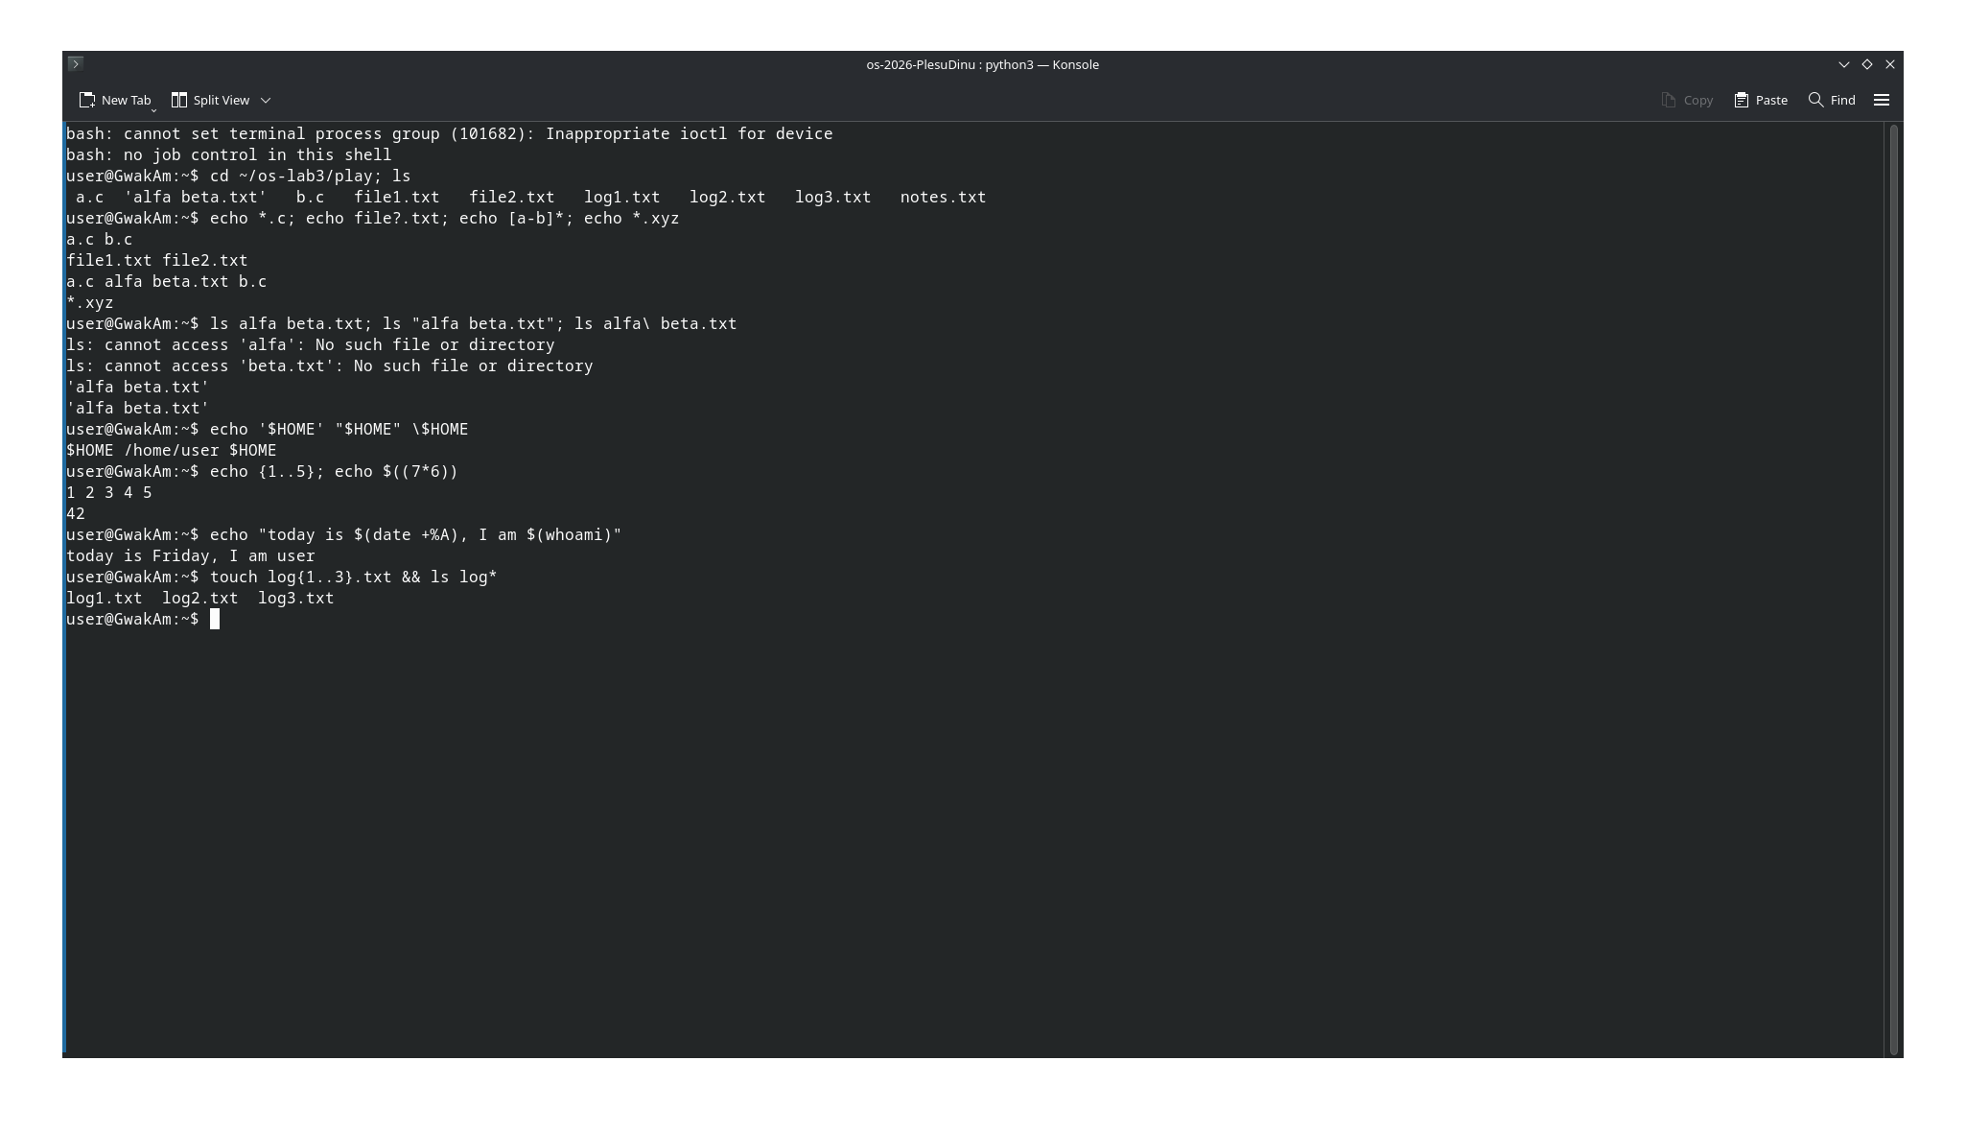
Figure 2.1 – Part 2: file list, globbing, quoting, spaces, and expansions

5. Part 3 – Redirection, Chaining, and Jobs
ls /etc /nope > out.txt 2> err.txt writes the /etc listing to out.txt and the missing-path diagnostic to err.txt. In ls /etc /nope > all.txt 2>&1, standard output is first redirected to all.txt, then standard error is made a copy of that destination, so both streams go into the file. In ls /etc /nope 2>&1 > all.txt, standard error first copies the original standard output (the terminal), then only standard output moves to the file; the error remains on the terminal.
wc -l < access.log reads standard input, so it prints only the count. wc -l access.log opens a named file and includes its name in the output. ; runs the next command regardless of the previous status; && runs it only after success; || runs it only after failure. A trailing & starts a background job; jobs lists it, and kill %1 requests its termination.
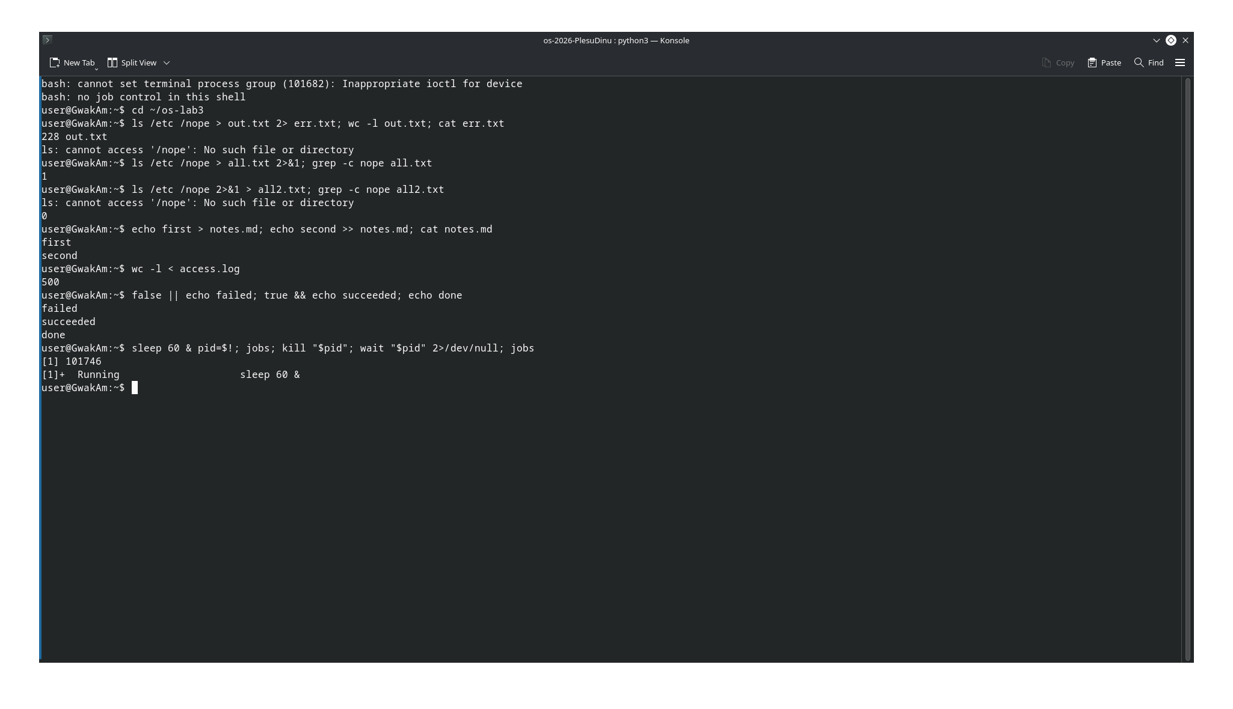
Figure 3.1 – Part 3: redirection, command chaining, and background jobs

6. Part 4 – One-Liners
The runnable answers are in oneliners.sh. For the assignment's deterministic 500-line data set:
Question | Result
Q1 failed requests | 100
Q2 distinct pages | 4: /page0, /page1, /page2, /page3
Q3 requests per page | 125 each
Q4 users with the most failures | user3 and user5, 15 failures each
Q5 user3 requests | 72 requests, 15 failed
Q6 last three failed requests | 10:10 user0, 10:15 user5, 10:20 user3
Q7 login shells | Depends on local /etc/passwd; the script groups identical shell paths.
Q8 ls line counts | ls -l includes one additional total summary line.

The bonus command selects failed requests whose minute ends in zero; the generated data contains 50 such requests.
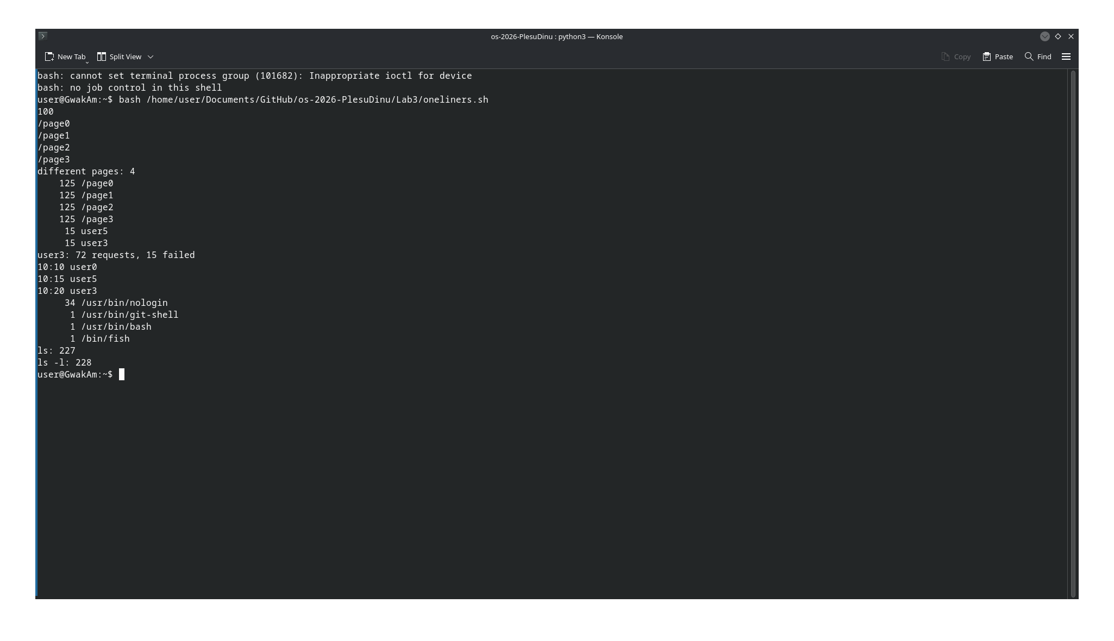
Figure 4.1 – Part 4: oneliners.sh results for Q1–Q8

7. Part 5 – First Script
report.sh checks that its input file exists, reports total and failed requests, then loops through user0 to user6 and prints each user's failed-request count. The shebang #!/usr/bin/env bash asks the environment to locate Bash to interpret the script. Without execute permission, ./report.sh fails with a permission error; after chmod +x report.sh it can be run directly. ./ names a path in the current directory because that directory is normally not included in PATH. Writing the diagnostic to file descriptor 2 keeps it on standard error; exit 1 communicates failure to the calling shell.
For a missing file, expected behavior is no such file: nope.log on standard error followed by exit status 1. The cron bonus was not run.
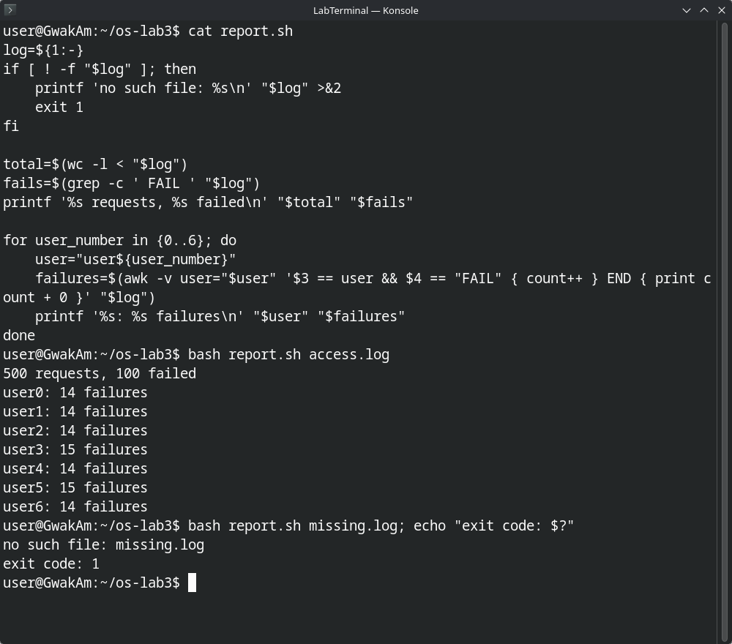
Figure 5.1 – Part 5: report.sh source, normal output, and missing-file handling

8. Conclusion
The shell parses and transforms command lines before programs receive their arguments. Globbing, quoting, variable expansion, command substitution, redirection, pipelines, and job control are shell responsibilities, while utilities such as grep, cut, sort, and wc perform focused operations that can be combined. The scripts make those operations repeatable and checkable.

