
MINISTRY OF EDUCATION, CULTURE AND RESEARCH
OF THE REPUBLIC OF MOLDOVA
Technical University of Moldova
Faculty of Computers, Informatics and Microelectronics
Department of Software Engineering and Automation
Pleșu Dinu FAF-241
Report
Laboratory Work No. 7
Operating Systems
Topic: Three Small Programs: Processes, Redirection, a Pipe
Checked by: Reitman Patricia, university assistant
Chișinău – 2026

Contents
1. Purpose of the Work
2. Part 1 – fork, exec, and wait
3. Part 2 – A zombie, on purpose
4. Part 3 – Redirection
5. Part 4 – A pipe
6. Conclusion

1. Purpose of the Work
Write three small C programs that show how Linux creates and replaces processes, redirects file descriptors, and connects commands with a pipe.

2. Part 1 – fork, exec, and wait
run.c prints the parent's PID, forks, and has the child execute ls -l. execlp() replaces the child process image, so the error message after it is reached only if execution fails. The child prints getppid(), which is the PID of its parent process. The parent observes status 0 when ls exits normally and 127 when execlp() fails and the child explicitly calls exit(127).
Run:
Commands / Output
gcc -Wall -Wextra -o run run.c
./run

The PID values and directory listing vary. When testing a missing command, replace the execlp("ls", ...) line with execlp("nosuchprog", "nosuchprog", (char *)NULL).
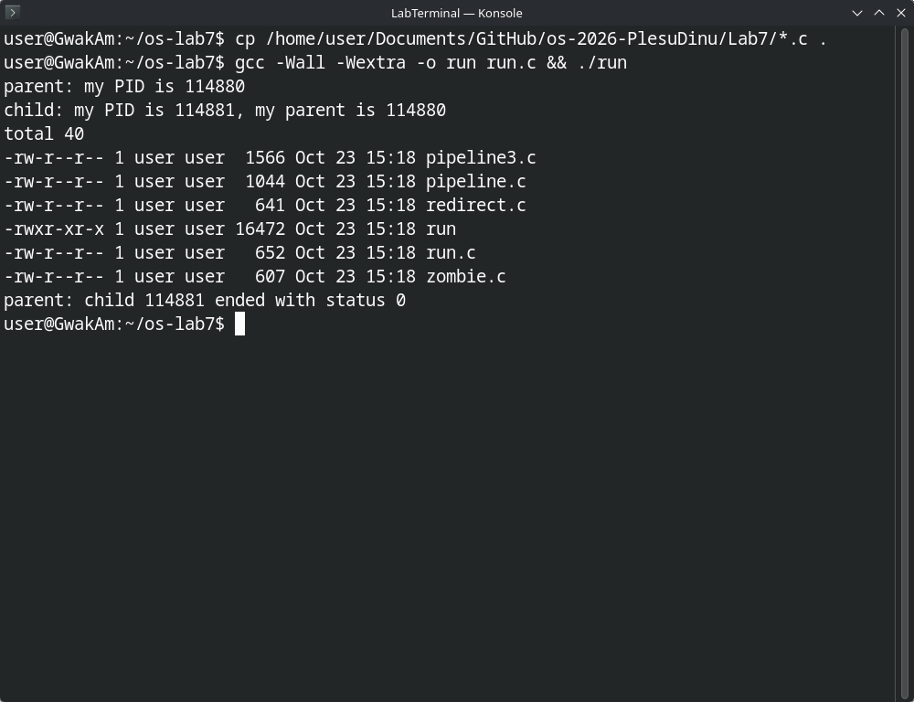
Figure 1.1 – run: parent PID, child PID and parent PID, ls -l output, and the exit status

3. Part 2 – A zombie, on purpose
zombie.c lets the child finish and delays the parent's waitpid() by 20 seconds. During the delay, ps -o pid,ppid,stat,cmd should show the child with Z in the state column and [ls] <defunct>. The parent reaps it when waitpid() runs; after that, the child entry disappears.
Commands / Output
gcc -Wall -Wextra -o zombie zombie.c
./zombie >/dev/null &
sleep 2
ps -o pid,ppid,stat,cmd

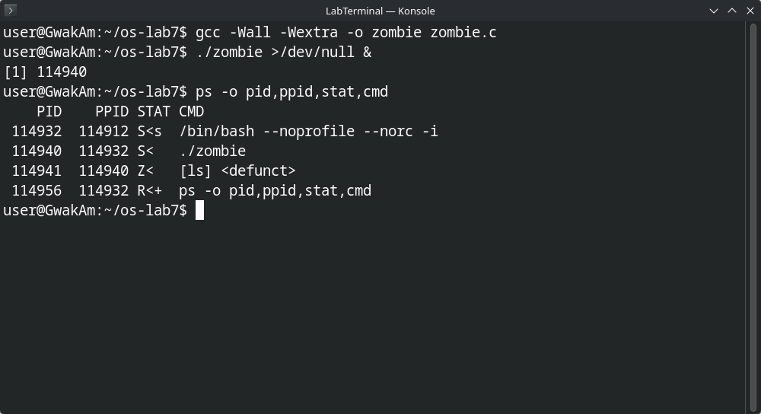
Figure 2.1 – zombie: the child is Z (defunct) while the parent sleeps

4. Part 3 – Redirection
redirect.c closes descriptor 1 in the child before opening out.txt. open() returns descriptor 1 because it allocates the lowest available descriptor. ls still writes to standard output, but that descriptor now refers to out.txt, so the listing is not printed on the terminal. To redirect standard error, close descriptor 2 before open().
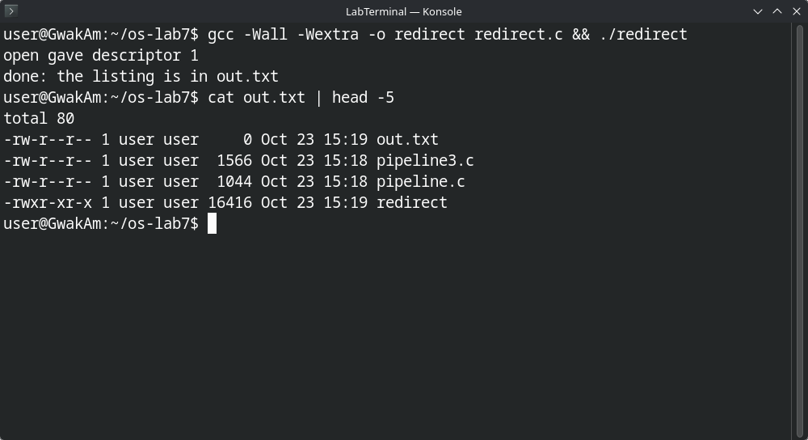
Figure 3.1 – redirect: open returns descriptor 1 and the listing goes to out.txt

5. Part 4 – A pipe
pipeline.c connects ls /etc to wc -l; its output should equal the shell pipeline ls /etc | wc -l when run against the same filesystem. The parent closes both pipe ends after forking. If it mistakenly retains the write end, wc never receives EOF. In that broken version wc waits for more input, while ls can exit.
pipeline3.c is the optional three-stage pipeline for ls /usr/bin | grep x | wc -l.
Compile and compare:
Commands / Output
gcc -Wall -Wextra -o pipeline pipeline.c
./pipeline
ls /etc | wc -l
gcc -Wall -Wextra -o pipeline3 pipeline3.c
./pipeline3
ls /usr/bin | grep x | wc -l

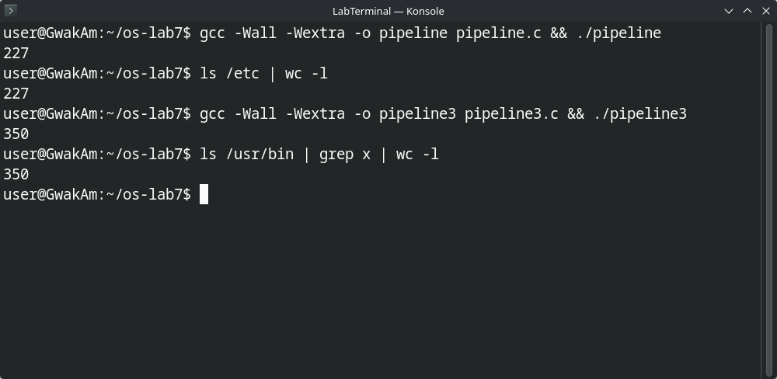
Figure 4.1 – pipeline and pipeline3 match the shell pipelines (227 and 350)

6. Conclusion
fork() creates a child, exec() replaces its program, and waitpid() collects its exit status. File descriptors make redirection and pipes composable: the programs keep using standard input/output while the process setup changes what those descriptors refer to. Closing every unused pipe end is necessary for EOF and termination.

