DEPARTMENT OF COMPUTER SCIENCE AND ENGINEERING

ISLAMIC UNIVERSITY OF TECHNOLOGY

A SUBSIDIARY ORGAN OF OIC
LAB REPORT 3
CSE 4512: COMPUTER NETWORKING LAB
Name: Nayeemul Hasan Prince
Student ID: 220041125
Section: 1A
Semester: 5th
Date of Submission: 05.12.2025

1. Lab Task
The objective of this laboratory assignment was to design a scalable network infrastructure for the "MAGA Headquarters" expansion. The design required supporting five distinct departments (Engineering, Marketing, Sales, Administration, and Management) using efficient Variable Length Subnet Masking (VLSM).
Key Objectives:
- Topology Design: Implement a multi-subnet topology with a central router and dedicated switches for each department.
- DHCP Configuration: * Deploy a Dedicated DHCP Server for Engineering, Marketing, and Sales.
  - Configure the Router as a DHCP Server for Administration and Management.
- NAT/PAT Implementation: Configure Network Address Translation to map internal private IP addresses to a limited pool of 7 Global IPs for internet access.
Calculations for Student ID: 25
- Network Prefix Formula: 192.i.((i+3) % 10).0
- i (Last two digits): 25
- Third Octet: (25 + 3) % 10 = 28 % 10 = 8
- Base Network: 192.25.8.0
Host Requirements & VLSM Calculation:
Department | Hosts Required | Block Size | CIDR | Subnet Mask | Network Address | Gateway (Router IP)
Engineering | 33 | 64 | /26 | 255.255.255.192 | 192.25.8.0 | 192.25.8.1
Management | 30 | 64 | /26 | 255.255.255.192 | 192.25.8.64 | 192.25.8.65
Sales | 14 | 32 | /27 | 255.255.255.224 | 192.25.8.128 | 192.25.8.129
Admin | 12 | 16 | /28 | 255.255.255.240 | 192.25.8.160 | 192.25.8.161
Marketing | 7 | 16 | /28 | 255.255.255.240 | 192.25.8.176 | 192.25.8.177

2. Final Network Topology
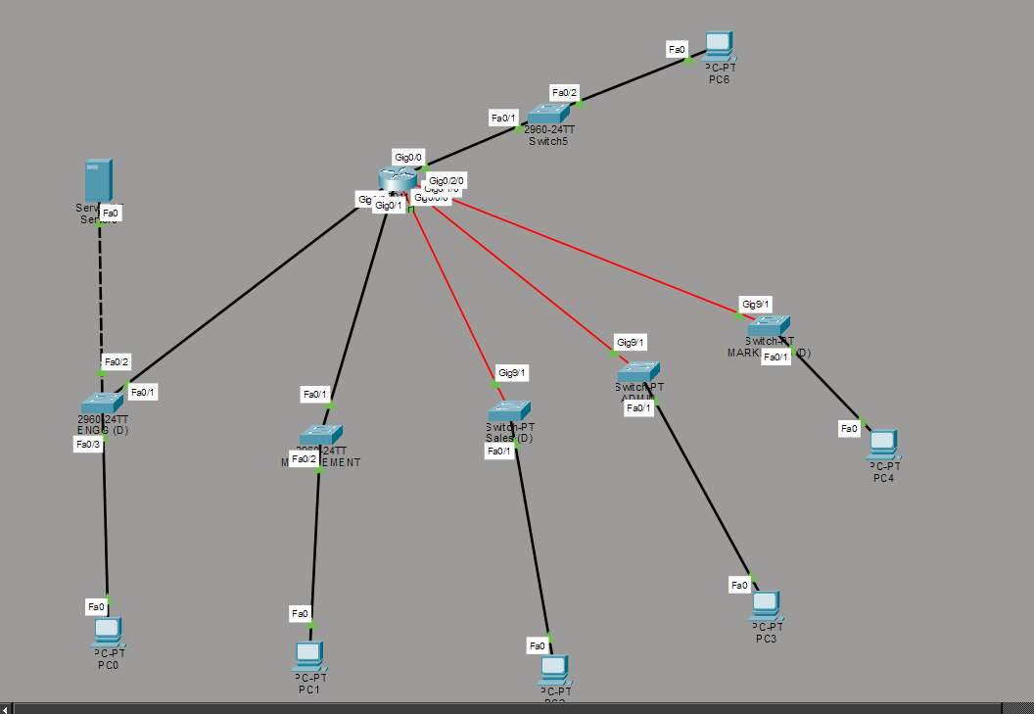

3. Procedure
The implementation was divided into three primary phases: Topology Setup, DHCP Configuration, and NAT/PAT Configuration.

3.1 Topology & Interface Configuration
- Module Expansion: A GigabitEthernet module (HWIC-1GE-SFP) was added to the central router to support 5 distinct LAN interfaces.
- Interface Configuration: Each router interface was assigned the first usable IP of its respective subnet (The Gateway).
.
- Global IP Network: The interface connecting to the Internet Router was configured with an IP from the 110.25.26.0/24 block.

3.2 DHCP Implementation
Part A: Dedicated DHCP Server (Engineering, Sales, Marketing)
- A Server-PT device was placed in the Engineering subnet with the static IP 192.25.8.2.
- Three DHCP pools were configured on the server with the specific VLSM masks calculated in Section 1.
- IP Helper: The ip helper-address 192.25.8.2 command was applied to the Router's Engineering, Sales, and Marketing interfaces to relay broadcast requests to the server.
Part B: Router-Based DHCP (Admin, Management)
- Two DHCP pools (ADMIN and MANAGEMENT) were created directly on the Router via CLI.
- The default-router command was used to push the specific gateway IP for each subnet.
- Gateway IPs were explicitly excluded using ip dhcp excluded-address to prevent IP conflicts.

3.3 NAT & PAT Configuration
- Interface Definition: Internal LAN interfaces were marked as ip nat inside, and the WAN interface facing the Internet Router was marked as ip nat outside.
- Address Pool: A NAT pool named GLOBAL_POOL was created using the 6 available public IPs: 110.25.26.2 to 110.25.26.7.
- Static NAT: A static translation was configured for the user PC (192.25.8.3) to map exclusively to 110.25.26.1.
- Dynamic PAT: An access list (ACL 1) was created to permit traffic from 192.25.8.0/24. This list was mapped to the GLOBAL_POOL with the overload keyword, enabling Port Address Translation for all other devices.

4. Observations & Results
4.1 DHCP Verification
The following screenshot demonstrates a PC successfully receiving an IP address, Subnet Mask, and Gateway from the DHCP server.
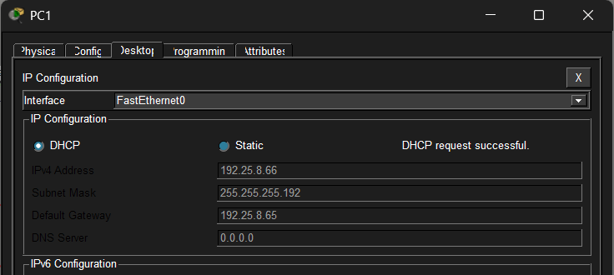
4.2 Connectivity Test (Ping)
Successful communication between different departments (Routing Verification) and to the external PC6 (NAT Verification).
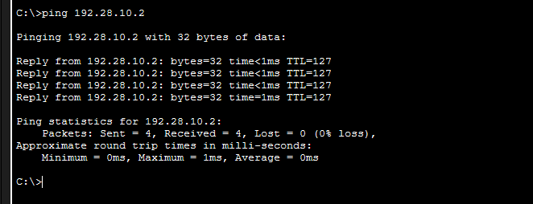
4.3 NAT Translation Table
The router's NAT table showing the Static entry for the main PC and Dynamic PAT entries for other hosts.
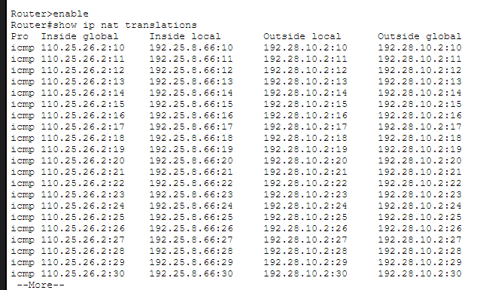

5. Challenges Faced
- Router Module Configuration: The FastEthernet interfaces added to the router initially failed to accept IP addresses because they defaulted to Layer 2 switch ports. This was resolved by entering the no switchport command to convert them into Layer 3 routed interfaces.
- DHCP Subnet Mask Errors: Initially, PCs received APIPA addresses (169.254.x.x) or incorrect gateways because the DHCP Server pools were configured with the default /24 mask. The issue was resolved by manually updating the DHCP pools to match the specific VLSM masks (/26, /27, /28) calculated for each department.
- Service Persistence: Connectivity was temporarily lost after a device restart because the DHCP Server service settings were not saved to NVRAM. This was corrected by ensuring the DHCP service was toggled ON and the configuration was explicitly saved on the server device.

