# Circuit diagram:

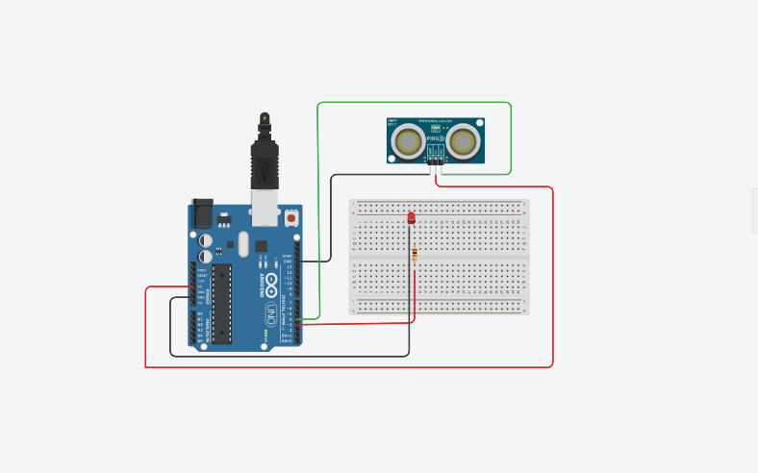

# Code:

const int TrigPin = 4;

const int ledPin = 3;

void setup()

{

Serial.begin(9600);

pinMode(3, OUTPUT);

}

void loop() {

long duration, cm;

pinMode(TrigPin, OUTPUT);

digitalWrite(TrigPin, LOW);

delayMicroseconds(2);

digitalWrite(TrigPin, HIGH);

delayMicroseconds(10);

digitalWrite(TrigPin, LOW);

pinMode(TrigPin, INPUT);

duration = pulseIn(TrigPin, HIGH);

cm = microsecondsToCentimeters(duration);

Serial.print("Distance: ");

Serial.print(cm);

Serial.print("cm");

Serial.println();

if(cm < 100) {

digitalWrite(ledPin, HIGH);

}

else {

digitalWrite(ledPin, LOW);

}

delay(100);

}

long microsecondsToCentimeters(long microseconds) {

return microseconds / 29 / 2;

}

# Output:

