KeenAble PWA — Test Report
Playwright Automated Test Suite
Date: 14 March 2026
Application URL: http://95.216.39.97:8086/
Confidential

Table of Contents
1. Overview
2. Test Environment
3. Folder Structure
4. Test Cases
5. Page / Feature Coverage Summary
6. How to Run Tests
7. Playwright Config Summary
8. Assumptions & Limitations
9. Conventions Used

1. Overview
KeenAble is a Mark My Presence application — a mobile-first Progressive Web App (PWA) designed for attendance and shift tracking. This report documents the black-box UI test suite developed using Playwright, focusing on mobile-first testing with awareness of Server-Side Rendering (SSR) and hydration states.
The test suite consists of 117 test cases covering various functional and non-functional aspects of the application. Of these, 0 have passed, 0 have failed, and 117 have not yet been executed.

2. Test Environment
Property | Value
Application URL | http://95.216.39.97:8086/
Test Framework | Playwright
Language | TypeScript
Node Version | v24.14.0
Primary Device | Mobile Chrome — Pixel 5
Secondary Device | Mobile Safari — iPhone 12
Viewport | 375x667 (default mobile)
Test Execution | npx playwright test
Report Format | HTML + DOCX
Screenshot Capture | On (all tests)
Video Recording | Off

3. Folder Structure
tests/
├── dashboard/
│ └── dashboard.spec.ts
├── data-display/
│ └── data-display.spec.ts
├── header-layout/
│ └── header-layout.spec.ts
├── leaves/
│ └── leaves.spec.ts
├── login/
│ └── login.spec.ts
├── navigation/
│ └── navigation.spec.ts
├── page-load/
│ └── page-load.spec.ts
├── pwa/
│ └── pwa.spec.ts
├── responsive-layout/
│ └── responsive-layout.spec.ts
├── schedule/
│ └── schedule.spec.ts
├── settings/
│ └── settings.spec.ts
└── utils/
├── auth.ts
└── screenshot.ts

4. Test Cases
Test ID: TC001 — Login Page Load
Test ID | TC001
Functional Feature | Login
Device Specs | Mobile â All Devices
Feature Type | Functional
Feature Name | Login Page Load
Priority | P0
Description | Verify login page loads successfully after SSR on mobile viewport
Expected Result | Not yet executed
Screenshot:
Device: Mobile-Chrome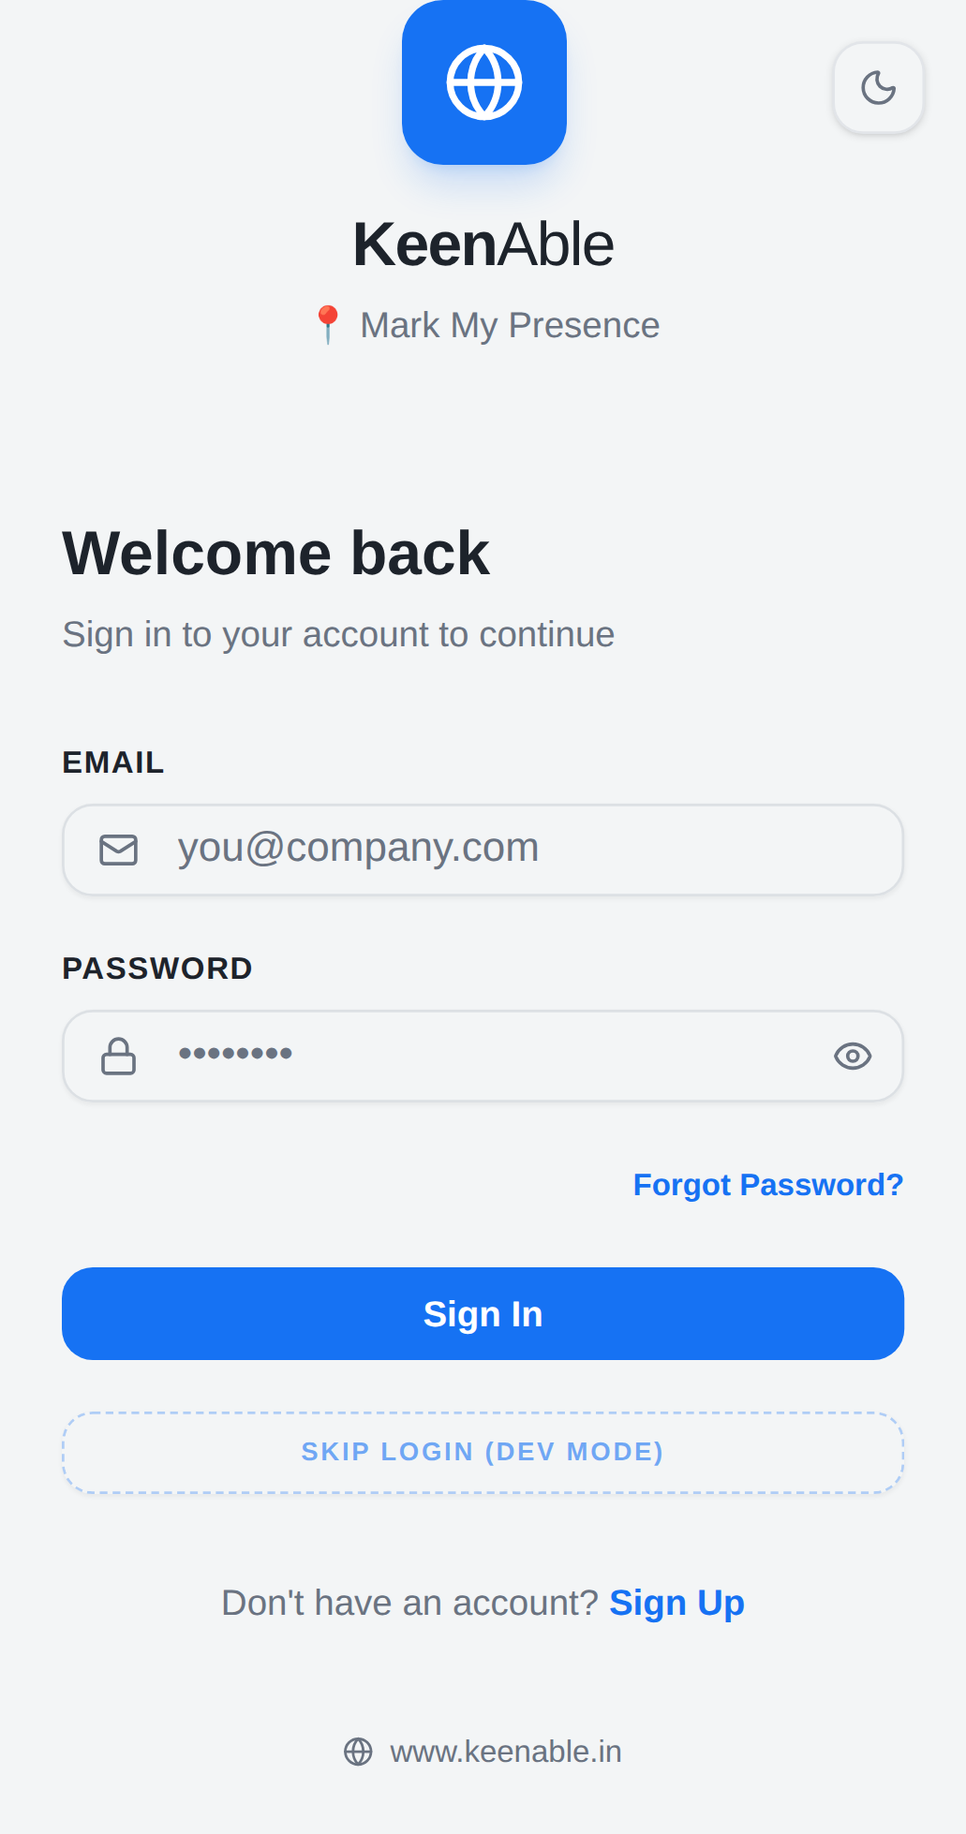

Test ID: TC002 — Login Page Title
Test ID | TC002
Functional Feature | Login
Device Specs | Mobile â All Devices
Feature Type | Functional
Feature Name | Login Page Title
Priority | P1
Description | Verify "KeenAble - Mark My Presence" title appears on login page
Expected Result | Not yet executed
Screenshot:
Device: Mobile-Chrome

Test ID: TC003 — Login Branding
Test ID | TC003
Functional Feature | Login
Device Specs | Mobile â All Devices
Feature Type | Functional
Feature Name | Login Branding
Priority | P1
Description | Verify branding "ð Mark My Presence" displays on login page
Expected Result | Not yet executed
Screenshot:
Device: Mobile-Chrome

Test ID: TC004 — Login Tagline
Test ID | TC004
Functional Feature | Login
Device Specs | Mobile â All Devices
Feature Type | Functional
Feature Name | Login Tagline
Priority | P2
Description | Verify tagline "Track your shifts, manage attendance, and stay connected with your team â all in one place." displays
Expected Result | Not yet executed
Screenshot:
Device: Mobile-Chrome

Test ID: TC005 — Feature Cards Visibility
Test ID | TC005
Functional Feature | Login
Device Specs | Mobile â All Devices
Feature Type | Functional
Feature Name | Feature Cards Visibility
Priority | P1
Description | Verify feature cards (Shift Tracking, Leave Management, Geo Location, Incident Reports) are visible
Expected Result | Not yet executed
Screenshot:
[No screenshot available]

Test ID: TC006 — Welcome Back Heading
Test ID | TC006
Functional Feature | Login
Device Specs | Mobile â All Devices
Feature Type | Functional
Feature Name | Welcome Back Heading
Priority | P1
Description | Verify "Welcome back" heading displays on login page
Expected Result | Not yet executed
Screenshot:
Device: Mobile-Chrome

Test ID: TC007 — Sign In Subtitle
Test ID | TC007
Functional Feature | Login
Device Specs | Mobile â All Devices
Feature Type | Functional
Feature Name | Sign In Subtitle
Priority | P1
Description | Verify "Sign in to your account to continue" subtitle displays
Expected Result | Not yet executed
Screenshot:
Device: Mobile-Chrome

Test ID: TC008 — Email Input Field
Test ID | TC008
Functional Feature | Login
Device Specs | Mobile â All Devices
Feature Type | Functional
Feature Name | Email Input Field
Priority | P0
Description | Verify email input field is visible and accepts text on mobile
Expected Result | Not yet executed
Screenshot:
Device: Mobile-Chrome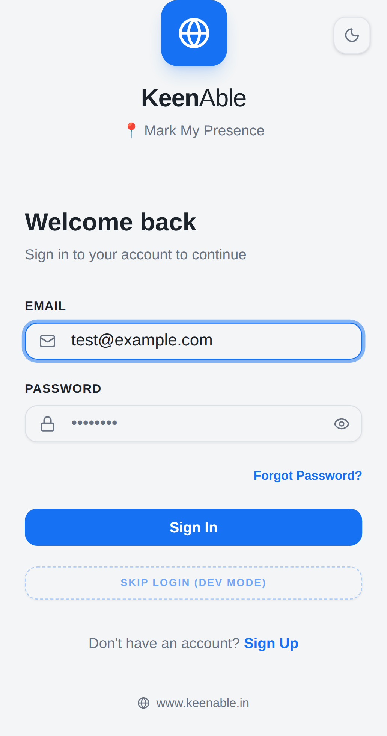

Test ID: TC009 — Password Input Field
Test ID | TC009
Functional Feature | Login
Device Specs | Mobile â All Devices
Feature Type | Functional
Feature Name | Password Input Field
Priority | P0
Description | Verify password input field is visible and accepts text on mobile
Expected Result | Not yet executed
Screenshot:
Device: Mobile-Chrome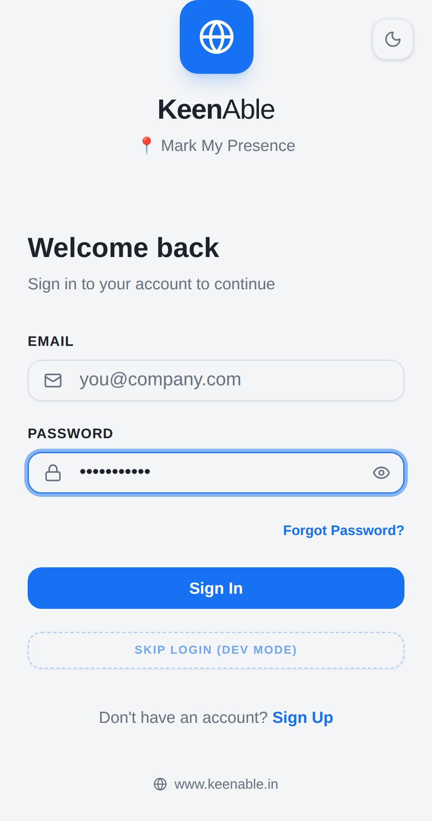

Test ID: TC010 — Forgot Password Link
Test ID | TC010
Functional Feature | Login
Device Specs | Mobile â All Devices
Feature Type | Functional
Feature Name | Forgot Password Link
Priority | P1
Description | Verify "Forgot Password?" link is visible on mobile
Expected Result | Not yet executed
Screenshot:
Device: Mobile-Chrome

Test ID: TC011 — Sign In Button
Test ID | TC011
Functional Feature | Login
Device Specs | Mobile â All Devices
Feature Type | Functional
Feature Name | Sign In Button
Priority | P0
Description | Verify "Sign In" button is visible and touch-interactable on mobile
Expected Result | Not yet executed
Screenshot:
Device: Mobile-Chrome

Test ID: TC012 — Skip Login Dev Mode
Test ID | TC012
Functional Feature | Login
Device Specs | Mobile â All Devices
Feature Type | Functional
Feature Name | Skip Login Dev Mode
Priority | P1
Description | Verify "Skip Login (Dev Mode)" button is visible and touch-interactable (Temporary â remove when Keycloak is fixed)
Expected Result | Not yet executed
Screenshot:
Device: Mobile-Chrome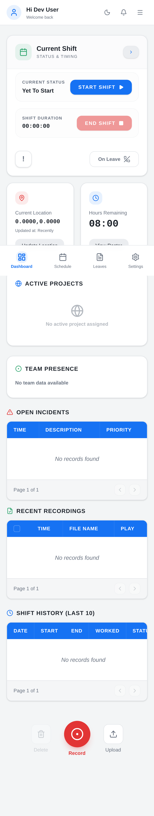

Test ID: TC013 — Sign Up Link
Test ID | TC013
Functional Feature | Login
Device Specs | Mobile â All Devices
Feature Type | Functional
Feature Name | Sign Up Link
Priority | P1
Description | Verify "Don't have an account? Sign Up" link is visible on mobile
Expected Result | Not yet executed
Screenshot:
Device: Mobile-Chrome

Test ID: TC014 — Keycloak Based Login
Test ID | TC014
Functional Feature | Login
Device Specs | Mobile â All Devices
Feature Type | Functional
Feature Name | Keycloak Based Login
Priority | P0
Description | Verify Keycloak based authentication works for authorized users (Currently blocked â Dev login workaround in place (TC013))
Expected Result | Not yet executed
Screenshot:
[No screenshot available]

Test ID: TC015 — Invalid Credentials
Test ID | TC015
Functional Feature | Login
Device Specs | Mobile â All Devices
Feature Type | Functional
Feature Name | Invalid Credentials
Priority | P0
Description | Verify error message displays when invalid credentials are entered
Expected Result | Not yet executed
Screenshot:
Device: Mobile-Chrome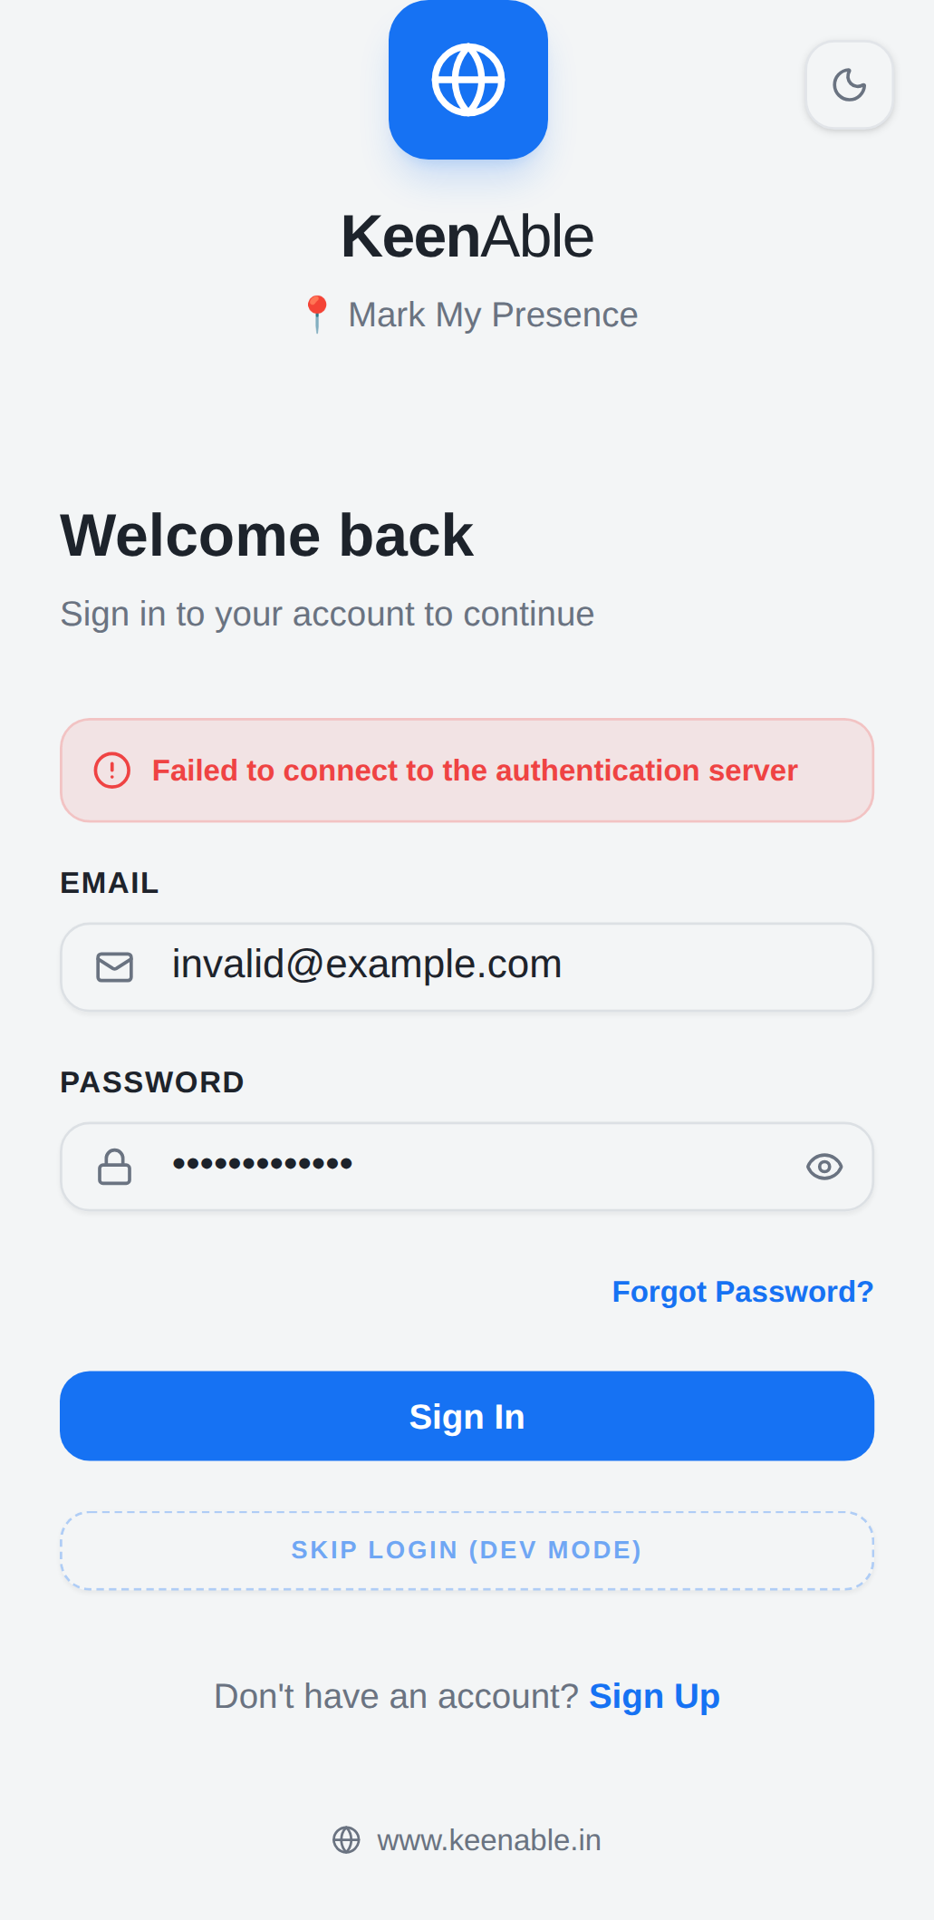

Test ID: TC016 — Valid Login
Test ID | TC016
Functional Feature | Login
Device Specs | Mobile â All Devices
Feature Type | Functional
Feature Name | Valid Login
Priority | P0
Description | Verify user can successfully log in with valid credentials
Expected Result | Not yet executed
Screenshot:
Device: Mobile-Chrome

Test ID: TC017 — Logout
Test ID | TC017
Functional Feature | Login
Device Specs | Mobile â All Devices
Feature Type | Functional
Feature Name | Logout
Priority | P0
Description | Verify user can log out from the application
Expected Result | Not yet executed
Screenshot:
Device: Mobile-Chrome

Test ID: TC018 — Session Expiry
Test ID | TC018
Functional Feature | Login
Device Specs | Mobile â All Devices
Feature Type | Functional
Feature Name | Session Expiry
Priority | P1
Description | Verify session expires after inactivity
Expected Result | Not yet executed
Screenshot:
[No screenshot available]

Test ID: TC019 — Login Form Validation
Test ID | TC019
Functional Feature | Login
Device Specs | Mobile â All Devices
Feature Type | Functional
Feature Name | Login Form Validation
Priority | P1
Description | Verify form validates empty email and password fields
Expected Result | Not yet executed
Screenshot:
Device: Mobile-Chrome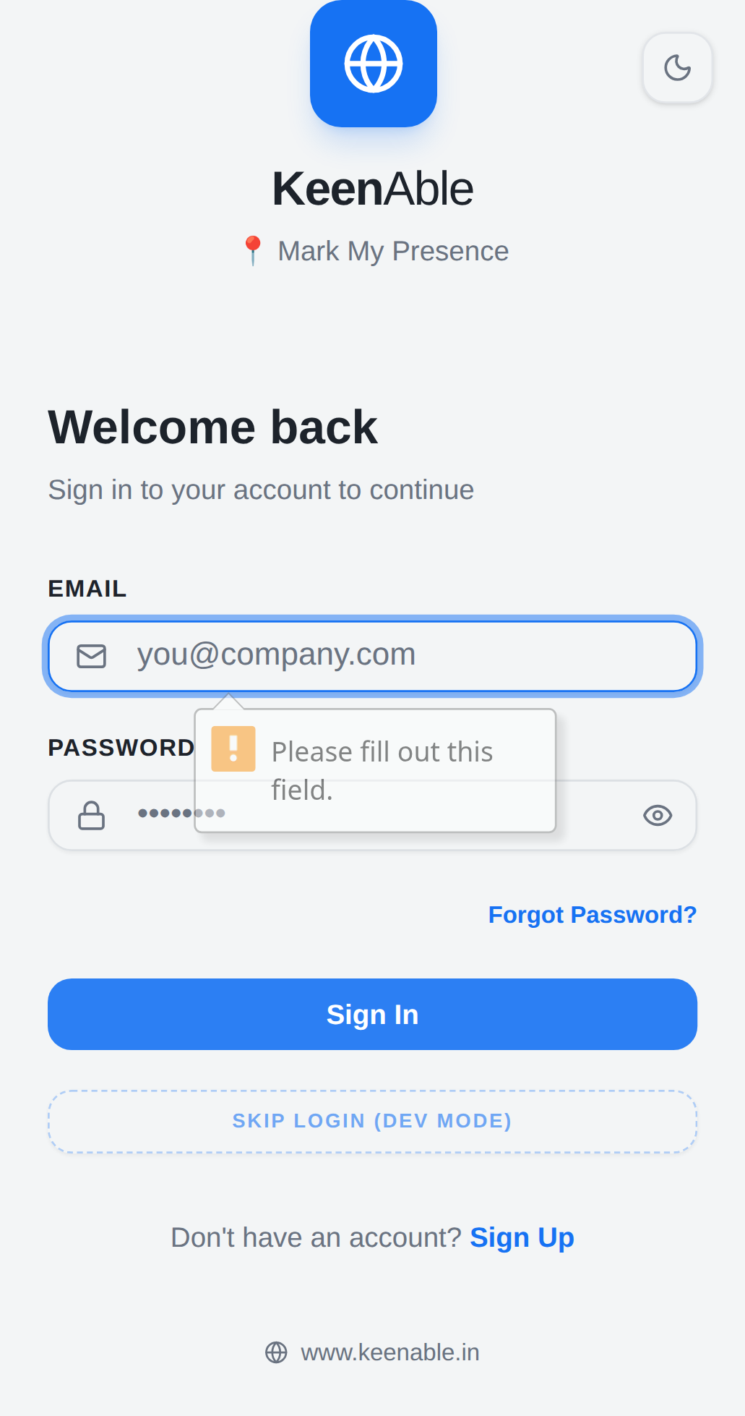

Test ID: TC020 — Login Page Performance
Test ID | TC020
Functional Feature | Login
Device Specs | Mobile â All Devices
Feature Type | Non-Functional
Feature Name | Login Page Performance
Priority | P2
Description | Verify login page loads within acceptable time on mobile
Expected Result | Not yet executed
Screenshot:
Device: Mobile-Chrome

Test ID: TC021 — Password Visibility Toggle
Test ID | TC021
Functional Feature | Login
Device Specs | Mobile â All Devices
Feature Type | Functional
Feature Name | Password Visibility Toggle
Priority | P1
Description | Verify password visibility toggle (show/hide) works on mobile
Expected Result | Not yet executed
Screenshot:
Device: Mobile-Chrome

Test ID: TC022 — Android Login
Test ID | TC022
Functional Feature | Login
Device Specs | Android Mobile Browser
Feature Type | Functional
Feature Name | Android Login
Priority | P0
Description | Verify login page works correctly in Android mobile browser
Expected Result | Not yet executed
Screenshot:
Device: Mobile-Chrome

Test ID: TC023 — iOS Login
Test ID | TC023
Functional Feature | Login
Device Specs | iOS Safari
Feature Type | Functional
Feature Name | iOS Login
Priority | P0
Description | Verify login page works correctly in iOS Safari
Expected Result | Not yet executed
Screenshot:
Device: Mobile-Chrome

Test ID: TC024 — Dashboard Page Load
Test ID | TC024
Functional Feature | Dashboard
Device Specs | Mobile â All Devices
Feature Type | Functional
Feature Name | Dashboard Page Load
Priority | P0
Description | Verify dashboard page loads successfully after SSR on mobile viewport
Expected Result | Not yet executed
Screenshot:
Device: Mobile-Chrome

Test ID: TC025 — Dashboard Welcome Greeting
Test ID | TC025
Functional Feature | Dashboard
Device Specs | Mobile â All Devices
Feature Type | Functional
Feature Name | Dashboard Welcome Greeting
Priority | P1
Description | Verify "Welcome back" greeting renders on dashboard (appears in SSR, fully visible after hydration)
Expected Result | Not yet executed
Screenshot:
Device: Mobile-Chrome

Test ID: TC026 — Current Shift Card Visibility
Test ID | TC026
Functional Feature | Dashboard
Device Specs | Mobile â All Devices
Feature Type | Functional
Feature Name | Current Shift Card Visibility
Priority | P0
Description | Verify Current Shift card is visible after hydration on mobile
Expected Result | Not yet executed
Screenshot:
Device: Mobile-Chrome

Test ID: TC027 — Start Shift Button
Test ID | TC027
Functional Feature | Dashboard
Device Specs | Mobile â All Devices
Feature Type | Functional
Feature Name | Start Shift Button
Priority | P1
Description | Verify Start Shift button is visible and touch-interactable (becomes interactive after hydration)
Expected Result | Not yet executed
Screenshot:
Device: Mobile-Chrome

Test ID: TC028 — Current Status Display
Test ID | TC028
Functional Feature | Dashboard
Device Specs | Mobile â All Devices
Feature Type | Functional
Feature Name | Current Status Display
Priority | P0
Description | Verify current status displays "Open Schedule" on mobile
Expected Result | Not yet executed
Screenshot:
Device: Mobile-Chrome

Test ID: TC029 — Shift Duration Card
Test ID | TC029
Functional Feature | Dashboard
Device Specs | Mobile â All Devices
Feature Type | Functional
Feature Name | Shift Duration Card
Priority | P1
Description | Verify Shift Duration card is visible on mobile
Expected Result | Not yet executed
Screenshot:
Device: Mobile-Chrome

Test ID: TC030 — End Shift Button
Test ID | TC030
Functional Feature | Dashboard
Device Specs | Mobile â All Devices
Feature Type | Functional
Feature Name | End Shift Button
Priority | P1
Description | Verify End Shift button is touch-interactable (becomes interactive after hydration)
Expected Result | Not yet executed
Screenshot:
Device: Mobile-Chrome

Test ID: TC031 — On Leave Indicator
Test ID | TC031
Functional Feature | Dashboard
Device Specs | Mobile â All Devices
Feature Type | Functional
Feature Name | On Leave Indicator
Priority | P1
Description | Verify "On Leave" indicator is visible on mobile
Expected Result | Not yet executed
Screenshot:
Device: Mobile-Chrome

Test ID: TC032 — Current Location Section
Test ID | TC032
Functional Feature | Dashboard
Device Specs | Mobile â All Devices
Feature Type | Functional
Feature Name | Current Location Section
Priority | P1
Description | Verify Current Location section is visible on mobile
Expected Result | Not yet executed
Screenshot:
Device: Mobile-Chrome

Test ID: TC033 — Update Location Button
Test ID | TC033
Functional Feature | Dashboard
Device Specs | Mobile â All Devices
Feature Type | Functional
Feature Name | Update Location Button
Priority | P1
Description | Verify Update Location button is touch-interactable (becomes interactive after hydration)
Expected Result | Not yet executed
Screenshot:
Device: Mobile-Chrome

Test ID: TC034 — Hours Remaining Card
Test ID | TC034
Functional Feature | Dashboard
Device Specs | Mobile â All Devices
Feature Type | Functional
Feature Name | Hours Remaining Card
Priority | P2
Description | Verify Hours Remaining card is visible on mobile
Expected Result | Not yet executed
Screenshot:
Device: Mobile-Chrome

Test ID: TC035 — View Roster Button
Test ID | TC035
Functional Feature | Dashboard
Device Specs | Mobile â All Devices
Feature Type | Functional
Feature Name | View Roster Button
Priority | P1
Description | Verify View Roster button is touch-interactable (becomes interactive after hydration)
Expected Result | Not yet executed
Screenshot:
Device: Mobile-Chrome

Test ID: TC036 — Active Project Section
Test ID | TC036
Functional Feature | Dashboard
Device Specs | Mobile â All Devices
Feature Type | Functional
Feature Name | Active Project Section
Priority | P2
Description | Verify Active Project section is visible on mobile
Expected Result | Not yet executed
Screenshot:
Device: Mobile-Chrome

Test ID: TC037 — Team Presence Section
Test ID | TC037
Functional Feature | Dashboard
Device Specs | Mobile â All Devices
Feature Type | Functional
Feature Name | Team Presence Section
Priority | P2
Description | Verify Team Presence section is visible on mobile
Expected Result | Not yet executed
Screenshot:
Device: Mobile-Chrome

Test ID: TC038 — Open Incidents Table
Test ID | TC038
Functional Feature | Dashboard
Device Specs | Mobile â All Devices
Feature Type | Functional
Feature Name | Open Incidents Table
Priority | P1
Description | Verify Open Incidents table loads and is horizontally scrollable on mobile
Expected Result | Not yet executed
Screenshot:
Device: Mobile-Chrome

Test ID: TC039 — Open Incidents Pagination
Test ID | TC039
Functional Feature | Dashboard
Device Specs | Mobile â All Devices
Feature Type | Functional
Feature Name | Open Incidents Pagination
Priority | P2
Description | Verify pagination shows correct information on mobile
Expected Result | Not yet executed
Screenshot:
Device: Mobile-Chrome

Test ID: TC040 — Recent Recordings Table
Test ID | TC040
Functional Feature | Dashboard
Device Specs | Mobile â All Devices
Feature Type | Functional
Feature Name | Recent Recordings Table
Priority | P1
Description | Verify Recent Recordings table is scrollable on mobile
Expected Result | Not yet executed
Screenshot:
Device: Mobile-Chrome

Test ID: TC041 — Play Button on Recordings
Test ID | TC041
Functional Feature | Dashboard
Device Specs | Mobile â All Devices
Feature Type | Functional
Feature Name | Play Button on Recordings
Priority | P1
Description | Verify Play button is visible and touch-interactable (becomes interactive after hydration)
Expected Result | Not yet executed
Screenshot:
Device: Mobile-Chrome

Test ID: TC042 — Record Button
Test ID | TC042
Functional Feature | Dashboard
Device Specs | Mobile â All Devices
Feature Type | Functional
Feature Name | Record Button
Priority | P1
Description | Verify Record button is touch-interactable (becomes interactive after hydration)
Expected Result | Not yet executed
Screenshot:
Device: Mobile-Chrome

Test ID: TC043 — Upload Button
Test ID | TC043
Functional Feature | Dashboard
Device Specs | Mobile â All Devices
Feature Type | Functional
Feature Name | Upload Button
Priority | P1
Description | Verify Upload button is touch-interactable (becomes interactive after hydration)
Expected Result | Not yet executed
Screenshot:
Device: Mobile-Chrome

Test ID: TC044 — Shift History Table
Test ID | TC044
Functional Feature | Dashboard
Device Specs | Mobile â All Devices
Feature Type | Functional
Feature Name | Shift History Table
Priority | P1
Description | Verify Shift History table is horizontally scrollable on mobile
Expected Result | Not yet executed
Screenshot:
Device: Mobile-Chrome

Test ID: TC045 — Shift History Pagination
Test ID | TC045
Functional Feature | Dashboard
Device Specs | Mobile â All Devices
Feature Type | Functional
Feature Name | Shift History Pagination
Priority | P2
Description | Verify Shift History pagination displays on mobile
Expected Result | Not yet executed
Screenshot:
Device: Mobile-Chrome

Test ID: TC046 — Delete Button on Shift History
Test ID | TC046
Functional Feature | Dashboard
Device Specs | Mobile â All Devices
Feature Type | Functional
Feature Name | Delete Button on Shift History
Priority | P1
Description | Verify Delete button is visible and touch-interactable (becomes interactive after hydration)
Expected Result | Not yet executed
Screenshot:
Device: Mobile-Chrome

Test ID: TC047 — Schedule Page Load
Test ID | TC047
Functional Feature | Schedule
Device Specs | Mobile â All Devices
Feature Type | Functional
Feature Name | Schedule Page Load
Priority | P0
Description | Verify Schedule page loads successfully on mobile
Expected Result | Not yet executed
Screenshot:
Device: Mobile-Chrome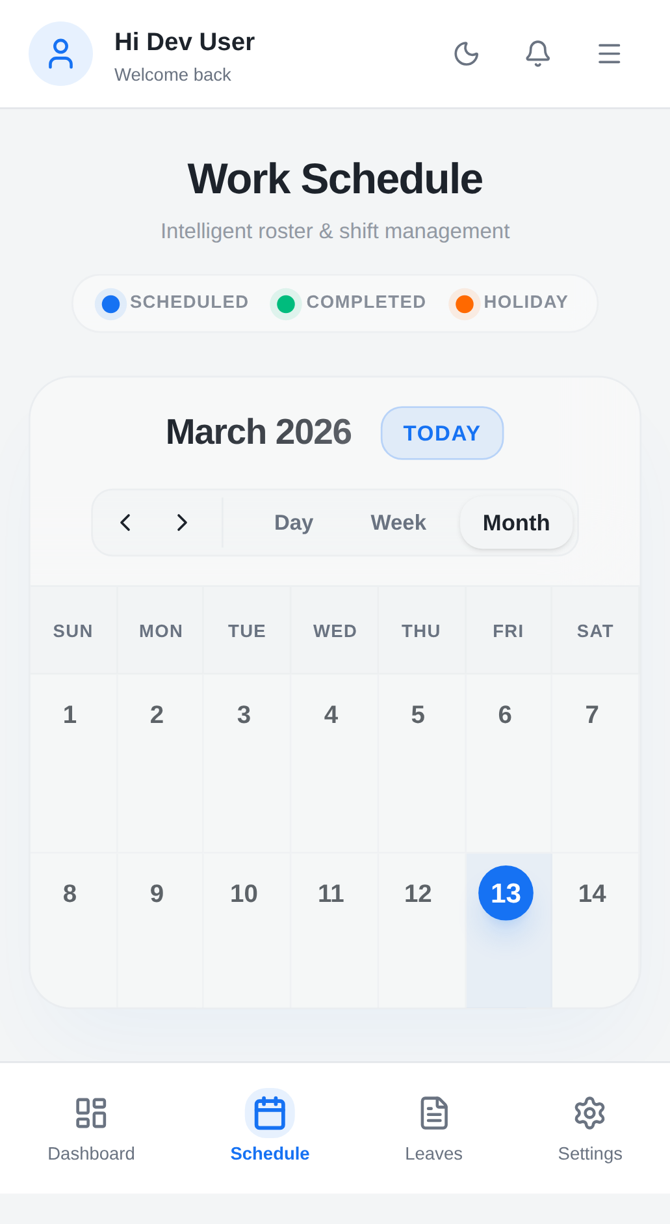

Test ID: TC048 — Schedule Page Subtitle
Test ID | TC048
Functional Feature | Schedule
Device Specs | Mobile â All Devices
Feature Type | Functional
Feature Name | Schedule Page Subtitle
Priority | P2
Description | Verify subtitle "Intelligent roster & shift management" is visible on mobile
Expected Result | Not yet executed
Screenshot:
Device: Mobile-Chrome

Test ID: TC049 — Scheduled Tab
Test ID | TC049
Functional Feature | Schedule
Device Specs | Mobile â All Devices
Feature Type | Functional
Feature Name | Scheduled Tab
Priority | P1
Description | Verify Scheduled tab is visible and touch-interactable (becomes interactive after hydration)
Expected Result | Not yet executed
Screenshot:
Device: Mobile-Chrome

Test ID: TC050 — Completed Tab
Test ID | TC050
Functional Feature | Schedule
Device Specs | Mobile â All Devices
Feature Type | Functional
Feature Name | Completed Tab
Priority | P1
Description | Verify Completed tab is visible and touch-interactable (becomes interactive after hydration)
Expected Result | Not yet executed
Screenshot:
Device: Mobile-Chrome

Test ID: TC051 — Holiday Tab
Test ID | TC051
Functional Feature | Schedule
Device Specs | Mobile â All Devices
Feature Type | Functional
Feature Name | Holiday Tab
Priority | P1
Description | Verify Holiday tab is visible and touch-interactable (becomes interactive after hydration)
Expected Result | Not yet executed
Screenshot:
Device: Mobile-Chrome

Test ID: TC052 — Calendar Visibility
Test ID | TC052
Functional Feature | Schedule
Device Specs | Mobile â All Devices
Feature Type | Functional
Feature Name | Calendar Visibility
Priority | P1
Description | Verify calendar component is visible and properly sized on mobile
Expected Result | Not yet executed
Screenshot:
Device: Mobile-Chrome

Test ID: TC053 — Today Button
Test ID | TC053
Functional Feature | Schedule
Device Specs | Mobile â All Devices
Feature Type | Functional
Feature Name | Today Button
Priority | P2
Description | Verify Today button is touch-interactable (becomes interactive after hydration)
Expected Result | Not yet executed
Screenshot:
Device: Mobile-Chrome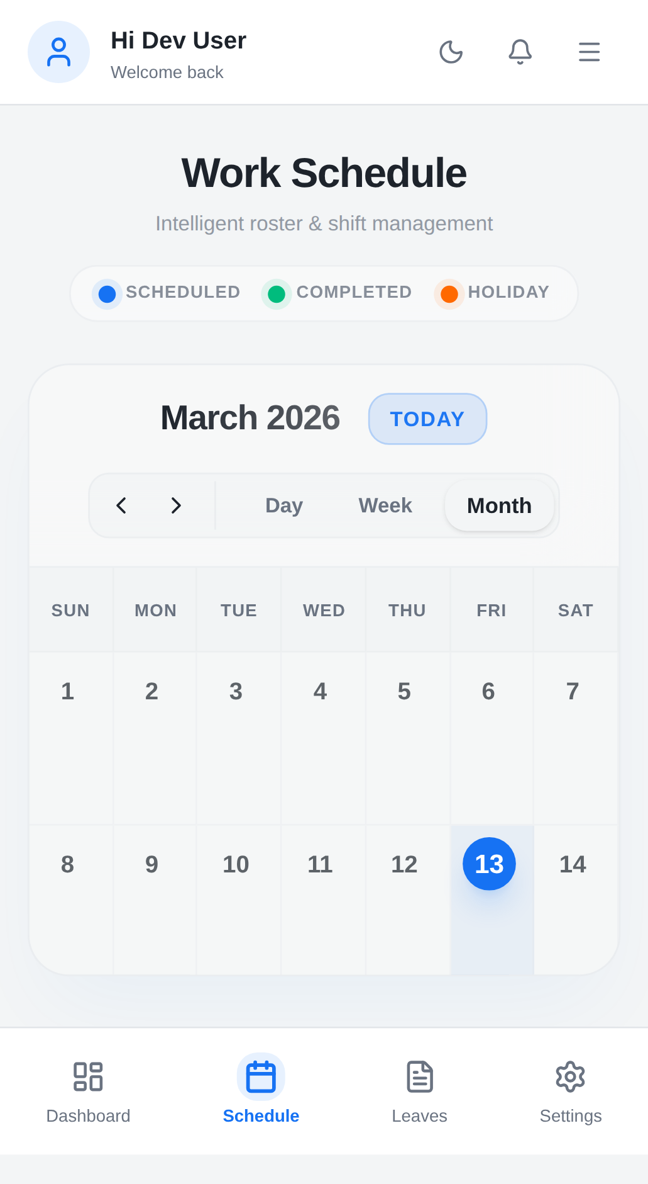

Test ID: TC054 — Left Navigation Button
Test ID | TC054
Functional Feature | Schedule
Device Specs | Mobile â All Devices
Feature Type | Functional
Feature Name | Left Navigation Button
Priority | P2
Description | Verify Left button is touch-interactable (becomes interactive after hydration)
Expected Result | Not yet executed
Screenshot:
Device: Mobile-Chrome

Test ID: TC055 — Right Navigation Button
Test ID | TC055
Functional Feature | Schedule
Device Specs | Mobile â All Devices
Feature Type | Functional
Feature Name | Right Navigation Button
Priority | P2
Description | Verify Right button is touch-interactable (becomes interactive after hydration)
Expected Result | Not yet executed
Screenshot:
Device: Mobile-Chrome

Test ID: TC056 — Day View Button
Test ID | TC056
Functional Feature | Schedule
Device Specs | Mobile â All Devices
Feature Type | Functional
Feature Name | Day View Button
Priority | P2
Description | Verify Day button is touch-interactable (becomes interactive after hydration)
Expected Result | Not yet executed
Screenshot:
[No screenshot available]

Test ID: TC057 — Week View Button
Test ID | TC057
Functional Feature | Schedule
Device Specs | Mobile â All Devices
Feature Type | Functional
Feature Name | Week View Button
Priority | P2
Description | Verify Week button is touch-interactable (becomes interactive after hydration)
Expected Result | Not yet executed
Screenshot:
Device: Mobile-Chrome

Test ID: TC058 — Month View Button
Test ID | TC058
Functional Feature | Schedule
Device Specs | Mobile â All Devices
Feature Type | Functional
Feature Name | Month View Button
Priority | P2
Description | Verify Month button is touch-interactable (becomes interactive after hydration)
Expected Result | Not yet executed
Screenshot:
Device: Mobile-Chrome

Test ID: TC059 — Leaves Page Load
Test ID | TC059
Functional Feature | Leaves
Device Specs | Mobile â All Devices
Feature Type | Functional
Feature Name | Leaves Page Load
Priority | P0
Description | Verify Leaves page loads successfully on mobile
Expected Result | Not yet executed
Screenshot:
Device: Mobile-Chrome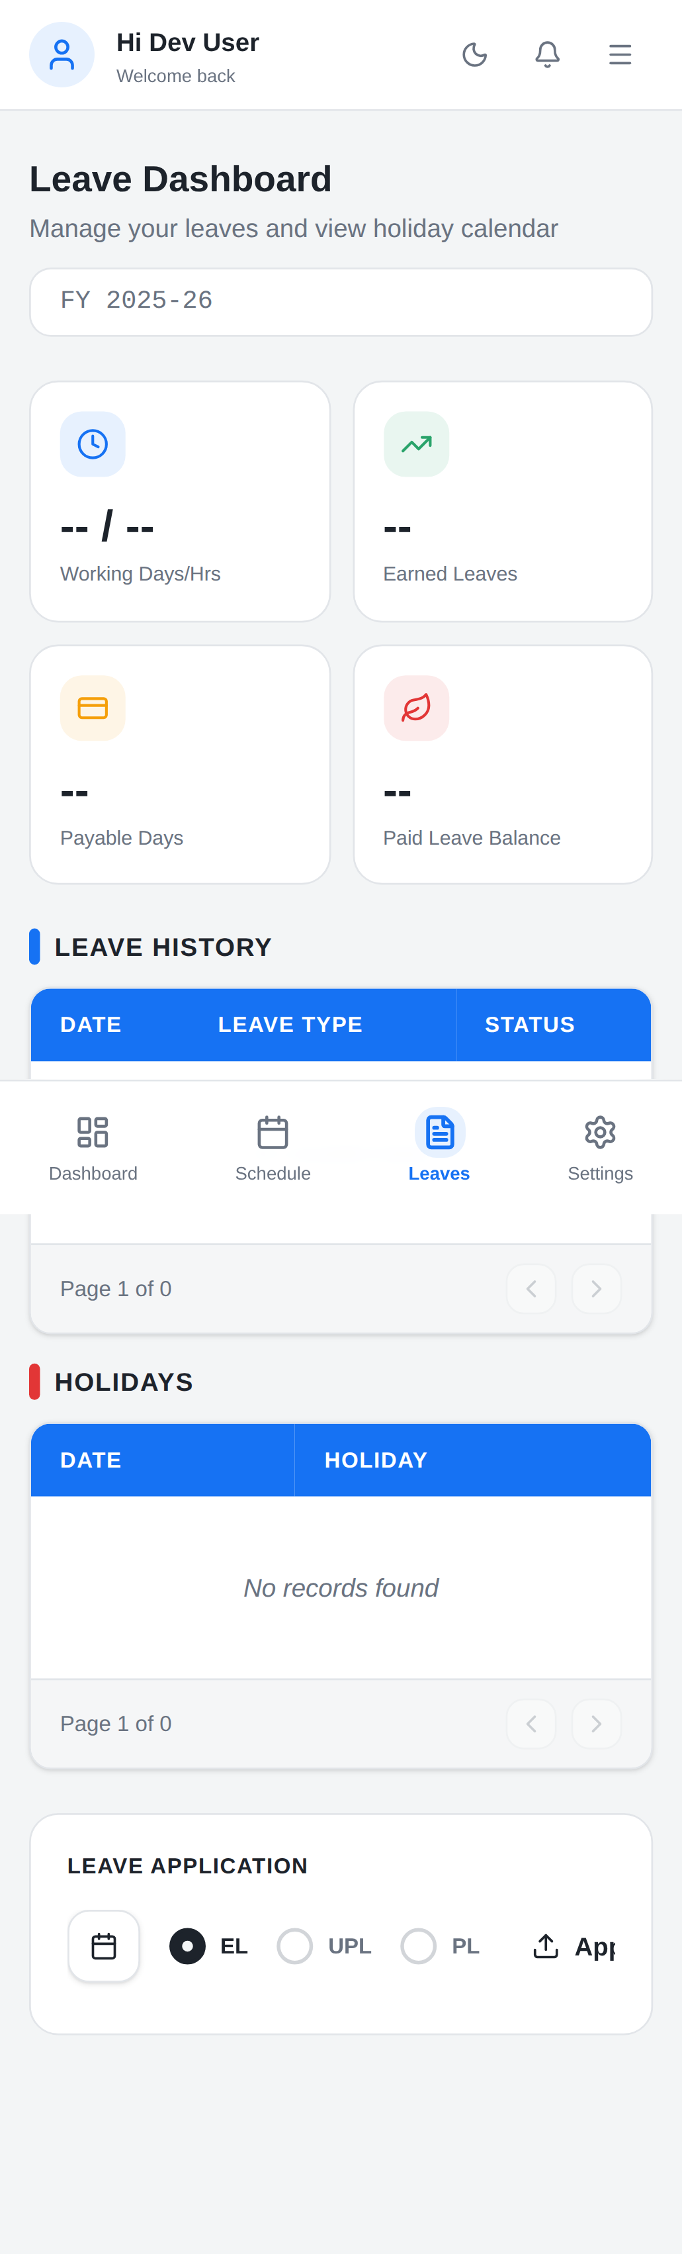

Test ID: TC060 — Leave Dashboard Subtitle
Test ID | TC060
Functional Feature | Leaves
Device Specs | Mobile â All Devices
Feature Type | Functional
Feature Name | Leave Dashboard Subtitle
Priority | P2
Description | Verify "Manage your leaves and view holiday calendar" subtitle is visible on mobile
Expected Result | Not yet executed
Screenshot:
Device: Mobile-Chrome

Test ID: TC061 — FY 2025-26 Label
Test ID | TC061
Functional Feature | Leaves
Device Specs | Mobile â All Devices
Feature Type | Functional
Feature Name | FY 2025-26 Label
Priority | P2
Description | Verify FY 2025-26 label is visible on mobile
Expected Result | Not yet executed
Screenshot:
Device: Mobile-Chrome

Test ID: TC062 — Working Days/Hrs Card
Test ID | TC062
Functional Feature | Leaves
Device Specs | Mobile â All Devices
Feature Type | Functional
Feature Name | Working Days/Hrs Card
Priority | P1
Description | Verify Working Days/Hrs card is visible on mobile
Expected Result | Not yet executed
Screenshot:
Device: Mobile-Chrome

Test ID: TC063 — Earned Leaves Card
Test ID | TC063
Functional Feature | Leaves
Device Specs | Mobile â All Devices
Feature Type | Functional
Feature Name | Earned Leaves Card
Priority | P1
Description | Verify Earned Leaves card is visible on mobile
Expected Result | Not yet executed
Screenshot:
Device: Mobile-Chrome

Test ID: TC064 — Payable Days Card
Test ID | TC064
Functional Feature | Leaves
Device Specs | Mobile â All Devices
Feature Type | Functional
Feature Name | Payable Days Card
Priority | P1
Description | Verify Payable Days card is visible on mobile
Expected Result | Not yet executed
Screenshot:
Device: Mobile-Chrome

Test ID: TC065 — Paid Leave Balance Card
Test ID | TC065
Functional Feature | Leaves
Device Specs | Mobile â All Devices
Feature Type | Functional
Feature Name | Paid Leave Balance Card
Priority | P1
Description | Verify Paid Leave Balance card is visible on mobile
Expected Result | Not yet executed
Screenshot:
Device: Mobile-Chrome

Test ID: TC066 — Leave History Section
Test ID | TC066
Functional Feature | Leaves
Device Specs | Mobile â All Devices
Feature Type | Functional
Feature Name | Leave History Section
Priority | P1
Description | Verify Leave History section heading appears on mobile
Expected Result | Not yet executed
Screenshot:
Device: Mobile-Chrome

Test ID: TC067 — Leave History Table Columns
Test ID | TC067
Functional Feature | Leaves
Device Specs | Mobile â All Devices
Feature Type | Functional
Feature Name | Leave History Table Columns
Priority | P1
Description | Verify Leave History table displays columns and is scrollable on mobile
Expected Result | Not yet executed
Screenshot:
Device: Mobile-Chrome

Test ID: TC068 — Leave History Pagination
Test ID | TC068
Functional Feature | Leaves
Device Specs | Mobile â All Devices
Feature Type | Functional
Feature Name | Leave History Pagination
Priority | P2
Description | Verify Leave History pagination displays on mobile
Expected Result | Not yet executed
Screenshot:
Device: Mobile-Chrome

Test ID: TC069 — Holidays Section
Test ID | TC069
Functional Feature | Leaves
Device Specs | Mobile â All Devices
Feature Type | Functional
Feature Name | Holidays Section
Priority | P1
Description | Verify Holidays section heading appears on mobile
Expected Result | Not yet executed
Screenshot:
Device: Mobile-Chrome

Test ID: TC070 — Holidays Table Columns
Test ID | TC070
Functional Feature | Leaves
Device Specs | Mobile â All Devices
Feature Type | Functional
Feature Name | Holidays Table Columns
Priority | P1
Description | Verify Holidays table displays columns and is scrollable on mobile
Expected Result | Not yet executed
Screenshot:
Device: Mobile-Chrome

Test ID: TC071 — Holidays Pagination
Test ID | TC071
Functional Feature | Leaves
Device Specs | Mobile â All Devices
Feature Type | Functional
Feature Name | Holidays Pagination
Priority | P2
Description | Verify Holidays pagination displays on mobile
Expected Result | Not yet executed
Screenshot:
Device: Mobile-Chrome

Test ID: TC072 — Leave Application Section
Test ID | TC072
Functional Feature | Leaves
Device Specs | Mobile â All Devices
Feature Type | Functional
Feature Name | Leave Application Section
Priority | P1
Description | Verify Leave Application section heading appears on mobile
Expected Result | Not yet executed
Screenshot:
Device: Mobile-Chrome

Test ID: TC073 — EL Radio Option
Test ID | TC073
Functional Feature | Leaves
Device Specs | Mobile â All Devices
Feature Type | Functional
Feature Name | EL Radio Option
Priority | P1
Description | Verify EL radio option is visible and touch-selectable (becomes interactive after hydration)
Expected Result | Not yet executed
Screenshot:
Device: Mobile-Chrome

Test ID: TC074 — UPL Radio Option
Test ID | TC074
Functional Feature | Leaves
Device Specs | Mobile â All Devices
Feature Type | Functional
Feature Name | UPL Radio Option
Priority | P1
Description | Verify UPL radio option is visible and touch-selectable (becomes interactive after hydration)
Expected Result | Not yet executed
Screenshot:
Device: Mobile-Chrome

Test ID: TC075 — PL Radio Option
Test ID | TC075
Functional Feature | Leaves
Device Specs | Mobile â All Devices
Feature Type | Functional
Feature Name | PL Radio Option
Priority | P1
Description | Verify PL radio option is visible and touch-selectable (becomes interactive after hydration)
Expected Result | Not yet executed
Screenshot:
Device: Mobile-Chrome

Test ID: TC076 — Apply Button
Test ID | TC076
Functional Feature | Leaves
Device Specs | Mobile â All Devices
Feature Type | Functional
Feature Name | Apply Button
Priority | P1
Description | Verify Apply button is touch-interactable (becomes interactive after hydration)
Expected Result | Not yet executed
Screenshot:
Device: Mobile-Chrome

Test ID: TC077 — Settings Page Load
Test ID | TC077
Functional Feature | Settings
Device Specs | Mobile â All Devices
Feature Type | Functional
Feature Name | Settings Page Load
Priority | P0
Description | Verify Settings page loads successfully on mobile
Expected Result | Not yet executed
Screenshot:
Device: Mobile-Chrome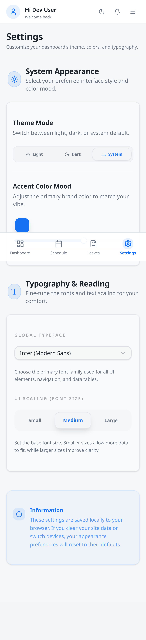

Test ID: TC078 — Settings Subtitle
Test ID | TC078
Functional Feature | Settings
Device Specs | Mobile â All Devices
Feature Type | Functional
Feature Name | Settings Subtitle
Priority | P2
Description | Verify "Customize your dashboard's theme, colors, and typography" subtitle is visible on mobile
Expected Result | Not yet executed
Screenshot:
Device: Mobile-Chrome

Test ID: TC079 — Theme Mode Section
Test ID | TC079
Functional Feature | Settings
Device Specs | Mobile â All Devices
Feature Type | Functional
Feature Name | Theme Mode Section
Priority | P1
Description | Verify Theme Mode section is visible on mobile
Expected Result | Not yet executed
Screenshot:
Device: Mobile-Chrome

Test ID: TC080 — Light Theme Button
Test ID | TC080
Functional Feature | Settings
Device Specs | Mobile â All Devices
Feature Type | Functional
Feature Name | Light Theme Button
Priority | P1
Description | Verify Light theme button is touch-interactable (becomes interactive after hydration)
Expected Result | Not yet executed
Screenshot:
Device: Mobile-Chrome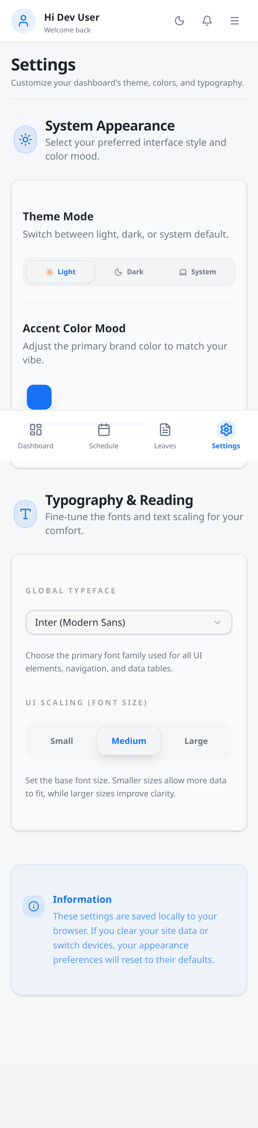

Test ID: TC081 — Dark Theme Button
Test ID | TC081
Functional Feature | Settings
Device Specs | Mobile â All Devices
Feature Type | Functional
Feature Name | Dark Theme Button
Priority | P1
Description | Verify Dark theme button is touch-interactable (becomes interactive after hydration)
Expected Result | Not yet executed
Screenshot:
Device: Mobile-Chrome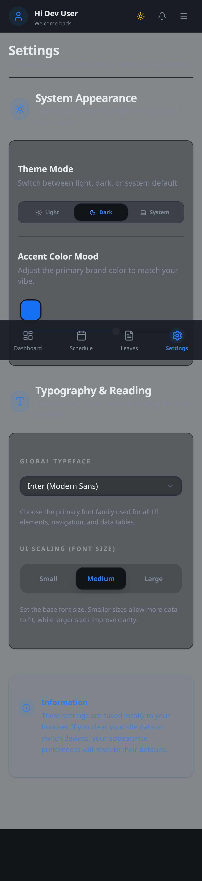

Test ID: TC082 — System Theme Button
Test ID | TC082
Functional Feature | Settings
Device Specs | Mobile â All Devices
Feature Type | Functional
Feature Name | System Theme Button
Priority | P1
Description | Verify System theme button is touch-interactable (becomes interactive after hydration)
Expected Result | Not yet executed
Screenshot:
Device: Mobile-Chrome

Test ID: TC083 — Accent Color Section
Test ID | TC083
Functional Feature | Settings
Device Specs | Mobile â All Devices
Feature Type | Functional
Feature Name | Accent Color Section
Priority | P1
Description | Verify Accent color section is visible on mobile
Expected Result | Not yet executed
Screenshot:
Device: Mobile-Chrome
Device: Mobile-Chrome

Test ID: TC084 — Accent Color Slider
Test ID | TC084
Functional Feature | Settings
Device Specs | Mobile â All Devices
Feature Type | Functional
Feature Name | Accent Color Slider
Priority | P1
Description | Verify Accent color slider is visible and draggable on mobile (becomes interactive after hydration)
Expected Result | Not yet executed
Screenshot:
Device: Mobile-Chrome

Test ID: TC085 — Color Preview Update
Test ID | TC085
Functional Feature | Settings
Device Specs | Mobile â All Devices
Feature Type | Functional
Feature Name | Color Preview Update
Priority | P2
Description | Verify color preview updates when slider value changes on mobile
Expected Result | Not yet executed
Screenshot:
Device: Mobile-Chrome

Test ID: TC086 — Global Typeface Dropdown
Test ID | TC086
Functional Feature | Settings
Device Specs | Mobile â All Devices
Feature Type | Functional
Feature Name | Global Typeface Dropdown
Priority | P1
Description | Verify Global Typeface dropdown is visible and opens on mobile (becomes interactive after hydration)
Expected Result | Not yet executed
Screenshot:
Device: Mobile-Chrome

Test ID: TC087 — Typeface Selection
Test ID | TC087
Functional Feature | Settings
Device Specs | Mobile â All Devices
Feature Type | Functional
Feature Name | Typeface Selection
Priority | P1
Description | Verify typeface selection updates UI font when changed on mobile (becomes interactive after hydration)
Expected Result | Not yet executed
Screenshot:
Device: Mobile-Chrome

Test ID: TC088 — UI Scaling Section
Test ID | TC088
Functional Feature | Settings
Device Specs | Mobile â All Devices
Feature Type | Functional
Feature Name | UI Scaling Section
Priority | P1
Description | Verify UI Scaling section is visible on mobile
Expected Result | Not yet executed
Screenshot:
Device: Mobile-Chrome

Test ID: TC089 — Small Scale Button
Test ID | TC089
Functional Feature | Settings
Device Specs | Mobile â All Devices
Feature Type | Functional
Feature Name | Small Scale Button
Priority | P1
Description | Verify Small scale button is touch-interactable (becomes interactive after hydration)
Expected Result | Not yet executed
Screenshot:
Device: Mobile-Chrome

Test ID: TC090 — Medium Scale Button
Test ID | TC090
Functional Feature | Settings
Device Specs | Mobile â All Devices
Feature Type | Functional
Feature Name | Medium Scale Button
Priority | P1
Description | Verify Medium scale button is touch-interactable (becomes interactive after hydration)
Expected Result | Not yet executed
Screenshot:
Device: Mobile-Chrome

Test ID: TC091 — Large Scale Button
Test ID | TC091
Functional Feature | Settings
Device Specs | Mobile â All Devices
Feature Type | Functional
Feature Name | Large Scale Button
Priority | P1
Description | Verify Large scale button is touch-interactable (becomes interactive after hydration)
Expected Result | Not yet executed
Screenshot:
Device: Mobile-Chrome

Test ID: TC092 — Information Card Visibility
Test ID | TC092
Functional Feature | Settings
Device Specs | Mobile â All Devices
Feature Type | Functional
Feature Name | Information Card Visibility
Priority | P2
Description | Verify Information card is visible with its data on mobile
Expected Result | Not yet executed
Screenshot:
Device: Mobile-Chrome

Test ID: TC093 — Mobile Header Rendering
Test ID | TC093
Functional Feature | Header / Layout
Device Specs | Mobile (375x667)
Feature Type | Functional
Feature Name | Mobile Header Rendering
Priority | P0
Description | Verify header renders correctly on mobile viewport (375x667)
Expected Result | Not yet executed
Screenshot:
Device: Mobile-Chrome

Test ID: TC094 — Mobile Layout Adaptation
Test ID | TC094
Functional Feature | Responsive Layout
Device Specs | Mobile (375x667)
Feature Type | Functional
Feature Name | Mobile Layout Adaptation
Priority | P0
Description | Verify layout adapts to mobile viewport without horizontal scrolling
Expected Result | Not yet executed
Screenshot:
Device: Mobile-Chrome

Test ID: TC095 — Mobile Bottom Navigation
Test ID | TC095
Functional Feature | Navigation
Device Specs | Mobile (375x667)
Feature Type | Functional
Feature Name | Mobile Bottom Navigation
Priority | P1
Description | Verify bottom navigation bar appears on mobile viewport
Expected Result | Not yet executed
Screenshot:
[No screenshot available]

Test ID: TC096 — Android Browser Header
Test ID | TC096
Functional Feature | Header / Layout
Device Specs | Android Mobile Browser
Feature Type | Functional
Feature Name | Android Browser Header
Priority | P0
Description | Verify header renders correctly in Android mobile browser
Expected Result | Not yet executed
Screenshot:
Device: Mobile-Chrome

Test ID: TC097 — iOS Safari Header
Test ID | TC097
Functional Feature | Header / Layout
Device Specs | iOS Safari
Feature Type | Functional
Feature Name | iOS Safari Header
Priority | P0
Description | Verify header renders correctly in iOS Safari
Expected Result | Not yet executed
Screenshot:
Device: Mobile-Chrome

Test ID: TC098 — Mobile Dropdown Behavior
Test ID | TC098
Functional Feature | Responsive Layout
Device Specs | Mobile (375x667)
Feature Type | Functional
Feature Name | Mobile Dropdown Behavior
Priority | P1
Description | Verify dropdowns adapt to touch UI on mobile
Expected Result | Not yet executed
Screenshot:
Device: Mobile-Chrome

Test ID: TC099 — Mobile Scroll Behavior
Test ID | TC099
Functional Feature | Responsive Layout
Device Specs | Mobile (375x667)
Feature Type | Functional
Feature Name | Mobile Scroll Behavior
Priority | P1
Description | Verify page scrolls vertically without issues on mobile
Expected Result | Not yet executed
Screenshot:
Device: Mobile-Chrome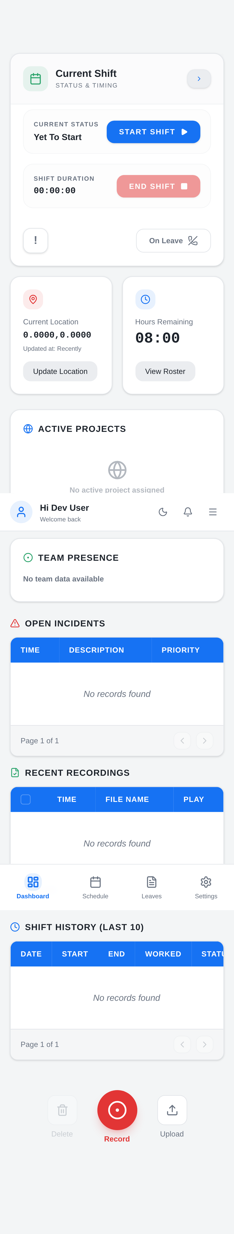

Test ID: TC100 — Mobile Form Input Handling
Test ID | TC100
Functional Feature | Forms / Inputs
Device Specs | Mobile (375x667)
Feature Type | Functional
Feature Name | Mobile Form Input Handling
Priority | P1
Description | Verify form inputs are usable on mobile viewport
Expected Result | Not yet executed
Screenshot:
Device: Mobile-Chrome

Test ID: TC101 — Mobile Viewport Scaling
Test ID | TC101
Functional Feature | Responsive Layout
Device Specs | Mobile (375x667)
Feature Type | Functional
Feature Name | Mobile Viewport Scaling
Priority | P1
Description | Verify viewport scaling is correct on mobile
Expected Result | Not yet executed
Screenshot:
Device: Mobile-Chrome

Test ID: TC102 — Mobile Table Responsiveness
Test ID | TC102
Functional Feature | Responsive Layout
Device Specs | Mobile (375x667)
Feature Type | Functional
Feature Name | Mobile Table Responsiveness
Priority | P1
Description | Verify tables are horizontally scrollable on mobile
Expected Result | Not yet executed
Screenshot:
Device: Mobile-Chrome

Test ID: TC103 — Service Worker Registration
Test ID | TC103
Functional Feature | PWA
Device Specs | Mobile â All Devices
Feature Type | Non-Functional
Feature Name | Service Worker Registration
Priority | P0
Description | Verify service worker registers successfully on mobile
Expected Result | Not yet executed
Screenshot:
Device: Mobile-Chrome

Test ID: TC104 — Offline Behavior
Test ID | TC104
Functional Feature | PWA Offline & Recovery
Device Specs | Mobile â All Devices
Feature Type | Non-Functional
Feature Name | Offline Behavior
Priority | P1
Description | Verify app behaviour when device goes offline, reloads while offline, and recovers when network is restored
Expected Result | Not yet executed
Screenshot:
[No screenshot available]

Test ID: TC105 — Mobile Navigation Menu Open
Test ID | TC105
Functional Feature | Navigation
Device Specs | Mobile (375x667)
Feature Type | Functional
Feature Name | Mobile Navigation Menu Open
Priority | P1
Description | Verify hamburger menu opens when tapped on mobile
Expected Result | Not yet executed
Screenshot:
Device: Mobile-Chrome

Test ID: TC106 — Mobile Navigation Menu Close
Test ID | TC106
Functional Feature | Navigation
Device Specs | Mobile (375x667)
Feature Type | Functional
Feature Name | Mobile Navigation Menu Close
Priority | P1
Description | Verify navigation menu closes when close button tapped
Expected Result | Not yet executed
Screenshot:
Device: Mobile-Chrome

Test ID: TC107 — Mobile Dashboard Link
Test ID | TC107
Functional Feature | Navigation
Device Specs | Mobile (375x667)
Feature Type | Functional
Feature Name | Mobile Dashboard Link
Priority | P0
Description | Verify Dashboard link navigates correctly from mobile menu
Expected Result | Not yet executed
Screenshot:
Device: Mobile-Chrome

Test ID: TC108 — Mobile Schedule Link
Test ID | TC108
Functional Feature | Navigation
Device Specs | Mobile (375x667)
Feature Type | Functional
Feature Name | Mobile Schedule Link
Priority | P0
Description | Verify Schedule link navigates correctly from mobile menu
Expected Result | Not yet executed
Screenshot:
Device: Mobile-Chrome

Test ID: TC109 — Mobile Leaves Link
Test ID | TC109
Functional Feature | Navigation
Device Specs | Mobile (375x667)
Feature Type | Functional
Feature Name | Mobile Leaves Link
Priority | P0
Description | Verify Leaves link navigates correctly from mobile menu
Expected Result | Not yet executed
Screenshot:
Device: Mobile-Chrome

Test ID: TC110 — Mobile Settings Link
Test ID | TC110
Functional Feature | Navigation
Device Specs | Mobile (375x667)
Feature Type | Functional
Feature Name | Mobile Settings Link
Priority | P0
Description | Verify Settings link navigates correctly from mobile menu
Expected Result | Not yet executed
Screenshot:
Device: Mobile-Chrome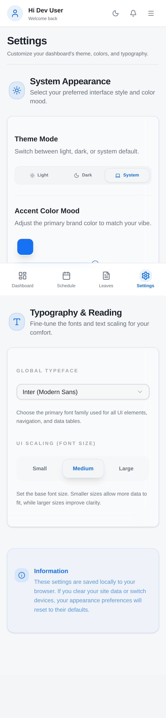

Test ID: TC111 — Mobile Sign Out Button
Test ID | TC111
Functional Feature | Navigation
Device Specs | Mobile (375x667)
Feature Type | Functional
Feature Name | Mobile Sign Out Button
Priority | P0
Description | Verify Sign Out button is visible and touchable in mobile menu
Expected Result | Not yet executed
Screenshot:
Device: Mobile-Chrome

Test ID: TC112 — Mobile Search Input
Test ID | TC112
Functional Feature | Header / Layout
Device Specs | Mobile (375x667)
Feature Type | Functional
Feature Name | Mobile Search Input
Priority | P1
Description | Verify Search input field is visible and usable on mobile
Expected Result | Not yet executed
Screenshot:
[No screenshot available]

Test ID: TC113 — Mobile Notification Button
Test ID | TC113
Functional Feature | Header / Layout
Device Specs | Mobile (375x667)
Feature Type | Functional
Feature Name | Mobile Notification Button
Priority | P1
Description | Verify Notification button is visible and touchable on mobile
Expected Result | Not yet executed
Screenshot:
Device: Mobile-Chrome

Test ID: TC114 — Mobile Theme Toggle
Test ID | TC114
Functional Feature | Header / Layout
Device Specs | Mobile (375x667)
Feature Type | Functional
Feature Name | Mobile Theme Toggle
Priority | P1
Description | Verify Theme toggle button works on mobile (becomes interactive after hydration)
Expected Result | Not yet executed
Screenshot:
Device: Mobile-Chrome

Test ID: TC115 — Page Transitions Mobile
Test ID | TC115
Functional Feature | Page Load Behavior
Device Specs | Mobile â All Devices
Feature Type | Non-Functional
Feature Name | Page Transitions Mobile
Priority | P1
Description | Verify page transitions between routes work correctly on mobile
Expected Result | Not yet executed
Screenshot:
Device: Mobile-Chrome

Test ID: TC116 — Console Error Check Mobile
Test ID | TC116
Functional Feature | Page Load Behavior
Device Specs | Mobile â All Devices
Feature Type | Non-Functional
Feature Name | Console Error Check Mobile
Priority | P0
Description | Verify no console errors on mobile page load
Expected Result | Not yet executed
Screenshot:
Device: Mobile-Chrome

Test ID: TC117 — Mobile Empty State Display
Test ID | TC117
Functional Feature | Data Display
Device Specs | Mobile â All Devices
Feature Type | Functional
Feature Name | Mobile Empty State Display
Priority | P2
Description | Verify empty state shows correctly on mobile
Expected Result | Not yet executed
Screenshot:
Device: Mobile-Chrome

5. Page / Feature Coverage Summary
Feature Area | Spec File | Total Tests | Passed | Failed | Not Run
Dashboard | tests/dashboard/dashboard.spec.ts | 23 | 0 | 0 | 23
Data Display | tests/data display/data display.spec.ts | 1 | 0 | 0 | 1
Forms / Inputs | tests/forms / inputs/forms / inputs.spec.ts | 1 | 0 | 0 | 1
Header / Layout | tests/header / layout/header / layout.spec.ts | 6 | 0 | 0 | 6
Leaves | tests/leaves/leaves.spec.ts | 18 | 0 | 0 | 18
Login | tests/login/login.spec.ts | 23 | 0 | 0 | 23
Navigation | tests/navigation/navigation.spec.ts | 8 | 0 | 0 | 8
PWA | tests/pwa/pwa.spec.ts | 1 | 0 | 0 | 1
PWA Offline & Recovery | tests/pwa offline & recovery/pwa offline & recovery.spec.ts | 1 | 0 | 0 | 1
Page Load Behavior | tests/page load behavior/page load behavior.spec.ts | 2 | 0 | 0 | 2
Responsive Layout | tests/responsive layout/responsive layout.spec.ts | 5 | 0 | 0 | 5
Schedule | tests/schedule/schedule.spec.ts | 12 | 0 | 0 | 12
Settings | tests/settings/settings.spec.ts | 16 | 0 | 0 | 16
TOTAL |  | 117 | 0 | 0 | 117

6. How to Run Tests
1. Install dependencies:
npm install
2. Activate virtual environment for report generation:
source test-env/bin/activate
3. Run all tests:
npx playwright test
4. Run a specific project only:
npx playwright test --project="Mobile Chrome"
5. Run a specific spec file:
npx playwright test tests/login/login.spec.ts
6. View the HTML report:
npx playwright show-report
7. Generate this Word report:
python3 generate_report.py

7. Playwright Config Summary
Setting | Value
Base URL | http://95.216.39.97:8086
Timeout | 30000ms
Retries | 1
Parallel | Yes
Reporter | html
Screenshot | On
Video | Off
Trace | On-First-Retry
Projects | Mobile Chrome, Mobile Safari

Projects
Project Name | Device | Viewport
Mobile Chrome | Pixel 5 | 393x851
Mobile Safari | iPhone 12 | 390x844

8. Assumptions & Limitations
- Tests are black-box only — no source code access
- Keycloak-based login is currently non-functional; Dev Mode login workaround (TC013) is used for all authenticated test flows
- Tests requiring Keycloak (TC015) are expected to fail until the login API is restored
- Orientation change tests (TC128, TC129) cannot be automated with Playwright fixed viewports — marked as manual
- Screenshots are taken at test end state, not mid-test
- All tests run on mobile viewports only (no desktop coverage)
- Network conditions are not simulated; tests assume stable connectivity
- Test data (dates, leave balances) may vary based on server state

9. Conventions Used
Convention | Description
Test ID format | TC001, TC002, ... (zero-padded to 3 digits)
Extra/unplanned tests | EXTRA-001, EXTRA-002, ...
Test naming in code | test('TC001 - Feature Name', ...)
Unimplemented features | test written with failing assertion (not fixme)
Auth flow | Uses Dev Mode login helper for all auth tests
Hydration wait | waitForHydration() called after every navigation
Screenshot naming | tc001-feature-name-passed.png
Imports | All tests import from fixtures/screenshot.fixture

