**Online Quiz Application Specification Document**

**DESCRIPTION**

* The Online Test Application system creates an application that enables users to provide online tests, review them, and display the results.

**System Details**

* This system contains three main modules: Quiz, Review, and Result. The quiz section of the online test application accepts the questions in JSON format. The JSON file can be easily shared from the server in the pre-defined format. The application renders the test at the client-side.
* The “Review and display result” section allows users to declare the results immediately. You can simply call another JSON with the answers in it and evaluate and display the results immediately.

**Flow of the Application**

* Create a new angular application using ‘ng new QuizApp’ command.
* Create a Json file for questions and options, mark correct options as true to say the selected options are correct or not, based on which we assign/rewards/deducts points.
* Create a header section for navigation bar which will be displayed in all screens of the application.

* Create a Welcome section where we display rules and regulations, and the name of the participant and a start button. As discussed earlier, the header section is blended with all screens.

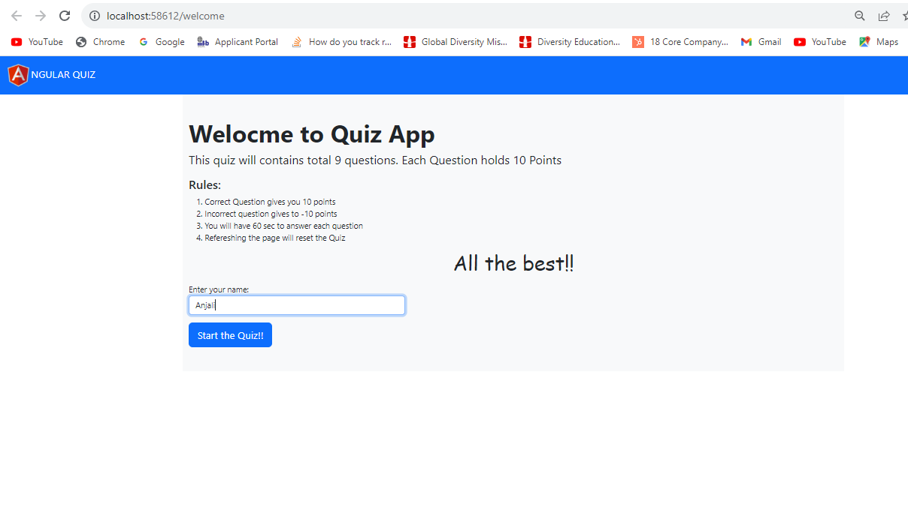

* Create a Questions section, where we display questions and the name of the participant entered. We designed an application to give participants 60 secs of timers to answer the question. Questions are taken from the Json file. After answering the question, we will display green for the correct answer and red for the incorrect guess. All validations, we get it from the Json file.

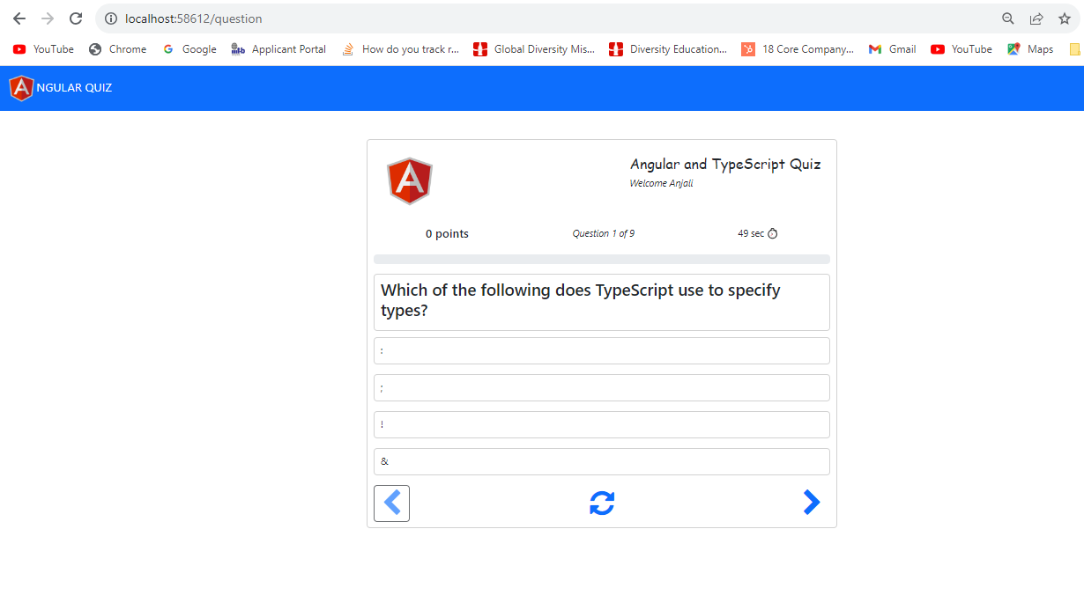

* After attempting all the questions, the application displays the stats of the quiz.

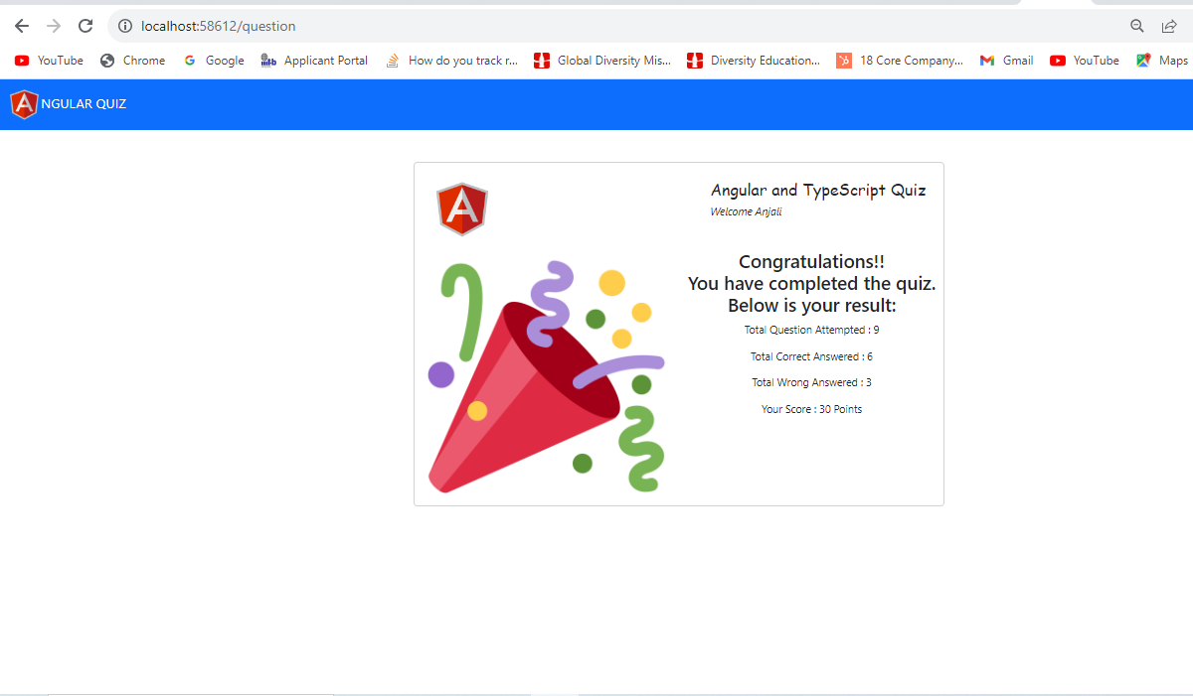

* For compiling the application, we use ‘ng serve --open’ command to compile and open the application in <http://localhost:4200> link.

**Conclusion:**

Online test application is created with help of angular which includes bootstrap, css and html. UI/Interface is quite understandable to use the application, main goal of the project is to build an Online application with the help of Angular with less complexity in the code.