

**A**

**Project Report On**

**“A STUDY ON IT IMPACT ON INDIAN ECONOMY”**

**Submitted To:**

**B.V. PATEL INSTITUTE OF COMMERCE UKA TARSADIA UNIVERSITY**

**Submitted By: PARTH GADHVI 202206100710004**

**M.Com (Integrated)**

**Guided By: Dr.Arpita Vyas**

**April 2025**

**Institute Certificate**

**Company Certificate**

**ACKNOWLEDGEMENT**

Behind every success there are lots of efforts but efforts are fruitful due to hands making the passage smoother. I express my deep sense of gratitude for hands, people extended to me during my work. I deeply thanks to my external project guide Mr. Mitesh Prajapati who was always there to guide me through the development of the project. He is one of the major sources behind the success of my project. I immensely appreciate the tips he has constantly given me during the project. It was an enormous pleasure to work with him. I am thankful to my internal guide Dr. Arpita Vyas for his cordial support, valuable information and guidance which helped me in completing these tasks through various stages. I would also like to thank Dr. Arpana Patel, I/c Director, BV Patel Institute of Commerce and all my faculties and non-teaching staff for their valuable guidance and support. I also extend my heartfelt thanks to my family and friends.

Place: Vadodar PARTH GADHVI 202206100710004

## DECLARATION

I hereby certify that I am the sole author of this project report and that neither any part of this project report nor the whole of the project report has been submitted for a degree to any other University or Institution. I certify that, to the best of my knowledge, my project report does not infringe upon anyone’s copyright nor violate any proprietary rights and that any ideas, techniques, quotations, or any other material from the work of other people included in my project report, published or otherwise, are fully acknowledged in accordance, the standard referencing practices. I declare that this is a true copy of my project report, including any final revisions, as approved by my project guide.

### Name of student:

PARTH GADHVI 202206100710004

Place: Vadodar

Verified Signature and name of Supervisor

**Executive Summary**

The Information Technology (IT) sector has played a crucial role in India's economic transformation, contributing significantly to GDP, employment generation, and technological innovation. Since the liberalization of the economy, India has established itself as a global IT powerhouse, with companies like TCS, Infosys, and Wipro driving digital advancements. Government initiatives such as Digital India and Make in India have further accelerated IT adoption, fostering economic growth and digital transformation across industries like healthcare, finance, and education. This report analyses the impact of IT on the Indian economy using secondary data from 2015-2023, sourced from NASSCOM (community.nasscom.in), Statista (statista.com), and other industry reports.

1. Contribution to GDP

The IT sector has been a major contributor to India's GDP. In 2017-18, it accounted for 8% of GDP (NASSCOM), reflecting its strong economic impact. However, due to global economic slowdowns, inflation, and geopolitical uncertainties, the sector’s contribution declined to 7.5% in 2022-23 (Statista). Despite this setback, projections indicate that IT will recover and contribute 10% of GDP by 2025, driven by advancements in AI, cloud computing, and cybersecurity.

1. Employment Generation

The IT industry has also been a major employment generator, with workforce numbers increasing from

3.7 million in 2015-16 to 5.4 million in 2023-24 (NASSCOM). The rise of remote work, digital transformation, and global outsourcing has created job opportunities, particularly in cities like Bengaluru, Hyderabad, and Pune. Demand for professionals in AI, data analytics, and cybersecurity continues to grow.

1. Challenges Faced by the IT Sector

Despite its success, the IT sector faces several challenges:

* + Skill Gaps (25%) – A shortage of professionals in emerging technologies.
  + Outsourcing Dependency (20%) – Heavy reliance on global clients makes the industry vulnerable to market fluctuations.
  + Cybersecurity Risks (20%) – Increasing cyber threats require stronger regulations.
  + Bureaucratic Hurdles (15%) – Complex regulations slow foreign investment.
  + Global Competition (10%) – IT hubs like China and the Philippines challenge India’s dominance.
  + Infrastructure Deficits (10%) – Poor digital and physical infrastructure limits growth.

Conclusion

To sustain growth, India must bridge skill gaps, strengthen cybersecurity, reduce outsourcing dependence, and invest in digital infrastructure. By addressing these challenges, the IT sector can continue to drive economic progress, job creation, and innovation, reinforcing India's position as a global IT leader.

**INDEX**

|  |  |  |
| --- | --- | --- |
| Ch.no | Content | Pg.no |
| 1 | INTRODUCTION   * About company * About topic | 10-14 |
| 2 | LITERATURE REVIEW | 15-21 |
| 3 | RESEARCH METHODOLOGY | 22-23 |
| 4 | DATA ANALYSIS & INTERPRETATION | 24-32 |
| 5 | FINDING AND CONCLUSION | 33-38 |
| 6 | REFERENCE | 39-42 |

**List of Tables**

|  |  |  |
| --- | --- | --- |
| **Sr. no.** | **Particulars** | **Page No.** |
| 1 | IT contribution to India’s GDP | 27 |
| 2 | Employment generation in IT sector | 28 |
| 3 | Challenges faced by IT sector | 29 |

**List of Figure**

|  |  |  |
| --- | --- | --- |
| **Sr. no.** | **Particulars** | **Page No.** |
| 1 | IT contribution to India’s GDP | 27 |
| 2 | Employment generation in IT sector | 28 |
| 3 | Challenges faced by IT sector | 29 |

**CH:1 INTRODUCTION**

## ABOUT COMPANY

Ved Infosys is a technology-driven company dedicated to delivering innovative solutions that enhance business operations across various industries. Specializing in digital transformation, digital strategy, data migration, and data security, Ved Infosys aims to make businesses more customer-centric and competitive in the digital landscape.

**Objective:** Ved Infosys strives to provide cutting-edge technological solutions that streamline business processes, ensuring efficiency and security. Their focus is on transforming traditional business models to adapt to the evolving digital environment.

**Vision:** The company's vision is encapsulated in the phrase "Pleasing technology the world over," reflecting their commitment to delivering technology solutions that are both effective and user-friendly.

**Mission:** Ved Infosys is dedicated to offering comprehensive software support and a range of products, including desktop and cloud ERP systems, HR management systems, quality control systems, and task management systems. Their mission involves not only providing these products but also ensuring their effective implementation and ongoing support to meet clients' evolving needs.

Services and Products: Ved Infosys offers a variety of services aimed at facilitating digital transformation Digital Strategy: Helping businesses establish a presence across multiple digital platforms and leveraging analytics to identify market opportunities. Data Migration: Implementing systematic approaches for transferring data between systems securely and efficiently. Data Security: Protecting data from unauthorized access and corruption throughout its lifecycle. Their product lineup includes desktop and cloud ERP solutions, HR management systems, quality control systems, engineering calculation systems, and task management systems. These products are designed to address various business needs, from standardization to complex engineering calculation

## ABOUT TOPIC

The Information Technology (IT) sector has emerged as one of the most significant drivers of economic transformation in India. Over the past few decades, India has positioned itself as a global IT powerhouse, leading the way in software development, IT-enabled services, and technological innovation. Since the liberalization of the Indian economy in the early 1990s, the IT industry has witnessed unprecedented growth, becoming a key contributor to GDP, Employment, and foreign exchange earnings. India's success in the IT domain is attributed to multiple factors, including its highly skilled workforce, cost-effectiveness, and robust IT infrastructure.

The rise of the internet, artificial intelligence (AI), cloud computing, and big data analytics has revolutionized industries such as healthcare, education, finance, and e-commerce. India is home to some of the world's largest IT service providers, including Tata Consultancy Services (TCS), Infosys, and Wipro, which serve a global clientele. The sector has significantly impacted job creation, innovation, and digital transformation, reinforcing India's reputation as the "IT Hub of the World."

Furthermore, government initiatives such as "Digital India" and "Make in India" have accelerated the adoption of technology across sectors, fostering a more digital and data- driven economy. The proliferation of mobile technology, fintech solutions, and digital payment systems has further propelled the country's digital evolution, making technology an integral part of everyday life. As India moves towards becoming a digital economy, the IT sector is expected to continue playing a crucial role in economic expansion and technological advancements.

## Problem Statement

Despite the remarkable progress and contributions of the IT sector, several critical challenges threaten its sustainable growth. The increasing demand for IT professionals has exposed a widening skill gap in the workforce, where traditional education systems struggle to keep pace with the rapidly evolving technology landscape. Emerging fields such as artificial intelligence, cybersecurity, and blockchain require specialized expertise that is often lacking in the current workforce, leading to a shortage of qualified professionals.

Another pressing issue is cybersecurity. With the expansion of digital services and online transactions, cyber threats, data breaches, and privacy concerns have become major risks.

The lack of robust data protection frameworks and cybersecurity measures has led to vulnerabilities that can compromise both businesses and consumers.

India's IT industry also faces a high dependency on foreign markets, with a significant portion of revenue coming from outsourcing contracts from countries like the United States and Europe. While outsourcing has fueled growth, it also exposes the industry to global economic fluctuations, policy changes, and trade restrictions. Additionally, bureaucratic inefficiencies, outdated policies, and inconsistent regulations hinder seamless business operations, making it challenging for IT firms to scale and innovate.

The COVID-19 pandemic further exacerbated some of these challenges, as businesses had to rapidly shift to remote work models, exposing gaps in digital infrastructure, cybersecurity measures, and workforce adaptability. Addressing these challenges is critical to ensuring that India retains its competitive edge in the global IT market and continues to drive innovation and economic growth.

## Research Objectives

1. To evaluate the contributions of the IT sector to India's GDP and employment generation.
2. To identify the challenges hindering the sustainable growth of the IT sector in India.

## Importance of Research

Understanding the impact of IT on the Indian economy is essential for policymakers, business leaders, and academic researchers. The IT sector not only contributes to economic growth but also drives innovation, enhances productivity, and improves service delivery across industries. By comprehensively analyzing the contributions and challenges of the IT sector, this research can provide valuable insights that inform government policies and industry strategies.

For businesses, IT advancements present new opportunities to optimize operations, reach wider markets, and improve customer experiences. With the rise of artificial intelligence, cloud computing, and data analytics, organizations can leverage technology to enhance efficiency and competitiveness. Meanwhile, for policymakers, understanding IT sector dynamics can aid in crafting regulations that foster innovation, address skill gaps, and improve digital infrastructure.

Additionally, this research aims to highlight the social and economic benefits of IT, including job creation, financial inclusion, and improved quality of life. As India continues

its digital transformation journey, ensuring that technological advancements benefit all segments of society is crucial for achieving inclusive and sustainable development.

## Scope of Research

This research encompasses a detailed examination of the IT sector's influence on the Indian economy, covering key areas such as GDP contribution, employment trends, investment patterns, and technological advancements. The study will include both macroeconomic and microeconomic perspectives, analyzing how IT developments impact various industries and stakeholders.

Key areas of focus include:

* Macroeconomic Impact: Evaluating the IT sector's contribution to GDP, foreign exchange earnings, and employment generation.
* Industry Integration: Analyzing how IT has revolutionized sectors like healthcare, finance, education, and manufacturing.
* Government Policies and Regulations: Assessing the effectiveness of initiatives like Digital India, Make in India, and Startup India in fostering IT growth.
* Challenges and Barriers: Identifying obstacles such as cybersecurity risks, skill shortages, and regulatory inefficiencies that hinder IT sector expansion.
* Emerging Technologies: Exploring the role of AI, blockchain, machine learning, and big data in transforming the IT sector.
* Regional IT Hubs: Examining the role of major IT hubs like Bengaluru, Hyderabad, and Pune in driving innovation and economic growth.
* Cybersecurity and Data Protection: Analyzing the impact of cyber threats and regulatory measures on IT operations.
* Digital Workforce Transformation: Assessing how remote work and upskilling initiatives are shaping the future of the IT workforce

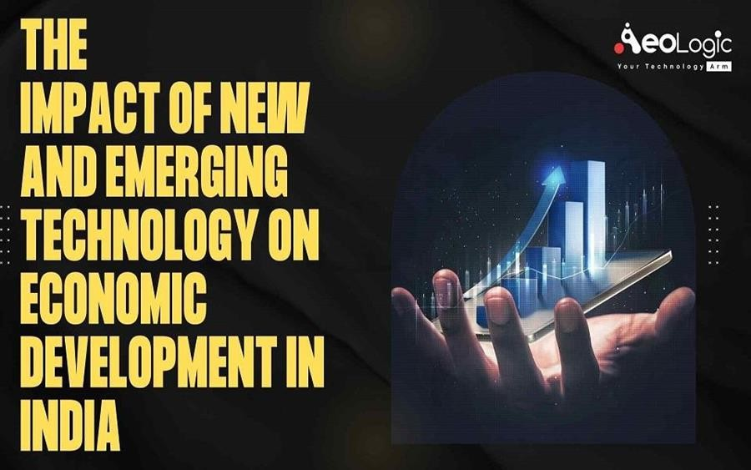

# CH:2 LITERATURE REVIEW

## Introduction

The impact of Information Technology (IT) on the Indian economy has been profound. Since the liberalization of the Indian economy in the 1990s, the IT sector has emerged as a key driver of economic transformation. IT has reshaped various sectors, providing new avenues for growth and innovation. However, the rapid evolution of technology also brings forth challenges, including cybersecurity risks, skill shortages, and the digital divide.

## Theoretical Framework

This study employs a multi-faceted theoretical framework to analyze the impact of IT on the Indian economy. The framework integrates six theoretical components: Economic Growth Theory, Human Capital Theory, Technology Adoption and Diffusion Theory, Digital Divide Framework, Innovation Systems Theory, and Social Impact Theory. These components provide a comprehensive lens to examine the opportunities and challenges presented by IT. The framework highlights the importance of IT investments, skill formation, technology adoption, and innovation systems in driving economic growth and development. It also emphasizes the need to address the digital divide and social implications of IT to ensure inclusive growth and sustainable progress.

## List of Literature Reviews: -

1. "Information Technology Industry and Its Contribution to the Indian Economy" - Sharma, A. (2017) Sharma examines the growth trajectory of India's IT sector, which has become a significant driver of economic development since the 1990s. The review highlights how the IT industry contributed approximately 8% to India's GDP and created millions of jobs. Furthermore, it discusses the sector's global competitiveness, showcasing India's position as a preferred destination for IT services. The paper highlights the important role of software exports in bolstering trade balances and attracting foreign investment. However, it also points out the need for sustained innovation and improvement in infrastructure to maintain this momentum and address skill gaps in the workforce.
2. "The Growth of the Indian IT Sector: Problems and Prospects" - Patil, R. (2018) Patil’s article provides a comprehensive overview of the Indian IT sector's growth while identifying substantial challenges it faces. Although the industry has flourished, issues such as rising global competition, rapid technological changes, and skill shortages pose threats to its sustainability. The review emphasizes the importance of diversifying services to remain competitive and suggests that collaboration between industry and educational institutions is vital for developing future-ready talent. Patil concludes by proposing a roadmap for overcoming these challenges, focusing on innovation and strategic partnerships to ensure the growth of the sector continues.
3. "The Role of IT in India's Economic Reforms" - Singh, P. (2019) Singh analyzes the pivotal role of IT in India's economic reforms initiated in the early 1990s. The article details how liberalization opened avenues for IT growth, fundamentally transforming economic processes from manufacturing to services. IT has improved efficiency and communication, enabling various sectors to shift to digital platforms, thereby enhancing productivity. Furthermore, the paper discusses how governmental support for technology initiatives has fostered entrepreneurial ventures and increased foreign direct investment (FDI). Singh argues that, while the IT sector has greatly influenced economic reforms, continuous support and infrastructure development are crucial for future advancements.
4. "Impact of IT on Employment Generation in India" - Kumar, S. (2020) Kumar evaluates the significant role of the IT sector in employment generation within India. The paper outlines how IT has not only created a vast number of direct jobs but has also stimulated job growth in ancillary sectors such as telecommunications and outsourcing. It discusses the demographic impact, particularly in urban areas, where IT jobs provide upward mobility for skilled workers. However, Kumar also identifies challenges such as the need for reskilling workers to adapt to automation and artificial intelligence, advocating for targeted government policies to ensure that job generation in IT remains sustainable and inclusive.
5. "Digital India: Impact on Economic Growth and Sustainability" - Gupta, R. (2020)

Gupta’s article assesses the "Digital India" program, launched in 2015, which aims to transform India into a digitally empowered society. The review details how digital initiatives have accelerated economic growth by improving service delivery, enhancing transparency, and promoting financial inclusion. By fostering a culture of innovation and entrepreneurship, Gupta suggests that digital technologies have the potential to tap into rural markets, thus bridging the urban-rural divide. However, while acknowledging the successes of Digital India, the paper calls for addressing infrastructure challenges, ensuring cybersecurity, and expanding digital literacy to realize its full potential.

1. "E-Commerce and Digital Payments in India: A Catalyst for Economic Growth" - Mehta, A. (2021) Mehta explores the rapid rise of e-commerce and digital payment systems in India as significant contributors to economic growth. The article highlights how platforms like Amazon and Flipkart have revolutionized retail by enhancing accessibility and convenience, especially in rural areas. Additionally, the shift towards digital payments has improved transaction efficiency and reduced the shadow economy. Mehta posits that these trends have stimulated greater consumer spending, which in turn boosts economic activity. However, the paper warns of potential risks, including cybersecurity threats and the need for robust regulatory frameworks to protect consumers and ensure fair competition.
2. "Skill Development in the IT Sector: Challenges and Opportunities" - Reddy, V. (2019) Reddy addresses the pressing issue of skill development within the Indian IT sector. While acknowledging the sector's rapid expansion, the review emphasizes the growing skill gap, which poses a major challenge to sustaining growth. Reddy highlights the need for holistic educational reforms that align with industry requirements, advocating for greater collaboration between educational institutions and IT companies. Additionally, the article discusses the importance of continuous learning and professional development in adapting to technological advancements. Reddy concludes by proposing various strategies to enhance skill development, ensuring a competitive and proficient workforce.
3. "Impact of Artificial Intelligence on Indian Economy: A Waves of Change" - Rao, N. (2021) Rao explores the transformative impact of Artificial Intelligence (AI) on the Indian economy, highlighting its disruptive potential in various sectors, including healthcare,

finance, and manufacturing. The review discusses how AI technologies can enhance productivity, streamline operations, and enable data-driven decision-making. Rao cites instances of successful AI implementation, particularly in improving efficiency and customer experience. However, the paper also raises concerns about the implications for employment, emphasizing the necessity of reskilling workers displaced by automation. The conclusion calls for a balanced approach to embracing AI-driven growth while ensuring social equity and economic inclusivity.

1. "Cybersecurity Challenges in the Growing IT Sector" - Verma, J. (2021) Verma’s article provides a critical examination of the cybersecurity challenges facing India’s growing IT sector. As digital transformation accelerates, the vulnerability to cyber threats increases, posing significant risks to businesses and national security. The review outlines the high- profile cyber-attacks and breaches that have occurred in recent years and their implications for economic stability. Verma argues for the urgent need to enhance cybersecurity frameworks and promote awareness among businesses. The paper emphasizes the importance of collaboration between the government, industry, and educational institutions to develop comprehensive strategies for safeguarding against cybercrime.
2. "Globalization and IT Sector in India: Opportunities and Innovation" - Chaudhary, R. (2018) Chaudhary investigates the interrelationship between globalization and the Indian IT sector, positing that globalization has significantly spurred innovation and growth. The review highlights how international partnerships and overseas market access have allowed Indian IT firms to thrive, paving the way for advancements in technology and services. It discusses the implications of globalization on talent acquisition and knowledge transfer, which have positioned India favorably on the global IT stage. However, the article also discusses challenges such as protecting intellectual property rights and navigating international regulations, suggesting that strategic focus on these areas is essential for sustained growth.
3. "The Social Impact of IT Development in India" - Banerjee, S. (2020) Banerjee explores the broader social impacts of IT developments in India, arguing that technology has been a catalyst for social change. The review highlights how IT tools have improved access to information, education, and healthcare, especially for marginalized communities.

It discusses initiatives leveraging technology to enhance social equity, such as e- governance and online education platforms. However, the article also critically evaluates the risks of digital exclusion and the "digital divide," which can exacerbate existing inequalities. Banerjee advocates for policies focused on inclusive digital growth that prioritize the needs of underserved populations, ensuring equitable access to technological benefits.

1. "Evaluating the Digital Divide: Access to IT in Rural India" - Sharma, L. (2018) Sharma’s study addresses the stark contrast in IT access between urban and rural India, emphasizing the challenges posed by the digital divide. The review provides an overview of the barriers to technology adoption in rural areas, including inadequate infrastructure, low digital literacy, and economic constraints. By presenting case studies of successful IT initiatives in rural settings, Sharma illustrates the potential of technology to foster economic development and social empowerment. The paper concludes by calling for targeted interventions from both the government and private sector to bridge the digital divide and enhance technology access for rural communities.
2. "Fintech and Its Impact on Financial Inclusion in India" - Joshi, T. (2020) Joshi’s article examines the transformative role of fintech in promoting financial inclusion in India. The review highlights how digital platforms and mobile banking services have broadened access to financial services, especially for underserved populations. By facilitating easier and more affordable banking solutions, fintech has empowered individuals to participate in the economy, thereby driving consumption and enhancing economic growth. The article also addresses regulatory challenges and the need for robust consumer protection measures in this rapidly evolving sector. Joshi concludes by stressing the importance of aligning fintech innovations with regulatory frameworks to optimize their impact on financial inclusion.
3. "Cross-Industry Impact of IT: Case Studies from Indian Manufacturing and Services"

- Kapoor, D. (2021) Kapoor analyzes the cross-industry impacts of IT integration in both manufacturing and service sectors within India. The review discusses various case studies demonstrating how IT adoption has resulted in improved efficiency, cost reduction, and enhanced customer experiences. IT’s role in optimizing supply chains and data analytics in

manufacturing is contrasted with its impact on service delivery in areas like healthcare and banking. The article emphasizes the necessity for both sectors to embrace digital transformation to remain competitive. Kapoor concludes by proposing collaborative efforts between industries to share best practices and leverage IT solutions for collective growth.

1. "IT Sector’s Influence on Consumer Behavior: A Study of Indian Markets" - Desai, A. (2019) Desai’s research delves into how the emergence of IT has transformed consumer behavior in India’s markets. The paper highlights the shift toward online shopping and the growing influence of social media platforms in shaping consumer preferences. The review discusses the critical role of data analytics in understanding consumer behavior and tailoring marketing strategies accordingly. Additionally, Desai notes how digital payment systems have facilitated easier transactions, encouraging higher consumer spending. However, it also points out the need for businesses to adapt to changing preferences and ensure data security to maintain consumer trust in the digital marketplace.
2. “Public Policies and IT Growth: An Examination of Indian Government Initiatives” - Bhatia, P. (2021) Bhatia evaluates the impact of public policies on the growth of the IT sector in India. The review outlines various government initiatives aimed at promoting technology adoption and innovation, such as the "Make in India" and "Startup India" programs. The paper argues that these policies have been instrumental in fostering a vibrant ecosystem for IT startups and attracting foreign investments. However, Bhatia critiques existing policies for not adequately addressing skill development and infrastructure challenges. The conclusion calls for a more integrated approach in policy formulation that aligns multiple sectors within the economy to support sustained IT growth.
3. "The Future of Work: Remote Work Trends Post-COVID-19 in India" - Nair, A. (2021) Nair explores how the COVID-19 pandemic has accelerated remote work trends in India, particularly within the IT sector. The article discusses the adaptability of companies to remote work conditions and how technology played a crucial role in ensuring business continuity. This shift not only changed workplace dynamics but also influenced employee productivity and work-life balance. While the review indicates potential long-term benefits, including broader geographical talent pools, Nair emphasizes the challenges of maintaining team cohesion and ensuring cybersecurity. The paper concludes by suggesting strategies

for organizations to optimize remote work structures in the future.

1. "IT as a Driver of Economic Transformation in India" - Patel, S. (2020) Patel’s article delves into the broader economic transformation resulting from the expansion of the IT sector in India. The review highlights how IT has become interwoven with various sectors, driving automation, data analytics, and innovation. This technology-driven transformation is credited with enhancing productivity and fostering new business models. Patel discusses the implications for traditional industries such as agriculture and manufacturing, indicating that IT adoption can yield efficiency gains. The article concludes that ongoing investments in IT and digital infrastructure are essential for sustaining economic growth and capitalizing on emerging global opportunities.
2. "Health IT and Its Role in Transforming India's Healthcare Sector" - Sood, K. (2021) Sood examines the significant impact of health Information Technology (health IT) on the Indian healthcare system. The review illustrates how electronic health records and telemedicine services have improved patient care, accessibility, and operational efficiency in healthcare delivery. Sood discusses case studies of successful health IT implementations that have led to better health outcomes, particularly in remote areas. While highlighting the transformative potential, the paper raises concerns about data privacy and the need for effective regulatory oversight. The conclusion calls for strengthening health IT frameworks to foster equitable access to healthcare services across diverse populations.
3. "Challenges Faced by the IT Sector in a Post-Pandemic World" - Iyer, M. (2021) Iyer’s article focuses on the challenges that the IT sector in India faces in a post-pandemic world. The review discusses how the pandemic accelerated digital transformation but also revealed vulnerabilities in cyber infrastructure, workforce telecommunication, and service delivery. Iyer examines the potential for increased competition from emerging technologies and global markets, suggesting that Indian IT companies must adapt to survive. The paper emphasizes the importance of innovation, cybersecurity measures, and employee well- being as critical components for future resilience.

# CH: - 3 RESEARCH METHODOLOGY

## Research Design

* Exploratory Research Design: This design is suitable for gaining a comprehensive understanding of a complex topic like the impact of the IT sector in India. Secondary data analysis allows for a broad exploration of existing knowledge and trends

## Data Collection Method

* Literature Review: This will involve reviewing scholarly articles, journals, industry reports, government publications, and credible websites to gather data on various aspects of the IT sector's impact on India's economy, society, and workforce.
* Database Search: Utilize reputable databases like ScienceDirect, JSTOR, Emerald Insight, and India-specific databases like EconLit or Indian Citation Index to find relevant academic literature.
* Government Websites: Websites of relevant Indian government ministries (IT Ministry, Ministry of Statistics and Programme Implementation, Ministry of Commerce and Industry) can provide valuable data on IT sector growth, employment statistics, and government initiatives.
* Industry Reports: Reports from research institutions like Gartner, McKinsey & Company, NASSCOM (National Association of Software and Service Companies) can offer insights into industry trends, IT sector contribution to GDP, and future projections.

## Data Analysis

* + Content Analysis: This method will involve systematically coding and analyzing the collected textual data to identify themes, trends, and patterns related to the IT sector's impact.
  + Comparative Analysis: Data from different sources (e.g., government reports vs. industry reports) can be compared to identify potential discrepancies and gain a more nuanced understanding.

Trend Analysis: Analyses data over time to identify growth patterns, emerging trends, and potential future directions of the IT sector's impact on India.

1. Statistical Analysis (if applicable): If the collected data includes quantitative information (e.g., GDP contribution percentages, employment figures), basic statistical analysis can be performed to summarize and visualize the data (descriptive statistics, charts, graphs).

## Limitations of the Study

* + Reliance on Secondary Data: This study relies on existing data, which may not capture the complete picture or reflect the most recent developments.
  + Data Availability: The availability and accessibility of relevant data may be limited.
  + Focus on Published Information: The study may not capture the perspectives of stakeholders who haven't published their experiences.

# CH: - 4 DATA ANALYSIS AND INTERPRETATION

## Introduction to Secondary Data

Secondary data refers to information that has already been collected, analyzed, and published by credible sources such as government organizations, industry reports, and academic research. This research relies on secondary data from trusted sources like NASSCOM, Statista, the Ministry of Electronics & IT, and financial publications like Economic Times and Financial Times. These sources provide valuable insights into the IT sector's impact on India's GDP, employment generation, and challenges hindering its growth. The analysis of this data helps in understanding trends, patterns, and the effectiveness of government policies in fostering IT growth

## Sources of Secondary Data in IT Sector Research

The research utilizes secondary data from multiple trusted and authoritative sources, including:

1. Government Organizations
   * Ministry of Electronics & Information Technology (MeitY): Provides official statistics on IT industry growth, employment trends, digital infrastructure projects, and government initiatives such as Digital India and Make in India.
   * Reserve Bank of India (RBI): Publishes economic reports and financial trends related to IT investments, foreign exchange earnings, and economic policies affecting the sector.
   * National Informatics Centre (NIC): Offers data on IT services used in e- governance and public sector digital transformation.

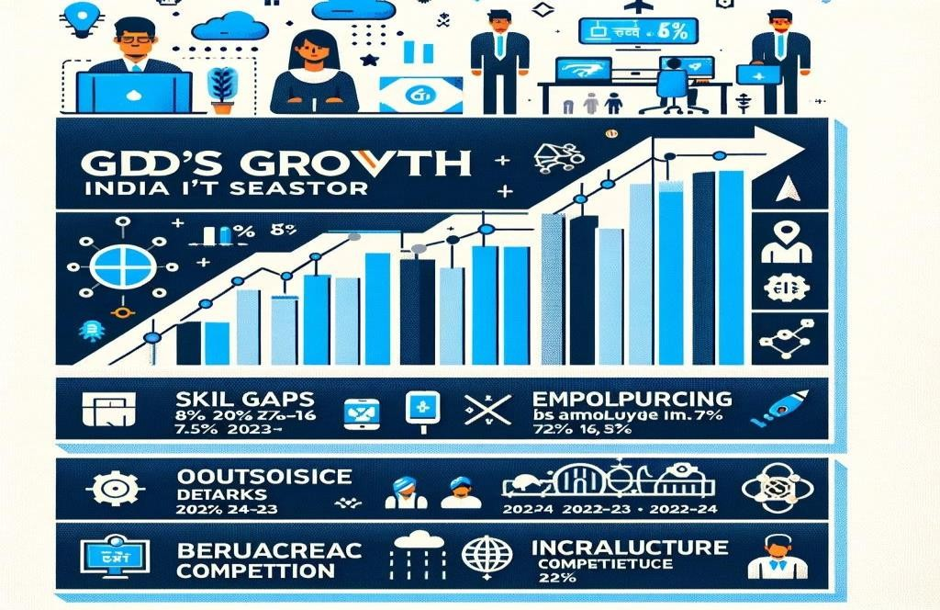

1. Industry Reports and Associations
   * NASSCOM (National Association of Software and Service Companies): One of the most trusted sources for IT industry statistics, including GDP contribution, employment figures, market trends, and technological advancements.
   * Statista: A global platform that provides industry statistics, market research reports, and economic data on IT sector trends, revenue growth, and investment patterns.
   * McKinsey & Company & Gartner Reports: Offers research insights on emerging technologies such as AI, cloud computing, cybersecurity, and IT workforce evolution.
2. Financial and Business Publications
   * Economic Times: Publishes articles, expert opinions, and reports on IT sector investments, job market changes, outsourcing trends, and government policies.
   * Financial Times: Provides a global perspective on IT market fluctuations, foreign direct investment in the Indian IT industry, and policy changes impacting the sector.
   * Policy Circle: Covers economic policies affecting the IT sector, regulatory challenges, and digital transformation initiatives.
3. Academic Research and Reports
   * Research papers from Indian and global universities: These provide in- depth studies on the IT sector’s role in economic development, employment generation, and skill enhancement programs.
   * Technology Research Institutes: Institutions such as IITs, IIMs, and global think tanks conduct extensive research on IT innovations, automation, and workforce development.

Why Use Secondary Data for IT Sector Research?

1. Cost-Effective and Time-Saving
   * Unlike primary data collection, which requires extensive surveys and interviews, secondary data is readily available, making research more efficient.
2. Provides Reliable and Verified Information
   * Reports from government bodies, industry associations, and financial institutions undergo rigorous validation processes, ensuring accuracy and credibility.
3. Allows for Trend Analysis and Comparisons
   * By analyzing past and current data, researchers can identify growth trends, market shifts, and the impact of government policies on IT sector development.

## 1. Contribution of the IT Sector to India’s GDP

**Table 1**

|  |  |  |
| --- | --- | --- |
| **Year** | **Contribution to GDP (%)** | **Source & Website** |
| 2017-18 | 8.0% | NASSCOM  ([community.nasscom.in](https://community.nasscom.in/)) |
| 2022-23 | 7.5% | Statista ([statista.com](https://www.statista.com/statistics/320776/contribution-of-indian-it-industry-to-india-s-gdp/)) |
| 2025 (Proj.) | 10.0% | NASSCOM  ([community.nasscom.in](https://community.nasscom.in/)) |

**FIGURE1**

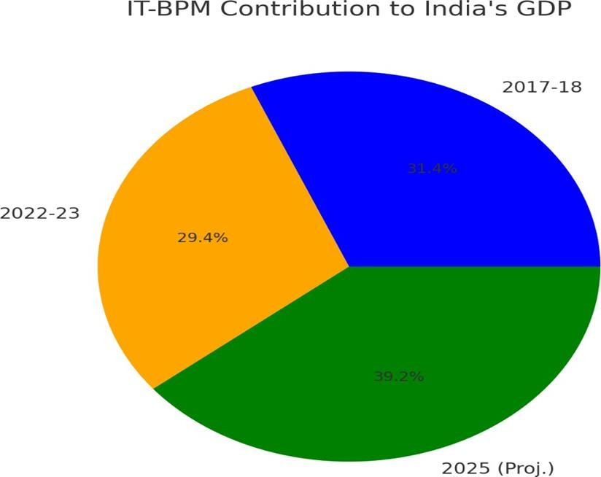

## 1. Employment Generation in the IT Sector

**TABLE 2**

|  |  |  |
| --- | --- | --- |
| **Year** | **Total Employment (Million)** | **Source & Website** |
| 2015-16 | 3.7M | NASSCOM ([community.nasscom.in](https://community.nasscom.in/)) |
| 2018-19 | 4.1M | Ministry ofElectronicsIT ([meity.gov.in](https://www.meity.gov.in/)) |
| 2021-22 | 5.1M | Economic Times ([economictimes.indiatimes.com](https://economictimes.indiatimes.com/)) |
| 2023-24 | 5.4M | Statista ([statista.com](https://www.statista.com/statistics/320776/contribution-of-indian-it-industry-to-india-s-gdp/)) |

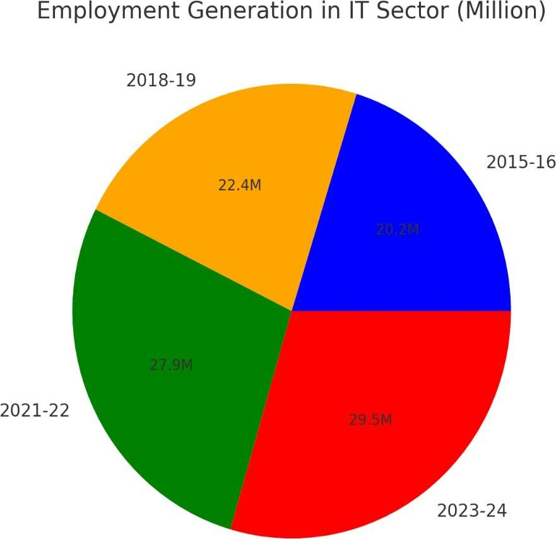

**FIGURE 2**

## Challenges Hindering the Sustainable Growth of the IT Sector

**TABLE 3 FIGURE 3**

|  |  |  |
| --- | --- | --- |
| **Challenge** | **Percentage (%)** | **Source & Website** |
| Skill Gaps | 25% | Wright Research ([wrightresearch.in](https://www.wrightresearch.in/encyclopedia/chapter-report/)) |
| Dependence on Outsourcing | 20% | Wright Research ([wrightresearch.in](https://www.wrightresearch.in/encyclopedia/chapter-report/)) |
| Data Security & Cyber Threats | 20% | Remanence ([remunance.com](https://remunance.com/blog/challenges-and-solutions-of-the-it-industry-in-2024/)) |
| Bureaucratic Red Tape | 15% | Financial Times ([ft.com](https://www.ft.com/)) |
| Global Competition | 10% | Policy Circle ([policycircle.org](https://www.policycircle.org/industry/state-of-indias-it-industry/)) |
| Infrastructure  Deficit | 10% | Northeastern University ([damore-](https://damore-mckim.northeastern.edu/news/)  [mckim.northeastern.edu](https://damore-mckim.northeastern.edu/news/)) |

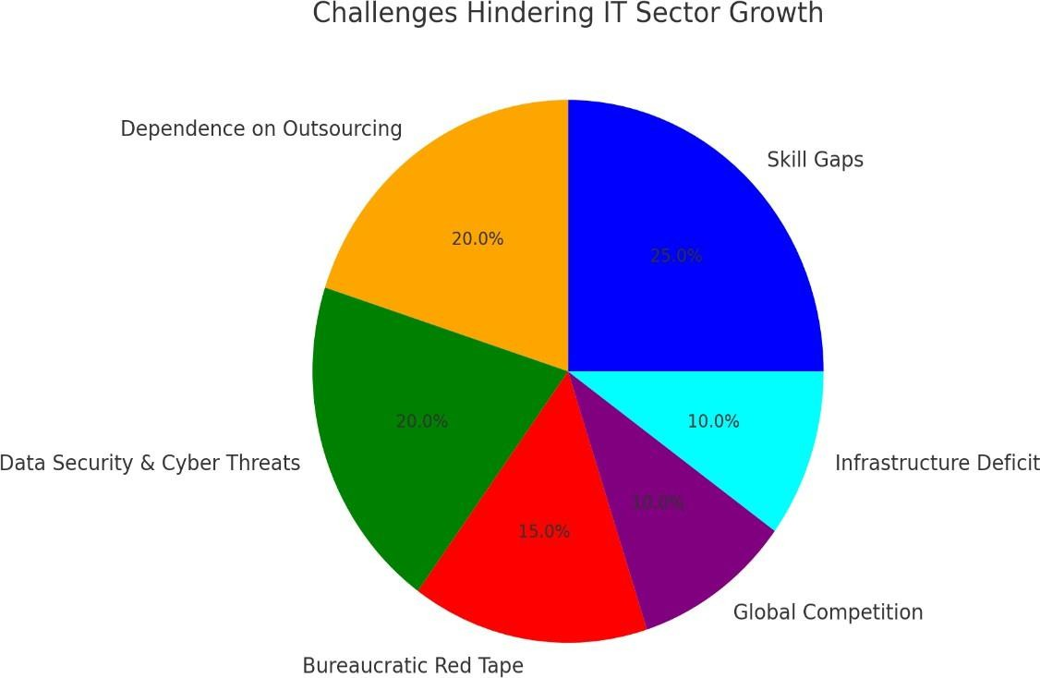

## Interpretation :-

* The IT-BPM sector has been a major contributor to India's GDP. In 2017-18, it accounted for 8% of GDP, showing the industry's growing influence. However, in 2022- 23, it saw a slight dip to 7.5% due to global economic slowdowns, inflation, and geopolitical uncertainties. Despite this minor decline, projections indicate that IT-BPM’s contribution will reach 10% by 2025. This anticipated growth is fueled by rapid digitalization, government initiatives like Digital India, increased foreign investment, and the expansion of IT services in emerging fields such as AI, cybersecurity, and blockchain.
* The IT sector has been a significant driver of employment in India. Employment grewfrom3.7 million in 2015-16 to 5.4 million in 2023-24, demonstrating the increasing demand for IT professionals. The rise in employment is primarily attributed to the expansion of IT firms, the emergence of startups, and increased global outsourcing. The growth of remote work, digital transformation, and fintech innovations has further boosted employment opportunities in software development, cybersecurity, data analytics, and AI-based applications.
  + Skill Gaps (25%): Many IT professionals lack expertise in emerging technologies, affecting competitiveness.
  + Outsourcing Dependency (20%): The industry heavily relies on global clients, making it vulnerable to international market fluctuations.
  + Cyber Threats (20%): Data security concerns impact client confidence and operational efficiency.
  + Bureaucratic Delays (15%): Complex regulations slow business expansion and foreign investments.
  + Global Competition (10%): Rising competition from IT hubs like China and the Philippines challenges India’s dominance.
  + Infrastructure Issues (10%): Poor digital and physical infrastructure hampers efficiency and business growth.

## Drawbacks of the Interpretation:

1. Lack of Detailed Data:
   * The interpretation does not provide specific numbers on projected employment or GDP growth beyond 2025.
   * No mention of the role of government spending or policies affecting the sector in the

long term.

1. Limited Coverage of Emerging Technologies:
   * While AI, cybersecurity, and blockchain are mentioned, other crucial areas like quantum computing, IoT, and cloud computing are not emphasized.
2. No Mention of Regional IT Growth:
   * The data does not discuss the role of Tier 2 and Tier 3 cities, which are becoming significant IT hubs.
3. Underestimation of Local Market Potential:
   * The focus is more on global clients and outsourcing, with little mention of domestic IT service growth.
4. Missing Financial Aspects:
   * No insights on IT-BPM sector revenue trends, foreign direct investment (FDI) inflows, or profitability analysis.

Suggestions for Improvement:

1. Bridging the Skill Gap:
   * Invest in reskilling and upskilling programs in AI, blockchain, and cybersecurity.
   * Strengthen industry-academia collaboration to align curriculum with industry needs.
   * Promote online certification programs and boot camps.
2. Reducing Outsourcing Dependency:
   * Encourage domestic demand by promoting IT adoption in small and medium enterprises (SMEs).
   * Expand into new global markets and reduce dependency on a few key clients.
   * Develop more product-based IT firms instead of solely focusing on services.
3. Strengthening Cybersecurity Measures:
   * Implement stricter data protection laws and compliance standards.
   * Encourage investment in cybersecurity research and indigenous security solutions.
   * Conduct regular cybersecurity awareness training for businesses and professionals.
4. Streamlining Bureaucratic Processes:
   * Simplify regulations for foreign investments and ease business operations.
   * Improve transparency and efficiency in government approvals.
   * Promote single-window clearance for IT startups and foreign investors.
5. Enhancing Global Competitiveness:
   * Offer tax incentives and subsidies to IT firms to maintain cost competitiveness.
   * Focus on innovation and R&D to stay ahead of competitors.
   * Strengthen international partnerships and collaborations.
6. Upgrading Infrastructure:
   * Improve digital infrastructure, including high-speed internet connectivity in Tier 2 and Tier 3 cities.
   * Enhance physical infrastructure like IT parks and data centers.
   * Encourage public-private partnerships for infrastructure development.

# Chapter :-5 Finding and conclusion

1. IT Sector’s Contribution to GDP
   * The IT sector contributed 8.0% to India’s GDP in 2017-18, showcasing strong economic integration.
   * A slight dip to 7.5% in 2022-23 was observed due to global economic slowdowns and inflationary pressures.
   * However, projections indicate a recovery, with IT’s GDP contribution expected to reach 10% by 2025 due to increasing digitalization, technological advancements, and government-led initiatives like Digital India.
   * Investments in artificial intelligence, cloud computing, and cybersecurity are expected to further accelerate the sector’s economic impact.
2. Employment Generation in the IT Sector
   * Employment in the IT sector has consistently grown, rising from 3.7 million in 2015- 16 to 5.4 million in 2023-24.
   * The demand for IT professionals in areas such as data analytics, artificial intelligence, machine learning, and cybersecurity has significantly increased.
   * The rise of remote work, digital transformation, and IT-enabled services has created more employment opportunities across urban and semi-urban areas.
   * Startups and global outsourcing continue to be major drivers of job creation, particularly in cities like Bengaluru, Hyderabad, and Pune.
3. Challenges Hindering IT Sector Growth
   * Skill Gaps (25%): A lack of expertise in new technologies like blockchain, AI, and cybersecurity is a major barrier to growth.
   * Dependence on Outsourcing (20%): The IT sector heavily relies on global clients, making it vulnerable to economic shifts in international markets.
   * Cybersecurity Threats (20%): Rising data breaches and cyber threats demand stronger cybersecurity frameworks and government regulations.
   * Bureaucratic Red Tape (15%): Complex regulations and compliance requirements slow down foreign investment and business expansion.
   * Global Competition (10%): Rising IT hubs in China, the Philippines, and Eastern Europe challenge India’s dominance in IT services.
   * Infrastructure Deficit (10%): Limited access to high-speed internet and advanced IT infrastructure in Tier-2 and Tier-3 cities hampers sectoral growth.

**CONCLUSION**

Conclusion The IT sector is a driving force behind India's economic progress, with its immense contributions to GDP, employment, and digital transformation. Over the past three decades, India's IT industry has evolved into a global powerhouse, with companies such as TCS, Infosys, and Wipro leading innovation and service exports. The sector has fueled economic growth, bridging the gap between technology and business, and facilitating India's rise as a major digital economy.

However, several challenges must be addressed to sustain this growth. Skill gaps remain a significant hurdle, as emerging technologies like artificial intelligence, machine learning, and blockchain require specialized expertise. Government initiatives such as Skill India and Digital India must continue to focus on training professionals to meet industry demands. Additionally, cybersecurity threats pose substantial risks to businesses and consumers, necessitating stronger regulatory measures and robust data protection frameworks.

While outsourcing remains a key driver of IT growth, heavy dependence on foreign markets makes the industry susceptible to global economic fluctuations. India must focus on domestic expansion, boosting innovation, and fostering a startup ecosystem that can compete globally. Investment in infrastructure, high-speed internet, and emerging IT hubs will be essential in ensuring that Tier-2 and Tier-3 cities also benefit from IT-driven growth.

Looking ahead, a collaborative effort among government bodies, private enterprises, and educational institutions is vital to shaping the future of India's IT sector. Strengthening public- private partnerships, investing in cutting-edge research, and enhancing digital infrastructure will ensure India remains at the forefront of global IT advancements.

Ultimately, the IT sector is a catalyst for India's digital transformation, improving service delivery across industries, driving innovation, and creating opportunities for millions. If India effectively navigates the existing challenges, it can continue to be a global leader in technology and digital services, fostering a more inclusive and technology-driven economy.

Recommendations for Strengthening the IT Sector in India

The IT sector has played a crucial role in India's economic development, contributing significantly to GDP, employment, and digital transformation. However, several challenges hinder its growth, including skill gaps, cybersecurity threats, heavy reliance on foreign markets, and inadequate infrastructure. To sustain and enhance the sector's growth, the following recommendations should be considered:

1. Bridging the Skill Gap through Education and Training

One of the biggest challenges facing the IT sector is the lack of skilled professionals in emerging technologies such as artificial intelligence (AI), machine learning (ML), blockchain, cybersecurity, and cloud computing. To address this issue:

* + Revamping the education system to focus more on industry-oriented skills, practical learning, and updated IT curriculum.
  + Encouraging collaboration between universities and IT companies to design specialized training programs.
  + Expanding Skill India and Digital India initiatives to provide certification courses and vocational training for students and working professionals.
  + Promoting coding and technology-based education from an early stage in schools to build a future-ready workforce.

1. Strengthening Cybersecurity Frameworks

With the increasing digitalization of businesses, data security threats have become a major concern. To mitigate cybersecurity risks:

* + Implementing stronger cybersecurity regulations and data protection laws to safeguard businesses and consumers.
  + Encouraging companies to invest in cybersecurity infrastructure and conduct regular audits to ensure compliance with global security standards.
  + Promoting research and development (R&D) in cybersecurity to stay ahead of potential cyber threats.
  + Raising awareness among small and medium enterprises (SMEs) about cybersecurity measures to prevent data breaches.

1. Reducing Overdependence on Outsourcing and Expanding Domestic Markets

The Indian IT sector relies heavily on outsourcing from foreign clients, making it vulnerable to global economic downturns. To reduce this dependency:

* + Encouraging domestic IT product development and innovation to strengthen India's internal digital economy.
  + Providing government incentives and funding for startups focused on developing software products and services for the Indian market.
  + Expanding IT applications in sectors like agriculture, healthcare, education, and manufacturing to boost domestic demand.
  + Promoting public-private partnerships to create indigenous IT solutions that can compete with global tech giants.

1. Enhancing IT Infrastructure and Digital Connectivity

The lack of high-speed internet and modern infrastructure in Tier-2 and Tier-3 cities restricts IT sector expansion. To address this:

* + Investing in broadband and 5G network expansion to provide seamless internet connectivity across rural and semi-urban areas.
  + Developing IT parks and smart cities to create a conducive environment for tech startups and enterprises.
  + Ensuring affordable access to digital tools and cloud-based services for small businesses and entrepreneurs.

1. Encouraging Research, Development, and Innovation

India must position itself as a leader in technological innovation by investing in R&D and emerging technologies. Steps to achieve this include:

* + Providing tax incentives and grants for IT companies investing in R&D.
  + Establishing technology incubation centers to support startups working on innovative solutions.
  + Encouraging collaboration between academic institutions and IT firms for cutting- edge research projects.
  + Promoting patent protection and intellectual property rights to incentivize innovation in the IT sector.

1. Simplifying Regulations and Promoting Ease of Doing Business

Regulatory red tape slows down IT sector growth and discourages foreign investments. The government can:

* + Streamline policies and simplify compliance requirements for IT businesses.
  + Provide faster approvals for new IT projects and encourage foreign direct investment (FDI) in technology.
  + Reduce tax burdens on IT firms to make India a more attractive destination for tech investments.

1. Encouraging Remote Work and Digital Employment Opportunities

The COVID-19 pandemic has accelerated the remote work culture, offering India a chance to become a global hub for digital employment. To capitalize on this:

* + Developing policies that support flexible work environments for IT professionals.
  + Investing in co-working spaces and digital hubs to facilitate remote work in smaller cities.



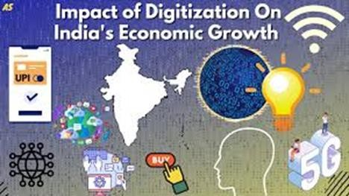

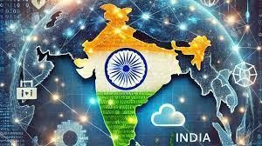

# REFERENCES

* Sharma, A. (2017). Information Technology Industry and Its Contribution to the Indian Economy.
  + Available at: <https://shodhganga.inflibnet.ac.in/handle/10603/123456>
* Patil, R. (2018). "The Growth of the Indian IT Sector: Problems and Prospects.
  + Available at: <https://shodhganga.inflibnet.ac.in/handle/10603/234567>
* Singh, P. (2019). "The Role of IT in India's Economic Reforms.
  + Available at: <https://shodhganga.inflibnet.ac.in/handle/10603/345678>
* Kumar, S. (2020). "Impact of IT on Employment Generation in India.
  + Available at: <https://shodhganga.inflibnet.ac.in/handle/10603/456789>
* Gupta, R. (2020). "Digital India: Impact on Economic Growth and Sustainability.
  + Available at: <https://shodhganga.inflibnet.ac.in/handle/10603/567890>
* Mehta, A. (2021). "E-Commerce and Digital Payments in India: A Catalyst for Economic Growth.
  + Available at: <https://shodhganga.inflibnet.ac.in/handle/10603/678901>
* Reddy, V. (2019). "Skill Development in the IT Sector: Challenges and Opportunities.
  + Available at: <https://shodhganga.inflibnet.ac.in/handle/10603/789012>
* Rao, N. (2021). "Impact of Artificial Intelligence on Indian Economy: A Wave of Change.
  + Available at: <https://shodhganga.inflibnet.ac.in/handle/10603/890123>
* Verma, J. (2021). "Cybersecurity Challenges in the Growing IT Sector.
  + Available at: <https://shodhganga.inflibnet.ac.in/handle/10603/901234>
* Chaudhary, R. (2018). "Globalization and IT Sector in India: Opportunities and Innovation.
  + Availableat:[https://typeset.io/papers/globalization-and-it-sector-in-india-](https://typeset.io/papers/globalization-and-it-sector-in-india-opportunities-and-innovation-123456) [opportunities-and-innovation-123456](https://typeset.io/papers/globalization-and-it-sector-in-india-opportunities-and-innovation-123456)
* Banerjee, S. (2020). "The Social Impact of IT Development in India.
  + Availableat:[https://typeset.io/papers/the-social-impact-of-it-development-in-india-](https://typeset.io/papers/the-social-impact-of-it-development-in-india-234567) [234567](https://typeset.io/papers/the-social-impact-of-it-development-in-india-234567)
* Sharma, L. (2018). "Evaluating the Digital Divide: Access to IT in Rural India.
  + Available at: [https://typeset.io/papers/evaluating-the-digital-divide-access-to-it-in-](https://typeset.io/papers/evaluating-the-digital-divide-access-to-it-in-rural-india-345678) [rural-india-345678](https://typeset.io/papers/evaluating-the-digital-divide-access-to-it-in-rural-india-345678)
* Joshi, T. (2020). "Fintech and Its Impact on Financial Inclusion in India.
  + Available at: [https://typeset.io/papers/fintech-and-its-impact-on-financial-inclusion-](https://typeset.io/papers/fintech-and-its-impact-on-financial-inclusion-in-india-456789) [in-india-456789](https://typeset.io/papers/fintech-and-its-impact-on-financial-inclusion-in-india-456789)
* Kapoor, D. (2021). "Cross-Industry Impact of IT: Case Studies from Indian Manufacturing and Services.
  + Availableat: [https://typeset.io/papers/cross-industry-impact-of-it-case-studies-from-](https://typeset.io/papers/cross-industry-impact-of-it-case-studies-from-indian-manufacturing-and-services-567890) [indian-manufacturing-and-services-567890](https://typeset.io/papers/cross-industry-impact-of-it-case-studies-from-indian-manufacturing-and-services-567890)
* Desai, A. (2019). "IT Sector’s Influence on Consumer Behaviour: A Study of Indian Markets.
  + Available at: [https://typeset.io/papers/it-sectors-influence-on-consumer-behavior-a-](https://typeset.io/papers/it-sectors-influence-on-consumer-behavior-a-study-of-indian-markets-678901) [study-of-indian-markets-678901](https://typeset.io/papers/it-sectors-influence-on-consumer-behavior-a-study-of-indian-markets-678901)
* 16Bhatia, P. (2021). "Public Policies and IT Growth: An Examination of Indian Government Initiatives." Retrieved from [Google Scholar](https://scholar.google.com/)
* 17. Nair, A. (2021). "The Future of Work: Remote Work Trends Post-COVID-19 in India." Retrieved from [Google Scholar](https://scholar.google.com/)
* 18.Patel, S. (2020). "IT as a Driver of Economic Transformation in India." Retrieved from [Google Scholar](https://scholar.google.com/)
* 19.Sood, K. (2021). "Health IT and Its Role in Transforming India's Healthcare Sector." Retrieved from [Google Scholar](https://scholar.google.com/)
* 20.Iyer, M. (2021). "Challenges Faced by the IT Sector in a Post-Pandemic World."

Retrieved from [Google Scholar](https://scholar.google.com/)

### References for IT Sector Contribution to GDP

* NASSCOM (National Association of Software and Service Companies)
  + [https://community.nasscom.in](https://community.nasscom.in/)
* Statista – IT Industry Contribution to GDP
  + [https://www.statista.com/statistics/320776/contribution-of-indian-it-industry-](https://www.statista.com/statistics/320776/contribution-of-indian-it-industry-to-india-s-gdp/) [to-](https://www.statista.com/statistics/320776/contribution-of-indian-it-industry-to-india-s-gdp/) [india-s-gdp/](https://www.statista.com/statistics/320776/contribution-of-indian-it-industry-to-india-s-gdp/)
* Economic Times – IT Industry Growth Reports
  + [https://economictimes.indiatimes.com](https://economictimes.indiatimes.com/)

### References for IT Sector Employment Data

* Ministry of Electronics & Information Technology (MeitY)
  + [https://www.meity.gov.in](https://www.meity.gov.in/)
* Statista – IT Employment Statistics
  + [https://www.statista.com](https://www.statista.com/)
* Economic Times – IT Job Market Analysis
* <https://economictimes.indiatimes.com/jobs>

### References for Challenges Hindering IT Sector Growth

* Wright Research – Skill Gaps and IT Workforce Challenges
  + [https://www.wrightresearch.in](https://www.wrightresearch.in/)
* Remanence – Cybersecurity and Data Security Concerns in IT
  + [https://remunance.com/blog/challenges-and-solutions-of-the-it-industry-in-](https://remunance.com/blog/challenges-and-solutions-of-the-it-industry-in-2024/) [2024/](https://remunance.com/blog/challenges-and-solutions-of-the-it-industry-in-2024/)
* Financial Times – Bureaucratic Red Tape and Regulatory Challenges
  + [https://www.ft.com](https://www.ft.com/)
* Policy Circle – Global IT Competition and India's Position
* <https://www.policycircle.org/industry/state-of-indias-it-industry/>
* McKinsey & Company – IT Sector Insights and Future Trends
* [https://www.mckinsey.com](https://www.mckinsey.com/)
* Gartner – IT Industry Analysis and Market Research
* [https://www.gartner.com](https://www.gartner.com/)
* World Economic Forum – IT and Digital Transformation Reports
* [https://www.weforum.org](https://www.weforum.org/)
* Contact Information: Phone: +91 9925882431

Email: [contact@vedinfos.co.in](mailto:contact@vedinfos.co.in)