**Lab Practical #01:**

Study of basic networking commands and IP configuration.

**Practical Assignment #01:**

1. Perform and explain various networking commands listed below:
   1. ipconfig
   2. ping
   3. getmac
   4. systeminfo
   5. traceroute / tracert
   6. netstat
   7. nslookup
   8. hostname
   9. pathping
   10. arp

## ipconfig

### Description:

ipconfig (Internet Protocol Configuration) is a command-line utility in Windows operating systems used to display and manage the network configuration of a computer's network interfaces. It provides essential details such as IP addresses, subnet masks, default gateways, and DNS servers. The tool is invaluable for network administrators and users to troubleshoot and configure network settings

|  |  |  |
| --- | --- | --- |
| No. | Option | Description |
| 1 | ipconfig /all | Displays comprehensive information about all network interfaces, including physical (MAC) addresses, DHCP lease details, and DNS settings. |
| 2 | ipconfig /release | Releases the IP address obtained from the DHCP server for all adapters. Use this command to relinquish the current DHCP assigned IP address |
| 3 | ipconfig /renew | Renews the IP address for all adapters from the DHCP server. This command requests a new IP address from the DHCP server, useful if your current IP lease has expired or you want a new IP |
| 4 | ipconfig /flushdns | Clears the DNS resolver cache, which can be useful when troubleshooting DNS issues or when DNS records have changed. |
| 5 | ipconfig /displaydns | Displays the contents of the DNS resolver cache, showing recent DNS query results stored on your local Computer |

### Implementation:

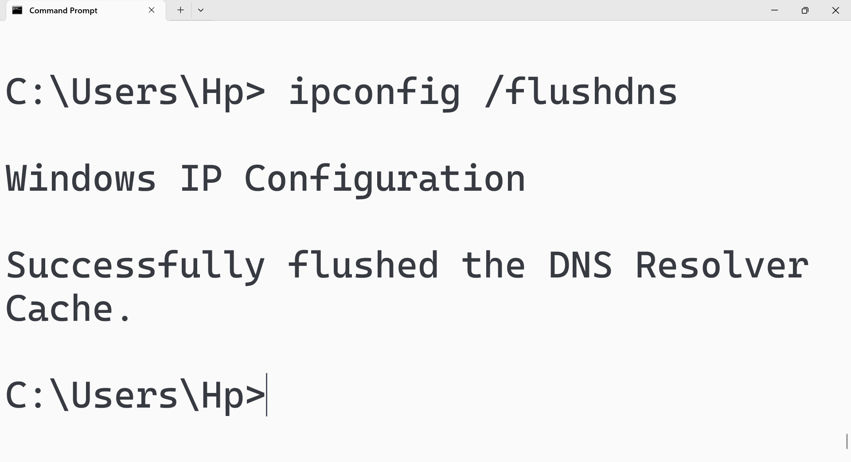

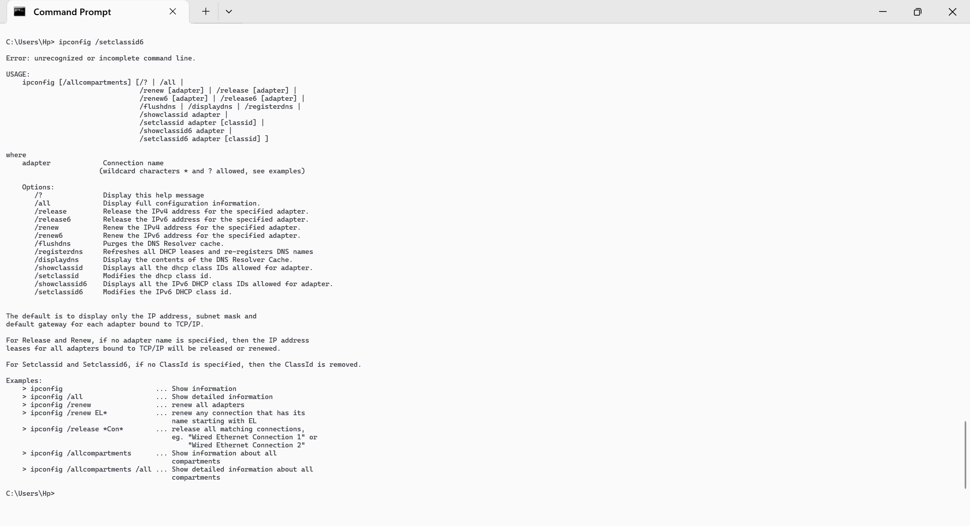

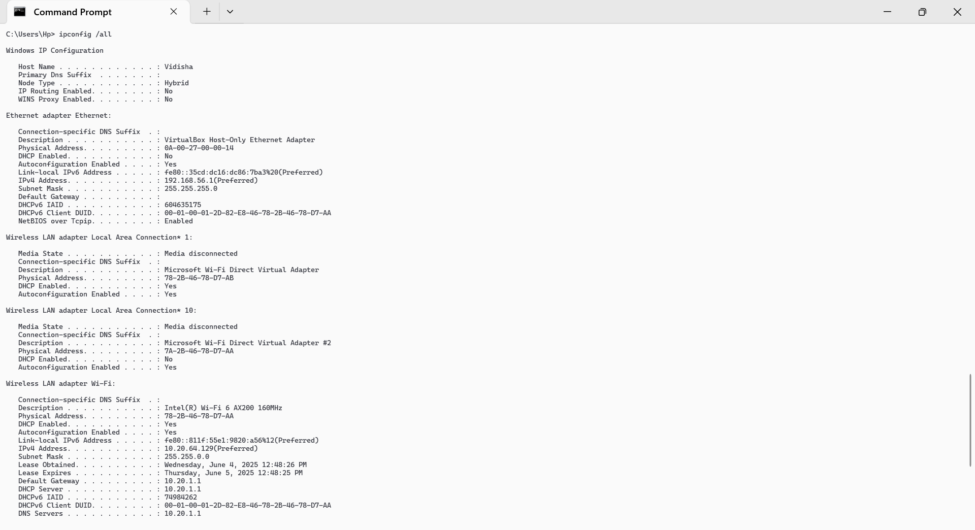

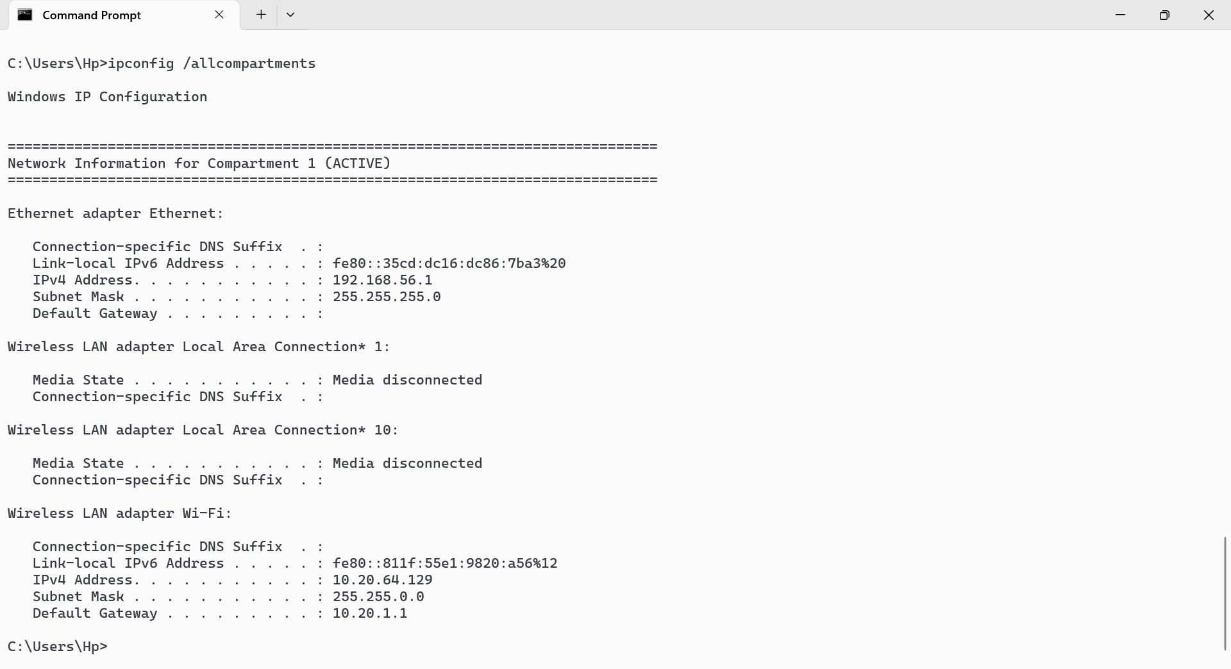

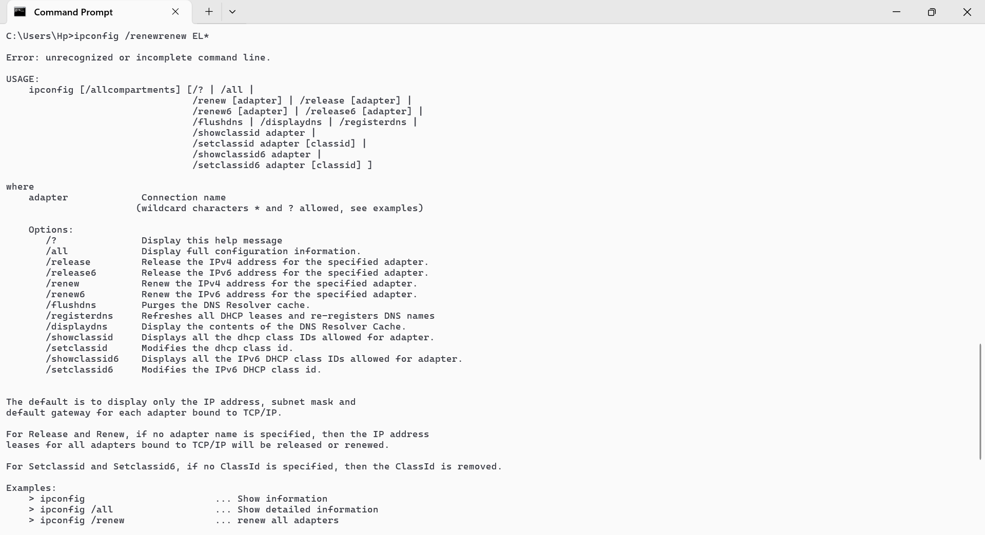

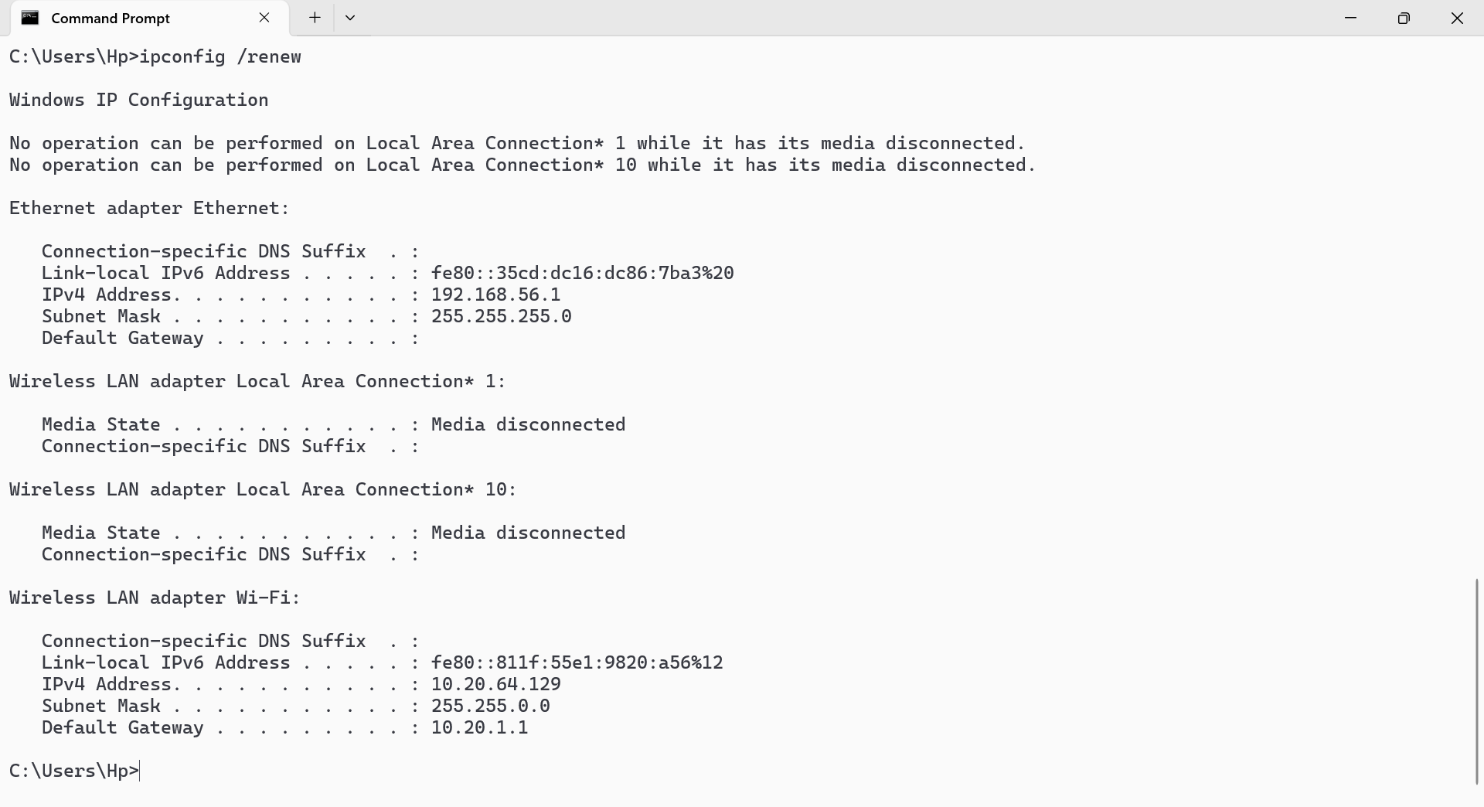

## ping

### Description:

The ping command is a network diagnostic tool used to test connectivity between your computer and a remote device or server. It sends ICMP Echo Request packets to the target and waits for Echo Reply packets. ping helps verify if a remote system is reachable and measures the time taken for messages to travel back and forth, indicating the network's latency and reliability

|  |  |  |
| --- | --- | --- |
| No. | Option | Description |
| 1 | -t | Keeps sending pings to the specified host until the command is manually stopped (Ctrl+C). Useful for continuous monitoring of connectivity |
| 2 | -l [size] | Sends ping requests with a specified packet size in bytes. Useful for testing network performance and diagnosing issues with larger packet sizes |
| 3 | -r [count] | Records the route of outgoing and return packets for a specified number of hops |
| 4 | -n [count] | Sends a specific number of ping requests to the target |
| 5 | S [srcaddr] | Uses the specified source IP address |

### Implementation:

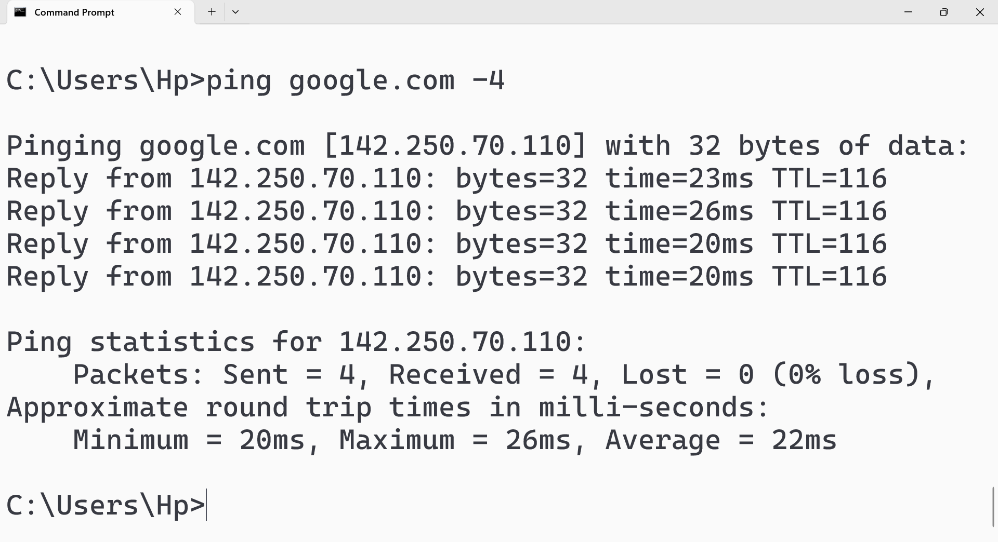

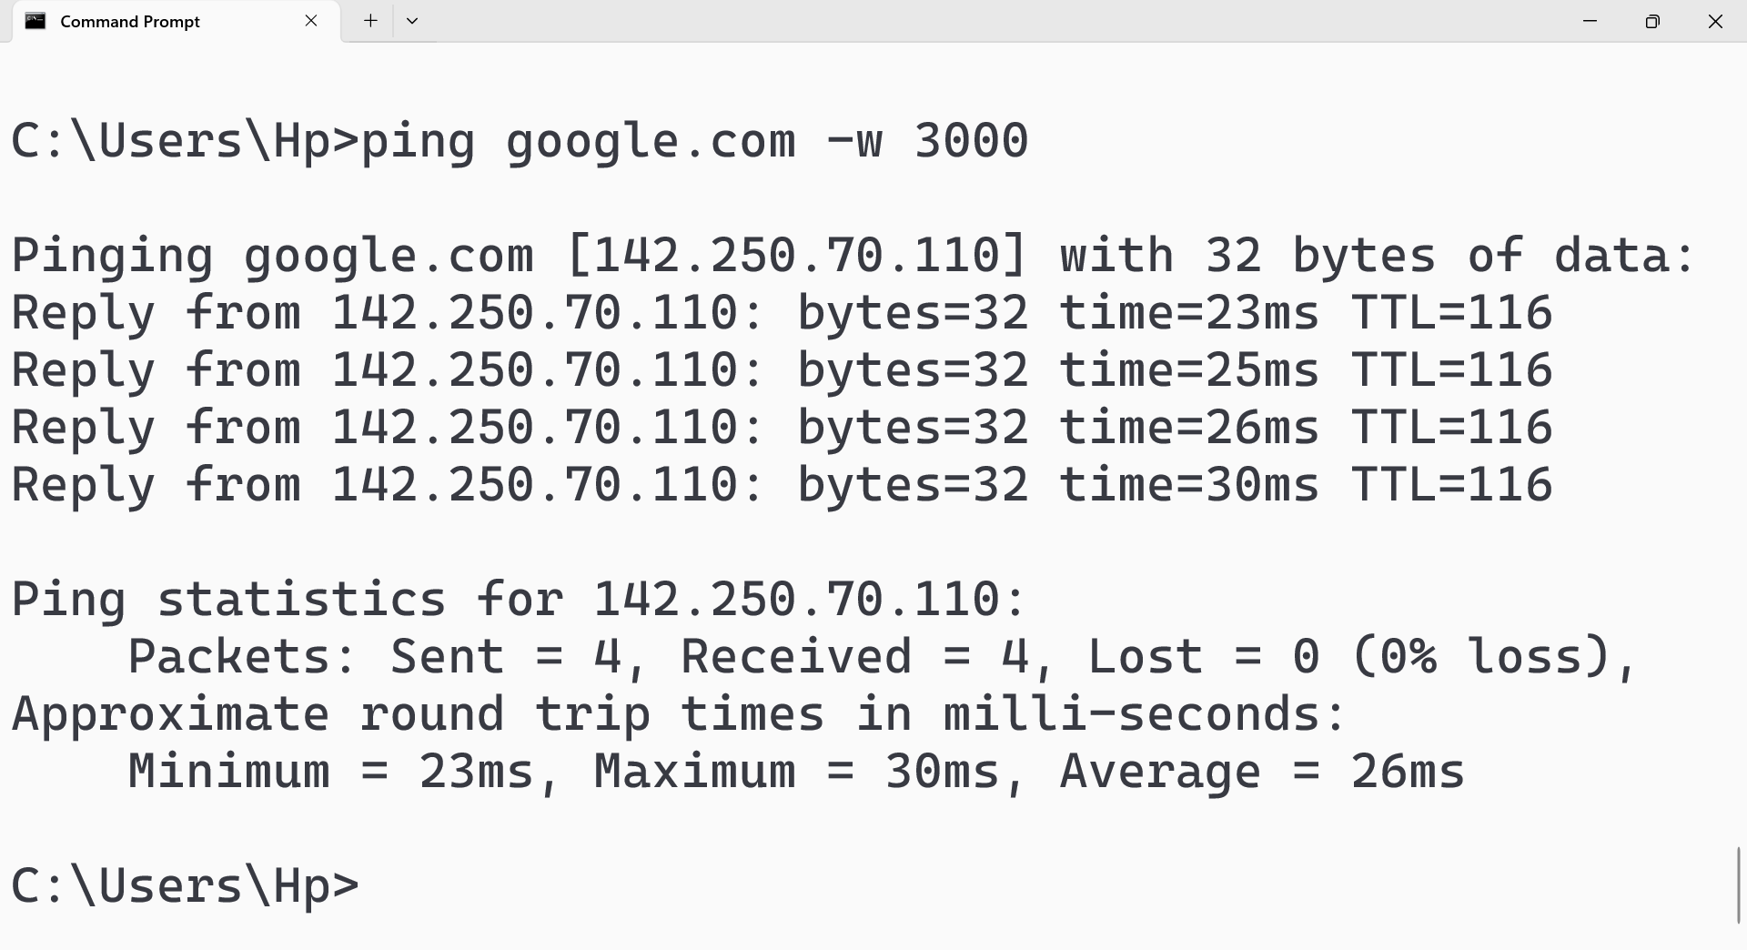

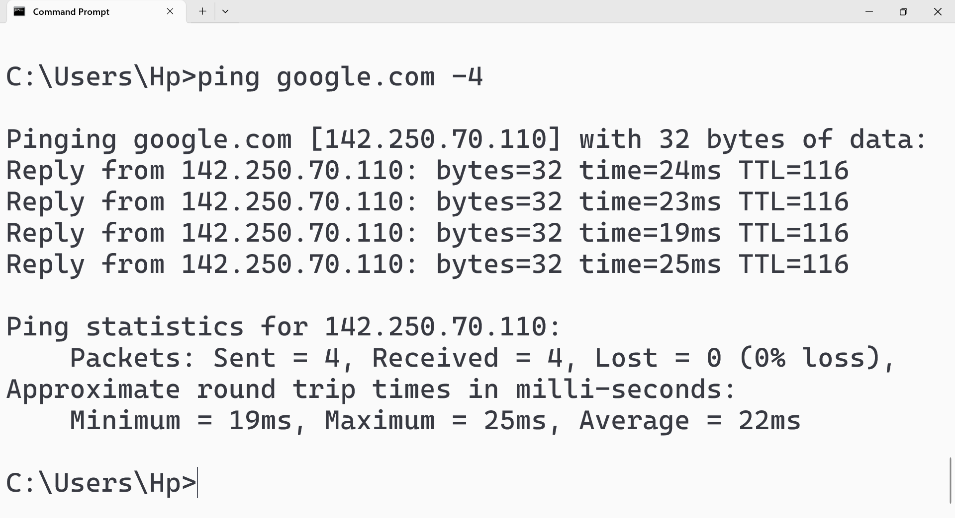

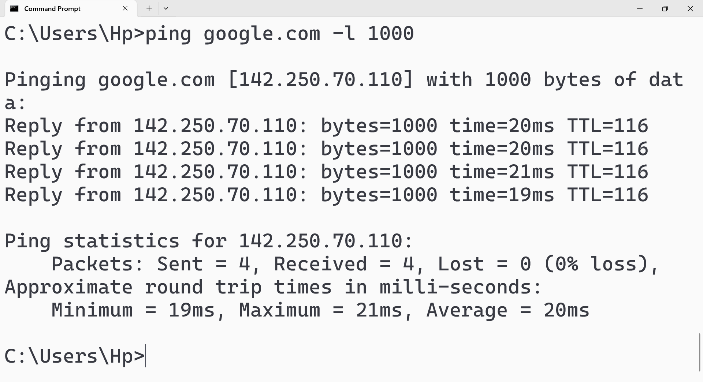

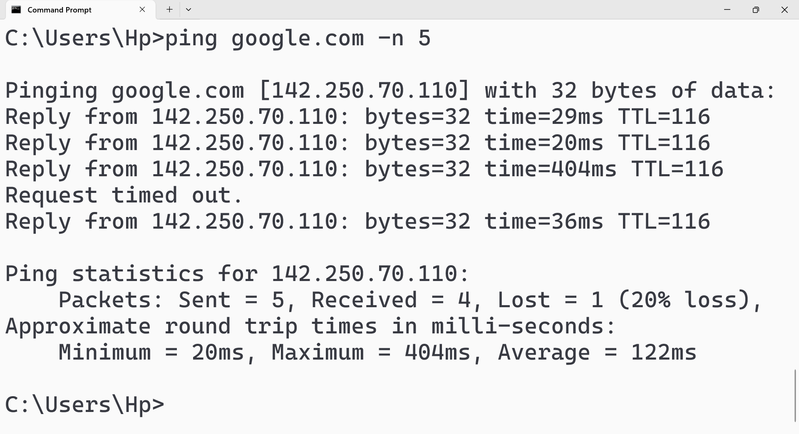

## getmac

### Description:

The getmac command, available in Windows, is used to display the Media Access Control (MAC) addresses of network adapters within a computer. It provides a way to view the unique hardware identifiers assigned to each network interface.

|  |  |  |
| --- | --- | --- |
| No. | Option | Description |
| 1 | /v | Provides more detailed information, including the transport name associated with each network adapter |
| 2 | /fo | Specifies the format of the output. Options include TABLE, LIST, or CSV |
| 3 | /nh | Omits the header row from the output. This is useful when outputting the information for scripting purposes. |
| 4 | /s [computer] | Retrieves MAC addresses from a remote computer. Requires administrative credentials for the remote system |
| 5 | /u [domain\user] | Specifies the user context under which the command should run, typically used in conjunction with the /s option for remote access |

### Implementation:

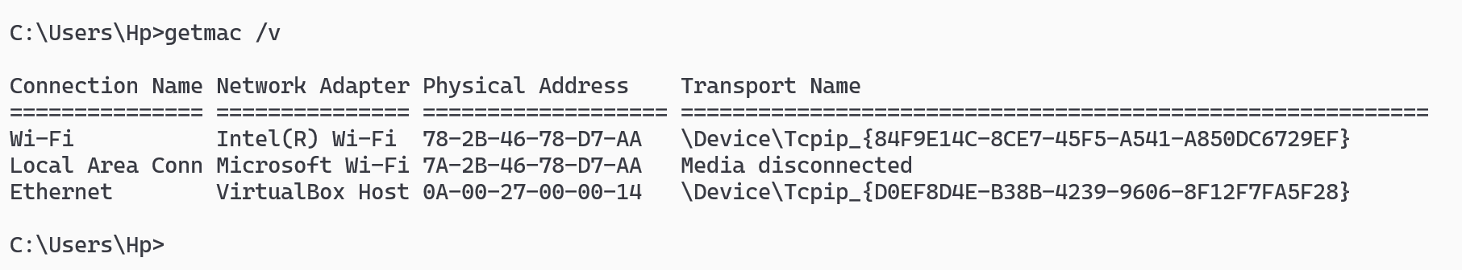

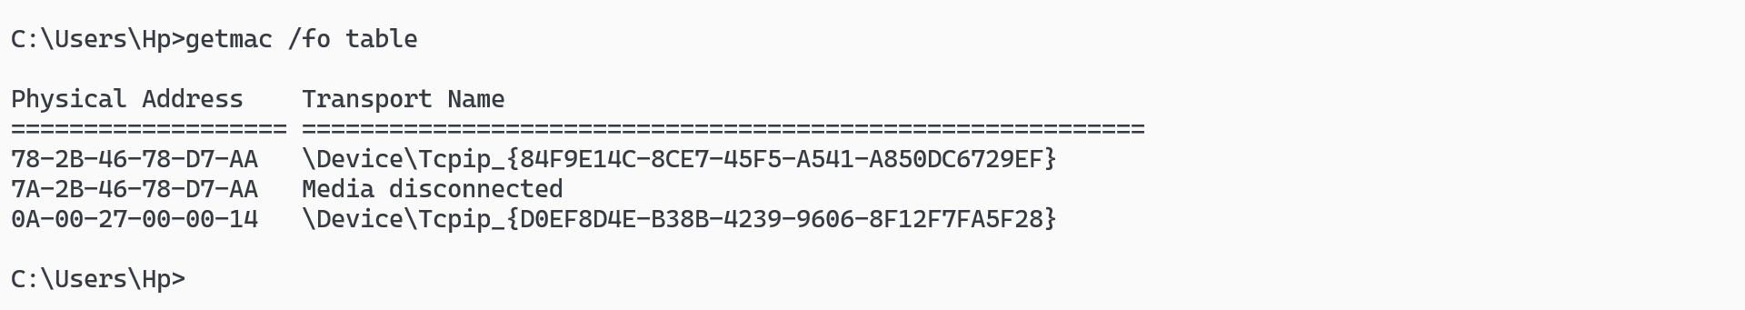

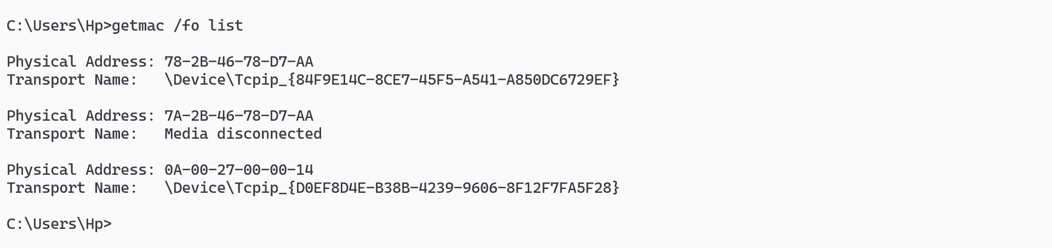

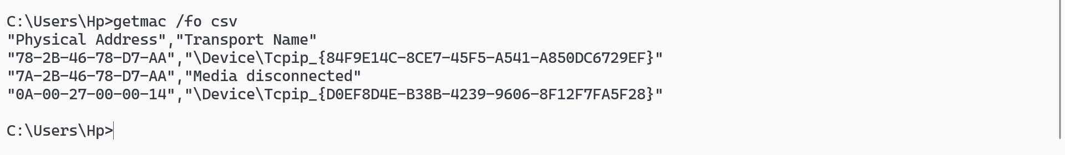

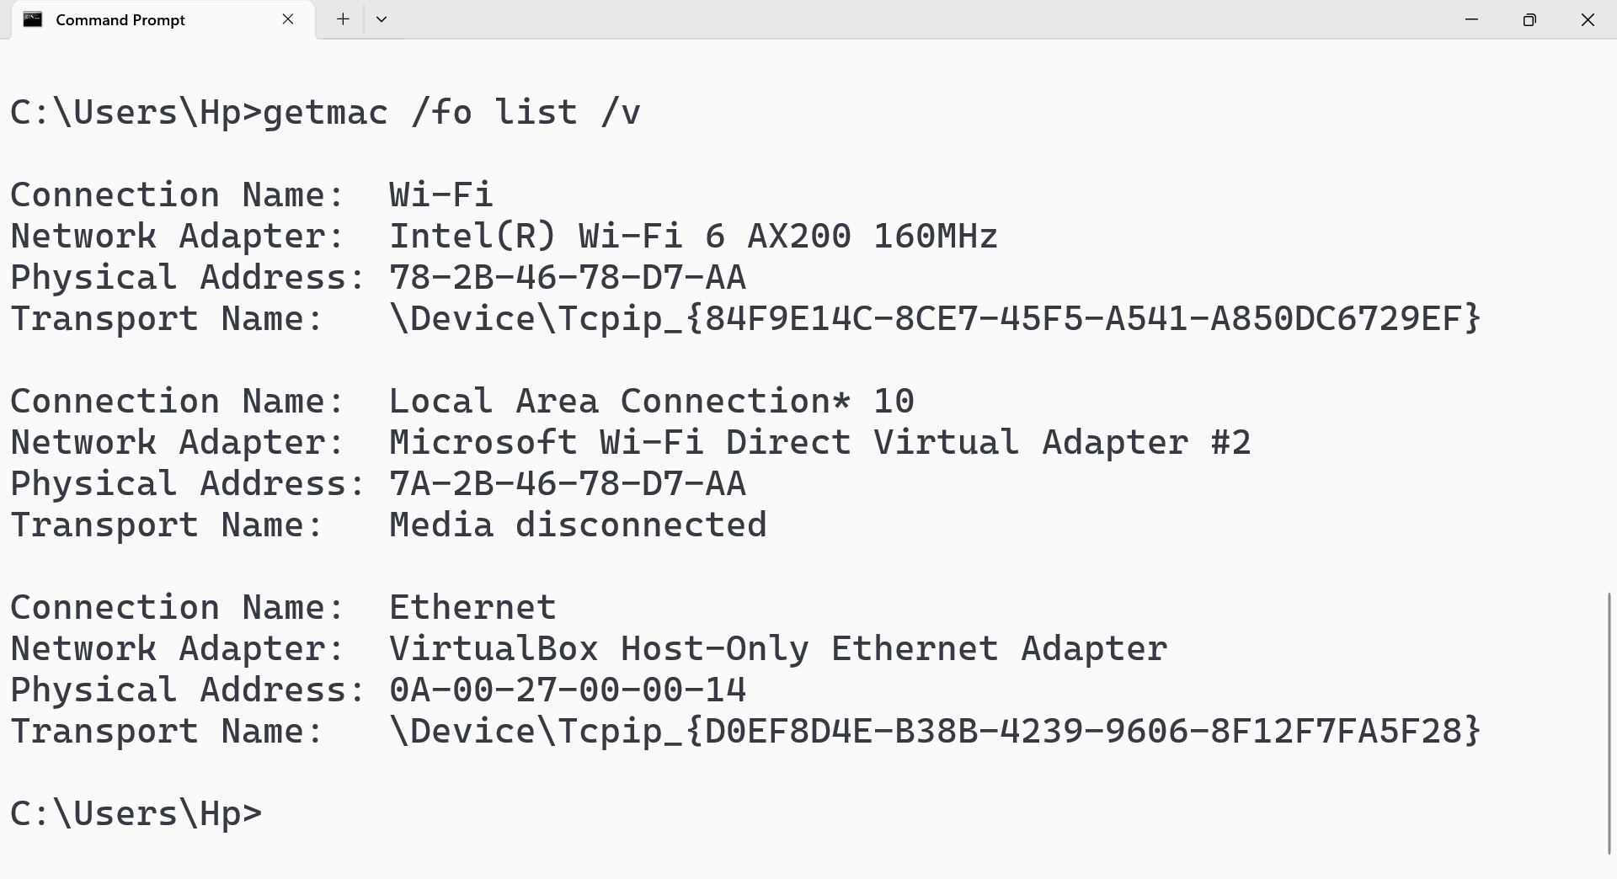

## systeminfo

### Description:

The systeminfo command is a built-in utility in Windows (and ReactOS) that provides comprehensive details about a computer and its operating system. It displays information like the operating system name, version, system manufacturer and model, hardware properties (like RAM and disk space), and network configuration.

|  |  |  |
| --- | --- | --- |
| No. | Option | Description |
| 1 | /s [computer] | Retrieves system information from a specified remote computer. Requires appropriate network access and administrative privileges on the remote machine |
| 2 | /fo [format] | Specifies the output format. Options include TABLE, LIST, or CSV |
| 3 | /nh | Omits the header row from the output. Useful when the output is being piped to another command or file |
| 4 | /u [domain\user] | Runs the command under the specified user account. Typically used with the /s option to access a remote computer |

### Implementation:

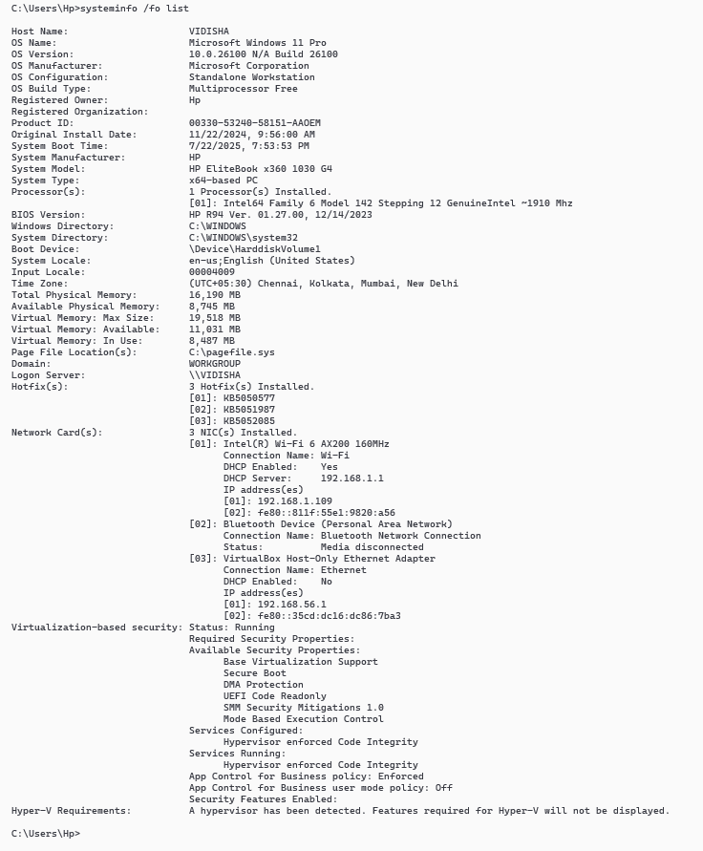

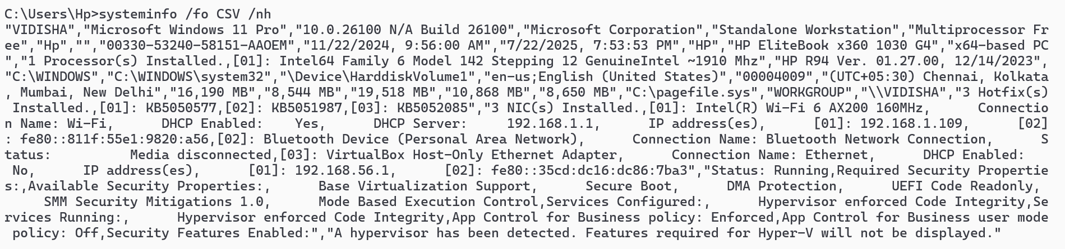

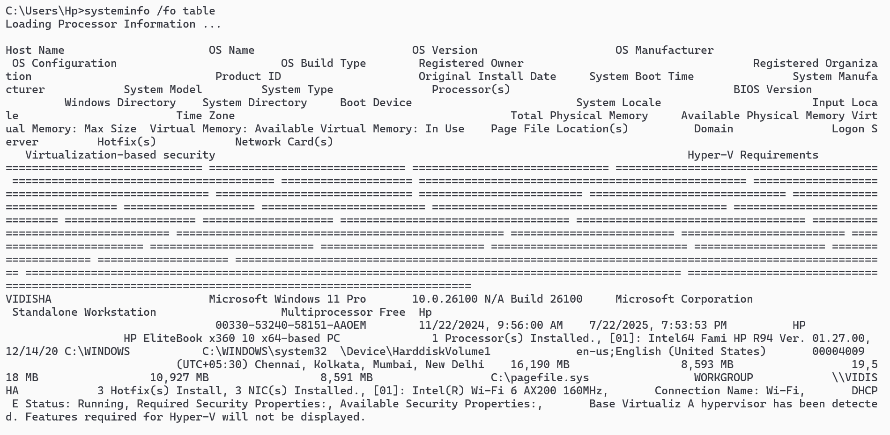

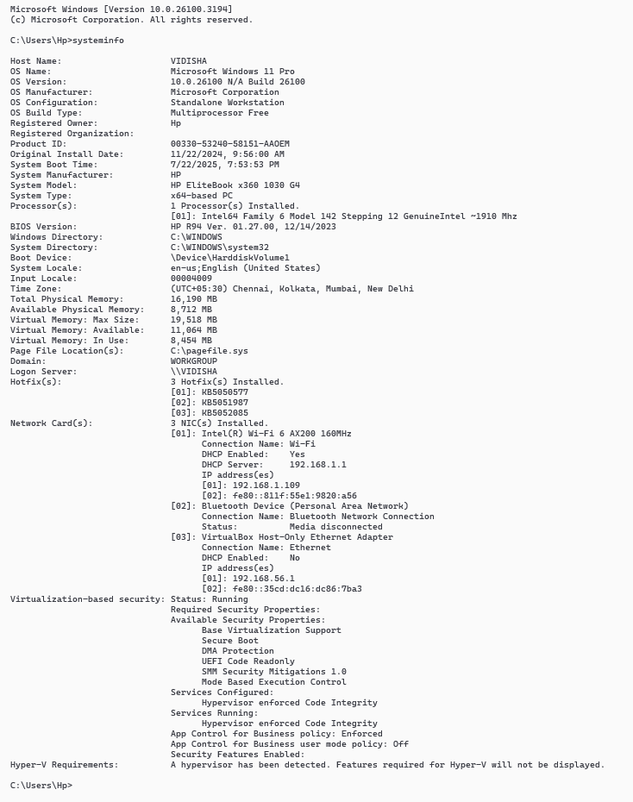

## tracerout / tracert

### Description:

Tracert, also known as traceroute, is a network diagnostic tool used to trace the path of an IP packet from a source to a destination. It displays a list of routers (hops) that the packet traverses and the time it takes to reach each hop. This helps in identifying network bottlenecks or issues along the path

|  |  |  |
| --- | --- | --- |
| No. | Option | Description |
| 1 | -d | Shows only IP addresses without resolving them to hostnames, which speeds up the process. |
| 2 | -w [timeout] | Sets the timeout (in milliseconds) to wait for each reply |
| 3 | -h [maximum_hops] | Limits the number of hops to trace before stopping. |
| 4 | -4 | Forces the use of IPv4 addresses. |
| 5 | -6 | Forces the use of IPv6 addresses. |

### Implementation:

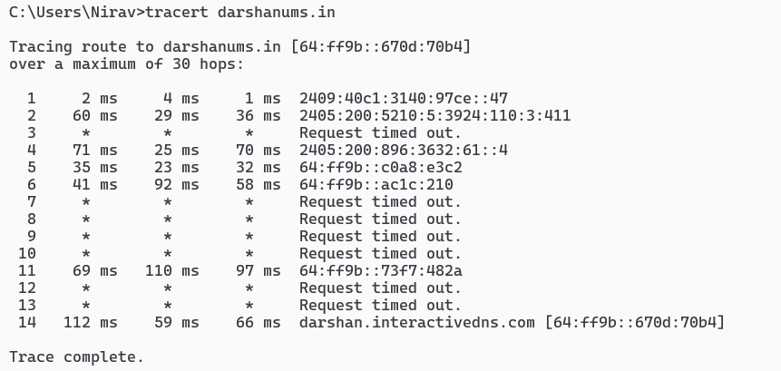

## netstate

### Description:

netstat is a command-line tool used to display network connections, routing tables, interface statistics, and other network-related information. It's a valuable utility for troubleshooting network issues and monitoring network activity.

|  |  |  |
| --- | --- | --- |
| No. | Option | Description |
| 1 | -a | Displays all connections and listening port |
| 2 | -n | Displays addresses and port numbers in numerical form, skipping name resolution |
| 3 | -o | Shows the process ID (PID) associated with each connection. |
| 4 | -p [protocol] | Shows connections for the specified protocol (e.g., tcp or udp) |

### Implementation:

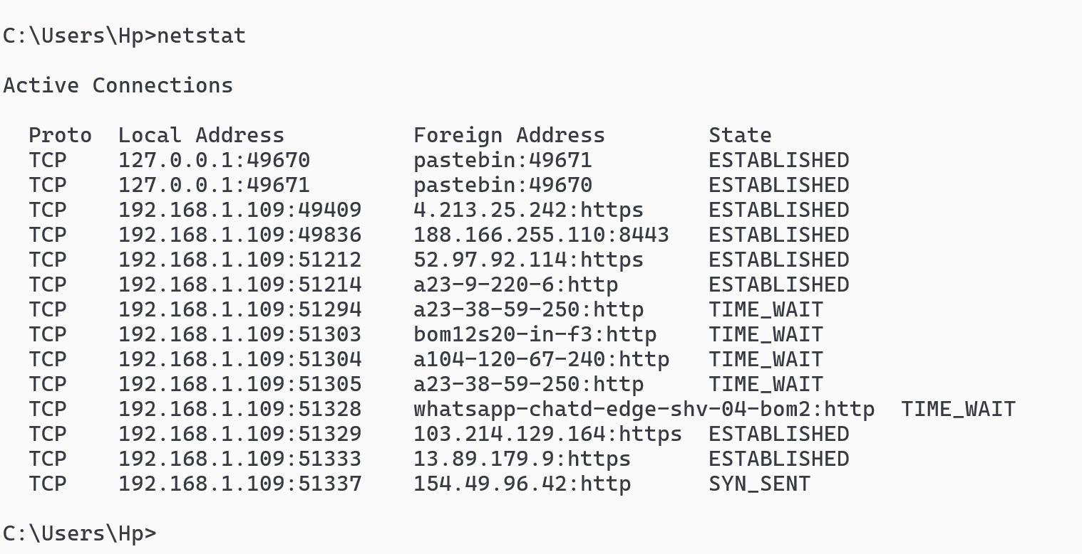

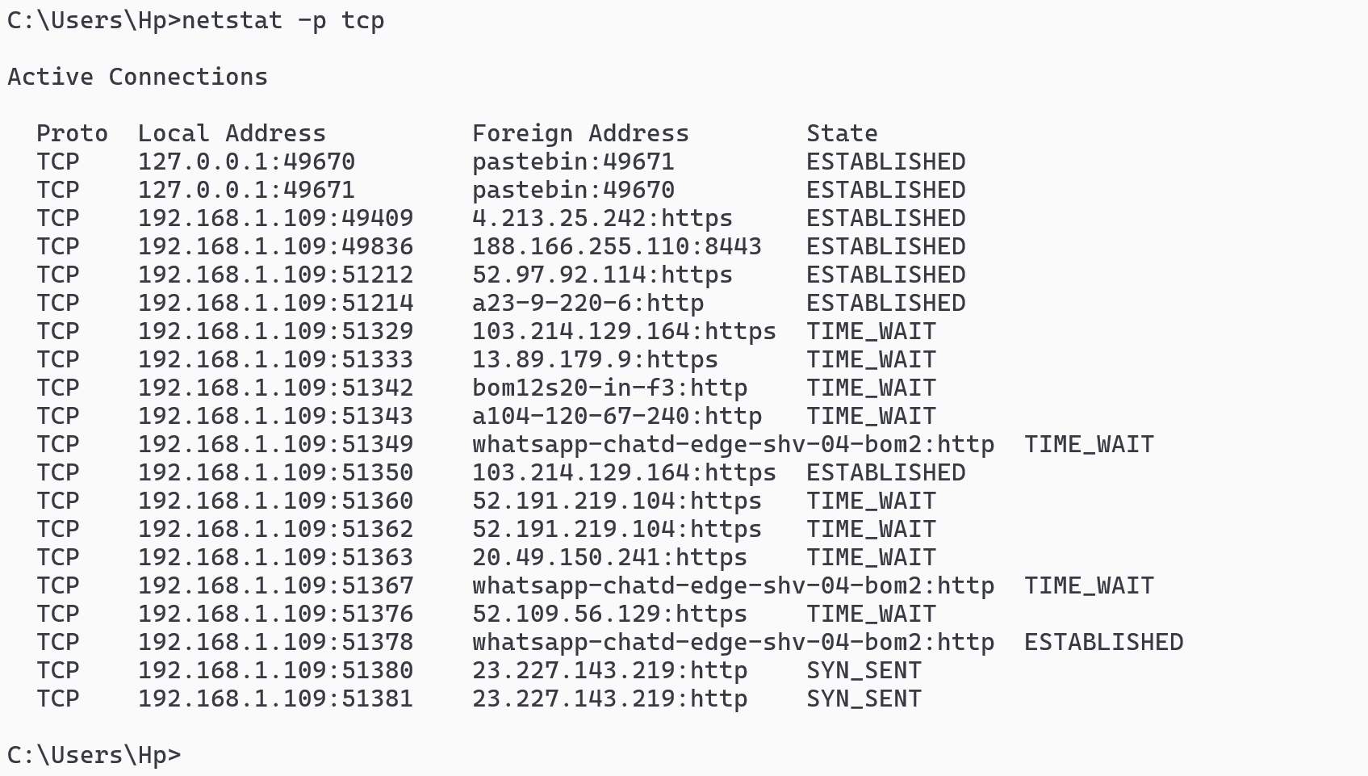

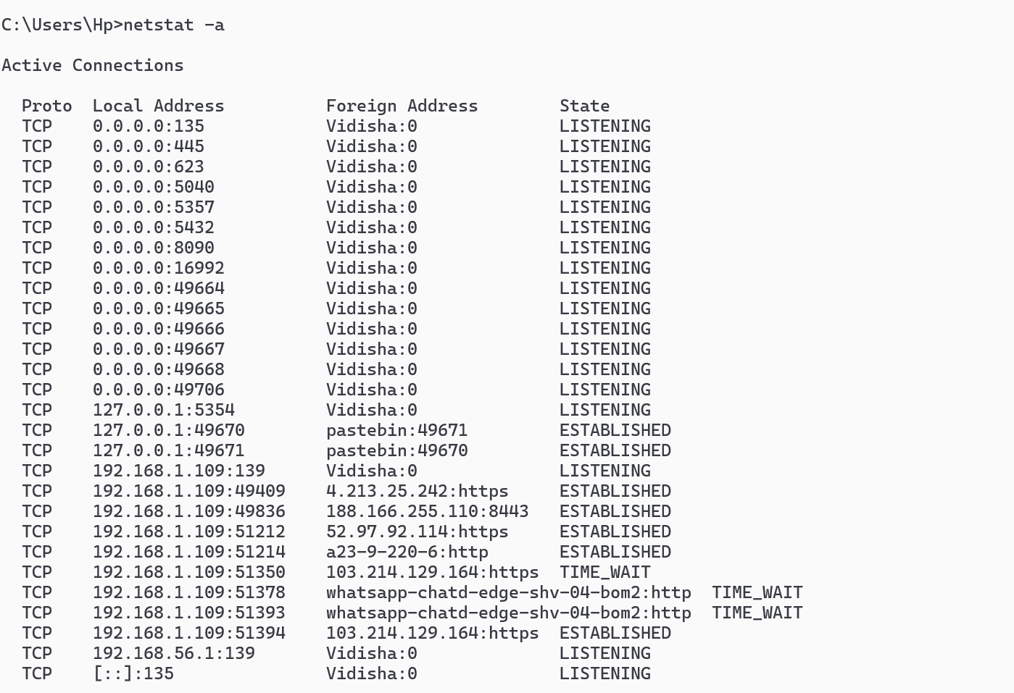

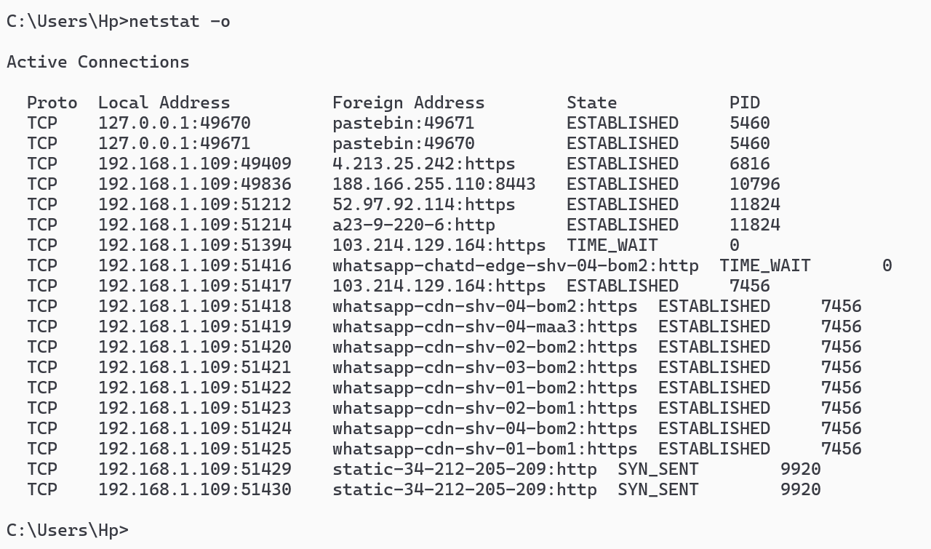

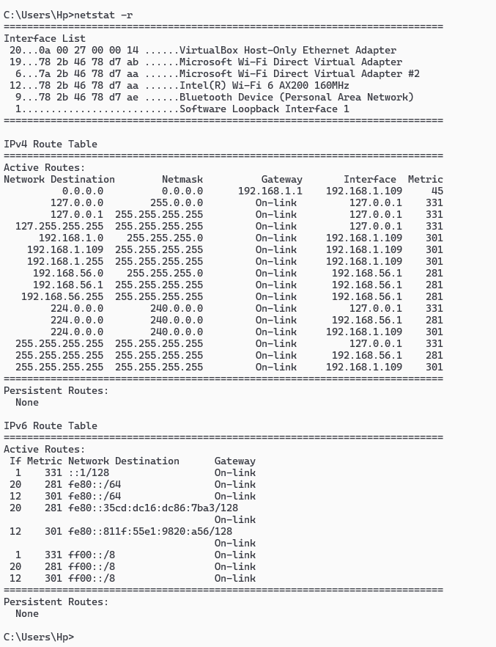

## nslookup

### Description:

nslookup (Name Server Lookup) is a network utility tool used to query Domain Name System (DNS) servers to obtain domain name or IP address mapping or any other specific DNS record. This command is valuable for troubleshooting DNS-related issues and understanding how domain names are resolved into IP addresses.

|  |  |  |
| --- | --- | --- |
| No. | Option | Description |
| 1 | nslookup [hostname] [DNS server] | Queries the specified DNS server (or the default one if not specified) for the IP address of the given hostname. |
| 2 | -query=[record_type] | An alternative to -type, specifies the type of DNS record to query. |
| 3 | -timeout=[number] | Sets the time to wait for a response from the DNS server in seconds. |
| 4 | -type=[record_type] | Specifies the type of DNS record to query (e.g., A, AAAA, MX, NS, CNAME, TXT, PTR). |
| 5 | -port=[number] | Specifies the port number to use for the DNS query (default is port 53) |

### Implementation:

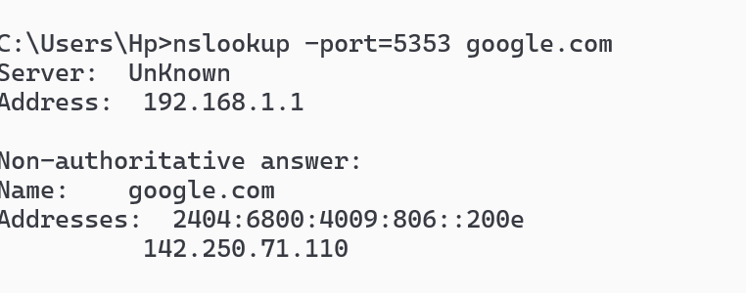

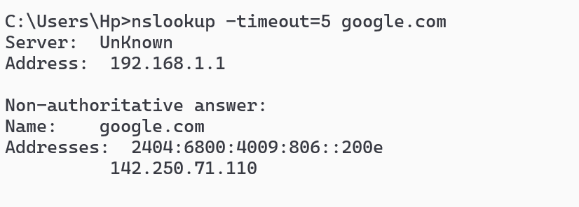

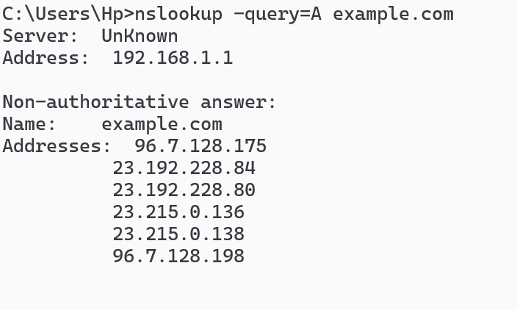

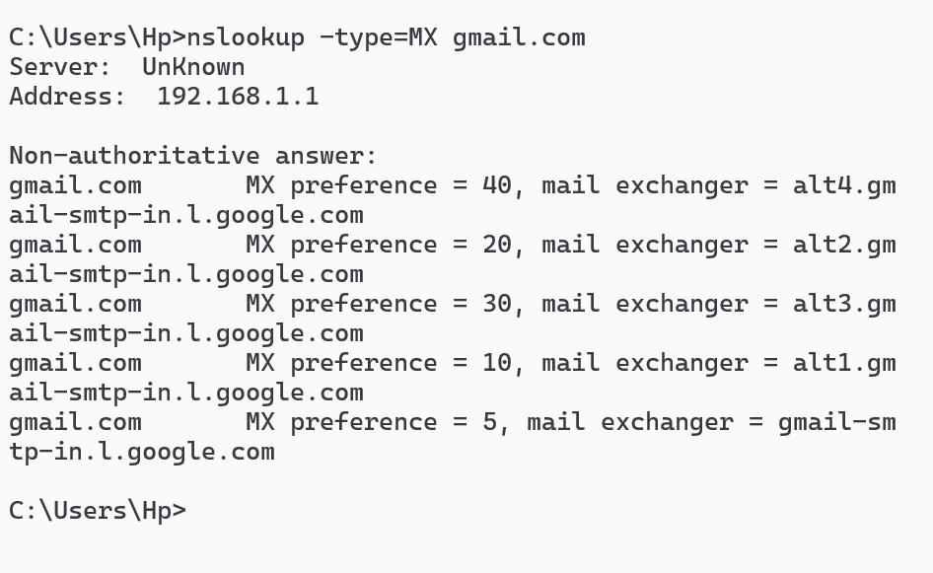

## hostname

### Description:

A hostname is a unique name assigned to a computer or device on a network, acting as a human-friendly identifier for that device. It allows users and systems to easily refer to and communicate with specific devices within a network, such as a local area network (LAN) or the internet. Essentially, it's a "nickname" for your computer or other network-connected device.

|  |  |  |
| --- | --- | --- |
| No. | Option | Description |
| 1 | -b, --boot | This option is used to set the hostname only until the next reboot. It changes the hostname temporarily for the current session. |
| 2 | -i, --ip-address | Displays the IP address(es) associated with the hostname. |
| 3 | -s, --short | Displays the short hostname (the portion of the hostname before the first dot). |
| 4 | -V, --version | Displays the version information of the hostname command. |
| 5 | -h, --help | Displays a help message that summarizes the usage and options of the hostname command. |

### Implementation:

Windows Command Prompt (cmd.exe) does not support options like -d, -f, or -s for displaying domain name, fully qualified domain name, or short hostname respectively



## pathping

### Description:

Pathping is a network diagnostic tool that combines the functionalities of ping and traceroute. It helps identify network latency and packet loss between a source and destination by sending multiple ICMP Echo Request messages to each router along the path.

|  |  |  |
| --- | --- | --- |
| No. | Option | Description |
| 1 | -n | Suppresses hostname resolution, displaying IP addresses instead. |
| 2 | -h maximum_hops | Specifies the maximum number of hops to search for the target. |
| 3 | -w timeout | Specifies the timeout in milliseconds to wait for each reply. |
| 4 | -p period | Specifies the wait period between successive pings, in milliseconds. |
| 5 | -q num_queries | Specifies the number of queries per hop. |

### Implementation:

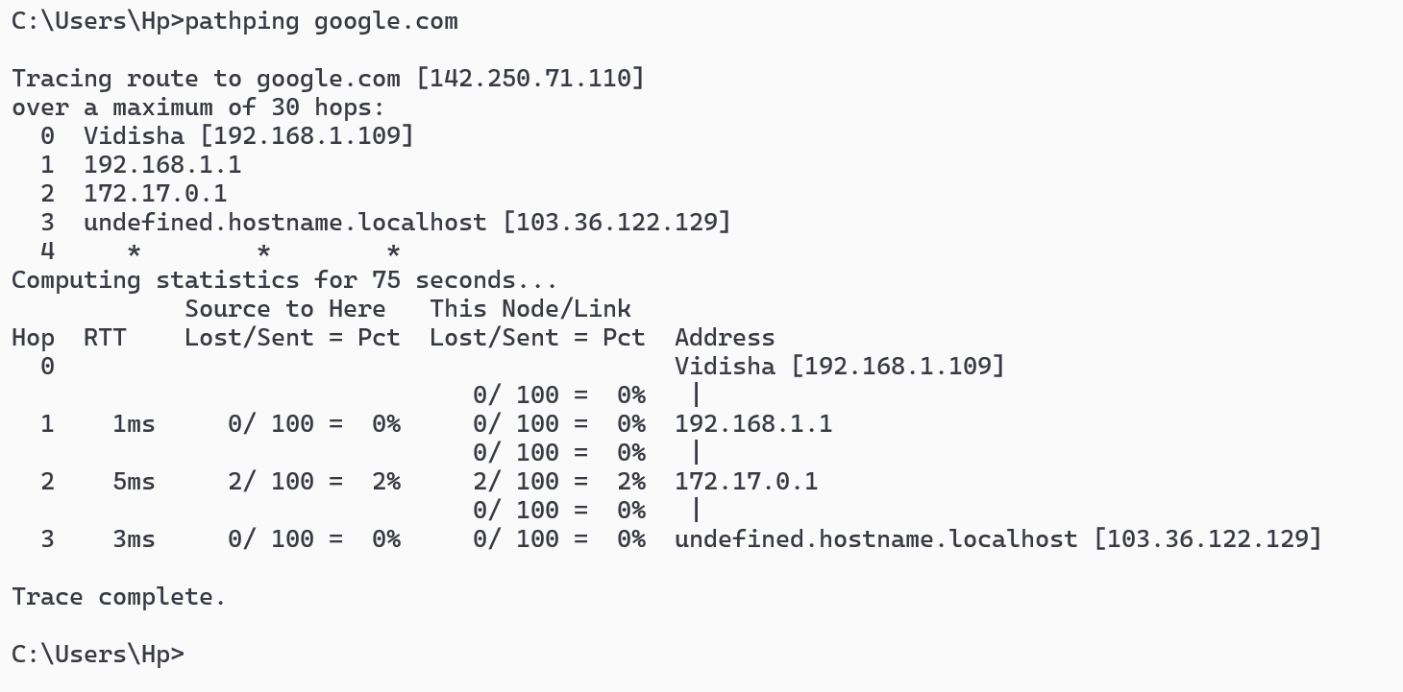

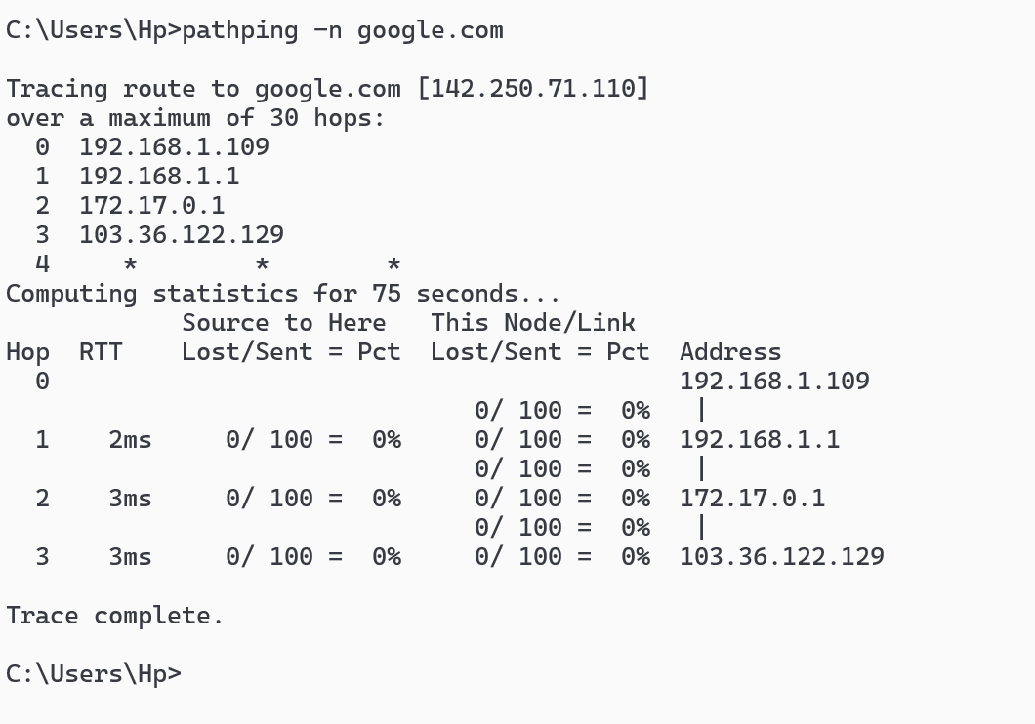

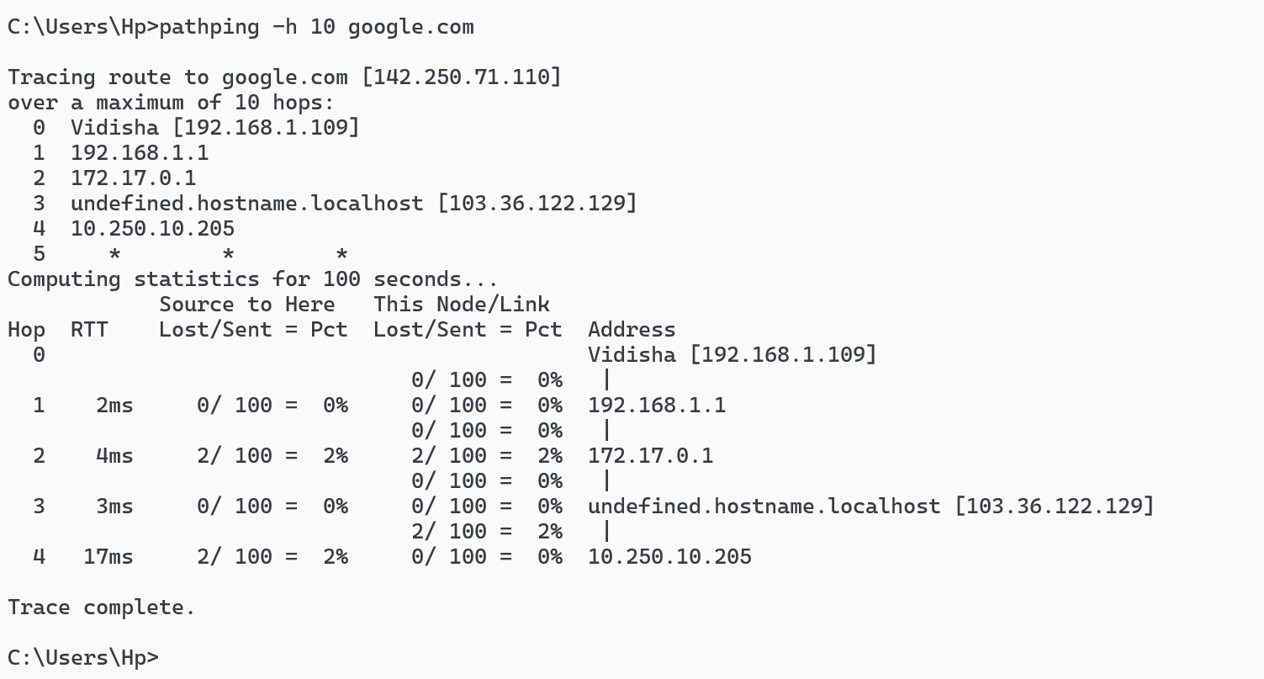

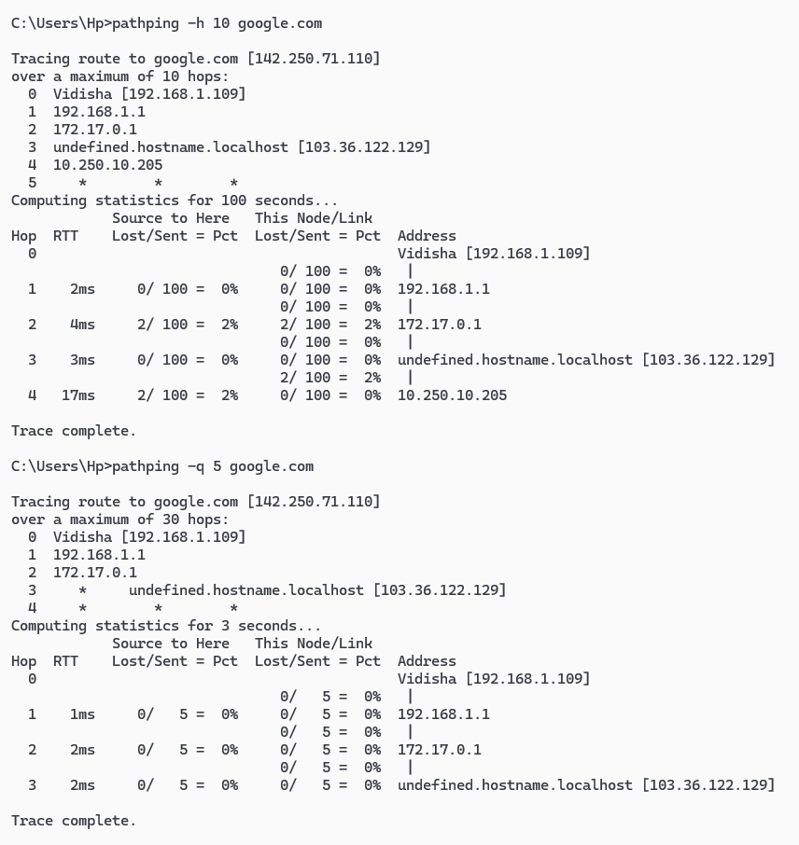

## arp

### Description:

The arp command is a network utility available on both Windows and Unix-like operating systems (such as Linux and macOS). Its primary function is to display and manipulate the Address Resolution Protocol (ARP) cache, which maps IP addresses to MAC addresses on a local network.

|  |  |  |
| --- | --- | --- |
| No. | Option | Description |
| 1 | arp -a | Displays the current ARP table. |
| 2 | arp -s | Adds a static entry to the ARP cache (manually specifying an IP address and MAC address). |
| 3 | arp -g | Same as -a; displays the ARP table. |
| 4 | arp -d | Deletes an entry with a specific IP address from the ARP cache. |
| 5 | arp -? or arp /? | Displays help information about the arp command and its options. |

### Implementation:

