**Lab Practical #03:**

Study of different types of network cables & connectors and crimping a LAN.

**Practical Assignment #03:**

1. List various networks cable. Also, write short description.
2. Difference between guided and unguided media.
3. Give cross-wired cable and straight through cable diagram (Color Code wise).

## List various networks cable and connectors. Also, write short description.

* **Coaxial Cable:** 
  + **Description**: Coaxial cables consist of a central copper conductor, surrounded by a plastic insulating layer, a metallic shield, and an outer insulating layer. They are commonly used for cable television, internet connections, and older Ethernet networks.
  + **Diagram**:

* **Unshielded Twisted Pair(UTP):** 
  + **Description**: UTP cables have pairs of twisted copper wires without additional shielding. They are widely used in Ethernet networks for both residential and commercial applications due to their flexibility and ease of installation.
  + **Diagram**:

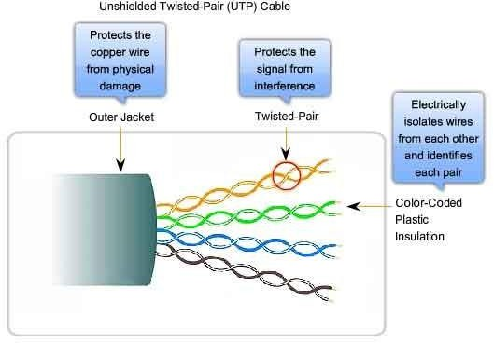

* **Shielded Twisted Pair(STP):** 
  + **Description**: STP cables are similar to UTP but have an additional shielding to protect against electromagnetic interference (EMI) and radio frequency interference (RFI). They are used in environments with high interference.
  + **Diagram:**

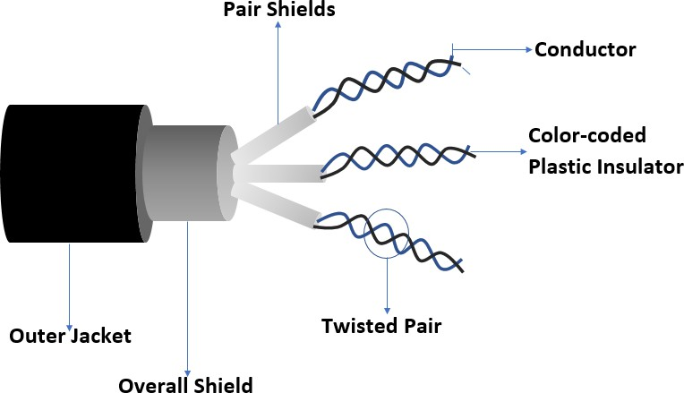

* **Fiber Optic Cable:** 
  + **Description**: Fiber optic cables use light to transmit data, offering high bandwidth and long-distance capabilities. They consist of strands of glass fibers surrounded by protective layers.
* **Single-mode Fiber(SMF):**
  + **Description**: SMF cables use a single strand of glass fiber and are used for long-distance data transmission with higher bandwidth capabilities.
  + **Diagram**:

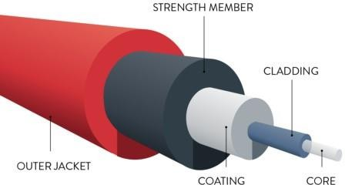

* **Multi-mode Fiber(MMF):**
  + **Description**: MMF cables use multiple strands of glass fiber and are used for shorter distance data transmission with moderate bandwidth capabilities.
  + **Diagram**:

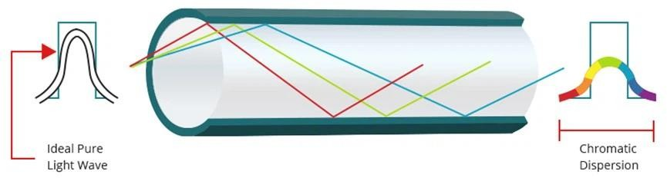

* **Connectors:**
* **RJ45:**
  + **Description**: The RJ45 connector is an 8-pin modular plug commonly used for Ethernet networking. It connects twisted pair cables to networking devices like routers, switches, and computers.
  + **Diagram:**

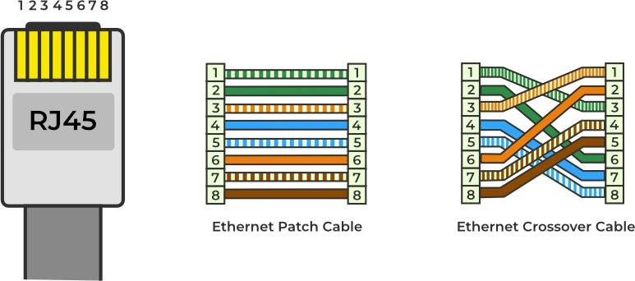

* **BNC (Bayonet Neill-Concelman):**
  + **Description**: BNC connectors are quick connect/disconnect RF connectors used with coaxial cables. They are widely used in television, radio, and other radio-frequency applications.
  + **Diagram:**

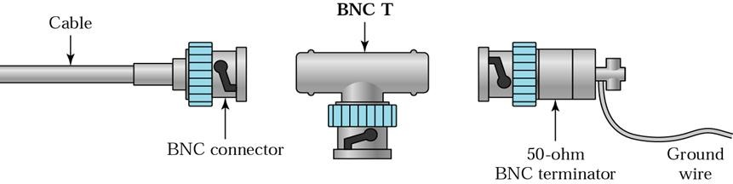

* **SC (Subscriber Connector):**
  + **Description**: SC connectors are used for fiber optic cables. They are push-pull connectors that provide excellent performance for single-mode and multi-mode fiber applications.
  + **Diagram:**

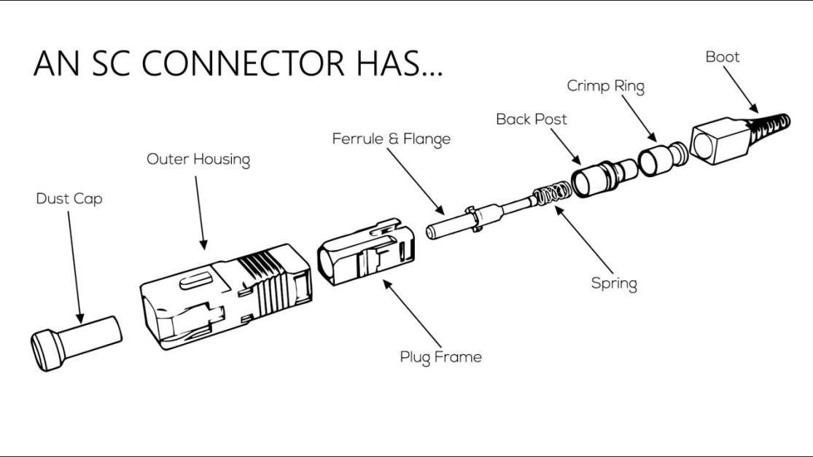

1. **Difference between guided and unguided media.**

|  |  |  |
| --- | --- | --- |
| **Sr. no.** | **Guided Media** | **Unguided Media** |
| 1. | The guided media is also called wired communication or bounded transmission media. | The unguided media is also called wireless communication or unbounded transmission media. |
| 2. | The signal energy propagates through wires in guided media. | The signal energy propagates through the air in unguided media. |
| 3. | Guided media is used for point-to- point communication. | Unguided media is generally suited for radio broadcasting in all directions. |
| 4. | It is cost-effective. | It is expensive. |
| 5. | Discrete network topologies are formed by the guided media. | Continuous network topologies are formed by the unguided media. |
| 6. | Signals are in the form of voltage, current, or photons in the guided media. | Signals are in the form of electromagnetic waves in unguided media. |
| 7. | Examples of guided media are twisted pair wires, coaxial cables, and optical fiber cables. | Examples of unguided media are microwave or radio links and infrared light. |
| 8. | By adding more wires, the transmission capacity can be increased in guided media. | It is not possible to obtain additional capacity in unguided media. |

## Give cross-wired cable and straight through cable diagram (Color Code wise).

1. Cross-wired Cable Diagram (Color Code)

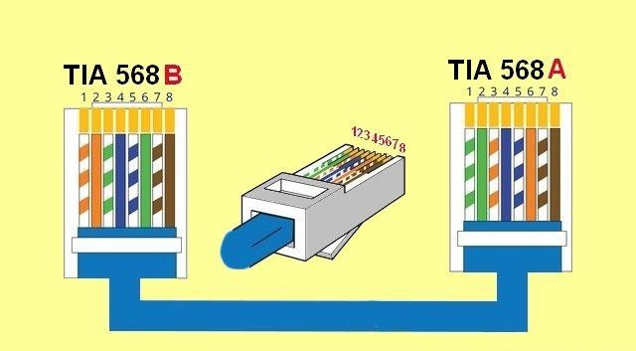

1. Straight Through Cable Diagram (Color Code)

