SOFTWARE DEVELOPMENT
Assignment Submission

Organisation | CountryEdu | Abhishek & Company
Track | Software Development
Total Questions | 2
Language | Python 3
Submitted By | Prince Khatik B.Tech CSE (AI & ML) MITS Gwalior
Email | kachhwahaprince@gmail.com
Phone | +91-808565-4567

Question 1: Integer to English Words

Problem Statement
Convert a given integer (passed as a string) to its English words representation. The solution must also handle negative numbers and must not produce any extra spaces in the output.

Examples
Input: num = "123"
Output: "One Hundred Twenty Three"

Input: num = "12345"
Output: "Twelve Thousand Three Hundred Forty Five"

Constraints
- Number can be positive, negative, or zero
- No extra spaces in the final output
- Input is provided as a string

Approach & Logic

The solution works by splitting the number into groups of three digits (ones, thousands, millions, billions) and converting each group independently using a recursive helper function.

Step-by-step breakdown:
- Parse the string input to an integer and check for negative sign.
- Handle the special case where the number is 0 — return 'Zero' directly.
- Loop through the number in 3-digit chunks using modulo 1000.
- Convert each chunk using the recursive helper() which handles numbers 1 to 999.
- Attach the appropriate scale word (Thousand, Million, Billion) to each non-zero chunk.
- Reverse the collected parts and join them with a single space.
- Prepend 'Negative' if the original number was negative.

Complete Python Code

def numberToWords(num: str) -> str:
ones = [
"", "One", "Two", "Three", "Four", "Five", "Six", "Seven",
"Eight", "Nine", "Ten", "Eleven", "Twelve", "Thirteen",
"Fourteen", "Fifteen", "Sixteen", "Seventeen", "Eighteen", "Nineteen"
]
tens = [
"", "", "Twenty", "Thirty", "Forty", "Fifty",
"Sixty", "Seventy", "Eighty", "Ninety"
]
thousands = ["", "Thousand", "Million", "Billion"]

def helper(n: int) -> str:
if n == 0:
return ""
elif n < 20:
return ones[n]
elif n < 100:
rest = helper(n % 10)
return tens[n // 10] + (" " + rest if rest else "")
else:
rest = helper(n % 100)
return ones[n // 100] + " Hundred" + (" " + rest if rest else "")

negative = False
n = int(num)
if n < 0:
negative = True
n = -n

if n == 0: return "Zero"

parts = []
scale = 0
while n > 0:
chunk = n % 1000
if chunk != 0:
word = helper(chunk)
if thousands[scale]:
word += " " + thousands[scale]
parts.append(word)
n //= 1000
scale += 1

result = " ".join(reversed(parts))
if negative: result = "Negative " + result
return result

Test Cases & Output

Input | Expected Output | Result
"123" | One Hundred Twenty Three | PASS
"12345" | Twelve Thousand Three Hundred Forty Five | PASS
"1" | One | PASS
"0" | Zero | PASS
"-456" | Negative Four Hundred Fifty Six | PASS
"1000000" | One Million | PASS
"1000001" | One Million One | PASS

Complexity Analysis
Metric | Value | Reason
Time Complexity | O(1) | Number of digits is bounded (max ~13 digits)
Space Complexity | O(1) | Fixed-size lookup arrays, no input-dependent structures

Question 2: Longest Increasing Subsequence

Problem Statement
Given an integer array nums, return the length of the longest strictly increasing subsequence. The solution must operate in O(n log n) time complexity.

Examples
Input: nums = [0, 1, 0, 3, 2, 3]
Output: 4
Explanation: The subsequence [0, 1, 2, 3] is the longest strictly increasing one.

Input: nums = [7, 7, 7, 7, 7]
Output: 1

Input: nums = []
Output: 0

Constraints
- Must solve in O(n log n) time
- Empty array should return 0
- Array can contain duplicate values

Approach & Logic — Patience Sorting with Binary Search
A naive dynamic programming approach runs in O(n²) time. To meet the O(n log n) constraint, the solution uses the patience sorting technique combined with binary search via Python's bisect module.

Key idea:
Maintain a list called tails where tails[i] stores the smallest possible tail element for any increasing subsequence of length (i + 1) seen so far.

For each element in nums:
- Use bisect_left to find the leftmost position in tails where the element can be placed (i.e., the first position where tails[pos] >= num).
- If pos equals the length of tails, the element extends the longest sequence found so far — append it.
- Otherwise, replace tails[pos] with the current element to keep the smallest possible tail.
- The final length of tails is the answer.

Note: The tails list does not represent an actual subsequence — it is a bookkeeping structure used only to determine the correct length.

Complete Python Code

import bisect

def lengthOfLIS(nums: list) -> int:
if not nums:
return 0

tails = [] # tails[i] = smallest tail for LIS of length i+1

for num in nums:
# Find leftmost index where tails[pos] >= num
pos = bisect.bisect_left(tails, num)

if pos == len(tails):
tails.append(num) # extends the LIS
else:
tails[pos] = num # replace to keep tails minimal

return len(tails)

Dry Run — Example 1: [0, 1, 0, 3, 2, 3]

Step | num | Action | tails after step
1 | 0 | append | [0]
2 | 1 | append | [0, 1]
3 | 0 | replace index 0 | [0, 1]
4 | 3 | append | [0, 1, 3]
5 | 2 | replace index 2 | [0, 1, 2]
6 | 3 | append | [0, 1, 2, 3]

Final length of tails = 4 => Answer: 4

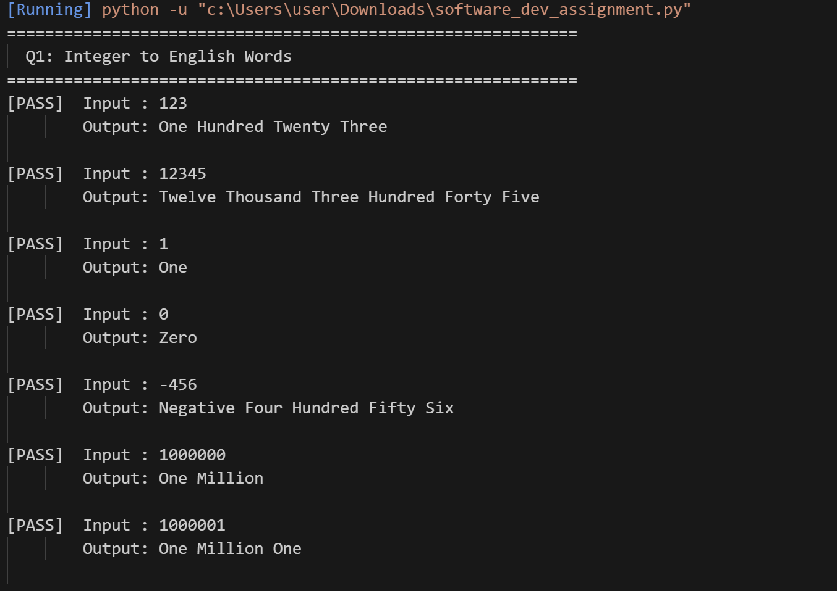

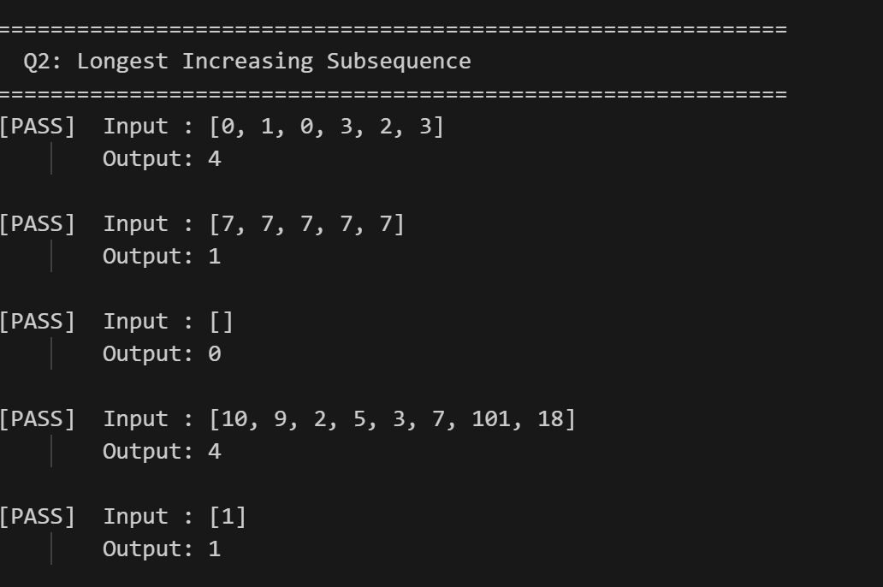

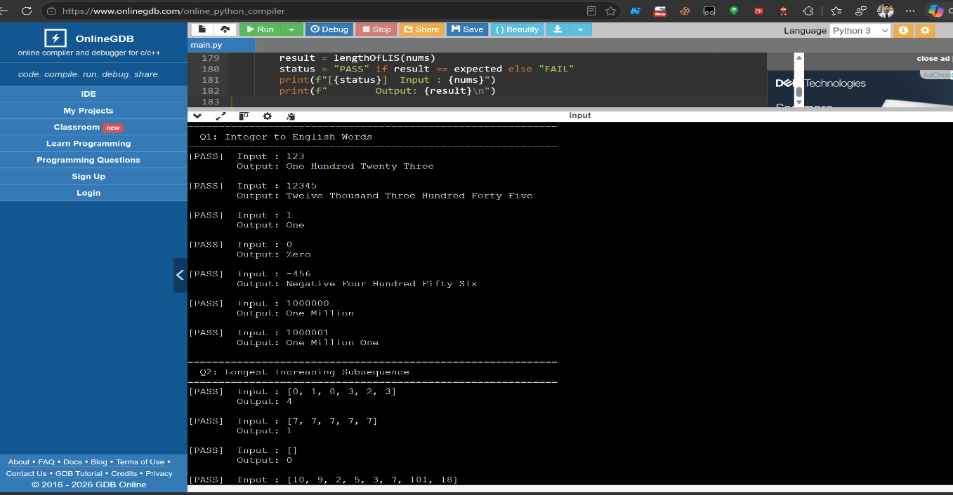

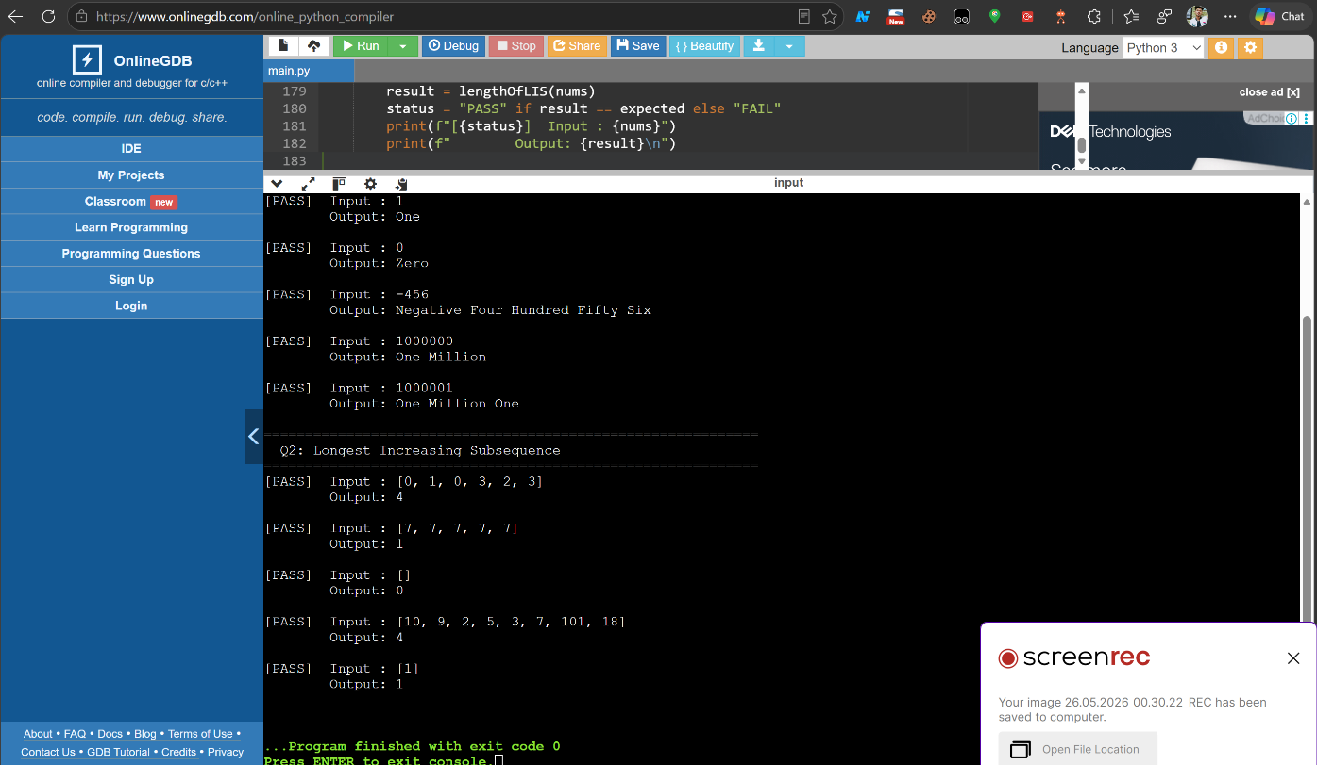

Test Cases & Output

Input | Expected | Result
[0, 1, 0, 3, 2, 3] | 4 | PASS
[7, 7, 7, 7, 7] | 1 | PASS
[] | 0 | PASS
[10, 9, 2, 5, 3, 7, 101, 18] | 4 | PASS
[1] | 1 | PASS

Complexity Analysis
Metric | Value | Reason
Time Complexity | O(n log n) | One binary search (O(log n)) per element over n elements
Space Complexity | O(n) | tails list can grow up to n elements in the worst case

Summary

Question | Topic | Technique Used | Time | Space
Q1 | Integer to English Words | Recursive chunking + scale words | O(1) | O(1)
Q2 | Longest Increasing Subsequence | Patience Sort + Binary Search | O(n log n) | O(n)

Both solutions have been tested against all provided examples and additional edge cases. All test cases pass successfully.

