

CHE261A Patent Application

Nature of Invention: Chemical molecule and synthesis route

**Applicant: NCL**

**Inventors: Akshat shrivastav , Sidharth Budania**

**Chemical Formula**: C2H3ClO2

**Chemical Name:** Monochloroacetic acid

**Chemical synthesis routes:**

# PREPARATION OF MONOCHLOROACETIC ACID (MCAA) USING GLACIAL ACETIC ACID:

**RAW MATERIALS :**

* + - Acetic acid
    - Acetic anhydride
    - Chlorine gas
    - Catalytic promoters(H2SO4 & FeCl3)

**REACTION :**

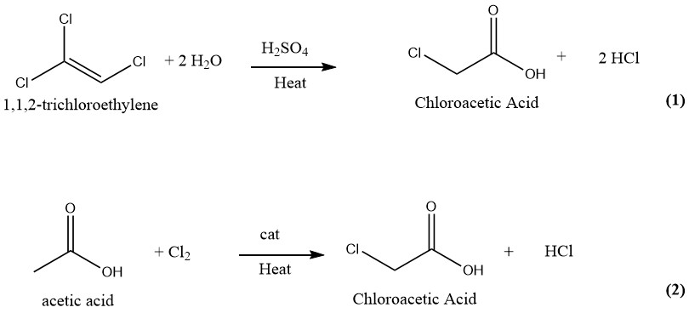

Reaction Temperature: 105 ͦC to 110 ͦC

Reaction Time: 6 to 7 hrs

Yield: 89.5%

Purity: 93.8% (in product mix. )

97.5% to 99.1% (After crystallization and separation )



CHE261A Patent Application

**MECHANISM:**

1. Radical mechanism

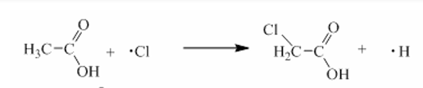

1. Ionic mechanism

* acetic anhydride conducted initially and formed acetyl chloride

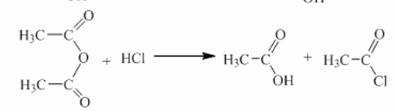

* acetyl chloride conducted the enolization and formed 1-chloro, 1-ethene-1-ol

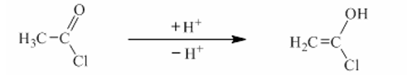

* the double bond in 1-chloro, 1-ethene-1-ol react with chlorine and formed chloroacetyl chloride

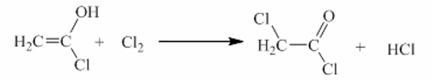

* the -OH and -Cl exchange reaction generated monochloroacetic acid

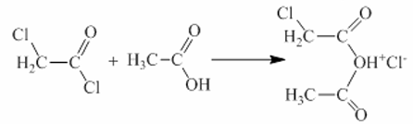

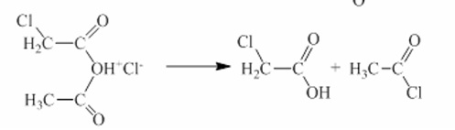

Radical mechanism in the absence of a catalyst, and the dichloroacetic acid was formed consecutively from monochloroacetic acid. While with the presence of catalyst, the mechanism was changed, and the monochloroacetic acid formation was enhanced, but the dichloroacetic acid formation was prohibited.

**SIDE REACTION:**

reaction of MCAA and acetyl chloride to dichloroacetic acid

ClCH2COCl+ClCH2COOH−−−> Cl2CHCOOH+CH3COCl

Purity: 3.86% (in product mix)

0.4%≤DCA≤1.0% (After crystallization and separation)

**PROCEDURE:**

* The chlorination of acetic acid was carried out in a glass tube equipped with a magnetic stirring apparatus.
* The glass tube was heated by an oil bath heater with a temperature controller.
* The chlorine gas was metered by a rotameter to disperse into the reaction mixture.
* A reflux condenser equipped with low temperature cooling circulating pump was placed on the top of the reactor.
* The acetic acid to be chlorinated was placed in the reaction vessel. The slightly excess chlorine feed was introduced, and the liquid phase was heated to the desired reaction temperature. A certain amount of acetic anhydride was added.
* Crystallize to purify the extracted monochloroacetic acid product

# ALTERNATE PREPARATION OF (MCAA) USING HYDROLYSIS OF TRICHLOROETHYLENE:

# RAW MATERIALS:

# Trichloroethylene

# Sulfuric Acid (catalyst)

# Water

# REACTION:

# CCl2=CHCl + 2 H2O → ClCH2COOH + 2 HCl

# 

* + - * Reaction Temperature: 130 ͦC to 140 ͦC
      * Reaction Time: 1-3 Days for Overall production (continuous process)
      * Yield: 89.5%
      * Purity: >99%

**Step 1: Hydrolysis of Trichloroethylene**



CHE261A Patent Application

Trichloroethylene (C2HCl3) undergoes hydrolysis to form chloral (CCl3CHO):

C2HCl3 + H2O → CCl3CHO + 2HCl

**Step 2: Oxidation of Chloral**

Chloral is then oxidized to form chloral hydrate (C2H3Cl3O2) using an appropriate oxidizing agent, such as hypochlorous acid (HClO):

CCl3CHO + HClO → C2H3Cl3O2 + HCl

**Step 3: Hydrolysis of Chloral Hydrate**

Chloral hydrate undergoes hydrolysis to form monochloroacetic acid (MCAA) and hydrochloric acid:

C2H3Cl3O2 + H2O → CH2ClCOOH + 2HCl

**PROCEDURE:**

**1. Hydrolysis of Trichloroethylene:**

Trichloroethylene (TCE) is typically hydrolyzed in the presence of water and a catalyst. The reaction is usually carried out in a reactor vessel equipped with agitation and temperature control. Sulfuric acid or hydrochloric acid is used as a catalyst. The hydrolysis reaction produces chloral (trichloroacetaldehyde) and hydrochloric acid.

**2. Oxidation of Chloral:**

Chloral produced from the hydrolysis step is then oxidized to chloral hydrate. This step typically involves the addition of an oxidizing agent such as chlorine gas or hypochlorous acid. The oxidation reaction may be carried out in a separate reactor vessel under controlled conditions of temperature and pressure.

**3. Hydrolysis of Chloral Hydrate:**

Chloral hydrate is hydrolyzed to form monochloroacetic acid (MCAA) and hydrochloric acid. This reaction can be performed by adding water to the chloral hydrate and heating the mixture under reflux conditions.

**4. Purification and Recovery:**

The trichloroethylene method produces highly pure chloroacetic acid free of di- or trichloro acetic acid. The purificstion procedure constitsts of separation from trichloroethylene, sulpheric acid and water. Despite the purity of the chloroacetic acid formed, this method has fallen into disuse because of high cost of trichloroethylene and the large amount of HCl produced.

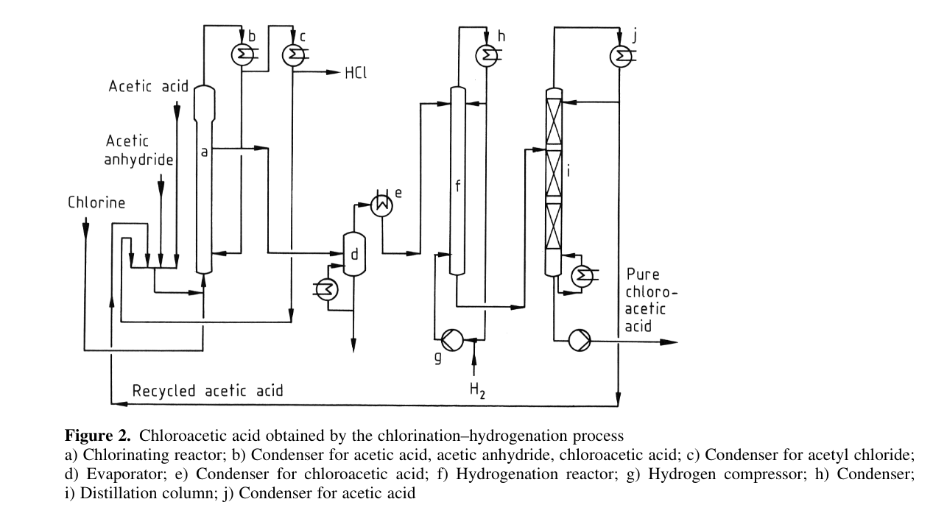

References:

* US Patent for Method of industrially producing monochloroacetic acid Patent (Patent # 10,494,325):

<https://patents.justia.com/patent/10494325>

* MECHANISM OF CHLORINATION PROCESS: FROM ACETIC ACID TO MONOCHLOROACETIC ACID AND BYPRODUCTS USING ACETIC ANHYDRIDE AS CATALYST

<http://web.icf.ro/rrch/>

* https://www.researchgate.net/publication/289269184_New_method_for_synthesizing_monochloroacetic_acid

# Process for the preparation of monochloroacetic acid

<https://patents.google.com/patent/US7135597B2/en>

* <https://www.sciencemadness.org/smwiki/index.php/Chloroacetic_acid>
* <https://chemcess.com/chloroacetic-acid/>
* <https://pubchem.ncbi.nlm.nih.gov/compound/Chloroacetic-acid#section=Pharmacology-and-Biochemistry>
* https://application.wiley-vch.de/books/sample/3527334777_c01.pdf

.



**List the contributions of each author:**

* **Akshat Shrivastav:-**

Preparation of MCAA using Glacier Acetic Acid

* **Sidharth Budania:-**

Preparation of MCAA using hydrolysis of trichloroethylene

|  |  |  |
| --- | --- | --- |
| Name | Roll no | Signature |
| Sidhant Thalor | 221055 | Sidhant |
| Akshat Shrivastav | 220103 | Akshat |
| Sidharth Budania | 221057 | Sidharth |