


HOSPITAL TRAINING REPORT

(NAVIN HOSPITAL, GREATER NOIDA)
A Report submitted for
Partial Fulfillment of B.Pharm VIIth smester Session 2025-26

Submitted by Mukund kumar
2310920500056
Under the supervision of dr. H.N. Singh (Professor)

Submitted to

Galgotias College of Pharmacy

(Approved by PCI and Affiliated to Dr. A.P.J. Abdul Kalam Technical University, Lucknow, U.P.)

1



GALGOTIAS COLLEGE OF PHARMACY
(ApprovedbyPCIandAffiliated toDr.A.P.J.AbdulKalamTechnical University, Lucknow, U.P.)

ENDORSEMENT BYTHE DIRECTOR

Thisisto certify that Mr. Mukund kumar, Roll No. 2310920500056 hassubmitted thereporton “Hospital Training” subjectcode BP509Pforpartial fulfillmentof B.
Pharm 5th Semester, session 2025-26. Thecontentsof thisreportdo notform the
basis for the award of any other degree to the candidate or to anybody else from this or any other university / Institutions.

Director

Dr. VikramSharma

2



GALGOTIAS COLLEGE OF PHARMACY
(ApprovedbyPCIandAffiliated toDr.A.P.J.AbdulKalamTechnical University, Lucknow, U.P.)

ENDORSEMENT BYTHE SUPERVISOR

This is certify that the report on “Hospital Training” is a bonafide work under the course
curriculum by Dr. A.P.J. Abdul Kalam Technical University, Lucknow for subject code BP509Psubmitted by Mr. Mukund kumar, Roll No 2310920500056 in a partial fulfillment
of B. Pharm 5th Semester, session 2025-26.

NAME OF SUPERVISOR-
Dr. H.N. Singh
(Professor)



GALGOTIAS COLLEGE OF PHARMACY
(ApprovedbyPCIandAffiliated toDr.A.P.J.AbdulKalamTechnical University, Lucknow, U.P.)

ENDORSEMENT BYTHE STUDENT

I Mukund kumar, Roll No. 2310920500056 here by declarethat the presented report on “Hospital Training” forsubjectcode BP509Punderthecoursecurriculum by Dr. A.P.J. Abdul Kalam Technical University, Lucknow, forsubjectcode BP509Phascarried outand
submitted by me.
I also confirm that, the report is only prepared for my academic requirement not for any other purpose.

Mukund kumar
ROLL NO- 2310920500056
B.PHARM VII SEM

Hospital Training Certificate

MHIM/HR/2024/0472 10th AUG 2025

TO WHOM IT MAY CONCERN

This is to certify that
Mr.Mukund kumar
S/O Raviranjan kumar raystudent of
Galgotias

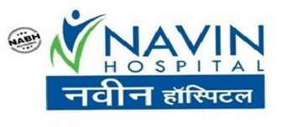

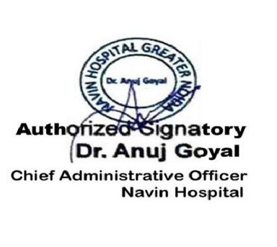
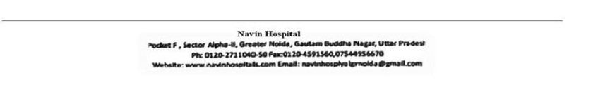
College of pharmacy, He has completed his Hospital Training in the Department of Pharmacy, Navin Hospital from 25/06/2025 to 10/08/2025.

He is found to be regular, honest and diligent in his duties and responsibilities during his internship.

We wish him all the success in his future endeavors.


ACKNOWLEDGEMENT
The training opportunity I had with Navin Hospital, Greater Noida, was a great chance for learning and professional development. I have learned a lot during my training duration of 45 days (25 june 2025 to 10 Aug 2025) and contain has been fortunate in getting and opportunity of working in this hospital.

I express my deepest thanks to Dr. Anuj Goyal, Providing necessary training facility and guidance during entire period of my training arrangement. I am also grateful for having a chance to meet so many people and professional who led me though me this training period.

I would like to thanks Dr. Vikram Sharma, Director, Galgotias college of pharmacy, Greater noida for his continous support and highest peak of encourangmentfordoing betterin life.

I feel to acknowledge my indebtedness and deep sense of gratitude to my Mentor Dr. H.N. Singh (Professor) whose valuable guidance and kind supervision given to me throughout the work.

I am immensely obliged to other staff and my friends for their elevating inspiration, encouraging guidance and kind supervision in the completion of my project.

Mukund kumar
Roll no-2310920500056
B.Pharm 7 sem

HOSPITAL TRAINING REPORT

TABLE OF CONTENTS

S.NO. | TOPIC | Page No
1 | Hospital Training Letter | 5
2 | Objective of Hospital Training | 8
3 | Introduction of Navin Hospital | 9
4 | Facilities Provided by Navin Hospital | 10
5 | outpatient department | 11
6 | General Wards | 12
7 | Emergency Department | 13
8 | Pharmacy Department | 14
9 | Hospital Internship Activity | 15
10 | First Aid Treatment | 16-19
11 | Cardio Pulmonary Resurcitation | 20
12 | Injections | 21-23
13 | Dressing | 24
14 | Prescription | 25
15 | Dispensing procedure | 26-27
16 | Diagnostic Report | 28-31
17 | Patient Observation Chart | 32-33
18 | Conclusion | 34

OBJECTIVES OF HOSPITAL TRAINING

- Hospital training is an observational oriented procedure in which a person is able to learn practically from their theoretically knowledge.

- Hospital training helps to study closely the ground level problems regarding their job profile
. • Hospital training provides practical knowledge to the students.

- Hospital training promotes an environment in which student is induced to adapt themselves quickly to changed circumstances.

- Hospital training puts the students in real life situations.

- Hospital training removes the hesitation of the students regarding their working skills and personality development.

NAVIN HOSPITAL
Navin Hospital was launched in 2003 in Greater Noida with a mission to deliver the best and affordable healthcare services to its residents. We would say that in all these years we have learned, evolved and emerged as the best hospital among all the other hospitals in Greater Noida.
At Navin, we cover from fundamental routine checkups and outpatient services to emergency cases for which we have a trauma center and an intensive care unit. Today we can proudly say we have gathered an experience which has made us more confident and expert in handling critical medical cases. The hospital is currently 100 bedded and fully equipped with the most advanced technologies to help our patients get better soon.
At Navin hospital, we are determined to provide best diagnostic, preventive and therapeutic services to our patients. The unwavering dedication and commitment of our specialists have made us today a multi-specialty hospital to serve our patients with the most recent and developed technology. Navin hospital being a multi-specialty unit now has the most efficient medical infrastructure and highly skilled team of doctors providing meticulous medical care in various super specialties such as Cardiology, Neurology and Neurosurgery, Urology, Plastic Surgery, Nephrology, Orthopedics, and Joint Replacement, etc.In addition to this we have an advanced diagnostic and interventional radiology services and most trusted laboratory for any kind of diagnosis.
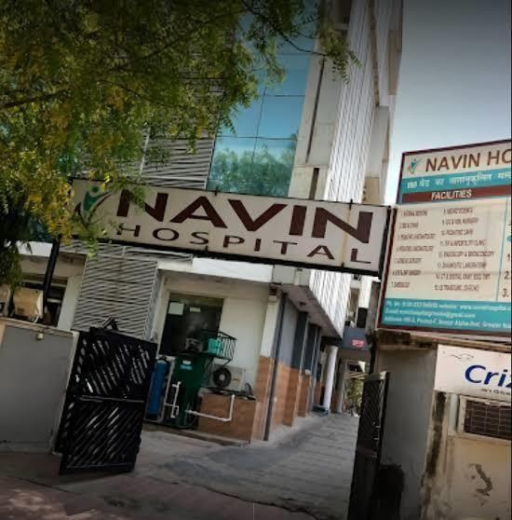
Fig 1 hospital entrance

FACILITIES PROVIDED AT NAVIN HOSPITAL

  - 24 hrs. Emergency 24
  - hrs. Ambulance
  - Services 24 hrs.
  - Admission 24 hrs.
Canteen

SECTIONS IN NAVIN HOSPITAL

  - General Wards
  - Emergency Wards Operation Theatre
  - ICU Department
  - Injection Room
  - Pathology Laboratory
  - Ultrasound Department
  - X-Ray Department
  - ECG Department
  - Dressing Department
  - Pharmacy

OUTPATIENT DEPARTMENT FACILITY

An outpatient department is the part of hospital designed for the treatment of outpatients. This department provides diagnosis and care for patients that do not need to stay overnight. It is an important part of the overall running of the department. The outpatient department will usually be on the ground floor of the hospital. Wheel chairs and stretchers are available for non-ambulatory patients. Close at hand will be X-rat facilities, laboratories, the medical record office and a pharmacy. In the main waiting area there are a range of facilities for the patients and their families including toilets, public telephones, canteen, and water dispenser. Some of the hospitals have no separate department for outpatients, so they may be treated in same department as patients that stay overnight. Navin Hospital, there is separate outpatient department. Timing for
OPD is 10:00 AM to 2:00 PM and 6:00 PM to 8:00 PM.

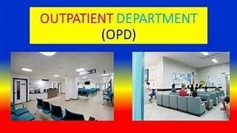

Fig 2 OPD

GENERAL WARDS

A general ward is a large room where people who need medical treatment

stay in general wards. General wards have a cubicle room having six to
eight patient bed and toilet in the wings of the ward.
- These wards are fully-equipped nursing station, Attendant couch,
Qualified dietitian for
diet advice and diet service.
- In general ward, those patients are only stay who is not suffered from any
chronic disease.

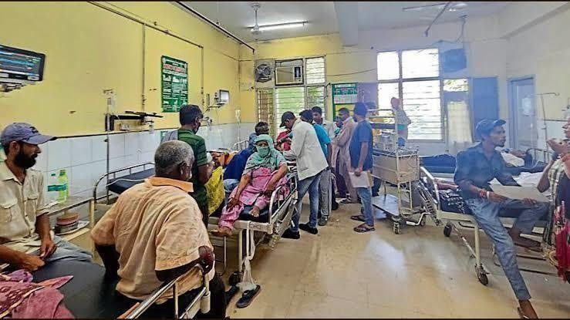

Fig 3 General wards

EMERGENCY DEPARTMENT

An Emergency Department (ED), also known as an Accident and Emergency department (A&E), Emergency Room (ER) and Casualty Department (CD).

- It is a medical treatment facility specializing in emergency medicine.

- The emergency department is usually found in a hospital or other primary care center.

- Due to the unplanned nature of patient attendance, the department must provide initial treatment for a broad spectrum of illnesses and injuries, some of which may be life threatening and require immediate attention.

- In some countries, emergency departments have become Important entry points for those without other means of access to medical care.

- The emergency departments of most hospitals operate 24 hours a day, although staffing levels may varied in an attempt to reflect patient volume.

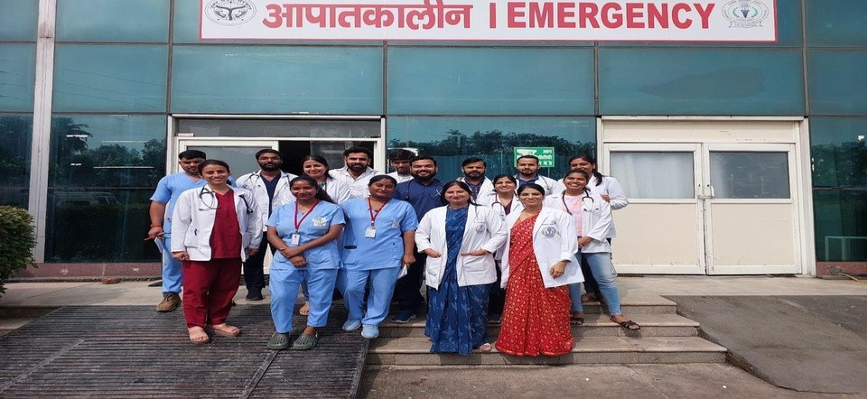

Fig 4 Emergency department

PHARMACY DEPARTMENT

Hospital pharmacy can usually be found within the premises of the hospital.

- Hospital pharmacy usually stock a large range of medications including more specialized and investigational medications (medicines that are being studied but have not yet been approved), then would be feasible in the community setting.

- Hospital pharmacies typically provide medications for the hospitalized patients only and are no retail establishments.

- They typically do not provide prescription service to the public.

- Some hospitals do have retail pharmacies with in them, which sell over the counter as well a prescription medications to the public, but these are not the actual hospital pharmacy.

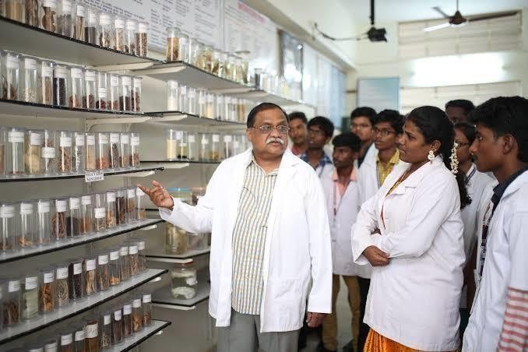

fig 5 Pharmacy department

HOSPITAL INTERNSHIP ACTIVITY
Hospital Internship Activities incl•ude –
  - First Aid Treatment
  - Injection
  - Dressing
  - Prescription
  - Dispensing Procedure
  - Diagnostic Report Patient Observation
Chart

FIRST AID TREATMENT
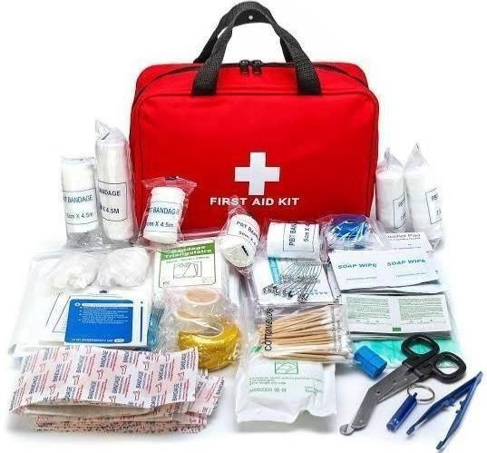

Fig 6

- First aid is the assistance given to any person suffering a sudden illness or injury, with care provided to preserve life, prevent the condition from worsening, and/or promote recovery.

  - It includes initial intervention in a serious condition prior to professional medical help being available, such as performing CPR while awaiting an ambulance, as well as the complete treatment of minor conditions, such as applying a plaster to a cut,

  - First aid is generally performed by the layperson, with many people trained in providing basic levels of first aid, and others willing to do so from acquired knowledge

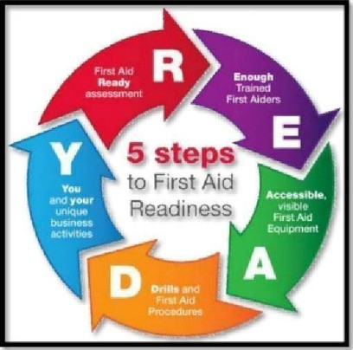

AIMS OF FIRST AID
The key aims of first aid can be summarized in three key points, which known as "3 P 's"--

  - Preserve Life — The overriding aim of all medical care which includes first aid is to save lives and minimize the threat of death.

  - Prevent further harm — Also sometimes called prevent the condition from worsening or danger of further injury, this covers both external factors such as moving a patient away from any cause of harm and applying first aid techniques to prevent worsening of the condition, such as applying pressure to stop a bleed becoming dangerous.

  - Promote recovery — First aid also involves trying to start the recovery process from the illness or injury and in some cases might involve completing a treatment, such as in the case of applying a plaster to a small wound.

FIRST AID SERVICES
Some people undertake specific training in order to provide first aid at public or private events, during filming or other places where people gather. They may be designated as a first aider, or use some other title. This role may be undertaken on a voluntary basis with organizations such as the Red Cross and St. John Ambulance or as paid employment with a medical contractor.

CONDITIONS THAT OFTEN REQUIRE FIRST AID
    - Altitude sickness, which can begin in susceptible people at altitudes as low as 5,000 feet, can cause potentially fatal swelling of the brain or lungs.

    - Anaphylaxis, a life-threatening condition in which the airway can become constricted and the patient may go into shock. The reaction can be caused by a systemic allergic reaction to allergens such as insect bites or peanuts. Anaphylaxis is initially treated with injection of epinephrine.

      - Battlefield first aid —This protocol refers to treating shrapnel, gunshot wounds, burns, bone fractures, etc. as seen either in the 'traditional' battlefield setting or in an area subject to damage by large-scale weaponry, such as a bomb blast.

      - Bone fracture, a break in a bone initially treated by stabilizing the fracture with a splint.

      - Burns, which can result in damage to tissues and loss of body fluids through the burn site.
      - Cardiac Arrest, which will lead to death unless CPR preferably combined with an AED is started within minutes. There is often no time to wait for the emergency services to arrive as 92 percent of people suffering a sudden cardiac arrest die before reaching hospital according to the American Heart Association.

      - Choking, blockage of the airway which can quickly result in death due to lack of oxygen if the patient's trachea is not cleared, for example by the Heimlich Maneuver.

Childbirth

Cramps in muscles due to lactic acid build up caused either by
        - inadequate oxygenation
of muscle or lack of water or salt.
        - Gender-specific conditions, such as dysmenorrhea and testicular torsion.

      - Heart attack or inadequate blood flow to the blood vessels supplying the heart muscle. Hair tourniquet a condition where a hair or other thread becomes tied around a toe or finger tightly enough to cut off blood flow.

      - Heavy bleeding, treated by applying pressure (manually and later with a pressure bandage) to the wound site and elevating the limb if possible.

      - Hyperglycaemia (diabetic coma) and Hypoglycaemia (insulin shock).

      - Insect and animal bites and stings.

      - Joint dislocation.

      - Poisoning, which can occur by injection, inhalation, absorption, or ingestion.

      - Seizures, or a malfunction in the electrical activity in the brain. Three types of seizures include a grand mal (which usually features convulsions as well as temporary respiratory abnormalities, change in skin complexion, etc.) and petit mal (which usually features twitching, rapid blinking, or fidgeting as well as altered consciousness and temporary respiratory abnormalities).

        - Muscle strains and Sprains, a temporary dislocation of a joint that immediately reduces automatically but may result in ligament damage.

      - Stroke, a temporary loss of blood supply to the brain.

      - Toothache, which can result in severe pain and loss of the tooth but is rarely life threatening, unless over time the infection spreads into the bone of the jaw and starts osteomyelitis.

CARDIOPULMONARY RESUSCITATION
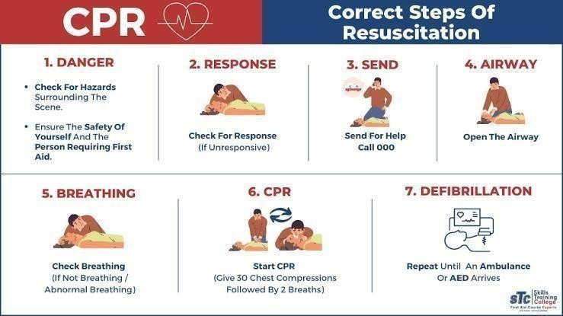

        - Cardiopulmonary Resuscitation (CPR) is a first aid technique to help people who suffer a "Cardiac Arrest" (their heart stops beating). It
        - involves chest compressions and rescue breaths to keep the casualty alive until a
        - defibrillator arrives.
        - A defibrillator is an electrical device which can be used to help restart
someone's heart.
CPR on its own is unlikely to restart someone's heart; however it will increase the
chance of a defibrillator being successful.
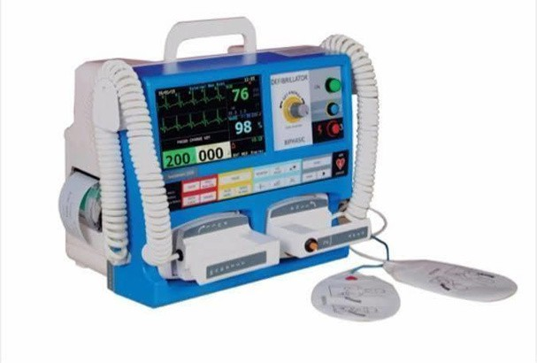
Fig 7

INJECTIONS

- An injection is the act of putting a liquid, especially a drug into a person's body using a needle and a syringe.

- Injection is a technique for delivering drugs by parenteral administration, that is, administration via a route other than through the digestive tract.

- Parenteral injection includes subcutaneous, intramuscular, intraperitoneal, intracardiac, intraarticular and intravenous injection. intravenous,

  - Injection is generally administered as a bolus, but can possibly be used for continuous drug administration as well.

Various Methods of Injections

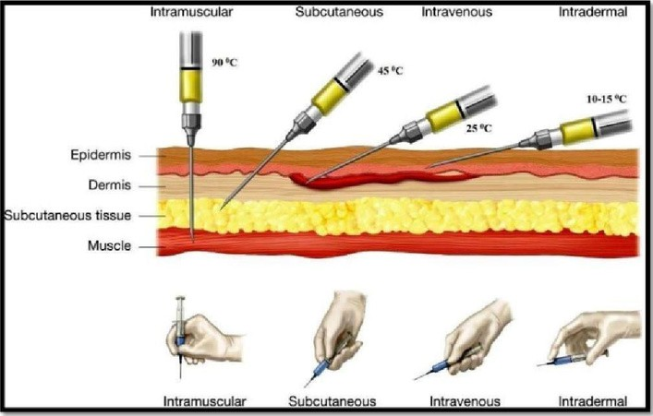
Fig 8

    - Intramuscular injection
It is delivering a substance deep into a muscle where they are quickly absorbed by blood vessels. The injection is often given at a 90-degree angle. Common injections sites include the deltoid, vastus lateralis and ventrogluteal muscles. Most inactivated vaccines like influenza are given by I.M. injection. Medical professionals are trained to give I.M. injections but patients can also be trained to self-administer medications like epinephrine.
    - Subcutaneous injection
In it, the medication is delivered to the tissues between the skin and the muscle. The injection is often given at a 45-degree angle, Absorption of the medicine is slower than that of intramuscular injections. Since the needle does not need to reach the muscles so often a bigger gauge and short needle is used. Usual site of administration is fat tissue behind the arm. Insulin Injection is a common type of subcutaneous injection medicine. Certain vaccines including MMR (Measles, Mumps and Rubella), Varicella
(Chickenpox), Zoster (Shingles) are given subcutaneously.
    - Intravenous injection
It involves needle insertion directly into the vein and the substance is directly delivered into the blood stream. The injection is often given at a 25-degree angle. In medicine and drug use, this route is the fastest way to get the desired effect since the medication moves immediately into blood circulation and to the rest of the body.
    - Intradermal injection
In this, medication is delivered directly into the dermis, the layer just below the epidermis of the skin. The injection is often given at a 5-to-15-degree angle with the needle placed almost flat against the patients’ skin. Absorption takes the longest as

compared to other parenteral routes. This route is often used for sensitivity tests like tuberculin and allergy tests and local anesthesia tests. Common sites of this are the forearm and the lower back.

    - Intra arterial route
This method is used for chemotherapy in cases of malignant tumors and in angiography.

    - Intra cardiac route
Injection can be applied to the left ventricle in case of cardiac arrest.

    - Intra thecal route
Intrathecal route involves the subarachnoid space. Injection may be applied for the lumbar puncture, for spinal anesthesia and for diagnostic purposes. This technique requires special precautions.

    - Intra-articular route
Intra-articular route involves injection into the joint cavity. Corticosteroids may be injected by this route in acute arthritis.

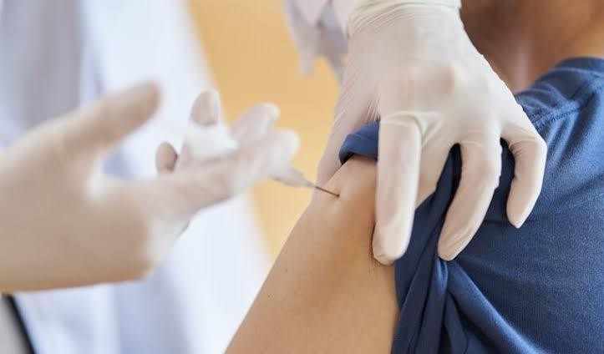
Fig 9

DRESSING
      - A dressing is a sterile pador compressapplied to a wound to promote healing and protect the wound from further harm.
      - A dressing is designed to be in direct contact with the wound as distinguished from a bandage, which is most often used to hold a
dressing in place, many modern dressings are self —adhesive.
      - Dressings serve a variety of purposes depending on the type, severity
and position of the wound.
Dressings are also important to help:
        - Stop bleeding and start clotting so the wound can heal
        - Absorb any excess blood, plasma or other
fluids o
Wound debridement o Begin the healing process

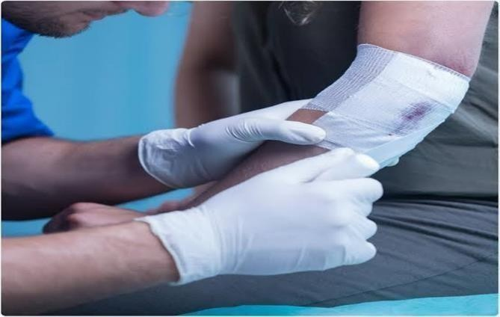
Fig 10
What type of wound care dressing is right for my wound?
- Hydrocolloid: Hydrocolloid dressings are used on burns, light to moderately draining wounds, necrotic wounds, under compression wraps, pressure ulcers and venous ulcers.

- Hydrogel: This type of dressing is for wounds with little to no excess fluid, painful wounds, necrotic wounds, pressure ulcers, donor sites, second degree or higher burns and infected wounds,

- Alginate: Alginate dressings are used for moderate to high amounts of wound drainage, venous ulcers, packing wounds and pressure ulcers in stage Ill or IV.

- Collagen: A collagen dressing can be used for chronic or stalled wounds, ulcers, bed sores, transplant sites, surgical wounds.

PRESCRIPTION

SECTIONS OF PRESCRIPTION
A prescription contains handwritten instructions for the dispensing and administering of medications. It can be more than an order for drugs as it can also include instructions for a therapist, the patient, nurse, caretaker, pharmacist or a lab technician for orders for lab tests,
X- rays, and other assessments,
Superscription - the heading with the date and the patient's name, address, age, etc. Symbol Rx - the Rx stands for "recipe" which in Latin means "to take."

  - Inscription - the information about the medication. It has the name of the ingredients and the amount needed, It includes the main ingredient, anything that helps in the action of the drug, something to modify the effects of the main drug, and the "vehicle" which makes the medicine more pleasant to take. • Subscription - The subscription section tells the pharmacist how to dispense the drug. This will have instructions on compounding the drug and the amount needed.

  - Signature - The signature has the directions that are to be printed on the medicine, The word "sig" means "write on label."

VARIANCES IN PRESCRIPTION WORDING

  - Prescriptions vary from state to state and doctor to doctor:

  - Sometimes the doctor will write "dispense as written," "do not substitute," or " medically necessary. "

  - Sometimes the age of the child is required and often the doctor will put the condition that is being treated.

  - Sometimes there is a label box.

DISPENSING PROCEDURE

Drug dispensing is often portrayed as merely being the process of giving a drug product to a patient. Dispensing Procedure

  - Ensure that the prescription has the name and signature of the prescriber and the stamp of the health center

. • Ensure that the prescription is dated and has the name of the patient.

  - If the prescription has not been written in a known (local) health center, the prescriber of the center should endorse it.

    - Avoid dispensing without a prescription or from an unauthorized prescriber. • Check the name of the prescribed drug against that of the container.

    - Check the expiration date on the container.

    - Calculate the total cost of the drug to be dispensed on the basis of the prescription where applicable.

Dispensing prescription on part- payment

    - When a patient does not have enough money to pay for all the drugs as prescribed, the dispenser is faced with a difficult situation.

    - The dispenser follows these things at that time — o Like doctor prescribed medicines for 7 days so, you can dispense only 3-5 days medicines according to money. o If you know the medical treatment is gone long, then write the left amount on prescription so you can take the left money on next time dispensing.

Correct drug dispensing

    - Dispensed drugs should be appropriately labelled so that the patient can benefit optimally from the use of the drug. Expired drugs should not be dispensed.

- Correct dispensing ensures that:
- The right patient is served.
- A desired dosage form of the correct drug is given.
- The prescribed dosage and quantity are given.
- The right container that maintains the potency of the drugs is used.
- The container is appropriately labelled.
- Clear instructions are delivered verbally to the patient.

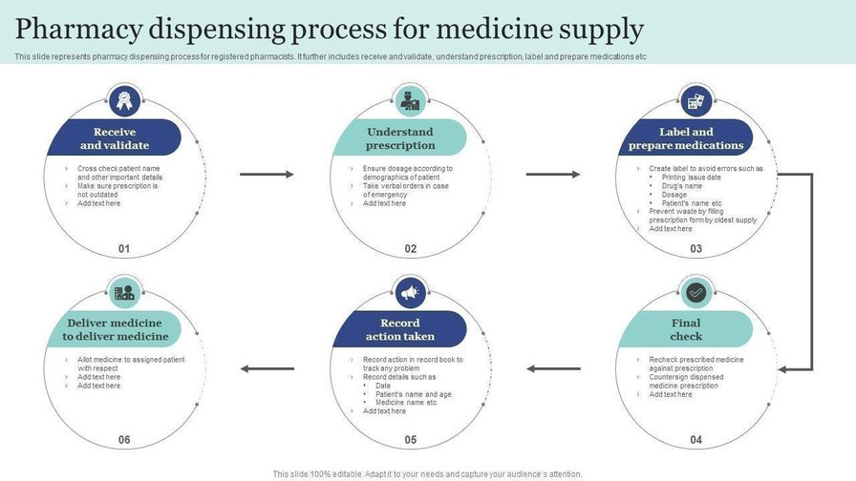

Fig 11

DIAGNOSTIC REPORT

- A diagnostic report is the set of information that is typically provided by a diagnostic service when investigations are complete.
- The information includes a mix of atomic results, text reports, images and codes.
- The Diagnostic Report resource is suitable for the following kinds of reports —
- Laboratory — Clinical Chemistry, Hematology, Microbiology, etc.
- Pathology/ Histopathology related disciplines
- Imaging Investigations — X-Ray, CT scan, MRI, etc.
- Other Diagnostics — Cardiology, Gastroenterology, etc.

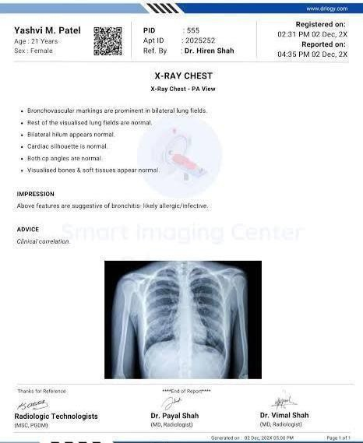

Fig 12

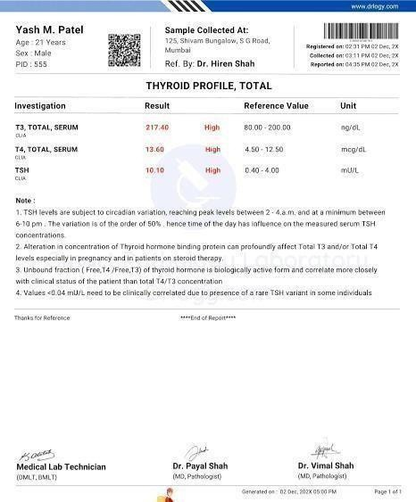

Fig 13

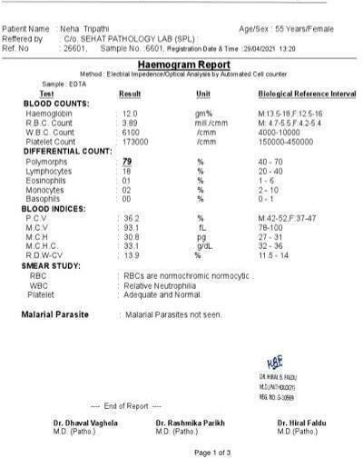

Fig 14

PATIENT OVSERVATION CHART

An observation and response chart are a document that allows the recording of patient observations and specifies the action to be taken in response to deterioration from the normal. The purpose of these charts is to support accurate and timely recognition of clinical deterioration and prompt action when deterioration is observed, the way in which observation charts are designed and used can contribute to both the poor recording of observations and failure to interpret them correctly. Ensuring that patients who deteriorate receive appropriate and timely care is a key safety and quality challenge.

The objective of an observation chart is to present the most important vital signs for detecting deterioration in most patients in a user-friendly manner.

- Single parameter tool (track and trigger) - Vital signs are compared with a simple set of criteria with predefined thresholds, with a response algorithm being activated when any criterion is met"

- The main vital signs are graphed so that trends can be easily 'tracked' There are also colour coded zones to indicate when patient observations are likely to represent deterioration, where a response is 'triggered'. Incorporating call criteria in observation charts is an effective way in which to highlight possible deterioration and assist clinicians with making decisions as to when to 'trigger' a response, whether that be for a clinical review or rapid response call.

- Aggregate scoring system - Core observations attract a weighted Score, "Weighted scores are assigned to physiological values and compared with predefined trigger thresholds. The main vital signs are collected and points are allocated. The points for each observation are added to give a score that helps identify patients with subtle signs of detoriation.

. A supporting Action Plan triggers certain actions when certain scores are reached
. • Combination system - Single or multiple parameter systems used in combination with aggregate weighted scoring systems.
- Non track and trigger - Other observations charts may include the collection of vital signs with no scoring or no criteria for a response.

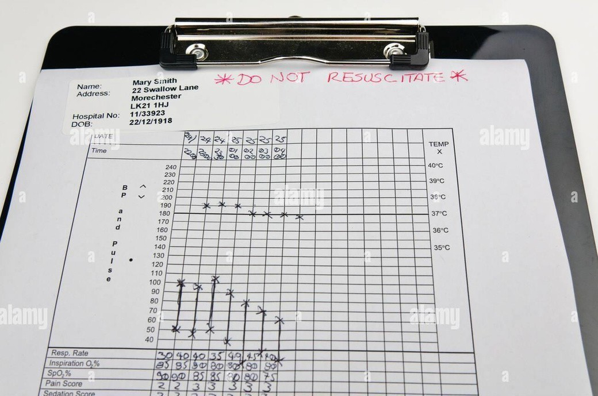

Fig 15

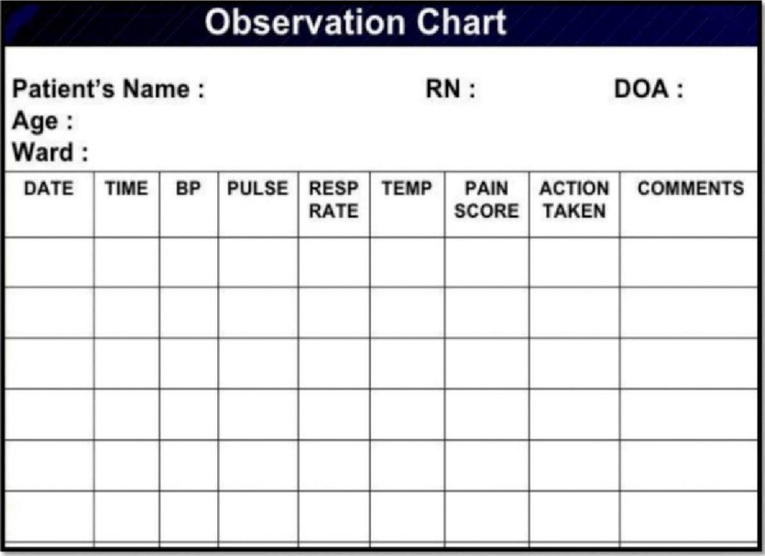

Fig 16

CONCLUSION

During training procedures, I have got lot of knowledge about flowing-
- Stated project a training regarding each and every first aid procedures. It includes checking the
- symptoms and treating at small scale in first aids and later transferring for surgical procedures.
- I got known regarding artificial respiration process and wound dressing.
- Sites of injection which includes knowledge of syringes, routes of injections.
Routes of
- injections such as I.V., I.M., I.D., Subcutaneous etc.
- In Prescription reading, its parts and the abbreviations used are studied by me in this project it's
- truly a scandalous matter for pharmacist’s study.
- Later the dispensing procedure is stated therefore which was practiced by me all around the
- training at regular intervals.
- I also learn about patient observation chart and how to fill it, use it.

