



**INFORMATION REPORT**

**In respect of Article / Document Lost in Delhi**

**SO No: 430 / 2014 Delhi Police**

## P.S: Crime Branch, Delhi LR No:1313216/2019 Date :25-07-2019

**1. Complainant's Details**

Karmawali ,S/D/W/O Rampyaare , RZ-A1/48, VIJAY ENCLAVE, PALAM DABRI ROQD, NEW DELHI-110045

[abrolkiran@gmail.com](mailto:abrolkiran@gmail.com)

|  |  |  |  |
| --- | --- | --- | --- |
| **2. Occurrence Details** | |  | |
| (a) Date And Time Of Report | | Date: 25-07-2019 | Time:16:02Hrs |
| 1. Date And Time Of Loss, If Known 2. Place of Loss vijay enclave market | | Date: 2019-07-20 | Time:06:03 Hrs |
| **3. Losts Article/s** | |  |  |
| **Sr:.**  1. | **Property Type** | **Property Description**  TGI2557188 VOTER ID CARD LOST ON THE NAME | |

OF KIRAN NOW CHANGED NAME KARMAWALI

1. **Any Other Details**

Voter id card lost in market

**Station House Officer: Crime Branch, Delhi**



**Note :**

* 1. **This is a digitally signed document .**
  2. **For verification visit 'Lost Articles Report' module on** [**www.delhipolice.nic.in**](http://www.delhipolice.nic.in/) **.**
  3. **Authority issuing duplicate document / article may obtain proof of identity .**

# Disclaimer :

1. **This application is for lodging report of Article / Document lost in Delhi .**
2. **Report lodged under this application is not a subject matter for enquiry / investigation .**
3. **In case loss is due to theft or any other crime, contact nearest Police Station .**
4. 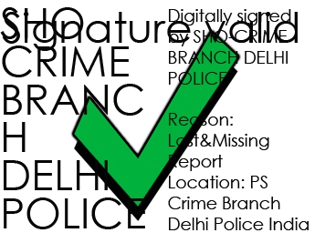**False report to Police is a punishable offence .**