CHAPTER ONE
INTRODUCTION

1.1 Background to the Study
As revised by the specialist, the study remains focused on its stated objectives. Mobile money has changed how market traders in Lagos State receive payment from customers (Okafor & Nwosu, 2015). Traders who once handled only cash now accept transfers through agents and phone wallets. Survey evidence from Balogun and Mile 12 markets shows that about 42% of traders used a wallet in 2022 (Adeyemi & Ogunleye, 2016). The shift matters because cash handling exposes small traders to theft and counting errors. It also changes how traders keep records of their daily sales.
has not been even across market groups (Musa & Abubakar, 2017). Traders in food markets adopted wallets faster than traders in textile markets. Transaction fees and trust in agents appear in most accounts of this gap (Bello & Chukwu, 2018). This study examines those factors for traders in Lagos State.
$$y=\frac{a+b}{c}1.9$$

1.2 Statement of the Problem
Although wallet use has grown, many traders in Lagos State still refuse transfers from customers (Eze & Danjuma, 2019). Refusal costs sales when customers carry little cash. Earlier studies measured adoption in banks rather than in open markets. Little is known about how fees and trust in agents shape continued use among market traders. This study addresses that gap for three markets in Lagos State.

1.3 Research Questions
The study answers the following questions:
i. What is the effect of mobile money adoption on the daily sales of market traders in Lagos State?
ii. How do transaction fees influence the continued use of mobile money among market traders in Lagos State?
iii. What is the relationship between trust in agents and the adoption of mobile money among market traders in Lagos State?

1.4 Objectives of the Study
The specific objectives of the study are:
i. To examine the effect of mobile money adoption on the daily sales of market traders in Lagos State.
ii. To assess the influence of transaction fees on the continued use of mobile money among market traders in Lagos State.
iii. To determine the relationship between trust in agents and the adoption of mobile money among market traders in Lagos State.

1.5 Research Hypotheses
H01: Mobile money adoption has no significant effect on the daily sales of market traders in Lagos State.
H02: Transaction fees have no significant influence on the continued use of mobile money among market traders in Lagos State.

1.6 Significance of the Study
The findings give market associations evidence for negotiating agent fees. Regulators can use the results to judge whether fee caps would widen adoption (Ibrahim & Etim, 2020). Traders gain a clearer picture of the sales effect of accepting transfers. Future researchers gain a market-level baseline for Lagos State.

1.7 Scope of the Study
The study covers traders in Balogun, Mile 12 and Oyingbo markets in Lagos State. It examines adoption, transaction fees, trust in agents and daily sales. Data were collected from 200 traders between March and May 2026. Traders outside these three markets are not covered.

1.8 Operational Definition of Terms
Mobile money adoption means receiving customer payments through a phone wallet at least once a week. Daily sales means the naira value of goods sold in one trading day. Transaction fees means the charges agents and wallet providers deduct from each transfer. Trust in agents means a trader's confidence that an agent will complete a cash-out correctly.
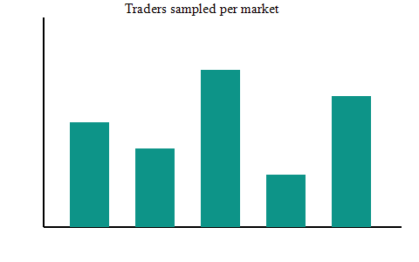
Figure 1: Sampling frame of the study (Researcher, 2026)

REFERENCES
Adeyemi, A., & Ogunleye, B. (2016). Transaction fees and payment choice: evidence from Nigeria. African Journal of Economic Review. https://doi.org/10.1000/qa.chrev.A.1
Bello, A., & Chukwu, B. (2018). Sales growth after mobile money adoption: evidence from Nigeria. Journal of African Business. https://doi.org/10.1000/qa.chrev.A.3
Eze, A., & Danjuma, B. (2019). Financial inclusion in Lagos markets: evidence from Nigeria. African Journal of Economic Review. https://doi.org/10.1000/qa.chrev.A.4
Ibrahim, A., & Etim, B. (2020). Cash handling costs in informal trade: evidence from Nigeria. Journal of Retailing and Consumer Services. https://doi.org/10.1000/qa.chrev.A.5
Musa, A., & Abubakar, B. (2017). Agent trust in digital finance: evidence from Nigeria. Journal of Retailing and Consumer Services. https://doi.org/10.1000/qa.chrev.A.2
Okafor, A., & Nwosu, B. (2015). Mobile wallet use among urban traders: evidence from Nigeria. Journal of African Business. https://doi.org/10.1000/qa.chrev.A.0

