AWS CLOUD COMPUTING

Module 1 – Introduction to AWS

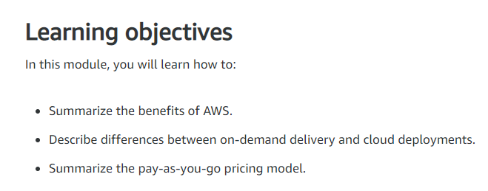

AWS offers a massive range of services for every business, starting with basic elements, like compute, storage, and network security tools, through complex solutions like blockchain, machine learning, or artificial intelligence, and robot development platforms, all the way through very specialized tool sets, like video production management systems, and orbital satellites you can rent by the minute.

Fundamental Cloud Compute Model.

Almost all modern computing centers around a basic client-server model. Now I know it can be more complicated than that, so let's take a look at our coffee shop.

This coffee shop is going to give us some real world metaphors to help you understand why AWS can change the way your IT operates.

Let's make Morgan the server, the barista. And I am the client, the customer. I make a request. In this case, it is for coffee. Now in the computing world, the request could be anything. It could be rain pattern analysis in South Africa, or the latest x-rays of your knee, or videos of kittens. Whatever is the business, basically a customer makes a request, and with permissions, the server responds to that request. All I want is a caffeinated beverage.

Morgan represents the server part of the client-server model. In AWS, she would be called an Amazon Elastic Compute Cloud, or EC2, an EC2 instance, a virtual server. So from an architectural point of view, the transaction we did is really simple to explain. I, the user, made a request to Morgan, the server. Morgan validated that the request was legitimate, in this case, did I give her money? Then she returned a response, which in this case, is a berry blaster with extra caramel shots.

Now in the real world, applications can get more complicated than just a single transaction with a single server. In a business solution that is more mature, it can get beautifully complex.

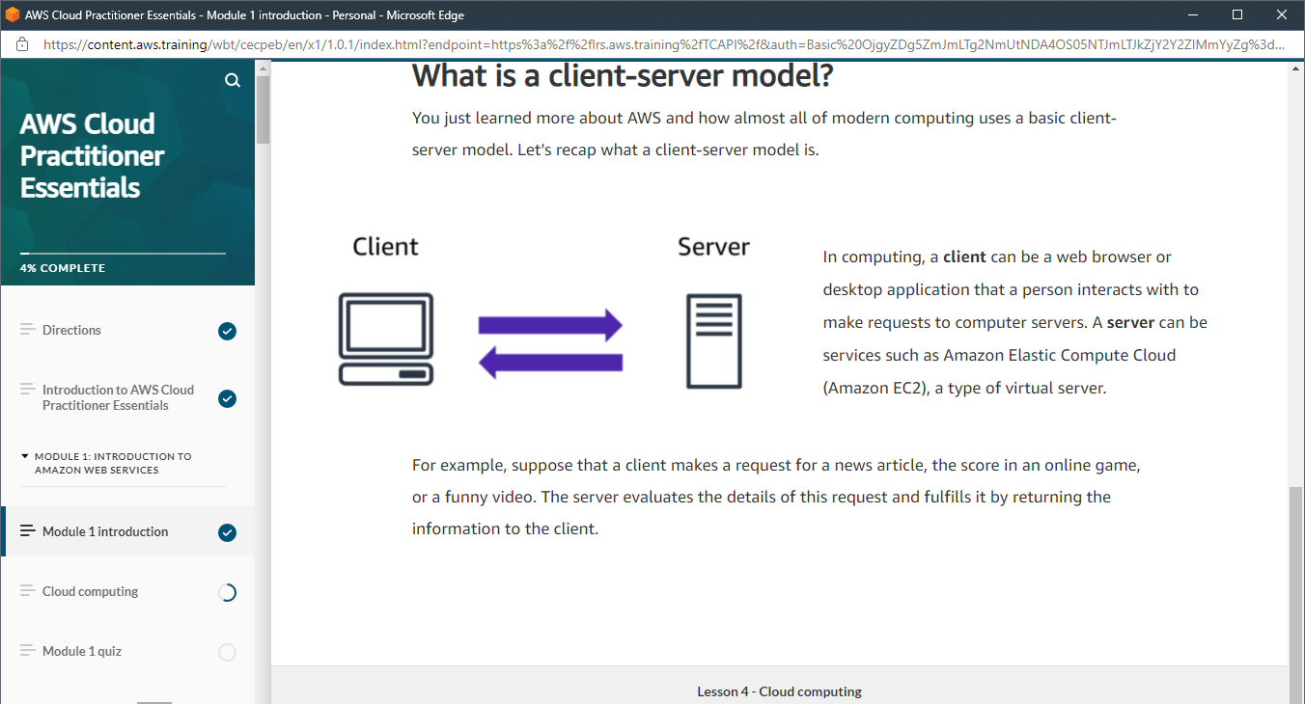

Pay-For-What-You-Use – The Coffee Shop Example

This principle makes sense when you run a coffee shop. Employees are only paid when they're in the store working. If Rudy and Morgan are off the clock, well then they don't get paid. The store owner simply decides how many baristas are needed and then just pays for the hours they work.

For example, the coffee shop is about to release a new drink, the Pumpkin Monster Spice. In anticipation of this launch, you could always staff your shop with a dozen baristas all day long, just in case you suddenly get an unexpected rush at some point in the day. Only, let's be honest. For most of your day, you don't have near enough customers to justify paying for all those employees.

And yet, this is exactly what happens in an on-premises data center. You can't just snap your fingers and triple your capacity. At AWS, you don't pre-pay for anything. And you don't have to worry about capacity constraints.

When you need instances, or baristas, you just click a button, and you have them. And when you don't need them, another click, and they go away, and you stop paying for them. The same way you don't pay for employees for hours that they're not working.

So, pay for what you need, becomes the first key value of many for running your business on AWS.

What is Cloud Computing?

Cloud computing is the on-demand delivery of IT resources over the internet with pay-as-you-go-pricing.

On-demand delivery – this indicates that AWS has the resources you need, when you need them. So you don't need to tell AWS in advance that you're going to need them. For instance, you suddenly find yourself needing 300 virtual servers. Well, with just a few clicks and you can launch them. Or you need 2000 terabytes of storage. You don't have to tell AWS in advance, just start using the storage you need, when you need it. Don't need them anymore, just as quickly, you can return them and stop paying immediately. This kind of flexibility is just not possible when you're managing your own data centres.

IT resources – The idea of IT resources is actually a big part of the AWS philosophy. We often get asked why AWS has so many products and the answer is really simple: Because businesses need them. If there are IT elements that are common across a number of businesses, then this is not a differentiator.

Take a MySQL database as an example. If your business runs a MySQL database, does your ability to install the MySQL engine make you a better company than your competitors? Well, probably not that. Do you keep backups in a way that makes you superior to other players in your vertical? Again, doubtful. The data inside your database, now that's critically different. The way you build your tables and manage the structures, absolutely separates you from the competition. But the engine is just the engine. At AWS, we call that the undifferentiated heavy lifting of IT. Tasks that are common, often repetitive and ultimately time-consuming; these are the tasks AWS wants to help you with. So you can focus on what makes you unique.

Over the internet – This seems simple enough, but it implies that you can access those resources using a secure webpage console or programmatically. No additional contracts or sales calls are needed.

Pay-As-You-Go – Here we re-emphasize what we pointed out here in the coffee shop. You don't staff a shop with employees 24 hours a day at the same levels you do during peak hours. In fact, some hours, you might not even staff them at all. So why pay for developer environments, for example, on weekends, if your developers aren't working on the weekends?

**Deployment models for cloud computing**

When selecting a cloud strategy, a company must consider factors such as required cloud application components, preferred resource management tools, and any legacy IT infrastructure requirements.

The three cloud computing deployment models are cloud-based, on-premises, and hybrid.

1. Cloud-Based Deployment

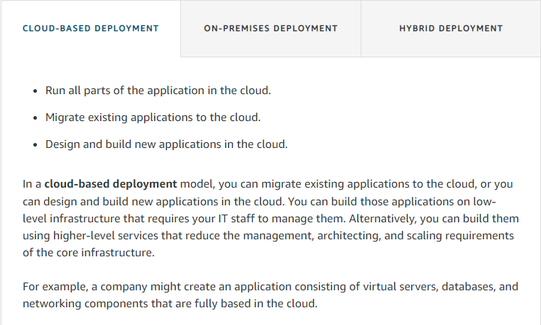

1. On-Premises Deployment

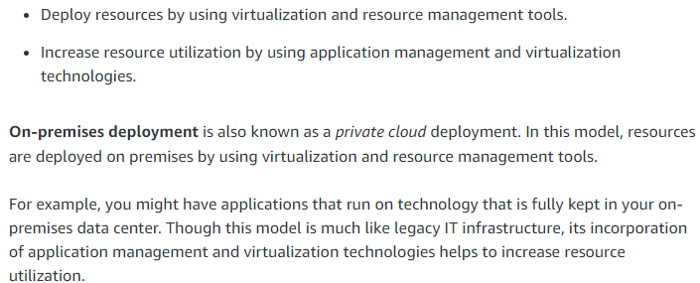

1. Hybrid Deployment

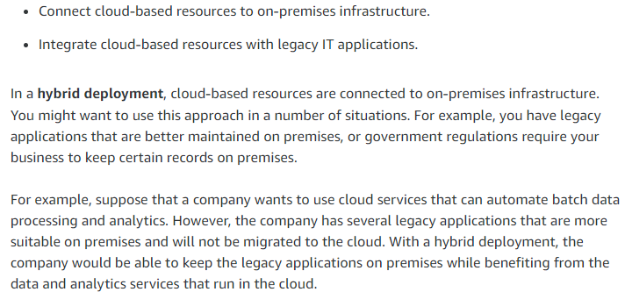

**Benefits of cloud computing**

Consider why a company might choose to take a particular cloud computing approach when addressing business needs.

1. **Trade upfront expense for variable expense**

Upfront expense refers to data centers, physical servers, and other resources that you would need to invest in before using them. Variable expense means you only pay for computing resources you consume instead of investing heavily in data centers and servers before you know how you’re going to use them. By taking a cloud computing approach that offers the benefit of variable expense, companies can implement innovative solutions while saving on costs.

2. **Stop spending money to run and maintain data centers**

Computing in data centers often requires you to spend more money and time managing infrastructure and servers. A benefit of cloud computing is the ability to focus less on these tasks and more on your applications and customers.

3. **Stop guessing capacity**

With cloud computing, you don’t have to predict how much infrastructure capacity you will need before deploying an application. For example, you can launch Amazon EC2 instances when needed, and pay only for the compute time you use. Instead of paying for unused resources or having to deal with limited capacity, you can access only the capacity that you need. You can also scale in or scale out in response to demand.

4. **Benefit from massive economies of scale**

By using cloud computing, you can achieve a lower variable cost than you can get on your own. Because usage from hundreds of thousands of customers can aggregate in the cloud, providers, such as AWS, can achieve higher economies of scale. The economy of scale translates into lower pay-as-you-go prices.

5. **Increase speed and agility**

The flexibility of cloud computing makes it easier for you to develop and deploy applications. This flexibility provides you with more time to experiment and innovate. When computing in data centers, it may take weeks to obtain new resources that you need. By comparison, cloud computing enables you to access new resources within minutes.

6. **Go global in minutes**

The global footprint of the AWS Cloud enables you to deploy applications to customers around the world quickly, while providing them with low latency. This means that even if you are located in a different part of the world than your customers, customers are able to access your applications with minimal delays.

Later in this course, you will explore the AWS global infrastructure in greater detail. You will examine some of the services that you can use to deliver content to customers around the world.