Contents

OSINT Report 1

Weekly Summary 3

Offensive content report 4

Disinformation from Public Source Report 5

# OSINT Report

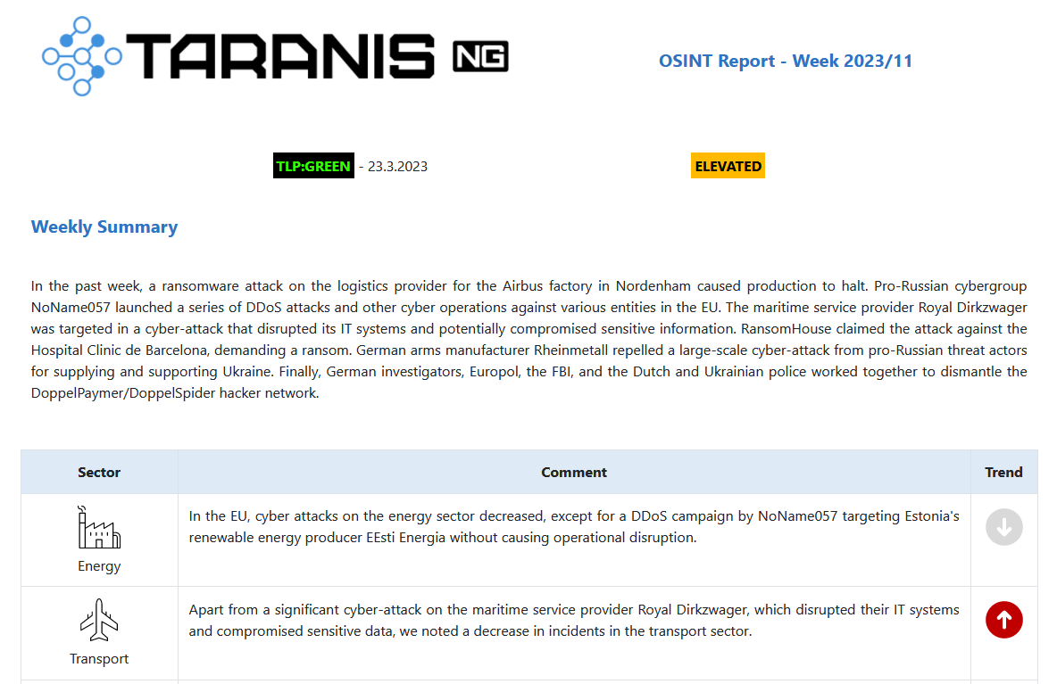

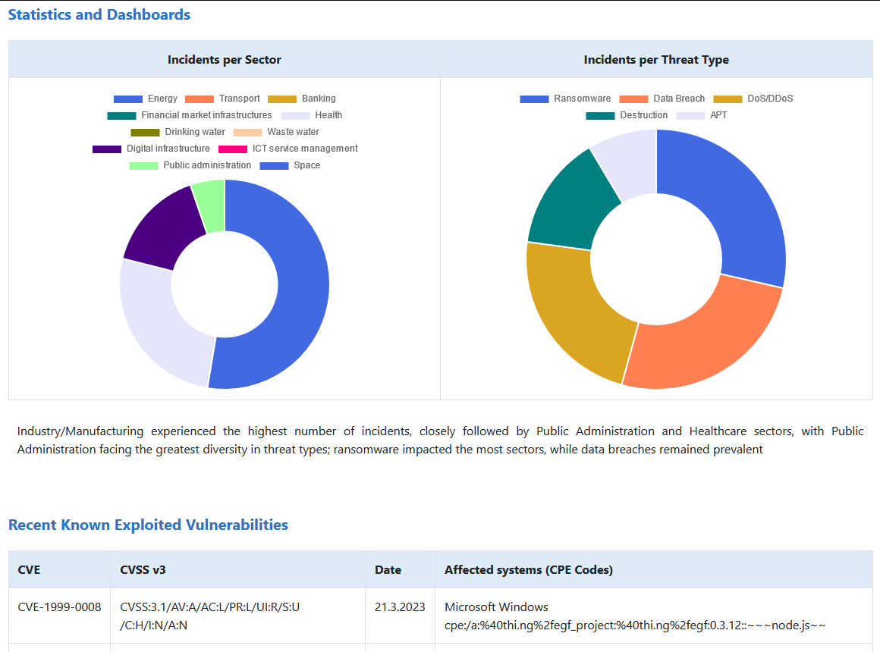

* It’s summary report about various cyber events
* The report contains various items of information sorted by sections:
  + Weekly Summary
    - Sector/Threat, Comment, Trend
* Statistics and Dashboards
  + Incidents per Sector
  + Incidents per Threat Type
* Recent Known Exploited Vulnerabilities
  + CVE, CVSS v3, Date,
  + Affected systems (CPE Codes)
* Ransomwares
  + Sector, Actor, Comment, Dashboard
* Latest Cyber Events
  + Event noted on, Sector, Threat actor,
  + Threat type, Severity, Confidence

**Usage:**

Create some new **Report items** with type **Vulnerability** **report, OSINT Report – Summary, OSINT Report – Ransomware, OSINT Report – Sectors, OSINT Report – Threats** and **OSINT Report - Cyber Event**.

To use all the report possibilities, you should add all types of report items to final product:

* **OSINT Report – Summary** – Main report text (Title, Summaries, Trends, Threat level, TLP)
* **OSINT Report – Ransomware** – Ransomware's part of the report (Name, Actor, Sector, Incidents)
* **OSINT Report – Sectors** – Sectors part of the report (Comment, Incidents, Trend)
* **OSINT Report – Threats** – Threats section of the report (Comment, Incidents, Trend)
* **OSINT Report – Cyber Event** – Cyber Events section of the report (Description, Sector, Threat actor, Threat type, Severity, Confidence)
* **Vulnerability Report -** Vulnerabilities section of the report (CVE, CVSS v3, Date, Affected systems)

Then create new **Product** with type **OSINT Weekly Report** and add your previous created Report items.

This report is inbuilt in Taranis (version after 2023/09)

If you need to edit the report design, use this HTML template: **/app/templates/template_osint.html**

# Weekly Summary

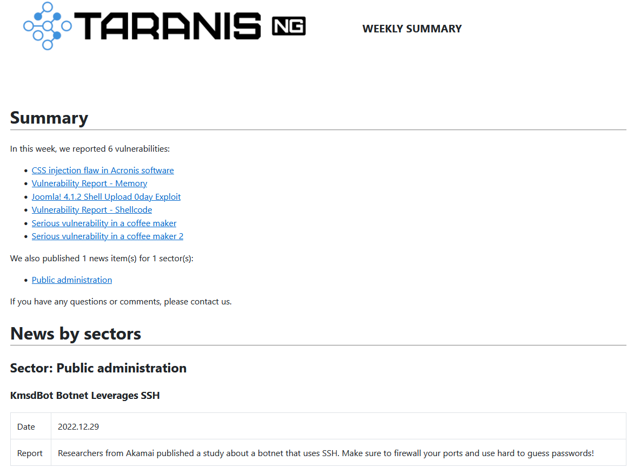

* It is summary report what happened for last week (vulnerabilities, news...)
* The report contains various items of information:
  + Vulnerability Report
    - Confidentiality, TLP
    - CVSS vector, Description
    - Exposure and Update Date
    - CVE, Impact, IOC
    - Affected Systems
    - Recommendations
    - Links
  + News by sectors
    - NIS Sector
    - Date
    - Headline
    - Article

**Usage:**

Create some new **Report items** with type **Vulnerability** **report** or **News by Sector**. Then create new **Product** with type **Weekly Bulletin** and add your previous created Report items.

To use all the reporting possibilities, you should add all types of these report items to final product:

* **Vulnerability** **report** – Vulnerability part of the report
* **News by Sector** – Sector news part of the report

This report is inbuilt in Taranis (version after 2023/09)

If you need to edit the report design, use this HTML template: **/app/templates/weekly.html**

# Offensive content report

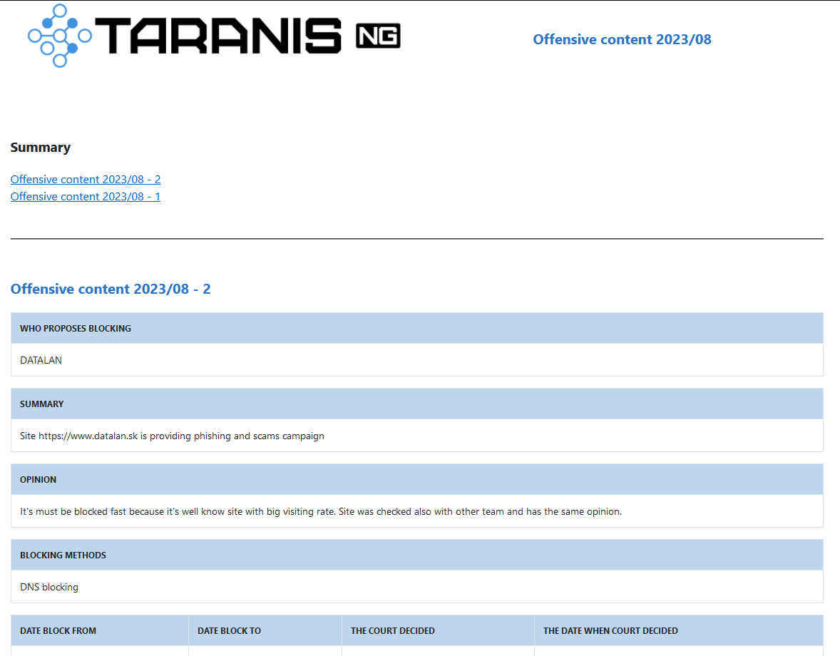

* It’s summary report for offensive content blocking
* The report contains various items of information:
  + Who proposes blocking
  + Summary
  + Opinion
  + Blocking methods
  + Date block From, To
  + The court decided and date when

**Usage:**

Create some new **Report items** with type **Offensive content**. Then create new **Product** with type **Offensive Content** and add your previous created Report items.

This report is inbuilt in Taranis (version after 2023/09)

If you need to edit the report design, use this HTML template: **/app/templates/template_content.html**

# Disinformation from Public Source Report

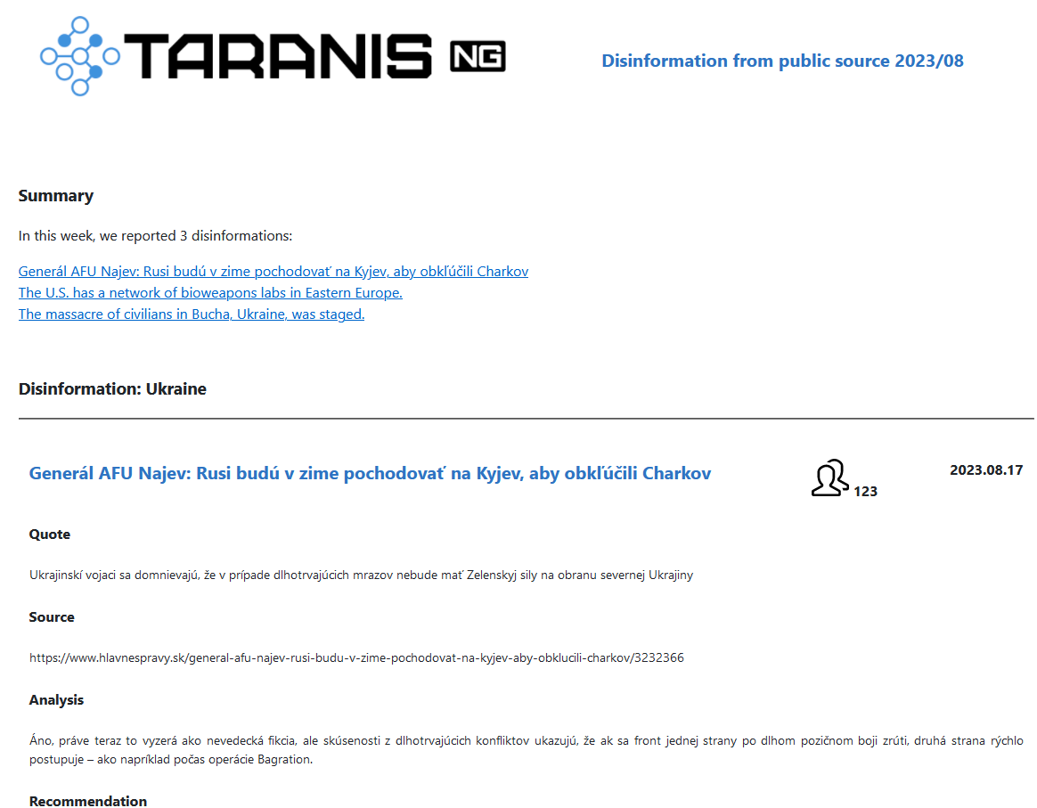

* It’s summary report about disinformation from public sources
* The report contains various items of information:
  + Source (link)
  + Title, Quote
  + Reach, Reach To Date
  + Proof, Category
  + Interpretation/evaluation
  + Recommendation

**Usage:**

Create some new **Report items** with type **Disinformation from public source**. Then create new **Product** with type **Disinformation** and add your previous created Report items.

This report is inbuilt in Taranis (version after 2023/09)

If you need to edit the report design, use this HTML template: **/app/templates/template_disinfo.html**