**A**

**Project Report**

**On**

**“Book My Table”**

**Submitted**

**To**

**Information Technology Department**

**April 2022**

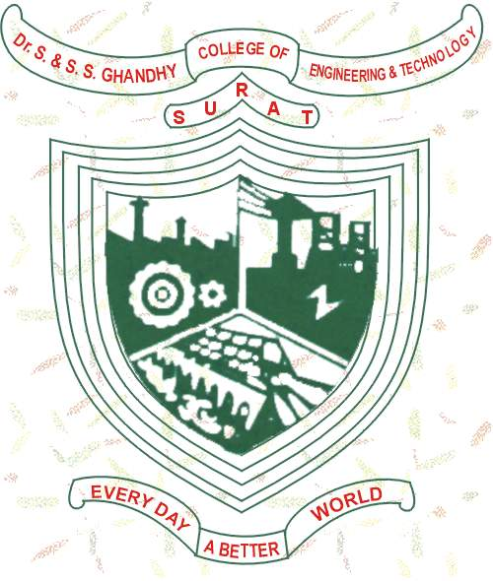

**Information Technology Department**

**DR. S & S. S. GHANDHY COLLEGE OF ENGINEERING & TECHNOLOGY, SURAT**

**Gujarat Technological University**

**DR. S & S. S. GHANDHY COLLEGE OF ENGINEERING & TECHNOLOGY, SURAT**



**6th SEMESTER**

**Project Report**

**On**

**“Book My Table”**

**Submitted**

**To**

**Information Technology Department**

**April 2022**

|  |  |
| --- | --- |
| **Guided by** | **Submitted by** |
| Papesh padhre (Lecturer) | Prince Beladiya(196120316004)  Darshak kakdiya(196120316026)  Rihil sanghani(196120316064) |