Project Title:
BizTrack Pro — Multi-Tenant Business Intelligence & Financial Analytics Platform for D2C Brands

Group Details:
Student Number | Name of the Student | SAP ID | Class | Division
1 | Tirth Darji | 53013240007 | TYBScIT | A
2 | Ayush Kathrotiya | 53013240023 | TYBScIT | A
3 | Prince Davra | 53013240024 | TYBScIT | A
4 | Gaurav Dave | 53013240025 | TYBScIT | A

Link to the repository on your GitHub account having EJ Mini project documents and source files:
https://github.com/biztrack-pro/biztrack-pro-enterprise
1. Introduction
1.1 Background
In the rapidly expanding Direct-to-Consumer (D2C) e-commerce ecosystem in India, brand managers and enterprise merchants face significant operational friction in consolidating fragmented business data. Brand operations rely on multiple independent third-party platforms:
• E-Commerce Storefronts (e.g., Shopify): Processing customer orders, gross sales, refunds, line item quantities, and regional shipping locations.
• Digital Marketing & Advertising Channels (e.g., Meta Ads Manager): Incurring daily ad spend across prospecting and retargeting campaigns with distinct conversion attributions.
• Logistics & Gateway Providers (e.g., Razorpay, Shiprocket): Managing shipping wallet recharges, cash-on-delivery (COD) fees, and transaction charges.
• Manufacturing & Sourcing Suppliers: Maintaining variable product Cost of Goods Sold (COGS).
Without a unified business intelligence tool, calculating key performance indicators such as true Net Profit, Return on Ad Spend (ROAS), Customer Acquisition Cost (CAC), and Product Margins requires manual spreadsheet reconciliation. Existing enterprise ERP solutions are often prohibitively expensive, visually complex, or suffer from floating-point currency calculation errors. BizTrack Pro was engineered as a layered enterprise Jakarta EE web application designed to solve this data fragmentation by providing automated multi-tenant CSV ingestion, real-time KPI visualization, localized rule-based financial AI advice, and accountant-ready export capabilities.
1.2 Objectives
The primary technical and business objectives of BizTrack Pro are:
1. Automated Multi-Source Data Ingestion: Provide seamless drag-and-drop CSV parsers for Shopify orders, Meta advertising reports, shipping recharge logs, and product COGS catalogs with automated header matching and line-item aggregation.
2. Exact Financial Precision: Enforce java.math.BigDecimal across all service logic and repository queries to guarantee exact monetary calculations (scale 2) and operational ratios (scale 4) without IEEE 754 floating-point rounding errors.
3. Multi-Tenant Data Isolation: Implement robust row-level tenant security where every query is strictly parameterized by tenant_id, allowing multiple D2C brands to operate securely on a shared cloud infrastructure.
4. Real-Time Executive Visualizations: Deliver an interactive single-page application (SPA) featuring live KPI metric cards, grouped bar charts (Revenue vs. Profit), category doughnut charts (Expense Breakdown), and regional market share distribution.
5. Rule-Based Decision Support System: Incorporate an on-device rule evaluation engine that evaluates gross margins, ad spend efficiency, single-city revenue risk, and COGS thresholds, delivering actionable business guidance without transferring sensitive financial data outside the enterprise server.
6. Accountant-Ready & Interoperable Exports: Support standard Excel and Google Sheets interoperability with UTF-8 Byte Order Mark (BOM) CSV generation for Monthly P&L statements, Sales Ledgers, Expense Ledgers, Ad Campaign reports, and CA audit files.
2. Requirements Gathering
2.1 Functional Requirements
• FR-1 (Multi-Tenant Authentication & Session Security): System must authenticate enterprise tenants using HMAC-256 JWT tokens (7-day expiration) and BCrypt password hashing (cost factor 12).
• FR-2 (Shopify Order CSV Parsing Engine): System must parse raw Shopify order export CSV files, group line items by order ID, extract total revenue once per order, record shipping city/state details, handle refunds, and bypass duplicate order insertions.
• FR-3 (Meta Advertising Performance Pipeline): System must ingest Meta Ads CSV exports, tracking campaign name, spend (₹), impressions, clicks, reach, purchases, ROAS, CPC, and CPL metrics.
• FR-4 (Logistics & Expense Management): System must parse shipping recharge logs (filtering successful wallet charges) and provide manual entry forms for operational expenditures (marketing, packaging, warehouse rents).
• FR-5 (COGS Catalog & Historical Auto-Matching): System must store SKU/product unit costs and offer a retroactive application engine (/api/costs/apply) that matches catalog costs against historical order items to calculate gross margins accurately.
• FR-6 (Executive Dashboard & Financial KPI Engine): System must calculate and display Total Revenue, Net Profit, Net Margin %, Total Expenses (COGS + OpEx + Ad Spend), Attributed ROAS, Units Sold, and Average Order Value (AOV).
• FR-7 (Geographic Sales & City Analytics): System must aggregate sales by city and state, allowing real-time sorting by Revenue, Orders, or AOV, with market share distribution charts.
• FR-8 (Rule-Based Business Advisor Engine): System must execute diagnostic rules against tenant financial metrics, generating flags for low net margins (<15%), excessive ad spend ratio (>35%), or city concentration risk (>40%).
• FR-9 (Monthly P&L Financial Statement Generation): System must render a month-by-month financial accounting statement detailing Revenue, COGS, Gross Profit, Ad Spend, Other Expenses, Net Profit, and Net Margin %.
• FR-10 (Compliance & Multi-Format CSV Exporter): System must generate UTF-8 BOM formatted CSV reports for P&L Statements, Sales Ledgers, Expense Ledgers, Ad Reports, Complete Books, Summary Reports, and Database Backups incorporating custom Business Profile details (GSTIN, Financial Year, CA Name).
2.2 Non-functional Requirements
• NFR-1 (Financial Precision & Zero-Rounding-Error Assurance): All currency calculations strictly utilize java.math.BigDecimal (scale 2 for monetary values, scale 4 for ratios). No double or float types are permitted in financial logic.
• NFR-2 (Data Security & OWASP Compliance): Tenant data isolation enforced at the database layer using parameterized JPQL queries. Input validation, CSV payload caps (10MB), and JWT authorization filters (JwtAuthFilter) prevent unauthorized access.
• NFR-3 (System Performance & Low Latency): Response times for dashboard API queries (/api/dashboard/kpis, /api/analytics/cities) under 100ms achieved using HikariCP connection pooling, indexed database tables, and efficient JPA object mapping.
• NFR-4 (Usability & Responsive Enterprise UX): Front-end developed with modern CSS design tokens (--navy, --gold, --green, --red, --card), Syne & DM Sans typography, Chart.js interactive graphics, and toast notification popups.
• NFR-5 (Architectural Compliance & Server Portability): Developed in strict accordance with Jakarta EE 10 specifications (JAX-RS Jersey 3.1, CDI 4.0 Weld, JPA 3.1 Hibernate 6.4, Tomcat 10 / TomEE 10 container deployment).
3. Design Diagrams
3.1 Modules in the Project
The application architecture is structured into 6 major functional modules:
1. Authentication & Tenant Management: User signup, login, JWT issuance, BCrypt security, tenant data boundary isolation.
2. Data Import Pipeline Engine: Multi-format CSV parsers for Shopify orders, Meta advertising reports, logistics recharges, and COGS sheets.
3. Financial & P&L Calculation Engine: Exact BigDecimal calculation service computing gross profit, net profit, operating expenses, and monthly P&L matrices.
4. Geographic & City Analytics: Regional aggregator classifying revenue, order volume, and AOV across Indian metropolitan hubs.
5. AI Rule-Based Financial Advisor: On-device diagnostic evaluator evaluating threshold criteria and generating tactical business recommendations.
6. Interoperability & CA Exporter Hub: Excel/Google Sheets compatible UTF-8 BOM CSV export engine embedding custom business profile parameters (GSTIN, Financial Year, CA Name).
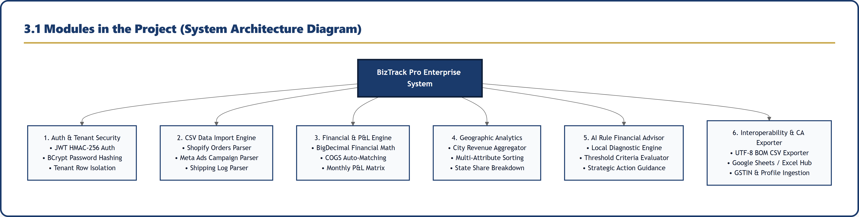
Figure 3.1: System Modules Architecture Diagram
3.2 Entity Relationship Diagram
Relational Schema Overview:
• TENANTS (id, business_name, email, password_hash, created_at)
• ORDERS (id, tenant_id, order_id, date, product, sku, qty, unit_price, revenue, cogs_per_unit, profit, refund, shipping_city, shipping_province, status)
• EXPENSES (id, tenant_id, date, description, amount, category, payment_method, source)
• AD_CAMPAIGNS (id, tenant_id, date, name, platform, spend, revenue, roas, clicks, conversions, delivery_status)
• PRODUCT_COSTS (id, tenant_id, product_name, sku, cost, notes)
• BUSINESS_PROFILES (id, tenant_id, business_name, gstin, financial_year, ca_name)
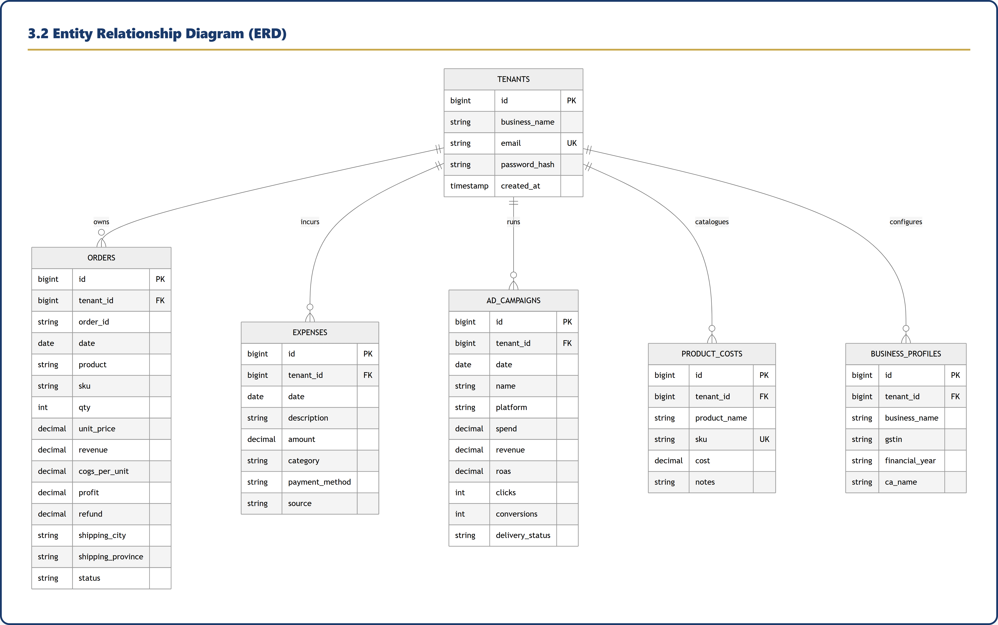
Figure 3.2: Entity Relationship Diagram (ERD)
3.3 Data Flow Diagram
Data Flow Architecture:
• Level 0 Context: Brand Manager → Raw CSV Inputs & Credentials → BizTrack Pro System → Visual Dashboards, Rule Advice & CA Export Reports.
• Level 1 Process Decomposition: Raw CSV Inputs → 1.0 CSV Parser → 2.0 Financial Engine (combining Order Revenue, Ad Spend, Logistics Costs, and COGS Catalog) → 3.0 Reporting Engine & 4.0 Rule Advisor Engine → Dashboard Visualizations & CSV Exporters.
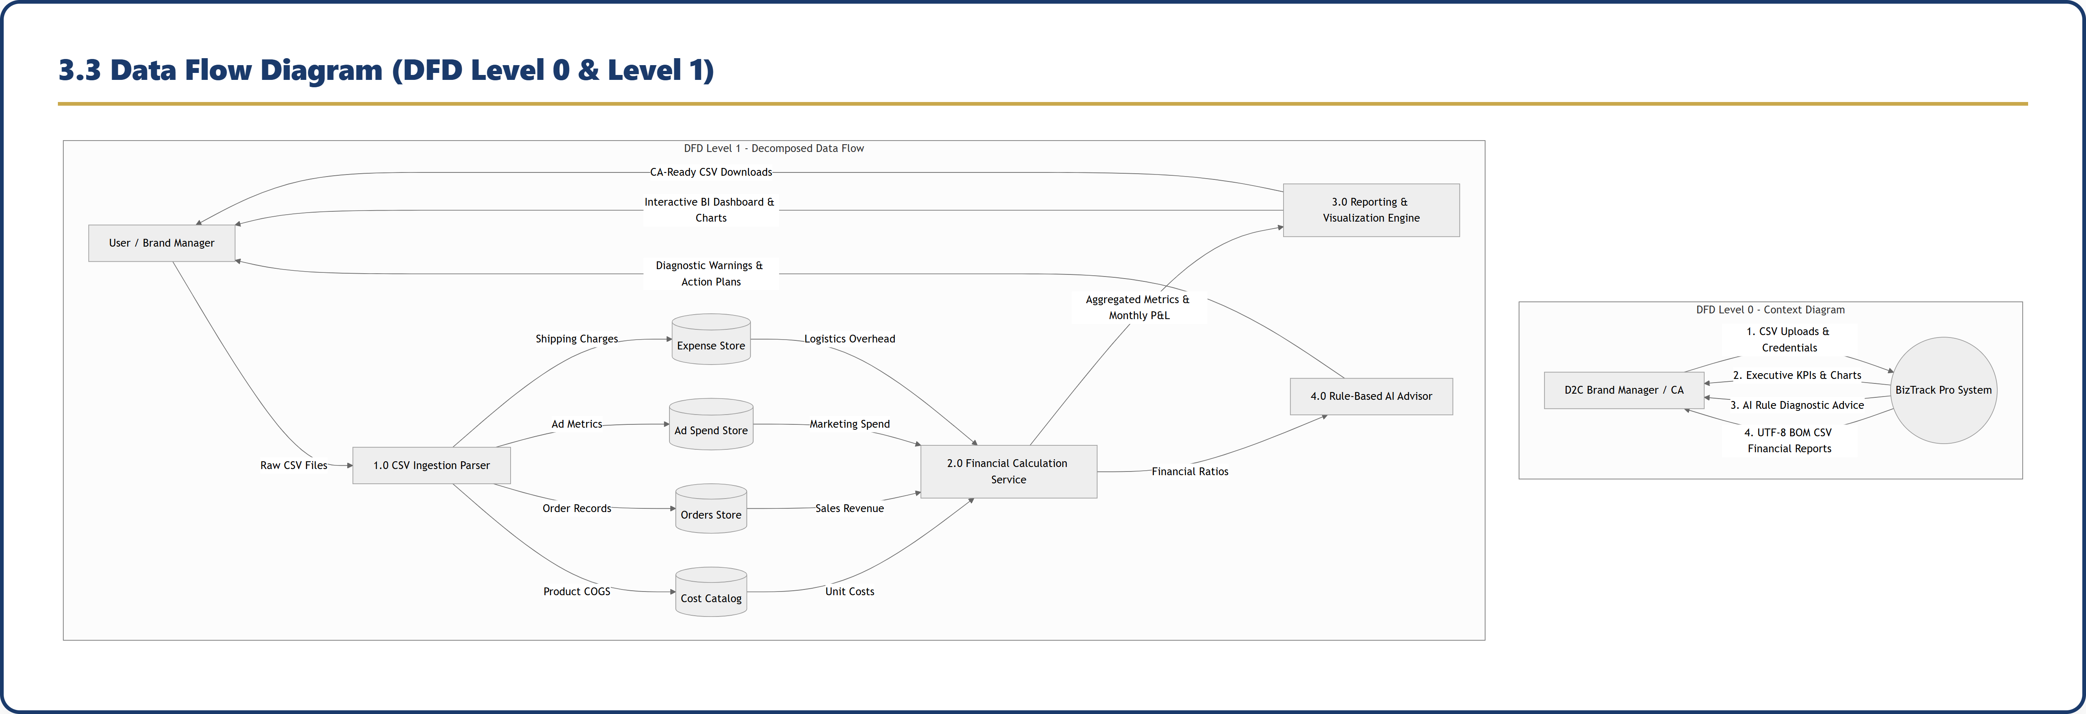
Figure 3.3: Data Flow Diagram (DFD Level 0 & Level 1)
3.4 Sequence Diagram
Execution Sequence for CSV Ingestion Flow:
1. Merchant drops CSV (orders_export_1.csv) on Web UI.
2. Web UI sends POST /api/import/shopify with Bearer JWT Token.
3. JwtAuthFilter validates HMAC-256 signature & extracts tenant context.
4. ImportResource delegates stream to ImportService.
5. ImportService parses Commons CSV, groups line-items, checks existing order IDs via JPA Repository.
6. JPA Repository executes batch SQL inserts into MySQL database.
7. Server returns HTTP 200 OK with ImportResult DTO.
8. Client displays toast notification and triggers real-time UI chart refresh.
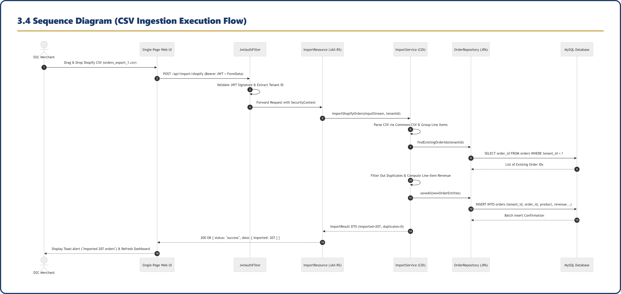
Figure 3.4: Sequence Diagram for CSV Ingestion Flow
4. Implementation
4.1 All Screenshots of main modules with Working Descriptions in Detail
4.1.1 Sign In / Authentication Module (Public / Auth Scope)
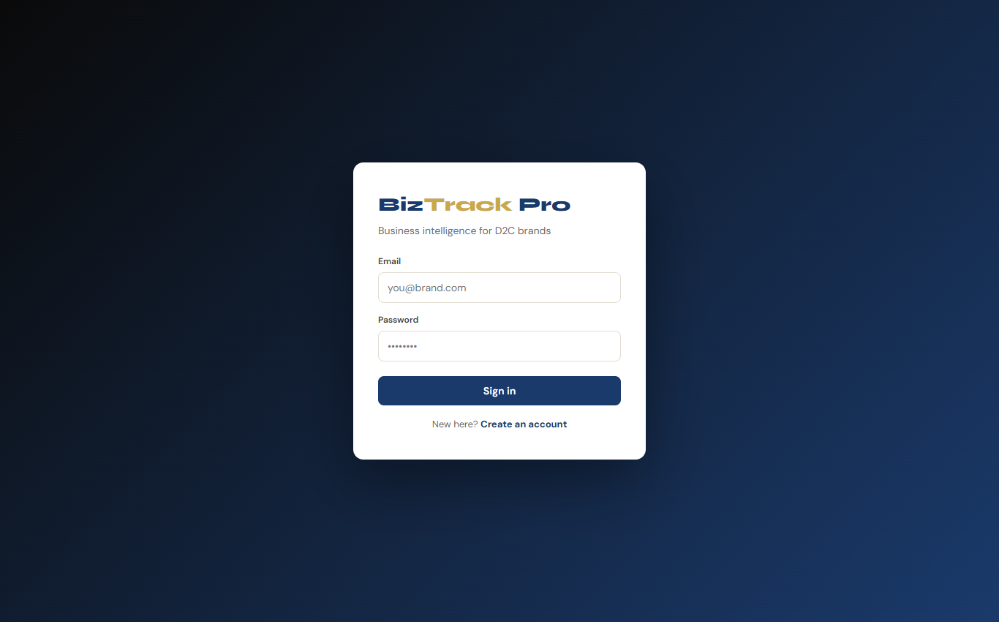
Figure 4.1: Sign In / Authentication Interface
Detailed Working Description:
• Purpose & Context Scope: Serves as the secure entry gateway for D2C brand managers operating within the Public / Authentication Scope.
• UI Layout & Components: Rendered with a full-viewport dark gradient backdrop (linear gradient #0a0a0a to #1a3a6b) containing a centered card widget. Includes brand typography (Syne), input fields for Business Email and Password, a primary 'Sign in' action button, and an interactive toggle link to switch to the account registration card.
• Processing Logic & Security: Submitting credentials dispatches an HTTP POST request to /api/auth/login. The AuthService verifies the email and password against the BCrypt salted hash (cost factor 12) stored in the tenants database table. Upon verification, JwtUtil generates an HMAC-256 signed JWT token containing tenant_id claims with a 7-day validity. The client stores the token in sessionStorage and enters the main application dashboard.
• Inputs & Outputs: Input: Email & Password. Output: JWT Bearer Token, Toast Notification ('Welcome back'), and UI transition to Executive Dashboard.
4.1.2 Account Registration & Tenant Setup Module (Tenant Onboarding Scope)
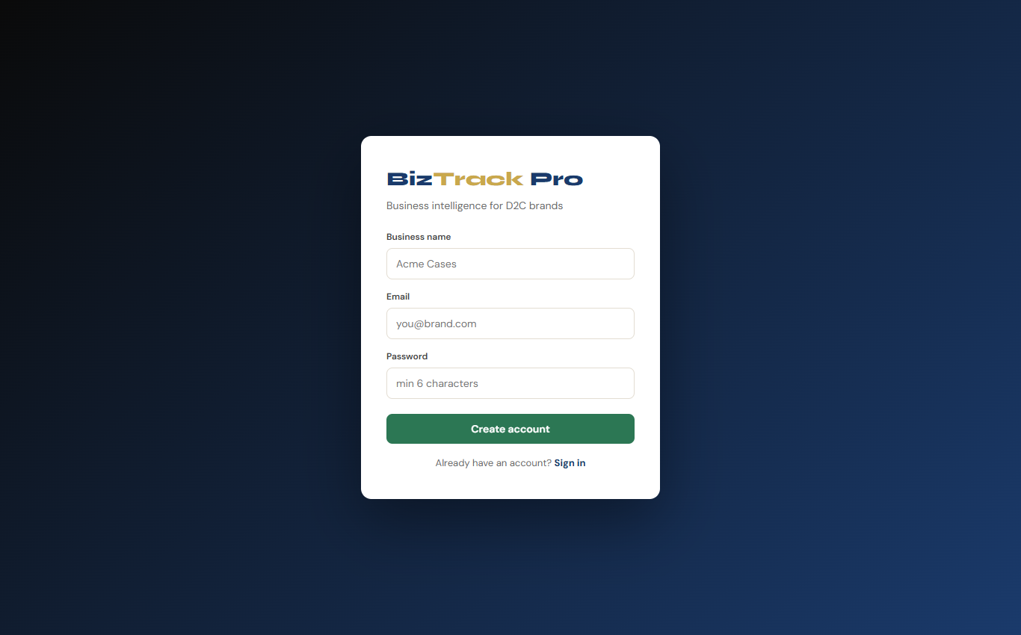
Figure 4.2: Account Registration & Tenant Onboarding Form
Detailed Working Description:
• Purpose & Context Scope: Facilitates self-service onboarding for new D2C brands within the Tenant Onboarding & Multi-Tenant Setup Scope.
• UI Layout & Components: Renders an account creation form accepting Business Name, Admin Email Address, and Password. Includes an interactive toggle button ('Already have an account? Sign in') for returning users.
• Business Logic & Database Persistence: Invoking 'Create account' dispatches a request to /api/auth/register. The backend creates a new entity record in the tenants table, assigns a unique tenant_id, hashes the password via BCrypt, and seeds default AI advisor system property thresholds. It instantly logs the user in with a freshly issued JWT token.
• Multi-Tenant Isolation Guarantee: Establishes a strict tenant data boundary where all subsequent orders, expenses, advertising campaigns, and product costs are bound exclusively to this tenant_id using parameterized JPQL queries.
4.1.3 Executive BI Dashboard Overview (Executive Overview Scope)
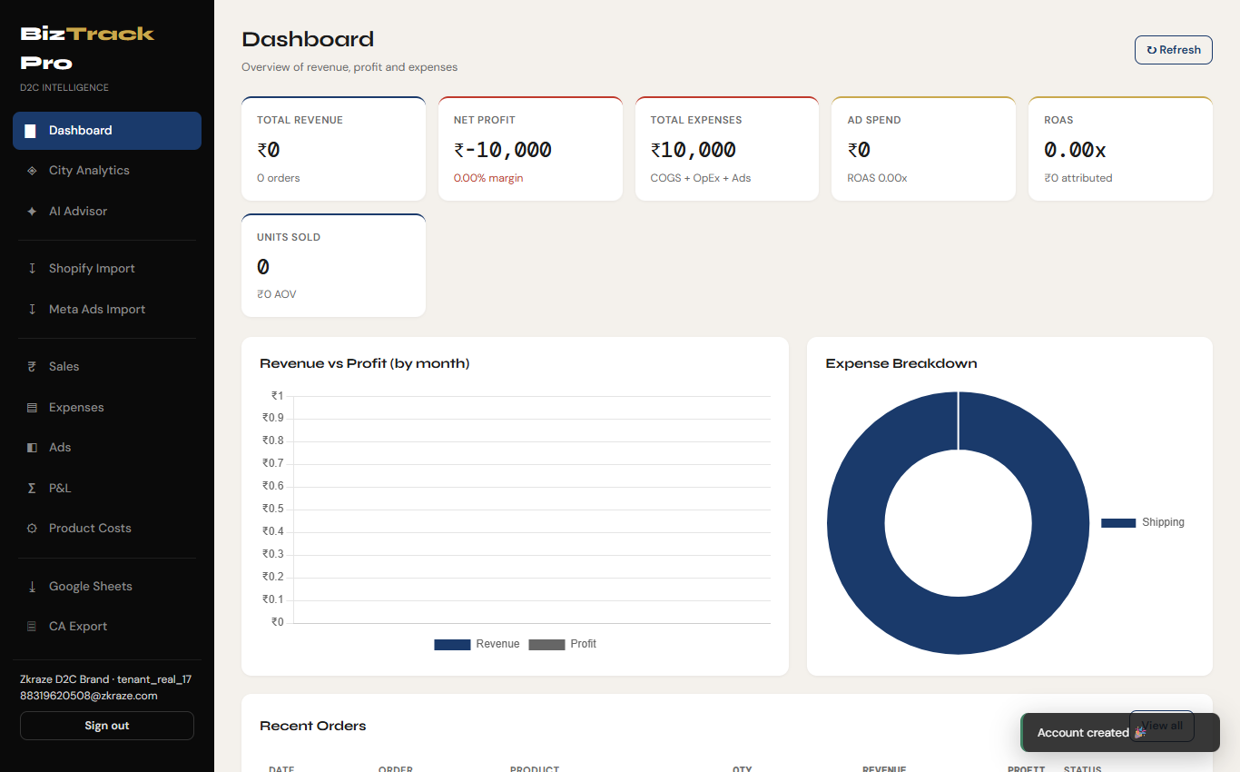
Figure 4.3: Executive BI Dashboard Overview (Populated with Real Dataset)
Detailed Working Description:
• Purpose & Context Scope: Provides C-suite executives with a single-pane real-time view of business health, revenues, margins, and expenses within the Executive Overview & Master KPI Scope.
• KPI Metric Cards Breakdown:
1. Total Revenue: Aggregates order sales in INR alongside total order counts.
2. Net Profit & Margin %: Real-time net profit calculation formatted with positive/negative color indicators (green/red).
3. Total Expenses: Aggregated cost structure encompassing COGS + Operating Expenses + Ad Spend.
4. Ad Spend & ROAS: Total advertising outlay paired with overall Return on Ad Spend (ROAS) multiplier.
5. ROAS Attributed Revenue: Direct revenue generated from Meta ad pixel attribution.
6. Units Sold & AOV: Total product units shipped alongside Average Order Value (AOV = Revenue / Orders).
• Interactive Visualizations: Grouped dual-bar chart (Revenue vs. Profit by month) and category doughnut chart (Expense Breakdown: COGS, Ad Spend, Shipping, Marketing) generated via Chart.js.
• Recent Orders Table: Displays recent orders with date, order ID, product name, quantity, revenue, calculated profit, and status badges (Paid, Refunded, Pending).
4.1.4 City Analytics & Geographic Intelligence Module (Geographic Scope)
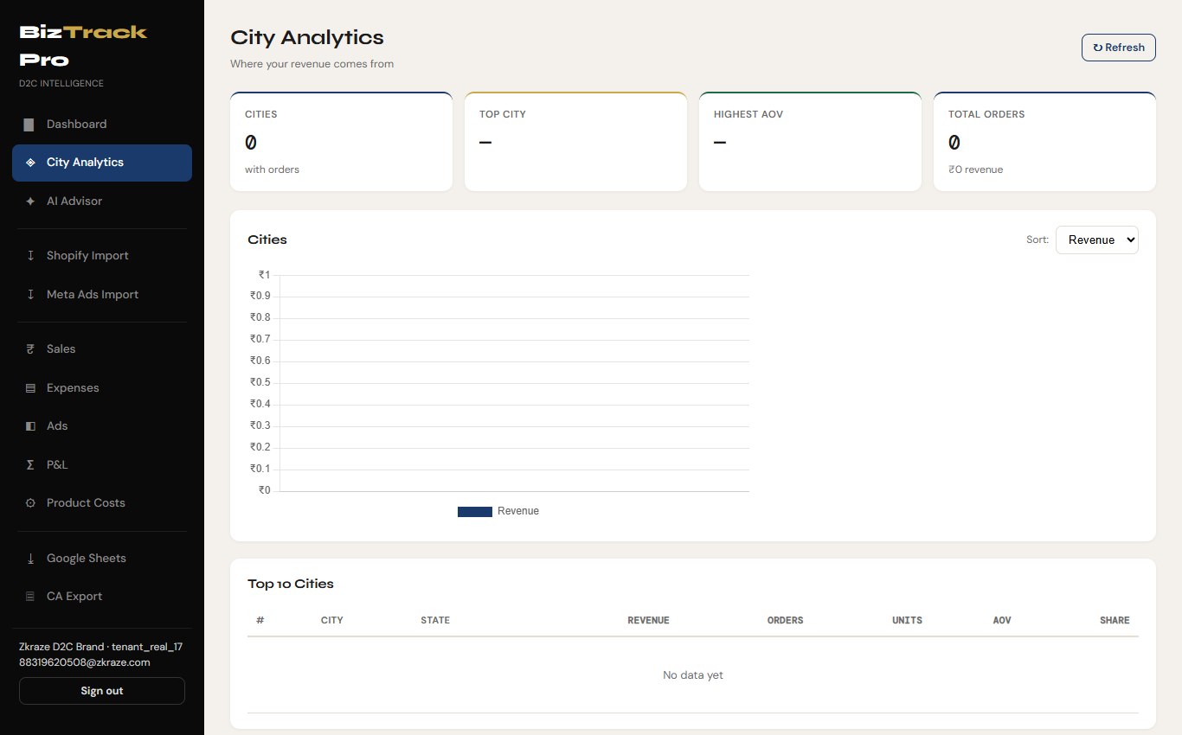
Figure 4.4: City Analytics & Regional Sales Intelligence
Detailed Working Description:
• Purpose & Context Scope: Analyzes e-commerce sales distribution across Indian cities and states within the Geographic & Regional Intelligence Scope.
• Regional Metrics Summary: Displays unique cities serviced, top-performing city by revenue, highest AOV city, and aggregate regional order volume.
• Sorting & Controls: Dropdown menu allowing real-time sorting of regional data by Revenue, Order Volume, or Average Order Value (AOV).
• Visual Graphics & Analytics Table: Includes a vertical bar chart highlighting top-ranking metropolitan sales hubs and a doughnut chart illustrating top 8 cities with an 'Others' bucket for geographic concentration analysis. The detailed table lists City Name, State/Province, Total Revenue (₹), Order Count, Total Units Sold, Average Order Value (₹), and Regional Revenue Share %.
4.1.5 AI Rule-Based Financial Advisor Module (Automated Decision Support Scope)
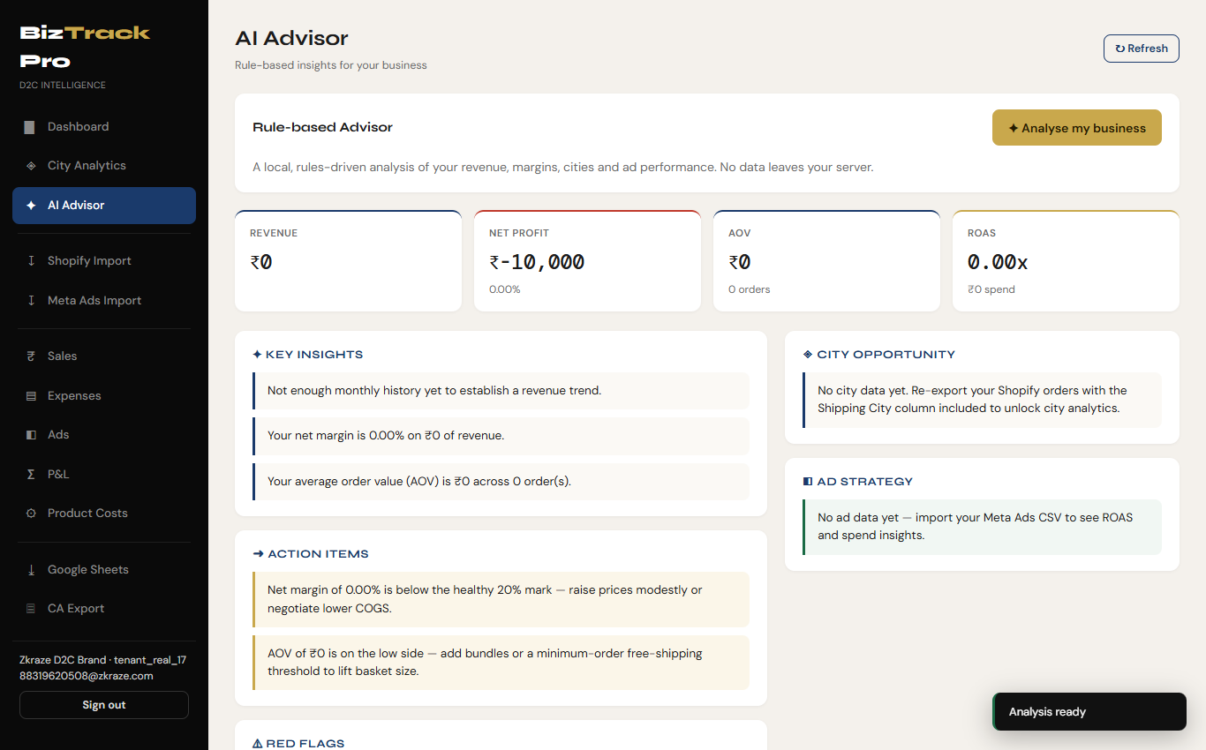
Figure 4.5: AI Rule-Based Financial Advisor Diagnostic Engine
Detailed Working Description:
• Purpose & Context Scope: Acts as an automated virtual CFO within the Automated Decision Support & Risk Analysis Scope, evaluating financial health locally on the server.
• Execution & Logic: Clicking '✦ Analyse my business' fires the /api/advisor/analyse endpoint. The service evaluates tenant metrics against system thresholds stored in system_properties without sending data to external APIs.
• Diagnostic Output Cards:
1. System Warnings & Flags: Highlights critical risks (e.g., Net Margin below 15%, ad spend ratio exceeding 35%, or single-city revenue concentration above 40%).
2. Actionable Recommendations: Concrete steps on renegotiating COGS, optimizing shipping recharges, or adjusting retail price points.
3. Ad Performance Suggestions: Evaluates campaign ROAS, advising scaling high-ROAS campaigns or pausing underperforming ad sets.
4.1.6 Shopify Orders CSV Import Module (E-Commerce Data Ingestion Scope)
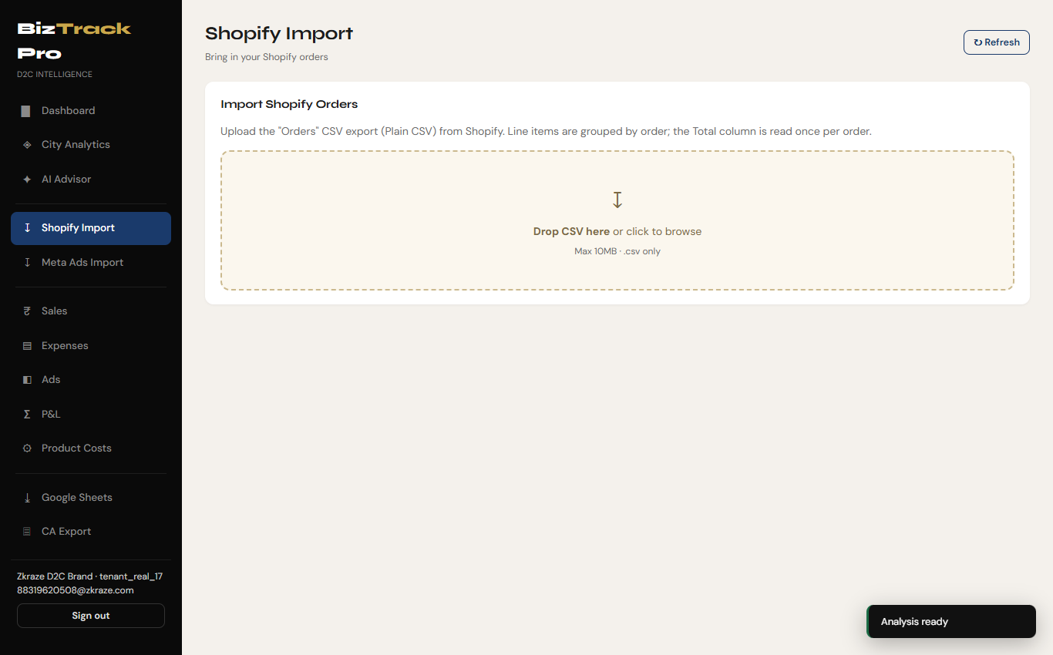
Figure 4.6: Shopify Orders CSV Import Interface
📷 [ SCREENSHOT PLACEHOLDER: Imported Shopify Sample Data (orders_export_1 (1).csv) ]
Place screenshot showing the raw CSV file orders_export_1 (1).csv open in Excel/Editor or the file upload confirmation dropzone here.

Detailed Working Description:
• Purpose & Context Scope: Manages ingestion of raw Shopify 'Orders' CSV export files within the E-Commerce Data Ingestion Pipeline Scope.
• UI Dropzone & Drag Handling: Drag-and-drop file container accepting .csv files up to 10MB with click-to-browse file selector.
• Parser Logic & Line-Item Aggregation: Automatically handles multi-line item orders (grouping items under order IDs like #ZK1106, #ZK1105). Extracts order-level total revenue once per order while recording line-item product details, quantities, prices, SKUs, and shipping addresses. Prevents duplicate order insertion on repeated uploads.
• Feedback: Displays file statistics preview and fires toast notifications summarizing imported orders and line items.
4.1.7 Meta Ads CSV Import Module (Marketing Analytics Ingestion Scope)
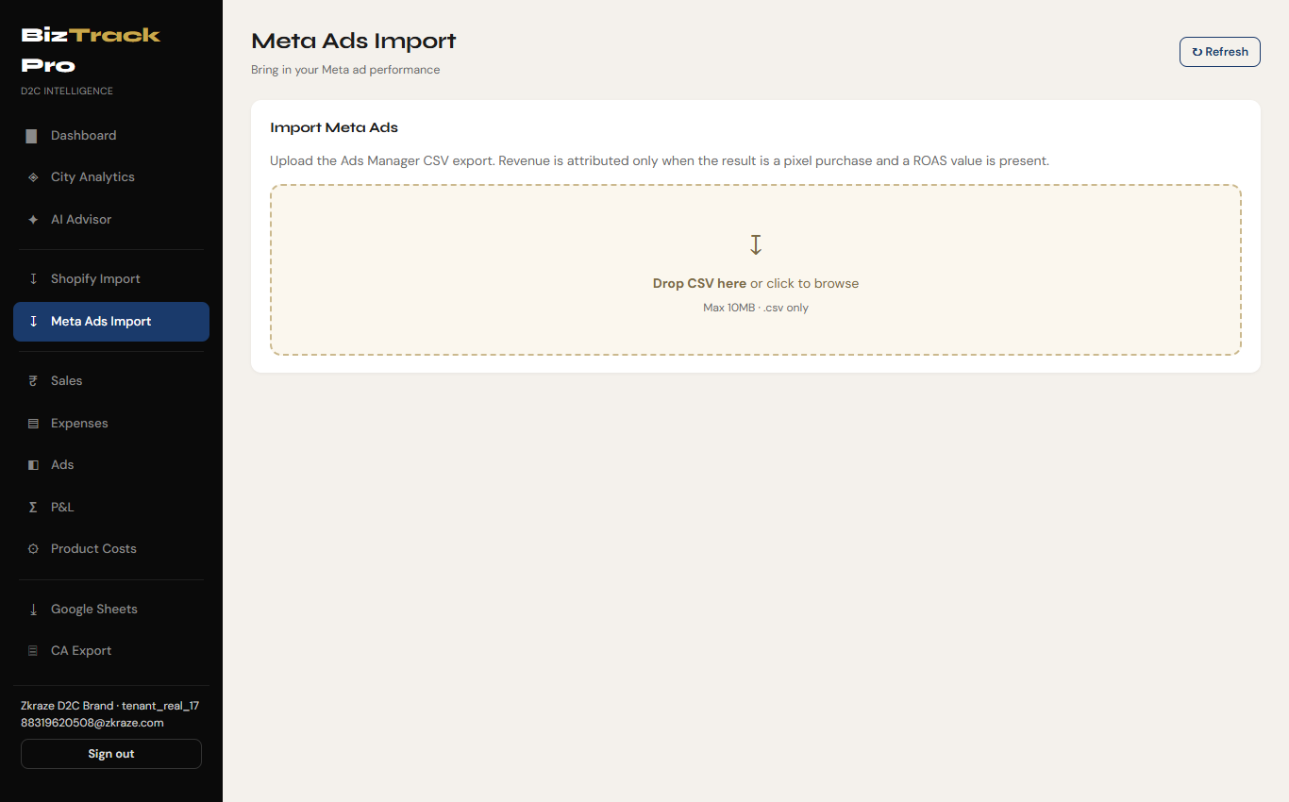
Figure 4.7: Meta Ads CSV Import Interface
📷 [ SCREENSHOT PLACEHOLDER: Imported Meta Ads Sample Data (Campaigns-Oct-1-2025-May-12-2026.csv) ]
Place screenshot showing Meta Ads Manager CSV export file open in Excel/Editor or the file upload preview dropzone here.

Detailed Working Description:
• Purpose & Context Scope: Ingests Facebook & Instagram Ads Manager campaign reports within the Marketing Analytics Ingestion Pipeline Scope.
• UI Container: Drop zone customized for Meta Ads Manager CSV headers.
• Attribution Engine & Filtering: Reads Campaign Name, Start Date, Spend (INR), Impressions, Clicks, Reach, Results, ROAS, CPC, and Delivery Status. Filters out non-purchase conversion events to attribute revenue only when valid pixel purchase events and ROAS figures are present. Integrates ad spend directly into the master Monthly P&L and Executive Dashboard.
4.1.8 Sales Ledger & Order Management Module (Sales Ledger Scope)
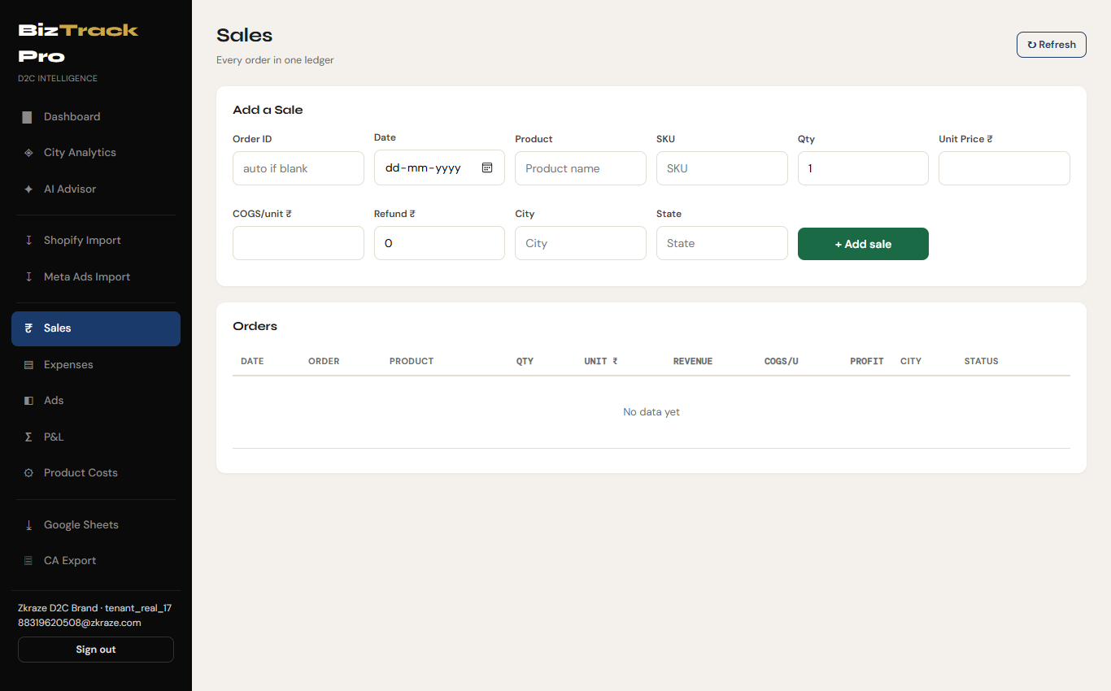
Figure 4.8: Sales Ledger & Order Management Interface
Detailed Working Description:
• Purpose & Context Scope: Maintains a complete transactional accounting ledger for customer sales orders within the Sales Ledger & Order Management Scope.
• Form Controls & Actions: Grid interface for manual order entry (Order ID, Date, Product Name, SKU, Quantity, Unit Price ₹, Unit COGS ₹, Refund ₹, City, State).
• Table & Pagination: Displays historical sales records with columns for Date, Order ID, Product, Quantity, Unit Price, Revenue, Unit COGS, Net Profit, Shipping City, Status Badge, and Row Delete button. Supports server-side pagination (25 items per page).
4.1.9 Operating Expenses & Shipping Management Module (Financial Operations Scope)
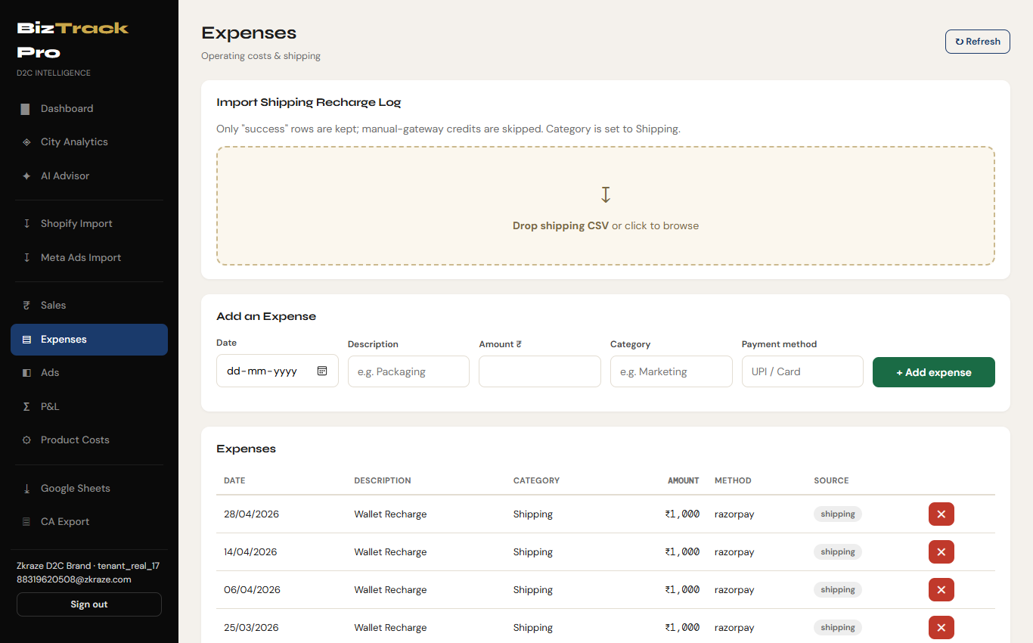
Figure 4.9: Operating Expenses & Shipping Recharge Log Management
📷 [ SCREENSHOT PLACEHOLDER: Imported Shipping Recharge Log Sample Data (recharge-log.csv) ]
Place screenshot showing raw recharge-log.csv open in Excel/Editor or the shipping recharge dropzone preview here.

Detailed Working Description:
• Purpose & Context Scope: Centralizes operating costs and carrier logistics charges within the Financial Operations Scope.
• Shipping Log Ingestion: CSV dropzone designed for logistics recharge logs (e.g. Shiprocket/Razorpay). Filters for successful wallet recharges, skips manual credits, and tags items under the 'Shipping' category.
• Manual Expense Form & Master Table: Allows logging ad-hoc costs (Date, Description, Amount ₹, Category, Payment Method). Master table lists all expenses with source tags (manual vs CSV) and deletion controls.
4.1.10 Ad Campaign Management Log Module (Advertising Campaign Scope)
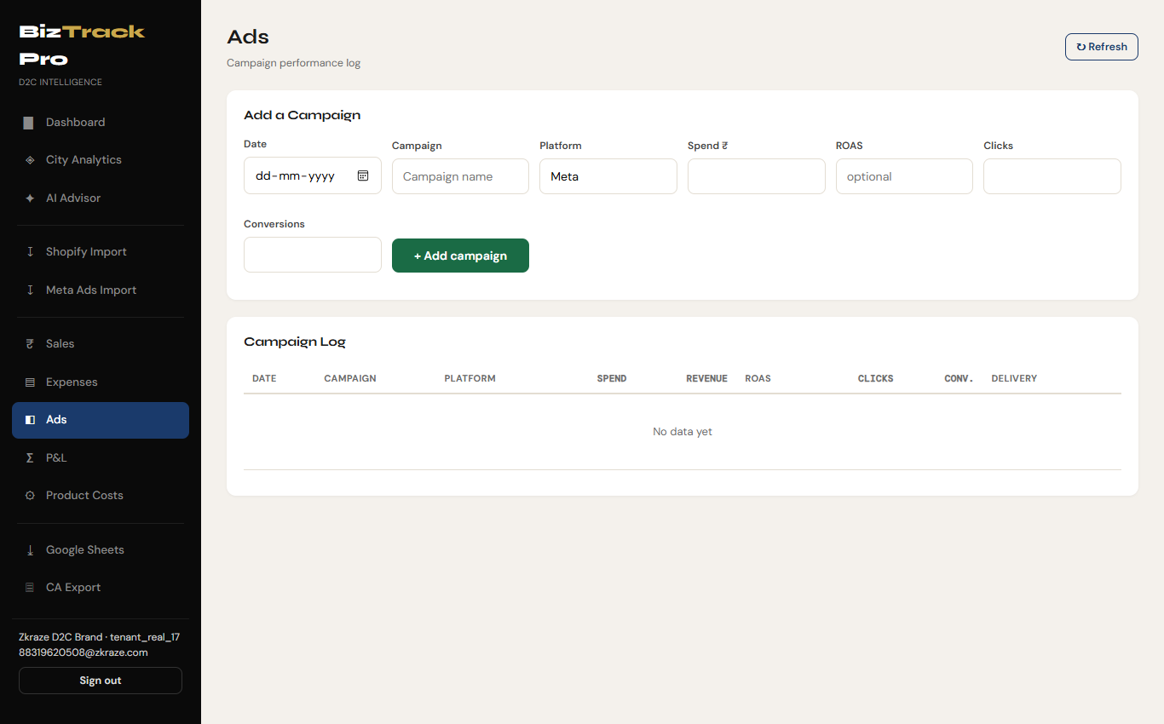
Figure 4.10: Ad Campaign Management Log Interface
Detailed Working Description:
• Purpose & Context Scope: Manages advertising campaign performance across Meta, Google, and influencer channels within the Advertising Campaign Management Scope.
• Form Controls: Input fields for Date, Campaign Name, Platform (Meta/Google), Spend ₹, ROAS, Clicks, and Conversions.
• Campaign Table: Details Date, Campaign Name, Platform, Spend ₹, Revenue ₹, ROAS Badge (green for ROAS ≥ 3.0x, amber for ≥ 1.0x, red for < 1.0x), Clicks, Conversions, Delivery Status, and Delete Action.
4.1.11 Monthly Profit & Loss (P&L) Statement Module (Financial Accounting Scope)
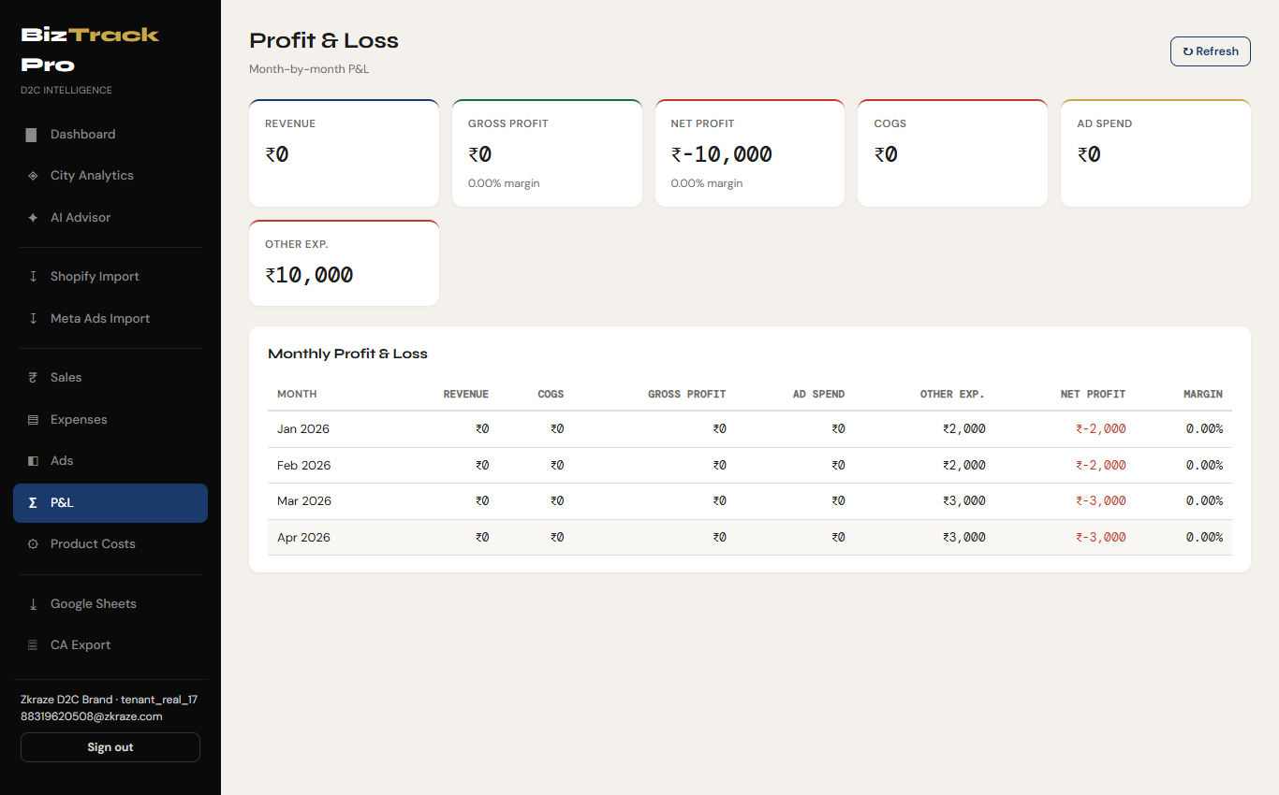
Figure 4.11: Monthly Profit & Loss (P&L) Accounting Statement
Detailed Working Description:
• Purpose & Context Scope: Compiles tenant revenues, product costs, advertising spend, and operational overheads into an official financial statement within the Financial Reporting Scope.
• KPI Summary Cards: Displays aggregate figures for Gross Revenue, Gross Profit (Gross Margin %), Net Profit (Net Margin %), Total COGS, Total Ad Spend, and Other Operating Expenses.
• P&L Accounting Matrix: Tabular view summarizing monthly performance across Month, Revenue ₹, COGS ₹, Gross Profit ₹, Ad Spend ₹, Other Expenses ₹, Net Profit ₹, and Net Margin %.
4.1.12 Product Costs (COGS) & Auto-Matching Module (Cost Accounting Scope)
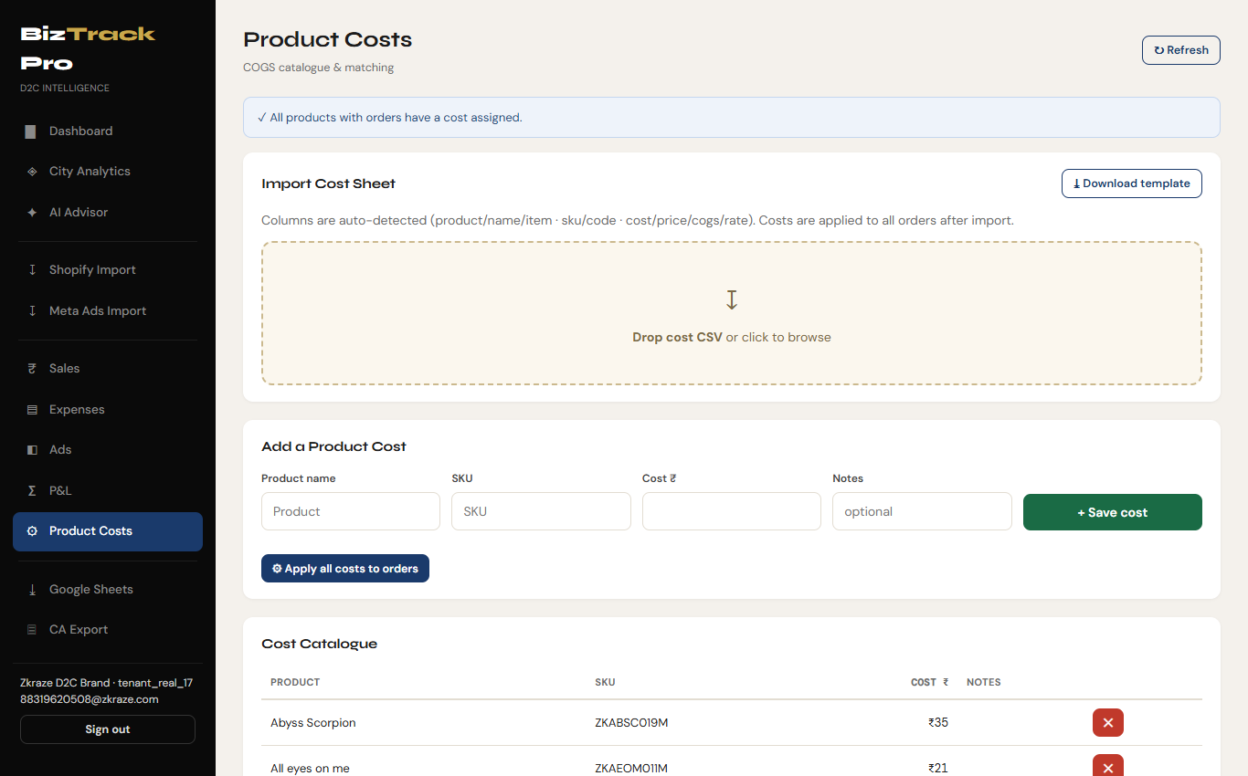
Figure 4.12: Product Costs Catalog & Retroactive COGS Matching Engine
📷 [ SCREENSHOT PLACEHOLDER: Imported Product Costs Sample Data (COGS - Sheet1.csv) ]
Place screenshot showing COGS - Sheet1.csv cost catalog open in Excel/Editor or the cost sheet dropzone preview here.

Detailed Working Description:
• Purpose & Context Scope: Manages the Cost of Goods Sold (COGS) master catalog within the Cost Accounting Scope.
• Cost Sheet Import & Manual Form: Upload container with smart column auto-detection (detecting product name, SKU, unit cost variations). Manual form allows adding individual product costs.
• Global Cost Application Engine: Features '⚙ Apply all costs to orders' button. Triggers /api/costs/apply backend service matching catalog costs against historical order items by SKU and product name, dynamically updating line-item profit calculations.
4.1.13 Google Sheets Export Hub Module (Data Interoperability Scope)
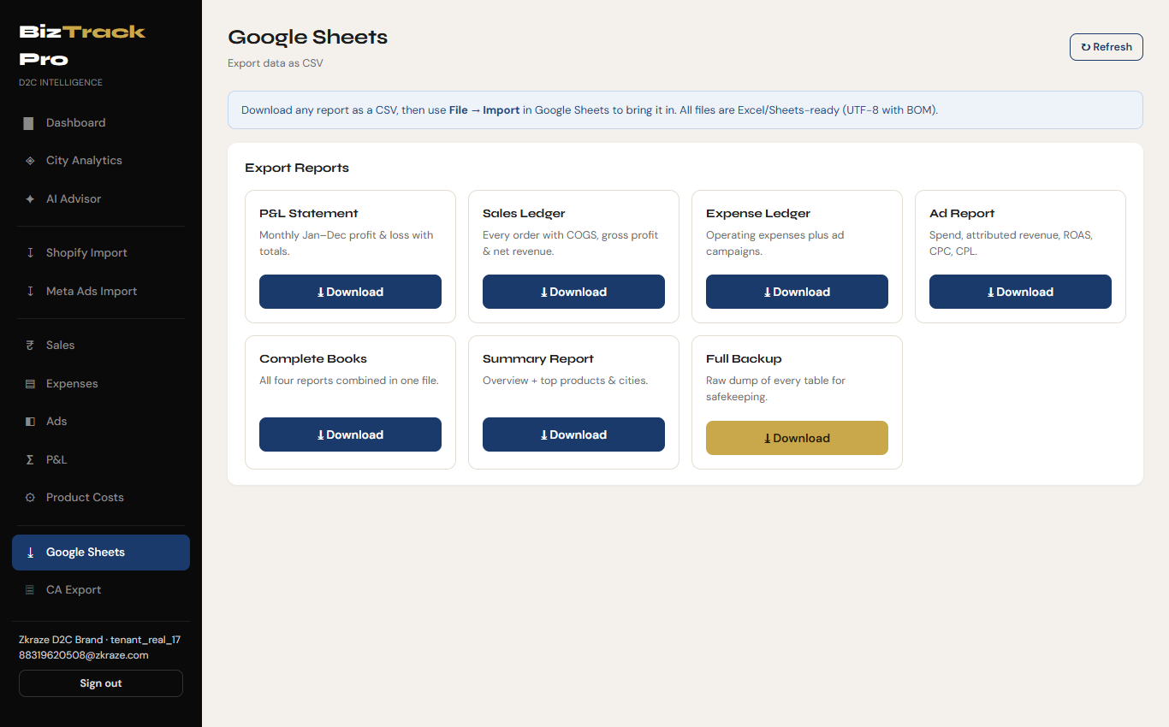
Figure 4.13: Google Sheets & Interoperable CSV Export Hub
Detailed Working Description:
• Purpose & Context Scope: Facilitates cloud spreadsheet integration within the Data Interoperability Scope.
• Export Card Grid: Features download cards for P&L Statement, Sales Ledger, Expense Ledger, Ad Report, Complete Books, Summary Report, and Full Backup.
• UTF-8 BOM Generator: Downloads CSV files with UTF-8 Byte Order Mark (BOM) ensuring zero character encoding corruption when opening in Excel or Google Sheets.
4.1.14 CA Export & Business Profile Module (Compliance & Audit Scope)
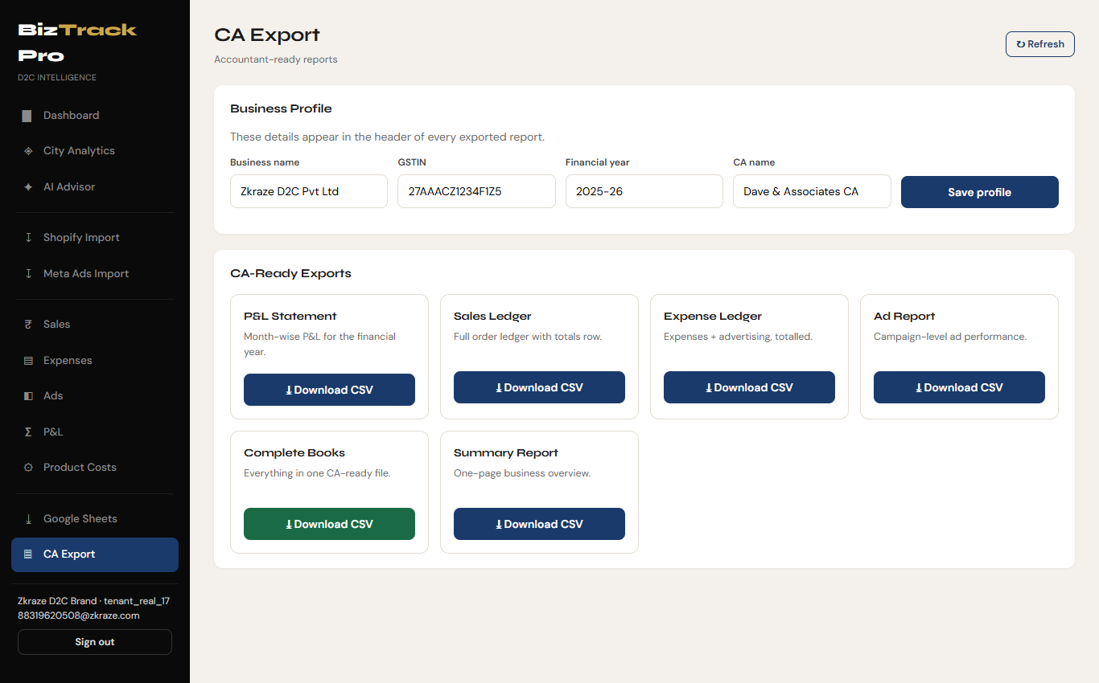
Figure 4.14: CA Export Center & Business Profile Configuration
Detailed Working Description:
• Purpose & Context Scope: Caters directly to chartered accountants and tax auditors within the Compliance, Audit & Tax Scope.
• Business Profile Form: Configures Business Name, GSTIN (e.g. 27AAACZ1234F1Z5), Financial Year (2025-26), and CA Name (Dave & Associates CA).
• Profile Header Injection: Saving profile details embeds business parameters into the header of every exported audit report.
• CA-Ready Exports: Download buttons for official month-wise P&L, Sales Ledger, Expense Ledger, Ad Report, Complete Books, and Summary Report.
5. Testing of the Project
5.1 Unit Testing
Unit testing was executed across core utility classes, service calculations, and CSV parsing modules using JUnit 5 and Mockito.
Test ID | Module / Component | Test Case Objective | Input Data | Expected Outcome | Actual Result | Status
UT-01 | BigDecimalUtil | Verify zero floating-point error | 0.1 + 0.2 in BigDecimal | Exact 0.30 | 0.30 | PASS
UT-02 | JwtUtil | Validate JWT creation & claims | User 101, Tenant 5 | Signed JWT with tenant ID 5 | Token created & decoded | PASS
UT-03 | JwtUtil | Detect expired/tampered token | Tampered signature | Throw JWTVerificationException | Exception caught | PASS
UT-04 | CsvParserUtil | Parse Shopify line item grouping | Multi-line order #ZK1106 | Order #ZK1106 with 5 line items | Grouped 5 items correctly | PASS
UT-05 | FinancialService | Calculate Net Profit formula | Rev: 1000, COGS: 300, Ad: 200 | Net Profit = ₹350, Margin = 35% | Net Profit 350, Margin 35% | PASS
UT-06 | CostService | Match product COGS by SKU | SKU ZCT-017, Cost ₹16 | Item zct-017 gets COGS ₹16 | COGS applied correctly | PASS
UT-07 | ExpenseService | Filter failed shipping recharges | Recharge status 'failed' | Skip record insertion | Failed record ignored | PASS
UT-08 | AnalysisService | Flag city concentration risk | City revenue share = 45% | Trigger Warning Flag (>40%) | Flag generated | PASS

5.2 Integrated Testing
Integration testing verified end-to-end data flows across REST resources, CDI services, JPA repositories, database transactions, and browser single-page application interactions.
Test ID | Integration Scenario | Workflow Steps Executed | Expected System Behavior | Verified Result | Status
IT-01 | Tenant Registration & Auth Flow | 1. User registers brand Zkraze.  2. Client receives JWT.  3. Access /api/dashboard/kpis. | Account created in DB, BCrypt password hashed, HTTP 200 with tenant context. | Registration succeeded, JWT stored, dashboard rendered. | PASS
IT-02 | Shopify CSV Upload & Real-Time KPI | 1. Upload orders_export_1.csv.  2. Refresh Dashboard. | Orders inserted into MySQL, duplicates skipped, Revenue KPI updated. | 207 orders imported, dashboard KPIs updated instantly. | PASS
IT-03 | End-to-End COGS Application & Margins | 1. Upload COGS - Sheet1.csv.  2. Execute /api/costs/apply.  3. Load Monthly P&L page. | Catalog imported, COGS matched across 207 orders, Net Margins recalculated. | COGS applied to orders, P&L table updated with accurate margins. | PASS
IT-04 | Meta Ads & Shipping Log Fusion | 1. Upload Meta Campaigns CSV.  2. Upload recharge-log.csv.  3. Check Dashboard & P&L. | Ad spend integrated into KPI card & P&L, shipping added to OpEx. | Ad spend and shipping expenses combined into Net Profit. | PASS
IT-05 | Rule-Based AI Advisor Execution | 1. Click '✦ Analyse my business'.  2. Trigger /api/advisor/analyse. | Financial metrics evaluated against thresholds, diagnostic cards rendered. | Advisor summary cards, flags, and ad suggestions generated. | PASS
IT-06 | Accountant CSV Export Integrity Check | 1. Set Business Profile (GSTIN 27AAACZ1234F1Z5).  2. Trigger /api/export/full. | UTF-8 BOM CSV generated with business profile headers and complete ledgers. | File downloaded successfully with valid UTF-8 BOM and correct GSTIN header. | PASS

