QR Code-Based Inventory Management System

Introduction
Inventory management plays a vital role in efficiently tracking stock and reducing errors in businesses. Our QR Code-Based Inventory Management System leverages QR scanning, Raspberry Pi, and Google Sheets to automate inventory tracking, ensuring accuracy and real-time updates. This system eliminates manual data entry, reduces human errors, and streamlines inventory operations.

Working Principle
The system follows these steps:
- Scanning the QR Code:
  - A QR Code Scanner Module captures the QR code from a product or inventory item.
- Processing the Data:
  - The Raspberry Pi receives and processes the scanned data.
- Validation of the QR Code:
  - The system checks whether the scanned QR code exists in the inventory database.
- Updating the Inventory:
  - If valid, the information is updated in a Google Sheets spreadsheet via a PC/Laptop for cloud-based storage and real-time tracking.
- Alert Mechanism:
  - If the QR code is invalid, a buzzer or LED triggers an alert to notify the user.
- Looping Back for the Next Scan:
  - The system returns to the scanning step for continuous operation.

Components Used
- QR Code Scanner Module – Reads QR codes from inventory items.
- Raspberry Pi – Acts as the processing unit for data validation and transmission.
- Google Sheets (via PC/Laptop) – Stores inventory records in the cloud for easy access.
- Buzzer– Provides an alert in case of incorrect or unregistered QR codes.
- Power Supply – Powers the Raspberry Pi and connected components.

Components Cost
- Raspberry Pi Model 4b (4GB RAM) : 5,599Rs.
- MH-ET LIVE Scanner : 1,680Rs.
- SD Card : 300Rs.
- Power Cable : 113Rs.
- Jumper Wires (male-female) : 35Rs.
- Resistors (4.7k)x2 : 5Rs.
Total Cost : 7,732Rs.

Implementation Challenges
🔴 Internet Connectivity Issues – Since the system relies on Google Sheets, a stable internet connection is necessary. Any downtime may disrupt inventory updates.
🔴 QR Code Readability – Poorly printed or damaged QR codes may not be recognized correctly, leading to scanning errors.
🔴 Processing Speed – If a large number of QR codes are scanned in quick succession, there may be a slight delay in updating records.
🔴 Hardware Integration – Ensuring smooth communication between the QR scanner, Raspberry Pi, and spreadsheet software requires precise hardware and software synchronization.

Flowchart Representation
A flowchart helps visualize the working of the system, ensuring a clear understanding of each step. The key decision point is QR code validation, which determines whether data is stored or an alert is triggered. The system then loops back for the next scan, making it a continuous process.

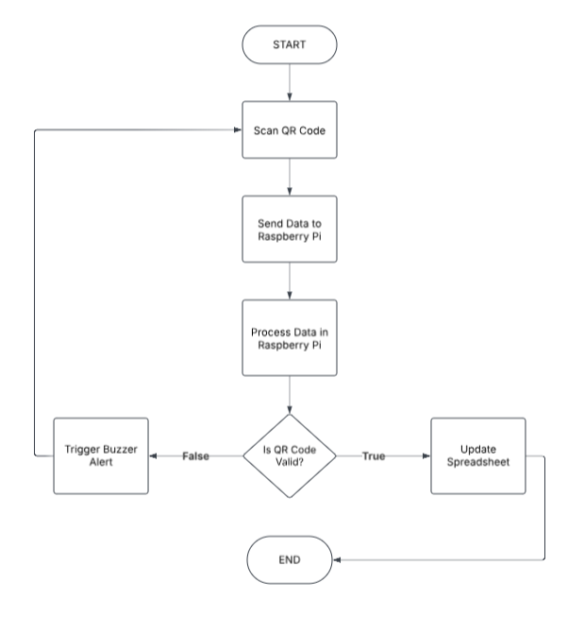

Advantages of the System
✅ Real-time Inventory Updates: Instant stock tracking via Google Sheets.
✅ Automation & Accuracy: Eliminates human errors in data entry.
✅ Cloud Storage & Accessibility: Data can be accessed from anywhere.
✅ Improved Security: Alerts notify users of unauthorized scans.
✅ Cost-Effective: Reduces the need for expensive inventory management software.

Conclusion
Our QR Code-Based Inventory Management System offers an efficient, automated, and scalable solution for businesses to track, manage, and monitor inventory with minimal human intervention. By integrating Raspberry Pi, QR scanning, and cloud storage, we provide a reliable, cost-effective, and real-time inventory tracking system.

