Superstore sales dataset Analytics Dashboard

Using Microsoft Excel, Power BI, SQL AND Python

Prepared by Obasi Israel Okwuchukwu

Executive Summary
This project delivers a comprehensive Sales analytics solution using Excel, Power BI, SQL, and data cleaning techniques. It provides actionable insights into sales performance, profitability, and regional trends. The dashboard enables stakeholders to make data-driven decisions for inventory planning, marketing, and revenue optimization.

1. Introduction
This project analyzes sales data to uncover key business insights such as revenue trends, top-performing products, and regional sales performance. The goal is to transform raw data into actionable intelligence.

2. Project Objectives
The key objectives of this analysis were:
• To clean and prepare the Superstore sales dataset for analysis
• To identify products generating the highest revenue
• To determine the best-performing countries and regions
• To analyze sales trends over time
• To identify top and bottom-performing products
• To calculate total revenue generated across the dataset
• To provide actionable insights and business recommendations

3. Business Problem
Sales personnel often struggle with fragmented data across regions and product categories. This leads to poor visibility into performance and inefficient decision-making.

4. Dataset Description
The dataset includes Order ID, Order Date, Product Name, Category, Quantity, Sales, Profit, City, and Region. It represents real-world retail transactions.

5. Data Cleaning and Preparation
Data cleaning involved removing duplicates, handling missing values, converting text to numeric formats, and standardizing date formats to ensure consistency and accuracy.

6. SQL Analysis
SQL queries were used to compute key metrics including Total Sales, Total Profit, Monthly Sales Trends, Top Performing Products, and Regional Sales Distribution.

7. Dashboard Overview
Below is the developed Power BI dashboard:
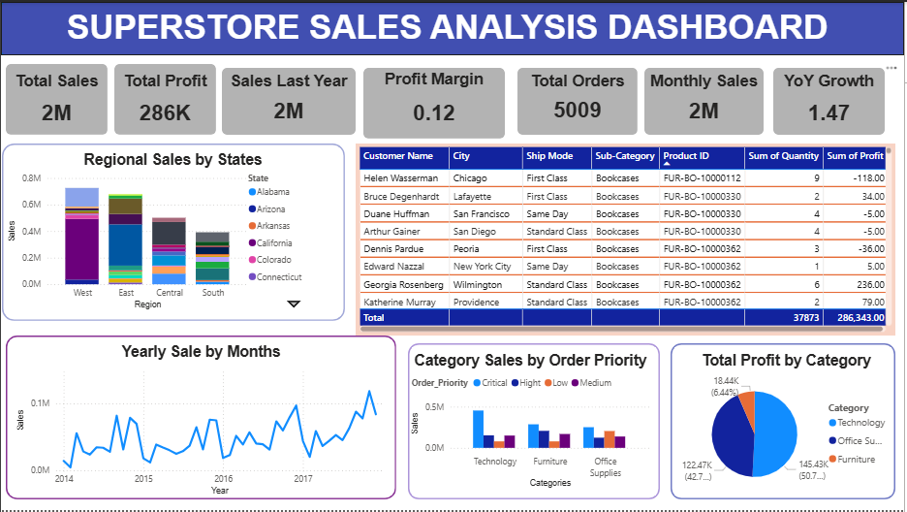

8. Key Performance Indicators
• Total Sales: 2M
• Total Profit: 286K
• Total Orders: 5009
• Profit Margin: 12%
• YoY Growth: 147%

9. Key Insights
• The West region generates the highest revenue.
• Certain product categories significantly outperform others.
• Sales show strong growth trends over time.
• Profit margins indicate moderate profitability with room for optimization.

10. Business Recommendations
• Increase investment in high-performing regions.
• Optimize pricing strategies to improve profit margins.
• Use seasonal trends to plan inventory and promotions.
• Focus marketing on top-performing categories.

11. Conclusion
This project demonstrates how data analytics can drive strategic business decisions. The dashboard provides a scalable solution for monitoring performance and improving profitability.

