WEEK 1 TASK
Data Acquisition, Cleaning, and Preprocessing
Public Dataset Case Study: Titanic Passenger Survival

Dataset | Titanic – Machine Learning from Disaster
Dataset size | 891 rows × 12 columns
Primary source | Kaggle Titanic competition
Tools | Python, Pandas, NumPy, Matplotlib, scikit-learn

Prepared as a Week 1 Data Analytics / Data Science practical report

1. Executive Summary
This report documents a complete Week 1 data acquisition, cleaning, and preprocessing workflow using the Titanic passenger dataset. The purpose is to demonstrate how a raw public dataset can be inspected, validated, cleaned, transformed, and prepared for downstream analysis or machine learning.
The raw training dataset contains 891 passenger records and 12 variables. The principal data quality issues are missing Age values (177 records), missing Cabin values (687 records), and two missing Embarked values. The dataset contains no duplicate rows and no duplicate PassengerId values. Potential numerical outliers were assessed using the IQR rule. Fare contains legitimate high-value observations, so they were not blindly deleted; instead, a 99th-percentile capped version is provided for algorithms that are sensitive to extreme values.
The final preprocessing workflow fills Age using the median, fills Embarked using the mode, creates a CabinKnown indicator rather than discarding the heavily missing Cabin field, standardizes categorical text, and creates a capped Fare feature plus a log-transformed Fare alternative. A model-ready subset is also encoded with one-hot encoding.

2. Objectives
- Acquire a publicly available dataset from a reliable source.
- Understand the structure, data types, distributions, and quality of the raw data.
- Identify missing values, duplicates, inconsistencies, and potential outliers.
- Apply defensible cleaning and preprocessing techniques using Python.
- Document each decision with code and explanatory commentary.
- Explain how preprocessing choices may influence later analysis or machine learning.

3. Dataset Selection and Data Acquisition

3.1 Dataset selected
The selected dataset is the Titanic training dataset from Kaggle's "Titanic – Machine Learning from Disaster" competition. Kaggle describes the training set as containing 891 passengers with the survival outcome available as the target variable. The data dictionary defines variables such as Survived, Pclass, Age, SibSp, Parch, Fare, Cabin, and Embarked.
Primary source: https://www.kaggle.com/competitions/titanic/data
For reproducible programmatic loading in a Python notebook, a public raw CSV mirror of the same Titanic training data can be used:
https://raw.githubusercontent.com/pplonski/datasets-for-start/refs/heads/master/Titanic/train.csv
The Kaggle source is treated as the authoritative dataset reference, while the raw GitHub URL is a convenient direct CSV endpoint for demonstrating automated acquisition.

3.2 Data acquisition code
import pandas as pd
url = "https://raw.githubusercontent.com/pplonski/datasets-for-start/refs/heads/master/Titanic/train.csv"
df = pd.read_csv(url)
print("Dataset shape:", df.shape)
print(df.head())
Rationale: pd.read_csv() provides a simple and reproducible way to load a CSV dataset directly from a public URL. Keeping the acquisition step in code makes the workflow repeatable rather than dependent on manual copying.

4. Initial Data Exploration

4.1 Structure of the dataset
Item | Result
Rows | 891
Columns | 12
Target variable | Survived
Numerical variables | PassengerId, Survived, Pclass, Age, SibSp, Parch, Fare
Categorical/text variables | Name, Sex, Ticket, Cabin, Embarked
Duplicate rows | 0
Duplicate PassengerId values | 0

print(df.shape)
print(df.info())
print(df.describe(include="all").T)
The initial inspection confirms that the data contains mixed numerical and categorical variables. This matters because numerical columns can be summarized statistically, whereas categorical columns require frequency-based checks and, for machine learning, appropriate encoding.
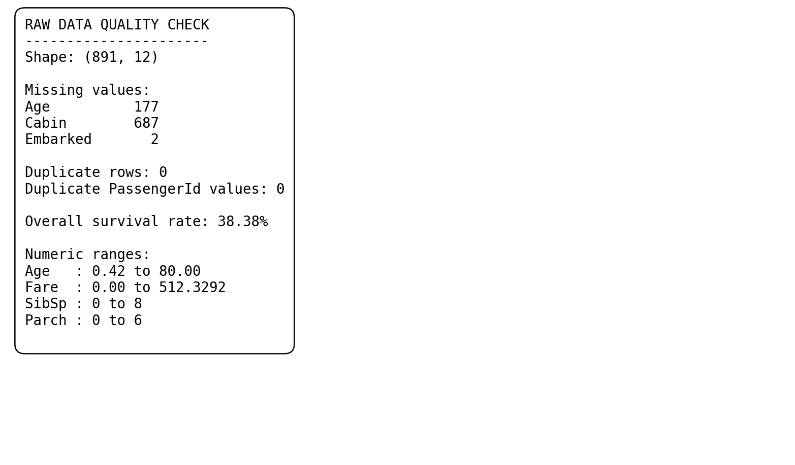
Figure 1. Representative initial data-quality output generated from the raw dataset.

5. Missing-Value Analysis and Treatment
Missing values were assessed column by column. The raw dataset contains missing observations in Age, Cabin, and Embarked. These are not equivalent problems: Age is an important numerical feature, Cabin is missing for the majority of passengers, and Embarked has only two missing values.
Column | Missing records | Missing %
Age | 177 | 19.87%
Cabin | 687 | 77.10%
Embarked | 2 | 0.22%

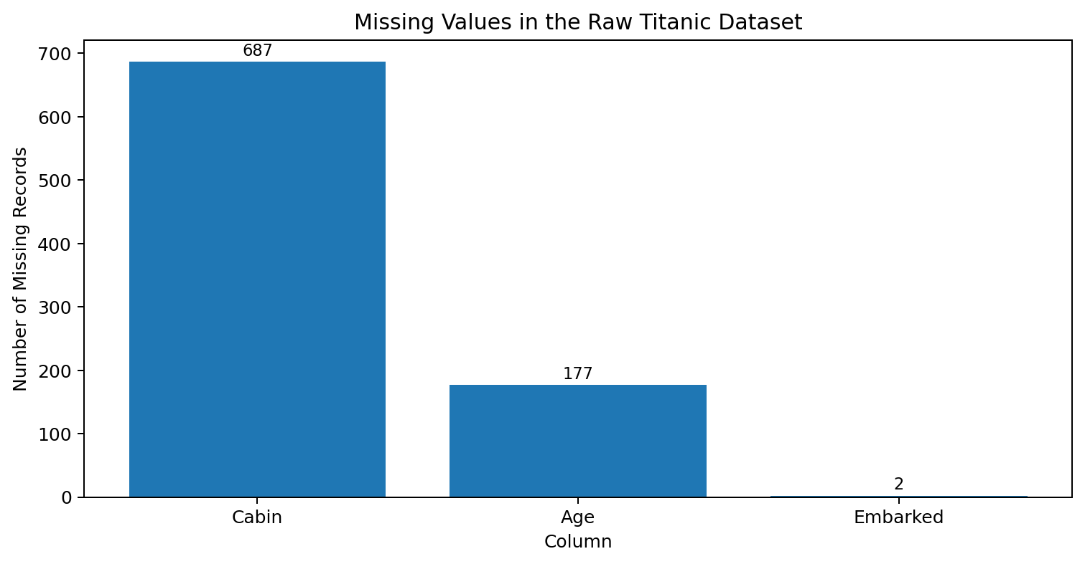
Figure 2. Missing-value profile before preprocessing.

5.1 Age
Age has 177 missing values (19.87%). Dropping every row with a missing Age would reduce the training sample substantially. A median-based imputation is used because the median is less sensitive to the right-skew and extreme observations that can occur in age-related data.
age_median = df["Age"].median()
df["Age"] = df["Age"].fillna(age_median)
The observed median Age is 28.00 years. In a production machine-learning pipeline, the median should be learned from the training split only and then applied to validation/test data to avoid data leakage.

5.2 Cabin
Cabin is missing for 687 of 891 records (77.10%). Directly replacing every missing Cabin with a guessed cabin number would create false information. Instead, the preprocessing creates a binary indicator CabinKnown, where 1 means a cabin value was recorded and 0 means it was not recorded.
df["CabinKnown"] = df["Cabin"].notna().astype(int)
This preserves the information contained in the presence or absence of a cabin record without inventing specific cabin identifiers.

5.3 Embarked
Embarked has only two missing records (0.22%). Because it is categorical and the missing proportion is very small, mode imputation is appropriate for this introductory workflow.
embarked_mode = df["Embarked"].mode()[0]
df["Embarked"] = df["Embarked"].fillna(embarked_mode)

6. Consistency and Validity Checks
Data cleaning is not limited to missing values. The workflow also checks for duplicate records, duplicate identifiers, impossible ranges, and inconsistent categorical formatting.
print("Duplicate rows:", df.duplicated().sum())
print("Duplicate PassengerId:", df["PassengerId"].duplicated().sum())
print(df["Sex"].value_counts(dropna=False))
print(df["Embarked"].value_counts(dropna=False))
# Standardize text fields
for col in ["Sex", "Embarked"]:
df[col] = df[col].astype(str).str.strip().str.lower()
No duplicate rows or duplicate PassengerId values were found. The raw categorical values are already largely standardized, but strip/lower normalization is included so that the pipeline remains robust if equivalent values such as 'Male', ' male ', or 'MALE' appear in a future version of the data.
Validation check | Observed result | Action
Duplicate rows | 0 | No removal required
Duplicate PassengerId | 0 | No correction required
Age range | 0.42–80.00 | No impossible ages observed
Fare range | 0.00–512.3292 | Investigate extreme values
Pclass | 1–3 | Valid according to data dictionary
Survived | 0–1 | Valid binary target

7. Outlier Detection and Treatment
Potential numerical outliers were evaluated using the interquartile range (IQR) rule. An observation below Q1 − 1.5×IQR or above Q3 + 1.5×IQR is flagged as a statistical outlier. A statistical outlier is not automatically an error; it may represent a legitimate rare observation.
Variable | Q1 | Q3 | Lower fence | Upper fence | Flagged
Age | 20.12 | 38.00 | -6.69 | 64.81 | 11
Fare | 7.91 | 31.00 | -26.72 | 65.63 | 116
SibSp | 0.00 | 1.00 | -1.50 | 2.50 | 46
Parch | 0.00 | 0.00 | 0.00 | 0.00 | 213

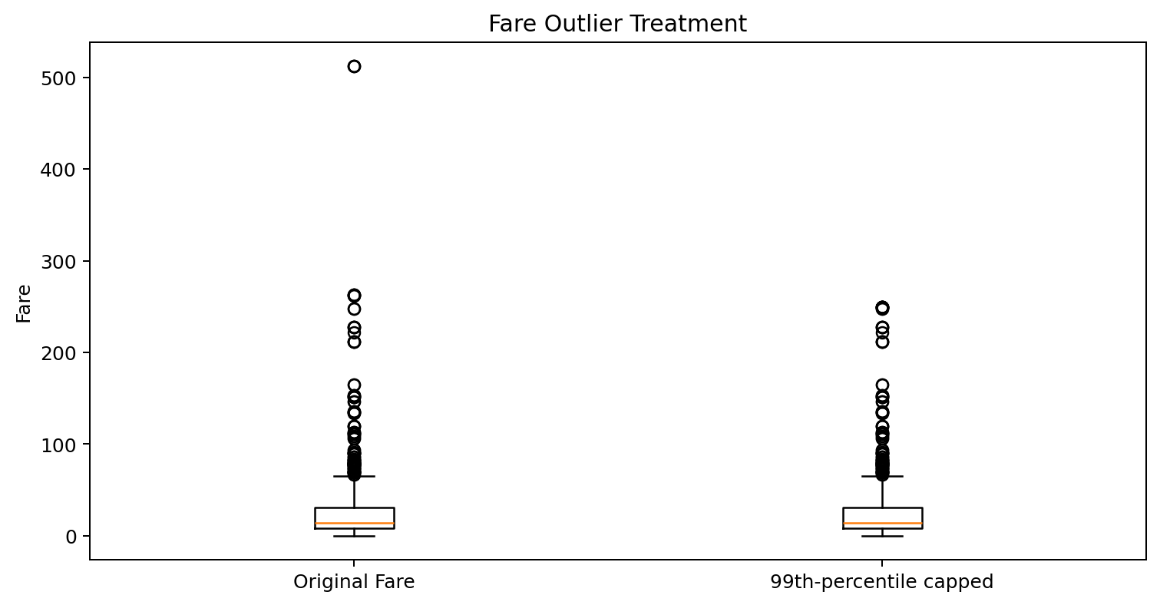
Figure 3. Fare distribution before and after 99th-percentile capping.
Fare is the clearest variable where extreme values can strongly affect scale-sensitive algorithms. The 99th percentile is approximately £249.01. Rather than deleting legitimate high-fare passengers, the report creates Fare_capped, which limits the influence of extreme values while retaining all 891 rows.
fare_cap = df["Fare"].quantile(0.99)
df["Fare_capped"] = df["Fare"].clip(upper=fare_cap)
SibSp and Parch also generate IQR flags because their distributions are concentrated near zero. These flags should not be treated as data-entry errors: having several relatives aboard is a meaningful passenger characteristic. Therefore, no rows are deleted solely because they are flagged by the mechanical IQR rule.
An alternative for skewed Fare values is a logarithmic transformation, which is also demonstrated:
df["Fare_log"] = np.log1p(df["Fare"])

8. Preprocessing for Further Analysis / Machine Learning

8.1 Feature selection
PassengerId is an identifier rather than a meaningful predictive feature. Name and Ticket contain useful information in some advanced workflows, but they require feature engineering and are not necessary for this Week 1 pipeline. Cabin is represented by CabinKnown because most cabin identifiers are missing.
model_df = df[[
"Survived", "Pclass", "Sex", "Age", "SibSp", "Parch",
"Fare_capped", "CabinKnown", "Embarked"
]].copy()

8.2 Categorical encoding
Machine-learning algorithms generally require numerical representations. One-hot encoding is used for Sex and Embarked so that categories are converted into separate binary features without imposing a false numeric ordering.
model_df = pd.get_dummies(
model_df,
columns=["Sex", "Embarked"],
drop_first=True
)
model_df = model_df.astype({
c: int for c in model_df.select_dtypes(include="bool").columns
})

8.3 Final missing-value verification
print(model_df.isna().sum())
print(model_df.shape)
After the selected preprocessing operations, the model-ready subset contains no missing values. The final dataset retains all 891 passenger rows rather than deleting records simply because they contain missing fields.

9. Impact of Preprocessing on Subsequent Analysis
Preprocessing choice | Benefit | Possible impact / limitation
Median Age imputation | Retains rows and provides a robust central estimate | Reduces natural age variability and can underestimate uncertainty
Mode Embarked imputation | Simple and appropriate for only two missing values | Introduces the most common category into missing records
CabinKnown indicator | Preserves missingness information without inventing cabin numbers | Does not recover the actual cabin/deck
Fare capping | Reduces influence of extreme fares | Can hide legitimate high-value observations
Fare log transform | Reduces right skew | Changes the scale and interpretation of Fare
One-hot encoding | Makes categories usable by ML models | Increases feature count
No deletion of IQR-flagged Parch/SibSp rows | Preserves meaningful passenger/family information | Extreme counts can still influence some models

These choices can change statistical estimates and model performance. For example, median imputation can make the Age distribution more concentrated around the median, while capping Fare reduces the leverage of expensive tickets. Therefore, preprocessing must be reported transparently and, for predictive modeling, should be fitted only on the training partition.

10. Before-and-After Quality Summary
Quality indicator | Before preprocessing | After preprocessing
Rows | 891 | 891
Selected model-ready columns | 12 (mixed types) | 10 (numeric only)
Missing values in selected features | 866 | 0
Duplicate rows in model-ready feature set (Section 10.1) | N/A (raw rows: 0 duplicates) | 111
Age missing | 177 | 0
Embarked missing | 2 | 0
Cabin information | 687 missing | CabinKnown indicator
Fare treatment | 0–512.3292 | 99th-percentile cap at 249.01

10.1 Note on Duplicate Rows in the Model-Ready Feature Set
Section 6 confirmed that the raw 891-row dataset contains zero duplicate rows and zero duplicate PassengerId values; that remains true throughout, since no rows were ever removed. The 111 figure above measures something different: it is the number of duplicate rows found within the reduced, model-ready feature table (df.duplicated().sum() run on model_df rather than on df). These are two distinct, individually correct measurements, not a contradiction. Once PassengerId, Name, Ticket and Cabin are dropped and Age/Fare are imputed and capped, many different passengers end up sharing identical values across the remaining nine features — for example, several third-class male passengers with the imputed median Age (28.0), no siblings/spouses, no parents/children, a similar capped Fare, no recorded cabin, and the same embarkation port become indistinguishable in feature space even though they are different people. This is a direct, concrete consequence of the preprocessing choices in Section 8: reducing columns and imputing missing values necessarily collapses some of the dataset's row-level uniqueness. It is not an error to correct, but it is worth flagging for later modelling — algorithms that are sensitive to repeated identical rows (e.g. certain distance-based methods, or a train/test split that happens to place duplicate feature rows on both sides) could be affected, so this should be checked again after any further feature engineering.

11. Descriptive Findings After Cleaning
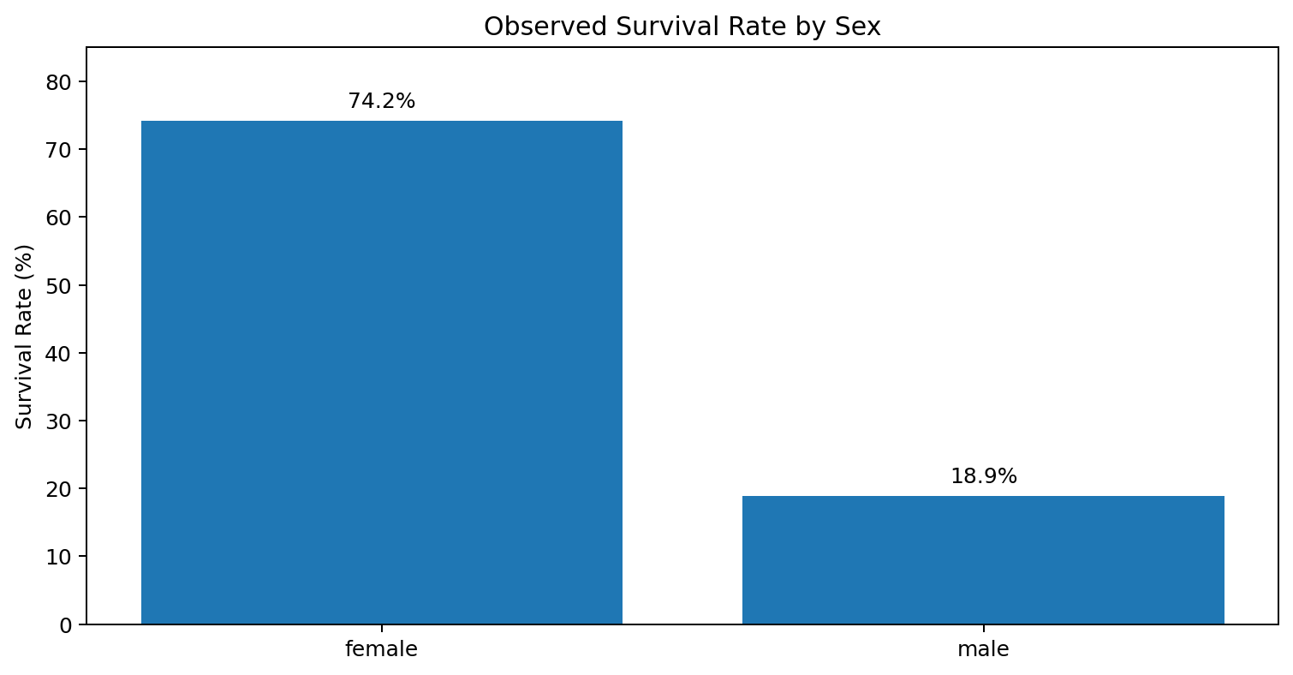
Figure 4. Survival rate by sex, shown as a descriptive check rather than a causal conclusion.
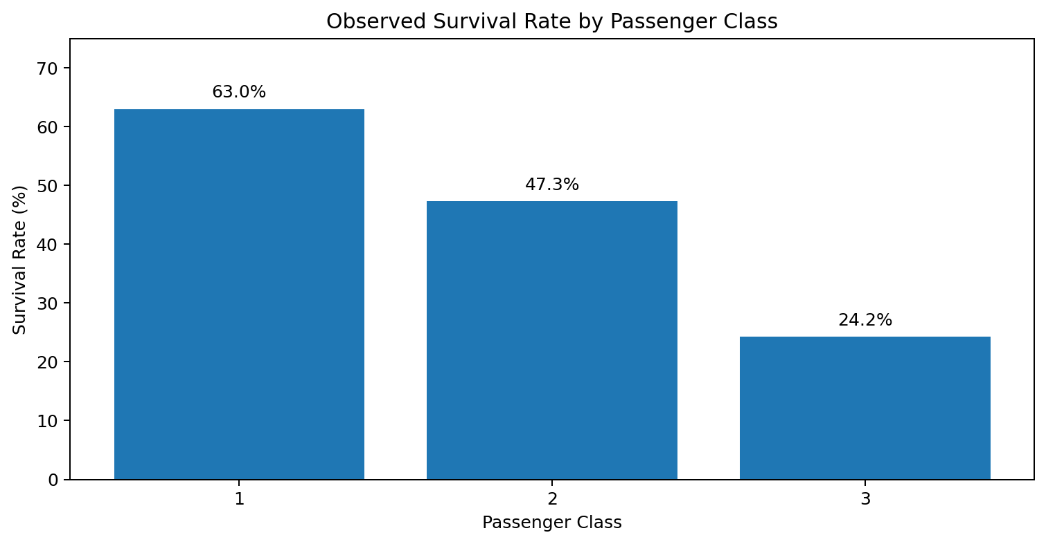
Figure 5. Survival rate by passenger class, shown as a descriptive check.
The overall observed survival rate is 38.38%. The descriptive breakdown shows approximately 74.2% survival for female passengers and 18.9% for male passengers. By passenger class, observed survival is 63.0% in first class, 47.3% in second class, and 24.2% in third class. These are descriptive associations in the dataset and should not be interpreted as causal effects.

12. Challenges Faced and How They Were Overcome
Large proportion of missing Cabin values: Rather than dropping most of the dataset or inventing cabin values, a CabinKnown indicator was created.
Missing Age values: Median imputation was selected to retain records while limiting sensitivity to skew and extreme values.
Extreme Fare values: IQR detection was used for diagnosis. Legitimate extremes were retained, while a 99th-percentile capped feature and log transformation were provided as controlled alternatives.
Categorical data: Text normalization and one-hot encoding were used to make categories consistent and machine-learning compatible.
Avoiding data loss: Rows were not deleted merely because they contained missing values or IQR flags; every removal or transformation was treated as a decision requiring justification.
Reproducibility: Data acquisition and preprocessing were written as executable Python code so the workflow can be repeated.

13. Recommended Best Practices for Future Analysis
- Split the dataset into training and validation/test sets before fitting imputers, scalers, or encoders.
- Use sklearn Pipeline and ColumnTransformer for production-quality preprocessing.
- Track the number of rows and missing values after every transformation.
- Keep the raw dataset unchanged and save the cleaned dataset as a separate artifact.
- Investigate domain-specific validity rules before deleting statistical outliers.
- Compare model performance with and without transformations such as Fare capping or log transformation.
- Document all assumptions so another analyst can reproduce the workflow.

14. Complete Python Code
import pandas as pd
import numpy as np
import matplotlib.pyplot as plt
# 1. Acquire data
url = "https://raw.githubusercontent.com/pplonski/datasets-for-start/refs/heads/master/Titanic/train.csv"
df = pd.read_csv(url)
# 2. Initial exploration
print(df.shape)
print(df.head())
print(df.info())
print(df.describe(include="all").T)
# 3. Missing-value analysis
missing = df.isna().sum()
missing_pct = (missing / len(df) * 100).round(2)
print(pd.DataFrame({"Missing": missing, "Percent": missing_pct}))
# 4. Duplicate checks
print("Duplicate rows:", df.duplicated().sum())
print("Duplicate PassengerId:", df["PassengerId"].duplicated().sum())
# 5. Missing-value treatment
df["Age"] = df["Age"].fillna(df["Age"].median())
df["Embarked"] = df["Embarked"].fillna(df["Embarked"].mode()[0])
# Cabin: preserve missingness as information
df["CabinKnown"] = df["Cabin"].notna().astype(int)
# 6. Text normalization
for col in ["Sex", "Embarked"]:
df[col] = df[col].astype(str).str.strip().str.lower()
# 7. Outlier assessment with IQR
for col in ["Age", "Fare", "SibSp", "Parch"]:
q1 = df[col].quantile(0.25)
q3 = df[col].quantile(0.75)
iqr = q3 - q1
lower = q1 - 1.5 * iqr
upper = q3 + 1.5 * iqr
flags = ((df[col] < lower) | (df[col] > upper)).sum()
print(col, "outlier flags:", flags)
# 8. Fare treatment alternatives
fare_cap = df["Fare"].quantile(0.99)
df["Fare_capped"] = df["Fare"].clip(upper=fare_cap)
df["Fare_log"] = np.log1p(df["Fare"])
# 9. Select model-ready features
model_df = df[[
"Survived", "Pclass", "Sex", "Age", "SibSp", "Parch",
"Fare_capped", "CabinKnown", "Embarked"
]].copy()
# 10. Encode categorical features
model_df = pd.get_dummies(
model_df,
columns=["Sex", "Embarked"],
drop_first=True
)
model_df = model_df.astype({
c: int for c in model_df.select_dtypes(include="bool").columns
})
# 11. Final validation
print("Final shape:", model_df.shape)
print("Final missing values:")
print(model_df.isna().sum())
# 12. Save cleaned data
model_df.to_csv("titanic_cleaned_week1.csv", index=False)

15. Conclusion
The Week 1 objective was achieved by taking a publicly available Titanic dataset through a structured data-quality workflow. The report demonstrates acquisition, exploration, missing-value handling, consistency checks, outlier assessment, feature construction, categorical encoding, and final validation.
The most important lesson is that data cleaning is not simply the removal of problematic records. Each issue requires a decision based on the meaning of the variable, the amount of missingness, the potential impact on analysis, and the risk of introducing bias. The resulting dataset is suitable as a starting point for exploratory analysis and supervised machine-learning experiments, provided that train/test leakage is controlled in later modeling.

16. References
- Kaggle. Titanic – Machine Learning from Disaster. https://www.kaggle.com/competitions/titanic/data
- Public raw CSV mirror used for reproducible acquisition: https://raw.githubusercontent.com/pplonski/datasets-for-start/refs/heads/master/Titanic/train.csv
- McKinney, W. Python for Data Analysis. O'Reilly Media.
- Pedregosa et al. Scikit-learn: Machine Learning in Python. Journal of Machine Learning Research, 2011.

