WEEK 2 TASK
Exploratory Data Analysis and Visualization
UCI Wine Recognition Dataset

Student | Devarakonda Vignesh varsha
Course / Internship | Virtual Data Science with Python Trainee
Week | 2
Tools | Python, Pandas, Matplotlib, Seaborn, scikit-learn
Submission | Exploratory Data Analysis Report

Prepared as a structured EDA report with reproducible code, visual analysis, and critical interpretation.

1. Executive Summary
This report presents an exploratory data analysis (EDA) of the UCI Wine Recognition Dataset. The dataset contains 178 wine samples described by 13 chemical measurements and grouped into three wine classes. The analysis uses Python and focuses on data quality, descriptive statistics, distributions, outliers, class-level differences, feature relationships, and visual patterns. The objective is not to build a predictive model, but to understand the structure of the data and identify relationships that could guide later machine-learning work.
The analysis found that the dataset is clean with no missing values and no duplicate rows. The three classes are moderately imbalanced (59, 71 and 48 samples). Several chemical features show strong relationships, and features such as flavanoids, proline, alcohol and color intensity show visible differences between classes. These patterns suggest that the chemical composition contains useful information for distinguishing wine origins/classes.

2. Dataset Selection and Background
The UCI Wine dataset was selected because it is a genuine public dataset with a manageable size for detailed EDA while still containing enough numerical variables to demonstrate univariate, bivariate and multivariate analysis. The original data represents chemical analysis of wines grown in the same region of Italy but derived from three different cultivars.
Dataset characteristic | Value
Source | UCI Machine Learning Repository – Wine
Samples | 178
Predictor features | 13 numerical chemical measurements
Target | 3 wine classes
Missing values | None reported
Task type | Classification / exploratory analysis
License | CC BY 4.0
The scikit-learn implementation used in this report is a standardized copy of the UCI dataset. It provides the same 178 samples and 13 features and is convenient for reproducible Python analysis.
from sklearn.datasets import load_wine
import pandas as pd
wine = load_wine(as_frame=True)
df = wine.frame
print(df.shape)
print(df.head())

3. EDA Methodology
1. Load the public dataset and convert it into a Pandas DataFrame.
2. Inspect shape, columns, data types, missing values and duplicate rows.
3. Generate descriptive statistics including count, mean, standard deviation, minimum, quartiles and maximum.
4. Examine class balance using counts and percentages.
5. Study distributions using histograms and compare selected features with boxplots.
6. Detect potential outliers using the 1.5 × IQR rule.
7. Compare feature distributions across wine classes.
8. Investigate relationships using scatter plots and a Pearson correlation matrix.
9. Aggregate feature values by class to compare group means.
10. Interpret the visual evidence and identify implications, limitations and possible next steps.

4. Initial Data Inspection
The final analysis table contains 178 rows and 13 chemical feature columns plus the class label. There are 0 missing feature values and 0 duplicate rows.
print(df.shape)
print(df.info())
print(df.isnull().sum())
print(df.duplicated().sum())
Check | Result | Meaning | Action
Rows | 178 | Small, manageable dataset | No sampling required
Features | 13 | All numerical chemical measurements | Suitable for numerical EDA
Missing values | 0 | No missing feature values detected | No imputation required
Duplicate rows | 0 | No exact duplicates detected | No duplicate removal required

5. Descriptive Statistics
Descriptive statistics provide the first numerical summary of the dataset. Mean and median describe central tendency, standard deviation measures dispersion, and quartiles help identify the middle 50% of observations.
summary = df[features].describe().T
print(summary[["count", "mean", "std", "min", "25%", "50%", "75%", "max"]])
Feature | Mean | Std. dev. | Min | Max
Alcohol | 13.00 | 0.81 | 11.03 | 14.83
Malic Acid | 2.34 | 1.12 | 0.74 | 5.80
Ash | 2.37 | 0.27 | 1.36 | 3.23
Alcalinity Of Ash | 19.49 | 3.34 | 10.60 | 30.00
Magnesium | 99.74 | 14.28 | 70.00 | 162.00
Total Phenols | 2.30 | 0.63 | 0.98 | 3.88
Flavanoids | 2.03 | 1.00 | 0.34 | 5.08
Nonflavanoid Phenols | 0.36 | 0.12 | 0.13 | 0.66
Proanthocyanins | 1.59 | 0.57 | 0.41 | 3.58
Color Intensity | 5.06 | 2.32 | 1.28 | 13.00
Hue | 0.96 | 0.23 | 0.48 | 1.71
Od280/Od315 Of Diluted Wines | 2.61 | 0.71 | 1.27 | 4.00
Proline | 746.89 | 314.91 | 278.00 | 1680.00

6. Class Distribution
The class counts are 59, 71, and 48 samples respectively. This means the classes are not perfectly balanced, although none is extremely rare. For exploratory analysis this imbalance is modest, but it should be considered in any later predictive modelling.
class_counts = df["target_name"].value_counts().sort_index()
print(class_counts)
print(class_counts / len(df) * 100)
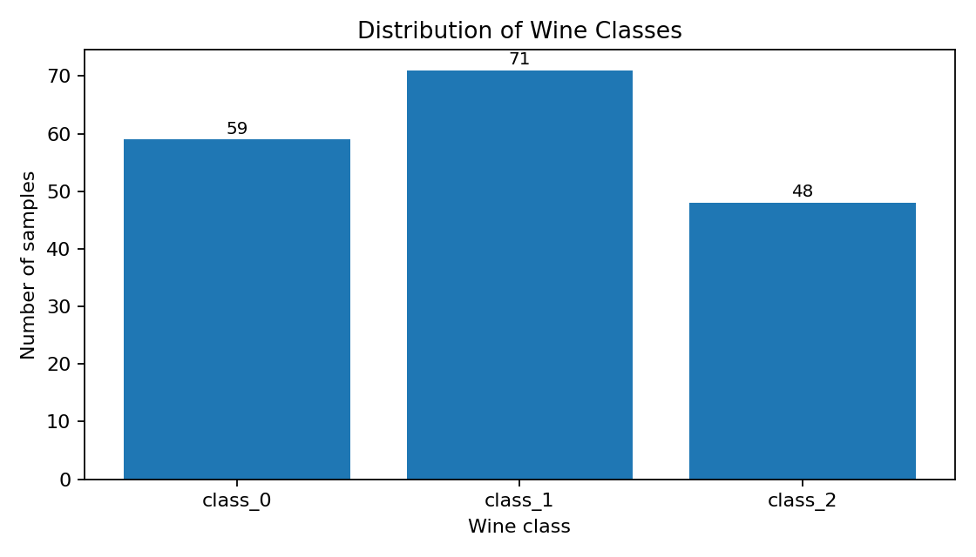
Figure 1. Number of observations in each wine class.

7. Univariate Analysis: Feature Distributions
Histograms were used to understand the shape, spread and concentration of individual variables. The selected examples show that the features operate on very different numerical scales. Proline has a much larger numerical range than alcohol or flavanoids, while malic acid is comparatively concentrated. Some distributions are approximately symmetric, while others show skewness or multiple concentration regions. Concretely, Proline spans from 278 to 1680 (a range of 1,402), Magnesium spans from 70 to 162 (a range of 92), while Alcohol spans only 11.03 to 14.83 (a range of 3.8) and Flavanoids 0.34 to 5.08 (a range of 4.74). This roughly 400-fold difference between Proline's range and Flavanoids' range means any algorithm sensitive to feature magnitude — K-Means, KNN, PCA, or gradient-based models — would let Proline and Magnesium dominate distance or gradient calculations unless features are standardized first.
fig, axes = plt.subplots(2, 2, figsize=(10, 7))
for ax, column in zip(axes.ravel(),
["alcohol", "malic_acid", "flavanoids", "proline"]):
ax.hist(df[column], bins=15, edgecolor="black")
ax.set_title(f"Distribution of {column}")
ax.set_xlabel(column)
ax.set_ylabel("Frequency")
plt.tight_layout()
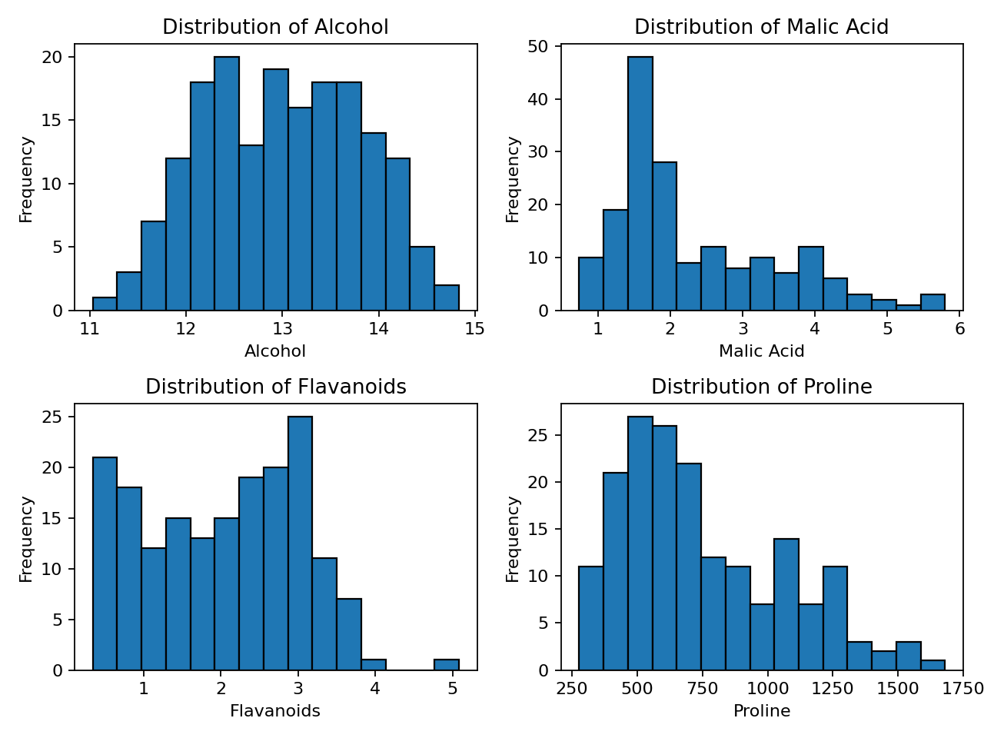
Figure 2. Histograms for four representative chemical measurements.

8. Outlier Analysis
Potential outliers were screened using the 1.5 × IQR rule. An observation is flagged when it is below Q1 − 1.5×IQR or above Q3 + 1.5×IQR. Such observations are not automatically errors; they may represent legitimate chemical variation. In this dataset the counts are modest: the most-affected features (Alcalinity of Ash, Magnesium, and Color Intensity) each have 4 flagged observations out of 178, or about 2.2% of samples, while Alcohol, Total Phenols, Flavanoids, Nonflavanoid Phenols, Od280/Od315 of Diluted Wines, and Proline have none. Notably, the three features that showed the strongest class separation in Section 9 (Alcohol, Flavanoids, Proline) are also the features with zero flagged outliers, so the outlier screen does not threaten the features the later analysis relies on most.
outlier_counts = {}
for column in features:
q1 = df[column].quantile(0.25)
q3 = df[column].quantile(0.75)
iqr = q3 - q1
lower = q1 - 1.5 * iqr
upper = q3 + 1.5 * iqr
outlier_counts[column] = ((df[column] < lower) |
(df[column] > upper)).sum()
Feature | Potential outliers
Alcalinity Of Ash | 4
Magnesium | 4
Color Intensity | 4
Malic Acid | 3
Ash | 3
Proanthocyanins | 2
Hue | 1
Alcohol | 0
Total Phenols | 0
Flavanoids | 0
Nonflavanoid Phenols | 0
Od280/Od315 Of Diluted Wines | 0
Proline | 0
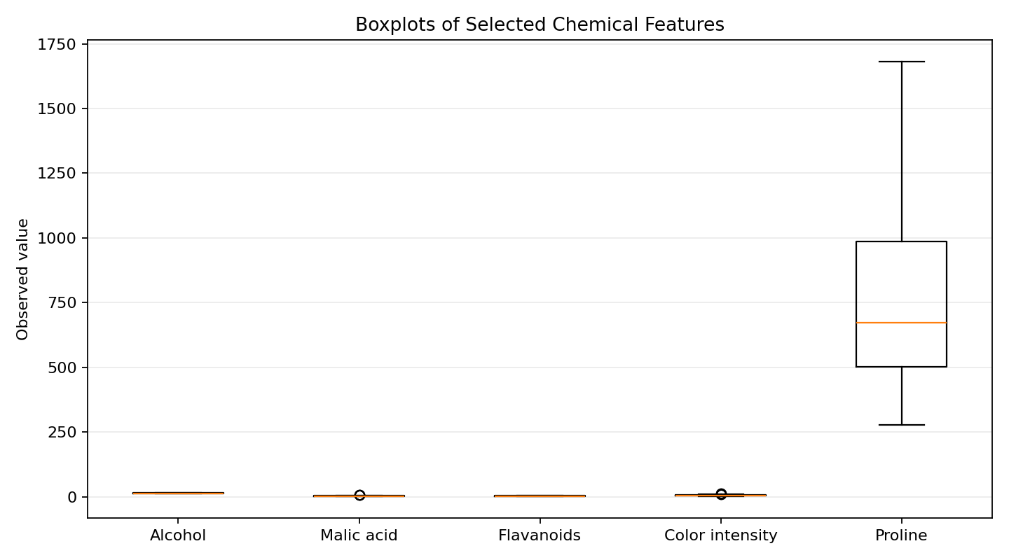
Figure 3. Boxplots highlighting spread and potential outlying observations.
Interpretation: features with visible points beyond the whiskers deserve attention in later modelling. However, the dataset documentation does not indicate that these observations are erroneous. Therefore, the EDA does not delete them.

9. Bivariate Analysis: Differences Between Classes
Comparing a numerical feature against the class label helps determine whether chemical measurements differ systematically among the three groups. The selected boxplots show noticeable class-level separation, especially for flavanoids and proline. Alcohol also shows a shift in its central tendency between groups. The actual class means make this concrete: mean Flavanoids is 2.98 for class_0, 2.08 for class_1, and only 0.78 for class_2 — nearly a 4-fold difference between the highest and lowest class. Mean Proline is 1115.71 for class_0 versus 519.51 for class_1, a gap of almost 600 units. Mean Alcohol is more modest but still separated: 13.74 (class_0), 12.28 (class_1) and 13.15 (class_2). These gaps are large relative to each feature's own standard deviation reported in Section 5, which is why these three features stand out as strong candidate predictors for later classification work.
selected = ["alcohol", "flavanoids", "proline"]
for column in selected:
groups = [df.loc[df.target_name == cls, column]
for cls in sorted(df.target_name.unique())]
plt.boxplot(groups)
plt.title(f"{column} by wine class")
plt.xlabel("Wine class")
plt.ylabel(column)
plt.show()
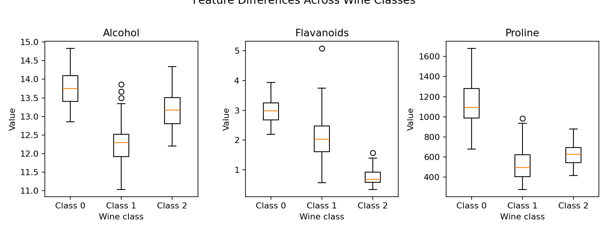
Figure 4. Class-wise boxplots for alcohol, flavanoids and proline.

10. Scatter Plot: Alcohol vs Proline
A scatter plot was used to examine two variables simultaneously and observe whether class membership follows visible regions. The plot shows that combinations of alcohol and proline can form distinguishable clusters. This does not prove that either feature alone causes class membership; it only shows an association in this dataset.
for cls in sorted(df["target_name"].unique()):
subset = df[df["target_name"] == cls]
plt.scatter(subset["alcohol"], subset["proline"], label=cls)
plt.xlabel("Alcohol")
plt.ylabel("Proline")
plt.title("Alcohol vs Proline by Wine Class")
plt.legend()
plt.show()
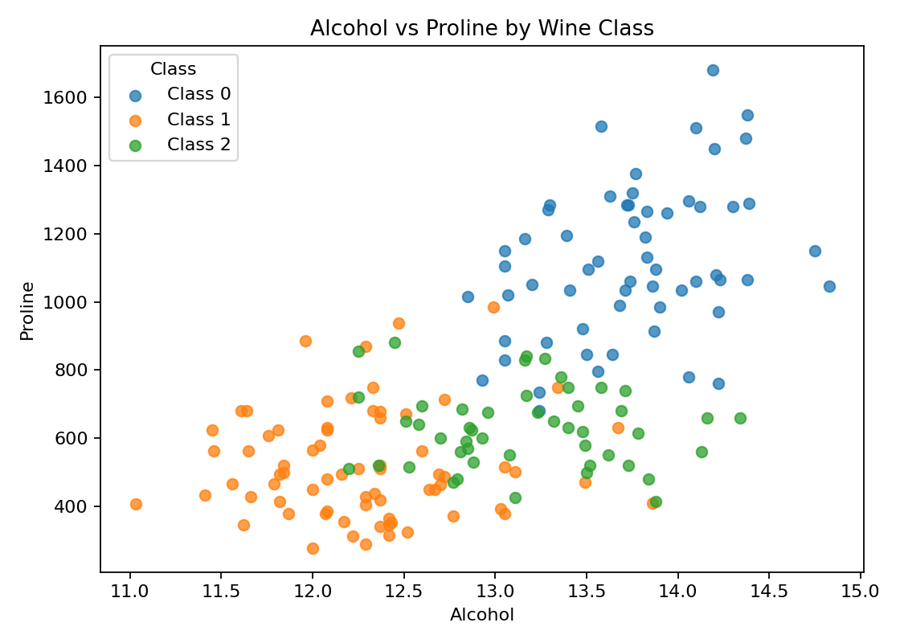
Figure 5. Relationship between alcohol and proline, separated by class.

11. Correlation Analysis
Pearson correlation was used to measure linear association between numerical features. Values close to +1 indicate strong positive linear association, values close to −1 indicate strong negative linear association, and values near 0 indicate weak linear association. Correlation should not be interpreted as causation.
corr = df[features].corr(method="pearson")
plt.figure(figsize=(11, 8))
sns.heatmap(corr, annot=True, fmt=".2f", cmap="coolwarm")
plt.title("Correlation Matrix")
plt.show()
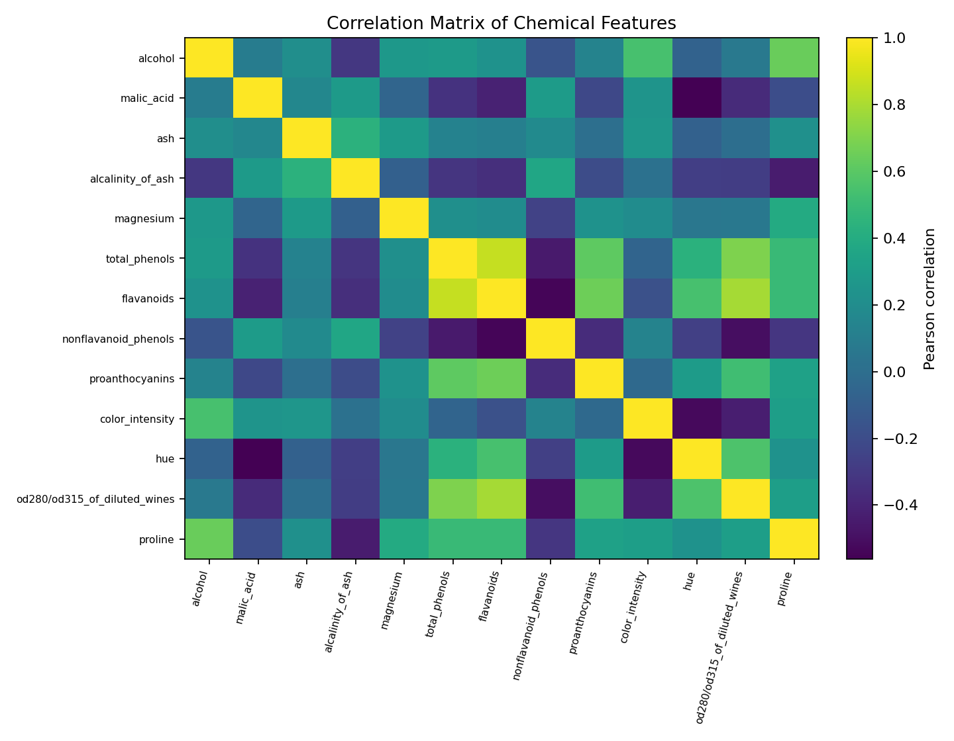
Figure 6. Pearson correlation matrix for the 13 chemical features.

11.1 Strongest Observed Relationships
Feature pair | Correlation | Direction
Total Phenols ↔ Flavanoids | 0.865 | Positive
Flavanoids ↔ Od280/Od315 Of Diluted Wines | 0.787 | Positive
Total Phenols ↔ Od280/Od315 Of Diluted Wines | 0.700 | Positive
Flavanoids ↔ Proanthocyanins | 0.653 | Positive
Alcohol ↔ Proline | 0.644 | Positive
Malic Acid ↔ Hue | -0.561 | Negative
Flavanoids ↔ Nonflavanoid Phenols | -0.538 | Negative
Color Intensity ↔ Hue | -0.522 | Negative
Nonflavanoid Phenols ↔ Od280/Od315 Of Diluted Wines | -0.503 | Negative
Total Phenols ↔ Nonflavanoid Phenols | -0.450 | Negative
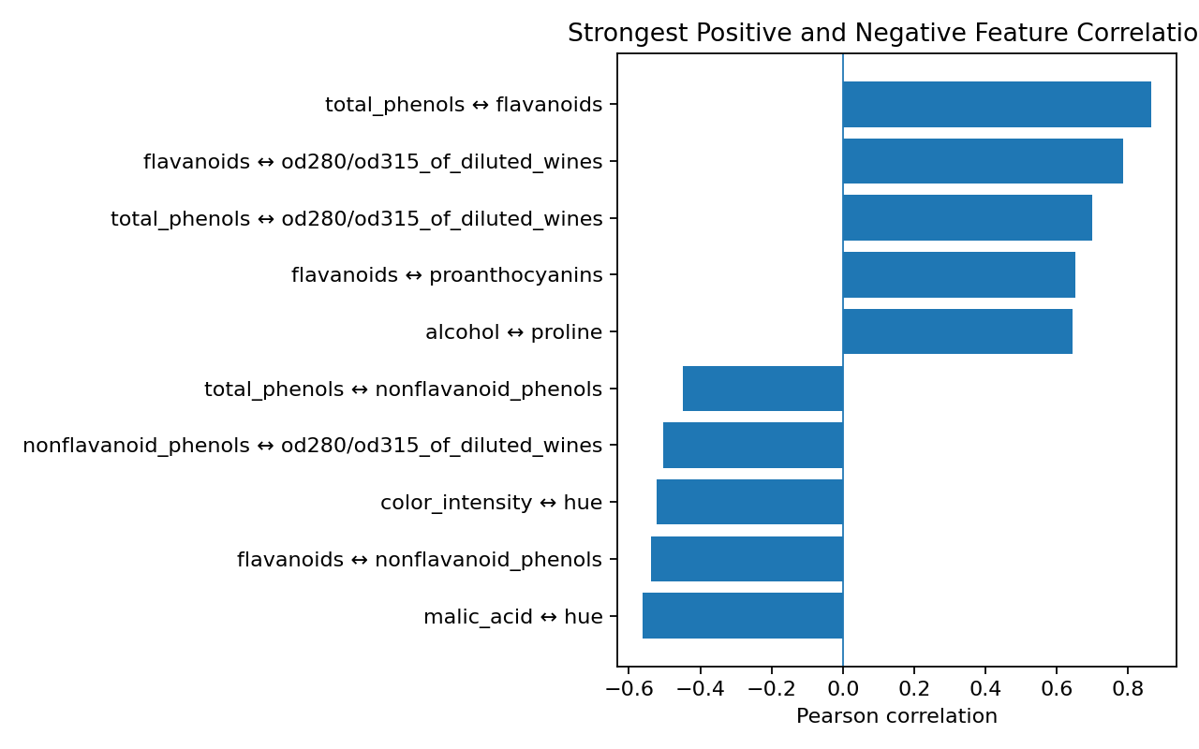
Figure 7. The strongest positive and negative pairwise correlations.
A strong correlation suggests that two measurements tend to move together in this dataset. This is useful for identifying redundant information and for understanding the structure of the chemical measurements before applying algorithms that can be affected by multicollinearity.

12. Aggregation and Class-Level Summary
A group-by aggregation was used to calculate the mean of every chemical feature within each wine class. This transformation reduces 178 individual observations into three class profiles and makes broad differences easier to compare.
class_means = df.groupby("target_name")[features].mean()
print(class_means)
# Example visualization
class_means[["alcohol", "flavanoids", "color_intensity", "proline"]].plot(kind="bar")
plt.ylabel("Mean value")
plt.title("Selected Feature Means by Class")
plt.legend(title="Feature")
plt.show()
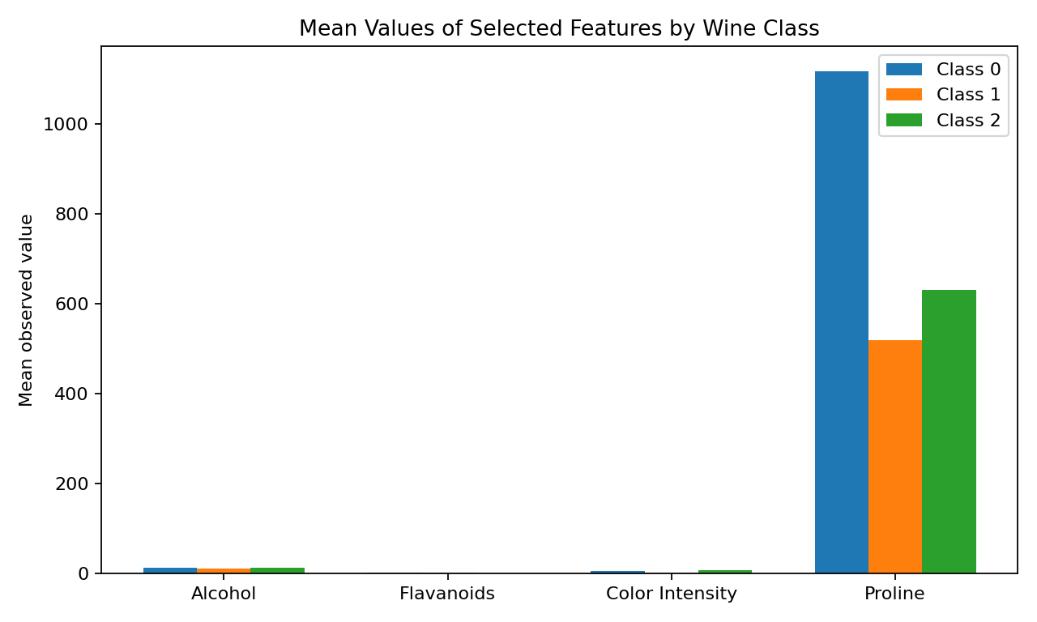
Figure 8. Mean values of selected features across the three wine classes.

13. Key Findings
- Clean dataset: No missing values and no duplicate rows were detected, so no imputation or duplicate removal was necessary.
- Moderate class imbalance: The classes contain 59, 71 and 48 observations. The imbalance is noticeable but not severe for exploratory work.
- Different feature scales: Chemical measurements vary substantially in numerical range, which would make scaling important for many distance- or gradient-based models.
- Class separation: Flavanoids, proline and alcohol show large differences among classes — mean Flavanoids ranges from 0.78 (class_2) to 2.98 (class_0), and mean Proline ranges from 519.51 (class_1) to 1115.71 (class_0) — suggesting strong discriminative information for later classification work.
- Strong correlations: Several chemical features are strongly related, indicating that some measurements contain overlapping information.
- Potential outliers: The IQR method flags potential outliers in several variables. They were retained because an outlier is not automatically a data error.
- Multivariate structure: The alcohol-versus-proline scatter plot shows class-dependent clustering, illustrating why examining variables jointly is valuable.

14. Critical Interpretation and Discussion
EDA is useful because it reveals patterns before a model is selected. In this dataset, the strongest insight is that the three wine classes are associated with different chemical profiles. The differences are not limited to one variable; several measurements shift together. This supports the idea that wine origin/class can be reflected in a multivariate chemical signature.
At the same time, the analysis should not overstate the results. The dataset is relatively small and comes from a specific experimental context. Observed correlations describe this sample and do not establish causal relationships. The classes also represent cultivars rather than a universal quality score, so the findings should not be interpreted as saying that one class is inherently 'better' wine.
The analysis also demonstrates why visualization and numerical summaries should be used together. A mean alone can hide skewness or outliers, while a plot without summary statistics can make comparisons harder to quantify. Combining both gives a more reliable understanding.

14.1 Concrete Impact on Preprocessing and Later Modelling
These EDA results have direct, specific consequences for how the data should be preprocessed before any model is built, rather than being observations that stand apart from later work.
- Feature scaling is not optional: the 13 features span very different numeric scales — Proline reaches into the hundreds (278–1680) while Nonflavanoid Phenols stays under 1 (0.13–0.66). Skipping standardization would let Proline and Magnesium dominate a K-Means or KNN model regardless of how informative the smaller-scale features are, so a StandardScaler (or similar) step is a direct requirement flowing from Section 7, not a generic best practice.
- Multicollinearity must be handled: Total Phenols and Flavanoids are strongly correlated (r = 0.865, Section 11.1). Including both as independent predictors in a linear model risks multicollinearity; a later modelling phase should drop one of the pair, combine them, or use a regularized model (Ridge/Lasso) or PCA to absorb the redundancy.
- Class imbalance affects the modelling plan: the classes are imbalanced (71/59/48, roughly a 1.5:1 ratio between the largest and smallest). Any later train-test split should be stratified, and evaluation should look beyond raw accuracy (e.g. macro-averaged F1), so the smaller class_2 (48 samples, 27% of the data) is not effectively ignored by a model that just predicts the majority class more often.
- Outliers do not threaten the strongest predictors: the IQR screen (Section 8) flagged at most 4 observations (2.2%) in any feature, and zero in Alcohol, Flavanoids or Proline — the same three features identified in Section 9 as the strongest class predictors. This means the features most later work will likely rely on do not need an outlier-robust transformation first, while Alcalinity of Ash, Magnesium and Color Intensity should be watched if they are used in a distance-based model.

15. Data Transformations Performed
Transformation | Purpose
Target decoding | Numeric target codes were mapped to readable class labels (class_0, class_1, class_2).
Column normalization | Column names were made code-friendly by replacing spaces with underscores where necessary.
Group aggregation | Group-by means were calculated by wine class for comparative visualization.
Correlation matrix | Pearson correlations were calculated across all numerical chemical features.
Outlier screening | IQR thresholds were calculated for each feature without deleting observations.

16. Reproducibility and Recommended Workflow
The analysis can be reproduced in a standard Python environment. Install the required packages, load the dataset using scikit-learn, and execute the analysis cells in order. For an assignment submission, keeping the notebook/script alongside the report is recommended.
pip install pandas matplotlib seaborn scikit-learn
# Core imports
import pandas as pd
import matplotlib.pyplot as plt
import seaborn as sns
from sklearn.datasets import load_wine
wine = load_wine(as_frame=True)
df = wine.frame
Suggested project structure:
week2_eda/
├── week2_eda.py
├── week2_eda_report.docx
├── figures/
│ ├── 01_class_distribution.png
│ ├── 02_distributions.png
│ ├── 03_boxplots.png
│ └── ...
└── README.md

17. Limitations and Future Work
- The dataset is small compared with real industrial datasets, so conclusions should not be generalized without validation.
- The EDA is descriptive; it does not evaluate predictive performance.
- The IQR method identifies statistical outliers but cannot determine whether a measurement is scientifically incorrect.
- Pearson correlation captures linear relationships and may miss nonlinear dependencies.
- A future phase could standardize features and compare classification models such as logistic regression, k-nearest neighbors, decision trees and random forests using cross-validation.
- Principal Component Analysis (PCA) could be explored to visualize the 13-dimensional structure in two dimensions.

18. Conclusion
The Week 2 EDA successfully transformed a public chemical-analysis dataset into a structured set of statistical and visual insights. The dataset is clean, contains three moderately imbalanced classes, and exhibits meaningful differences and correlations among chemical features. Visualizations such as histograms, boxplots, scatter plots and a correlation heatmap make these patterns easier to understand than raw tables alone.
The most important outcome is not simply the plots themselves, but the reasoning attached to them: each visualization answers a specific analytical question, and each observed pattern is interpreted with appropriate caution. This provides a strong foundation for later machine-learning or deeper statistical analysis.

19. References
- UCI Machine Learning Repository — Wine Dataset, Dataset ID 109. https://archive.ics.uci.edu/dataset/109/wine
- scikit-learn documentation — load_wine dataset documentation. https://scikit-learn.org/stable/modules/generated/sklearn.datasets.load_wine.html
- Pandas documentation — Pandas Python Data Analysis Library. https://pandas.pydata.org/
- Matplotlib documentation — Matplotlib visualization library. https://matplotlib.org/
- Seaborn documentation — Seaborn statistical visualization library. https://seaborn.pydata.org/

Appendix A — Compact End-to-End EDA Script
import pandas as pd
import matplotlib.pyplot as plt
import seaborn as sns
from sklearn.datasets import load_wine
# 1. Load
wine = load_wine(as_frame=True)
df = wine.frame.copy()
df["target_name"] = df["target"].map(dict(enumerate(wine.target_names)))
df = df.drop(columns=["target"])
# 2. Inspect
print(df.shape)
print(df.info())
print(df.isna().sum())
print(df.duplicated().sum())
print(df.describe())
# 3. Class distribution
print(df["target_name"].value_counts())
sns.countplot(data=df, x="target_name")
plt.title("Wine Class Distribution")
plt.show()
# 4. Histograms
df.hist(figsize=(12, 10), bins=15)
plt.tight_layout()
plt.show()
# 5. Boxplot
sns.boxplot(data=df.drop(columns="target_name"))
plt.xticks(rotation=75)
plt.title("Feature Boxplots")
plt.tight_layout()
plt.show()
# 6. Scatter
sns.scatterplot(data=df, x="alcohol", y="proline", hue="target_name")
plt.title("Alcohol vs Proline by Class")
plt.show()
# 7. Correlation
corr = df.drop(columns="target_name").corr()
sns.heatmap(corr, annot=True, fmt=".2f")
plt.title("Correlation Matrix")
plt.show()
# 8. Aggregation
print(df.groupby("target_name").mean(numeric_only=True))

