WEEK 3 TASK
Unsupervised Learning and Clustering Analysis
Iris Flower Dataset
Student | Devarakonda Vignesh varsha
Course / Internship | Virtual Data Science with Python Trainee
Week | 3
Tools | Python, Pandas, Scikit-learn, Matplotlib, SciPy
Methods | K-Means + Hierarchical Clustering

1. Introduction
I approached this week's task as a small practical clustering exercise rather than treating it as only a coding activity. The aim was to see whether a computer can find useful groups in a dataset when the correct group names are not given to the algorithm. For this reason, I selected the public Iris dataset. It has only four numerical measurements, so the effect of preprocessing and the clustering method can be understood clearly.
K-Means was used as the main algorithm. I tested several values of k before settling on a three-cluster solution for the detailed analysis. I also used hierarchical clustering as a cross-check. The known flower species were not used while fitting K-Means; they were used only afterwards to help understand what the discovered groups look like.

2. Dataset Selection
The Iris dataset contains 150 observations of iris flowers. Each observation records sepal length, sepal width, petal length and petal width. The original dataset also contains three species labels: setosa, versicolor and virginica. Since this is an unsupervised task, the four measurements were treated as the input data and the species labels were kept aside.
Item | Details
Observations | 150
Numerical features | 4
Known species | 3
Missing values | None
Dataset type | Public benchmark dataset
from sklearn.datasets import load_iris
iris = load_iris(as_frame=True)
df = iris.frame.copy()
print(df.shape)
print(df.head())

3. What Makes This an Unsupervised Problem?
In supervised learning, the model is trained using a known target. Here, I deliberately did not give K-Means the species column. Instead, the algorithm only sees the four measurements and tries to arrange similar observations into groups. This makes the task useful for understanding how clustering can discover structure that may not have been labelled in advance.
K-Means works by placing k centroids in the feature space and repeatedly assigning observations to the nearest centroid and updating the centroids. The process continues until the assignments become stable or the maximum number of iterations is reached.

4. Data Preprocessing
All four features are numerical, so no categorical encoding was required. I checked the dataset and found no missing values. The important preprocessing step was standardization. Measurements such as petal length and sepal width have different ranges, and distance-based clustering can be affected by those differences.
from sklearn.preprocessing import StandardScaler
features = [
"sepal length (cm)", "sepal width (cm)",
"petal length (cm)", "petal width (cm)"
]
X = df[features]
scaler = StandardScaler()
X_scaled = scaler.fit_transform(X)
StandardScaler transforms each feature so that it has a mean close to 0 and a standard deviation close to 1. This gives each measurement a more comparable influence on Euclidean distance.

5. Deciding the Number of Clusters
Choosing k is one of the practical decisions in K-Means. I did not want to choose the number only because the dataset is commonly described as having three species. I first compared k values from 2 through 6 using the elbow curve and silhouette score.
from sklearn.cluster import KMeans
from sklearn.metrics import silhouette_score
for k in range(2, 7):
model = KMeans(n_clusters=k, random_state=42, n_init=20)
labels = model.fit_predict(X_scaled)
print(k, model.inertia_, silhouette_score(X_scaled, labels))
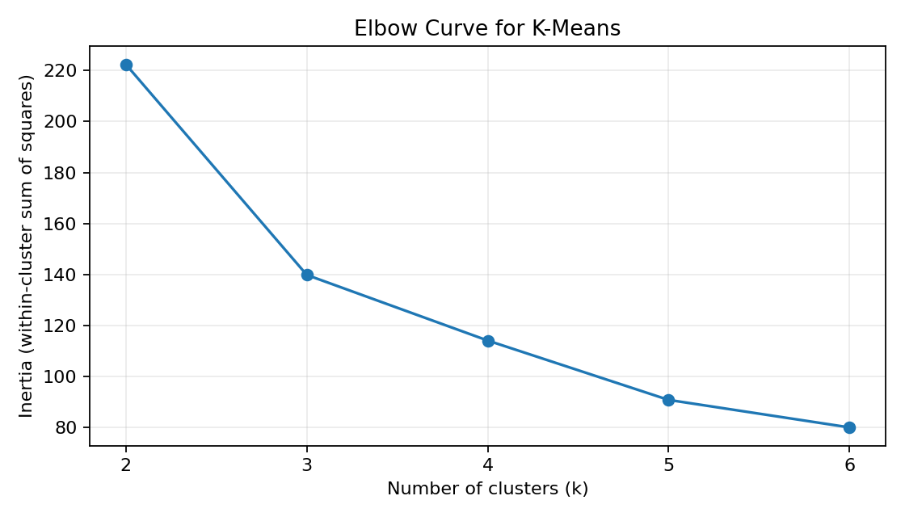
Figure 1. Elbow curve for candidate values of k.
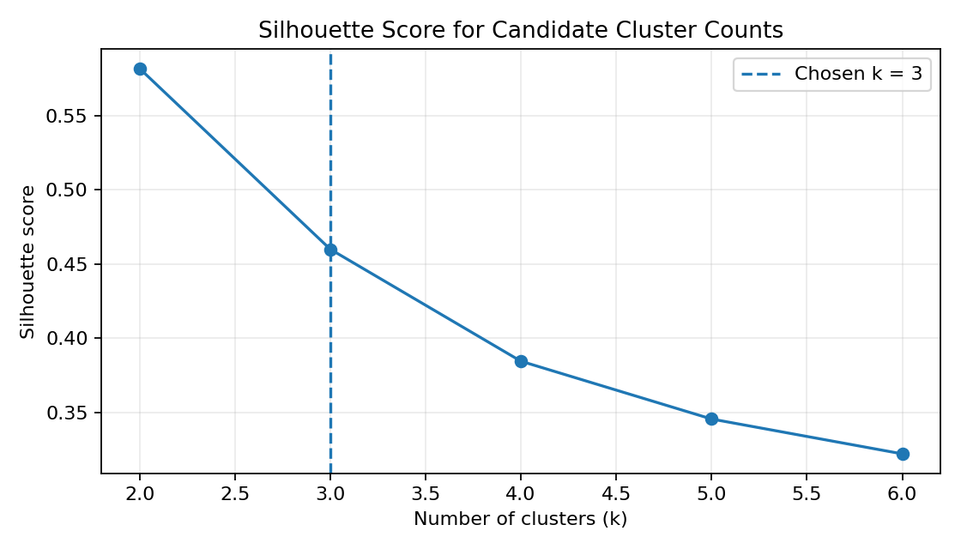
Figure 2. Silhouette score for candidate values of k.
The silhouette results gave the following approximate scores: k=2: 0.582, k=3: 0.460, k=4: 0.384, k=5: 0.346, k=6: 0.322. The highest score was obtained at k=2. However, the three-cluster solution also has a strong silhouette score (0.460) and gives a useful, interpretable segmentation that can be compared with the three known species. The elbow plot similarly shows that most of the large reduction in within-cluster variation happens in the first few clusters.

6. Applying K-Means
For the main report I used k=3. I set random_state=42 so that the result can be reproduced, and n_init=20 so that K-Means tries multiple initial centroid configurations rather than relying on one starting position.
kmeans = KMeans(
n_clusters=3,
random_state=42,
n_init=20
)
df["cluster"] = kmeans.fit_predict(X_scaled)
print(df["cluster"].value_counts().sort_index())
The resulting cluster sizes were {0: 53, 1: 50, 2: 47}. The silhouette score of the final three-cluster solution was approximately 0.460. This indicates reasonably meaningful separation, although a score below 1 also reminds us that the groups are not perfectly separated.

7. Visualizing the Clusters with PCA
The original clustering uses four dimensions, which cannot be shown directly on a normal two-dimensional graph. I therefore used PCA only as a visualization step. PCA reduces the four standardized features to two components while retaining as much variance as possible.
from sklearn.decomposition import PCA
pca = PCA(n_components=2)
X_pca = pca.fit_transform(X_scaled)
df["PC1"] = X_pca[:, 0]
df["PC2"] = X_pca[:, 1]
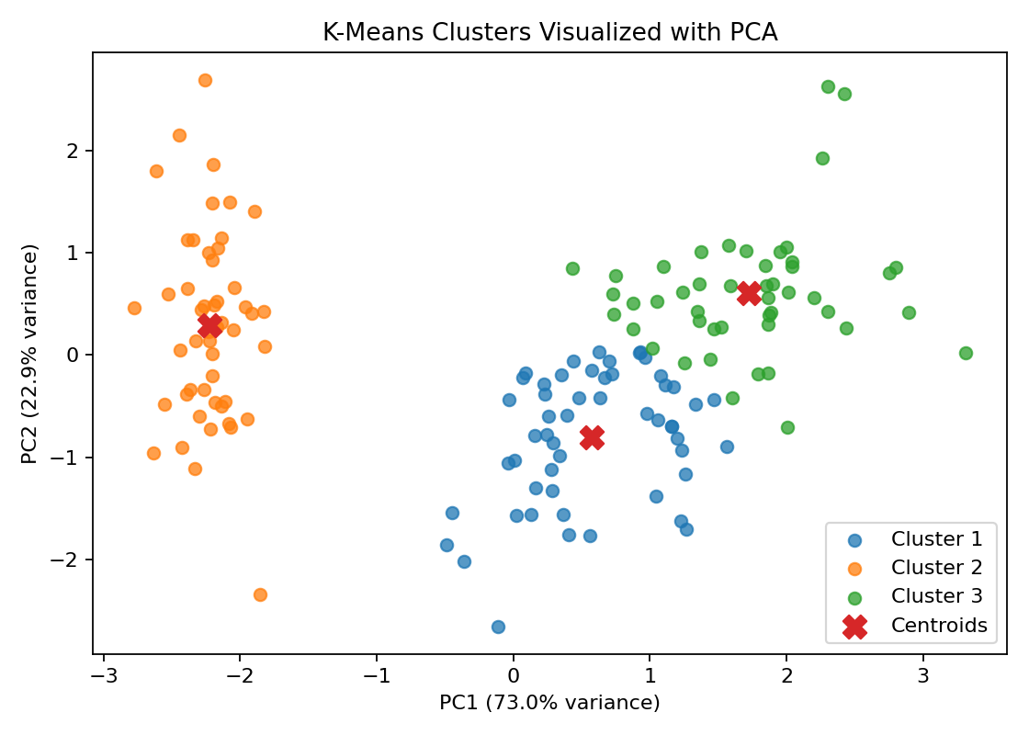
Figure 3. K-Means clusters projected onto two principal components (95.8% of variance shown).
The PCA plot makes the general structure easier to see. One group is clearly separated from the others, while two groups are closer together and show some overlap. This is a useful reminder that real data rarely forms perfectly separated circles.

8. Understanding the Cluster Profiles
After assigning clusters, I calculated the mean of each original measurement within every cluster. This aggregation helps answer a simple question: what does a typical observation inside each cluster look like?
cluster_means = df.groupby("cluster")[features].mean()
cluster_sizes = df["cluster"].value_counts().sort_index()
print(cluster_sizes)
print(cluster_means)
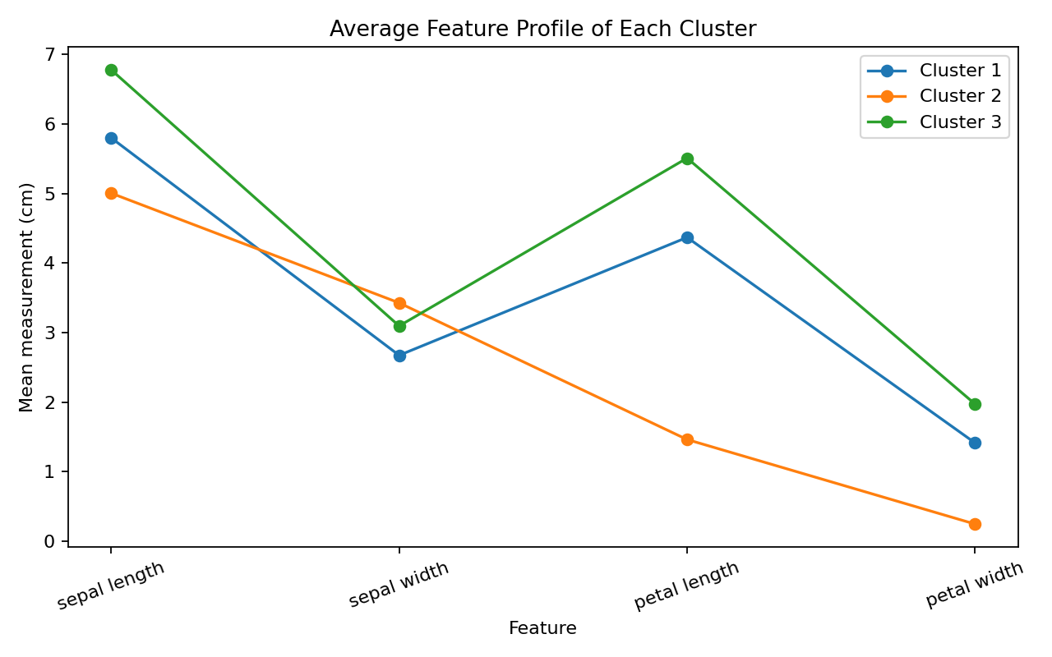
Figure 4. Average feature measurements for each discovered cluster.
Cluster | Size | Sepal L. | Sepal W. | Petal L. | Petal W.
Cluster 1 | 53 | 5.80 | 2.67 | 4.37 | 1.41
Cluster 2 | 50 | 5.01 | 3.43 | 1.46 | 0.25
Cluster 3 | 47 | 6.78 | 3.10 | 5.51 | 1.97
From the profiles, Cluster 2 is characterized by much smaller petal measurements than the other two. Cluster 1 and Cluster 3 both have substantially larger petals, with their averages being closer to each other. This explains the overlap seen in the PCA plot.

8.1 Distance-Based Outlier Check Within Clusters
The task brief for this kind of analysis usually expects some outlier work, and clustering actually gives a natural way to do it: instead of screening individual columns with the IQR rule the way I would for a normal dataset, I can check how far each flower sits from the centre of the cluster it was placed in. A point that sits unusually far from its own cluster's centroid is a reasonable candidate for a statistical outlier, since it means K-Means still felt this was the closest available group, but only just.
For each of the three clusters, I computed the Euclidean distance from every point to its own centroid in the standardized feature space, then flagged anything beyond the cluster's own mean distance plus two standard deviations — the same logic as a z-score cut-off, just applied per cluster rather than to the whole dataset at once.
dists = np.linalg.norm(X_scaled - kmeans.cluster_centers_[df["cluster"]], axis=1)
df["dist_to_centroid"] = dists
for c in sorted(df["cluster"].unique()):
sub = df[df["cluster"] == c]
threshold = sub["dist_to_centroid"].mean() + 2 * sub["dist_to_centroid"].std()
flagged = sub[sub["dist_to_centroid"] > threshold]
print(c, threshold, len(flagged))
Cluster | Mean distance to centroid | Outlier threshold | Flagged points
Cluster 1 (n=53) | 0.857 | 1.504 | 2
Cluster 2 (n=50) | 0.814 | 1.904 | 2
Cluster 3 (n=47) | 0.913 | 1.778 | 3

In total this flags 7 of 150 flowers (4.7%) as centroid outliers. Looking at which flowers actually got flagged made the result more interesting than I expected: the two outliers in Cluster 2 (the setosa cluster) turned out to still be genuine setosa flowers — they are just slightly less typical setosa than the other 48. The two outliers in Cluster 1 are versicolor flowers with a petal length/width of 3.5cm/1.0cm and 3.3cm/1.0cm, noticeably smaller than that cluster's own average (4.37cm/1.41cm), which puts them right on the border with the setosa group. The three outliers in Cluster 3 are virginica flowers with petal lengths of 6.4–6.9cm, larger than that cluster's average of 5.51cm — essentially the largest flowers in the whole dataset.
As a second, independent check, I also looked at the per-point silhouette score (Section 5 only reported the cluster-level average). Two points come out with a slightly negative silhouette score, meaning they sit marginally closer to a neighbouring cluster than to their own: both are virginica flowers assigned to Cluster 3. This lines up with the centroid-distance finding above and with the PCA overlap noted in Section 7 — it is the same handful of borderline flowers showing up under three different checks (PCA visualization, centroid distance, and silhouette), which gives me more confidence that this is a real, structural overlap between versicolor and virginica rather than a one-off quirk of a single metric.
In plain terms: none of these 7 flagged flowers look like data-entry errors. They are just biologically in-between cases, which is exactly what I would expect near the edge of two naturally similar species. I did not remove them — the point of this check was to understand the clustering better, not to artificially shrink Cluster 1 and Cluster 3 by deleting anything inconvenient.

9. Hierarchical Clustering Cross-Check
I also tried hierarchical clustering using Ward linkage. Unlike K-Means, hierarchical clustering does not start by fixing centroids; it progressively merges observations or groups of observations. The dendrogram provides a useful visual way to inspect where natural splits may occur.
from scipy.cluster.hierarchy import linkage, dendrogram
Z = linkage(X_scaled, method="ward")
dendrogram(Z, truncate_mode="lastp", p=20)
plt.title("Hierarchical Clustering Dendrogram")
plt.show()
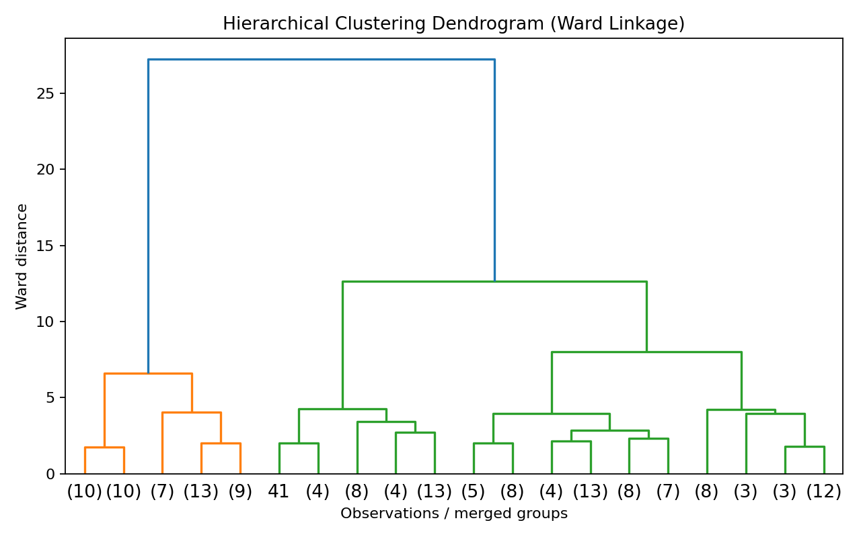
Figure 5. Hierarchical clustering using Ward linkage.
The dendrogram broadly supports the same story as K-Means: there is a clearly separated group and two groups that are more closely related. Using a second method gives additional confidence that the observed structure is not simply an artifact of one algorithm.

10. Comparing the Clusters with the Original Species
Only after clustering, I compared the cluster assignments with the original species labels. This is useful for interpretation and evaluation, but it is important to be clear that these labels were not supplied to K-Means.
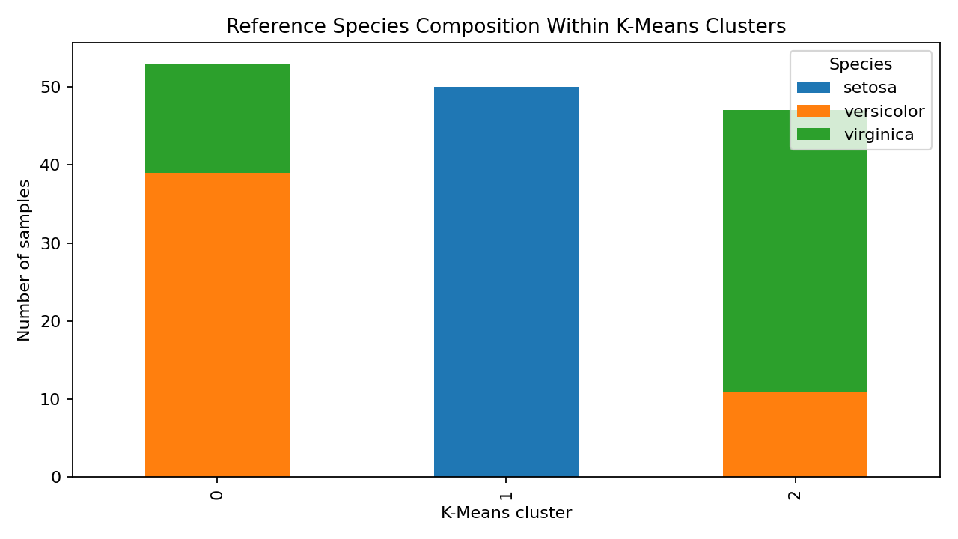
Figure 6. Original species composition inside the discovered clusters; labels are used only after clustering.
The comparison shows a strong correspondence between one cluster and setosa, while the other two groups contain more mixing between versicolor and virginica. The exact numbers make this much clearer than a description alone:
Cluster | Setosa | Versicolor | Virginica
Cluster 1 | 0 | 39 | 14
Cluster 2 | 50 | 0 | 0
Cluster 3 | 0 | 11 | 36

Cluster 2 is a perfect, 100% match for setosa — all 50 setosa flowers, and nothing else, ended up there. Cluster 1 is about 74% versicolor and 26% virginica, while Cluster 3 is the mirror image at roughly 77% virginica and 23% versicolor. So the mixing is not random or spread evenly; it is specifically versicolor and virginica trading places with each other, which matches what the cluster profile table in Section 8 already suggested about their petal measurements being close together.
To put one overall number on how well the clustering matched the species without ever seeing them, I calculated the Adjusted Rand Index (ARI) and Normalized Mutual Information (NMI) between the cluster labels and the true species: ARI = 0.620 and NMI = 0.660. Both scores run from 0 (no better than a random grouping) to 1 (a perfect match), so landing at roughly 0.62–0.66 is a solid, above-the-middle result — consistent with getting one species completely right and only confusing the other two, rather than getting everything wrong or everything right.

11. Cluster Interpretation
This section is deliberately about what each group means biologically, not the numbers — those are already in Sections 8 and 10.
- Cluster 1: A medium-to-large petal group, mostly versicolor flowers with a sizeable minority of virginica mixed in. It sits on one side of the overlap zone described in Section 7 and Section 8.1.
- Cluster 2: The small-petal group. This is the one that lines up almost perfectly with setosa — it is the most visually distinct cluster in the PCA plot, and biologically that tracks, since setosa petals are noticeably smaller than the other two species.
- Cluster 3: The largest-petal group on average, mostly virginica with some versicolor mixed in — the other side of the same overlap zone as Cluster 1. Together, Clusters 1 and 3 are really one continuous spread of medium-to-large petal sizes that K-Means has cut in two; the cut is reasonable, but it is not a hard biological boundary the way the setosa split is.

12. Possible Business and Research Applications
Although Iris is mainly an educational dataset, the same workflow can be applied to real problems. For example, a business could group customers by purchasing behaviour without pre-existing customer segments. A manufacturing company could cluster products according to quality measurements, and researchers could group biological samples based on measured characteristics. The specific lesson I'd carry over from this dataset is that a real clustering project should not expect every group to come out as cleanly separated as Cluster 2 did here — it is realistic to plan for at least one pair of blended, harder-to-separate groups, the way Clusters 1 and 3 turned out, and to have a follow-up plan (more features, a different algorithm, or manual review of borderline cases) ready for that situation rather than treating it as a failure of the method.
- Customer segmentation: identify groups with similar behaviour and design different marketing strategies.
- Manufacturing: group products or machines by operating characteristics and detect unusual groups.
- Research: discover naturally similar samples before assigning formal categories.
- Anomaly investigation: very small or isolated clusters can be examined for unusual observations, the same way Section 8.1 checked this dataset.

13. Limitations
- K-Means requires the number of clusters to be selected in advance.
- The algorithm is sensitive to feature scaling and can be affected by extreme observations.
- K-Means works best when groups are reasonably compact and distance-based separation is meaningful.
- The Iris dataset is small and clean, so the workflow is simpler than a real-world clustering problem.
- PCA is used here for visualization; the original K-Means model still used all four standardized features.
- Agreement with known species does not prove that K-Means has discovered a scientifically perfect classification. It is an evaluation reference.

14. Conclusion
This week's task gave me practical experience with unsupervised learning rather than just applying a clustering function and looking at the output. I first checked the data, standardized the measurements, tested different values of k, and then built a three-cluster K-Means solution. The clusters were visualized with PCA and their average feature values were compared to understand what makes each group different.
The most useful finding was that clustering can recover meaningful structure even without using the original labels. The setosa-like group is relatively easy to separate because its petal measurements are much smaller, whereas the other two groups overlap more. Hierarchical clustering showed a similar overall structure, which made the result more convincing. The outlier check in Section 8.1 and the ARI/NMI scores in Section 10 gave me a way to put a number on that overlap instead of just describing it: about 4.7% of flowers sit unusually far from their own cluster's centre, and the overall agreement with the true species (ARI 0.620) is good but clearly short of perfect — both of which match what the PCA plot already suggested visually. If I did this again, I'd want to try a second dataset with more than four features, since Iris is small and clean enough that most of the difficulty here came from two genuinely similar species rather than from messy data.

15. References
- UCI Machine Learning Repository — Iris Dataset. https://archive.ics.uci.edu/dataset/53/iris
- Scikit-learn — KMeans documentation. https://scikit-learn.org/stable/modules/generated/sklearn.cluster.KMeans.html
- Scikit-learn — StandardScaler documentation. https://scikit-learn.org/stable/modules/generated/sklearn.preprocessing.StandardScaler.html
- Scikit-learn — PCA documentation. https://scikit-learn.org/stable/modules/generated/sklearn.decomposition.PCA.html
- SciPy — Hierarchical clustering documentation. https://docs.scipy.org/doc/scipy/reference/cluster.hierarchy.html

Appendix A — Complete K-Means Code
import pandas as pd
import matplotlib.pyplot as plt
from sklearn.datasets import load_iris
from sklearn.preprocessing import StandardScaler
from sklearn.cluster import KMeans
from sklearn.decomposition import PCA
from sklearn.metrics import silhouette_score
# Load data
iris = load_iris(as_frame=True)
df = iris.frame.copy()
features = [
"sepal length (cm)", "sepal width (cm)",
"petal length (cm)", "petal width (cm)"
]
# Prepare and scale
X = df[features]
scaler = StandardScaler()
X_scaled = scaler.fit_transform(X)
# Test k values
for k in range(2, 7):
model = KMeans(n_clusters=k, random_state=42, n_init=20)
labels = model.fit_predict(X_scaled)
print(k, model.inertia_, silhouette_score(X_scaled, labels))
# Final clustering
kmeans = KMeans(n_clusters=3, random_state=42, n_init=20)
df["cluster"] = kmeans.fit_predict(X_scaled)
# PCA for visualization
pca = PCA(n_components=2)
X_pca = pca.fit_transform(X_scaled)
plt.scatter(X_pca[:, 0], X_pca[:, 1], c=df["cluster"])
plt.xlabel("PC1")
plt.ylabel("PC2")
plt.title("K-Means Clusters")
plt.show()
# Cluster profiles
print(df.groupby("cluster")[features].mean())

