-- ***********************

-- Name: Prince Jodhani

-- Student ID: 149455206

-- Date: 23-03-2022

-- Purpose: Lab 7 DBS311

-- ***********************

**-- Question 1 –** In this question you create a new database named seneca and a collection student. We store student data in this collection

**-- Q1 SOLUTION –**

db.seneca.insertOne({"first_name": "Sara", "last_name": "Stone","email": "s_stone@gmail.com","city": "Toronto","status": "full-time","gpa": 3.6,"program": "CPA"})

**-- Question 2 –** Write a command to check if the document has been created successfully.

**-- Q2 SOLUTION –**

* db.seneca.find()



* **db.seneca.find().forEach(printjson)**

* How many fields are in your document? **Total 8**
* Is there any new field added to your document? **Yes its called “_id”. It is auto generated.**
* If yes, what is the name of the field? **Name is “_id”.**
* Write a command to remove the document that you created in Question 1. (We have only one document at this time, but when removing documents make sure you will not remove some other documents if not needed. So, make sure your command will remove “Sara Stone” from your collection. For now, we assume that we do not have duplicate names in our database.)
* **db.seneca.deleteOne({"last_name": "Stone"})**

To see if the document is removed successfully, write a search statement to see if the document exists.

* No, The record is deleted.

**-- Question 3 –** We want to add some students to our collection, but this time, we define the value for the _id field.

**-- Q3 SOLUTION –**

* To add these students, we want to store these documents into a variable first. Define a variable named studarray and add these two document to the variable.

**studarray = [**

**{"_id": "1001","first_name": "Sara", "last_name": "Stone","email": "s_stone@email.com","city": "Toronto","status": "full-time","gpa": 3.8,"program": "CPA"},**

**{"_id": "1002","first_name": "Jack", "last_name": "Adam","email": "j_adam@email.com","city": "North York","status": "part-time","gpa": 3.6,"program": "CPA"}**

**]**

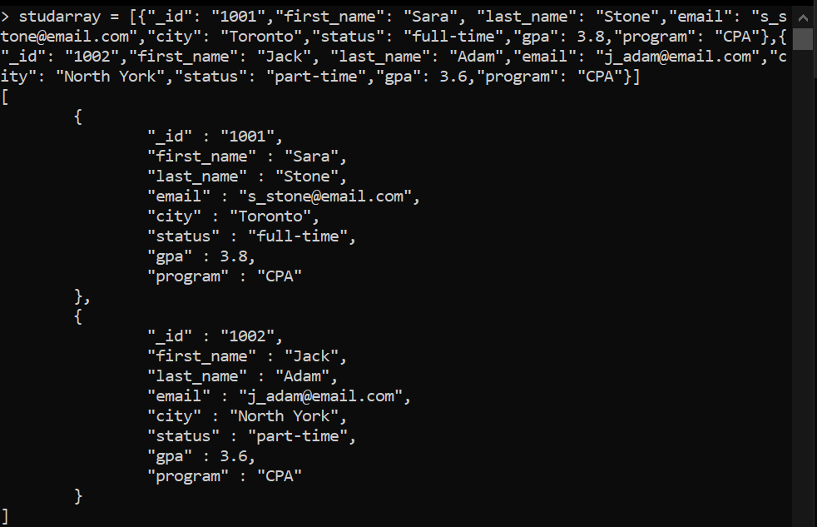

Now, use the studarray array to insert the documents to your collection student. Write your insert statement in the box bellow

* **db.student.insert(studarray)**

What message is displayed after you execute the insert statement. Copy the message in the following box:

**BulkWriteResult({**

**"writeErrors" : [ ],**

**"writeConcernErrors" : [ ],**

**"nInserted" : 2,**

**"nUpserted" : 0,**

**"nMatched" : 0,**

**"nModified" : 0,**

**"nRemoved" : 0,**

**"upserted" : [ ]**

**})**

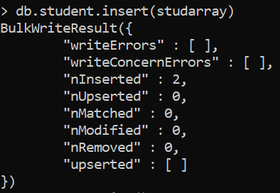

Write a statement that shows all documents inserted in your collection student:

* **db.student.find()**

**-- Question 4 –** Write a statement to remove all documents in the student collection.

**-- Q4 SOLUTION –**

* **db.student.remove()**

**-- Question 5 –** Write a statement to drop the database seneca. Before dropping a database, make sure your current database is the one you want to delete. For this question, we want to delete (drop) the seneca database.

**-- Q5 SOLUTION –**

* **db.student.drop():**

**> db.student.drop()**

**true**

