Group Members Name:

Name: Prince Jodhani Student ID: 149455206

Name: Juvairiya Shaikh Studen ID: 145185203

Name: Juan Castel Student ID: 147891204

ER Diagram of College registration system

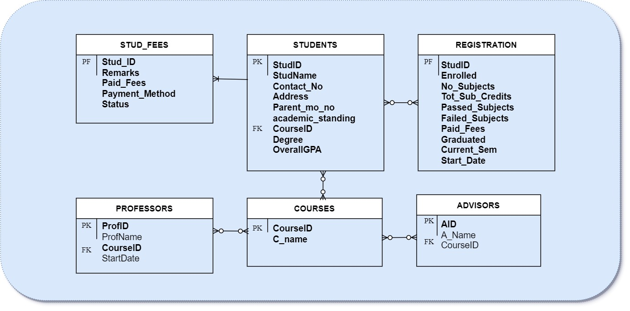

Tables created by:

|  |  |  |
| --- | --- | --- |
| Prince Jodhani | Juvairiya Shaikh | Juan Castel |
| Students | Professors | Stud_Fees |
| Registration | Advisors | Courses |

CPP Console Output:

