**What is Biteable?**

Biteable is a video animation company providing video animation services to users. it made video creation easy. Users can create their video with zero skills in animation, like after effects.

**Did you know?**

* **66%** of marketers do not make videos because they think it is too time-consuming.
* **41%** of marketers do not make videos because they believe it is a complex process
* **37%** of marketers do not make videos because they think it is too expensive.
* **60%** of businesses use video as a marketing tool.
* **74%** of marketers say that video has a better return on investment than static imagery.

**Why use our service?**

* Makes video instantly
* Easy to use
* Results-focused
* Simplified video-making process
* Affordable service

**Types of video animation templates available:**

* **Advertising:** It makes videos ready to upload on a social ad campaign.
* **Business:** It makes your video based on business strategy.
* **Corporate:** It will create your video based on the corporate environment.
* **Enterprise:** Helpful to make enterprise videos for everyone in your organization.
* **HR:** Built for people operations.
* **LinkedIn:** Make videos that get attention.
* **Presentations:** Make a video presentation that can attract viewers.
* **Sales:** Make videos for sales employees in the company.
* **Training:** Create training videos that will be helpful to the employee.

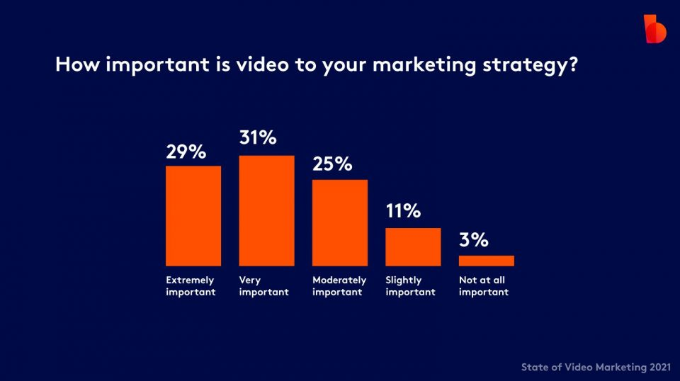

**References:**

Biteable (n.d.). biteable.com