/**********************************************

Workshop 10

Course: JAC444 - 4th

Last Name: Jodhani

First Name: Prince

ID: 149455206

Section: NEE

This assignment represents my own work in accordance with Seneca Academic Policy.

Signature : Prince

Date: 05/08/2022

**********************************************/

Output of Workshop 10:

**Task 1:**

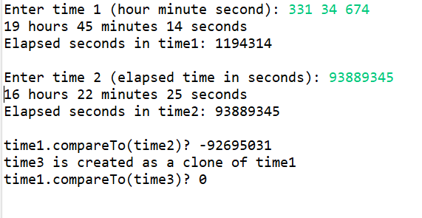

**Task 2:**

