/**********************************************

Workshop 2

Course: JAC444 - 4th

Last Name: Jodhani

First Name: Prince

ID: 149455206

Section: NEE

This assignment represents my own work in accordance with Seneca Academic Policy.

Signature : Prince

Date: 05/06/2022

**********************************************/

**Task 1**

**Screenshot 1**

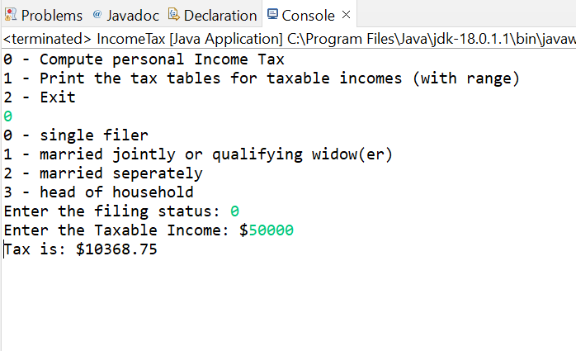

**Screenshot 2**