/**********************************************

Workshop 3

Course: JAC444 - 4th

Last Name: Jodhani

First Name: Prince

ID: 149455206

Section: NEE

This assignment represents my own work in accordance with Seneca Academic Policy.

Signature : Prince

Date: 12/06/2022

**********************************************/

**Task 1:**

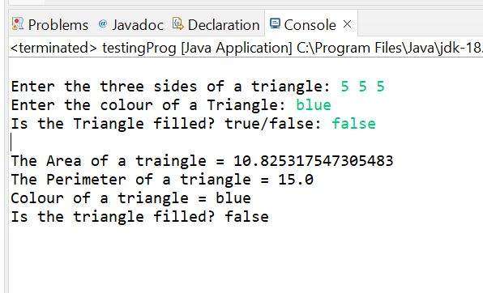

**Task 2:**

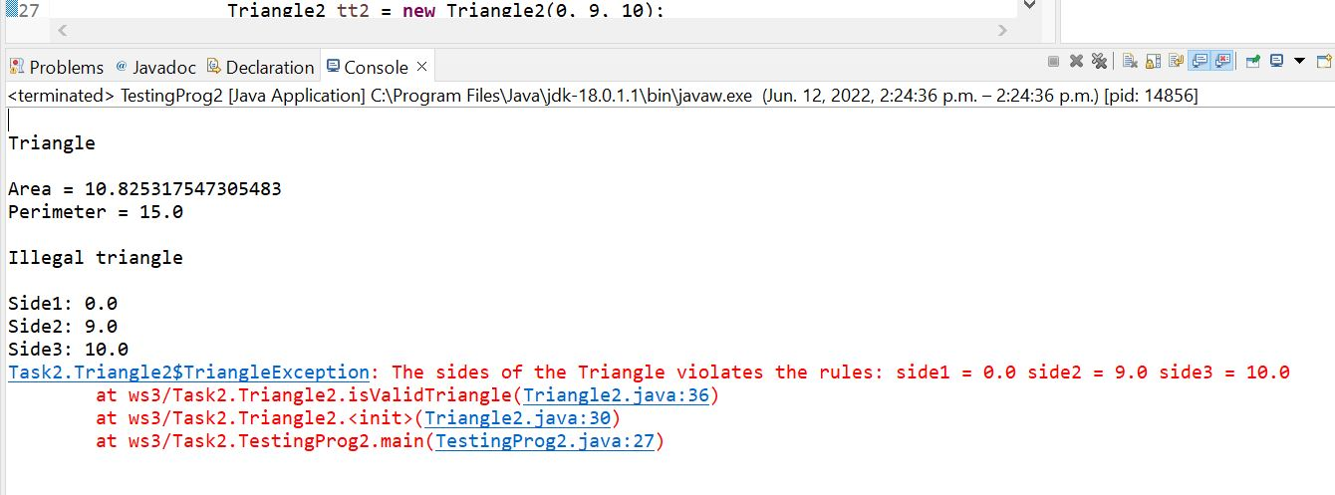

It will throw the exception if invalid values entered for the triangle sides.