/**********************************************

Workshop 9

Course: JAC444 - 4th

Last Name: Jodhani

First Name: Prince

ID: 149455206

Section: NEE

This assignment represents my own work in accordance with Seneca Academic Policy.

Signature : Prince

Date: 31/07/2022

**********************************************/

**Task:**

**Server:**

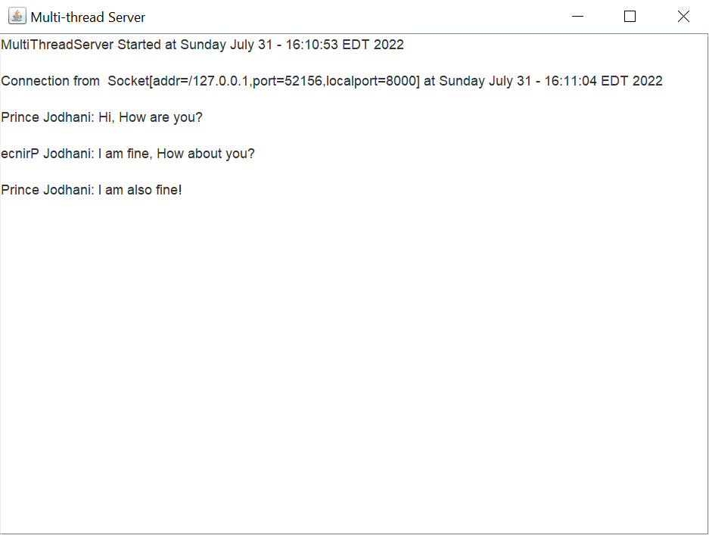

**Client:**

