**How to play Snake Game**

1. When playing the game, keep your hand moving on the game board. If you stop, the board may interpret it as a signal that you want to quit the game.
2. While playing the game, be mindful of the speed at which you move your hand. If you move too quickly, your hand may go off the game board. If you move too slowly, it may be interpreted as if you have stopped moving your hand.
3. When the game starts, the snake must not cross over its own body. If it does, it will be considered as if the snake has bitten its own body and the game will end.

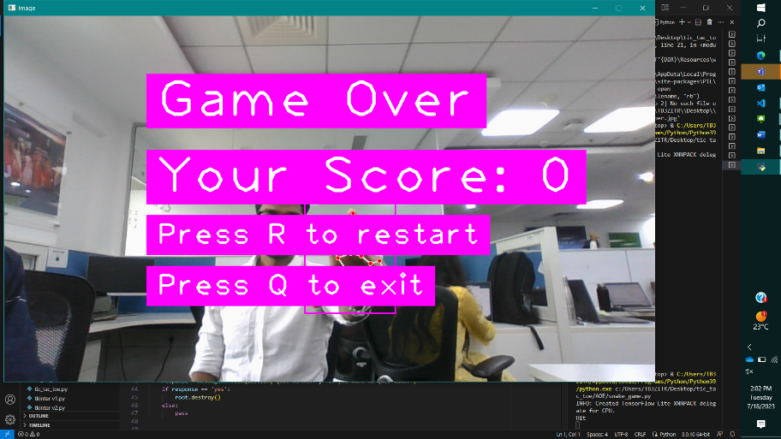

1. In the game, donuts will constantly appear in random positions on the game board. To increase your score and the size of the snake, you must continuously feed it donuts.
2. After the game is over, you can check your scorecard. If you want to play again, press **“R”** to restart the game while moving your hand.
3. For quitting the game, press **“Q”** and you will return back to the home page.

