Adventist University of Central Africa

HEALTHCARE GEOSPATIAL ANALYSIS
CASE STUDY: RWANDA MINISTRY OF HEALTH

A final-year project Presented in partial fulfillment of the Requirements for the
degree of BACHELOR OF SCIENCE IN INFORMATION TECHNOLOGY
Major in
Information Management

By
Bahizi Jonas
January, 2025

ABSTRACT
Research Project for Bachelor's Degree in Information Technology
Emphasis in Information Management
Adventist University of Central Africa
TITLE: HEALTHCARE GEOSPATIAL ANALYSIS
Name of researcher: BAHIZI Jonas
Name of supervisor: Ishimwe M. Prince
Date Completed: November 2024
HealthGeoTrack is an advanced geospatial analysis software that integrates Geographic Information Systems (GIS) with analytics to optimize healthcare resource allocation, disease surveillance, and public health planning. By combining data on healthcare facilities, demographics, disease incidence, environmental factors, and population mobility, it enables real-time monitoring of disease spread and identification of high-risk areas. The software helps map healthcare infrastructure, especially in underserved or remote regions, and supports targeted interventions to improve access to care. Additionally, HealthGeoTrack contributes to enhancing healthcare system resilience by simulating disaster scenarios, identifying critical evacuation routes, emergency shelters, and optimal supply distribution points, ensuring that healthcare systems are well-prepared for crises.
The system uses several advanced technologies, including GIS for spatial data analysis, machine learning algorithms to detect trends and patterns in health data, and real-time data integration for continuous surveillance of disease outbreaks. These technologies enable HealthGeoTrack to provide actionable insights for resource management and public health planning. A mixed-method approach will be used to evaluate the software’s impact in Rwanda, including a documentation methodology to review relevant reports, case studies, and literature, along with qualitative interviews with policymakers, healthcare providers, and public health officials.

DECLARATION
I, BAHIZI Jonas, with ID 23410, hereby declare that the project report HEALTHCARE GEOSPATIAL ANALYSIS based on my own work carried out during the course of my study under the supervision of Ishimwe M. Prince. I submit the statements made and conclusions drawn are an outcome of my research work, and it has not been previously submitted anywhere.
Signature : …………………….
Date: /…. /…..

APPROVAL
I, Ishimwe M. Prince hereby certify that this project report has been done under my supervision and submitted with my approval.
Signature………………………………...
Date……/…………/………

DEDICATION
I dedicate this book
To my lovely family
To all my friends and relatives and to my supervisor for his guidance.

TABLE OF CONTENT

ABSTRACT i
DECLARATION ii
APPROVAL iii
DEDICATION iv
TABLE OF CONTENT v
LIST OF FIGURES ix
LIST OF TABLES x
LIST OF ABBREVIATIONS xi
ACKNOWLEDGMENTS xii
CHAPTER 1 13
Introduction 13
Background of the Study 13
Statement of the Problem 14
Choice and Motivation of the Study 14
Objectives of the Study 15
General Objective 15
Specific objectives 15
Scope of the Study 15
Methodologies and Techniques Used in the Study 16
Documentation 16
Interview 16
Expected Results 18
Organization of the Report 18
CHAPTER 2 20
ANALYSIS OF THE CURRENT SYSTEM 20
Introduction 20
Description of the Current System Environment 20
Historical Background 20
Mission 21
Vision 21
Description of the Current System 22
Analysis of the Current System 22
Modeling of the Current System 23
Problems with the Current System 24
Proposed Solutions 24
System Requirements 25
Functional Requirements 25
Non-Functional Requirements 26
CHAPTER 3 27
REQUIREMENTS ANALYSIS AND DESIGN OF THE NEW SYSTEM 27
Introduction 27
Unified Modeling Language 28
Design of the New System 32
Use Case Diagram 32
Class Diagram 38
Sequence diagram 39
Activity Diagram 43
Database Design 45
Data Dictionary 46
System Architecture Design 53
CHAPTER 4 54
IMPLEMENTATION OF THE NEW SYSTEM 54
Introduction 54
Technologies Used 54
Front End 55
Back End 55
Software Testing 60
Unit Testing 61
Integration Testing 61
Hardware and Software Requirements 62
Client-Side Software Requirements 62
Server-Side Software Requirements 63
Client-Side Hardware Requirements 63
Server-Side Hardware Requirements 63
CHAPTER 5 64
CONCLUSION AND RECOMMENDATIONS 64
Conclusion 64
Recommendation 65
REFERENCES 66
Books 66
Websites 66
APPENDICES 67
Curriculum Vitae 68
Data Collection Letter 70

LIST OF FIGURES
Figure 1: Modeling of the Current System 23
Figure 2: Use case diagram 34
Figure 3: Class Diagram 38
Figure 4: Sequence diagram for Access User Management 40
Figure 5: Sequence diagram for Login 41
Figure 6: Sequence diagram for User Management 42
Figure 7: Sequence diagram for Manage Data Backup 43
Figure 8: Activity Diagram 44
Figure 9: Database diagram 45
Figure 10: Health Facilities Data Dictionary 46
Figure 11: Disease Incident Data Dictionary 47
Figure 12: Population Data Dictionary 48
Figure 13: Resource Allocation Data Dictionary 49
Figure 14: Accessibility Data Dictionary 50
Figure 15: Policy Evaluation data Dictionary 51
Figure 16: User Table Data Dictionary 52
Figure 17: Architecture diagram 53
Figure 18: Home Page 56
Figure 19: Login 57
Figure 20: Decision Maker dashboard 58
Figure 21: User Dashboard 59

LIST OF TABLES
Table 1: Use-case diagram elements 33
Table 2: Use case description for user management 36
Table 3: Health data 37
Table 4: Sequence diagram annotation with their explanation 40

LIST OF ABBREVIATIONS
AJAX | Asynchronous JavaScript and XML
API | Application Programming Interface
AUCA | Adventist University of Central Africa
CSS | Cascading Style Sheet
DOM | Document Object Model
HTML | Hypertext Markup Language
IDE | Integrated Development Environment
JS | JavaScript
JSON | JavaScript Object Notation
MVC | Model-View-Controller
REST | Representational State Transfer
SQL | Structured Query Language
UI | User Interface
UX | User Experience

ACKNOWLEDGMENTS
Firstly, I thank God for all He has been with me in this journey of my studies and even till now. There are many students who dropout due to different reasons but by His grace I have been at university till the end of all classes.
I can’t forget that as a student I needed the basic knowledge to be where I am now with skills I have. My appreciation goes to AUCA administration for the academic program and positive impact on students. I have noticed the lifestyle of student after joining AUCA. Thank you for changing the student’s mindset.
I would like to thank my parents, who helped me in their prayers, advices, and encouragement. They virtually and financially worked along with me.
I am extremely grateful to the departments staff members who always there for students to be successful. I am deeply thankful to Ishimwe M. Prince as my supervisor, who guided me in the accomplishment of this work, his professional assistance and ideas.
I am grateful for my colleagues who played a crucial role in my studies, their team working and support gave me a lift and experience.
I am thankful to my friends in general for being always there for me where things seemed to be impossible.
Finally, thanks a lot to everyone who has been involved in this work directly or indirectly for their help and contribution.
God Bless you all!

Bahizi Jonas

CHAPTER 1
GENERAL INTRODUCTION

Introduction
HealthGeoTrack is an innovative software solution designed to address critical challenges in healthcare delivery, resource management, and public health planning. By leveraging the power of geographic information systems (GIS) and advanced analytics, this tool provides actionable geospatial insights that enable more efficient allocation of healthcare resources, real-time disease surveillance, and targeted interventions for underserved populations. HealthGeoTrack plays a pivotal role in identifying areas lacking adequate healthcare services, optimizing resource distribution, and improving disaster preparedness. These capabilities empower healthcare organizations and policymakers to make data-driven decisions that contribute to more equitable and effective healthcare systems. By enhancing accessibility, efficiency, and resilience in healthcare, HealthGeoTrack aims to improve population health outcomes and ensure sustainable public health solutions (Health Service Packages for Public Health Facilities, 2017).

Background of the Study
Rwanda’s healthcare sector is currently grappling with a variety of challenges that significantly hinder its ability to provide fair, equitable, and accessible healthcare services to all citizens. These issues are particularly acute in remote, underserved, and rural areas where healthcare delivery faces substantial logistical and infrastructural barriers. In addition to these access issues, the healthcare system must also manage the complexities of responding to disease outbreaks and mitigating environmental health risks, both of which place additional strain on limited resources. Recognizing the severity of these challenges, the Ministry of Health is actively seeking technology-driven solutions designed to enhance the planning, implementation, and monitoring of public health initiatives. HealthGeoTrack, an advanced geospatial analysis tool, has been identified as a critical component of this strategy. This tool consolidates and integrates diverse data types, including demographic information, details about healthcare facilities, and trends in disease outbreaks. By providing actionable insights, HealthGeoTrack empowers healthcare planners, administrators, and policymakers to make data-informed decisions that optimize resource allocation, improve healthcare accessibility, and strengthen the overall resilience of Rwanda’s healthcare sector.

Statement of the Problem
Rwanda’s healthcare system faces numerous challenges in guaranteeing equitable access to healthcare services, especially in rural and underserved regions where disparities are most evident. Additionally, the system struggles with the effective management of disease outbreaks, the allocation of critical resources, and the monitoring of public health trends. The Ministry of Health currently lacks a robust and comprehensive tool capable of seamlessly integrating and analyzing both spatial and demographic data, a crucial requirement for making informed decisions in healthcare delivery and public health response. Without such a solution, optimizing resource distribution, identifying disease patterns, and addressing geographic healthcare inequalities remain difficult. HealthGeoTrack is specifically designed to address these pressing challenges by offering a powerful, cutting-edge geospatial analysis platform. This tool empowers policymakers and healthcare administrators with the ability to utilize data-driven insights for strategic planning, equitable resource allocation, and effective responses to public health issues across Rwanda’s diverse regions.

Choice and Motivation of the Study
The decision to implement HealthGeoTrack within Rwanda’s healthcare sector stems from the urgent need for a comprehensive, data-driven solution to tackle persistent healthcare disparities, improve resource allocation efficiency, and strengthen disease monitoring capabilities. With Rwanda’s varied geography and a significant portion of its population residing in rural and underserved regions, the Ministry of Health requires a sophisticated tool capable of seamlessly integrating spatial, demographic, and health-related data to enable informed, forward-thinking decision-making. HealthGeoTrack delivers these essential capabilities, empowering the Ministry to prioritize equitable healthcare access, enhance resilience, and respond effectively to emerging public health challenges. This advanced platform aligns perfectly with Rwanda’s overarching goal of promoting fairness in healthcare delivery and fortifying the nation’s public health infrastructure to ensure sustainable growth and better health outcomes for all citizens.

Objectives of the Study

General Objective
The general objective of this study is to evaluate the effectiveness of HealthGeoTrack in enhancing Rwanda’s healthcare system by supporting equitable resource distribution, improving disease surveillance, and aiding strategic public health planning. The study aims to assess how HealthGeoTrack can facilitate data-driven decision-making, optimize healthcare access, and strengthen response capabilities in underserved regions across the country.

Specific objectives
The specific objectives of the study are to assess HealthGeoTrack’ s ability to map healthcare facilities and identify underserved areas in Rwanda, evaluate the platform’s effectiveness in monitoring disease outbreaks and supporting timely public health interventions, analyze how HealthGeoTrack optimizes resource allocation based on geographic and demographic data, and determine the software’s role in enhancing disaster preparedness and response planning for the Ministry of Health. By addressing these objectives, the study aims to provide comprehensive insights into the potential impact of HealthGeoTrack on improving healthcare delivery and public health outcomes in the country.

Scope of the Study
The scope of this study encompasses the evaluation of HealthGeoTrack within the context of Rwanda’s healthcare system, focusing on its application in geospatial analysis for healthcare delivery, disease surveillance, and resource allocation. It will involve assessing the software's effectiveness in mapping healthcare facilities, identifying underserved populations, and monitoring disease trends across various geographic regions. The study will also explore HealthGeoTrack's role in disaster preparedness and response planning. While the primary focus is on the Ministry of Health’s use of the software, the findings may also provide insights applicable to other stakeholders in Rwanda's public health sector.

Methodologies and Techniques Used in the Study

Documentation
The study will employ a documentation methodology that involves the collection and analysis of relevant literature, reports, and case studies related to HealthGeoTrack and geospatial analysis in healthcare. This will include reviewing existing data on healthcare facilities, disease incidence, and public health interventions in Rwanda, as well as examining the operational frameworks of HealthGeoTrack. By synthesizing these resources, the study aims to establish a comprehensive understanding of the software's capabilities, its implementation within the Rwandan healthcare context, and its potential impact on improving healthcare delivery and public health outcomes. This documentation will serve as a foundation for further analysis and evaluation in the study.

Interview
The study will incorporate qualitative data collection through interviews with key stakeholders in Rwanda's healthcare sector, including policymakers, healthcare providers, and public health officials. These interviews will aim to gather insights on their experiences with HealthGeoTrack, its functionality, and its impact on healthcare delivery and decision-making processes. Participants will be asked about the challenges they face in resource allocation, disease monitoring, and access to healthcare services, as well as their perceptions of how HealthGeoTrack addresses these challenges. This qualitative approach will provide valuable perspectives that complement the documented data, enriching the study's findings and recommendations for improving healthcare outcomes in Rwanda.
Question 1: What are the major challenges you face in resource allocation and disease monitoring within Rwanda’s healthcare system?
Answer: One of the primary challenges is the lack of centralized data that integrates information from various regions. This makes it difficult to assess needs and allocate resources effectively. Additionally, disease monitoring is hindered by delayed reporting and incomplete data, especially in rural areas where infrastructure and access to technology are limited.

Question 2: How has HealthGeoTrack impacted your ability to make informed decisions in healthcare delivery?
Answer: HealthGeoTrack has significantly improved decision-making by providing real-time, geospatial data on healthcare facilities, disease outbreaks, and population demographics. This has allowed us to identify underserved areas more accurately, optimize resource allocation, and respond promptly to emerging health issues.
Question 3: What specific features of HealthGeoTrack do you find most useful in addressing healthcare challenges?
Answer: The mapping feature that visualizes healthcare facilities and disease hotspots is incredibly useful. Additionally, the real-time data analytics and reporting capabilities enable us to monitor trends and make evidence-based decisions quickly. The platform’s user-friendly interface also facilitates efficient data interpretation and collaboration among stakeholders.
Question 4: What limitations or areas of improvement do you see in HealthGeoTrack?
Answer: While the platform is powerful, its reliance on internet connectivity can be a limitation in remote areas. Also, there is a need for more localized customization to address unique challenges faced by specific regions. Training for users in rural areas would also enhance the platform’s effectiveness.
Question 5: In your opinion, how can HealthGeoTrack be further improved to better serve Rwanda's healthcare needs?
Answer: Integrating more predictive analytics capabilities and AI-driven insights could enhance the platform’s ability to forecast disease outbreaks and resource needs. Expanding offline functionality and improving data collection methods in remote areas would also make the system more robust and accessible. Additionally, creating a feedback mechanism for healthcare workers could help refine and adapt the tool based on their on-the-ground experiences.

Expected Results
The expected results of the study include a comprehensive evaluation of HealthGeoTrack’s effectiveness in enhancing healthcare delivery and public health outcomes in Rwanda. The findings are anticipated to demonstrate improved mapping and identification of underserved areas, more efficient resource allocation based on geographic data, and enhanced disease surveillance capabilities leading to timely interventions. Additionally, the study aims to reveal valuable insights from stakeholders regarding the software's impact on decision-making and disaster preparedness efforts.

Organization of the Report
The five chapters that make up this research project are as follows:
Chapter One is a general Introduction to describe from scratch the startup of the study and talks about the background of the study, it focuses mostly on showing what the system is about, and all of these shared characteristics of both new and old systems are included.
This chapter gives you a little bit of information on what the system is about to solve and how it will be operating.

Chapter Two is the analysis of the existing system, by deeply working into the analysis phase of the system were helped to discover how the old system and new system will differ and how the new system to fill the gap in between. I also talk about the description of both systems and the problem that the old system has. And finally, I see what the system should do and what characteristics it should have to accomplish the needs.

Chapter Three is the requirement Analysis and design of the new system; it concerns with deep understanding of the system where it will show the logical and physical models used in the system. The chapter will try to make it easy to understand the system by using some diagrams to make the system simplified in terms of understanding.
Chapter Four is about the implementation and testing of the new System and will try to look at the graphic part of the application where screenshots of some activities being performed will be taken to reveal how the operation is being done. The chapter will go through all the testing that needs to be done, all show what they will be like.

Chapter Five is about comprehensively encapsulates the culmination of our exhaustive study, delving into detailed analyses and synthesizing invaluable insights. It not only presents the conclusion drawn from our rigorous examination but also proffers astute recommendations for guiding future endeavors that will be pursued in subsequent projects.

CHAPTER 2

ANALYSIS OF THE CURRENT SYSTEM

Introduction
The analysis of the current healthcare system in Rwanda reveals several challenges that hinder effective healthcare delivery, including geographic disparities in access to services, inadequate resource allocation, and limited disease surveillance capabilities. Despite progress in improving healthcare infrastructure, many rural areas remain underserved, with healthcare facilities often lacking essential resources and support. Additionally, existing systems for monitoring disease trends are fragmented, making it difficult to implement timely interventions. This analysis serves as a foundation for understanding the critical need for innovative solutions, such as HealthGeoTrack, which can integrate spatial and demographic data to optimize healthcare planning and improve health outcomes across the country.

Description of the Current System Environment

Historical Background
The Rwanda Ministry of Health (MoH) is the government agency responsible for providing healthcare services to the people of Rwanda. It creates and enforces health policies, manages public health programs, and oversees healthcare facilities such as hospitals and clinics. The Ministry works with international organizations, non-governmental organizations (NGOs), and private companies to improve health services and outcomes across the country.
The business model for geospatial analysis model centralizes and integrates diverse data to improve decision-making and resource allocation. By merging data from healthcare facilities, surveys, and international sources, it addresses outdated and fragmented information. Revenue comes from government contracts, consulting, software licensing, and training. Key activities include data collection, processing, analysis, and software customization, supported by technology and skilled staff. The model focuses on collaboration with health directorates, local offices, data providers, and international organizations for accurate, real-time healthcare insights.
The Ministry of Health in Rwanda faces challenges with its geospatial analysis system due to outdated and manually analyzed data from various sources, including healthcare facilities and international databases. This fragmented approach results in incomplete information and impedes comprehensive analysis, slowing decision-making. For example, outdated data on healthcare facility locations hampers accurate mapping and effective management.
The Rwanda Ministry of Health faces inefficiencies due to fragmented and outdated geospatial data, impacting disease tracking, resource allocation, and healthcare access. A solution like Health Geo Track could enhance data integration, improve disease monitoring, optimize resource distribution, and better prepare for emergencies, leading to better healthcare services and outcomes.

Mission
The mission of the Rwanda Ministry of Health is to ensure the provision of accessible, equitable, and quality healthcare services to all Rwandans. The Ministry aims to promote public health, prevent diseases, and improve the overall health status of the population through effective healthcare policies, strategic planning, and collaboration with various stakeholders. By fostering a resilient healthcare system, the Ministry seeks to enhance health service delivery, strengthen health infrastructure, and empower communities to take charge of their health. Additionally, the Ministry is committed to implementing evidence-based interventions and promoting health education to achieve sustainable health outcomes across the country.

Vision
The vision of the Rwanda Ministry of Health is to achieve a healthy and prosperous nation where all individuals have access to comprehensive, high-quality healthcare services. The Ministry envisions a resilient healthcare system that is responsive to the needs of the population, promoting wellness and preventing diseases through proactive health initiatives. By fostering collaboration among government, communities, and partners, the Ministry aims to enhance the overall health status of the Rwandan people and contribute to the country’s socioeconomic development, ultimately ensuring that every Rwandan can lead a healthy and productive life.

Description of the Current System
The Function/Department Where the Problem Exists
The current healthcare system in Rwanda operates through various departments within the Ministry of Health, including disease surveillance, resource management, and healthcare delivery. However, significant challenges exist in the coordination and integration of these functions, leading to inefficiencies in resource allocation and delays in responding to disease outbreaks. The lack of a comprehensive geospatial analysis tool hampers the ability to effectively monitor healthcare access and identify underserved populations. These issues are particularly pronounced in rural areas, where healthcare services are limited, and timely information is crucial for making informed decisions. Addressing these challenges within the relevant departments is essential for enhancing the overall effectiveness of Rwanda's healthcare system.
Actors in the Department: Roles and Responsibilities
Within this department, several key actors play crucial roles, each with specific responsibilities aimed at ensuring the successful functioning of the Water Quality Management System.
Roles:
- The admin: is responsible for managing the HealthGeoTrack system, including user access, data integrity, and system maintenance.
- The health analyst: is responsible for monitoring health data and analyzing trends to support public health decisions.
- The data entry clerk: is responsible for entering and updating health data in the system.

Analysis of the Current System
HealthGeoTrack leverages advanced geospatial analysis to optimize healthcare resource allocation, disease surveillance, and public health planning by integrating Geographic Information Systems (GIS) with powerful analytics. The system consolidates critical data from diverse sources, including healthcare facilities, demographics, disease incidence, environmental factors, and population movement, to provide real-time insights into disease spread, healthcare infrastructure, and identify high-risk areas. This data-driven approach enables targeted interventions in underserved regions, improving healthcare access, optimizing resource distribution, and enhancing infrastructure mapping. Additionally, HealthGeoTrack strengthens healthcare system resilience by simulating various disaster scenarios, identifying critical evacuation routes, emergency shelters, and ensuring optimal supply distribution during crises. The system’s use of GIS, machine learning for trend detection, and real-time data integration enables continuous disease surveillance and informed decision-making, offering actionable insights for public health authorities. In Rwanda, while these geospatial tools have already contributed positively, the analysis highlights ongoing challenges, such as the need for improved resource management, better healthcare access in remote areas, and enhanced disaster preparedness. A mixed-method evaluation of HealthGeoTrack’ s implementation in Rwanda, including document reviews and stakeholder interviews, will offer deeper insights into its effectiveness in addressing healthcare disparities, optimizing public health outcomes, and strengthening overall healthcare planning and delivery in the country.
HealthGeoTrack is a powerful geospatial tool that optimizes healthcare resource allocation, disease surveillance, and public health planning.

Modeling of the Current System
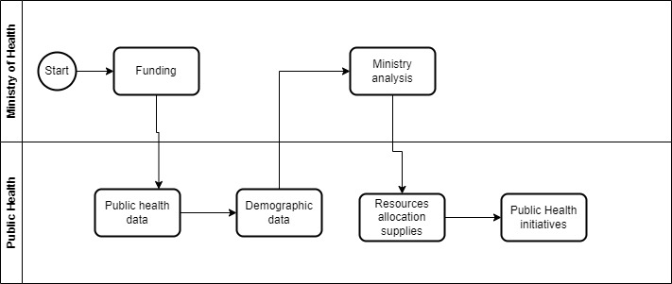
Figure 1: Modeling of the Current System

Problems with the Current System
The Rwanda Ministry of Health's current system faces significant challenges, including inefficiencies in data collection and processing, lack of integration across data sources, and reliance on manual processes. These issues result in delays, increased operational costs, and outdated information, hindering effective decision-making and response to public health needs. The following are the key problems identified in the system:
- Inefficiencies in data collection, processing, and analysis: These lead to delays and increased costs, compromising the Ministry's ability to respond effectively to public health challenges.
- Data siloed across various sources: This results in inconsistencies and gaps that hinder comprehensive analysis and informed decision-making.
- Time-consuming manual entry of diverse data types: This process is error-prone, negatively affecting data quality and reliability.
- Slow data processing: This causes outdated and incomplete information for decision-makers, leading to poor strategic choices.
- High operational costs due to manual processes and inefficiencies: These inefficiencies waste resources and reduce the effectiveness of public health programs.
- Difficulty in accessing fragmented healthcare data: This impairs the ability of healthcare providers and policymakers to make informed decisions.

Proposed Solutions
To overcome the challenges faced by the Rwanda Ministry of Health, strategic solutions have been proposed to enhance data management and efficiency. Implementing an integrated data management system, automating data collection, and improving analytics capabilities will reduce errors and delays. Additionally, standardizing data entry and enabling real-time reporting will ensure access to accurate, up-to-date information for effective decision-making. The key proposed solutions are outlined below:
- Implement an Integrated Data Management System:
Develop a centralized platform to consolidate data from various sources, ensuring seamless integration and accessibility.
- Automate Data Collection and Processing:
Utilize automated tools to streamline data entry and analysis, reducing errors and saving time.
- Enhance Data Analytics Capabilities:
Invest in advanced analytics tools for real-time data analysis to provide up-to-date insights for decision-makers.

- Standardize Data Entry Protocols:
Establish uniform standards for data collection to improve consistency and data quality.
- Implement Real-Time Reporting:
Develop real-time reporting and dashboards for easy access to current data by healthcare providers and policymakers.
Requirement Specifications:
The requirement specification activity encompasses a comprehensive set of features and capabilities that the system must possess to ensure its effective use. These requirements are categorized into two primary types: functional requirements and non-functional requirements. Functional requirements specify the essential functions that the system must support, detailing the specific operations and activities that the system must be able to perform. In contrast, non-functional requirements impose constraints on the operation of the system, focusing on performance criteria, usability, reliability, and other operational aspects that do not directly relate to specific system functions but are crucial for overall system performance and user satisfaction.

System Requirements

Functional Requirements
- The application should be a web-based application.
- The system should allow users to log in and log out.
- The system must integrate various data sources, including demographics and disease incidence.
- It must support real-time analysis to provide up-to-date insights for decision-making.
- An intuitive interface is needed for easy navigation and data handling.
- The system should include tools for mapping healthcare facilities and visualizing health data.
- It must generate real-time reports and dashboards for accessible insights.
- Support for multiple user roles with varying access levels is necessary for data security.

Non-Functional Requirements
Performance
- The system must be able to handle many concurrent users without any degradation in performance.
- The response time of the system must be under 1 second for 90% of all transactions.
Security
- Data Protection
- All data inside the system shall be protected against malware attacks or unauthorized access.
- The system must use strong encryption to protect all sensitive data in transit and at rest.
Maintainability
- The system must have a documented architecture, source code, and database schema that is easy to understand and modify by new developers.
- This allows the code base to be cleaner, more organized, and less error-prone.

CHAPTER 3

REQUIREMENTS ANALYSIS AND DESIGN OF THE NEW SYSTEM

Introduction
After a thorough examination of the Current methodology in Chapter 2, our next phase is to delve into process enhancement. The aim is to create a streamlined and efficient process that fully meets organizational needs. To address the challenges of the current approach, a meticulous analysis is crucial, leading to a well-defined design that serves as a solid foundation for effective solutions.
Process enhancement involves studying and understanding the current process to identify requirements, limitations, and areas for improvement. This includes analyzing steps, workflows, and interactions to comprehend its current state and shortcomings.
Moving forward, process design is the process of creating a blueprint for a new or improved process based on the findings of the analysis. This includes defining the process's structure, flow, interfaces, and operations to address identified requirements and enhance overall efficiency and effectiveness.
Together, process analysis and process design form a comprehensive approach to evaluate, optimize, and create processes that meet specific objectives and deliver desired outcomes. The focus of process design is on achieving the process's objectives.
Analysis and Design Methodology
Object Oriented Methodology (OOM)
Providing a structured framework for system development, OOM begins with an analysis phase, gaining a thorough understanding of user requirements. The subsequent design stage formulates an application model with intricate details for a comprehensive representation.
The main building blocks in Object Oriented Methodology Are Classes and Objects, where an Object is an instance of a class, representing individual entities with defined boundaries in the software system. In contrast, a class serves as a blueprint or description of a group of objects with similar attributes and behaviors (geeksforgeeks, 2024).

Unified Modeling Language
A general-purpose modeling language in software engineering, UML offers graphic notation techniques for visual models of object-oriented software-intensive systems. It provides a standard way to visualize a system's architectural blueprints, including activities, actors, business processes, database schemas, and reusable software components.
The Unified Modeling Language (UML) has a standard way to visualize a system’s architectural blueprints, including elements like:
- Activities
- Actors
- Business Processes
- Database schemas
- Reusable software components
Object-oriented analysis and design (OOAD)
OOAD is a popular technique for analyzing and designing applications, systems, or businesses. It employs the object-oriented paradigm and visual modeling throughout the development life cycle, facilitating effective communication with stakeholders and ensuring high product quality. UML, the Unified Modeling Language, is the standard notation used for representing these models.
Object-Oriented Analysis:
An approach examining how data interacts within a system, based on the object-oriented programming paradigm. It defines and analyzes requirements for system success.
Object-Oriented Design:
Involves planning a system of interacting objects to address a software problem systematically. Building upon identified candidate objects, it extends their definitions significantly, emphasizing how the system achieves functionality. OOD expands upon the analysis model to generate implementation specifications, focusing on how the system achieves functionality.

UML Concepts
Name of class
Attributes
Operations()

- The upper part holds the name of the class.
- The middle part contains the attribute of the class.
- The last part gives the method or operation the class can take or undertake.
An attribute is named property of a class that describes a range of values that instances of the property may hold.
A method is the implementation of a service that can be requested from any object to the class to affect behavior.
Relationships: A relationship is a connection among things.
They are most important relationships which are association, generalization and dependency Association
Use cases and actors are connected through association relationships, indicating the interactions between actors and the corresponding use cases. A line between an actor and a use case represents the association. This association signifies two-way communication between the actor and the use case.
Generalization
Generalization represents a relationship between a general entity (superclass or parent) and a more specific entity (subclass or child). It is denoted by an arrow pointing from the subclass to the superclass. This relationship signifies that the subclass inherits attributes, behavior, and relationships from the superclass.
Dependency
Dependence is a weaker form of relationship which indicates that one class depends on another because it uses it at some point in time.
Extend
The extension relationship indicates that the behavior of the extension use case can be included in the extended use case under certain conditions. It is represented by a dashed arrow from the extension use case to the extended use case, labeled as "extended." Notes or constraints can be associated with this relationship to specify the conditions under which this behavior will be executed.
Actor: An actor represents a role that can be performed by a user or another system when interacting with the system. It is not tied to a specific individual but rather signifies a particular function or responsibility. In the case of system interactions, the actor can be depicted as a stick figure labeled with the actor's name.

Use Case: A use case is a significant system process that provides a benefit to one or more actors. It is labeled with a descriptive verb-noun phrase and represents a significant piece of system functionality.


System boundary boxes (optional)
System Boundary: A rectangle, known as the system boundary box, is drawn around the use cases to define the scope of the system. Anything contained within the box represents the functionality that is within the system's scope, while anything outside the box is considered out of scope.
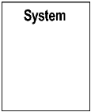
In this project, we will focus only on Actors, Use Cases and System boundaries as UML notations.
Software development process:
In culinary arts, the cooking process involves dividing the culinary work into distinct phases or stages, each consisting of activities aimed at effective planning and management. It is often considered a subset of the culinary creation life cycle. The process may include predefined recipes and techniques used by a cooking team to prepare or enhance a dish, ensuring it meets the diner's expectations.
Flavorful Approaches
Flavorful approaches to cooking can utilize various traditional methods such as baking, grilling, frying, boiling, and sautéing. However, sautéing using a high-heat methodology is commonly associated with flavorful approaches.
Difference from Conventional Approaches: The primary distinction between a conventional approach, like traditional cooking, and a flavorful approach lies in how a dish is composed. In conventional approaches, the dish composition process is either ingredient-centric or technique centric. However, flavorful approaches recognize the close relationship between ingredients and techniques, making it challenging to prioritize one over the other as the primary focus.
Unified Process (UP)
Unified Process (UP): The Unified Process is an architecture-centric, use case-driven, iterative, and incremental development process, also known as the unified software development process. It aims to incorporate the favorable aspects of traditional software process models while embracing the principles of agile software development.
The UP divides its phases (Inception, Elaboration, Construction, and Transition) into a series of time-boxed iterations. Each iteration delivers an increment, which enhances the system by adding or improving its functionality compared to the previous release.
Analysis of the new system
• Analysis Phase: The analysis phase addresses essential questions about the system, including its intended users, functionality, and usage locations. It involves studying the system, analyzing it, and selecting logical alternatives to model and design an information system. Use cases, which describe interactions between users and the system, are a highly effective tool in the analysis process.

Design of the New System

Use Case Diagram
Use Case: In system analysis, a use case is a methodology employed to identify, clarify, and organize system requirements. It comprises a set of potential interaction sequences between users and the system within a specific environment, all aimed at achieving a particular goal. The use case should encompass all system activities that hold significance for the users. It can be visualized as a collection of possible scenarios associated with a specific objective.
Use Case Diagram: A use case diagram is a UML diagram that depicts a business or software system, its external users (referred to as actors), and a series of actions (referred to as use cases) that users can or should perform while utilizing the system. Use case diagrams are utilized to illustrate the system's functionality from the perspective of an external user (Kramer, 2024).
The symbols below are used in use case diagram:
Description | Shape
An actor: Is a Person/System that derives benefit from and is external to the subject.

A use case: Represents a major piece of system functionality. | 
A Field relationship:   Links an actor with the use case(s) with which it interacts. | 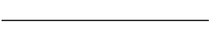
A boundary: It is a box drawn around the use case to denote the edge or boundary of the system being modeled. | 
Table 1: Use-case diagram elements
The figure below describes the operations of the new system and the stakeholders through the use case diagram.
Use Case Diagram

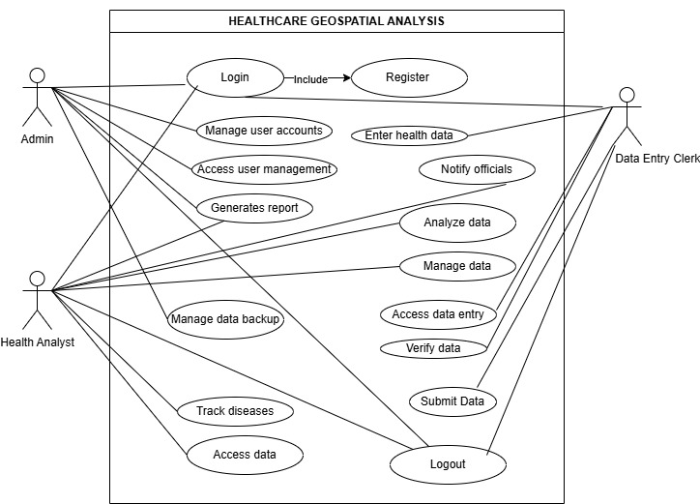

Figure 2: Use case diagram
Description of the application case
Use Case description details what a use case uses, and what it requests in order to be well executed.
Each use case looks like this:
- Name: A name of a use case.
- Description: what a system intends to do
- Actor: The actor involved in the use case
- Pre-condition: The system state before the use case can begin
- Post-condition: The system state when the use case is over
- Normal flow: The actual steps of the use case
- Alternative flow: Steps which may happen in case a normal flow fails.

Use case description for user Management
Name: User Management
Actor: Admin
Description: This use case describes the process by which the admin creates a new user account in the HealthGeoTrack system.

Pre-condition: The Admin has logged into the HealthGeoTrack system.
The admin has the necessary permissions to create user accounts.

Post-condition: A new user account is created and stored in the system.
The user is notified of their account details.

Normal flow:
- The admin logs into the HealthGeoTrack system.
- The admin navigates to the user management section.
- The admin selects the option to create a new user account.
- The admin fills in the required user information (e.g., name, email, role).
- The admin assigns appropriate permissions to the new user.
- The admin saves the new user account.
- The system confirms the successful creation of the user account.
- The new user receives an email notification with account details.

Alternative flow:
The admin fills in the required user information.
The admin attempts to save the new user account.
The system checks for existing accounts with the same email address.
If an email address conflict is found, the system displays an error message indicating the email already exists.
The admin is prompted to enter a different email address.
The admin enters a new email address and saves the account again.
The system confirms the successful creation of the new user account.

Table 2: Use case description for user management
Enter Health Data

Name
User Account
:

Actor:

Data Entry Clerk

Description: The Data Entry Clerk is responsible for inputting various health-related data into the HealthGeoTrack system.

-
Pre-condition: The Data Entry Clerk has an active account and is authorized to access the HealthGeoTrack system.

Post-condition: define the state of the system after the completion of the use case, indicating what must be true once the use case has successfully executed or encountered an alternative flow.

Normal flow: Log In:
The Data Entry Clerk logs into the HealthGeoTrack system using their credentials.
Access Health Data Entry Form:
The Data Entry Clerk navigates to the health data entry section of the system.
Fill in Health Data Fields:
The Data Entry Clerk fills in the required fields, including:
Patient ID
Patient Name
Date of Birth
Health Metrics (e.g., blood pressure, cholesterol levels)
Demographic Information (e.g., gender, address)

Alternative flow: The Data Entry Clerk attempts to submit the health data form without filling in all required fields
The system detects the missing information.
The system highlights the required fields that are incomplete and displays an error message.
The Data Entry Clerk fills in the missing information and resubmits the form.
The system confirms the successful data entry.

Table 3: Health data

Class Diagram
A class diagram serves as a fundamental visual representation that effectively illustrates the structure of the system by depicting various classes, their associated attributes, methods, and the relationships between these classes. This diagram provides a comprehensive and detailed overview of the system's architecture, allowing for a clear understanding of how different components interact and communicate within the system.

Importance of class diagram
- Class diagrams enable effective communication, serving as a blueprint for software development.
- They identify key entities, attributes, and relationships, aiding in system analysis and design.
- Class diagrams promote modular and reusable design, improving system quality and Maintainability (paradigm, 2023).
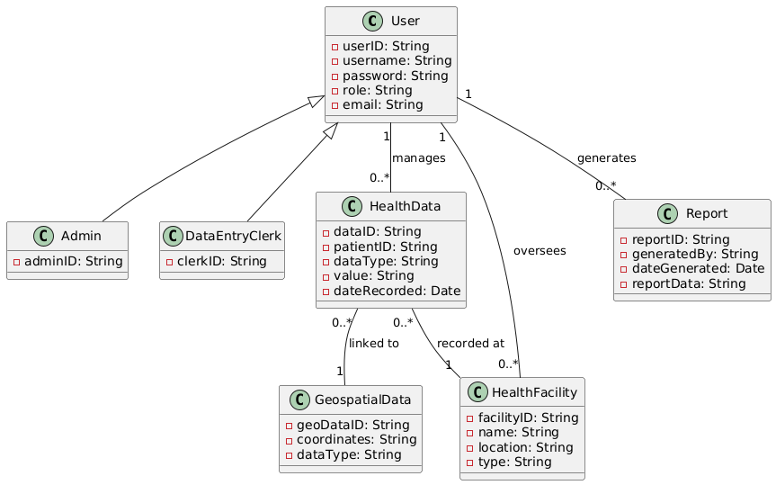
Figure 3: Class Diagram

Sequence diagram
A sequence diagram is a form of interaction diagram which shows objects as lifelines running down the page, with their interactions over time represented as messages drawn as arrows from the source lifeline to the target lifeline. A sequence diagram shows object interactions arranged in time sequence. (Kraemer, 2009).
The notations and their definitions that are used in sequence diagram:

Term and definition | Symbol
An actor:  - It can be a person or system that derives benefit from and is external to the system.  - It participates in a sequence by sending and/or receiving messages.  - It is placed across the top of the diagram. | 
An object lifeline:  UML object symbol illustrates class role, but doesn't list object attributes. It is placed across the top of the diagram. | 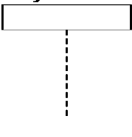
An activation:  Activation boxes represent the time an object needs to complete a task. It denotes when an object is sending or receiving messages. | 
A message:  - It conveys information from one object to another.  - An operation call is labeled with the message being sent and a solid arrow, whereas a return is labeled with the value being returned and shown as a dashed arrow. | 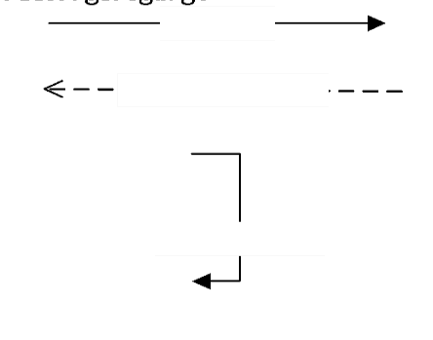
Table 4: Sequence diagram annotation with their explanation
Sequence diagram for creating a layer of the organization structure
As the sequence diagram graphically displays the interaction between actors and the system, the diagram below clearly describes how the user interacts with the system.

Sequence diagram for Access User Management.

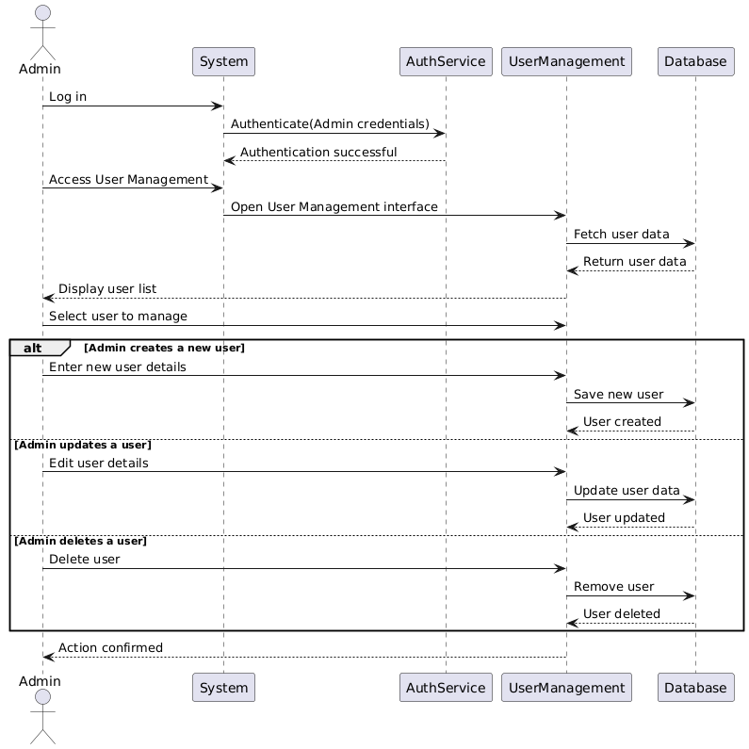
Figure 4: Sequence diagram for Access User Management
Sequence diagram for Login.

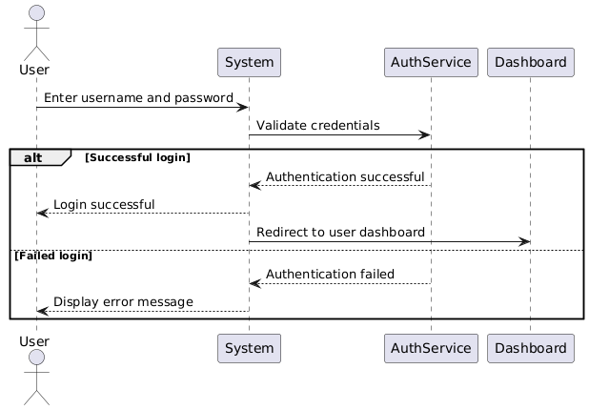
Figure 5: Sequence diagram for Login

Sequence diagram for User Management.
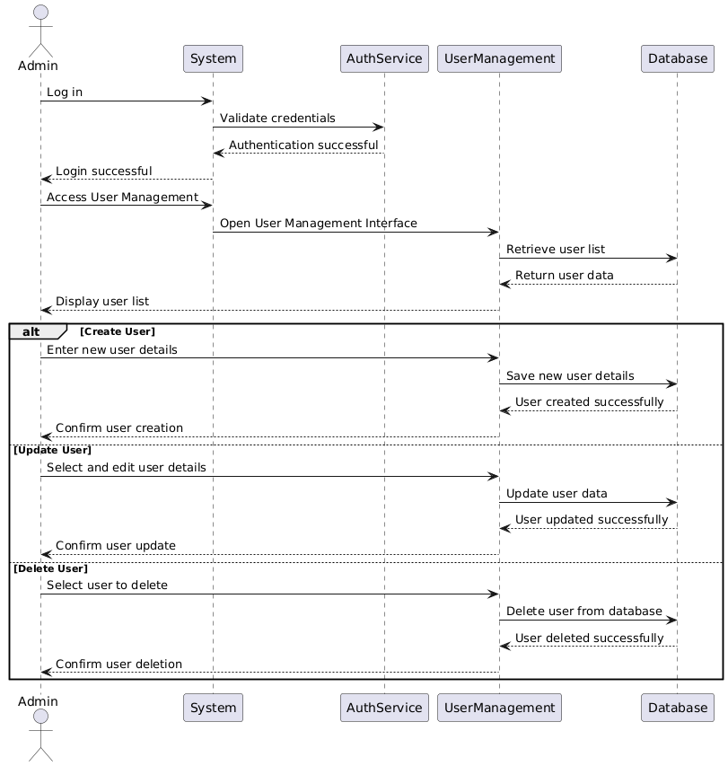
Figure 6: Sequence diagram for User Management

Sequence diagram for Manage Data Backup.
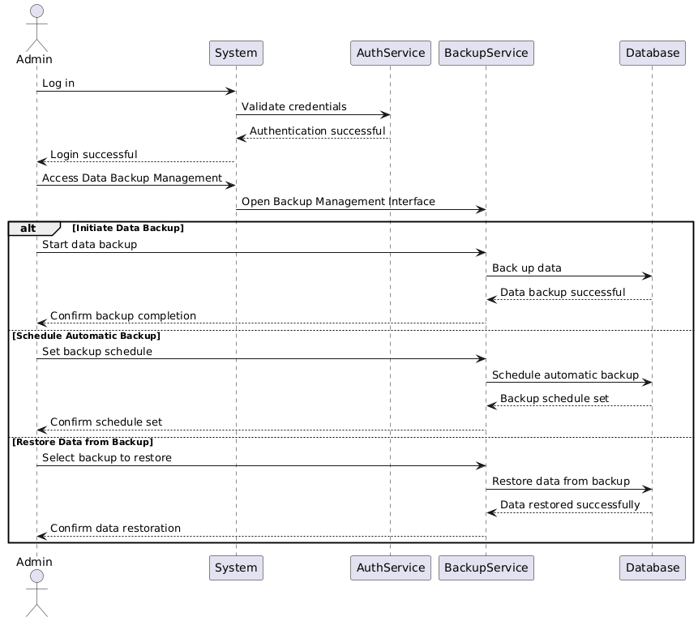
Figure 7: Sequence diagram for Manage Data Backup

Activity Diagram
The activity diagram below illustrates the key processes in the Healthcare Geospatial Analysis System. This system streamlines data collection, integration, analysis, and reporting to support public health planning and decision-making. Activities include data validation, outbreak detection, resource allocation, and policy evaluation, all aiming to enhance healthcare delivery and response.
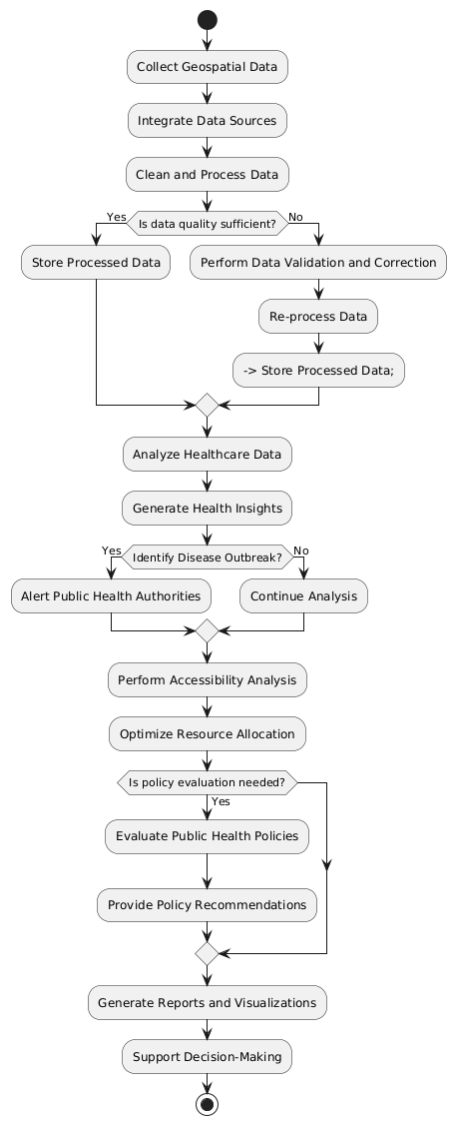
Figure 8: Activity Diagram

Database Design
Database modeling is the systematic approach of creating a comprehensive data model that encompasses logical and physical design decisions. It includes essential parameters for storage and enables the generation of a data definition language design, ultimately facilitating the creation of a database.
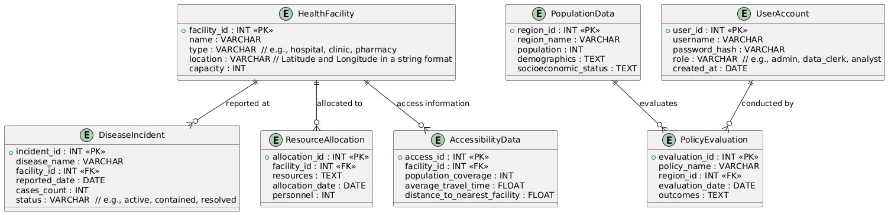
DATABASE DIAGRAM

Figure 9: Database diagram

Data Dictionary
A data dictionary diagram is a visual representation of a system's data elements, mapping their attributes and relationships. It showcases key data components as interconnected blocks, outlining their functions and associations. The diagram aids in understanding data structures and enables efficient communication between software and hardware architecture, fostering effective human interaction.
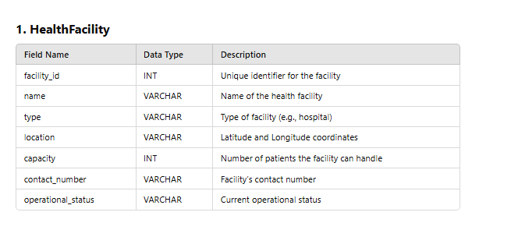
Figure 10: Health Facilities Data Dictionary
The HealthFacility table contains detailed information about healthcare facilities in the system. It stores critical attributes such as the facility's name, type, geographical location (latitude and longitude), capacity, contact number, and operational status. This table plays a vital role in managing healthcare infrastructure by providing comprehensive data on available resources and their operational status. By centralizing this information, the table ensures that healthcare services are effectively monitored, resource allocation is optimized, and underserved areas can be identified. Additionally, it supports decision-making for public health planning and enables quick response during health crises or emergencies by highlighting key facility metrics.
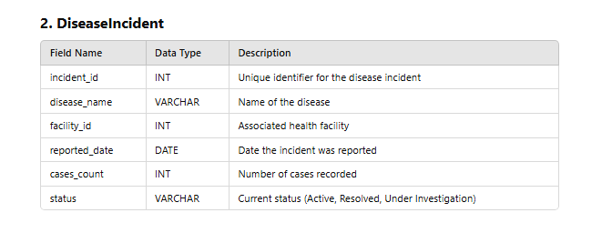
Figure 11: Disease Incident Data Dictionary
The DiseaseIncident table records information about disease outbreaks reported by healthcare facilities. It includes fields such as the name of the disease, the facility where it was reported, the date of reporting, the number of cases, and the status of the incident (e.g., active, resolved, or under investigation). This table is crucial for tracking and monitoring disease patterns, enabling timely public health interventions. By providing a centralized repository for disease data, it allows for real-time analysis and helps identify trends or hotspots. This information supports policymakers and health administrators in planning targeted interventions to mitigate the spread of diseases.
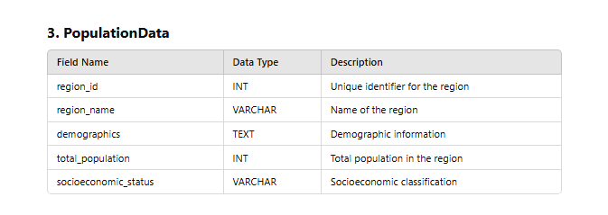
Figure 12: Population Data Dictionary
The PopulationData table provides comprehensive demographic and socioeconomic information for different regions. It includes details such as the region's name, population size, demographic composition, and socioeconomic status. This table is essential for understanding regional health needs and addressing disparities in healthcare delivery. By analyzing the data, policymakers and healthcare providers can identify vulnerable populations and allocate resources more effectively. Additionally, it supports public health planning by offering insights into factors influencing health outcomes, such as population density and economic conditions. This information ensures that healthcare services are equitably distributed and tailored to the unique needs of each region.
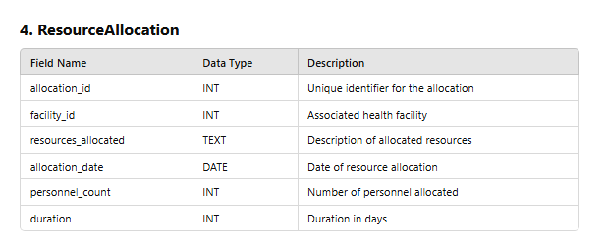
Figure 13: Resource Allocation Data Dictionary
The ResourceAllocation table captures data related to the distribution of healthcare resources, such as personnel, equipment, and funding, to various facilities. It includes fields for the allocation ID, facility ID, description of resources allocated, date of allocation, personnel count, and the duration of resource usage. This table ensures efficient resource management by providing a clear record of allocations, enabling administrators to monitor resource utilization. It supports planning by identifying gaps in resource availability and helps optimize distribution based on facility needs. Additionally, it facilitates accountability and transparency by documenting resource allocation decisions and their outcomes over time.
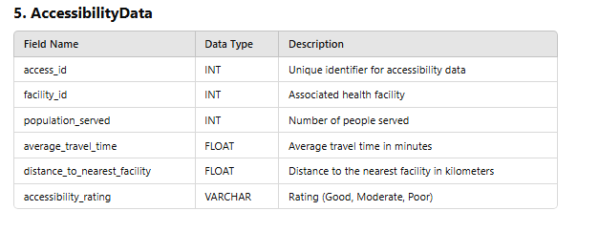
Figure 14: Accessibility Data Dictionary
The AccessibilityData table contains information about the accessibility of healthcare facilities for the population they serve. It includes metrics such as the number of people served, average travel time to the facility, distance to the nearest facility, and accessibility ratings (e.g., good, moderate, poor). This table is essential for evaluating healthcare access and identifying barriers to care. By analyzing this data, policymakers can implement strategies to improve accessibility, such as building new facilities or improving transportation infrastructure. The table ensures that underserved populations are prioritized and that healthcare services are distributed equitably to enhance overall population health.
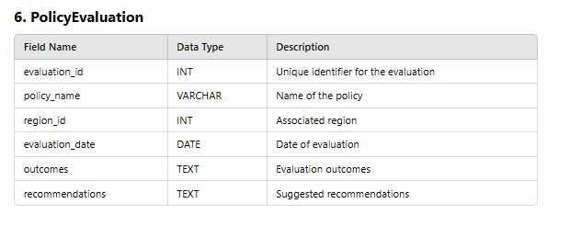
Figure 15: Policy Evaluation data Dictionary
The PolicyEvaluation table assesses the effectiveness of public health policies and programs. It stores information such as the policy name, region impacted, evaluation date, outcomes, and recommendations. This table is critical for ensuring evidence-based decision-making by providing insights into the success or limitations of policies. Policymakers can use this data to refine strategies, address gaps, and improve the overall impact of public health initiatives. Additionally, the table supports accountability by documenting the evaluation process and results. It serves as a valuable tool for continuous improvement in healthcare delivery and planning, ensuring that policies align with public health goals.
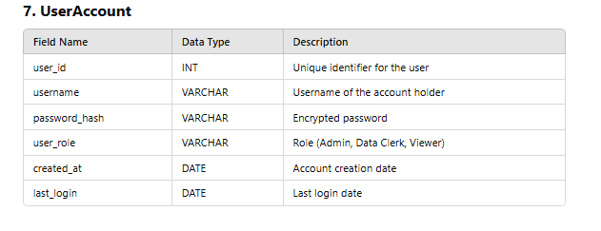
Figure 16: User Table Data Dictionary
The UserAccount table manages user information and access control within the system. It includes fields such as user ID, username, encrypted password, role (e.g., admin, data clerk, viewer), account creation date, and last login. This table is vital for maintaining system security by ensuring only authorized personnel can access sensitive data. Role-based access control allows different levels of access, ensuring data integrity and confidentiality. The table also supports system management by tracking user activity and providing insights into system usage. By centralizing user information, it ensures efficient account management and enhances the overall security of the system.

System Architecture Design
System architecture is a detailed, visual representation that maps the key functionalities and components of a system to the underlying hardware and software that supports them, establishing a clear relationship between these elements and incorporating human interaction. It provides a roadmap for how various software modules, hardware infrastructure, and user interfaces interact to deliver the system’s intended capabilities, ensuring seamless integration. The diagram often features interconnected blocks, representing essential system components, and arrows or lines indicating data flows, control signals, and communication pathways. Beyond simply listing components, system architecture highlights the integration of external systems, databases, APIs, and cloud services, addressing both functional and non-functional requirements such as performance, scalability, security, and maintainability. It serves as a blueprint for the development, maintenance, and future modifications of the system, allowing stakeholders—engineers, designers, and decision-makers—to visualize the system's operation and interactions
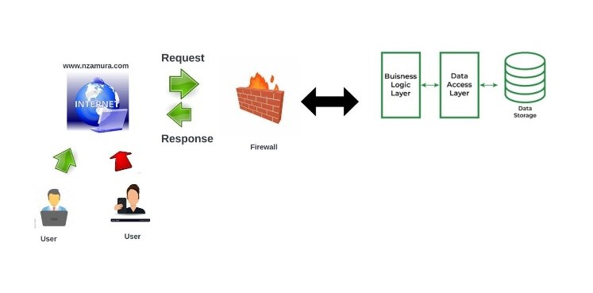
Figure 17: Architecture diagram

CHAPTER 4

IMPLEMENTATION OF THE NEW SYSTEM

Introduction
The creation of "HealthGeoTrack" is covered in this chapter. It contains a quick synopsis of the technologies that were utilized to make the application work, as well as screenshots of the new system and the testing that were conducted. Not to mention, requirements for hardware and software compatibility.
This chapter delves into the practical aspects of building and deploying the HealthGeoTrack system, showcasing the steps taken to ensure its functionality and efficiency. It begins by outlining the technological stack utilized, including programming languages, frameworks, and database management systems that form the backbone of the application. Detailed descriptions of each component are provided to highlight their role in the system's operation. Furthermore, this chapter includes comprehensive screenshots of the system's interfaces, demonstrating its user-friendly design and key functionalities. It also addresses the rigorous testing procedures carried out to validate the system’s performance, reliability, and security under different conditions. The hardware and software requirements essential for the system's successful deployment are detailed, ensuring compatibility and scalability. By the end of this chapter, readers will gain a thorough understanding of the implementation process, from the selection of technologies to the final steps of system deployment and validation.

Technologies Used
The inclusion of technologies used in this document serves to provide a clear understanding of the tools and resources employed in developing the HealthGeoTrack system. By listing the hardware and software technologies, readers can appreciate the foundation on which the system was built, ensuring transparency in its design and implementation. This section not only highlights the programming languages, frameworks, and database systems but also explains their significance in achieving the system’s goals, such as efficiency, scalability, and security. Moreover, documenting the technologies used allows for easier replication, future upgrades, and maintenance by providing developers and stakeholders with a comprehensive technical roadmap.

Front End
- HTML (Hypertext Markup Language): Used for structuring the content of web pages by defining elements like text, images, links, etc.
- CSS (Cascading Style Sheets): Used for styling web pages, including layout, colors, fonts, and overall appearance.
- ReactJS: A JavaScript library for building interactive user interfaces, allowing developers to create reusable UI components like buttons, search bars, and more.

Back End
- MySQL: A relational database management system used to create and manage databases, storing and retrieving data for applications.
- XAMPP: A cross-platform web server solution stack that includes components like MariaDB (a MySQL alternative), Apache HTTP Server, PHP, and Perl, providing a full-stack environment for web development.
- Python: A high-level, interpreted programming language used for developing various applications, including web development.
- Django: A high-level Python web framework that enables rapid and secure web development, handling backend processes, database management, and server-side logic.
- Pandas: A powerful data analysis library in Python used for manipulating and analyzing structured data, making it ideal for healthcare data management and analytics.
- NumPy: A library for numerical computations, used to handle complex mathematical operations and large datasets efficiently within the system.
- Matplotlib/Seaborn: Visualization libraries in Python used for creating insightful charts, graphs, and data visualizations, aiding in decision-making and trend analysis.
- Django REST Framework (DRF): A robust toolkit for building RESTful APIs, allowing seamless integration between the frontend and backend.
- Pytest: A testing framework in Python used for writing and running automated tests to ensure system reliability and performance.
These libraries complement Django and enhance the system’s capabilities, providing a strong foundation for managing data, creating APIs, visualizing trends, and ensuring reliable operations.
Presentation of the New System
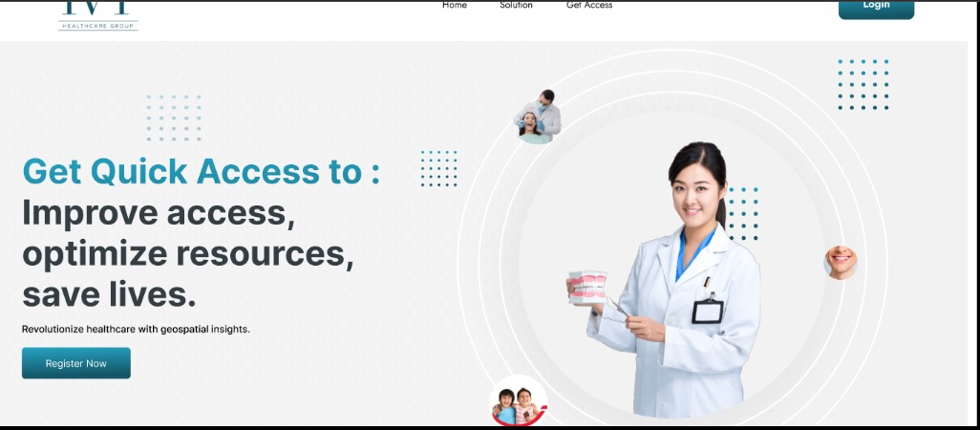
Figure 18: Home Page
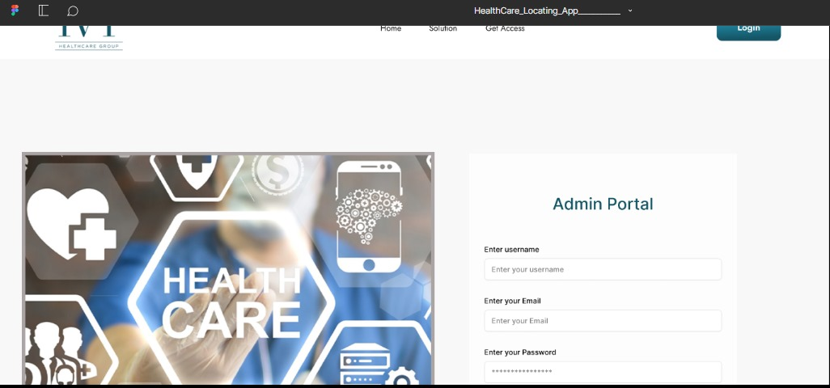
Figure 19: Login
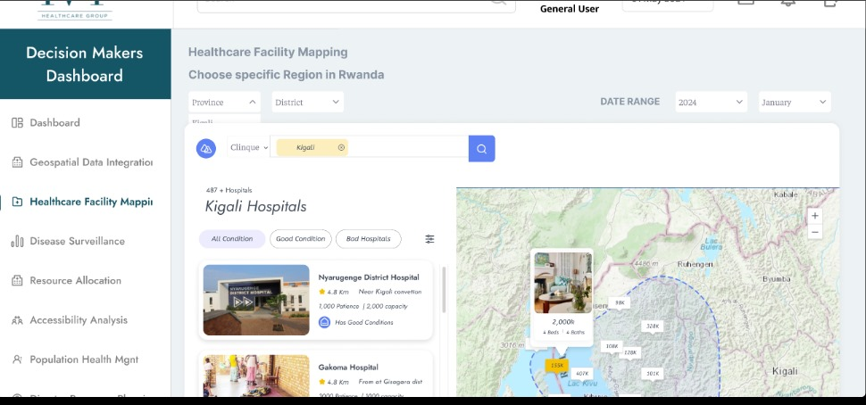
Figure 20: Decision Maker dashboard

Figure 21: User Dashboard

Software Testing
Software testing plays a crucial role in the software development process, serving as a tool to ensure that the software design and functionality align with its intended purpose. It is an essential step that verifies whether the application performs as expected and fulfills the requirements outlined during the planning phase. Proper software testing not only identifies and addresses potential flaws but also builds confidence in the software’s reliability and usability before deployment.
One of the primary considerations during software testing is determining whether the application adheres to the principles that guided its creation and design. This involves examining the software’s architecture, logic, and features to ensure consistency with the objectives set out during the development phase. By verifying adherence to these principles, testers can ensure that the application aligns with its foundational goals and delivers the intended value to its users.
Another critical aspect of software testing is evaluating whether the application functions as it should under various conditions. This includes testing the system’s performance, security, usability, and compatibility with different devices, operating systems, and environments. By doing so, developers can identify areas that need improvement, ensuring that the software is robust, efficient, and user-friendly.
Additionally, software testing assesses whether the application can be implemented consistently while meeting the needs of its stakeholders. This involves understanding user expectations and ensuring that the application addresses those needs effectively. For instance, the application must provide accurate data, intuitive navigation, and seamless functionality to meet the stakeholders’ demands and contribute to their objectives.
In conclusion, software testing is a vital step in the development process, providing a systematic approach to evaluating the software's design, functionality, and user satisfaction. Through comprehensive testing, developers can ensure the software's quality, reliability, and alignment with stakeholder needs, paving the way for successful implementation and operation.

Unit Testing
Unit testing is a critical method used to verify that specific programs or software components function as intended. This technique focuses on testing individual units or small sections of source code to ensure that they meet their design and functionality requirements. A unit can represent a single function, a method, or a module within the larger software system. By isolating these components during testing, developers can systematically identify and address issues, ensuring that each piece operates correctly before being integrated into the complete system.
In essence, unit testing involves examining specific fragments of source code, their associated control data, and usage methods to verify their acceptability and correctness. It is an essential step in the development process, as it allows developers to confirm that each component adheres to its predefined requirements. Additionally, unit testing helps detect logical errors early in the development process, which reduces the time and cost of debugging later stages of development.
One of the core benefits of unit testing is its ability to catch errors at the most granular level of the code. By testing each small component individually, developers can pinpoint issues that may be hidden when components are combined. This makes unit testing one of the most effective tools for comprehensive error detection, ensuring that the software is built on a solid foundation.
Moreover, unit testing provides ongoing validation as the program evolves. Each stage of code creation is accompanied by corresponding unit tests, which verify that new code additions do not introduce errors or disrupt existing functionality. This iterative approach ensures that the software maintains high quality and reliability throughout the development cycle.
In conclusion, unit testing plays an essential role in software development by confirming the correctness of individual components, detecting logical faults, and ensuring compliance with requirements. It is a foundational practice that contributes to creating robust and reliable software systems.

Integration Testing
Integration testing is a crucial phase of the software testing process that focuses on combining and evaluating multiple software components simultaneously to ensure they work together as intended. While unit testing verifies the functionality of individual components, integration testing takes it a step further by assessing the interaction between these components. This process is essential to confirm that the various parts of the software have been assembled correctly and function cohesively as a system.
The primary goal of integration testing is to identify and resolve any issues that may arise when different modules or components interact. These issues can include data flow errors, interface mismatches, or unexpected behavior resulting from the combination of components. By conducting integration tests early and consistently, developers can detect and address these problems before they escalate, ensuring that the system operates smoothly and efficiently.
This phase of testing is typically conducted after a sufficient number of unit tests have been performed on individual software and hardware components. Once the individual components are verified to be functioning correctly, they are integrated and tested together to evaluate their compatibility and interaction. This process ensures that the system as a whole meets both functional and technical requirements.
In practice, the application modules are rigorously tested one after the other, following a systematic approach until all components are integrated and complete. Various testing techniques, such as top-down, bottom-up, or hybrid integration testing, can be employed based on the system's complexity and the project's needs. Each test evaluates specific interactions between components, verifying that the integration aligns with the software's design and intended functionality.
In conclusion, integration testing plays a vital role in the software development lifecycle by ensuring that all components work together harmoniously. It validates the system's overall functionality and reliability, contributing to the delivery of a robust, high-quality software solution that meets user and technical requirements.

Hardware and Software Requirements

Client-Side Software Requirements
- Operating System: Windows 10 or later, macOS 10.14 or later, Linux distributions (e.g., Ubuntu 18.04 or later)
- Web Browser: Latest versions of Google Chrome, Mozilla Firefox, Microsoft Edge, or Safari

Server-Side Software Requirements
- Processor: Dual-core CPU or better (e.g., Intel i3 or AMD equivalent)
- Memory: Minimum 4 GB RAM (8 GB recommended)
- Storage: Minimum 50 GB free disk space
- Display: 1280x720 resolution or higher
- Network: Reliable internet connection with at least 5 Mbps speed
- Peripherals: Keyboard, mouse, and optionally a scanner and printer for document processing

Client-Side Hardware Requirements
- Operating System: Linux distributions (e.g., Ubuntu Server 18.04 or later, CentOS 7 or later), Windows Server 2016 or later
- Web Server: Apache HTTP Server 2.4 or later
- Application Server: Node.js for JavaScript-based backend, or any compatible server depending on the backend language used (Django for Python)
- Database: MySQL 8.0 or later
- Frameworks/Libraries: React.js for the front-end framework.
- Authentication: Simple JWT or another secure token-based authentication system

Server-Side Hardware Requirements
- Processor: Quad-core CPU or better (e.g., Intel Xeon or AMD EPYC)
- Memory: Minimum 16 GB RAM (32 GB or more recommended for large-scale operations)
- Storage: Minimum 1 TB SSD (additional storage based on data volume)
- Network: High-speed internet connection with at least 100 Mbps bandwidth
- Redundancy: Redundant power supplies and network interfaces
- Backup: Regular backup solutions with offsite storage.

CHAPTER 5

CONCLUSION AND RECOMMENDATIONS

Conclusion
The implementation of HealthGeoTrack marks a transformative milestone in Rwanda's healthcare system by addressing critical challenges in healthcare delivery, resource management, and public health planning. This innovative system integrates GIS technology, advanced analytics, and automated data processing, revolutionizing healthcare data management and decision-making processes to improve efficiency and outcomes.
The platform tackles inefficiencies in data collection, processing, and analysis, providing a robust technical foundation built with Python, Django, ReactJS, and MySQL. Its real-time data integration, automated processing, and analytical capabilities enhance disease surveillance, disaster preparedness, and resource allocation through geospatial analysis. Key achievements include the integration of diverse data sources, standardized data entry protocols, and the elimination of data silos, enabling reliable monitoring and planning.
The system's architecture is designed to meet both functional and non-functional requirements, ensuring high performance, security, and scalability. Its UML-based, object-oriented design guarantees maintainability while addressing immediate needs and supporting future expansion.
HealthGeoTrack's successful deployment highlights Rwanda's dedication to leveraging technology for improved healthcare outcomes. Continued investment in infrastructure, data quality management, and staff training will be essential for sustaining the platform’s long-term impact. Future priorities include expanding analytical capabilities, integrating emerging technologies, and adapting the platform to evolving healthcare needs.
This implementation serves as a model for other developing nations seeking to enhance their healthcare systems through data-driven decision-making and geospatial analysis. The project's success in addressing Rwanda's healthcare challenges while maintaining high standards of security, performance, and usability demonstrates the viability of sophisticated technological solutions in improving public health outcomes in developing regions.

Recommendation
The implementation of HealthGeoTrack has shown great potential in transforming Rwanda's healthcare system through geospatial analysis. To further enhance the system's capabilities, the Rwanda Ministry of Health should consider several key improvements.
The integration of Internet of Things (IoT) technology would significantly enhance real-time monitoring and data collection. IoT sensors throughout healthcare facilities could automatically gather vital information about medical equipment status, vaccine storage conditions, and patient vital signs. This would enable more proactive healthcare management and faster response to emerging health issues.
A robust data infrastructure, including edge computing capabilities, would be essential to support IoT integration. The Ministry should develop a comprehensive IoT device management system to ensure reliable data collection. Artificial intelligence and machine learning algorithms could then analyze this data to predict disease outbreaks and optimize resource allocation.
The development of a mobile application interface with offline functionality would improve accessibility for healthcare workers in rural areas. To ensure successful implementation, the Ministry should adopt a phased approach, starting with pilot programs in selected facilities and providing comprehensive training programs.
These enhancements would transform HealthGeoTrack into a more comprehensive healthcare management system, better equipped to serve Rwanda's population and address future public health challenges through improved monitoring, prediction, and response capabilities.

REFERENCES

Books
(Alan, 2005)
(Tyler, 2020)
(Valdez, 2016)
(Health Service Packages for Public Health Facilities, 2017)

Websites
Tyler, E. (2020). CSS. Retrieved August from Wikipedia.org: https://en.wikipedia.org/wiki/Cascading_Style_Sheets Accessed on July 01 ,2023
Valdez, A. (2019). Java Script. Retrieved from Wikipedia.org: https://en.wikipedia.org/wiki/JavaScript Accessed on July 19 ,2023
Visual Paradigm. (2023). What is Class Diagram? Retrieved from www.visual-paradigm.com: https://www.visual-paradigm.com/guide/uml-unified-modeling-language/what-is-class-diagram/ Accessed on July 02 ,2023
Visual paradigm. (2023). What is Unified Modelling Language (UML)? Retrieved from www.visual-paradigm.com: https://www.visual-paradigm.com/guide/uml-unified-modeling-language/what-is-uml/ Accessed on July 02 ,2023
Moore, L. (2023). MYSQL DEFINITION. Retrieved from www.techtarget.com: https://www.techtarget.com/searchoracle/definition/MySQL Accessed on August 02 ,2023
Lucid Chart. (2023). UML Sequence Diagram Tutorial. Retrieved from www.lucidchart.com: https://www.lucidchart.com/pages/uml-sequence-diagram Accessed on July 21 ,2023
Lucid chart. (2023). UML Use Case Diagram Tutorial. Retrieved from www.lucidchart.com: https://www.lucidchart.com/pages/uml-use-case-diagram Accessed on July 12 ,2023.

APPENDICES

Curriculum Vitae

 RWANDA-KIGALI CITY

BAHIZI JONAS
I’m committed, Energetic, Friendly and Hard worker with a spirit of Team worker

jonasbahizi@gmail.com +250785513857

EXPERIENCE

Rwanda Interfaith Council on Health
-Data Collector
- I have served and am currently volunteering for both KAZI International and Edify.
EDUCATION
Bachelor's Degree in Information Telecommunication (Information management) at Adventist University of Central Africa (AUCA)
01/2020-Present

TECHNICAL SKILLS
- -Cyber Security Skills
- -Computer Networks Skills
- -Mobile Programing Applications Skills
- -PL/SQL Skills
- Linux Skills
- Java Script

-Microsoft word Application Skills-
-Microsoft PowerPoint Applications

NON-TECHNICAL SKILLS
-Arbitrate
-Communication
-Decision making
-Fast learner

AWARDS
Cornerstone lead student leadership training (Certificate)
-Public Speaking at Voice Masters Africa (Certificate)
- Sells and Marketing at Career Building Consultants Ltd (Certificate)
- Driving License(B)
Volunteering Certificate from Kazi International
LANGUAGES
English Kinyarwanda
Proficient Proficient

Data Collection Letter

