Adventist University of Central Africa

RWANDA BASKETBALL TALENT BOOST SYSTEM
CASE STUDY: RWANDA BASKETBALL FEDERATION (FERWABA)

A final year project Presented in partial fulfillment of the Requirements for the
degree BACHELOR OF SCIENCE IN INFORMATION TECHNOLOGY
Major in
Software Engineering

By
Mugabe Prince
August 2024

ABSTRACT
Research Project for the Bachelor’s Degree in Information Technology
Adventist University of Central Africa
Topic: Rwanda Basketball Talent Boost System
Name of the Researcher: MUGABE Prince
Name and the Degree of the Faculty Advisor: Ivan BISENGIMNA
Date of Completion: August 2024
The Rwanda Basketball Talent Boost System aims to revolutionize basketball talent development in Rwanda by leveraging technology to democratize access and foster inclusivity, particularly for aspiring players from rural areas. The initiative addresses existing inefficiencies and security vulnerabilities that currently favor urban centers and traditional talent recognition pathways.
Since its establishment in 1974, the Rwanda Basketball Federation (FERWABA) has promoted basketball in Rwanda, overcoming challenges such as the 1994 Genocide against the Tutsi. However, the current talent development system faces issues like restricted access to opportunities and the absence of a centralized talent promotion platform. The PIECES framework analysis reveals inefficiencies in performance, information, economic, control, and service aspects of the system.
The proposed Rwanda Basketball Talent Boost System provides an innovative online platform for basketball players from diverse backgrounds to showcase their talents globally. Key features include user registration with identity verification through the National Identification Agency (NIDA), ensuring the authenticity of player profiles. Players can upload skill demonstration videos, making it easier for scouts and coaches to assess their abilities. The system validates profiles to enhance credibility and visibility, offering aspiring athletes’ greater recognition and access to professional opportunities. By addressing both functional and non-functional requirements, this platform fosters a fairer, more efficient talent development process, empowering young players with unprecedented opportunities for professional growth and recruitment in the global basketball industry.

DECLARATION
I, MUGABE Prince with student id 23831 at Adventist University of Central Africa in Faculty of Information Technology, Department of Software Engineering certify that I am the only person who created this project report and that it has never been submitted, in whole or in part, for consideration toward a degree. Except in cases where I cite or give credit to other sources, everything of the work that is provided here is original to me.
Signature: ……………………………….
Date: …/......./.........

APPROVAL
I, Ivan BISENGIMANA, hereby confirm that I have given my consent for this project report to be completed and submitted under my supervision.
Signature……………………………….
Date………………

DEDICATION
To the Almighty God, the Divine Creator; To my cherished family, especially my parents and siblings; To all of my friends: You have all been my strongest allies; I will always be appreciative of everything that lecturers have done.

TABLE OF CONTENTS
ABSTRACT i
DECLARATION ii
APPROVAL iii
DEDICATION iv
TABLE OF CONTENT v
LIST OF TABLES ix
LIST OF FIGURES x
LIST OF ABBREVIATIONS xi
ACKNOWLEDGEMENT xii
CHAPTER I 1
GENERAL INTRODUCTION 1
Introduction 1
Background of the Study 2
Statement of the Problem 3
Choice and Motivation of the Study 4
Objective of the Study 4
General Objective 4
Specific Objectives 4
Scope of the Project 5
Methodology and Techniques 7
Observation 7
Interviews 7
Expected Result 9
Organization of the Report 10

CHAPTER 2 11
ANALYSIS OF THE EXISTING SYSTEM 11
Introduction 11
Description of the Current System Environment 11
Historical Background 11
Mission 11
Vision 12
Description of the Current System 12
Analysis of the Current System 13
The Modeling of the Current System 13
Problems with the Current System 14
Proposed Solutions 17
System Requirements 17
Functional Requirements 17
Non-functional Requirements 18
CHAPTER 3 19
REQUIREMENTS ANALYSIS AND DESIGN OF THE NEW SYSTEM 19
Introduction 19
Analysis and Design Methodology 19
Design of the new system 22
Use Case Diagram 22
Class diagram 28
Sequence diagram 29
Database diagram 32
Activity Diagram 33
Data Definition 35
System Architecture 36
CHAPTER 4 40
IMPLEMENTATION AND TESTING OF THE NEW SYSTEM 40
Introduction 40
Tools and Technologies used 40
Frontend 40
Backend 40
Presentation of the New System 41
Software Testing 46
Unit Testing 47
Integration Testing 47
Validation Testing 47
System Testing 47
User Acceptance Testing (UAT) 48
Performance Testing 48
Security Testing 48
Regression Testing 49
Hardware and Software compatibility requirements 49
Client-Side Software Requirements 49
Client-Side Hardware Requirements 49
Server-Side Software Requirements 49
Server-Side Hardware Requirements 50
CHAPTER 5 51
CONCLUSION AND RECOMMENDATIONS 51
Conclusion 51
Recommendations 52
REFERENCES 53
Books 53
Websites 53
APPENDICES 54
CURRICULUM VITAE 55

LIST OF TABLES
Table 1: Use case Diagram Elements 23
Table 2 : Use case description of Player signup process. 26
Table 3: Use case description of Login 27
Table 4: Use case description of player registration 28
Table 5: Sequence description table 30

LIST OF FIGURES
Figure 1: Model of existing Rwanda Basketball Talent Boost System 14
Figure 2: Use case diagram of the new system 24
Figure 3: Class diagram of the new system 29
Figure 4: Sequence diagram for signup 31
Figure 5: Sequence diagram for player registration 32
Figure 6: Database diagram of the new system 33
Figure 7: Activity diagram showing signup for the new system 34
Figure 8: Activity diagram showing player registration for the new system 34
Figure 9: User data definition table 35
Figure 10: Player data definition table 35
Figure 11: Player status data definition table 36
Figure 12: System Architecture of the new system 38
Figure 13: System home page 41
Figure 14: System signup page 42
Figure 15: System login page 43
Figure 16: System player registration page 44
Figure 17: Manages user admin dashboard page 45
Figure 18: System Player dashboard page 46

LIST OF ABBREVIATIONS
AUCA Adventist University of Central Africa
CSS Cascading Style Sheets
DBMS Database Management System
FERWABA Rwanda Basketball Federation
GB Gigabyte
HTML Hypertext Markup Language
ID Identification
JS JavaScript
KPIs Key Performance Indicators
KTS Kaby Tech Solution
MINISPORT Ministry of Sport
NIDA National Identification Agency
OMG Object Management Group
OS Operating System
RAM Random Access Memory
REB Rwanda Education Board
TLS Transport Layer Security
UML Unified Modelling Language
VS Code Visual Studio Code
XAMPP Cross-Platform, Apache, MySQL, PHP, and Perl

ACKNOWLEDGEMENT
First and foremost, I give thanks to God for His unwavering support along my academic path and up to this point. Many students quit their studies early for a variety of reasons, but by God's grace, I stayed to the completion of every course.
I have to remember that in order to be where I am now with my abilities, I required the fundamental information as a student. I am grateful to the administration of AUCA for the educational program and its beneficial impact on students. I've been aware of the student way of life ever since I started attending AUCA. Thank you for assisting the student in gaining a fresh viewpoint.
I express my gratitude to my parents for their support, guidance, and encouragement. They collaborated with me both monetarily and virtually.
I am so appreciative of the department staff members that are continuously striving for the success of their pupils. I am really appreciative of Ivan BISENGIMANA, my supervisor, for his expert advice, thoughts, and guidance in helping me complete this task.
I am appreciative of my co-workers who were instrumental in my academic career; their cooperation and encouragement lifted me up and provided valuable experience.
In general, I am grateful to my friends for always supporting me when things looked unachievable.
In conclusion, I would want to express my gratitude to all those who have assisted and contributed to this work, whether directly or indirectly.
May God bless each and every one of you!

Prince MUGABE

CHAPTER I

GENERAL INTRODUCTION

Introduction
Sports serve as a fundamental need of human society for having a better life, dating back to ancient civilizations where athletic competitions celebrated skill and fostered community bonds. From humble beginnings, sports have evolved into highly structured events with global reach and significant economic impact. Today, professional athletes command immense salaries, while billions of fans worldwide engage with major sporting events such as the World Cup and the Super Bowl.
In many developing nations like Rwanda, sports participation remains rooted in local communities, though interest in internationally recognized sports is steadily increasing. Since the 1990s, basketball has gained notable popularity in Rwanda, largely introduced by American missionaries. Across the country, basketball courts and pickup games symbolize the growing enthusiasm for the sport.
The significance of basketball in Rwanda extends beyond mere recreation. Introduced at a critical juncture in Rwanda's history, basketball has served as a catalyst for national reconciliation and youth development in the aftermath of the 1994 genocide against the Tutsi. Through intense competitions and camaraderie, basketball has helped forge a sense of patriotism and unity among Rwandans.
With ongoing infrastructure development and investment in training programs, Rwanda's basketball scene continues to flourish. Talented young players aspire to represent their country on regional and global stages, reflecting the sport's potential to inspire and unite diverse communities. As Rwanda embraces the transformative power of sports, basketball stands as a testament to the country's resilience, hope, and commitment to a brighter future.

Background of the Study
The Rwanda Basketball Federation (FERWABA) has played a pivotal role in the development and promotion of basketball within Rwanda, serving as the governing body responsible for overseeing the sport at various levels. Understanding the historical background of FERWABA is essential for contextualizing its impact on the growth of basketball and the broader societal changes it has influenced in Rwanda.
FERWABA traces its roots back to the early stages of organized basketball in Rwanda, which gained momentum in the latter half of the 20th century. As basketball became increasingly popular, the need for a centralized governing body emerged to regulate competitions, establish standards, and coordinate development initiatives aimed at promoting youth participation and talent identification. This laid the foundation for the thriving basketball community seen today.
Formally established in 1978, FERWABA focused its early efforts on grassroots programs, forming partnerships with local communities, schools, and sports organizations. These efforts were critical in expanding youth engagement in sports across Rwanda, particularly as basketball gained traction. However, these early initiatives were not without challenges. The lack of infrastructure, limited access to professional coaching, and inadequate funding posed significant hurdles to the sport’s growth.
Over the years, FERWABA has collaborated with both governmental and international organizations to address these challenges. Notably, it has spearheaded projects for the construction of basketball facilities and the professionalization of coaching and referee training programs. These initiatives culminated in the organization of competitive leagues and tournaments that helped develop Rwanda's talent pool and put the country on the map for regional and international basketball competitions.
FERWABA’s role extends beyond sports. In the aftermath of the 1994 genocide against the Tutsi, FERWABA became a symbol of unity and healing in a divided nation. Basketball was not just a sport but a tool for reconciliation and nation-building. By promoting inclusivity and diversity, FERWABA played a crucial role in Rwanda's efforts to rebuild and foster a sense of national identity. This connection between sports and societal healing has become a core focus of FERWABA's mission, making basketball a medium through which Rwandans find common ground.
Despite these successes, FERWABA continues to face challenges, particularly regarding gender equality and international competitiveness. While the federation has made strides in promoting women’s basketball, disparities remain in terms of resources and opportunities available to female athletes. Addressing these gaps remains a priority as FERWABA seeks to elevate Rwanda’s standing in global basketball arenas.
Today, FERWABA’s commitment to developing basketball at all levels—through talent development programs, gender equality initiatives, and infrastructure expansion—positions it as a key player in Rwanda's social and athletic future. As the basketball landscape in Rwanda continues to evolve, FERWABA stands as a testament to the transformative power of sports in building an inclusive, resilient, and prosperous society.

Statement of the Problem
In Rwanda, the burgeoning interest in basketball is hindered by systemic challenges that impede talented youth, especially those in rural areas, from effectively showcasing their potential. The current landscape lacks a centralized platform for youth to profile their basketball skills and achievements, exacerbating the disparity between urban and rural talent recognition. Moreover, the absence of accessible tools for talent promotion limits opportunities for aspiring athletes to gain visibility on regional and international platforms.
This thesis addresses these critical gaps by proposing the development of a comprehensive software system designed to empower Rwandan youth to showcase their basketball talent profiles. By leveraging technology, the proposed system aims to provide a user-friendly platform accessible to youth across diverse geographical and socioeconomic backgrounds. Through the system, youth will have the opportunity to create personalized profiles highlighting their skills, achievements, and aspirations in basketball.
By democratizing access to talent promotion tools and fostering inclusivity, the proposed software system seeks to level the playing field for aspiring basketball athletes in Rwanda. Through enhanced visibility and connectivity, youth from all corners of the country will be empowered to pursue their basketball aspirations with greater confidence and opportunities for recognition on both domestic and global stages. Ultimately, the implementation of such a system holds the potential to revolutionize talent scouting and promotion in Rwandan basketball, catalyzing the emergence of a more diverse and vibrant basketball community.

Choice and Motivation of the Study
The decision to study the development of a software system empowering Rwandan youth in showcasing their basketball talents stems from the transformative potential of sports in society. Sports, including basketball, have historically catalyzed social change and individual empowerment globally. In Rwanda, with its rich cultural heritage and burgeoning basketball enthusiasm, investing in youth sports programs is pivotal. The study aims to address systemic barriers hindering young athletes, especially in rural areas, from showcasing their talents by leveraging technology. By democratizing access to talent promotion tools, the study seeks to bridge urban-rural divides, foster inclusivity, and promote national unity.
The study is grounded in the belief that sports, particularly basketball, can empower youth and contribute to national development. By providing means for showcasing talents, the software system aims to instill pride, ambition, and determination among young athletes, inspiring future generations. Leveraging innovation and technology, the study proposes a scalable solution adaptable to Rwanda's evolving basketball community. By streamlining talent scouting and enhancing visibility, the software system has the potential to unlock opportunities beyond Rwanda's borders. In essence, the study reflects a commitment to leveraging sports and technology to empower Rwandan youth, promote inclusivity, and foster a vibrant basketball community rooted in resilience and excellence.

Objective of the Study

General Objective
The study's main goal is to create a comprehensive software system that empowers Rwandan youth, regardless of geographical or socioeconomic constraints, to showcase their basketball talents effectively on national and international platforms.

Specific Objectives
- To develop a system which hinder Rwandan youth, particularly those in rural areas, from accessing platforms to showcase their basketball talents.
- To design and develop a user-friendly software system that transcends geographical and socioeconomic boundaries, enabling youth to create personalized profiles highlighting their basketball skills, achievements, and aspirations.
- To assess the feasibility and scalability of the proposed software system in addressing the identified challenges and promoting inclusivity within Rwanda's basketball community.
- To evaluate the impact of the software system on empowering Rwandan youth, fostering inclusivity, and promoting national unity through enhanced visibility and connectivity in the basketball sphere.
- To provide recommendations for the sustainable implementation and further enhancement of the software system to continually meet the evolving needs of Rwanda's basketball community and youth empowerment initiatives.

Scope of the Project
The development of the software system aimed at empowering Rwandan youth in showcasing their basketball talents follows a structured project lifecycle. This methodology outlines the various phases undertaken to conceptualize, design, develop, and implement the software system.
Planning
In the planning phase, the project objectives, goals, and scope were defined. Key stakeholders, including youth, coaches, scouts, and basketball associations, were identified. A comprehensive assessment of requirements, constraints, and risks was conducted to establish a clear roadmap for the project.
Requirement Gathering
In the requirement gathering step, extensive efforts were made to capture the needs and expectations of all stakeholders. This involved conducting focus groups with youth, coaches, and basketball scouts to understand their specific needs and challenges. Questionnaires and surveys were distributed to a broader audience to gather quantitative data on user preferences and requirements. In-depth interviews were held with key stakeholders to capture detailed functional and non-functional requirements. Additionally, observations were made to analyze current basketball talent development processes and systems, identifying gaps and opportunities for innovation. This comprehensive approach ensured a thorough understanding of the requirements needed for the system's successful development.
Analysis
Stakeholder requirements for the features and functionality of the software system were obtained during the analysis phase. To learn about the needs and preferences of users, focus groups, questionnaires, and interviews were held. To find opportunities for innovation and development, the basketball community in Rwanda examined its current procedures and systems.

Design
The design phase involved creating detailed specifications and blueprints for the software system. This included designing a user-friendly interface, ensuring scalability, flexibility, and compatibility with existing infrastructure and technologies.
Implementation
The implementation phase focused on developing the software system according to the design specifications. Features for creating and managing user profiles, uploading multimedia content, and connecting with coaches and scouts were implemented. Data analytics functionalities were integrated to track user engagement and talent trends.
Testing
To verify the software system's operation, usability, and performance, extensive testing was done. To find and fix any flaws or problems, system, user acceptability, unit, and integration testing were carried out.
Deployment
Deployment involves nationwide rollout, user-friendly access via web and mobile, integration with NIDA for identity verification, scalability, stringent security, performance optimization, support protocols, compliance, training, and KPI-driven monitoring for effective talent empowerment.

Maintenance
Protocols and procedures for ongoing maintenance, support, and updates to the software system were established. Training and documentation were provided for administrators, coaches, and youth users. System performance was monitored, and enhancements and optimizations were implemented to ensure the long-term success and sustainability of the software system.
Integration
Each phase of the project lifecycle contributed to the overall success and sustainability of the software system. The structured approach ensured alignment with stakeholder requirements, adherence to quality standards, and responsiveness to changing circumstances.

Challenges and Lessons Learned
Throughout the project lifecycle, various challenges were encountered and valuable lessons were learned. These experiences have informed future software development efforts and underscore the importance of adaptability, collaboration, and continuous improvement.

Methodology and Techniques
For this research thesis focusing on the development of the Rwanda Basketball Talent Boost System, two primary research methodologies were employed: observation and interviews.

Observation
The research began with observational studies aimed at gaining firsthand insights into the current practices and challenges within the Rwandan basketball talent management ecosystem. Through direct participation in basketball training sessions, talent scouting events, and player assessments, the researcher observed the existing workflow and operational dynamics. Detailed field notes were maintained to document key activities, processes, and observed challenges such as inefficiencies in player data management, decentralized scouting practices, and barriers to talent visibility.

Interviews
Structured interviews were conducted with a range of stakeholders involved in basketball talent management in Rwanda. This included coaches, scouts, players, and administrators from various Rwandan basketball clubs and federations. The interviews were semi-structured, allowing for a predefined set of questions while also enabling flexibility to explore new insights and perspectives. The discussions with stakeholders focused on gathering their perspectives on the current state of talent development, existing challenges, and their specific requirements for an improved system.
Below are some questions asked and the responses provided by players and stakeholders:
- Question 1: What are the key challenges you face in identifying and nurturing basketball talent in Rwanda?
Sample Response (Coach): "One of the biggest challenges we face is the lack of a centralized talent management system. Right now, data about players—such as their skills, performance stats, and progress—is scattered across various clubs and regions. This makes it difficult for us to track and nurture talent efficiently. Additionally, we struggle with limited resources, such as access to qualified scouts and advanced training facilities, especially in rural areas."
- Question 2: How do you currently scout and track potential basketball talent?
Sample Response (Scout): "Scouting is largely decentralized and inconsistent. Each scout has their own methods and criteria for evaluating players, which can lead to discrepancies in talent identification. We typically rely on watching games and informal networks to find players, but there’s no standardized system for recording and sharing player data across the country. This makes it hard to ensure we’re scouting the best talent or giving opportunities to all deserving players."
- Question 3: What features or improvements would you like to see in a basketball talent management system?
Sample Response (Administrator): "A centralized digital platform where all player profiles are stored would be ideal. It should include key stats, scouting reports, and video footage, which can be accessed by coaches, scouts, and federation officials. Additionally, the system should enable better communication between clubs and ensure transparency in talent selection. We also need features that make it easier to track player development over time and identify gaps in training that need to be addressed."
- Question 4: How does the current system impact the visibility and development of young players?
Sample Response (Player): "As a player, I feel like there are many talented individuals who aren’t getting noticed, especially those from smaller clubs or rural areas. Without a proper system to showcase our skills and progress, it’s harder to make it to the next level. I think a talent management system would help us get the visibility we need and connect with opportunities to play in bigger leagues."
- Question 5: How do you think technology can help improve the talent scouting and development process?
Sample Response (Scout): "Technology can play a huge role in making the scouting process more efficient and equitable. For example, if we had a mobile app where players could upload their game stats and videos, it would make it easier for scouts like me to evaluate them, even from remote locations. We could also use data analytics to compare player performance over time and make more informed decisions about who gets selected for teams or further training."

Expected Result
The observational research provided deep insights into the current practices and operational challenges within Rwandan basketball talent management. It revealed the intricate workflow involved in player registration, video validation, and talent promotion. Documenting these challenges was crucial for understanding the gaps and inefficiencies that the new system aims to address.
The stakeholder interviews yielded diverse perspectives on the strengths and weaknesses of the current talent management practices. Coaches emphasized the need for better player data management and centralized scouting platforms. Scouts highlighted challenges in validating player videos and promoting talent effectively. Players expressed concerns about visibility and access to opportunities.
By employing observation and interviews, this research laid a solid foundation for the development of the Rwanda Basketball Talent Boost System. The insights gathered not only informed the design and implementation phases of the system but also ensured alignment with stakeholder needs and expectations. Addressing the identified challenges through innovative solutions will contribute to enhancing the overall effectiveness and efficiency of basketball talent management in Rwanda, thereby fostering greater opportunities for player development and professional growth in the sport.

Organization of the Report
Chapter one: provides a thorough overview of the project, including its goals and the features that the new system is expected to have.
Chapter two: Performs a thorough examination of the current system, assessing its functional features, advantages, disadvantages, and offering workable fixes.
Chapter three: presents the conceptual framework for the suggested fixes, showing workflows and procedures through the use of UML diagrams.
Chapter four: Details the design and implementation phases of the new system, providing insights into its features, technologies, testing procedures, and deployment strategies.
Chapter five: Concludes the research endeavor by offering valuable recommendations and insights, consolidating references and sources for further exploration. This structured approach ensures a coherent and systematic exploration of the project's facets, covering introduction, analysis, design, implementation, and conclusion.

CHAPTER 2

ANALYSIS OF THE EXISTING SYSTEM

Introduction
The purpose of this chapter is to give a quick explanation of the terminology used while the project is being developed. In order to gather all the needs for the new system, a brief presentation of the institution is given, along with a detailed analysis of the current system and a description of its faults. In the end, the suggested fix for the issues raised will be emphasized.

Description of the Current System Environment

Historical Background
The Rwanda Basketball Federation (FERWABA) boasts a storied history that mirrors the nation's journey through triumph and adversity. Established in 1974, FERWABA emerged as the authoritative body governing basketball in Rwanda, tracing its roots to the passionate efforts of early enthusiasts and the strategic vision of sports leaders. From its inception, basketball found fertile ground in Rwandan soil, with the sport gradually permeating communities and schools across the country. Over the decades, FERWABA has weathered the storms of historical upheavals, including the aftermath of the 1994 Genocide against the Tutsi, which dealt a significant blow to the sport's infrastructure and human capital. However, through resilience and determination, FERWABA persevered, spearheading initiatives to rebuild, rejuvenate, and expand the reach of basketball in Rwanda. Today, FERWABA stands as a beacon of hope and unity, embodying the spirit of reconciliation and progress as it continues to empower generations of Rwandan Basketball players and enthusiasts.

Mission
FERWABA's mission is to provide an enabling environment for skill development, talent nurturing, and high-level competition for basketball as a sport in Rwanda. With a focus on fostering a supportive and empowering ecosystem, FERWABA endeavors to create opportunities for players, coaches, and officials to thrive and excel in their respective roles. By promoting skill enhancement, talent identification, and equitable access to resources, FERWABA aims to cultivate a vibrant and sustainable basketball culture that enriches the lives of individuals and contributes to the broader sports landscape in Rwanda.

Vision
Developing and promoting basketball policies in Rwanda, enhancing the technical and moral skills of coaches and referees, advocating for the interests of clubs and associations, creating a youth basketball program, and planning and participating in both national and international competitions are just a few of the goals.

Description of the Current System
Mastering the current system is crucial in order to develop a new one. Understanding the intricacies of the suggested or present one is emphasized more in system analysis rather than in deciding whether or not to modify it and whether it is desirable. Below is an explanation of the present system model:
- For each Rwandan to become a professional player who is very famous he/she must either have started playing from school when they joined at first for studying purpose and by joining the sport activities that have been provided by the Ministry of Education (REB) in partnership with the ministry of Sport (MINISPORT). On the other hand, people may become fond of the basketball and decide to make it professional at their old age where they may happen to be no longer studying. It’s in that case the republic of Rwanda has set the sport activities in every region regardless the individuals that may group and organize their selves by forming a club and start playing the Basketball as hobby.
- After joining any of the different approach that described above, a member is authorized to attend the activities that have been settled up by the school, organization, and or by the club. By thus, this is where the individual gets an opportunity of proving what he/she is capable of. Schools play a tournament known as “interscolaire” as the process assigned by REB in partnership with MINISPORT as the measure process of developing basketball talents from Rwandan youths which regardless other sport activities that are available.
On the other sides, different organizations and institutions that are available in Rwanda either public or private, clubs that have been formed also set some competitions and they attend to challenge among themselves for entertainment purpose and from here it become another great opportunity for the individuals who wish to play basketball as professional career by proving with the great extraordinary talent level capability.
- From every competition and tournament that is ongoing there are always different members of the professional playing clubs on the country level that are under management of Rwanda Basketball Federation (FERWABA) who are available overseeing what is going around, how players perform and which talents can be found among the players. By thus, an individual gets a higher chance to be selected by any of the professional team in accordance with their potentials under basketball.
- After being selected by one or more professional team a player is invited to get a test. From there he/she passes all the available tests that have been set by the team and if he/she manages to pass then the team will notify FERWABA that they are about to sign a contract with that player, FERWABA will check all the requirements for that person and if everything goes well then, they give an acknowledgement and the player will therefore sign a contract with the team which would be by then the beginning of the professional career.

Analysis of the Current System

The Modeling of the Current System
The Following illustration demonstrate the current process that every Rwandan passes throughout to become famous as Basketball player from the beginning at that time when he/she plays as hobbies till they reach to that extent they play as professionals.
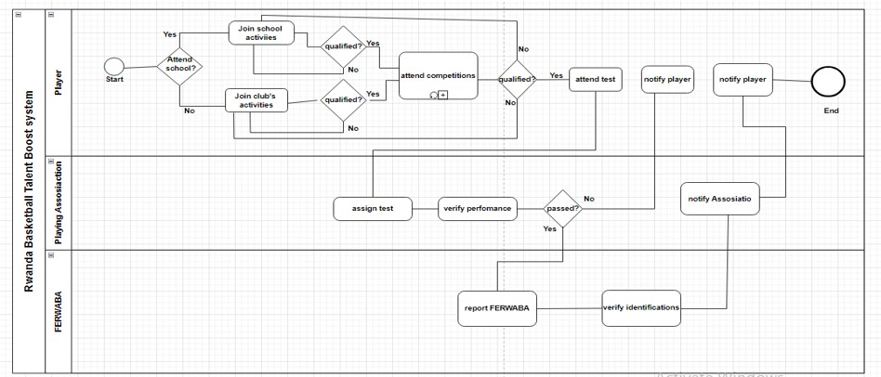
Diagram that demonstrates the current Basketball talent boost process
Figure 1: Model of existing Rwanda Basketball Talent Boost System

Problems with the Current System
The existing talent development process in Rwandan basketball faces several obstacles, including limited access to opportunities for players in rural areas, reliance on traditional pathways, and barriers to visibility and recognition. The current system lacks a centralized platform for talent promotion and often favors individuals with access to urban centers and established networks. Below are some of the obstacles that are met by the players:
Firstly, on behalf of the scenario where a person passes through the school, play competitions and get selected by the professional teams it has been found that that some people miss the opportunity because if his/her corresponding schools are defeated at early stage by thus they miss the chance of continue playing the competitions until to that level where they are seen by their potential since the observers from the professional teams mostly the hiring team members can’t reach every school. This means that that they could reach the schools which have reached on higher level on the tournament of the competitions where it affects the player as an individual.
On behalf of such individuals who pass through the clubs process we can find the obstacles they also meet alongside the development of their talents and career building where most of the famous clubs are available in cities. By thus, teams use to access those clubs that are available and most known ones which facilitate the members from those clubs to get that opportunity of being accessed and also affect some others on the other side mostly those who are located from those different clubs by which are not yet famous alongside the country.
Although Rwanda's basketball talent development process has seen progress in recent years, it grapples with inherent limitations that impede equitable access and opportunities for all as tackled on above. Currently, the system exhibits a bias towards individuals situated in urban centres, where resources and visibility are abundant. Consequently, talented players from rural areas encounter significant barriers in gaining recognition and progressing in their careers. Furthermore, reliance on conventional pathways to talent discovery exacerbates disparities and stifles the potential of undiscovered talents.
Regardless of the specified problems of the current system, it is better to look the problems under PIECES’ framework so that the solution may take over all the sectors to make more functional and important than the current one; by this below are the problem of the current Rwanda Basketball
Performance
Throughput
- The player can’t attend all the schools or clubs within Rwanda.
- The club or school can’t support all the players to the federation club by itself.
- The federation club cannot all the schools or clubs within Rwanda at once.
- Rwanda Basketball Federation (FERWABA) cannot access all the schools or clubs.
Response Time
- It requires a long period for a player to be able to convince the team leaders.
- It takes time for the club or school leaders in charge to give adequate time to prove his/her talent.
- It takes a long time for the federation club to know that there are some players across the country with talent.
- On behalf of the Rwanda Basketball Federation (FERWABA) it takes some days to know, register the new player.

Information
- Input
- The school keeps players in local machines.
- The federation clubs record the players in local machine.
- Rwanda Basketball federation (FERWABA) records the players in internal server.
- Output:
There is no automatic option for viewing the developed for both schools, professional teams as well as Rwanda Basketball Federation (FERWABA).
- Storage
Player information are kept in excel files in the registrations’ office computers.
Economics
- The Players: The system drive the player to start playing without being paid.
- The school: The current system cost the school some expenses by which they provide to the player’s consumption.
- The Professional Club: Sometimes the club expends much money to the players while keeping and helping them to develop the level of playing before working as professionals.
- Ministry of Sport (MINISPORT): gives high amount of money Rwanda Basketball Federation (FERWABA) for developing the level of basketball in a country.
Control
- Security on the School: Sometimes players find teams that can hire them aside within secrete and if it goes so the school never get profit from them.
- Security on the playing club:
- The club is not secured because sometimes they help players from the junior level up to professionalism and the players never consider that yet moves to other particular teams freely sometimes without informing the current ones.
- Player information are kept into local machines after recording them.

- Security on the player side: The player is not secured either within the school or the playing club because they have no contract and can be expelled at any time.
- Security on the Rwanda Basketball Federation (FERWABA): Player information are stored in the local machine at years.
Efficiency
The current system is not efficient to the player, school, playing club and the Rwanda Basketball Federation (FERWABA).
Service
The current Rwanda Basketball Talent Development System process is very exhausting, time consuming, money expending on both player, school, playing club and Rwanda Basketball Federation (FERWABA).

Proposed Solutions
The proposed solution of Rwanda Basketball Talent Boost System heralds a paradigm shift in Rwandan basketball talent development, harnessing cutting-edge technology to democratize access and foster inclusivity. At its core, the envisioned software system empowers individuals to autonomously showcase their basketball prowess, irrespective of geographic or socioeconomic constraints. Through a multifaceted approach, the system aims to revolutionize the talent scouting and promotion landscape, offering hope for aspiring players across Rwanda.
In fact, Rwanda Basketball Talent Boost would be a good solution to help those individuals from all regions of the country to sensibilize their talent not only on the country level but on all over the globe because the system is available online where peoples from different teams, nations, and continents have access to the system to be able to see which talents are available in Rwanda. By thus, since the system provides the talents within Rwanda and is for Rwandan’s talents this must help initially to provide some job opportunities to available talents.

System Requirements

Functional Requirements
the functional requirements of the proposed system outline its operational capabilities and functionalities crucial for realizing its transformative potential:
- user registration: the system must facilitate seamless user registration, enabling individuals to create accounts and access the platform's features.
- identity verification: integration with the national identification agency (NIDA) API will ensure robust identity verification, safeguarding the integrity of user profiles and preventing fraudulent activities.
- video upload and validation: users will be able to upload videos showcasing their basketball skills, subject to rigorous validation to ensure authenticity and adherence to established standards.
- profile display: validated user profiles and videos will be prominently featured on the platform's homepage, enhancing the visibility of talented players and fostering engagement with stakeholders.

Non-functional Requirements
beyond its functional capabilities, the proposed system must adhere to a set of non-functional requirements to ensure its effectiveness, scalability, and user satisfaction:
- security: To safeguard user data and limit illegal access or breaches, strict security measures will be placed in place.
- scalability: the system must have the capacity to accommodate a growing user base and an expanding repository of videos, ensuring seamless performance even under increased demand.
- usability: a user-centric design approach will be adopted to enhance usability and accessibility, catering to users of diverse backgrounds and skill levels.
- performance: optimized system performance will minimize latency and downtime, ensuring uninterrupted video playback and an immersive user experience.
- accessibility: compliance with accessibility standards will ensure that the platform is accessible to users with disabilities, promoting inclusivity and equal opportunity for all.
by adhering to these requirements, the proposed system aims to revolutionize basketball talent development in Rwanda, ushering in a new era of accessibility, inclusivity, and opportunity for aspiring players.

CHAPTER 3

REQUIREMENTS ANALYSIS AND DESIGN OF THE NEW SYSTEM

Introduction
The process of creating a new system involves innovating the old one; it aims to satisfy the user by offering features that the old system did not have. Upon conducting a thorough study of the previous system, it becomes evident that certain useful items are lacking. Regardless of the achievements made by the previous system, there is always room for improvement.
System analysis is the process through which a person examines a system in order to model, analyses, and select a rational course of action for an information system. It's a method of solving problems that makes the system better and guarantees that every part of the system functions as intended to fulfil its intended function.
System design is the process of creating a new system or redesigning an old one by demonstrating how its modules or components meet the necessary specifications. Planning requires understanding the current system and figuring out how to use the new one most effectively for maximum efficiency.
System Design focuses on how to accomplish the objective of the system.

Analysis and Design Methodology
Methodology based on objects
Software component reuse is encouraged and made easier by the "Object Oriented Methodology" system development methodology. This method enables the efficient reuse of pre-existing components and the sharing of those components by other systems as a computer system is built piece by piece.

When creating a system with the Object-Oriented Methodology, the two main essential building elements that are useful are classes and objects.
An object, which is an instance of a class, is a discrete entity with a well-defined boundary that includes states and behavior described as a software representation. An object can be an idea,
Software component reuse is encouraged and made easier by the "Object Oriented Methodology" system development methodology. This method enables the efficient reuse of pre-existing components and the sharing of those components by other systems as a computer system is built piece by piece.
When creating a system with the Object-Oriented Methodology, the two main essential building elements that are useful are classes and objects.
An object, which is an instance of a class, is a discrete entity with a well-defined boundary that includes states and behavior described as a software representation. An object can be an idea,
Software component reuse is encouraged and made easier by the "Object Oriented Methodology" system development methodology. This method enables the efficient reuse of pre-existing components and the sharing of those components by other systems as a computer system is built piece by piece.
When creating a system with the Object-Oriented Methodology, the two main essential building elements that are useful are classes and objects.
An object, which is an instance of a class, is a discrete entity with a well-defined boundary that includes states and behavior described as a software representation. An object can be an idea,
Software component reuse is encouraged and made easier by the "Object Oriented Methodology" system development methodology. This method enables the efficient reuse of pre-existing components and the sharing of those components by other systems as a computer system is built piece by piece.
Generally, use cases and abstract definitions of the most significant objects are used in object-oriented modelling. The Unified Modelling Language (UML) is the most widely used language for object-oriented modelling.

Modelling Language Unified (UML)
In software engineering, the Unified Modelling Language (UML) is a general-purpose modelling language that offers a uniform method for visualizing system designs. It is a common notation used to model systems that are object-oriented.
At Rational Software in the 1990s, Grady Booch, Ivar Jacobson, and James Rumbaugh developed it. It has been under the management of the Object Management Group (OMG) since its adoption in 1997. The International Organization for Standardization (ISO) approved the Unified Modelling Language in 2000 as a standard for modelling software-intensive systems.
Data modelling (entity connection diagrams), business modelling (work flows), object modelling, and component modelling are all combined into the Unified Modelling Language (UML). According to Louis Rivest (2002), it may be applied to any process, at any point in the software development life cycle, and with any type of implementation technology.
Architectural blueprints for systems can be visualized in a consistent manner using the Unified Modelling Language (UML), which includes components like:
Activities
- actors,
- business procedures,
- database schemas,
- (logical) components,
- Statements in programming language
By combining the notations of the Booch method, object-modelling technique (OMT), and object-oriented software engineering (OOSE) into a single, widely used modelling language, UML has synthesized these notations. According to Jeffrey L. & et al. (1998), UML is intended to be a standard modelling language that can represent both distributed and concurrent systems.

Design of the new system
The system design is primarily the first and most important stage of system development, aiding in the understanding of the features and operation of any given system by its users. Additionally, the process of designing a system's architecture, parts, modules, interfaces, and data in order to meet predetermined requirements can also be referred to as system design.

Use Case Diagram
A use case diagram is a type of UML diagram that displays a business or software system, some external users (referred to as actors), and a set of actions (referred to as use cases) that users of the system can or should complete. Use case diagrams are a tool for outlining a system's functionality from the perspective of outside users (Jeffrey L, 2007).
Actors, use cases, and their relationships are all included in use case diagrams. The application's system or subsystem is modelled by the diagram. A single use case diagram depicts a specific system functionality. Use case diagrams are employed to compile a system's needs, taking into account both internal and external factors. The majority of these specifications are design-related. Therefore, use cases are created and actors are discovered during the process of gathering a system's functionalities through analysis.
The use case graphic makes use of the following symbols:

Description | Shape
An actor:  - Is any entity that has a certain function within a system; this could be an individual, a group, or an external system. It is typically represented as the skeleton below. is represented as a human figure by default, or as a rectangle with the word "actor" inside if a nonhuman actor is engaged(alternative).  - Can be linked to other actors through a super class or specialization field, indicated by a stick figure by default. | 
A use case:
- Represents a significant portion of the system's functionality and has the ability to expand or incorporate other use cases.
- it bears a descriptive verb-noun phrase label.
- Positioned within the system's perimeter,

A boundary:
- A box is drawn around the use case to indicate the border or edge of the system that is being modelled.
- Contains the subject's name either at the top or inside.
- Depicts the extent of the topic, such as a system or a specific business procedure.

A Field relationship:
Creates a connection between an actor and the use case(s) it engages with.
Table 1: Use case Diagram Elements

The figure below describes the operations of new system through the use case diagram
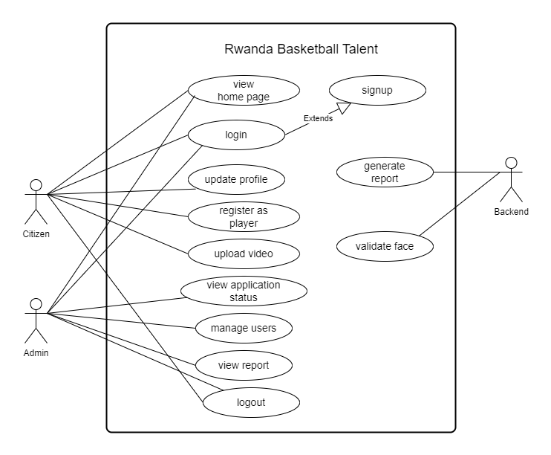
Figure 2: Use case diagram of the new system
Use-case description
A use case's description explains what it does and what it needs in order to be carried out successfully. Every use case appears as follows:
- Name: Each use case should have a name that clearly describes the main goal of the use case. The name may have to be several words long to be understood
- Description: The description text may be represented by one or more comments in the model. It can be utilized to offer more details in support of the use case.
- Actor: A user's role as they engage with the system, you're modelling is represented by an actor. A machine, an organization, a human user, or another external system can all be considered users. Every actor has a distinct name that identifies their function as a user interacting with the system.
- Pre-condition: Are tests that need to pass in order for the use case to move on,
- Post-condition: It indicates the things that the use case needs to finish handling before it ends.
- Normal flow: a flow that starts with a Start Event, travels via activities in parallel and alternative directions, and ends with an End Event.
- Alternative flow: It covers deviations from typical conduct as well as optional or extraordinary behavior in relation to normal behavior.
The actors' roles and use case descriptions can thus be developed by composing on the use case description of the Rwanda Basketball Talent Boost System after looking at the meaning of a use case illustration with its components.

Name: User sign up
Actor: Player
Description: This allows player to create an account so that he will be able to access system features for player registration after logging in.
Normal flow:
- The creation of a user account
- Player clicks on the signup button
- The system displays the signup form for a player to insert his/her data.
- The user then fills out the form, takes a picture, and submits it.
- The system then verifies the data. The system creates credentials.
- The player verifies the credentials.
- The system keeps track of data;
- It shows messages on the screen that are labelled as "user created."
- The login form is redirected by the system.
Alternative flow:

- The system displays a notice stating the error if the data is invalid.
- The notice "The system fails" will be displayed if the system is unable to store information.

Table 2 : Use case description of Player signup process.
Use case description for Login
Name: Login
Actor: System Admin and player (New player and existing player)
Description: This allows the users to access system features according to their roles
Pre-condition: the user should first have credentials
Post-condition: the system shows the user if he/she successfully accessed his/her account
Normal flow:
- User login on the system
- The admin has account if not he/she has to request for credentials
- The system checks the corresponding given information
- If given information is true then the system displays the page corresponding to the type of user or it display the error message
Alternative flow:
- If the request was not found the system provides the message indicating the error.
- If the system fails to retrieve information display message “The system fails”
Table 3: Use case description of Login
Use case description for accessing Player registration
Name: Create a player in the Database
Actor: Player
Description: This allows user to register in te system as a player
Pre-condition: the player should first login
Post-condition: the system save player data in the database
Normal flow:

- The player must have system credentials
- And then he/she will be able to login into the system using these credentials
- After logging into the system, user’s information must get retrieved from database
- The system must redirect user to registration page and displays hi/her information retrieved from database
- The player must fill the form with the corresponding form fields
- The system must validate all form fields according to the server-side specified formats
- The system must compare captured picture with the one retrieved from database as user information
- The system must validate user presence and performance in the uploaded video
- The system must save player data in database if they correspond to the requirements
- The system must redirect player video on the home page after registration

Alternative flow:
- If the request is not found the system provides the message indicating the error.
- If player registration works successful the system must generate success message to the player
- If registration fails the system must responding with the corresponding error message
Table 4: Use case description of player registration

Class diagram
A class diagram is a structural diagram that illustrates a system's classes, properties, operations, and relationships between the classes in order to depict the system's organization. The class diagram for the national budget planning information system is displayed in the figure below.
The advantages of class diagrams:
- Class diagrams offer a number of benefits for any organization. Use UML class diagrams to:
- Showcase information systems' data models, regardless of their complexity.
It is advisable to comprehend the overall structure of an application's schematics.
Communicate any unique requirements for a system visually and share that knowledge across the company.
- Make comprehensive diagrams that indicate any particular code that needs to be implemented and coded to the specified structure.
- Describe the types used in a system that are later passed between its components in a way that is independent of implementation.
Below is the class diagram of the Rwanda Basketball talent Boost System:
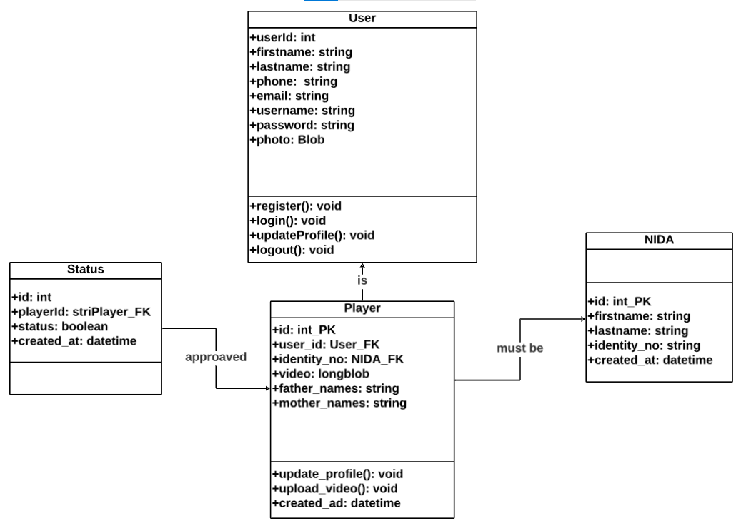
Figure 3: Class diagram of the new system

Sequence diagram
One type of interaction diagram is a sequence diagram, in which the objects are represented as lifelines running down the page, and the messages indicating the interactions between the objects over time are shown as arrows from the source lifeline to the target lifeline. An object's interactions are arranged chronologically in a sequence diagram.
The following notations are used in sequence diagrams along with their definitions:
Term and definition | Symbol
An actor:  - It could be an external system or someone that gains advantages from the system.  - It engages in a series of events by transmitting and receiving messages.  - It is positioned across the diagram's top. | 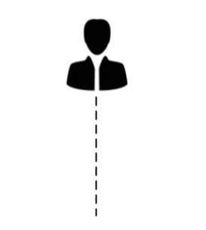
An object lifeline:
It is positioned across the top of the diagram and engages in a sequence by sending and/or receiving messages.

An activation:  It is a long, narrow rectangle that indicates whether an object is sending or receiving signals and is placed on top of a lifeline. | 
A message:
- It transfers data from one thing to another.
- A return is labelled with the value returned and displayed as a dashed arrow, while an operation call is labelled with the message being delivered and a solid arrow.
Table 5: Sequence description table
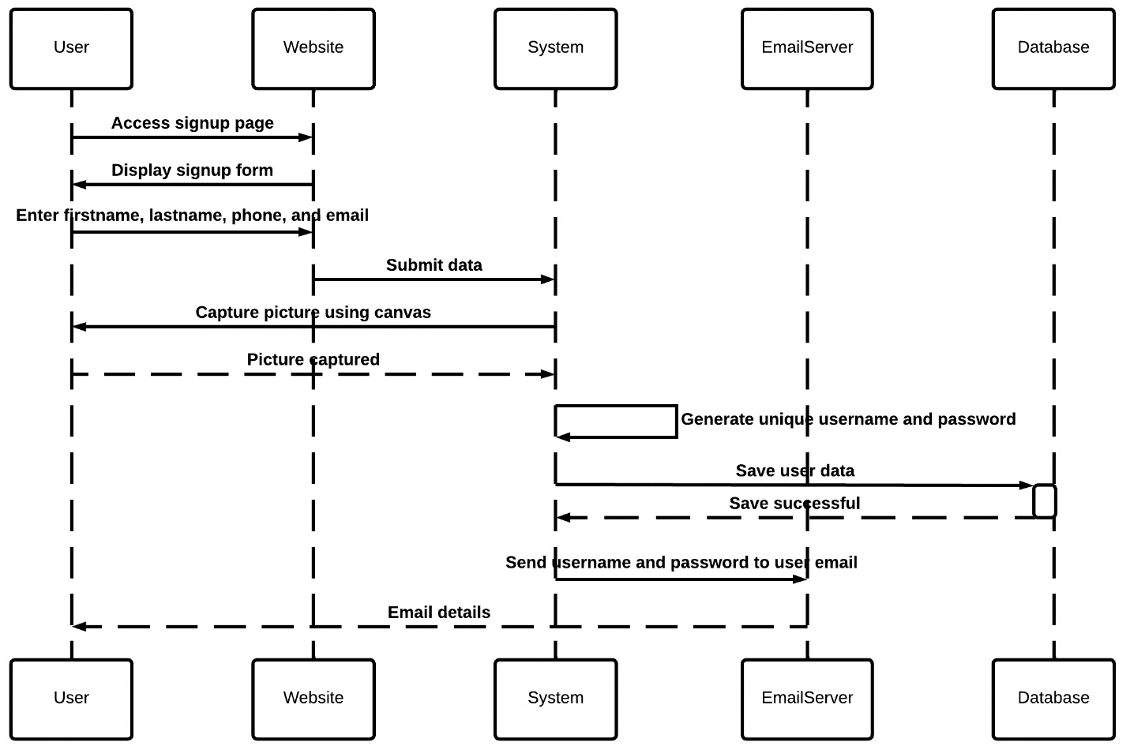
The Rwanda Basketball Talent Boost diagram is shown below, which details the protocol for communication for each stage of the registration process a player goes through, from signup to player registration completion in the system.
Figure 4: Sequence diagram for signup
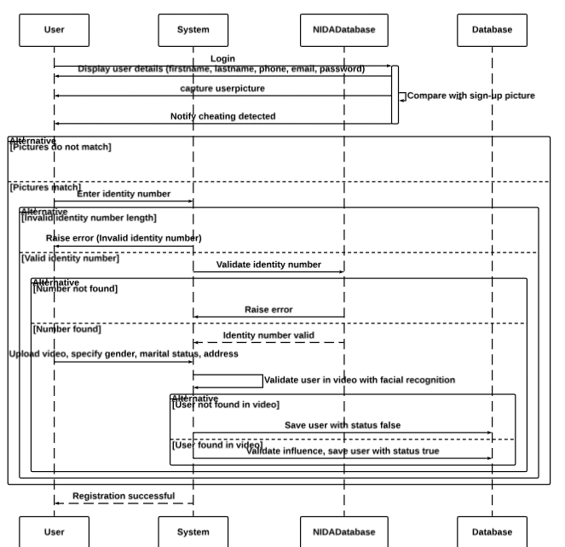
Figure 5: Sequence diagram for player registration

Database diagram
A database schema is a blueprint for how a database is built, or, in the case of relational databases, how its structure is partitioned into database tables. It describes the organization of data in a formal language that is supported by the database management system (DBMS). A collection of formulas, or words, known as integrity constraints that are applied to a database provide the formal specification of a database schema. The compatibility of the schema's components is guaranteed by these integrity constraints. (As stated by Proper in 2005)
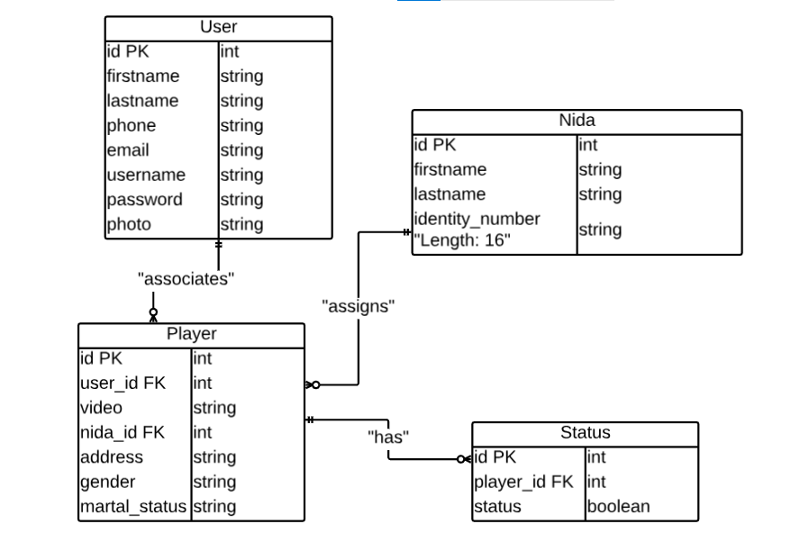
Figure 6: Database diagram of the new system

Activity Diagram
A Unified Modelling Language (UML) flowchart type that illustrates the progression of an activity within a system or process is called an activity diagram. Because it outlines what should occur in the modelled system, it is called a "behavior diagram" and is used to describe the various dynamic features of a system.
Activity diagrams can be used to visualize even the most complicated systems. Because of this, activity diagrams are frequently used in use case descriptions or business process modelling.
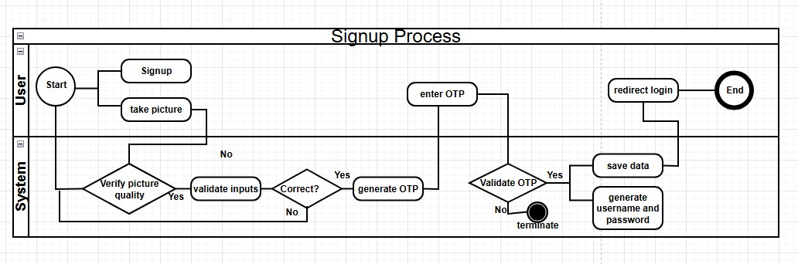
schematic inside of a company. They display each stage in an activity together with the sequence in which they are provided. They can also display how data moves between different operations.
The process is depicted in activity diagrams from the beginning (the initial state) to the finish (the final state). An action, decision node, control flows, start node, and end node are all included in an activity diagram.
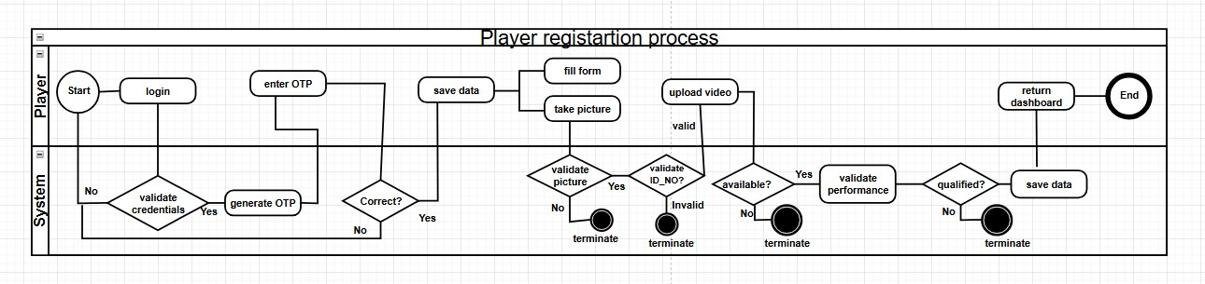
Figure 7: Activity diagram showing signup for the new system
Figure 8: Activity diagram showing player registration for the new system

Data Definition
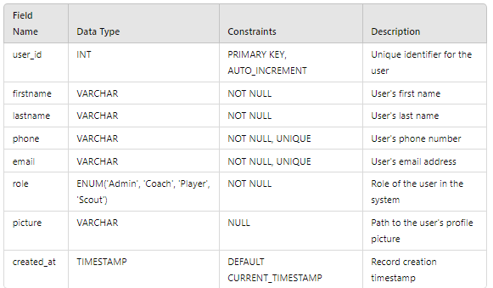
Data definition involves specifying the structure, types, and constraints of data in a database. It includes defining tables, fields, data types, primary and foreign keys, and other constraints to ensure data integrity, consistency, and efficient access, forming the foundation for database management and operations.

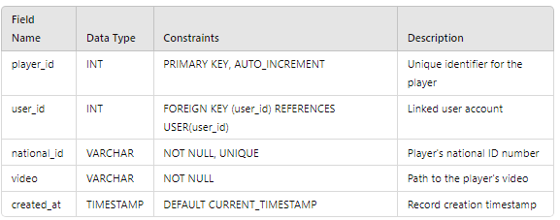
Figure 9: User data definition table
Figure 10: Player data definition table
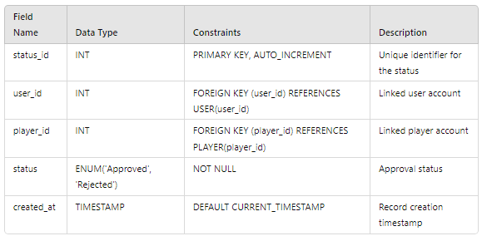
Figure 11: Player status data definition table

System Architecture
The technique of putting software system components into visual representations is called architecture diagramming. The term "architecture" in a software system describes a variety of functions, how they are implemented, and how they interact with one another. Architecture diagrams graphically represent the different data movements within the system because software is intrinsically abstract. They also draw attention to the way the program engages with its surroundings.
What advantages does architecture diagramming offer?
Architecture diagrams offer a number of advantages, including scalability, efficiency, cooperation, and risk reduction.
- Collaboration:
Architecture diagrams provide a unified understanding of system functionality and any problems, greatly enhancing collaboration between developers and designers. There are several advantages to having a common understanding of a website, application, or system. It guarantees a project achieves its objectives, aids in team development of efficient system software components, and promotes collaboration throughout the design phase.
- Risk reduction:
Potential hazards to system development, such as flawed reasoning, erroneous assumptions, or insufficient testing, are identified by architecture diagrams. Development teams can make adjustments earlier and lower the likelihood that important problems will surface later by recognizing and managing risks early in the software development lifecycle.
- Efficiency:
Architecture diagrams give a clear picture of the structure and parts of the system. As a result, stakeholders are able to precisely identify issues and promptly address them. Additionally, diagrams facilitate system scalability and maintenance, making continuous modifications more effective.
- Scalability:
Architecture diagrams give interested parties the ability to see effective approaches to grow a system. A diagram might, for instance, indicate whether the architecture of a system is distributed or centralized. Monolithic components cannot be upgraded or replaced in a timely manner because distributed components scale more effectively. In a similar vein, graphical depictions shed light on the movement and storage of data. Potential bottlenecks and strategies to prevent them can be identified by stakeholders.
NOTE: System architecture diagrams offer a visual representation of the many parts of a system and demonstrate how they interact and communicate with one another. These diagrams show the architecture and structure of a system. This makes it possible to comprehend the system's operation and potential improvements.
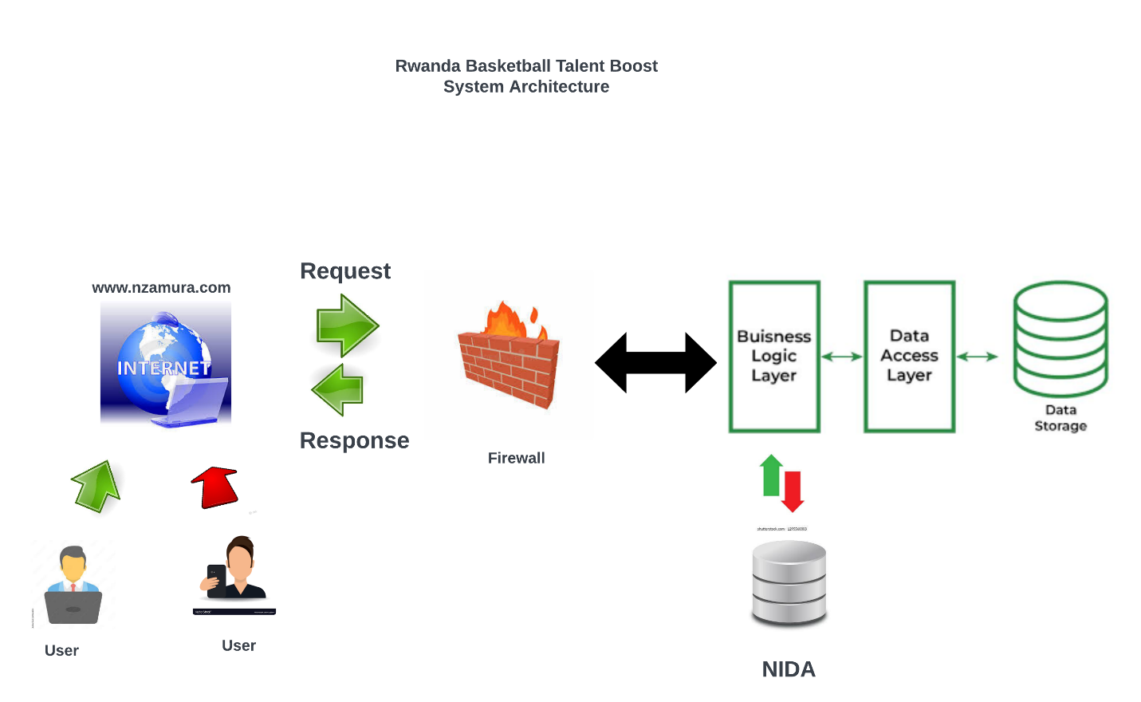
Figure 12: System Architecture of the new system
System architecture Description
- User: This is the front-end layer where users interact with the system through a web-based interface. It handles user input, displays information, and facilitates user actions such as sign-up, login, and player registration.
- Web Application Server: This layer hosts the web application and serves as the entry point for user requests. It handles routing, session management, and communication with the application logic layer.
- Application Logic Layer: This layer contains the core business logic of the system. It handles operations such as user authentication, data validation, OTP generation, picture matching, video processing, and performance evaluation. It communicates with the data access layer to read and write data to the database.
- Data Access Layer: This layer provides an abstraction over the database and handles all database operations. It retrieves and stores user data, player data, and player status information.
- Database: This is the persistent storage layer that stores user data, player data, and player status information in separate tables or collections.
- NIDA API: This is an external API provided by the Rwanda National Identity Agency (NIDA) for validating user IDs and retrieving associated information.
The flow of operations would be as follows:
- The user interacts with the system through the user interface, initiating actions such as sign-up, login, and player registration.
- The web application server handles the user requests and communicates with the application logic layer.
- The application logic layer performs necessary validations, generates OTPs, matches pictures, processes videos, evaluates performance, and interacts with the data access layer for database operations.
- The data access layer reads and writes data to the database, storing user data, player data, and player status information.
- During the player registration process, the application logic layer communicates with the NIDA API to validate the user's ID and retrieve associated information.
- The video processing system analyses the uploaded video, checks for the user's presence, and evaluates their basketball performance.
Based on the evaluation results, the application logic layer determines whether to save the player's data or reject the registration, updating the player status accordingly.

CHAPTER 4

IMPLEMENTATION AND TESTING OF THE NEW SYSTEM

Introduction
The creation of a "Rwanda Basketball Talent Boost System" is covered in this chapter. It contains a quick synopsis of the technologies that were utilized to make the application work, as well as screenshots of the new system and the testing that were conducted. Not to mention, requirements for hardware and software compatibility.

Tools and Technologies used
The following range of hardware and software tools were utilized in the development of this application:

Frontend
- HTML (Hypertext Markup Language): Used for structuring the content of web pages by defining elements like text, images, links, etc.
- CSS (Cascading Style Sheets): Used for styling web pages, including layout, colors, fonts, and overall appearance.
- ReactJS: A JavaScript library for building interactive user interfaces, allowing developers to create reusable UI components like buttons, search bars, and more.

Backend
- MySQL: A relational database management system used to create and manage databases, storing and retrieving data for applications.
- XAMPP: A cross-platform web server solution stack that includes components like MariaDB (a MySQL alternative), Apache HTTP Server, PHP, and Perl, providing a full-stack environment for web development.
- Python: A high-level, interpreted programming language used for developing various applications, including web development.
- Django: A high-level Python web framework that enables rapid and secure web development, handling backend processes, database management, and server-side logic.

Presentation of the New System
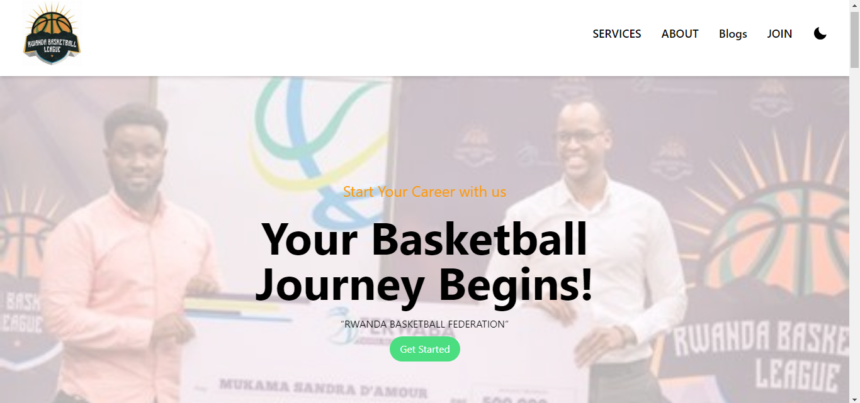
Figure 13: System home page

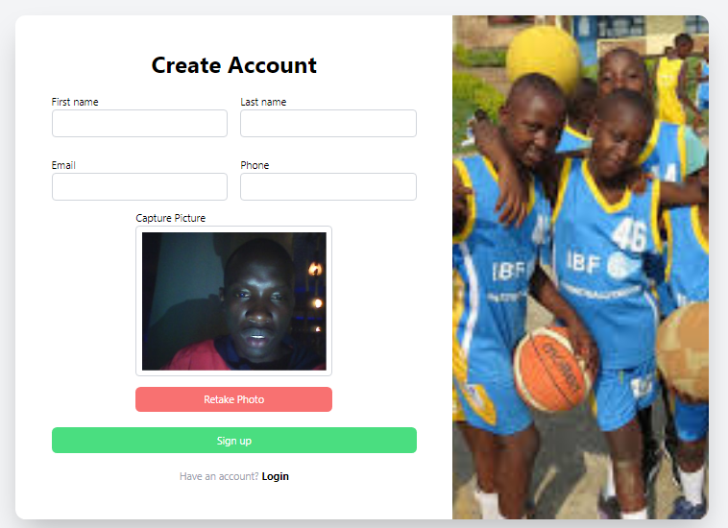
Figure 14: System signup page
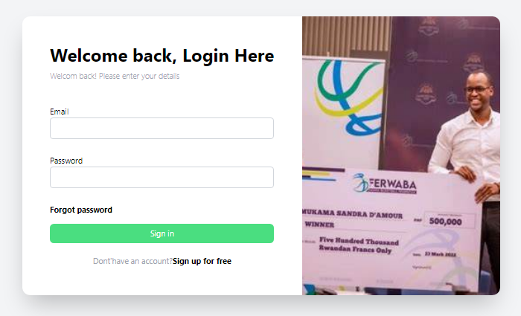
Figure 15: System login page
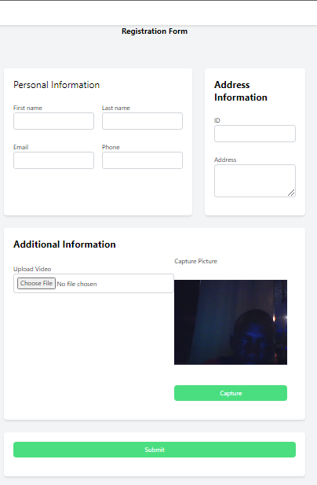
Figure 16: System player registration page
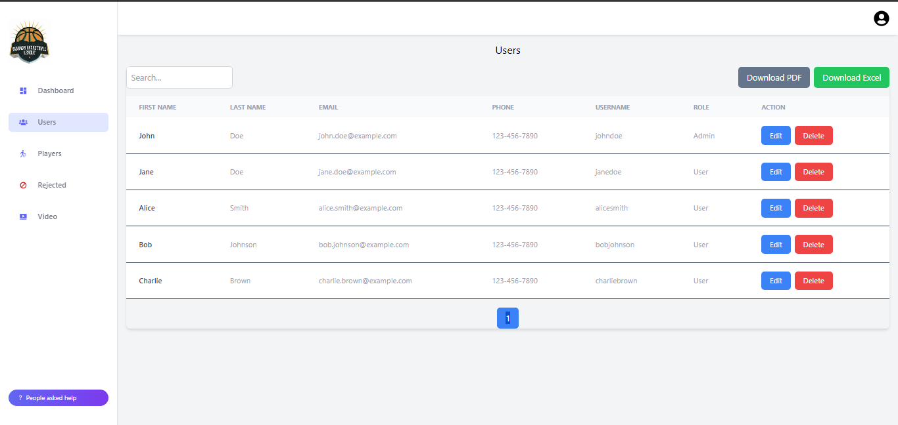

Figure 17: Manages user admin dashboard page

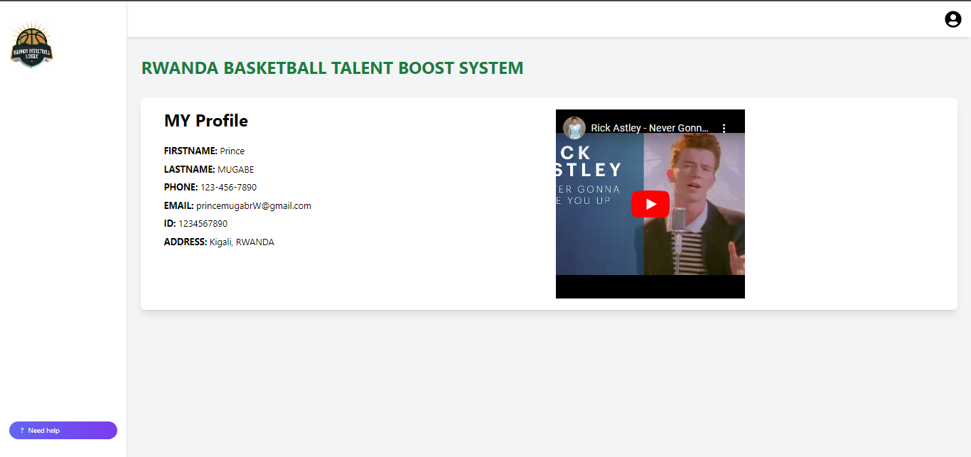
Figure 18: System Player dashboard page

Software Testing
Software testing is a useful tool for software design. They help ascertain whether the software actually completes the purpose for which it was intended.
It's critical to remember the following when performing software testing:
Does the application adhere to the principles that influenced its creation and design?
Does the application work the way it should?
Can the application be implemented in the same way while meeting the needs of the stakeholders?
Here are a few software tastings:

Unit Testing
This method checks that a specific program or piece of software is operating correctly. It is a technique for determining if individual source code fragments, collections of one or more computer program modules, associated control data, usage methods, and operational guidelines are acceptable for use. Put another way, every tiny part that can be put together with the intention of confirming that every piece is in compliance with its requirements and looking for logical faults One of the most effective tools for achieving the most comprehensive error detection is unit testing. A unit test has been performed on the program at each stage of code creation.

Integration Testing
The Integration test phase of software testing involves combining and evaluating multiple software components at once. This test is essential to verify that all of the software's many components have been assembled correctly. The system as a whole is tested when a sufficient number of tests have been conducted on the hardware and software components. To ensure that the completed software components satisfied all functional and technical requirements, the application modules were rigorously tested one after the other until they were complete.

Validation Testing
In the last test phase, the program is verified in its external environment. The product has been tested in its final configuration to ensure that it fully satisfies the requirements set forth in the first phase. To ensure that the application's setup satisfies the specified needs, the validation test is crucial. For example, the email address must start with @ and end with gmail.com, the national ID must have 16 digits, the uploaded video must be between two and five minutes long, etc. We found that the operations' progress matched the functional criteria after the application underwent extensive testing.

System Testing
Objective: to verify the integrated system in its whole against the given specifications. System tests cover all functional and non-functional requirements, including usability, performance, security, and compatibility. End-to-end scenarios are tested to ensure the system meets user needs and business objectives. Manual and automated testing methods are employed to ensure thorough coverage. The expected outcomes are that the system meets all specified requirements, performs as expected in real-world conditions, and any discrepancies between expected and actual behavior are identified and addressed.

User Acceptance Testing (UAT)
Objective: To guarantee that the system satisfies end users' requirements and expectations.
UAT is conducted by Rwandans, NIDA, and other stakeholders who will use the system. Real-life image recognition and scenarios are tested, such as capturing automatic pictures and comparing them with the ones captured within the user submitted video. Feedback is gathered from users on system usability, functionality, and performance. The expected outcomes are that users confirm the system meets their needs and is easy to use, any issues or suggestions for improvement are documented and addressed, and the system is approved for final deployment based on user feedback.

Performance Testing
Objective: To evaluate the system’s performance under various conditions, including normal and peak loads. Load testing tools (e.g., JMeter, LoadRunner) simulate multiple users accessing the system simultaneously. Tests measure response times, throughput, and resource utilization (CPU, memory, etc.). Stress testing is conducted to determine the system's behavior under extreme load conditions. The expected outcomes are that the system performs well under expected and peak loads, with acceptable response times and resource utilization, potential performance bottlenecks are identified and optimized, and the system can handle the anticipated number of users and transactions without degradation in performance.

Security Testing
Objective: To identify and mitigate security vulnerabilities within the system. Security testing tools (e.g., OWASP ZAP, Burp Suite) are used to perform vulnerability assessments. Common security threats, such as SQL injection, cross-site scripting (XSS), and cross-site request forgery (CSRF), are tested. Penetration testing simulates real-world attacks to evaluate the system's defenses. The expected outcomes are that security vulnerabilities are identified and mitigated, sensitive data is protected through proper encryption and access controls, and the system complies with relevant security standards and regulations.

Regression Testing
Objective: To ensure that new changes do not adversely affect the existing functionality of the system. Automated regression test suites are run after each update or modification to the system. Test cases from previous testing phases are re-executed to ensure no new defects are introduced. Continuous integration tools facilitate the regular execution of regression tests. The expected outcomes are that the system remains stable and functional after updates and changes, any new defects introduced by changes are quickly identified and addressed, and confidence is maintained in the system’s reliability and quality over time.

Hardware and Software compatibility requirements

Client-Side Software Requirements
- Operating System: Windows 10 or later, macOS 10.14 or later, Linux distributions (e.g., Ubuntu 18.04 or later)
- Web Browser: Latest versions of Google Chrome, Mozilla Firefox, Microsoft Edge, or Safari

Client-Side Hardware Requirements
- Processor: Dual-core CPU or better (e.g., Intel i3 or AMD equivalent)
- Memory: Minimum 4 GB RAM (8 GB recommended)
- Storage: Minimum 50 GB free disk space
- Display: 1280x720 resolution or higher
- Network: Reliable internet connection with at least 5 Mbps speed
- Peripherals: Keyboard, mouse, and optionally a scanner and printer for document processing

Server-Side Software Requirements
- Operating System: Linux distributions (e.g., Ubuntu Server 18.04 or later, CentOS 7 or later), Windows Server 2016 or later
- Web Server: Apache HTTP Server 2.4 or later
- Application Server: Node.js for JavaScript-based backend, or any compatible server depending on the backend language used (Django for Python)
- Database: MySQL 8.0 or later
- Frameworks/Libraries: React.js for the front-end framework.
- Authentication: Simple JWT or another secure token-based authentication system

Server-Side Hardware Requirements
- Processor: Quad-core CPU or better (e.g., Intel Xeon or AMD EPYC)
- Memory: Minimum 16 GB RAM (32 GB or more recommended for large-scale operations)
- Storage: Minimum 1 TB SSD (additional storage based on data volume)
- Network: High-speed internet connection with at least 100 Mbps bandwidth
- Redundancy: Redundant power supplies and network interfaces
- Backup: Regular backup solutions with offsite storage

CHAPTER 5

CONCLUSION AND RECOMMENDATIONS

Conclusion
The primary goal of this project was to develop the Rwanda Basketball Talent Boost System, a web application designed to help Rwandan youth register and gain visibility as basketball talents. This initiative addresses the need for a centralized system to manage and nurture basketball talent in Rwanda, overcoming issues like decentralized scouting, inefficient data management, and limited visibility, especially in rural areas.
The research involved observational studies, interviews, and document reviews, identifying the shortcomings of the current system. Insights from coaches, scouts, and players guided the design of the new system. Using UML analysis, a targeted system architecture was developed to meet the needs of both players and professional organizations.
The system was built with modern programming tools to ensure it is user-friendly, secure, and scalable. Testing confirmed that the platform effectively addressed previous inefficiencies, enhancing talent data management, player visibility, and scouting efficiency.
The Rwanda Basketball Talent Boost System offers significant benefits: aspiring players can create profiles to showcase their skills and attract scouts, while clubs gain access to a centralized database, streamlining recruitment. This system supports the professionalization of basketball in Rwanda and aligns with national sports development goals, promoting youth participation and skill development.
In conclusion, the Rwanda Basketball Talent Boost System effectively meets its objectives by providing a streamlined, scalable solution for basketball talent management. It promises to transform talent identification and development in Rwanda, with potential for future expansion and continued impact on the country’s basketball landscape.

Recommendations
To further enhance the Rwanda Basketball Talent Boost System, AUCA should focus on integrating both academic and athletic dimensions into a unified platform. This platform should not only facilitate basketball talent promotion but also track academic performance, offering a comprehensive view of student-athletes. By leveraging AUCA’s existing academic systems, the platform can incorporate robust identity verification processes, ensuring the authenticity of user profiles and maintaining a secure environment.
A critical improvement involves enhancing the video upload and validation processes. By implementing a dual validation system that assesses both athletic skills and academic performance, the platform will ensure that showcased talents are credible and meet high standards. Transitioning to cloud-based storage solutions will further optimize data management, improving accessibility, security, and scalability. An integrated database that combines athletic and academic profiles will facilitate efficient searches and evaluations by university scouts and coaches.
Security is paramount, and the platform should adhere to best practices in data protection, including encryption and secure authentication. Establishing clear access controls will protect sensitive information, ensuring that only authorized personnel can access academic and athletic data.
The platform should be designed with a user-centric approach, prioritizing ease of use and accessibility for students, faculty, and staff. Ensuring compliance with accessibility standards will promote inclusivity for users from diverse backgrounds.
To support inclusive talent development, AUCA should implement performance metrics to monitor system effectiveness and user engagement. Regular evaluations of these metrics will help identify areas for improvement and enhance both academic and athletic growth. Additionally, leveraging AUCA’s academic and regional athletic networks to promote student-athletes can open up further opportunities for recognition and career advancement.
By focusing on these recommendations, AUCA can significantly enhance the effectiveness of the Rwanda Basketball Talent Boost System, contributing to the development and success of student-athletes both academically and athletically.

REFERENCES

Books
(Alan, 2005)
(Tyler, 2020)
(Valdez, 2016)

Websites
Tyler, E. (2020). CSS. Retrieved August from Wikipedia.org: https://en.wikipedia.org/wiki/Cascading_Style_Sheets Accessed on July 01 ,2023
Valdez, A. (2019). Java Script. Retrieved from Wikipedia.org: https://en.wikipedia.org/wiki/JavaScript Accessed on July 19 ,2023
Visual Paradigm. (2023). What is Class Diagram? Retrieved from www.visual-paradigm.com: https://www.visual-paradigm.com/guide/uml-unified-modeling-language/what-is-class-diagram/ Accessed on July 02 ,2023
Visual paradigm. (2023). What is Unified Modelling Language (UML)? Retrieved from www.visual-paradigm.com: https://www.visual-paradigm.com/guide/uml-unified-modeling-language/what-is-uml/ Accessed on July 02 ,2023
Moore, L. (2023). MYSQL DEFINITION. Retrieved from www.techtarget.com: https://www.techtarget.com/searchoracle/definition/MySQL Accessed on August 02 ,2023
Lucid Chart. (2023). UML Sequence Diagram Tutorial. Retrieved from www.lucidchart.com: https://www.lucidchart.com/pages/uml-sequence-diagram Accessed on July 21 ,2023
Lucid chart. (2023). UML Use Case Diagram Tutorial. Retrieved from www.lucidchart.com: https://www.lucidchart.com/pages/uml-use-case-diagram Accessed on July 12 ,2023.

APPENDICES
Self-motivated person who is passionate about technology, innovation and challenging tasks to find solutions. Strong creative and analytical skills. Team player with an eye for detail.

Prince MUGABE

CURRICULUM VITAE
Contact

Experience
REFERENCE
+250 780 035 234

Manage at KB Tech Solution Ltd
Bahati HAKIZIMANA
+86 178 2403 9516

Head of Department at Adventist University of Central Africa
Prince ISHIMWE M.
+250 788 558 449

Authority
at Rwanda Revenue

Senior System developer

Ivan BISENGIMANA K.

LANGUAGES
Certifactions

Data Analyst 101: Excel

Formulas & Functions
Introduction to SQL
Introduction to cloud security
Introduction to cloud computing
Data science
English proficiency
Linux Essential
Networking Essential
- Kinyarwanda (Native)
- English (Fluent)
- Swahili (Intermediate)
Groupe scholaire Ndego I
(EKK)
English-Kiswahili-Kinyarwanda
Advanced certificate in
2015 - 2017
Africa (AUCA)
Adventist University of Central
Engineering
Bachelor’s Degree in Software
2020 - Current
Education
Kigali, Rwanda
Address
Princemugabe568@gmail.com
Email
+250 788 457 408
Phone
- Assisted lead teachers in planning and delivering English lessons to students of varying ages and proficiency levels.
- Conducted small group and one-on-one tutoring sessions to provide additional support for students.
- Developed and implemented engaging lesson plans that enhanced students’ reading, writing, speaking, and listening skills.
Assistant teacher at Groupe Scolaire Ndego I
Jan 2018 – Jul 2018
- Conducted market research to identify potential sales opportunities and target markets.
- Analysed market trends, competitor activities, and consumer preferences to inform business strategies.
- Developed and executed sales plans to achieve company objectives.
Sale distributor and market researcher at Crystal Water CO LTD
Aug 2018 – Jul 2020
Feb 2023 – Currently
Software developer at Kaby Tech Solution ltd
- Develop and maintain backend infrastructure for various web and mobile applications.
- Design and implement RESTful APIs to support frontend functionalities.
- Collaborate with cross-functional teams to define, design, and ship new features.

