Adventist University of Central Africa

COMMUNITY HEALTH WORKERS EMPOWERING MANAGEMENT SYSTEM

CASE STUDY: Ministry of Health (MOH)

A final-year project Presented in partial fulfillment of the

Requirements for the degree of

BACHELOR OF SCIENCE IN INFORMATION TECHNOLOGY

Major in

Software Engineering

By

Harerimana Umuhire Clement

December, 2024

# ABSTRACT

A Project for Bachelor's Degree in Information Technology

Emphasis in Software Engineering

Adventist University of Central Africa

TITLE: COMMUNITY HEALTH WORKERS EMPOWERING MANAGEMENT SYSTEM

Name of researcher: Harerimana Umuhire Clement

Name of supervisor: Eng. Nsengiyumva Juvenal

Date Completed: December 2024

The Community Health Workers Empowering Management System (CHWEMS) is a web-based platform developed to improve the management, training, and certification of community health workers (CHWs) in Rwanda, especially in underserved rural areas. The platform addresses the critical shortage of CHWs, which has resulted in overcrowded health centers and limited healthcare access. By providing CHWs with remote training, certification, and tools to enhance service delivery, CHWEMS aims to strengthen healthcare at the grassroots level. The platform also helps improve data collection and reporting to local health authorities, ensuring more effective healthcare management and better patient outcomes in rural communities.

The development of CHWEMS involved various methods and technologies to ensure its success. Observation involved directly watching how CHWs work, while documentation recorded these findings to identify challenges. Agile methodology allowed for continuous improvement through small, iterative updates. Object-Oriented Analysis and Design (OOAD) helped create a modular and scalable system structure. The frontend was built using the React framework for an interactive user interface. The backend was developed with Python and Django to handle data processing and system functionality. MySQL was chosen as the database to ensure efficient and secure data storage. These tools and methods ensured the platform's scalability, ease of use, and reliable performance.

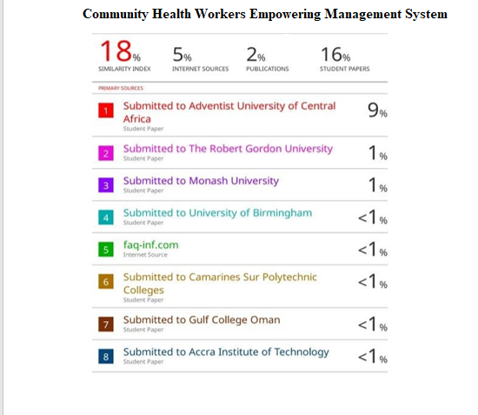**ANTI-PLAGIARISM REPORT**

# DECLARATION

I, **Harerimana Umuhire Clement, with ID 23388, hereby** declare that the project report **Community Health Workers Empowering Management System** based on my own work carried out during the course of my study under the supervision of Eng. Nsengiyumva Juvenal. I submit the statements made and conclusions drawn are an outcome of my research work, and it has not been previously submitted anywhere.

**Signature:** …………………….

**Date: /**…. /…..

# APPROVAL

I, **Eng. Nsengiyumva Juvenal** hereby certify that this project report has been done under my supervision and submitted with my approval.

**Signature**………………………………...

**Date**……/…………/………

# DEDICATION

I dedicate this book

To my lovely family

To all my friends and relatives and to my supervisor for his guidance.

# TABLE OF CONTENTS

ABSTRACT i

DECLARATION ii

APPROVAL iii

DEDICATION vi

TABLE OF CONTENTS v

LIST OF FIGURES ix

LIST OF TABLES x

LIST OF ABBREVIATIONS xi

ACKNOWLEDGMENTS xii

CHAPTER 1 1

GENERAL INTRODUCTION 1

Introduction 1

Background of the Study 2

Problem Statement 3

Choice and Motivation in the Study 3

Objectives of the Study 3

General Objective 3

Specific objectives 3

Scope of the Study 4

Methodologies and Techniques Used in the Study 4

Documentation 5

Interview 5

Expected Results 6

Organization of Report 6

CHAPTER 2 8

ANALYSIS OF THE CURRENT SYSTEM 8

Introduction 8

Historical Background 8

Mission 9

Vision 9

Description of the Current System 9

Analysis of the Current System 10

Modeling of the Current System 11

Problems of the Current System 11

Proposed Solutions 12

System Requirements 12

Functional Requirements 12

Non-Functional Requirements 13

CHAPTER 3 14

REQUIREMENTS ANALYSIS AND DESIGN OF THE NEW SYSTEM 14

Analysis and Design Methodology 14

Unified Modeling Language 15

Design of the New System 19

Use Case Diagram 19

Class Diagram 23

Sequence diagram 24

Activity Diagram 27

Database Design 28

Data Dictionary 28

System Architecture Design 29

CHAPTER 4 31

IMPLEMENTATION OF THE NEW SYSTEM 31

Introduction 31

Technologies Used 31

Front End 31

Back End 31

Presentation of the New System 32

Software Testing 39

Unit Testing 40

Integration Testing 40

Hardware and Software Requirements 40

Client Side Software Requirements 40

Server-Side Software Requirements 40

Client Side Hardware Requirements 41

Server Side Hardware Requirements 41

CHAPTER 5 42

CONCLUSION AND RECOMMENDATIONS 42

Conclusion 42

Recommendations TO MOH 43

Recommendations to the Future Researchers 43

REFERENCES 44

Books 44

Websites 44

APPENDICES 45

Curriculum Vitae 46

Data Collection Letter 50

# LIST OF FIGURES

Figure 1: Modeling of the current system ...................................................................................... 9

Figure 2: Use case diagram .......................................................................................................... 18

Figure 3: Class diagram................................................................................................................. 23

Figure 4: Sequence diagram for Citizen Requests Healthcare Assistance ................................... 25

Figure 5: Sequence diagram for training and certification process .............................................. 25

Figure 6: Activity Diagram……………………………............................................................... 26

Figure 7: Database diagram………………………………........................................................... 26

Figure 8: Data dictionary diagram ............................................................................................... 27

Figure 9: Login page..................................................................................................................... 28

Figure 10: Manage service………................................................................................................ 29

Figure 11: Create Account............................................................................................................ 30

Figure 12: Create New Trainings ................................................................................................. 32

Figure 13: Training Candidate Information.................................................................................. 32

Figure 14: Manage Exam Questions ............................................................................................ 33

Figure 15: Manage Results........................................................................................................... 34

Figure 16: Apply for Trainings..................................................................................................... 35

Figure 17: Report page................................................................................................................. 35

# LIST OF TABLES

Table 1: Use-case diagram elements ............................................................................................ 18

Table 2: Use case description for Request Healthcare Visit ........................................................ 20

Table 3: CHW Training and Certification .................................................................................... 21

Table 4: Sequence diagram annotation with their explanation .................................................... 21

# LIST OF ABBREVIATIONS

|  |  |
| --- | --- |
|  |  |
| **AJAX** | Asynchronous JavaScript and XML |
| **API** | Application Programming Interface |
| **AUCA** | Adventist University of Central Africa |
| **MOH** | Ministry of Health |
| **CSS** | Cascading Style Sheet |
| **DOM** | Document Object Model |
| **HTML** | Hypertext Markup Language |
| **IDE** | Integrated Development Environment |
| **JS** | JavaScript |
| **JSON** | JavaScript Object Notation |
| **MVC** | Model-View-Controller |
| **REST** | Representational State Transfer |
| **SQL** | Structured Query Language |
| **UI** | User Interface |
| **UX** | User Experience |

# ACKNOWLEDGMENTS

Firstly, I thank God for all He has been with me in this journey of my studies and even till now. There are many students who dropout due to different reasons but by His grace I have been at university till the end of all classes.

I can’t forget that as a student I needed the basic knowledge to be where I am now with skills I have. My appreciation goes to AUCA administration for the academic program and positive impact on students. I am extremely grateful to the IT faculty especially Software Engineering department staff members who always there for students to be successful.

I am deeply thankful to Eng. Nsengiyumva Juvenal as my supervisor, who guided me in the accomplishment of this work, his professional assistance and ideas.

I would like to thank my parents, who helped me in their prayers, advices, and encouragement. They virtually and financially worked along with me.

I am grateful for my siblings for their practical support, it was deeply emotional, a constant reminder that I wasn't alone in this endeavor played a crucial role in my studies.

I am grateful for my colleagues who played a crucial role in my studies, their team working and support gave me a lift and experience.

I am thankful to my friends in general for being always there for me where things seemed to be impossible.

Finally, thanks a lot to everyone who has been involved in this work directly or indirectly for their help and contribution.

God Bless you all!

**Harerimana Umuhire Clement**

# CHAPTER 1

# GENERAL INTRODUCTION

## Introduction

Rwanda has made significant strides in improving its healthcare system, particularly through the development of its Community Health Program, which began in 1995. The program has played a vital role in extending healthcare services to remote and underserved areas, contributing to improved health outcomes, such as a reduction in maternal mortality and increased access to skilled birth attendants. Despite these achievements, challenges remain in ensuring equitable healthcare access, improving the distribution of health professionals, and enhancing community participation in health management. The Ministry of Health continues to prioritize the development of a qualified, motivated, and effectively managed healthcare workforce, aiming to address these issues and achieve universal health coverage. This project aims to support these goals by developing a system to empower Community Health Workers (CHWs), improving their training, issuing certification, and ability to deliver quality healthcare services to rural communities (Rwanda National Strategy for Health Professions Development NSHPD 2020-2030, 2020).

In Rwanda, particularly in rural areas, there is a critical shortage of community health workers, resulting in overcrowded health centers and limited healthcare access for residents. As the demand for home-based healthcare continues to rise, the existing training and certification processes for CHWs are often inadequate, leading to delays in treatment and insufficient healthcare services in remote locations. Additionally, many health records and reports are not adequately documented or reported to local health authorities, creating gaps in data collection and health management. The lack of a centralized system to manage training, issuing certification, and inadequate organization of customizable reports for CHWs has contributed to these ongoing challenges, hindering effective healthcare provision in rural communities. This has also made it difficult to track the performance of CHWs and identify areas that need improvement. Without proper training and support, CHWs face challenges in delivering consistent and high-quality care. A comprehensive solution is necessary to enhance the efficiency and effectiveness of CHWs in providing healthcare services.

## Background of the Study

Rwanda’s healthcare system consists of various levels of healthcare facilities, including referral hospitals, district hospitals, health centers, and a vast network of over 45,000 community health workers (CHWs) who serve at the grassroots level (Rwanda National Health Sector Policy, 2005). Since its inception, the community health program in Rwanda has played a critical role in improving healthcare outreach, especially in rural and underserved areas, by providing essential services such as health promotion, disease prevention, maternal care, and basic health services (Daniel, 2021). This program has been instrumental in reaching populations that are otherwise difficult to serve due to geographical barriers, inadequate transportation, and a lack of health infrastructure. Through their grassroots engagement, CHWs serve as a vital bridge between the formal healthcare system and the community, ensuring that basic healthcare services are delivered effectively and efficiently at the local level.

Despite these achievements, several challenges continue to affect the effectiveness of CHWs and the overall healthcare system in Rwanda. One of the key challenges is the insufficient integration between different levels of the healthcare system, which can lead to inefficiencies in the referral process and poor coordination between CHWs, health centers, and district hospitals (BINAGWAHO, 2015). Additionally, many remote areas still face limited access to healthcare services, and CHWs often lack sufficient training, resources, and support to address the complex health needs of their communities. The training and certification process for CHWs, while critical, remains fragmented, and there is no centralized system that effectively tracks their progress, performance, and certification status. This lack of systematic training and management contributes to delays in service delivery, inconsistent health record-keeping, and suboptimal healthcare outcomes in rural communities.

This study aims to address these challenges by developing a system designed to enhance the training, certification, and management of CHWs, improving their overall efficiency and effectiveness in delivering healthcare services. The proposed system will offer remote training opportunities, ensuring that CHWs are equipped with the latest knowledge and skills to provide quality care. Additionally, it will create a centralized platform for tracking CHW certifications, documenting health records, and generating customize reports, which will facilitate local health authorities and policy makers to take data based effective decisions.

## Problem Statement

Despite significant progress in Rwanda's healthcare system, challenges persist in achieving universal health coverage, particularly in rural areas. Many communities still face barriers to accessing healthcare due to geographic isolation, limited financial resources, and insufficient community participation in health management. Additionally, there is a lack of integration between decentralized health services and local governance, and the capacity of Community Health Workers (CHWs) remains underdeveloped due to inadequate training and support. The existing system does not fully address the need for efficient training, certification, and management of CHWs, limiting their ability to provide timely and effective care. This project aims to overcome these challenges by developing a platform that empowers CHWs, improves healthcare delivery, and enhances the overall management of community health services.

## Choice and Motivation in the Study

As an Information Technology student, this project presents an opportunity to apply my academic knowledge and skills in software engineering to solve real-world problems in the healthcare sector. The motivation behind this study is driven by a desire to leverage technology to improve healthcare delivery, particularly in underserved rural areas. By developing a system that empowers Community Health Workers (CHWs) with remote training, certification, and better management tools, I aim to contribute to the improvement of healthcare access and quality in Rwanda. This project not only aligns with my passion for technology but also supports the national efforts to strengthen the health workforce and enhance service delivery across the country.

## Objectives of the Study

### General Objective

The general objective of this study is to develop a platform that connects citizens with healthcare services by empowering Community Health Workers (CHWs) through efficient training, certification, and appointment management, thereby improving healthcare access in rural communities.

### Specific objectives

Below are the special objectives of the system:

* Develop a centralized database system to manage CHW training, certification, and documentation.
* Enable local health authorities to train and certify CHWs.
* Allow citizens to request healthcare services remotely though appointment booking.
* Facilitate CHWs in documenting health records and generating customized reports for local health centers.
* Improve communication between CHWs, citizens, and health authorities.
* Ensure security, user-friendliness, and data privacy of the system.

## Scope of the Study

The scope of this study focuses on developing the "CHWs Empowering Management System," a platform designed to enhance the training, certification, and management of Community Health Workers (CHWs) in rural areas. The system will enable remote training, facilitate healthcare service requests from citizens, and streamline communication between CHWs and local health authorities. The platform aims to improve healthcare delivery in underserved communities by providing CHWs with the tools to document health data, generate reports, and manage appointments efficiently, all while ensuring a user-friendly interface and secure data handling.

## Methodologies and Techniques Used in the Study

This study employed a combination of qualitative and quantitative research methodologies to develop the "Community Health Workers Empowering Management System" (CHWEMS). The approach was designed to gain a comprehensive understanding of the existing challenges faced by community health workers (CHWs) and the healthcare system in Rwanda. In order to gather rich insights into the needs and perspectives of CHWs, local citizens, and health authorities, the study utilized both participant and non-participant observation, semi-structured interviews, and a thorough analysis of existing documentation related to health service delivery and CHW training. These methodologies provided a nuanced understanding of the gaps in healthcare service delivery, allowing for the creation of a platform that effectively addresses the needs of CHWs while ensuring efficient data management and healthcare service coordination. The integration of these techniques aimed to ensure that the final system is both user-centric and responsive to the real-world challenges of rural healthcare provision in Rwanda.

### Documentation

In this study, documentation was used as a key data collection tool to gather and analyze relevant information. I, HARERIMANA UMUHIRE CLEMENT (ID: 23388), systematically reviewed existing records, reports, and policies related to the Community Health Worker (CHW) program and healthcare delivery in Rwanda. This included evaluating official documents, such as the Rwanda Health Sector Strategic Plan 2018-2024 (Ministry of Health, 2021), which outlines the government's vision for improving health outcomes and the role of CHWs. I also reviewed the Rwanda Demographic and Health Survey 2019-2020 (National Institute of Statistics of Rwanda, 2020), providing data on health indicators, CHW performance, and access to healthcare services. Additionally, I examined health sector reports and policies focusing on the management and training of CHWs, helping identify areas for improvement and aligning the proposed system with national health goals. These documents provided crucial insights into the current state of CHW training, certification, and healthcare service delivery, establishing a solid foundation for the development of the CHWs Empowering Management System. By using these documents, I ensured the platform would align with national priorities, address existing gaps, and contribute to strengthening Rwanda’s healthcare system.

### Interview

In this study, semi-structured interviews were employed as a primary method for collecting qualitative data from key stakeholders, including Community Health Workers (CHWs), local health authorities, and healthcare professionals. According to Kvale and Brinkmann (2009), this method is particularly effective in exploring complex phenomena by enabling the researcher to adapt questions based on responses and follow up on emerging themes. As HARERIMANA UMUHIRE CLEMENT (ID: 23388), I conducted a phone interview with Dr. NSABIMANA Jean Cloude, Senior Doctor at KING KAISAL Hospital in Rwanda, to gain insights into the challenges and expectations related to CHW training, certification, and management. Semi-structured interviews are flexible, allowing for open-ended discussions where participants can freely express their experiences. This approach provided rich, in-depth insights into the issues surrounding CHW operations. Dr. NSABIMANA highlighted key concerns, including the need for more structured training programs for CHWs and better integration of CHWs into the broader healthcare system to reduce the pressure on overcrowded health centers. The feedback gathered from this interview was crucial in shaping the design of the CHWs Empowering Management System, ensuring it addresses the real-world needs of CHWs and healthcare professionals. The interview also provided valuable guidance on how to enhance the integration of CHWs into Rwanda’s healthcare system.

## Expected Results

The new Community Health Workers Empowering Management System will enable CHWs to receive remote training and certification, reducing the costs associated with attending physical training sessions.

The new system is expected to give the following results:

* Successful implementation of the CHWs Empowering Management System.
* Enable remote training, certification, and efficient management of healthcare appointments for CHWs.
* Improve communication between CHWs, local health centers, and citizens.
* Enhance health data documentation and Customize report generation by CHWs.
* Contribute to improved health outcomes and better healthcare management in underserved communities.
* System will be secured through authentication
* System will have database to store data
* System will be user friendly

## Organization of Report

This study is systematically organized into five distinct chapters, each serving a specific purpose in the overall research process.

**Chapter One**: is an essential foundation for the entire report. It introduces the research topic, the motivation behind the study, and the background of the problem. This chapter outlines the purpose of the CHWs Empowering Management System and describes how the system is designed to address the challenges faced by community health workers (CHWs) in Rwanda. By explaining the context and the gap in the existing healthcare system, this chapter sets the stage for the subsequent chapters, which delve into more detailed aspects of the system's design and implementation.

**Chapter Two**: is a detailed analysis of the current system used for managing and training CHWs. This chapter is essential because it establishes a comparison between the existing system and the proposed new system. By evaluating the limitations and shortcomings of the old system, this chapter highlights the key areas where improvements are necessary. Furthermore, it explains how the new system will fill these gaps, ensuring that the CHWs are better supported and equipped to provide quality healthcare services. This analysis forms the basis for the system’s requirements and design in the following chapters.

**Chapter Three:** is a deep dive into the technical aspects of the proposed system, focusing on both the functional and non-functional requirements. This chapter will demonstrate how the new system was designed to address the identified gaps from the previous chapter. By using logical and physical models, diagrams, and system flow charts, this chapter simplifies complex concepts and illustrates how the system will operate in a real-world context. The aim is to present a clear and accessible explanation of how the system meets the needs of the CHWs and healthcare providers in Rwanda.

**Chapter Four**: is a practical aspect of the system, illustrating how the design and requirements outlined in earlier chapters were brought to life through implementation. This chapter emphasizes the graphical interface and user experience of the system, showcasing screenshots of activities performed within the platform. It also covers the testing phase, which is critical to ensuring the system functions as intended. The chapter provides an overview of the testing methodologies used, highlighting the key areas of focus such as functionality, performance, and usability, ensuring that the system is ready for deployment and can meet the expectations of end users.

**Chapter Five:** encapsulates the entire study, synthesizing the findings and providing a conclusion based on the research conducted. It not only summarizes the key takeaways but also offers valuable recommendations for future development and enhancements of the CHWEMS platform. This chapter reflects on the success of the system in addressing the identified challenges and suggests potential areas for improvement or further research, ensuring that the work is seen as a part of an ongoing effort to improve the healthcare system in Rwanda.

# CHAPTER 2

# ANALYSIS OF THE CURRENT SYSTEM

## Introduction

Starting from community level, national level Community health workers (CHWs) program was established to support Health promotion and disease Prevention efforts at the village level. For the past two decade the CHWs Program has grown stronger, and it plays an essential role in primary healthcare delivery in Rwanda. The Ministry of Health recognizes CHWs as full-time workers who play a key role in extending service to the communities, and commends their contribution towards Rwanda’s Health Systems Strengthening (Health Sector Policy, 2015).

The community health worker program is among the key pillars of health system. It is primary run by Community Health Workers Who are elected by the village member based on defined criteria such as ability to read, write and calculate, having completed at least primary level education, aged between 20-50 years, wiling to volunteer, being a resident of the village, he/she is elected to serve; not being a local leader or a remunerated health worker at a health facility, honest, reliable and trusted by the community. A cell coordinator, selected from among the CHWs in each administrative Cell, assumes a direct supervision of CHWs in that area, while the Health Center coordinates, monitors and supervises all activities done by CHWs in the Health center catchment area. The Community and Environment Health Officer (CEHO) based at Health Center is in charge of all CHWs activities.

**Description of the Current System Environment**

### Historical Background

Rwanda has developed a well-established and comprehensive community health service package that includes community mobilization (sensitization), prevention, curative, and health promotion activities. The Community Health Worker (CHW) program was initially introduced as a strategy to bridge the healthcare access gap, particularly in rural and underserved areas. Despite not having formal medical training, CHWs are highly valued and respected within the communities they serve due to their dedication and vital role in improving local health outcomes. The program began in the 1990s and has since become a cornerstone of Rwanda’s healthcare system, particularly in reaching the most remote and difficult-to-access populations (Ministry of Health, 2021). Over the years, the range of services offered by CHWs has expanded significantly. They now provide services such as maternal and child health care, disease prevention, health promotion, and the management of chronic conditions. Today, CHWs are integral to the country’s efforts to achieve universal health coverage, as they contribute directly to improving health outcomes and reducing the burden on health centers (World Health Organization, 2020). These services are essential for reaching underserved populations, especially in rural areas where access to professional healthcare can be limited due to geographical, financial, or infrastructural barriers (National Institute of Statistics of Rwanda, 2020).

### Mission

The mission of the CHWs Empowering Management System (CHWEMS) is to create an accessible platform that trains and certifies community healthcare workers (CHWs), allowing them to better serve citizens, especially in underserved rural areas. The system aims to improve healthcare access by equipping CHWs with necessary skills and ensuring they are easily accessible to local communities, supporting Rwanda’s goals of universal health coverage and enhanced healthcare delivery in remote areas (Ministry of Health, 2021; World Health Organization, 2020).

### Vision

To revolutionize healthcare access for citizens by eliminating barriers to timely treatment and empowering communities with the tools and resources needed to improve health outcomes and save lives.

## Description of the Current System

The current system for managing Community Health Workers (CHWs) in Rwanda faces several challenges, including manual processes for training, certification, and communication, which result in inefficiencies. Limited access to remote training resources and a lack of system integration between CHWs, local health authorities, and citizens lead to delays in service delivery and poor coordination. Additionally, the absence of a centralized platform for data management hinders the tracking of patient records and CHW activities. These issues make it difficult to scale the workforce to meet the growing healthcare demands, especially in rural areas, ultimately limiting the effectiveness of CHWs in providing timely and quality care.

Actors in the Department: Roles and Responsibilities

Within this department, several key actors play crucial roles, each with specific responsibilities aimed at ensuring the successful functioning of the Community Health Workers Empowering Management System.

Roles:

**Local Health Authority (CEHO):**

* Manages and oversees CHWs.
* Schedules training, sets up exams, certifies CHWs, and monitors performance.
* Reviews health reports generated by CHWs.

**Community Health Worker (CHW):**

* Provides health services to citizens in their community.
* Completes training and certification, manages health data, and generates reports.
* Responds to citizen healthcare requests and documents health information.

**Citizen/Patient:**

* Requests healthcare visits and consultations from certified CHWs.
* Provides health information during appointments for accurate care.

## Analysis of the Current System

The current system for managing CHW services in Rwanda is nonexistent, with data processing handled manually, leading to inefficiencies and disorganization. There is no centralized platform to manage CHW activities, resulting in poor data processing, inefficient data storage, and a lack of system integration between CHWs, citizens, and local health authorities. Limited infrastructure and inadequate training for CHWs further reduce healthcare access, especially in rural areas. Overcrowded health centers and the absence of an organized system cause delays in care and strain the healthcare system. A digital platform is urgently needed to automate data collection, storage, and communication, improving training, service delivery, and healthcare outcomes while reducing the burden on local health centers. **An automated system would enable real-time tracking of CHW activities and patient data, enhancing service coordination and reporting. Improved data management would allow health authorities to make informed decisions and allocate resources more effectively. This would ultimately lead to better health outcomes and more efficient use of healthcare resources.**

### Modeling of the Current System

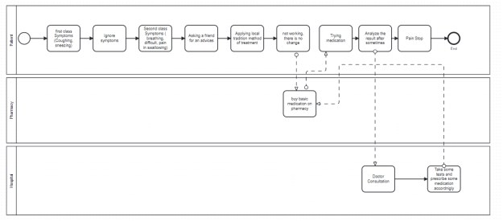

**Figure 1: Modeling of the current system**

### Problems of the Current System

Community health workers services face several challenges, as follow:

* **Nonexistent system:** No centralized platform exists to manage CHW activities.
* **Manual data processing:** CHW data is processed manually, causing inefficiencies and disorganization.
* **Poor data management:** Inefficient data storage and lack of real-time access to health data.
* **Lack of system integration:** No direct communication between CHWs, citizens, and local health authorities.
* **Limited infrastructure and training:** Inadequate training for CHWs reduces healthcare access, especially in rural areas.
* **Overcrowded health centers:** Causes delays in care and strains healthcare resources.
* **Single service based CHW:** community health workers are divided into 4 categories based on service they provide for instance each village should have one woman in of maternal and new born health care, male and female work together as binome and one other CHW in charge of health promotion.

## Proposed Solutions

The proposed solution involves developing a digital platform to automate data collection, storage, and communication among CHWs, citizens, and health authorities. This platform will improve data management, enabling health authorities to make informed decisions and allocate resources more effectively. It will also enhance CHW training and service delivery, leading to better healthcare outcomes in rural areas. Additionally, by strengthening home-based care and community health services, the platform will help reduce the burden on local health centers and improve overall healthcare access.

**Requirement Specifications:**

The requirement specification activity encompasses a comprehensive set of features and capabilities that the system must possess to ensure its effective use. These requirements are categorized into two primary types: functional requirements and non-functional requirements. Functional requirements specify the essential functions that the system must support, detailing the specific operations and activities that the system must be able to perform. In contrast, non-functional requirements impose constraints on the operation of the system, focusing on performance criteria, usability, reliability, and other operational aspects that do not directly relate to specific system functions but are crucial for overall system performance and user satisfaction.

## System Requirements

### Functional Requirements

### 

**REQ1:** System will allow users to register

**REQ2:** System will allow users to login

**REQ3:** System will allow CEHO to schedule training, and manage training materials

**REQ4:** System will allow community health worker to take training

**REQ5:** System will allow CEHO to setup an exam, and shuffle questions for difference users

**REQ6:** System will verify community health worker identity before taking an exam

**REQ7:** when he/she passes exam after training.

**REQ8:** System will allow citizen requesting appointment from certified community health worker

**REQ9:** System will allow certified community health worker to manage appointments with citizen

**REQ10:** System will allow certified community health worker to generate reports

**REQ11:** System will allow CEHO to view reports of community health workers

### Non-Functional Requirements

**Performance**

* The system must be able to handle many concurrent users without any degradation in performance.
* The response time of the system must be under 1 second for 90% of all transactions.

**Security**

* All data inside the system shall be protected against malware attacks or unauthorized access.
* The system must use strong encryption to protect all sensitive data in transit and at rest.

**Maintainability**

* The system must have a documented architecture, source code, and database schema that is easy to understand and modify by new developers.

**Usability**

* The user interface must be intuitive and easy to navigate for CHWs and health authorities, even with limited technical skills.

# CHAPTER 3

## REQUIREMENTS ANALYSIS AND DESIGN OF THE NEW SYSTEM

**Introduction**

After a thorough examination of the Current methodology in Chapter 2, our next phase is to delve into process enhancement. The aim is to create a streamlined and efficient process that fully meets organizational needs. To address the challenges of the current approach, a meticulous analysis is crucial, leading to a well-defined design that serves as a solid foundation for effective solutions.

Process enhancement involves studying and understanding the current process to identify requirements, limitations, and areas for improvement. This includes analyzing steps, workflows, and interactions to comprehend its current state and shortcomings.

Moving forward, process design is the process of creating a blueprint for a new or improved process based on the findings of the analysis. This includes defining the process's structure, flow, interfaces, and operations to address identified requirements and enhance overall efficiency and effectiveness.

Together, process analysis and process design form a comprehensive approach to evaluate, optimize, and create processes that meet specific objectives and deliver desired outcomes. The focus of process design is on achieving the process's objectives.

## Analysis and Design Methodology

**Object Oriented Methodology (OOM)**

Providing a structured framework for system development, OOM begins with an analysis phase, gaining a thorough understanding of user requirements. The subsequent design stage formulates an application model with intricate details for a comprehensive representation.

The main building blocks in Object Oriented Methodology Are Classes and Objects, where an Object is an instance of a class, representing individual entities with defined boundaries in the software system. In contrast, a class serves as a blueprint or description of a group of objects with similar attributes and behaviors (geeksforgeeks, 2024).

## Unified Modeling Language

A general-purpose modeling language in software engineering, UML offers graphic notation techniques for visual models of object-oriented software-intensive systems. It provides a standard way to visualize a system's architectural blueprints, including activities, actors, business processes, database schemas, and reusable software components.

The Unified Modeling Language (UML) has a standard way to visualize a system’s architectural blueprints, including elements like:

Activities

Actors

Business Processes

Database schemas

Reusable software components

**Object-oriented analysis and design (OOAD)**

OOAD is a popular technique for analyzing and designing applications, systems, or businesses. It employs the object-oriented paradigm and visual modeling throughout the development life cycle, facilitating effective communication with stakeholders and ensuring high product quality. UML, the Unified Modeling Language, is the standard notation used for representing these models.

**Object-Oriented Analysis:**

An approach examining how data interacts within a system, based on the object-oriented programming paradigm. It defines and analyzes requirements for system success.

**Object-Oriented Design:**

Involves planning a system of interacting objects to address a software problem systematically. Building upon identified candidate objects, it extends their definitions significantly, emphasizing how the system achieves functionality. OOD expands upon the analysis model to generate implementation specifications, focusing on how the system achieves functionality.

UML Concepts

|  |
| --- |
| **Name of class** |
| Attributes  Operations() |

* The upper part holds the name of the class.
* The middle part contains the attribute of the class.
* The last part gives the method or operation the class can take or undertake.

**An attribute** is a named property of a class that describes a range of values that instances of the property may hold.

**A method** is the implementation of a service that can be requested from any object to the class to affect behavior.

**Relationships:** A relationship is a connection among things.

The most important relationships are association, generalization, and dependency.

**Association**

Use cases and actors are connected through association relationships, indicating the interactions between actors and the corresponding use cases. A line between an actor and a use case represents the association. This association signifies two-way communication between the actor and the use case.

**Generalization**

Generalization represents a relationship between a general entity (superclass or parent) and a more specific entity (subclass or child). It is denoted by an arrow pointing from the subclass to the superclass. This relationship signifies that the subclass inherits attributes, behavior, and relationships from the superclass.

**Dependency**

Dependence is a weaker form of relationship which indicates that one class depends on another because it uses it at some point in time.

**Extend**

The extension relationship indicates that the behavior of the extension use case can be included in the extended use case under certain conditions. It is represented by a dashed arrow from the extension use case to the extended use case, labeled as "extended." Notes or constraints can be associated with this relationship to specify the conditions under which this behavior will be executed.

**Actor**: An actor represents a role that can be performed by a user or another system when interacting with the system. It is not tied to a specific individual but rather signifies a particular function or responsibility. In the case of system interactions, the actor can be depicted as a stick figure labeled with the actor's name.



**Use Case:** A use case is a significant system process that provides a benefit to one or more actors. It is labeled with a descriptive verb-noun phrase and represents a significant piece of system functionality.



System boundary boxes (optional)

**System Boundary:** A rectangle, known as the system boundary box, is drawn around the use cases to define the scope of the system. Anything contained within the box represents the functionality that is within the system's scope, while anything outside the box is considered out of scope.

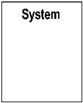

In this project, we will focus only on Actors, Use Cases and System boundaries as UML notations.

**Software development process:**

In culinary arts, the cooking process involves dividing the culinary work into distinct phases or stages, each consisting of activities aimed at effective planning and management. It is often considered a subset of the culinary creation life cycle. The process may include predefined recipes and techniques used by a cooking team to prepare or enhance a dish, ensuring it meets the diner's expectations.

**Flavorful Approaches**

Flavorful approaches to cooking can utilize various traditional methods such as baking, grilling, frying, boiling, and sautéing. However, sautéing using a high-heat methodology is commonly associated with flavorful approaches.

Difference from Conventional Approaches: The primary distinction between a conventional approach, like traditional cooking, and a flavorful approach lies in how a dish is composed. In conventional approaches, the dish composition process is either ingredient-centric or technique centric. However, flavorful approaches recognize the close relationship between ingredients and techniques, making it challenging to prioritize one over the other as the primary focus.

**Unified Process (UP)**

Unified Process (UP): The Unified Process is an architecture-centric, use case-driven, iterative, and incremental development process, also known as the unified software development process. It aims to incorporate the favorable aspects of traditional software process models while embracing the principles of agile software development.

The UP divides its phases (Inception, Elaboration, Construction, and Transition) into a series of time-boxed iterations. Each iteration delivers an increment, which enhances the system by adding or improving its functionality compared to the previous release.

**Analysis of the new system**

• **Analysis Phase:** The analysis phase addresses essential questions about the system, including its intended users, functionality, and usage locations. It involves studying the system, analyzing it, and selecting logical alternatives to model and design an information system. Use cases, which describe interactions between users and the system, are a highly effective tool in the analysis process.

## Design of the New System

### Use Case Diagram

Use Case: In system analysis, a use case is a methodology employed to identify, clarify, and organize system requirements. It comprises a set of potential interaction sequences between users and the system within a specific environment, all aimed at achieving a particular goal. The use case should encompass all system activities that hold significance for the users. It can be visualized as a collection of possible scenarios associated with a specific objective.

**Use Case Diagram**: A use case diagram is a UML diagram that depicts a business or software system, its external users (referred to as actors), and a series of actions (referred to as use cases) that users can or should perform while utilizing the system. Use case diagrams are utilized to illustrate the system's functionality from the perspective of an external user (Kramer, 2024).

**The symbols below are used in use case diagram:**

|  |  |
| --- | --- |
| **Description** | **Shape** |
| **An actor:** Is a Person/System that derives benefit from and is external to the subject. |  |
| **A use case:** Represents a major piece of system functionality**.** |  |
| **A Field relationship:**  Links an actor with the use case(s) with which it interacts. |  |
| **A boundary:** It is a box drawn around the use case to denote the edge or boundary of the system being modeled. |  |

**Table 1: Use-case diagram elements**

The figure below describes the operations of the new system and the stakeholders through the use case diagram.

**Use Case Diagram**

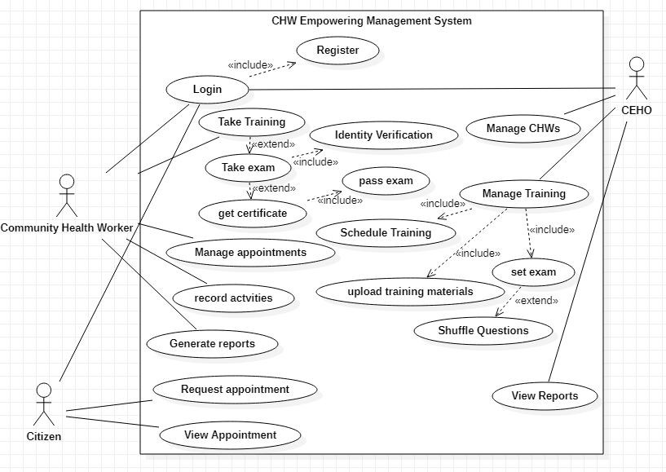

**Figure 2: Use case diagram**

**Description of the application case**

Use Case description details what a use case uses, and what it requests in order to be well executed.

Each use case looks like this:

* **Name:** A name of a use case.
* **Description:** what a system intends to do
* **Actor:** The actor involved in the use case
* **Pre-condition**: The system state before the use case can begin
* **Post-condition:** The system state when the use case is over
* **Normal flow:** The actual steps of the use case
* **Alternative flow:** Steps which may happen in case a normal flow fails.

Citizen Request for Healthcare Services

|  |
| --- |
| **Name**: Request Healthcare Visit |
| **Actor:** Citizen (Patient) |
| **Description:** This use case allows citizens to request a healthcare visit from a certified community health worker (CHW) for medical assistance. |
| **Pre-condition:** The citizen must be registered in the system and have access to the platform. |
| **Post-condition:** The request is successfully logged, and a notification is sent to the relevant CHW in the citizen's area. |
| **Normal flow:**   * Citizen logs into the system. * Citizen selects the type of healthcare service required (e.g., general health check, maternal care). * Citizen inputs necessary health information (symptoms, medical history). * The system matches the citizen’s request with an available certified CHW in their area. * The system sends a request notification to the assigned CHW. * The CHW reviews the request and confirms the appointment. * The CHW visits the citizen’s home and provides the required care. |

**Alternative flow**:

The system will notify the citizen about the CHW's unavailability and provide an option to request a different available CHW.

The citizen can choose to wait for the original CHW or select another available CHW in their area.

**Table 2: Use case description for Request Healthcare Visit**

|  |
| --- |
|  |

### Class Diagram

A class diagram serves as a fundamental visual representation that effectively illustrates the structure of the system by depicting various classes, their associated attributes, methods, and the relationships between these classes. This diagram provides a comprehensive and detailed overview of the system's architecture, allowing for a clear understanding of how different components interact and communicate within the system.

**Importance of class diagram**

* Class diagrams enable effective communication, serving as a blueprint for software development.
* They identify key entities, attributes, and relationships, aiding in system analysis and design.
* Class diagrams promote modular and reusable design, improving system quality and Maintainability (paradigm, 2023).

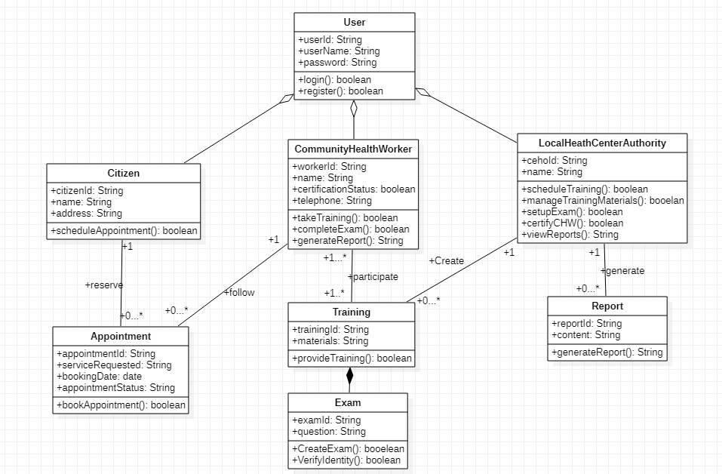

**Figure 3: Class diagram**

### Sequence diagram

A sequence diagram is a form of interaction diagram which shows objects as lifelines running down the page, with their interactions over time represented as messages drawn as arrows from the source lifeline to the target lifeline. A sequence diagram shows object interactions arranged in time sequence. (Kraemer, 2009)

The notations and their definitions that are used in sequence diagram:

|  |  |
| --- | --- |
| Term and definition | Symbol |
| An actor:   * It can be a person or system that derives benefit from and is external to the system. * It participates in a sequence by sending and/or receiving messages. * It is placed across the top of the diagram. |  |
| An object lifeline:  UML object symbol illustrates class role, but doesn't list object attributes. It is placed across the top of the diagram. |  |
| An activation:  Activation boxes represent the time an object needs to complete a task. It denotes when an object is sending or receiving messages. |  |
| A message:   * It conveys information from one object to another. * An operation call is labeled with the message being sent and a solid arrow, whereas a return is labeled with the value being returned and shown as a dashed arrow. |  |

**Table 4: Sequence diagram annotation with their explanation**

As the sequence diagram graphically displays the interaction between actors and the system, the diagram below clearly describes how the user interacts with the system.

**Sequence diagram for Citizen Requests Healthcare Assistance.**

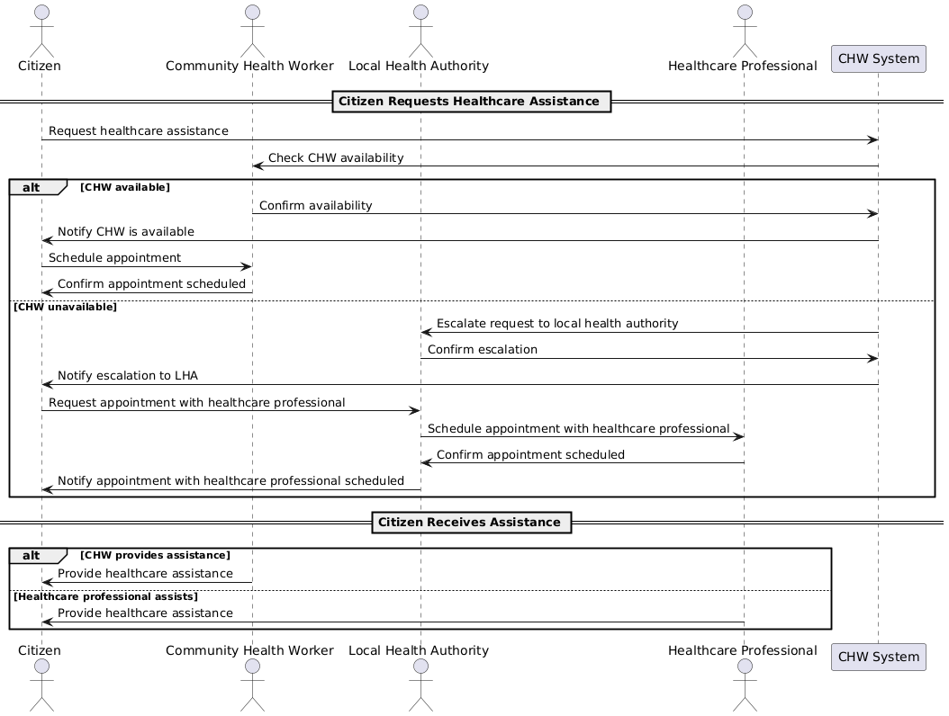

**Figure 4: Sequence diagram for Citizen Requests Healthcare Assistance**

**For Training and Certification Process.**

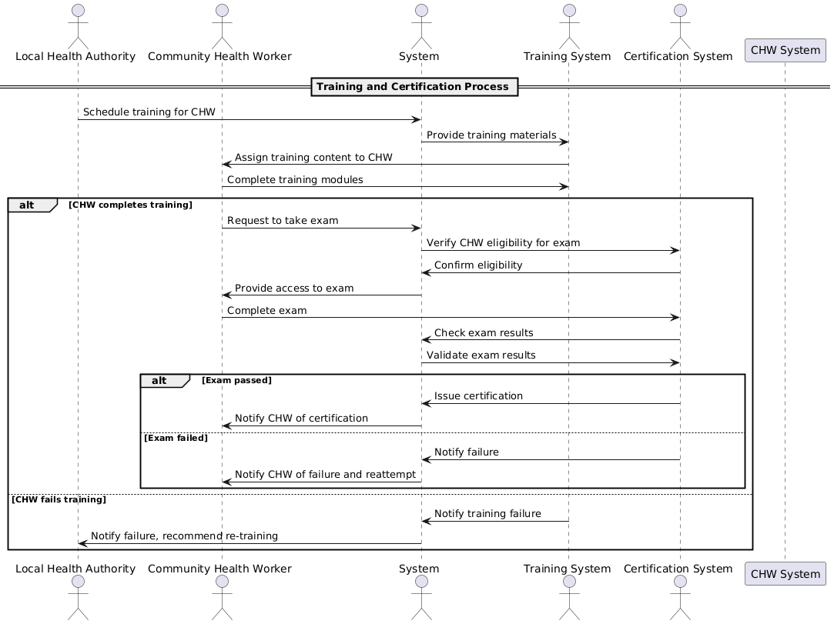

**Figure 5: Sequence diagram for training and certification process**

### Activity Diagram

The activity diagram is a visual representation of the Community Health Workers Empowering Management System processes at Ministry of Health (Moh), illustrating activities, decisions, and the flow of communication.

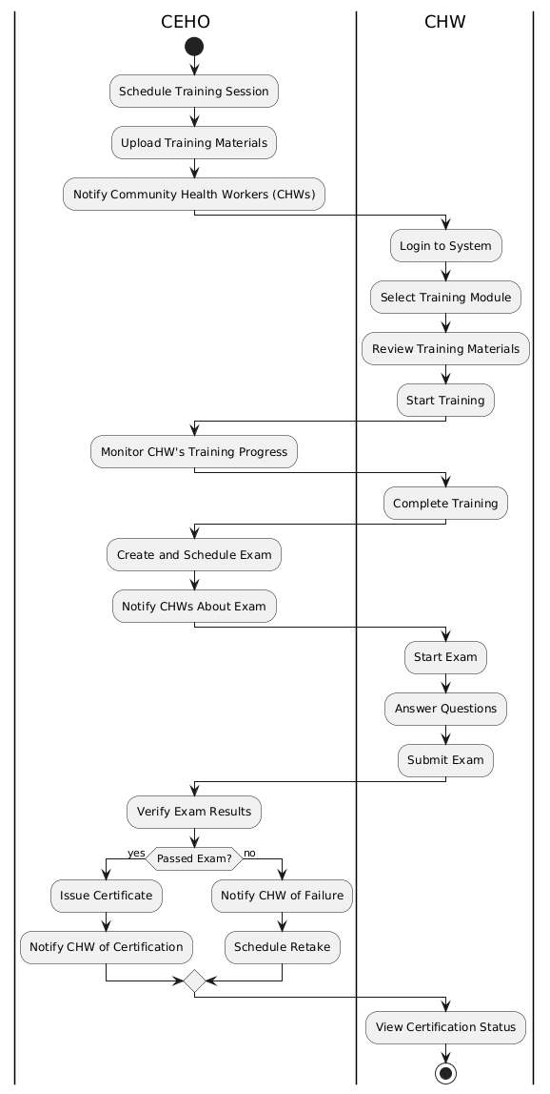

**Figure 6: Activity Diagram**

### Database Design

Database modeling is the systematic approach of creating a comprehensive data model that encompasses logical and physical design decisions. It includes essential parameters for storage and enables the generation of a data definition language design, ultimately facilitating the creation of a database.

DATABASE DIAGRAM

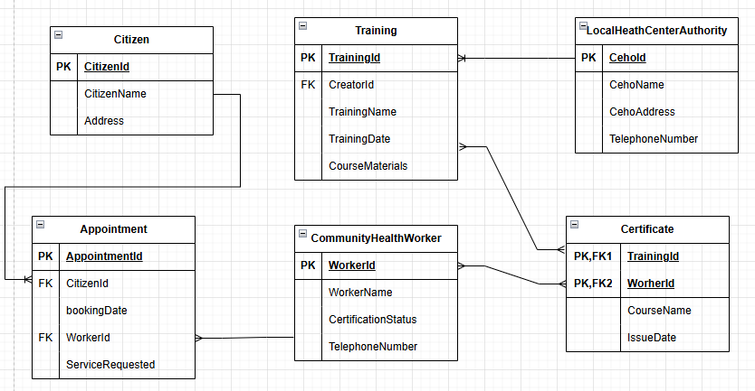

**Figure 7: Database diagram**

### Data Dictionary

A data dictionary diagram is a visual representation of a system's data elements, mapping their attributes and relationships. It showcases key data components as interconnected blocks, outlining their functions and associations. The diagram aids in understanding data structures and enables efficient communication between software and hardware architecture, fostering effective human interaction.

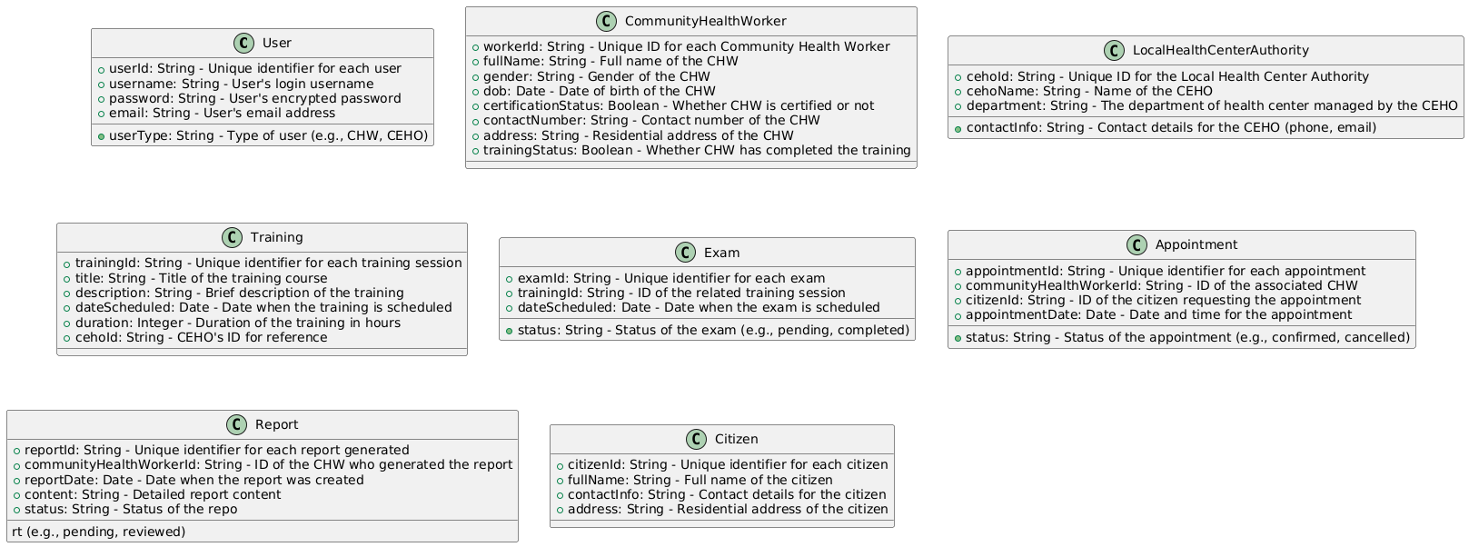

**Figure 8: Data dictionary diagram**

### System Architecture Design

System architecture is a visual depiction of a system that maps functionalities onto hardware and software components, establishes a relationship between software and hardware architecture, and incorporates human interaction. It is a diagram illustrating the system's key components represented by interconnected blocks, showcasing their relationships and functions.

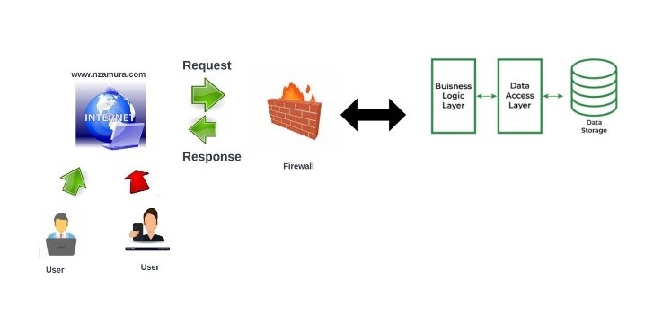

**Figure 9: System architecture design**

In the CHWEMS (Community Health Workers Empowering Management System), the process of requesting data from the platform follows a structured flow, similar to how a typical web request is handled. Below is a detailed description of this process, tailored to the system's specific use case:

* User Request: A user (CHW, citizen, or health authority) initiates a request through the CHWEMS platform, such as accessing training materials or requesting healthcare services.
* Request Sent Over the Internet: The request is securely transmitted from the user's device to the CHWEMS server using protocols like HTTP/HTTPS, ensuring data privacy.
* Server Processing: The CHWEMS server processes the request, interacting with the MySQL database to retrieve or store the necessary data (e.g., training content or health records).
* Response Generated and Sent Back: After processing, the server sends the response (training materials, service confirmation, or health data) back to the user's device in a structured format like JSON or HTML.
* Display in User Interface: The frontend, built with React, dynamically displays the response in an easy-to-understand format, ensuring accessibility and usability for the user.
* User Interaction and Follow-up: Based on the response, the user may take further actions, such as submitting requests, accessing more resources, or updating data, supporting continuous interaction within the system

# CHAPTER 4

# IMPLEMENTATION OF THE NEW SYSTEM

## Introduction

The implementation of the new Community Health Workers Empowering Management System aims to enhance the efficiency and accessibility of healthcare services by empowering Community Health Workers (CHWs) with a comprehensive digital platform. This system will streamline the training, certification, and management of CHWs, enabling them to deliver better healthcare services to underserved populations. Through remote training modules, real-time certification processes, and citizen health service requests, the system addresses key challenges such as limited access to healthcare, insufficient CHW training, and overcrowded local health centers. By connecting citizens with trained professionals and supporting the effective management of healthcare activities, Community Health Workers Empowering Management System will improve healthcare outcomes, especially in rural areas, and contribute to the overall strengthening of the healthcare system.

## Technologies Used

### Front End

* HTML: Used to create the structure of web pages, defining the elements and layout.
* CSS: Used to style and format the appearance of web pages, controlling the visual aspects like colors, fonts, and layout.
* JavaScript: Used for client-side scripting, enabling interaction with users, controlling the browser, and altering the displayed content dynamically.

### Back End

* MySQL: Utilized for creating and managing the database. It handles storing and retrieving data from the database.
* PHP: Used as the server-side scripting language for web development. PHP enables dynamic content generation and interacts with the database to fetch or modify data as needed.
* XAMPP: A comprehensive web server solution stack package that combines Apache HTTP Server and MariaDB (a fork of MySQL) as the database server. It provides the necessary environment for running PHP scripts and handling database operations on the server-side.

To summarize, the Frontend technologies (responsible for the user interface and user interactions) consist of HTML, CSS, and JavaScript. On the other hand, the Backend technologies (responsible for server-side operations, data storage, and retrieval) include MySQL, PHP, and the XAMPP stack (Apache HTTP Server + MariaDB). These technologies work together to create a fully functional web application with both frontend and backend capabilities.

## Presentation of the New System

**Login Page**

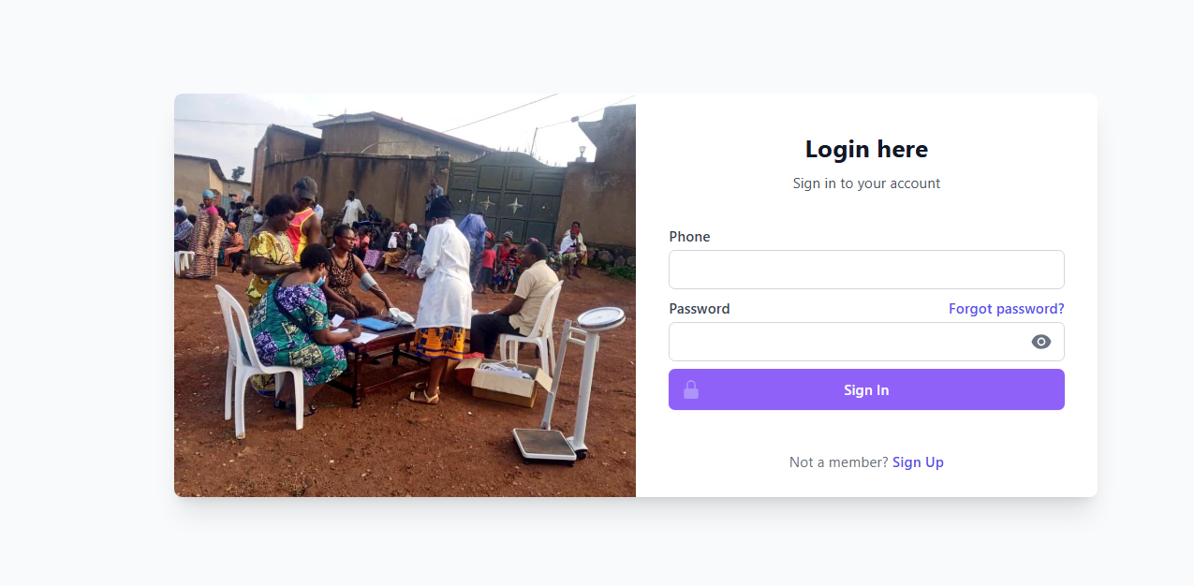

**Figure 10: login page**

**Manage Service**

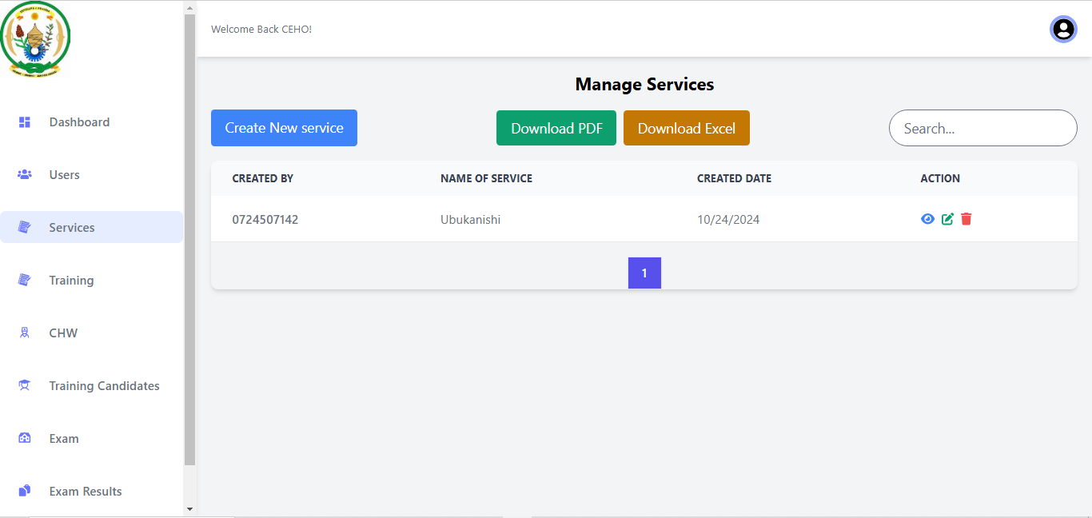

**Figure 11: Manage service**

**Manage Training Modules**

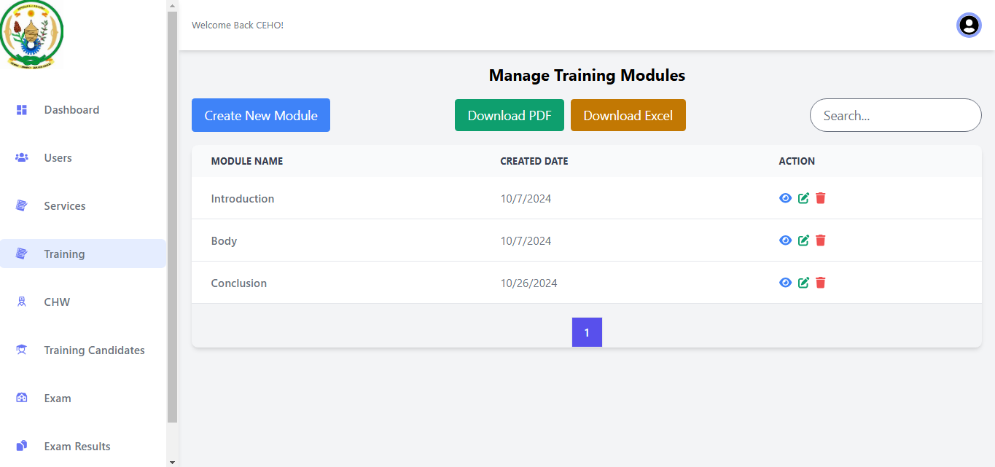

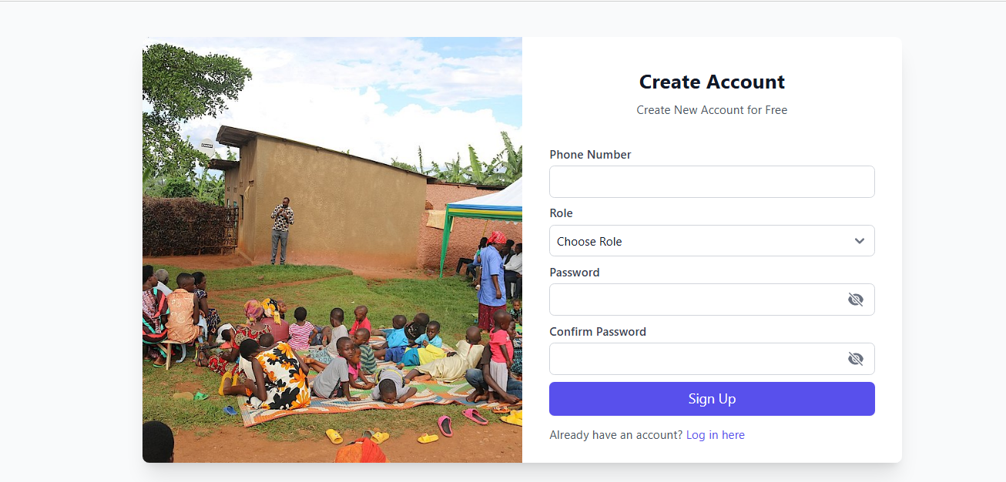

**Figure 12: Create Account**

**Create New Trainings**

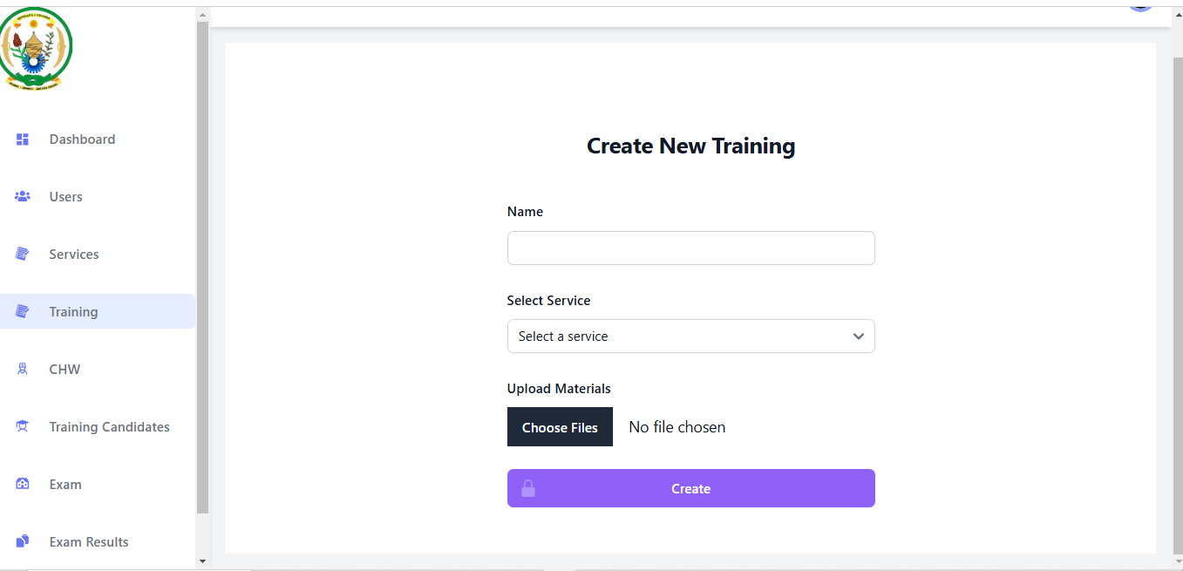

**Figure 13: Create New Trainings**

**Create New Health Community Worker**

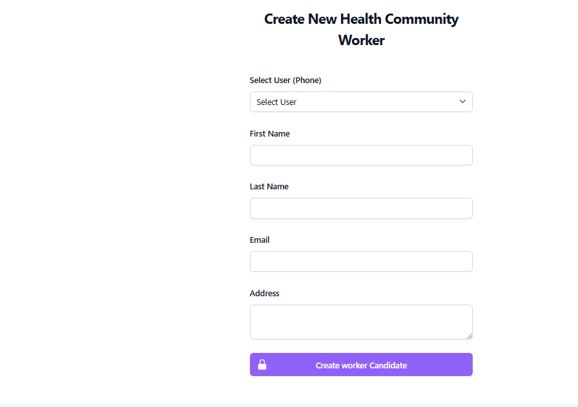

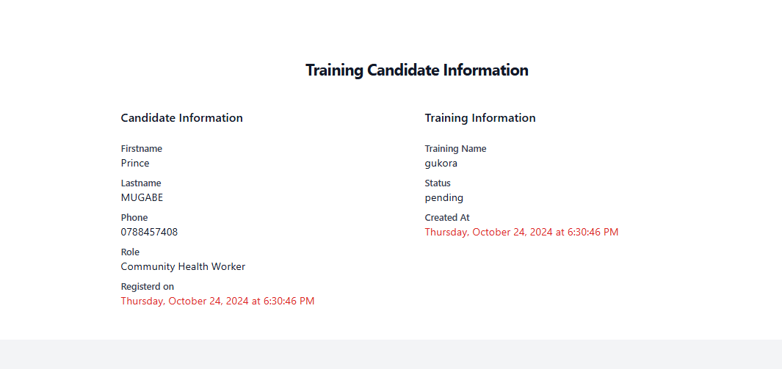

**Figure 14: Training Candidate Information**

**Manage Exam Questions**

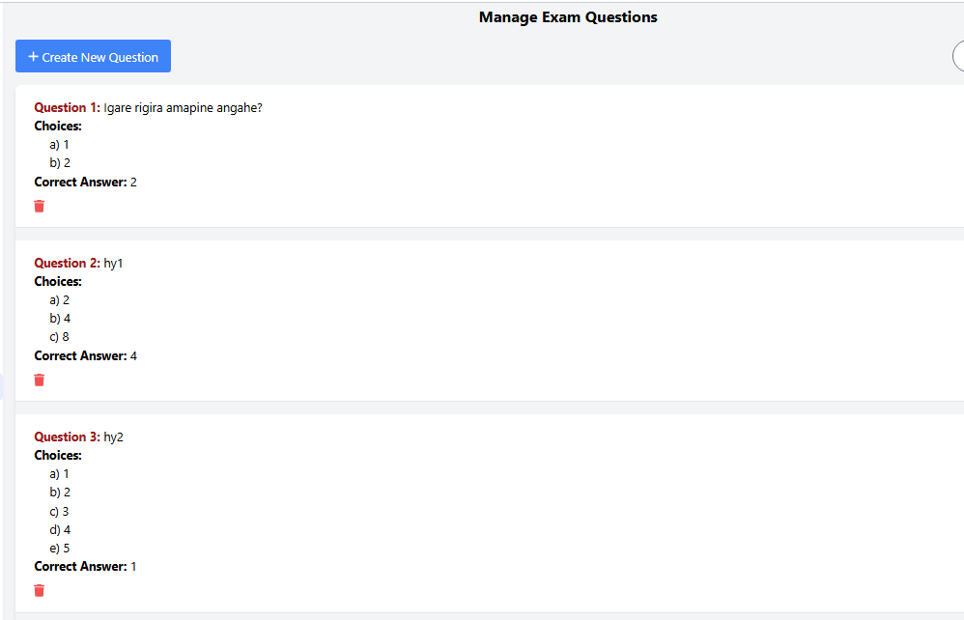

**Figure 15: Manage Exam**

**Manage Results**

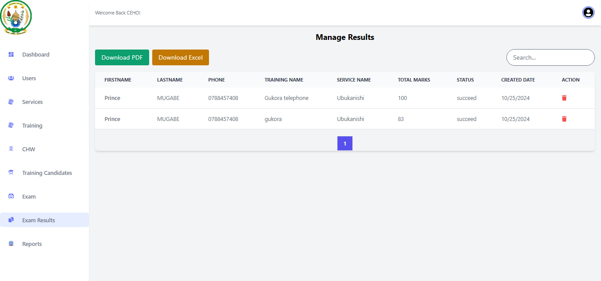

**Figure 16: Manage Results**

**Apply For Trainings**

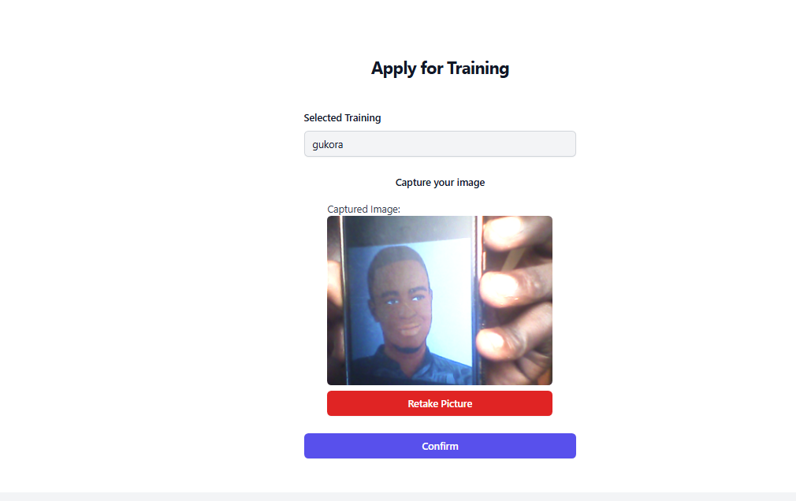

**Figure 17: Apply for Trainings**

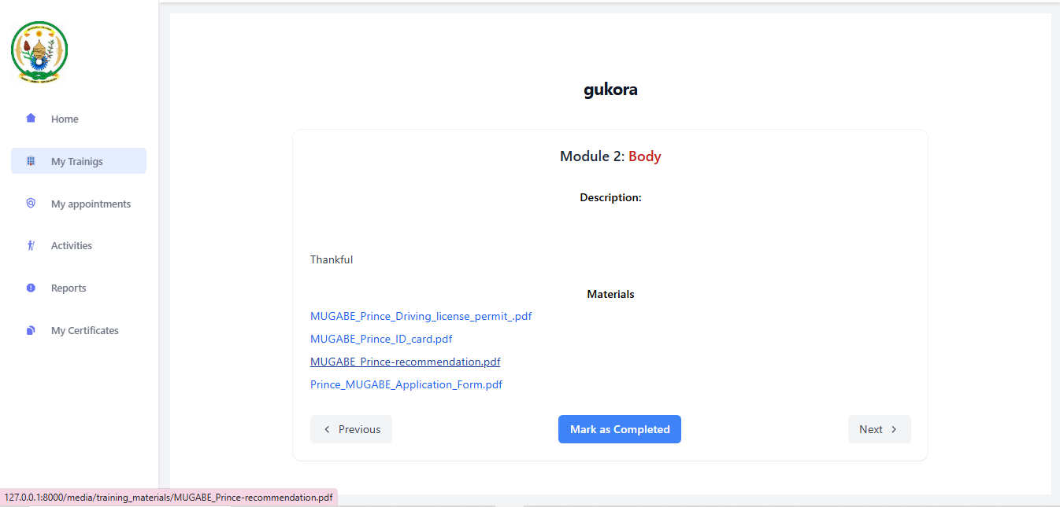

**Reports**

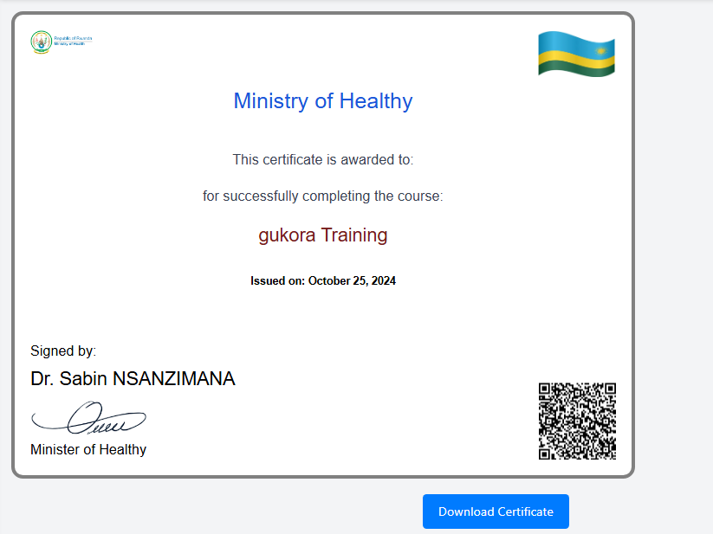

**Figure 18: Certificate image**

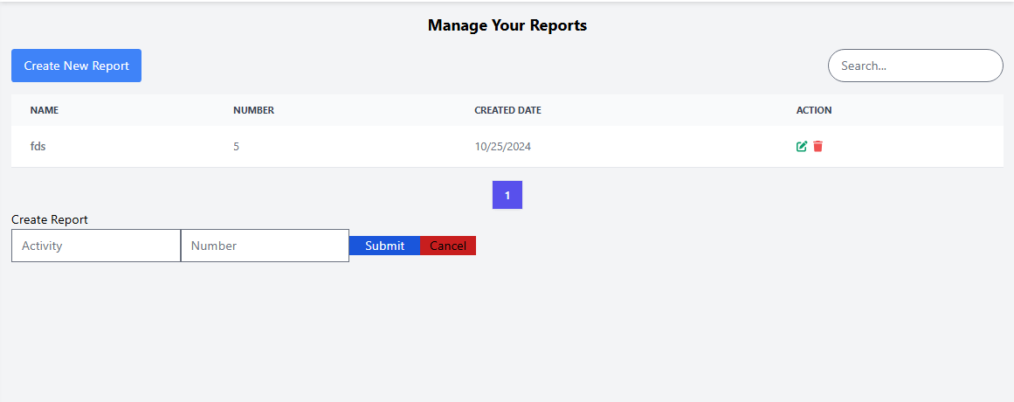

**Figure 19: Customize Report Image**

## Software Testing

**Software testing** is an essential practice that involves systematically assessing and validating the functionality of software. Its primary objective is to ensure that the software’s performs as intended.

Testing serves multiple purposes, including the early detection and prevention of bugs, minimizing development expenses, and enhancing overall performance (Geeksforgeeks, 2024). They are some key points to check in software testing

* Compliance with Requirements: Ensure that the software meets the specified requirements and objectives that guided its design and development. This involves validating that the software functions as intended and delivers the desired outcomes.
* Functional Validity: Verify that the application works as expected and meets the intended behavior. This includes testing all the functionalities and features of the software to ensure they operate correctly and produce accurate results.
* Performance Testing: Measure and optimize the software's performance by assessing factors such as response time, scalability, and resource usage. This involves evaluating how the software performs under different workloads and ensuring it meets performance expectations, providing a smooth and efficient user experience.

### Unit Testing

Unit testing is a crucial aspect of software development that concentrates on validating the smallest testable components of an application, known as units, in isolation to ensure their correct functioning.

Unit testing can be performed manually; however, it is commonly automated to streamline the process and enhance efficiency.

### Integration Testing

Integration testing is a critical stage in software testing, where individual software modules are integrated and tested collectively as a unified system. This testing phase ensures the correct assembly of various software components and verifies that they function harmoniously. The integration testing process involves a series of tests that progressively combine software and hardware components until the entire system is thoroughly tested. By first conducting individual tests on software components and subsequently integrating them, we can ensure that they seamlessly work together as intended.

## Hardware and Software Requirements

### Client Side Software Requirements

Web Browser: The latest versions of widely used browsers such as Mozilla Firefox, Google Chrome, Safari, or Microsoft Edge.

### Server-Side Software Requirements

* Operating System: Compatible with major operating systems, including Windows 10 and 11, macOS, and popular Linux distributions (e.g., Ubuntu, Fedora).
* PHP Version: Compatible with the latest stable version of PHP (e.g., PHP 5 or higher).
* Database: Support for popular databases like MySQL or PostgreSQL.
* Web Server: Compatibility with web servers such as Apache or Nginx.
* Security Measures: Implementation of appropriate security measures, including secure coding practices, encryption of sensitive data, and protection against common web vulnerabilities (e.g., SQL injection, cross-site scripting).
* Backup and Recovery: Regular backup mechanisms and procedures in place to ensure data integrity and facilitate recovery in case of system failures or data loss.

### Client Side Hardware Requirements

* Microprocessor: Intel Core i3 or higher processor.
* Memory (RAM): Minimum 2 Gigabytes (GB) of RAM.
* Storage Space: At least 1 Gigabyte (GB) of free disk space.

### Server Side Hardware Requirements

* Web Server: Apache HTTP Server or Nginx, compatible with PHP and capable of handling high traffic and concurrent connections efficiently.
* Database: MySQL or MariaDB database server, with a version of at least 5.7.
* Network Infrastructure: A high-speed network card with a minimum bandwidth of 1 Gigabit per second (Gbps).
* RAM: Minimum 4 Gigabytes (GB) of RAM.
* Storage Space: At least 5 Gigabytes (GB) of available hard disk space.

# CHAPTER 5

# CONCLUSION AND RECOMMENDATIONS

## Conclusion

The Community Health Workers Empowering Management System (CHWEMS) represents a crucial step forward in enhancing the effectiveness and efficiency of community-based health initiatives. By empowering Community Health Workers (CHWs) with the right tools, resources, and support, this system ensures that health interventions are more responsive, sustainable, and scalable in addressing the health needs of underserved populations.

The implemented Community Health Workers Empowering Management System boasts the following key features:

Improved Access to Healthcare: By leveraging technology and data management systems, CHWs can more effectively monitor, track, and deliver health services to communities, particularly in remote or underserved areas. This system ensures better follow-up and continuity of care, contributing to healthier communities.

Data-Driven Decision Making: Through real-time data collection, health analytics, and reporting features, CHWEMS allows for informed decision-making by healthcare providers, policymakers, and stakeholders. This leads to more accurate assessments of health needs, resource allocation, and program outcomes.

Enhanced Training and Support for CHWs: The system offers a platform for ongoing education, training, and professional development of CHWs. With the right resources, CHWs can improve their skills and knowledge, making them more effective in their roles.

Sustainability and Scalability: By streamlining operational processes and improving coordination among different health stakeholders, CHWEMS ensures that health interventions are sustainable over time.

## Recommendations TO MOH

Recommendations for optimizing the (CHWEMS) Community Health Workers Empowering Management System are:

* Increase Accessibility: Ensure multilingual support and compatibility with low-tech devices for wider accessibility.
* Ongoing Training: Provide regular updates and mobile learning tools for continuous capacity building of CHWs.
* Enhance Data Utilization: Improve data quality, expand analytics, and use data to influence policy decisions.
* Strengthen Community Engagement: Include feedback channels and foster peer learning among CHWs.
* Ensure Sustainability: Collaborate with governments and donors, ensure adaptability, and promote local ownership.
* Improve User Experience: Simplify the user interface and add offline capabilities for CHWs in remote areas.
* Monitor and Evaluate: Regularly assess the system’s effectiveness using KPIs and dashboards for continuous improvement.
* Focus on Interoperability: Integrate the system with national health systems and other sectors for a comprehensive approach.

## Recommendations to the Future Researchers

Future research on the **CHW Empowering Management System** should focus on two main areas:

* Develop a Mobile App: Future researchers should create a mobile app for the CHW Empowering Management System to increase accessibility, especially in rural areas with limited internet connectivity. The app should support offline capabilities and mobile learning tools for continuous CHW training.
* Integrate Drone Delivery System: Researchers should explore integrating the system with drone technology for delivering medical supplies and equipment to remote areas. This will enhance healthcare service delivery by providing quicker access to essential resources for CHWs and citizens.

# REFERENCES

## Books

(Digital Health, 2019)

(B.E.A, 2016)

(BINAGWAHO, 2015)

(Daniel, 2021) (Rwanda National Strategy for Health Professions Development NSHPD 2020-2030, 2020)

(Health Sector Policy, 2015)

## Websites

*World Health Organization (WHO). (n.d.). World Health Organization (WHO). Retrieved December 14, 2024, from* [*https://www.who.int*](https://www.who.int)

Van Rossum, G. (1991). Python Programming Language. Retrieved from [*https://python.org*](https://python.org)

MySQL AB. (1995). MySQL Database Management System. Retrieved from [*https://mysql.com*](https://mysql.com)

Kothari, C. R. (2004). Research Methodology: Methods and Techniques (2nd ed.). New Age International

Booch, G. (1994). Object-Oriented Analysis and Design with Applications (2nd ed.). Addison-Wesley.

Beck, K., et al. (2001). Manifesto for Agile Software Development. Retrieved from [*https://agilemanifesto.org*](https://agilemanifesto.org)

Facebook. (2013). React: A JavaScript Library for Building User Interfaces. Retrieved from [*https://react.dev*](https://react.dev)

*Digital Health Initiative. (n.d.). Digital Health Initiative. Retrieved December 14, 2024, from* [*https://www.digitalhealthinitiative.org*](https://www.digitalhealthinitiative.org)

# APPENDICES

## Curriculum Vitae

Harerimana Umuhire Clement

+250786423227 . Gasabo District, Kigali City, Rwanda

[harerimanaclementkella@gmail.com](mailto:harerimanaclementkella@gmail.com).<https://www.linkedin.com/in/harerimana-umuhire-clemen>.<https://github.com/Hareriman>

C:\Users\HP\AppData\Local\Temp\ksohtml17164\wps5.pngSummary

As a potential graduate from the Adventist University of Central Africa in Kigali City, I have acquired

comprehensive training and experience as a software engineer and programmer. Alongside my qualifications as a licensed computer networking skills through Cisco Academy, I possess proficiency in various computer-related software such as programming with C, C#, and Java, as well as expertise in SQL Database Development and Programming. Additionally, I have expanded my skills in web development, including frameworks like Spring Boot, ASP.NET Core, and ASP.NET MVC. With my diverse skill set, combined with unwavering passion, I am confident in my ability to contribute significantly and succeed in your organization.

C:\Users\HP\AppData\Local\Temp\ksohtml17164\wps6.pngEducation

**Adventist university of central Africa**

Bachelor of Information Technology - BTech, Software Engineering Jan 2020 – Now

Relevant Computer Courses: Programming with C, Object Oriented Programming, Programming with Java, Introduction to Big data, Data structure, Computer Networks, Introduction to Linux Administration, Dotnet and Web Technology and Internet.

Relevant Mathematics Courses: Digital Computer Fundamentals, Applied Mathematics, Descriptive Statistics, Statistics and Probability and Multivariable Calculus & Differential equations.

**Ecole Des Science de Musanze**

Rwanda Advanced Certificate of Education – Physics, Chemistry and Biology 2016 –Dec 2018

Relevant Courses: Physics, Alternative Computer Sciences and subsidiary mathematics

C:\Users\HP\AppData\Local\Temp\ksohtml17164\wps7.pngSkills

**Technical Skills**

Languages: C, Java, SQL, JavaScript, Python, C#, C++

Frameworks: REACTJS & Vite, Spring Boot, ASP.NET Core, ASP.NET MVC, NumPy, Pandas

Platforms: Code Blocks, Bootstrap, Nice page, WIX, NetBeans IDLE, PyCharm, VS Code, IntelliJ IDEA,

Arduino IDLE, Oracle Database, Oracle VM, PostgreSQL, Xampp, SQL Server, Visual Studio,

Postman, Code Signal, Program, Railways and GitHub

**Soft Skills**

Communication skills: English Proficiency

Leadership skills: Mobilization, Motivation speaking, negotiation

Other: Attention to detail, Creativity, initiative, problem solving, analytical & Critical thinking, Riddle Solving,

Teamworking, Reflective Thinking & Writing, Working well under the pressure.

C:\Users\HP\AppData\Local\Temp\ksohtml17164\wps8.pngExperience

**Network Operation Center Engineer**

**Korean Telecom Rwanda Networks Dec 2023 – Now**

Relevant Responsibilities

- First Line Technical Support on IP&LTE-Related Issues Impacting Customer Service.

- Analyze the network fault, provide first-line support, dispatch responsibilities engineer, escalate where needed, and follow up until the issue is fixed.

- Inspect degradation of network performance.

- Ensure Timely reporting of NOC daily, weekly, and monthly reports.

- Track all network incidents from start to completion and draft incident reports.

- Perform Health check and backup of core nodes

Relevant Technically Skills

-Long Term Evolution (4G) Technology

-Internet Protocol (Configuration and Troubleshooting)

-Evolution Packet System

-Voice over LTE (VOLTE)

- IP Multimedia Subsystem (IMS)

-Transmission (Fiber)

-Radio Access Networks

**Bridge Program Trainee**

**Carnegie Mellon University Africa Sept 2023 – Nov 2023**

Relevant Academic Skills

-Skills Audit (Self-awareness and self-evaluation)

-learn how to write an academic research article

-Learn how to conduct a seminar

-Reflective Thinking & Writting

-Presentation Skills

-Learn how to prepare for pitch

Relevant Technically Skills

-Introduction to IOT System

-Introduction to Tinker cad Simulation, Design Electronic Circuit

-Programming Arduino micro-controller through Arduino IDLE with C++

-Dealing with an Ultra-sonic sensor, an Infrared Sensor, and a DH11 Sensor

-Robot Car Project (L298N Motor Drive Module, Four-channel tracking Module, HC-SR04 Ultrasonic

Module, Bluetooth Module)

C:\Users\HP\AppData\Local\Temp\ksohtml17164\wps9.png [View certificate here](https://drive.google.com/file/d/1s3NwrSjIahlS2X4pCQMUqFwf1qZ33qUR/view?usp=sharing)

C:\Users\HP\AppData\Local\Temp\ksohtml17164\wps10.pngProjects

**Event-Ticket Management**  March 2023 – May 2023 This is a Simple Information System that is developed to allow the event organizer to sell their tickets online for a specific event. I did this project for an academic purpose only. It is java’s Spring boot-based project. [click here](https://github.com/Hareriman/Event_Ticket_WebApps)

**Healthcare Management System** April 2023 – May 2023

This is a simple Healthcare Management System that would be helping medical professions to manage medical records for their patients. I did this web-based project for an academic purpose only.it is C#’s ASP.NET CORE based project. [click here](https://github.com/Hareriman/HealthcareProject)

C:\Users\HP\AppData\Local\Temp\ksohtml17164\wps11.pngLicenses & Certifications

**Network Security** - Cisco Networking Academy 13 Jan 2022

C:\Users\HP\AppData\Local\Temp\ksohtml17164\wps12.png [View certificate here](https://drive.google.com/file/d/1_I40d_CZ9Pd-Gc1m7AwFZDFJzSiNCHoQ/view?usp=sharing)

**NDG Linux Essentials** - Cisco Networking Academy 15 Nov 2022

C:\Users\HP\AppData\Local\Temp\ksohtml17164\wps13.png [View certificate here](https://drive.google.com/file/d/1zBqXonnmTSBoXBUqpzUR-hdv_cObCFcn/view?usp=sharing)

**Introduction to Cybersecurity** - Cisco Networking Academy 22 Jun 2022

C:\Users\HP\AppData\Local\Temp\ksohtml17164\wps14.png [View certificate here](https://drive.google.com/file/d/1h65jGWbhoZUR-Lv56lNM2gHiM9W2THVT/view?usp=sharing)

**Networking Essentials** - Cisco Networking Academy 30 Dec 2021

## Data Collection Letter