**Handwriting Detection**

1. Jiya Nayak – 21BCE164
2. Riya Mehta – 22BCE516
3. Prince Nasit – 21BCE163

Description – project is based on deep learning to recongnize handwritten characters.

* Installation Steps

1. Install tensorflow

-m pip install tensorflow

1. Install Keras

conda install -c conda-forge keras

1. Install opencv

conda install -c conda-forge opencv

1. Install scikit-learn

pip install -U scikit-learn

1. Install Pandas

conda install -c anaconda pandas

1. Install numpy

conda install numpy

1. Install dataset

https://www.kaggle.com/datasets/sachinpatel21/az-handwritten-alphabets-in-csv-format

**Steps to run project:-**

* **Run ipynb**

1. Run Project.ipynb
2. Run cells except 19 & 20
3. Draw character

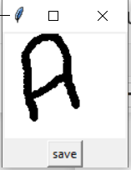

1. Click on Save after that result will be printed

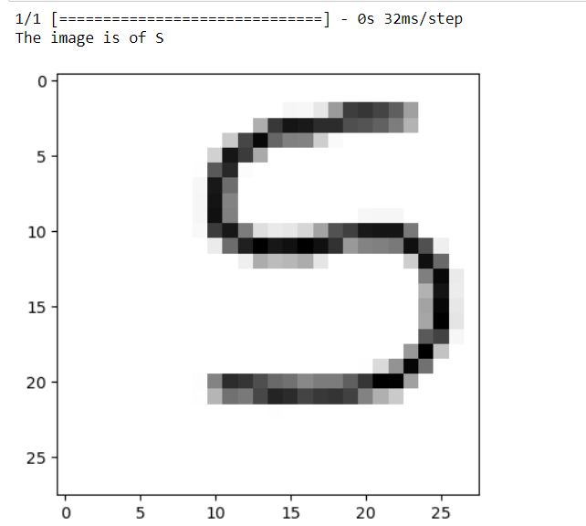

* Run website

1. Open anaconda navigator
2. Launch visual studio
3. In terminal type – streamlit run.py
4. Upload image file

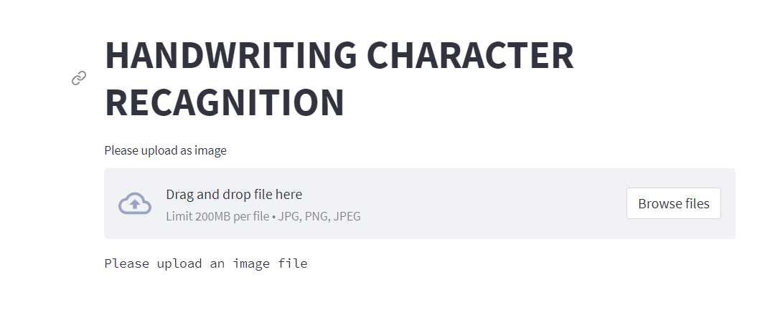

1. Output will be displayed

