Keeply
An ownership-resolution platform for product returns, repairs and warranty claims
Project report and submission document: a Laravel 12 / PHP 8.3 web application
Submitted by | Prince Patel
Course | (to be completed)
Institution | (to be completed)
Guide | (to be completed)
Date | (to be completed)
Platform | PHP 8.3.33, Laravel Framework 12.69.3, SQLite (local pilot) / MySQL 8 (production target), Windows 11
Runtime dependency added | dompdf/dompdf 3.1.6 (exact pin) for PDF generation
Test result | 75 automated tests, 399 assertions, all passing (full suite, 15 October 2026)

Contents
Right-click here and choose Update Field to build the contents.

1. Abstract
People rarely have trouble keeping a receipt. The trouble starts when a product fails: working out whether it is still under return or warranty, finding the right evidence, remembering who promised what on which call, and putting together a clear, factual request the seller or service centre can't easily brush off. Most of that work ends up scattered across email, WhatsApp, photo galleries and memory.
Keeply is a web application that takes one product problem through to a recorded outcome. A user records a product with category-specific details, attaches private evidence, and opens a resolution case when something goes wrong. Keeply then:
- works out the return and warranty position from the recorded facts and shows its reasoning;
- keeps a dated chronology of contacts, repairs, expenses and promises;
- turns promised follow-ups into reminders on the dashboard and by email;
- lists which evidence is present, missing or optional, and why;
- produces an immutable, versioned Warranty Action Pack PDF containing the facts, the
chronology, an evidence integrity manifest and an editable request letter;
- records the final outcome while keeping the full history.
The application is a modular Laravel monolith with 13 domain tables, 12 domain services, 6 authorisation policies and 75 automated tests. Security and privacy are part of the design rather than add-ons. Every record is scoped to a workspace and checked by a policy. Uploaded files are checked by their actual bytes and stored outside the public web root. Serial numbers are encrypted at rest. Assessments and Action Packs can't be changed after they are created. Account deletion follows a documented 30-day retention window.

2. Introduction

2.1 Background
Consumer products like laptops, phones, appliances and furniture come with return windows and manufacturer warranties measured from the purchase date. Whether a claim succeeds usually comes down to a few facts: when the product was bought, when the fault appeared, what proof exists, and what has already been said to the business. These facts are usually known to the consumer, but they are rarely organised when they are needed.

2.2 Problem statement
When a product fails, the owner has to answer questions under time pressure:
- Is the product still inside its return period or warranty, and until what date?
- Which documents and identifiers will the business ask for, and do I have them?
- Who did I speak to, when, under which reference number, and what did they promise?
- How do I present all of this clearly enough to get a repair, replacement or refund?
- What finally happened, and what did it cost me?
Existing tools mostly stop at storing receipts or reminding the user when a warranty is about to expire (Section 4). Few of them help after the failure has happened, which is when the user actually needs help.

2.3 Proposed solution
Keeply treats the resolution case as its main object, not the receipt. Its core loop is:
Record a product → discover an important action → complete it using organised evidence.

2.4 Product principles
- Factual, not legal. Keeply organises and calculates from what the user recorded. It
never claims eligibility or gives legal advice, and it says so on every assessment and Action Pack.
- Unknown is never expired. If a needed fact is missing, the result is unknown and the
missing fact is named. It is never shown as a false "expired".
- Explain every result. Every coverage state and checklist row shows the fact that
produced it.
- History is never rewritten. Assessments and Action Packs are frozen snapshots, so
editing the product later cannot change what was claimed at the time.
- Private by default. Evidence never sits in a public directory, and every request is
checked against workspace membership.

3. Objectives and Scope

3.1 Objectives
# | Objective | Where it is met
O1 | Secure registration, verification, login and password recovery | Section 9.1
O2 | Private workspaces with enforced membership-based access | Sections 9.1, 10
O3 | Product records whose form is generated from database metadata | Section 9.2
O4 | Private, integrity-hashed evidence uploads | Section 9.3
O5 | Resolution cases with a controlled state machine | Section 9.4
O6 | A chronological, editable case timeline | Section 9.5
O7 | Follow-up reminders in-app and by queued email | Section 9.6
O8 | Explainable return/warranty coverage calculation | Section 9.7
O9 | Immutable, versioned assessment snapshots | Section 9.8
O10 | A factual evidence checklist | Section 9.9
O11 | Printable preview and immutable private Action Pack PDF | Section 9.10
O12 | Final outcome recording that preserves history | Section 9.11
O13 | Account data export and retention-safe deletion | Section 9.12
O14 | Security-header, caching and accessibility baseline | Sections 10, 11

3.2 In scope (Version 1)
Authentication, personal workspace, two product categories (Laptop, Other product) with dynamic fields, private documents, resolution cases, timeline, reminders, coverage assessment, evidence checklist, Action Pack preview and PDF, outcomes, export/deletion and a local Windows pilot runtime.

3.3 Explicitly out of scope
OCR of receipts, AI suggestions, retailer or manufacturer integrations, sending claims to businesses on the user's behalf, shared household workspaces with invitations, native mobile apps, payments, and a public production deployment. These are covered in Section 17.

4. Existing System Study
Desk research (Phase 0 validation, October 2026) looked at current consumer tools:
Product | What it does well | What it does not do
HousePulse (iOS) | Home maintenance schedules and reminders | No failure-to-resolution workflow, no claim dossier
WarrantyHub / Warranty Tracker (iOS) | Stores receipts and warranty expiry dates, sends expiry alerts | Stops at expiry; no case timeline, evidence check or request document
Homer (iOS) | Home inventory, documents, maintenance | Inventory-centred; no coverage reasoning after a fault
Business warranty software | Claim processing for manufacturers and retailers | Built for the business side, not the consumer
Ad-hoc (email, WhatsApp, gallery, notes) | Free and familiar | Evidence scattered, no deadlines, no chronology, nothing to hand over

Finding. Storing receipts, reminding about warranty expiry, tracking maintenance and keeping a home inventory are already common features, so none of them is a defensible point of difference. Keeply's difference is the part that comes after the failure: coverage reasoning, a chronology, an evidence check and a factual request pack. This is still a hypothesis: the Phase 0 interview kit is ready, but no user interviews have been done yet (backlog item K-001). This report doesn't claim the market need has been validated.

5. Requirements Specification

5.1 Functional requirements
ID | Requirement
FR-01 | A visitor can register; registration creates the user, a personal workspace and an owner membership in one transaction.
FR-02 | A user must verify their email before reaching any workspace page (signed, expiring link).
FR-03 | A user can log in (rate-limited), log out, and reset a forgotten password.
FR-04 | A user can add a product by choosing a category; the form fields, types and rules come from the database.
FR-05 | A user can attach a receipt, warranty, manual, product photo or other evidence (PDF/JPG/PNG/WebP, ≤ 10 MB) and download it again.
FR-06 | A user can open a case for a product with title, description, date noticed, desired outcome (repair, replacement, refund, return, diagnosis, other) and priority (low, normal, high).
FR-07 | A case moves only through allowed status transitions; "Resolved" can only be reached by recording an outcome.
FR-08 | A user can add and edit timeline entries of 11 types across 7 channels, with optional reference, expense and promised follow-up date; entries always display in date order.
FR-09 | A promised follow-up creates exactly one reminder, which stays in step with edits, shows on Today when due, and can be completed.
FR-10 | Due reminders are emailed once, through a queue, with duplicate-send protection.
FR-11 | Each case shows return and warranty positions as Active / Expired / Unknown with deadline and explanation.
FR-12 | A user can save a numbered, immutable assessment snapshot.
FR-13 | Each case shows an evidence checklist (Present / Missing / Optional / Not applicable) based on the latest snapshot.
FR-14 | A user can preview an Action Pack choosing assessment version, evidence and letter text, then generate an immutable private PDF version.
FR-15 | A user can record one final outcome, with date, summary and optional recovered value.
FR-16 | A user can export their data as JSON and request account deletion with password and confirmation phrase.

5.2 Non-functional requirements
Category | Requirement
Security | Every private route needs an authenticated, verified user; every record access is checked by a policy; CSRF on all state changes.
Privacy | Evidence and PDFs stored outside the public directory; serial numbers encrypted; export excludes secrets and internal paths.
Integrity | SHA-256 hash for every stored file; assessments and Action Packs cannot be updated or deleted through the model.
Correctness | Date boundaries are inclusive; month-end warranties do not overflow; money stored as integer minor units.
Accessibility | Labelled controls, visible focus, errors linked to fields, usable at 320 px width, aria-current navigation.
Maintainability | Business rules in small, tested service classes; thin controllers; validation in Form Request classes.
Portability | Runs on SQLite locally and MySQL 8 in production with no code change.

6. Technology Stack
Layer | Technology | Version | Why
Language | PHP | 8.3.33 | Typed properties, enums, readonly value objects, named arguments
Framework | Laravel | 12.69.3 (skeleton v12.12.2) | Routing, Eloquent ORM, policies, queues, scheduler, mail, signed URLs
Dependency manager | Composer | 2.10.3 | Locked, checksum-verified install
PDF | dompdf/dompdf | 3.1.6 | Pure-PHP HTML-to-PDF, remote loading and PHP execution disabled
Database | SQLite (local) / MySQL 8 (target) | — | Zero-setup pilot; relational production target
Views | Blade templates | — | Server-rendered HTML, escaped output by default
Styling | Hand-written CSS (public/css/keeply.css, 2,865 lines) | — | Custom "Personal Cabinet" design, no CSS framework
Scripting | One 3-line same-origin script | — | Print button compatible with a strict CSP
Testing | PHPUnit via php artisan test | — | Feature and unit tests on an isolated database
Formatting | Laravel Pint | — | Consistent PSR-12-based code style

Code size (measured): 3,228 lines of PHP in app/, 1,993 lines of Blade templates, 14 migrations, 22 test files.

7. System Design

7.1 Architecture
Keeply is a modular monolith: one deployable Laravel application with clear internal layers. Controllers only receive the request, check authorisation and pass work on. Form Request classes validate input. Services hold the business rules. Eloquent models handle persistence.
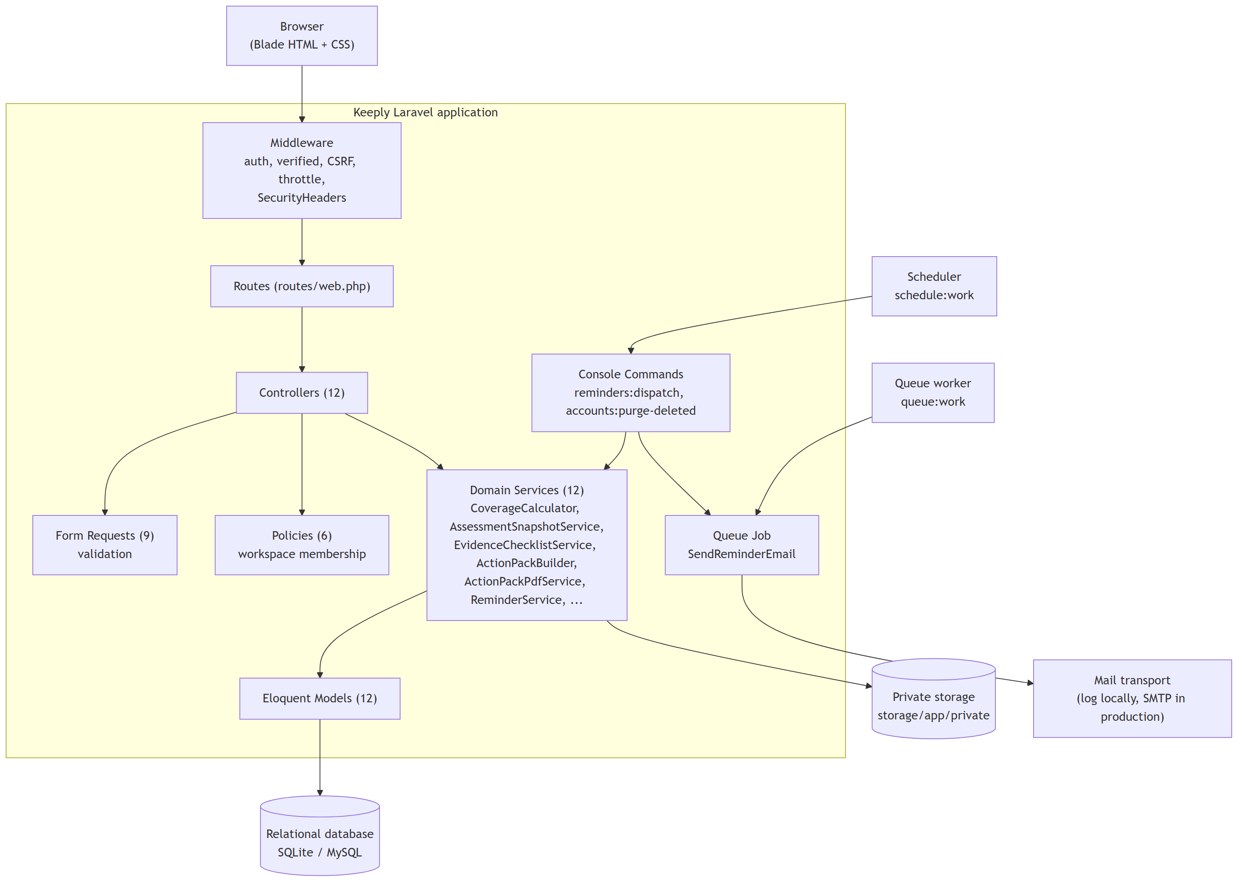
Figure 1

7.2 Use case diagram
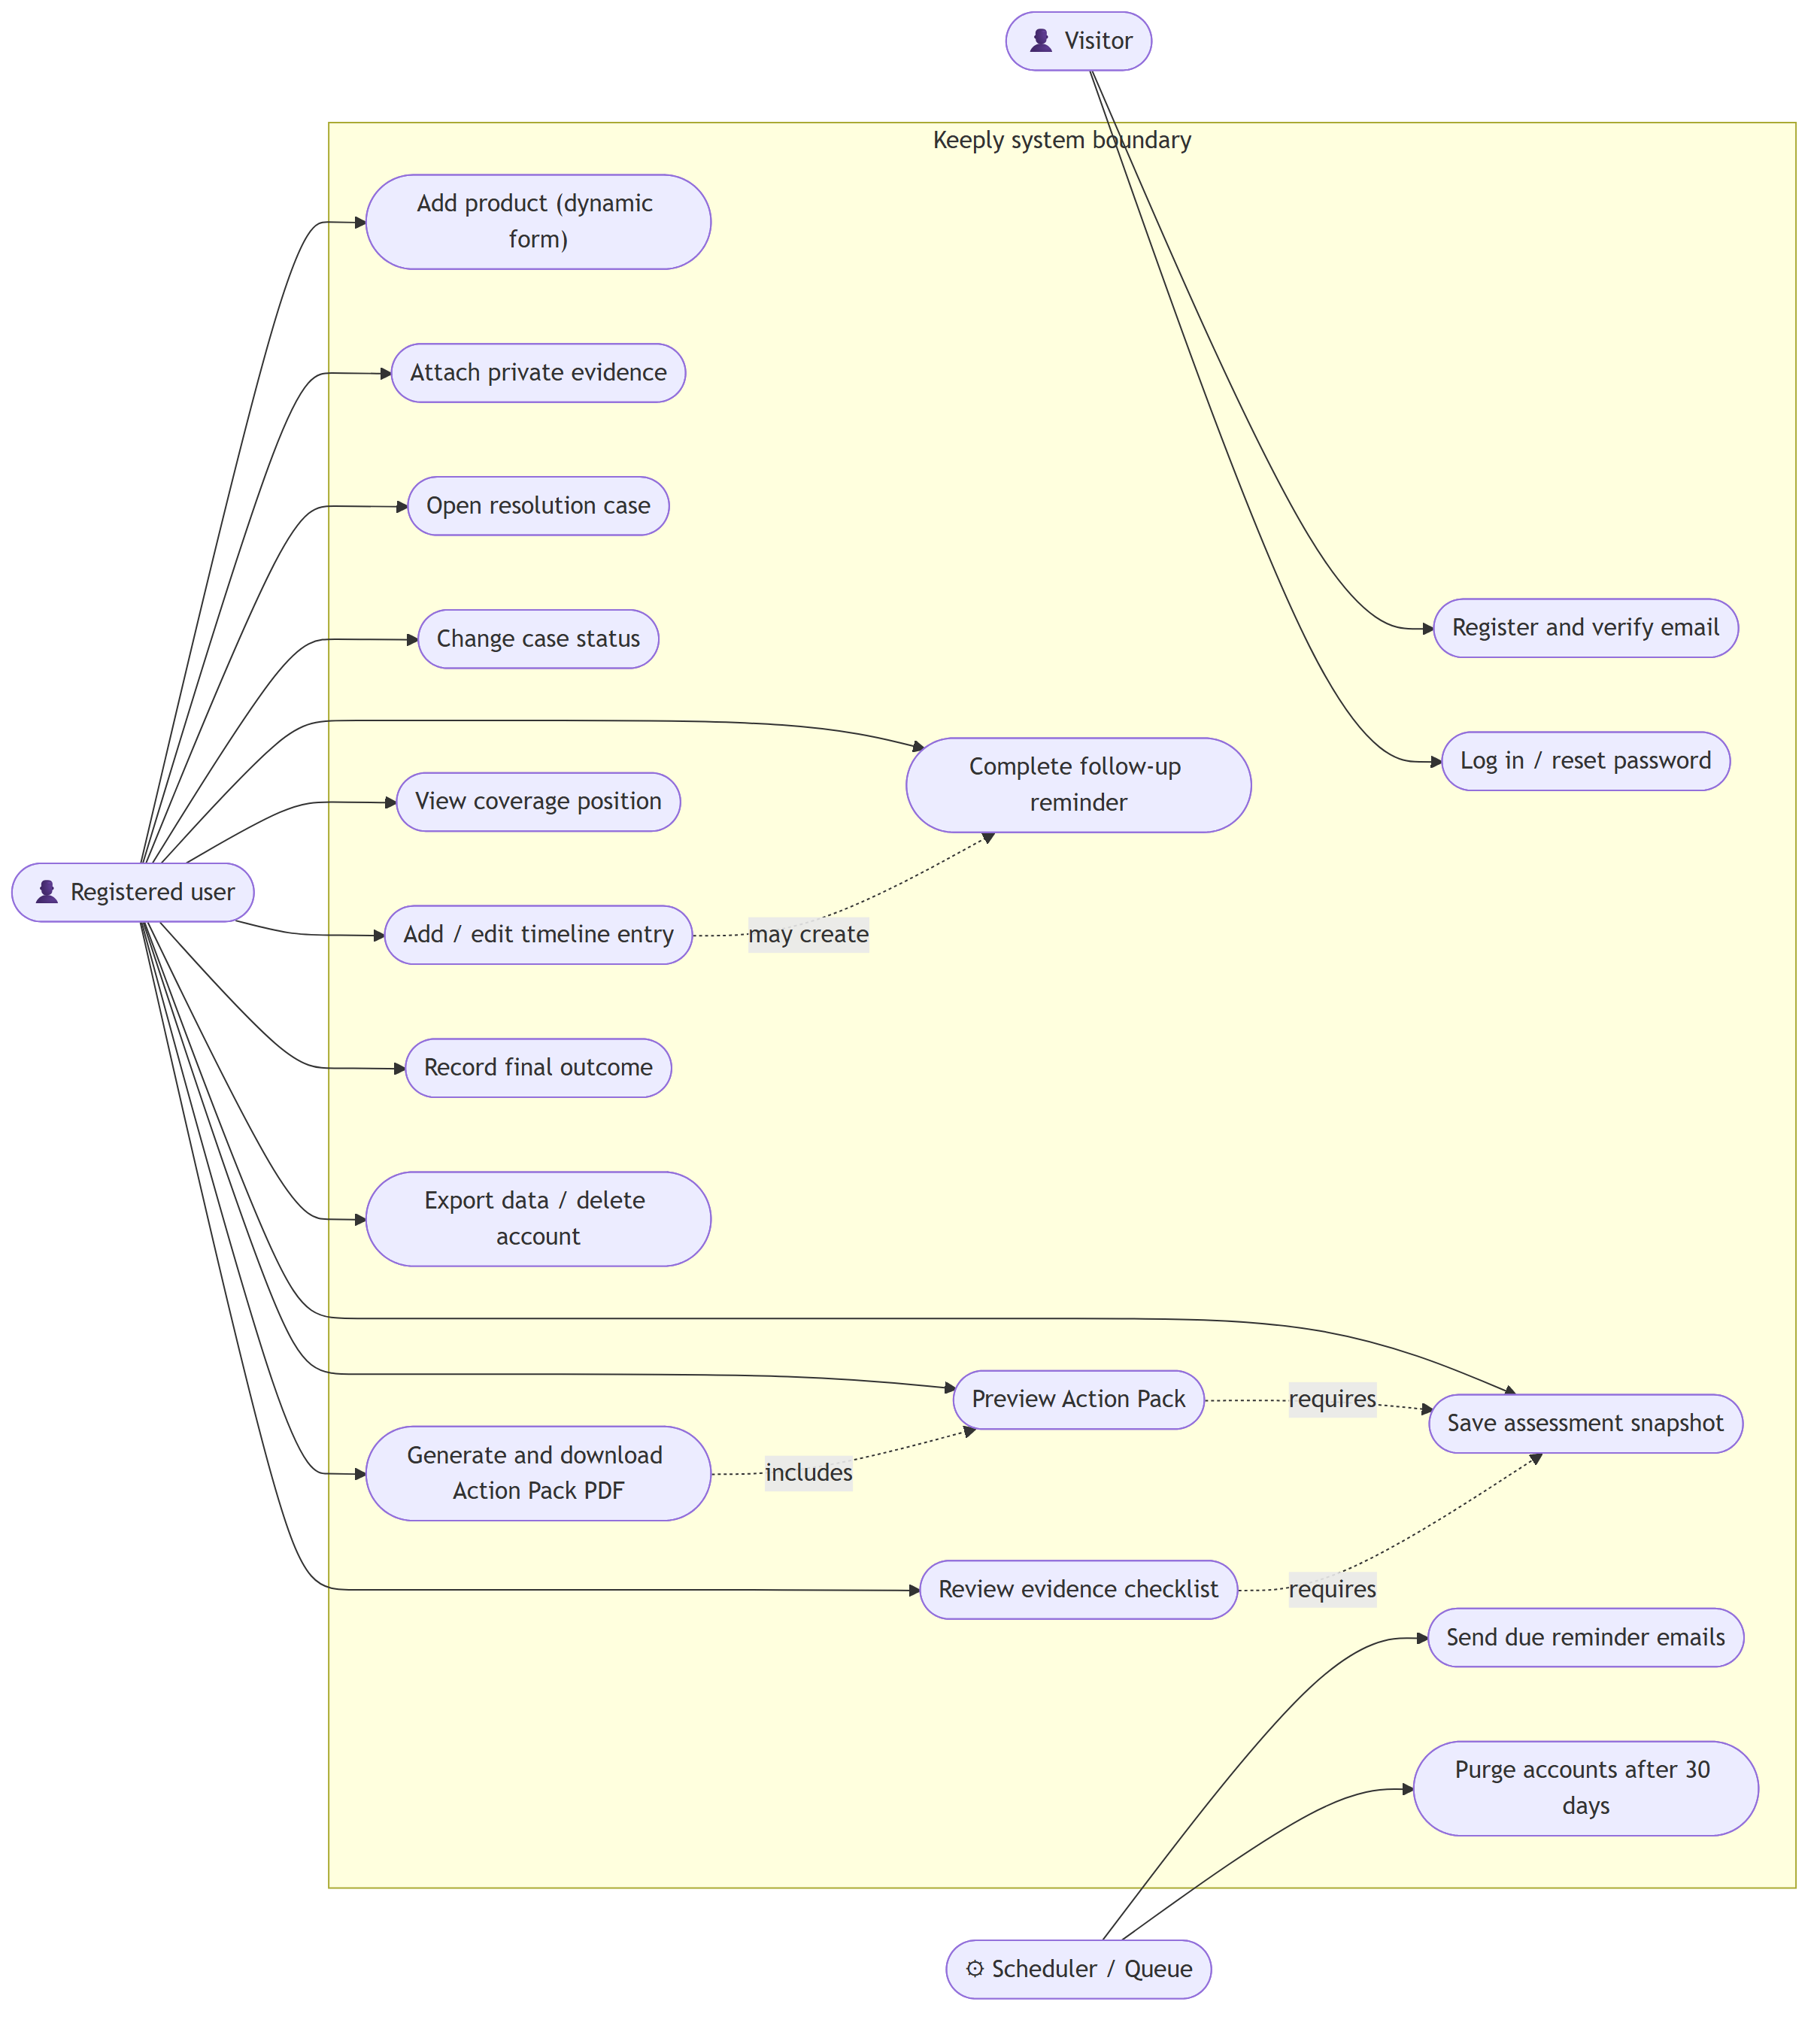
Figure 2

7.3 Activity diagram: the core user journey
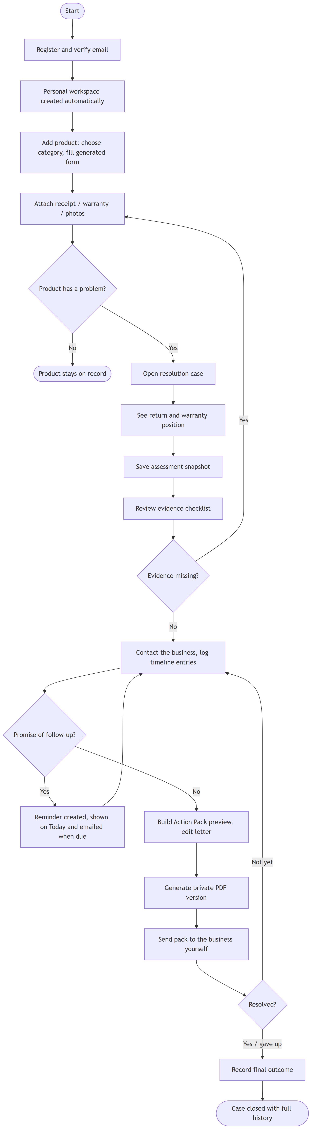
Figure 3

7.4 Class diagram: domain model
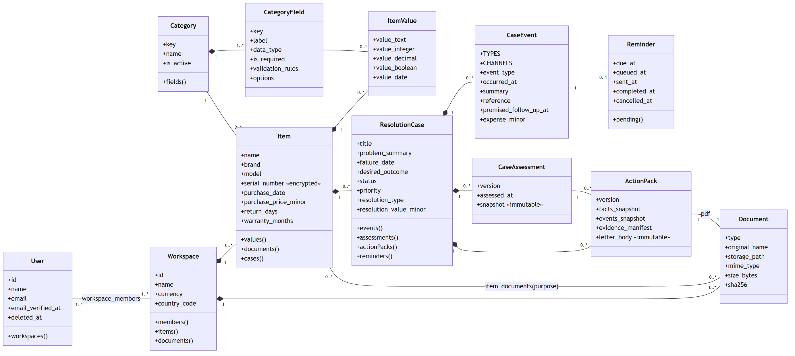
Figure 4

7.5 Class diagram: service layer
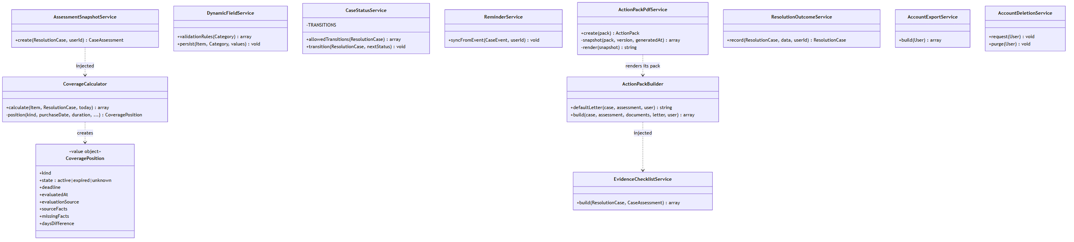
Figure 5
Method signatures in the service diagram are simplified to show responsibilities; see the source files in `app/Services` for exact parameters.

7.6 State diagram: resolution case lifecycle
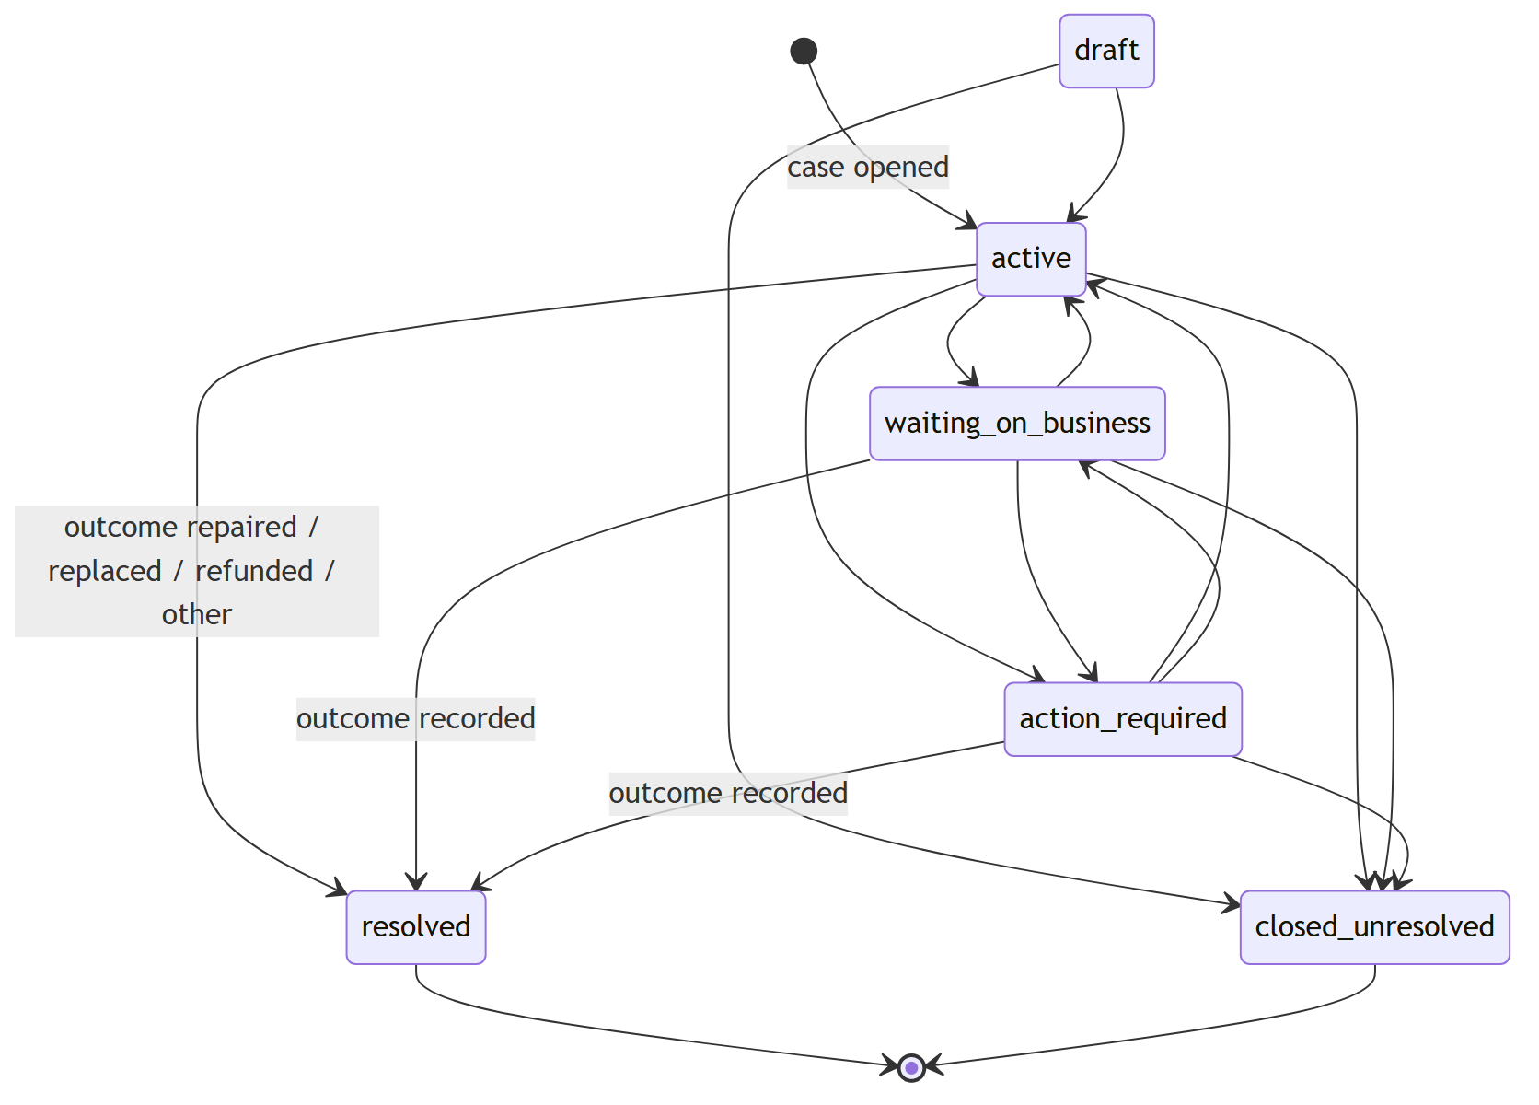
Figure 6
The transition table lives in one constant in CaseStatusService; any other move is rejected with a validation message. resolved can't be chosen from the status menu. It is reached only through ResolutionOutcomeService, so a case can never be marked resolved without saying what happened. A rejected or abandoned outcome ends in closed_unresolved.

7.7 Sequence diagram: generating an Action Pack PDF
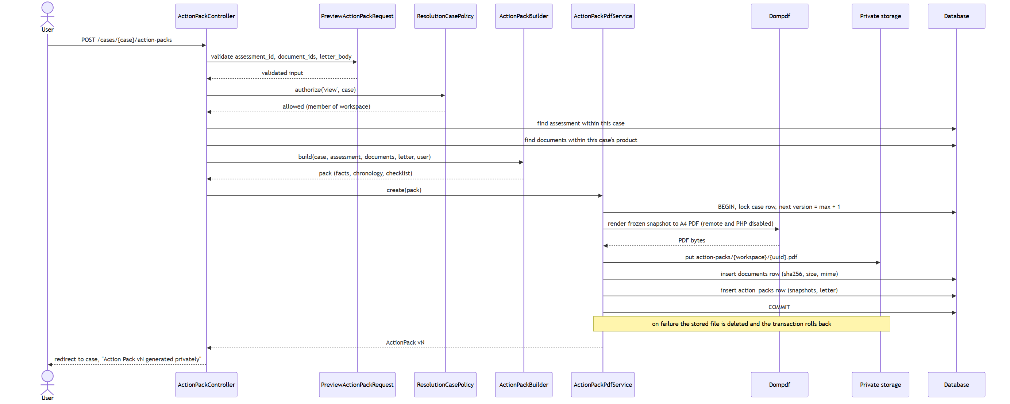
Figure 7

7.8 Sequence diagram: queued reminder email
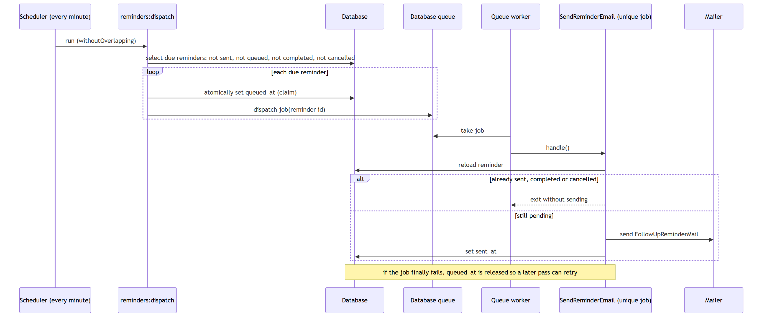
Figure 8

7.9 Deployment diagram: local Windows pilot
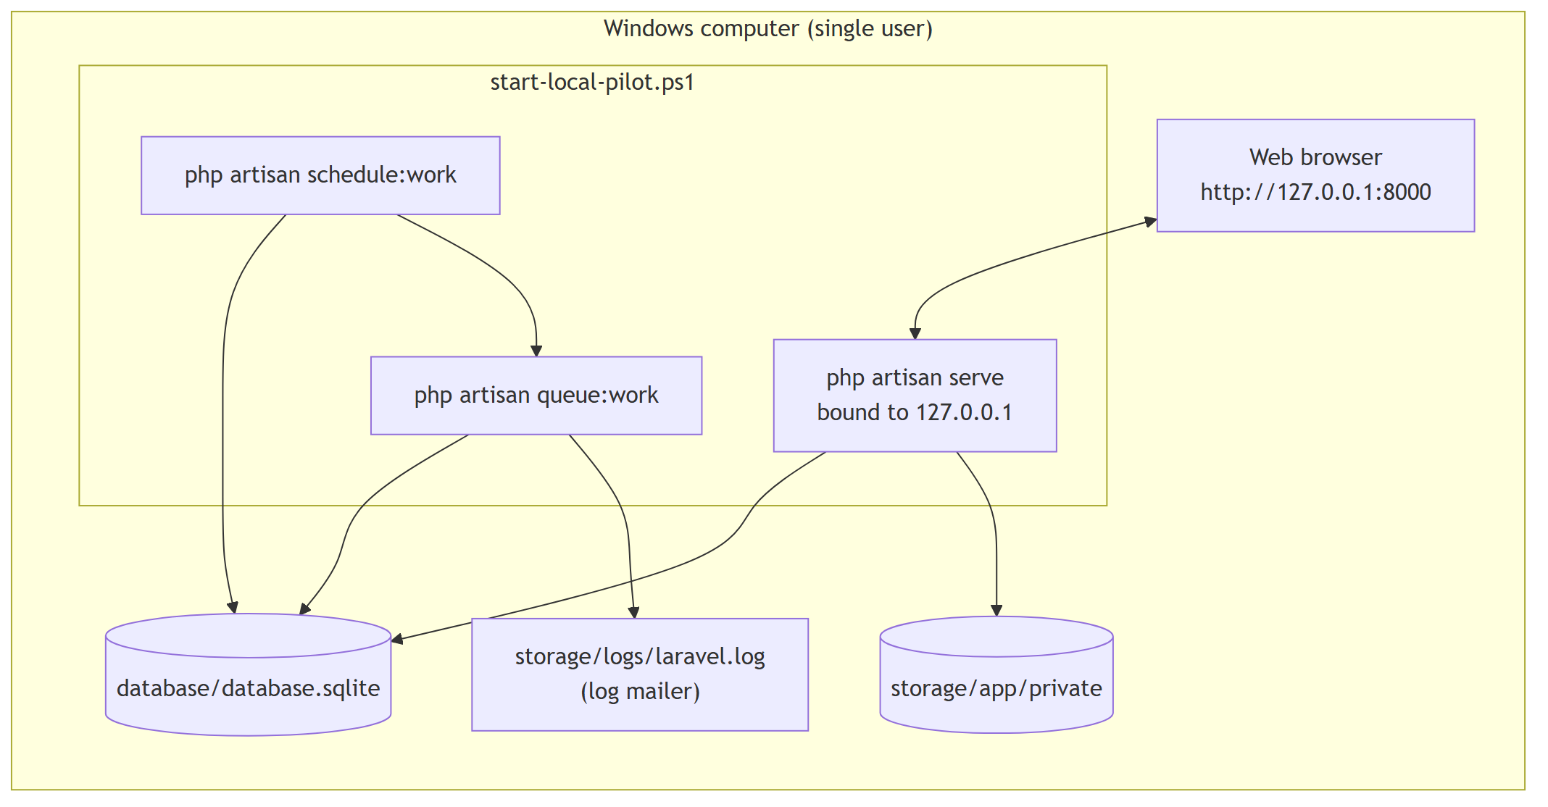
Figure 9

8. Database Design

8.1 Entity-relationship diagram
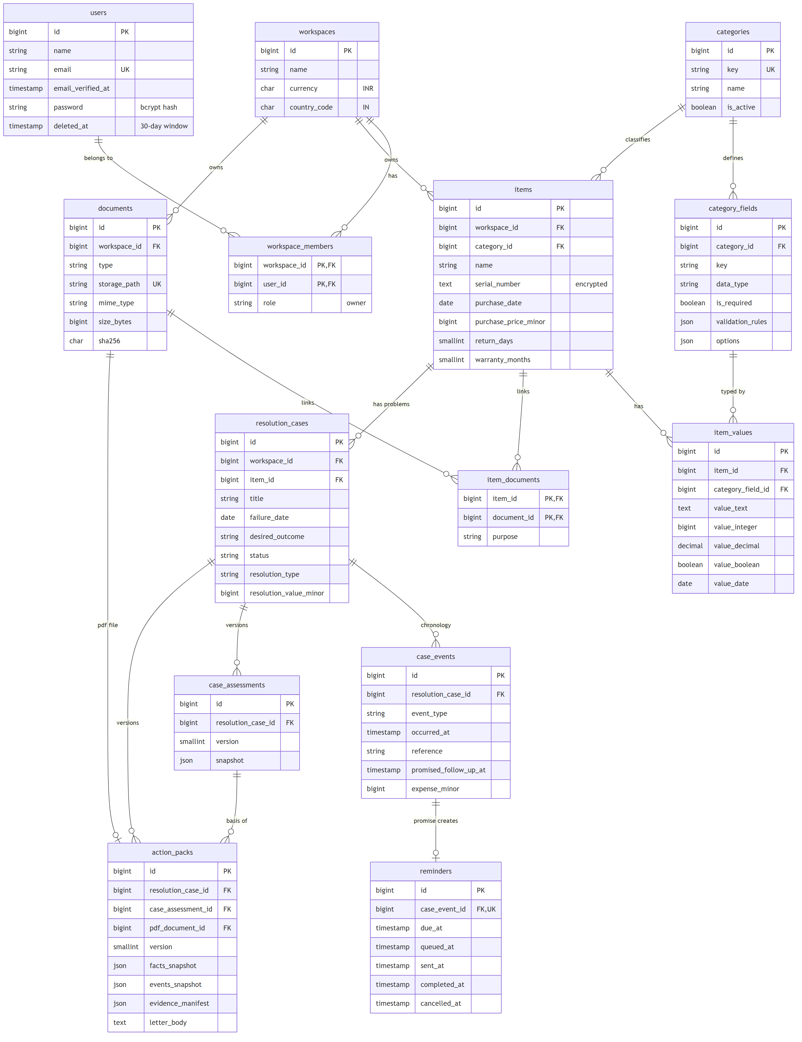
Figure 10

8.2 Table dictionary
Table | Purpose | Key constraints
users | Accounts | Unique email; soft delete for the 30-day recovery window
workspaces | Private data boundary | Default currency INR, country IN
workspace_members | Who may access a workspace | Composite primary key (workspace, user); role
categories | Product categories (Laptop, Other product) | Unique key
category_fields | Field definitions that generate the product form | Unique (category, key); JSON rules and options
items | Products | Indexed by (workspace, status); soft delete
item_values | Category-specific answers in typed columns | Unique (item, field)
documents | Private files and generated PDFs | Unique storage path; SHA-256 indexed
item_documents | Links a document to a product with a purpose | Composite primary key
resolution_cases | One product problem | Indexed by (workspace, status) and (item, status)
case_events | Timeline entries | Indexed by (case, occurred_at)
reminders | Follow-up actions | One reminder per event (unique case_event_id); dispatch index (due, queued, sent)
case_assessments | Immutable coverage snapshots | Unique (case, version)
action_packs | Immutable generated packs | Unique (case, version); PDF document restricted from deletion

8.3 Design decisions
- Hybrid schema for dynamic fields. Common facts used in calculations and searches
(purchase date, return days, warranty months) are real columns. Category-specific answers go in item_values, which has one column per data type (text, integer, decimal, boolean, date) instead of one string column. Values keep their type, can be compared, and are checked against the field's declared type.
- Money as integers. Prices, expenses and recovered values are stored in minor units
(paise), so there is no floating-point rounding.
- Snapshots as JSON. An assessment or Action Pack stores the exact facts it was based on,
so a later edit to the product leaves earlier versions unchanged.
- Restrict, not cascade, on evidence of record. An Action Pack's PDF document and its
assessment are restrictOnDelete, so the database itself won't delete the basis of a generated pack while the pack still exists.

9. Module Implementation

9.1 Authentication and workspaces (K-011, K-012)
Built with Laravel's own authentication, hashing, signed URLs and password broker, without a starter-kit dependency. RegisteredUserController creates the user, the workspace and the owner membership inside one database transaction, so a user can never exist without a workspace. Email verification uses a signed link that expires after 30 minutes and is limited to 6 requests per minute. In local development, where no real mail is configured, the verification page offers Verify and continue, which goes through the same signed link instead of promising an email that will never arrive. Login is rate-limited, and logout invalidates the session. WorkspacePolicy checks membership positively.

9.2 Dynamic product records (K-020 to K-022)
categories and category_fields define the form. CategorySeeder defines Laptop (processor, memory GB, storage GB, storage type, screen size, operating system, charger included) and Other product (variant, condition at purchase). DynamicFieldService turns each field definition into Laravel validation rules (required, type, min/max, max length, decimal places, allowed options) and saves each answer into the matching typed column. Adding a new category or field takes data, not code. Serial numbers use Laravel's encrypted cast, so the database only ever holds ciphertext.

9.3 Private documents (K-023)
StoreDocumentRequest accepts PDF, JPG, PNG and WebP up to 10 MB, for a purpose of receipt, warranty, manual, product photo or other. Besides the file-extension rule, the request reads the actual uploaded bytes with PHP's finfo, and the MIME type that gets stored comes from that check. Files are saved under a random path on the private disk with a SHA-256 hash. DocumentController::download streams the file only after DocumentPolicy confirms membership. Uploads are limited to 20 per minute.

9.4 Resolution cases (K-030)
A case belongs to a product and its workspace. CaseStatusService holds the transition table shown in Section 7.6. The case page shows only the transitions allowed from the current status, and the server rejects anything else.

9.5 Case timeline (K-031)
case_events supports 11 event types (issue observed, contact, response, visit, shipment, repair, expense, promise, escalation, note, outcome) and 7 channels (phone, email, chat, in person, web, post, other). One shared Blade partial is used for both adding and editing. Entries are always sorted by occurred_at and then id, so correcting a date moves the entry to the right place. Expenses are validated to two decimal places and stored as minor units.

9.6 Follow-up reminders (K-032, K-060)
ReminderService::syncFromEvent is called whenever an event is saved. It creates, updates or cancels the event's single reminder (a unique foreign key enforces one reminder per event). Due and overdue reminders appear on Today, and Mark complete removes them. For email, the scheduled reminders:dispatch command claims each due reminder by setting queued_at before it dispatches a unique SendReminderEmail job. The job checks the reminder again before sending and stamps sent_at. A retry after success sends nothing. Changing the promised date resets the delivery fields so the corrected reminder still gets sent.

9.7 Coverage calculator (K-040)
CoverageCalculator returns two CoveragePosition value objects (return, warranty) using these rules:
- Evaluation date = the reported failure date if recorded, otherwise today. The source is
saved too.
- Return deadline = purchase date + return_days.
- Warranty deadline = purchase date + warranty_months using addMonthsNoOverflow, so
31 January + 1 month = 28 February, not 3 March.
- active when the evaluation date is on or before the deadline (the deadline day counts as
covered); otherwise expired.
- unknown when the purchase date or duration is missing, or the problem date is before the
purchase date. Each missing fact is named.

9.8 Assessment snapshots (K-041)
AssessmentSnapshotService serialises the calculator's exact inputs and outputs into case_assessments.snapshot with the next version number. The CaseAssessment model refuses updates and deletes. Every saved version is listed on the case page, newest first.

9.9 Evidence checklist (K-042)
EvidenceChecklistService compares the latest (or a chosen) snapshot with the product's documents and the case timeline across six items: proof of purchase, product identifier, issue photo, warranty document, repair history and communication reference. Each gets one state, Present, Missing, Optional or Not applicable, along with an explanation and the source fact. For example, a receipt becomes missing only when the desired outcome is a repair, replacement, refund or return. A warranty document becomes not applicable when the saved snapshot shows the warranty has expired. A communication reference becomes missing only after a contact has actually been logged.

9.10 Action Pack preview and PDF (K-050, K-051)
ActionPackBuilder prepares a default factual letter and assembles the pack: owner, product, seller, coverage position from the chosen assessment version, issue and desired outcome, the dated chronology, the selected evidence with SHA-256 hashes, and any missing or optional evidence. The preview is an HTML page that is not stored, with a print button. Generating the pack (Section 7.7) freezes everything into action_packs and stores a real A4 PDF privately. The original evidence files are not merged or changed; the PDF carries their integrity manifest instead. Any user-written letter text is escaped.

9.11 Final outcome (K-052)
ResolutionOutcomeService::record runs in one transaction with a row lock. It refuses a second outcome and refuses future dates. It sets resolved (repaired, replaced, refunded, other) or closed_unresolved (rejected, abandoned), stores the recovered value in minor units, adds an outcome event to the timeline, and cancels pending reminders without deleting them.

9.12 Account export and deletion (K-061)
AccountExportService produces a portable JSON file with products, dynamic values, cases, timelines, reminders, assessments, Action Pack snapshots and document metadata. It leaves out passwords, sessions, tokens, internal storage paths and the binary files themselves. Deletion needs the current password and the exact phrase DELETE MY ACCOUNT, is limited to 3 attempts per minute, and is blocked while another person belongs to the workspace. It soft-deletes the user straight away, which blocks login. The daily accounts:purge-deleted job (02:30) permanently removes accounts older than 30 days. It deletes and verifies the private files first, and only then deletes the database rows (Section 12.4).

10. Security and Privacy Design
Threat | Control
Accessing another user's data by changing an ID in the URL | Every model route goes through a policy that checks workspace membership; nested routes check that the child belongs to the parent (an event must belong to the case in the URL)
Cross-site request forgery | Laravel CSRF tokens on all POST/PATCH/DELETE forms
Brute force | Throttling on login, verification (6/min), uploads (20/min), account deletion (3/min)
Malicious upload (e.g. PHP disguised as PDF) | finfo checks the actual bytes; storage outside the web root; random file names; downloads sent with nosniff
Cross-site scripting | Blade's escaped {{ }} output for all user text, including the Action Pack letter; strict Content Security Policy
Clickjacking | frame-ancestors 'none', X-Frame-Options: DENY
Data left in browser cache on shared PCs | Cache-Control: private, no-store on authenticated pages and downloads
Server-side request forgery via PDF | Dompdf remote loading and PHP execution disabled
Database leak exposing serial numbers | encrypted cast on serial_number
Tampering with past claims | Immutable assessment and Action Pack models; unique version constraints; SHA-256 manifest
Data kept after deletion | Documented 30-day retention, retry-safe purge (docs/DATA_RETENTION.md)

The full pre-pilot review, with four findings found and fixed, is in docs/PILOT_READINESS_REVIEW.md.

11. User Interface and Accessibility
The visual direction, Personal Cabinet, was picked from three full-page mockups. It looks like tactile folders with cream archival surfaces, blue index tabs and yellow summary slips, written in plain household language. The interface is server-rendered Blade with one hand-written stylesheet. Empty states are honest and show no fake data.
Accessibility measures:
- Semantic landmarks (header, nav, main) and a single h1 per page.
- Every input has a visible <label>. Errors are linked to their field through
aria-describedby and marked with aria-invalid.
- Visible keyboard focus styles.
- aria-current="page" on the active navigation link.
- Navigation stays reachable at 320–640 px widths. Hiding it was a real defect found in
review and fixed (Section 12.4).
- Status values use text labels, not colour alone.

12. Testing

12.1 Strategy
Each backlog item had a written acceptance gate (for example "Later item edits do not alter old assessments"). Each one was implemented together with a feature test file that proves the gate through real HTTP requests against an isolated test database. Pure date logic is unit tested on its own. Every test file includes a cross-workspace denial case.

12.2 Test inventory
Test file | Tests | What it proves
AuthenticationTest | 6 | Register, verify, login, logout, reset, local verify-and-continue
WorkspaceAuthorizationTest | 4 | Guest, unverified, member and foreign-user access
FrontendRenderingTest | 2 | Landing, auth and empty-workspace pages render
CategoryMetadataTest | 2 | Categories and fields seed and load correctly
DynamicItemTest | 4 | Generated validation, typed values, encryption, isolation
PrivateDocumentTest | 3 | Upload/download, disguised file rejected, foreign 403
ResolutionCaseTest | 4 | Case creation, future-date rejection, transitions, isolation
CaseTimelineTest | 4 | Chronology after edits, expenses, authorisation
FollowUpReminderTest | 4 | Reminder sync, cancellation, Today visibility, completion
CoverageCalculatorTest (unit) | 6 | Boundary day, month-end, unknown states, inconsistent dates
CoverageDisplayTest | 2 | Coverage section rendering on the case
AssessmentSnapshotTest | 3 | Frozen values after edits, versioning, isolation
EvidenceChecklistTest | 4 | All four states, explanations, expired warranty
ActionPackPreviewTest | 4 | Prerequisite, evidence selection, letter, scoping
ActionPackPdfTest | 3 | Valid %PDF- bytes, private storage, frozen versions, 403
ResolutionOutcomeTest | 4 | Terminal states, history kept, finality, isolation
QueuedReminderEmailTest | 4 | Claimed once, no duplicate on retry, eligibility, re-delivery
AccountDataControlTest | 5 | Export privacy, wrong password, 30-day window, purge, shared block
AccountPurgeSafetyTest | 1 | Storage failure preserves records for retry
PilotReadinessTest | 4 | Security headers, no-store, ARIA errors, print script, mobile nav
ExampleTest (feature + unit) | 2 | Framework smoke tests
Total | 75

12.3 Consolidated result
> php artisan test
...
Tests: 75 passed (399 assertions)
Duration: 38.65s
The full suite was run once on 15 October 2026 with PHP 8.3.33 and Laravel 12.69.3, and everything passed.

12.4 Defects found by testing and review
Defect | How it was found | Fix
A .pdf file containing PHP source passed Laravel's file-type rule | PrivateDocumentTest security case failed | Direct finfo check on the uploaded bytes; stored MIME type taken from it
No browser security-header baseline | K-062 review | Global SecurityHeaders middleware
Mobile CSS hid all main navigation at ≤ 640 px | K-062 review | Stacked header, all links visible, horizontal overflow allowed
Validation errors not announced for their field | K-062 review | aria-invalid + aria-describedby on sensitive forms
Account purge deleted database rows before files, so a storage failure could leave untracked private files | K-062 consequence check | Delete and verify files first; abort the database deletion on failure; regression test added

13. User Guide

13.1 Getting started
- Open Keeply in the browser (Section 14) and choose Create account.
- Enter your name, email and a password. A private workspace is created for you.
- On the verification page, select Verify and continue (local) or open the link in your
email (production). You arrive at Today.

13.2 Adding a product
- Go to Products → Add a product.
- Choose a category. The form changes to show that category's fields.
- Fill in the name, brand, model, serial number (stored encrypted), purchase date, price,
seller, return period in days and warranty length in months.
- Save. Without the purchase date and periods, coverage will show as Unknown, so add
them if you have them.

13.3 Attaching evidence
- Open the product and find Private documents.
- Choose the purpose (receipt, warranty, manual, product photo, other) and the file (PDF,
JPG, PNG or WebP, up to 10 MB).
- Upload. The file is stored privately with an integrity hash and can be downloaded again
from the same place.

13.4 Handling a problem
- On the product page, choose Open a case. Describe the problem, the date you noticed
it, the outcome you want and its priority.
- Read Recorded coverage position to see whether the return and warranty periods are
active, with the deadline and reasoning.
- Select Save assessment snapshot to fix this position as version 1. Save again later
for new versions.
- Check the Evidence checklist and upload anything marked Missing.
- Each time you contact the business, expand Add timeline entry and record the date,
channel, person, reference number, any expense, and any Promised follow-up date.
- Promised follow-ups appear on Today when they are due, and are emailed. Select
Mark complete once you have dealt with one.
- Use the status control to show Waiting on business or Action required.

13.5 Creating an Action Pack
- On the case, select Build Action Pack preview.
- Choose the assessment version, tick the evidence to include, and edit the letter.
- Select Preview and check the dossier. You can print it straight away.
- Select Generate private PDF. A numbered version is saved and listed on the case for
download. Send it to the business yourself; Keeply does not submit it.

13.6 Closing a case
Under Record final outcome, choose repaired, replaced, refunded, rejected, abandoned or other. Enter the date, what happened and any value recovered. This can only be done once, and the whole history stays on the case.

13.7 Your data
Under Account you can download a JSON export of everything you have recorded, or request deletion by entering your password and typing DELETE MY ACCOUNT. Access stops immediately, and the data is permanently removed after 30 days.

14. Installation and Running Locally

14.1 Prerequisites
Requirement | Version used | Notes
Windows | 10 / 11 | PowerShell 5.1 or 7
PHP | 8.3 | Extensions: pdo_sqlite, sqlite3, mbstring, openssl, fileinfo, zip, curl, intl optional. XAMPP's PHP 8.1 is too old for Laravel 12
Composer | 2.10.3 | Only needed for a fresh install
Browser | Any current browser

PHP can be installed per-user with winget install PHP.PHP.8.3. The pilot script finds it automatically even if it is not on PATH.

14.2 First-time setup
cd Keeply\application
composer install
copy .env.example .env
php artisan key:generate
php artisan migrate --seed
--seed loads the Laptop and Other product categories.

14.3 Running the full local pilot (recommended)
.\scripts\start-local-pilot.ps1
The script finds PHP 8.3, creates the SQLite database if needed, applies migrations, and starts three processes: the web server on 127.0.0.1:8000, the queue worker and the scheduler. It then checks the landing page. Open http://127.0.0.1:8000. To use another port:
.\scripts\start-local-pilot.ps1 -Port 8010
Stop everything with:
.\scripts\stop-local-pilot.ps1
Reminder emails are written to storage/logs/laravel.log rather than sent.

14.4 Running manually (three terminals)
php artisan serve --host=127.0.0.1 --port=8000
php artisan queue:work --queue=emails,default
php artisan schedule:work
Only the first command is needed to use the website. The other two power the reminder emails and the deletion purge.

14.5 Running the tests
php artisan test
php artisan test --filter=CoverageCalculatorTest

14.6 Troubleshooting
Symptom | Cause | Fix
php is not recognised | PHP 8.3 not on PATH | Use the pilot script, or add the WinGet PHP folder to PATH
"Port 8000 is already in use" | Another server is running | .\scripts\start-local-pilot.ps1 -Port 8010
"Keeply's local pilot is already running" | An earlier start is still live | .\scripts\stop-local-pilot.ps1, then start again
"A local pilot process exited during startup" | PHP error at boot | Read storage\logs\pilot-web-error.log and pilot-queue-error.log
Reminder emails never appear in laravel.log | Worker started without --queue=emails,default (reminders use the emails queue) | Use the pilot script, or start the worker with the command in 14.4
Site stops when the PowerShell window is closed | Old launcher started the servers as children of that window | Current launcher starts them detached; use stop-local-pilot.ps1 to stop
Script blocked by execution policy | Windows default policy | powershell -ExecutionPolicy Bypass -File .\scripts\start-local-pilot.ps1
Category list is empty | Seeder not run | php artisan db:seed
Laravel requires PHP ≥ 8.2 | XAMPP PHP 8.1 being used | Run with PHP 8.3

14.7 Backup
Stop the pilot, then copy both database/database.sqlite and storage/app/private. Restoring only one of them leaves document records and files out of step.

15. Project Structure
application/
├── app/
│ ├── Console/Commands/ DispatchReminderEmails, PurgeDeletedAccounts
│ ├── Http/
│ │ ├── Controllers/ 12 domain controllers + 7 Auth controllers
│ │ ├── Middleware/ SecurityHeaders
│ │ └── Requests/ 9 Form Request validators
│ ├── Jobs/ SendReminderEmail
│ ├── Mail/ FollowUpReminderMail
│ ├── Models/ 12 Eloquent models
│ ├── Policies/ 6 workspace-membership policies
│ ├── Services/ 12 domain services
│ └── ValueObjects/ CoveragePosition
├── database/
│ ├── migrations/ 14 migrations
│ └── seeders/ CategorySeeder
├── docs/ REPORT.md, DATA_RETENTION.md, LOCAL_WINDOWS_PILOT.md,
│ PILOT_READINESS_REVIEW.md, diagrams/
├── public/ css/keeply.css, js/keeply.js
├── resources/views/ Blade templates (auth, items, cases, action-packs, account, emails)
├── routes/ web.php, console.php (schedule)
├── scripts/ start-local-pilot.ps1, stop-local-pilot.ps1
├── tests/ Feature (20 files), Unit (2 files)
└── tools/ render-diagrams.py, report-to-docx.py

16. Limitations
- Market need not yet validated. No user interviews have been done (K-001). The workflow
is based on reasoning and desk research, not observed behaviour.
- Local pilot, not production. The pilot runs on one computer with SQLite, the PHP
development server and a log mailer. There is no HTTPS, no off-site backup and no monitoring. Production deployment (K-063) has not been started.
- Single-member workspaces. The schema supports shared households, but there are no
invitations or ownership transfer yet, so deleting a shared workspace is blocked.
- Two categories. Only Laptop and Other product are seeded, and there is no admin screen
for adding categories yet.
- Calculation is literal. Coverage uses recorded durations only. It doesn't read policy
terms, statutory consumer rights, exclusions or extended warranties.
- Visual and usability review pending. The independent first-time-user review (K-013) and
one narrow-screen screenshot from K-062 were not completed.

17. Future Scope
Area | Enhancement
Validation | Run the 12 planned interviews (6 households, 6 freelancers/studios) and adjust the workflow to what they show
Deployment | Laravel-capable host, managed MySQL, S3-compatible private storage, supervised queue worker and scheduler, transactional email, HTTPS, backups
Sharing | Household workspaces with invitations, roles and ownership transfer
Categories | Admin screen for categories and fields; phones, appliances, furniture, vehicles
Data entry | Optional receipt OCR to pre-fill purchase facts, always shown to the user for confirmation
Guidance | Seller- and brand-specific claim procedures and contact directories
Rights awareness | Optional, clearly sourced notes on Consumer Protection Act 2019 rights (without giving legal advice)
Notifications | SMS/WhatsApp reminders, calendar (.ics) export
Evidence | Bundle original evidence files into the Action Pack as a ZIP or merged PDF
Mobile | Installable PWA with camera capture for photos and receipts
Insight | Personal summary of money recovered, average resolution time, most reliable sellers
Business model | Free tier; paid household plan; B2B tools for repair shops and small retailers
Integrations | Retailer order import, manufacturer warranty registration

18. Conclusion
Keeply delivers the complete Version 1 loop: a user can record a product, find out where they stand when it fails, gather and check their evidence, track every contact and promise, produce a factual and tamper-evident Action Pack, and record the outcome. Each of these steps was built as a bounded checkpoint with its own acceptance gate, and together they are covered by 75 passing automated tests. Laravel's policies, queues, scheduler, signed URLs and encryption are used for real product needs. The design choices that make Keeply trustworthy are deliberate: unknown is never expired, history is never rewritten, and evidence is never public. The main open question isn't technical. It is whether real owners will use the workflow, and the validation plan in Section 17 is built to answer that.

19. References
- Laravel 12.x Documentation. laravel.com/docs/12.x
- PHP Manual: Fileinfo. php.net/manual/en/book.fileinfo.php
- Dompdf. github.com/dompdf/dompdf
- OWASP Secure Headers Project. owasp.org/www-project-secure-headers
- OWASP File Upload Cheat Sheet. cheatsheetseries.owasp.org
- W3C, Web Content Accessibility Guidelines (WCAG) 2.2. w3.org/TR/WCAG22
- Mermaid diagram syntax. mermaid.js.org
- Consumer Protection Act, 2019 (India). consumeraffairs.nic.in

Appendix A. Route Table
Method | URI | Purpose
GET | / | Landing page
GET/POST | /register, /login | Registration, login (guests only)
GET/POST | /forgot-password, /reset-password/{token}, /reset-password | Password recovery
GET | /verify-email, /verify-email/{id}/{hash} | Verification prompt and signed link
POST | /logout | Log out
GET | /today | Dashboard: counts and due reminders
GET | /account, /account/export | Account page, JSON export
DELETE | /account | Request deletion (throttled)
GET/POST | /items, /items/create, /items/{item} | Products
POST | /items/{item}/documents | Upload evidence (throttled)
GET | /documents/{document} | Authorised download
GET/POST | /items/{item}/cases/create, /items/{item}/cases | Open a case
GET | /cases, /cases/{case} | Case list and detail
PATCH | /cases/{case}/status | Status transition
POST/GET/PATCH | /cases/{case}/events… | Timeline add/edit
POST | /cases/{case}/assessments | Save snapshot
GET/POST | /cases/{case}/action-packs/create, …/preview, …/action-packs | Action Pack flow
GET | /action-packs/{pack} | Download PDF
POST | /cases/{case}/outcome | Record outcome
PATCH | /reminders/{reminder}/complete | Complete reminder

Appendix B. Screenshots to Capture for Submission
These should be real captures from the running application (Section 14.3). Insert them where your course template asks for output screens.
# | Screen | What it should show
1 | Landing page | Personal Cabinet design
2 | Registration with a validation error | Error shown beside the field
3 | Verify and continue | Local verification step
4 | Today (empty) | Honest empty state
5 | Add product, Laptop selected | Generated category fields
6 | Product detail with documents | Uploaded receipt and photo, hashes
7 | Rejected disguised upload | Error for a renamed non-PDF file
8 | New case form | Desired outcome and priority
9 | Case page: coverage position | Active/Expired/Unknown with deadline
10 | Assessment history | Versions 1 and 2
11 | Evidence checklist | Present, missing and optional rows
12 | Timeline with expense and promise | Chronological order
13 | Today with an overdue reminder | Highlighted overdue action
14 | laravel.log reminder email | Queued email content
15 | Action Pack preview | Dossier page
16 | Generated Action Pack PDF | Opened in a PDF viewer
17 | Recorded outcome | Resolved case with outcome event
18 | Account page | Export and deletion controls
19 | 403 page | Opening another account's case URL
20 | Mobile width (≈ 390 px) | Navigation visible
21 | Terminal: php artisan test | 75 passed (399 assertions)

Appendix C. Regenerating This Document
python tools\render-diagrams.py # Mermaid → docs\diagrams\diagram-N.png (local, mermaid-cli)
python tools\report-to-docx.py # docs\REPORT.md → docs\Keeply-Submission-Report.docx
Diagrams are rendered entirely on this machine by mermaid-cli's bundled headless Chromium; no source is sent to an online service.

