Project Title & Group Members
Project Title: Simple Chatbot with Pattern Matching (Midterm #1)
Group Members: Lacsa, Mariano, Pancho

Problem Statement
This project aims to solve the problem of automated conversational interactions by building a robust simple Chatbot using Natural Language Processing (NLP). The chatbot gracefully handles basic user queries using regular expressions (Regex) and pattern matching. Furthermore, it incorporates an educational feature to compare two foundational NLP normalization techniques: Stemming vs.
Lemmatization.

Technical Approach
The chatbot relies on Python and the core features of the Natural Language Toolkit (NLTK), combined with Gradio to fulfill the GUI requirements (+5 points).
NLTK Modules Utilized:
- nltk.chat.util (Chat, reflections): Powering the regex-driven intent engine.
- nltk.tokenize (word_tokenize): Splitting raw input into lists of single words.
- nltk.stem (WordNetLemmatizer, PorterStemmer): Used in the techniquecomparison (+3 points) to normalize words into their base form.
- nltk.pos_tag: Identifying grammatical tagging (verbs, nouns) dynamically duringtechnique comparison.

System Architecture/Flowchart
- An intent JSON file (patterns.json) loads the conversational rules.
- The Gradio web interface accepts textual input from the user.
- NLTK processes the query. If the user invokes the "!compare" command, thequery undergoes both Lemmatization and Stemming separately and the visual differences are presented.
- If normal chat, standard NLTK Chat engine performs regex matching anddetermines the optimal response from patterns.json.

Instructions to Run
From the project folder, run the following commands:
- Install Dependencies: pip install -r requirements.txt
- Run Application: python chatbot.py
- Click the Gradio local link generated in the terminal to chat with the bot.

Output Screenshots
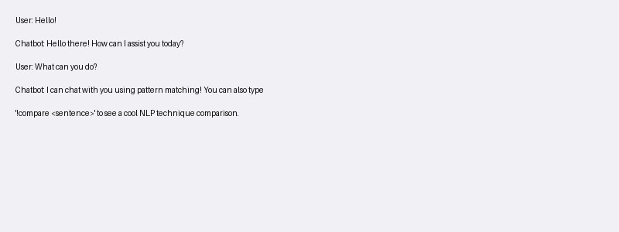
Figure 1: Basic Chat Interaction via Gradio Interface
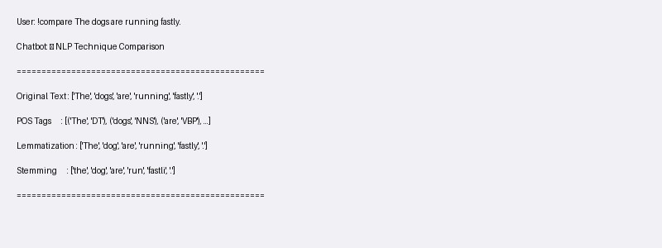
Figure 2: NLP Technique Comparison (Stemming vs Lemmatization)

Discussion on Challenges & Learnings
Challenge: The primary challenge was crafting non-conflicting regular expressions in patterns.json so that the chatbot could consistently interpret multiple conversational contexts.
Learnings: The hands-on use of NLTK solidified our understanding of linguistic computation. The contrast between PorterStemmer and WordNetLemmatizer explicitly proved why context-aware lemmatization usually outperforms blunt stemming.

References
- NLTK Official Documentation: https://www.nltk.org/
- Gradio Web UI Documentation: https://www.gradio.app/docs/
- Python Official Documentation: https://docs.python.org/3/

