5052 Statistical Machine Learning Project

Kah Meng Soh

2022-04-24

library(glmnet)

## Warning: package 'glmnet' was built under R version 4.1.3

## Loading required package: Matrix

## Loaded glmnet 4.1-4

data=read.csv('C:/Users/micke/Desktop/Boston.csv')  
data_scaled <- cbind(scale(data[,1:13]),data[,14])  
xfull <- data[,1:13]  
yfull <- data[,14]  
set.seed(1)  
size <- floor(0.8 * nrow(data_scaled))  
trainset <- sample(seq_len(nrow(data_scaled)), size = size)  
train <- data_scaled[trainset, ]  
xtrain <- train[,1:13]  
ytrain <- train[,14]  
test <- data_scaled[-trainset,]  
xtest <- test[,1:13]  
ytest <- test[,14]

#Ridge Regression (alpha=0)  
grid <- 10^seq(10, -2, length = 100)  
ridge.mod <- glmnet(xtrain, ytrain, alpha = 0, lambda = grid)  
plot(ridge.mod)

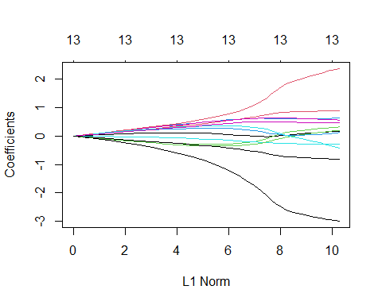

set.seed (1)  
cv.out <- cv.glmnet(xtrain, ytrain, alpha = 0)  
plot(cv.out)

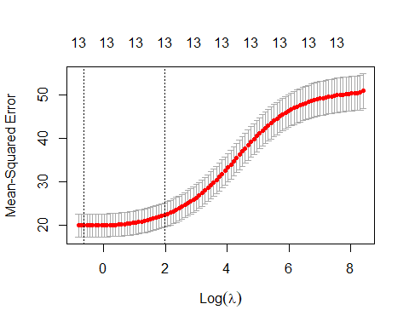

bestlam <- cv.out$lambda.min  
bestlam

## [1] 0.5351856

ridge.pred <- predict(ridge.mod , s = bestlam,newx = xtest)  
mean (( ridge.pred - ytest)^2)

## [1] 14.77947

coef <- glmnet(xfull, yfull, alpha = 0)  
predict(coef , type = "coefficients", s = bestlam)[1:14, ]

## (Intercept) X CRIM ZN INDUS CHAS   
## 27.826955292 -0.001203380 0.096158020 0.008949904 0.086844314 -0.955692138   
## NOX RM AGE DIS RAD TAX   
## 5.901173898 -4.027397442 0.073770929 0.057393868 0.032810947 0.000917734   
## PTRATIO B   
## 0.140751760 -0.007696599

#Lasso Regression (alpha=1)  
lasso.mod <- glmnet(xtrain, ytrain, alpha = 1, lambda = grid)  
plot(lasso.mod)

## Warning in regularize.values(x, y, ties, missing(ties), na.rm = na.rm):  
## collapsing to unique 'x' values

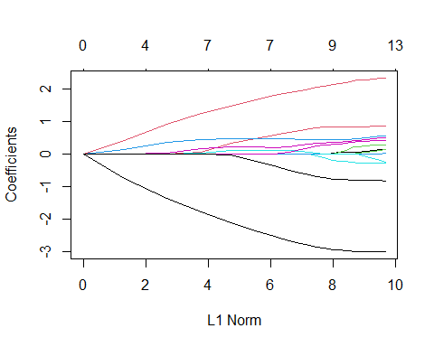

set.seed (1)  
cv.out <- cv.glmnet(xtrain, ytrain, alpha = 1)  
plot(cv.out)

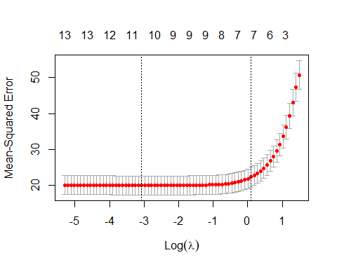

bestlam <- cv.out$lambda.min  
bestlam

## [1] 0.04654771

lasso.pred <- predict(lasso.mod , s = bestlam,newx = xtest)  
mean (( lasso.pred - ytest)^2)

## [1] 14.43777

coef <- glmnet(xfull, yfull, alpha = 1)  
predict(coef , type = "coefficients", s = bestlam)[1:14, ]

## (Intercept) X CRIM ZN INDUS CHAS   
## 31.690947761 0.000000000 0.096199990 0.010378337 0.075099239 -0.830553410   
## NOX RM AGE DIS RAD TAX   
## 4.032377483 -4.393469001 0.084259847 0.035239579 0.034167165 0.000000000   
## PTRATIO B   
## 0.092351600 -0.007991245

#OLS Regression  
train=data.frame(train)  
test=data.frame(test)  
ols.mod = lm(V14~.,train)  
ols.pred= predict(ols.mod, newdata=test)  
mean (( ols.pred - ytest)^2)

## [1] 14.50773

ols.modfull = lm(MEDV~.,data)  
summary(ols.modfull)

##   
## Call:  
## lm(formula = MEDV ~ ., data = data)  
##   
## Residuals:  
## Min 1Q Median 3Q Max   
## -15.8948 -2.7585 -0.4663 1.7963 26.0911   
##   
## Coefficients:  
## Estimate Std. Error t value Pr(>|t|)   
## (Intercept) 36.458826 5.100994 7.147 3.22e-12 ***  
## X -0.002526 0.002080 -1.215 0.225046   
## CRIM -0.108762 0.032855 -3.310 0.001000 **   
## ZN 0.048031 0.013785 3.484 0.000538 ***  
## INDUS 0.019932 0.061468 0.324 0.745871   
## CHAS 2.705245 0.861298 3.141 0.001786 **   
## NOX -17.541602 3.822390 -4.589 5.66e-06 ***  
## RM 3.839225 0.418422 9.175 < 2e-16 ***  
## AGE -0.001938 0.013380 -0.145 0.884866   
## DIS -1.493304 0.199892 -7.471 3.68e-13 ***  
## RAD 0.324925 0.068111 4.771 2.43e-06 ***  
## TAX -0.011598 0.003807 -3.046 0.002443 **   
## PTRATIO -0.947985 0.130822 -7.246 1.67e-12 ***  
## B 0.009357 0.002685 3.485 0.000536 ***  
## LSTAT -0.526184 0.050704 -10.377 < 2e-16 ***  
## ---  
## Signif. codes: 0 '***' 0.001 '**' 0.01 '*' 0.05 '.' 0.1 ' ' 1  
##   
## Residual standard error: 4.743 on 491 degrees of freedom  
## Multiple R-squared: 0.7414, Adjusted R-squared: 0.734   
## F-statistic: 100.6 on 14 and 491 DF, p-value: < 2.2e-16

#Elastic-Net Regression (alpha=0.25)  
en.mod <- glmnet(xtrain, ytrain, alpha = 0.25, lambda = grid)  
plot(en.mod)

## Warning in regularize.values(x, y, ties, missing(ties), na.rm = na.rm):  
## collapsing to unique 'x' values

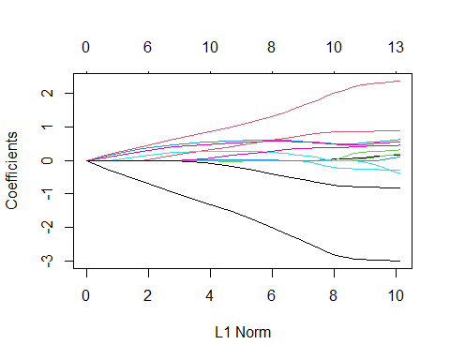

set.seed (1)  
cv.out <- cv.glmnet(xtrain, ytrain, alpha = 0.25)  
plot(cv.out)

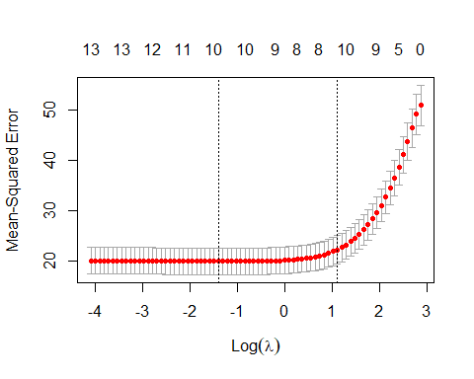

bestlam <- cv.out$lambda.min  
bestlam

## [1] 0.2461333

en.pred <- predict(en.mod , s = bestlam,newx = xtest)  
mean (( en.pred - ytest)^2)

## [1] 14.66154

coef <- glmnet(xfull, yfull, alpha = 0.25)  
predict(coef , type = "coefficients", s = bestlam)[1:14, ]

## (Intercept) X CRIM ZN INDUS   
## 30.9339420692 0.0000000000 0.0951289398 0.0065256277 0.0726368669   
## CHAS NOX RM AGE DIS   
## -0.7742990650 4.3186370290 -4.2444735517 0.0779824509 0.0000000000   
## RAD TAX PTRATIO B   
## 0.0277256363 0.0004871178 0.0959397144 -0.0077286520

#Elastic-Net Regression (alpha=0.5)  
en.mod <- glmnet(xtrain, ytrain, alpha = 0.5, lambda = grid)  
plot(en.mod)

## Warning in regularize.values(x, y, ties, missing(ties), na.rm = na.rm):  
## collapsing to unique 'x' values

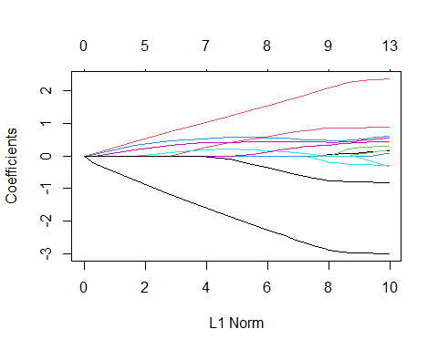

set.seed (1)  
cv.out <- cv.glmnet(xtrain, ytrain, alpha = 0.5)  
plot(cv.out)

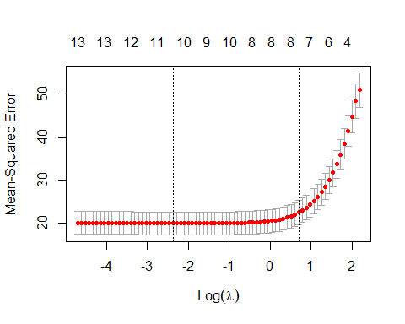

bestlam <- cv.out$lambda.min  
bestlam

## [1] 0.09309542

en.pred <- predict(en.mod , s = bestlam,newx = xtest)  
mean (( en.pred - ytest)^2)

## [1] 14.47749

coef <- glmnet(xfull, yfull, alpha = 0.5)  
predict(coef , type = "coefficients", s = bestlam)[1:14, ]

## (Intercept) X CRIM ZN INDUS   
## 3.139752e+01 -6.895468e-06 9.618278e-02 9.885703e-03 7.564503e-02   
## CHAS NOX RM AGE DIS   
## -8.319786e-01 4.218923e+00 -4.357463e+00 8.277538e-02 2.974948e-02   
## RAD TAX PTRATIO B   
## 3.372231e-02 0.000000e+00 9.638423e-02 -7.942063e-03

#Elastic-Net Regression (alpha=0.75)  
en.mod <- glmnet(xtrain, ytrain, alpha = 0.75, lambda = grid)  
plot(en.mod)

## Warning in regularize.values(x, y, ties, missing(ties), na.rm = na.rm):  
## collapsing to unique 'x' values

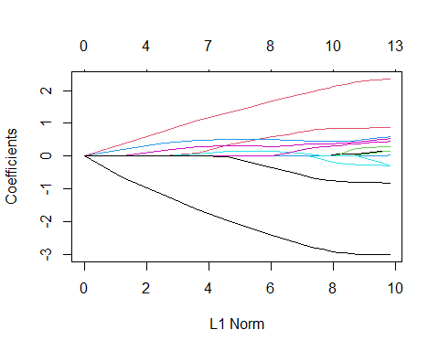

set.seed (1)  
cv.out <- cv.glmnet(xtrain, ytrain, alpha = 0.75)  
plot(cv.out)

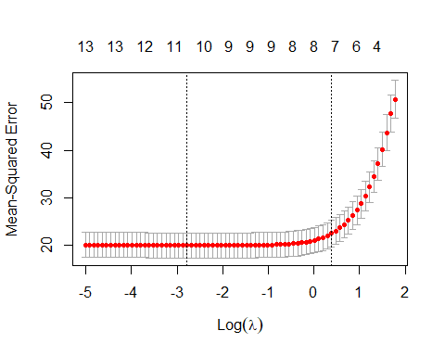

bestlam <- cv.out$lambda.min  
bestlam

## [1] 0.06206361

en.pred <- predict(en.mod , s = bestlam,newx = xtest)  
mean (( en.pred - ytest)^2)

## [1] 14.45078

coef <- glmnet(xfull, yfull, alpha = 0.75)  
predict(coef , type = "coefficients", s = bestlam)[1:14, ]

## (Intercept) X CRIM ZN INDUS CHAS   
## 31.56994197 0.00000000 0.09622312 0.01020119 0.07515211 -0.83108151   
## NOX RM AGE DIS RAD TAX   
## 4.12893649 -4.38104567 0.08369280 0.03375657 0.03384228 0.00000000   
## PTRATIO B   
## 0.09408938 -0.00797361

# To study the linearity assumption of OLS we will look at OLS although lasso regression is better.  
#MSE of OLS 14.50773 is too high compared to the sample mean of response 22.532806, maybe the data isn't fit for linear regression, let's see if some underlying assumption of OLS violated.  
par(mfrow = c(2, 2))  
plot(ols.modfull)

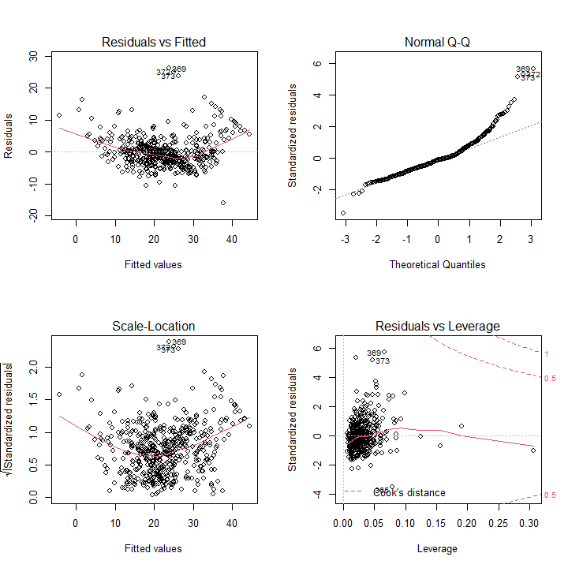

#There is banana shape in the residual vs fitted plot suggesting non-linearity of data, let's try boxcox transformation just to be sure.  
par(mfrow = c(1, 1))  
library(MASS)  
bc=boxcox(ols.modfull)

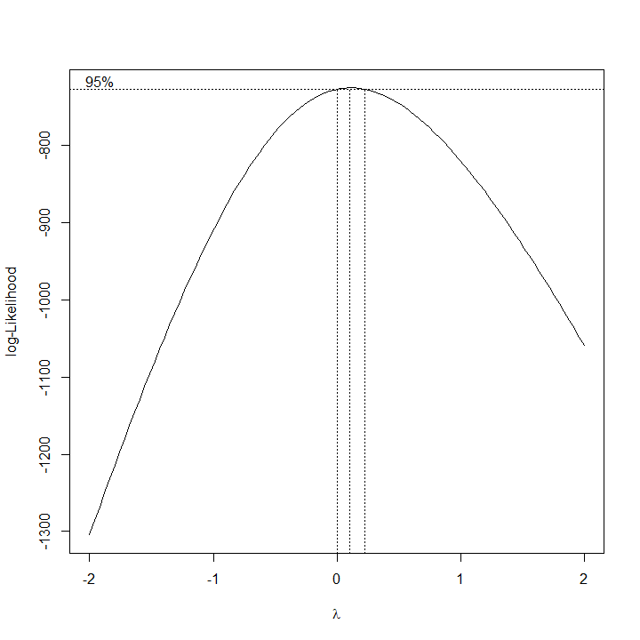

i=which.max(bc$y)  
bc$x[i]

## [1] 0.1010101

#Suggested transformation is power of close to 0, which is log transformation.   
ols.modfull = lm(log(MEDV)~.,data)  
par(mfrow = c(2, 2))  
plot(ols.modfull)

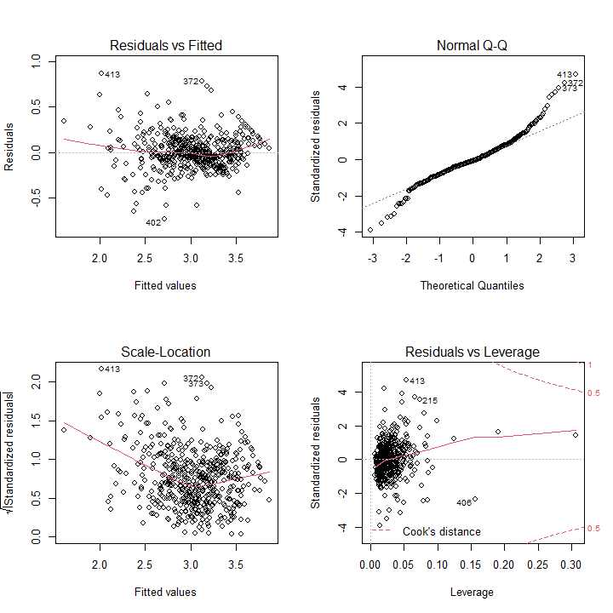

#The transformed model still failed the non-linearity assumption, further suggesting that the true underlying model is non-linear.