Slack username: Honeywell
Email: crownprincesamuelaadeyemo@gmail.com
Insighta Labs+ System Design for Scale
Stage 4a: Backend Engineering Design Document

1. Requirements

Functional Requirements
- Accept structured filter and aggregation queries from CLI, web portal, and API consumers.
- Parse rule-based query inputs (e.g. "young males in South Africa" → age: 18–35, gender: male, country: ZA).
- Return query results within near-interactive response times.
- Enforce authentication and role-based access control (RBAC) on all query endpoints.
- Support periodic/batch ingestion of new profile data into the system.
- Maintain all existing Stage 3 functionality: GitHub auth, RBAC, CLI, web portal.

Non-Functional Requirements
Requirement | Target | Notes
P50 Latency | < 500ms | Most queries should feel instant
P95 Latency | < 2 seconds | Heavy aggregations still within tolerance
Scalability | Tens of millions of profiles | Dataset grows from millions baseline
Query Throughput | Hundreds to low thousands/min | Multi-team daily usage
Availability | High, no SLA specified | Managed services reduce ops burden
Consistency | Read-after-write for writes; eventual OK for reads | Read replicas introduce short lag
Deployability | Single-region, managed services preferred | Avoid distributed systems complexity

2. Architecture
The architecture evolves the existing system by adding a query cache and a read replica alongside the primary database. No new infrastructure categories are introduced, just targeted additions to address the identified bottlenecks: repeated queries hitting the database, and read load contention.

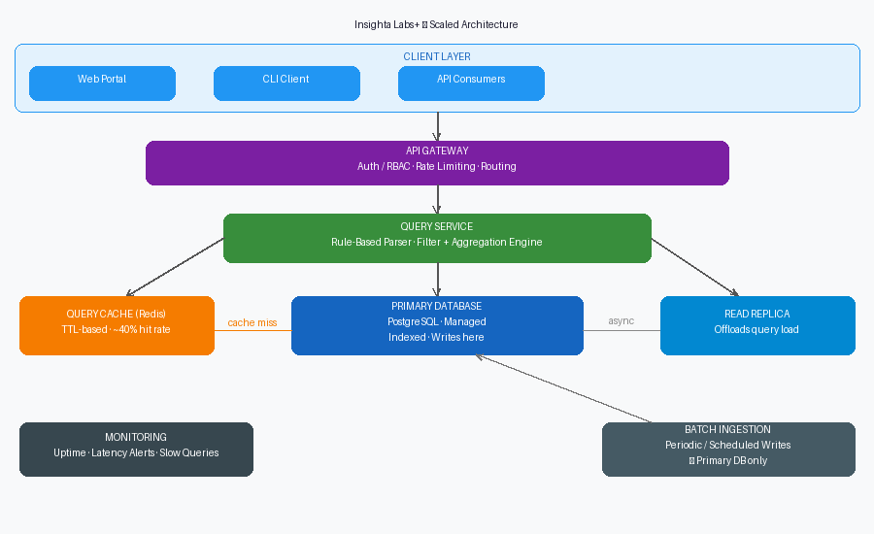
Figure 1: Insighta Labs+ Scaled Architecture

Core Components
Component | Role
API Gateway | Single entry point. Enforces auth/RBAC, rate limiting, and routes requests to the Query Service.
Query Service | Parses rule-based inputs, executes filters/aggregations. Checks cache before hitting the database.
Query Cache (Redis) | Stores results of frequent/recent queries. Reduces DB load for repeated patterns.
Primary DB (PostgreSQL) | Source of truth. Handles all writes (batch ingestion). Indexed for query performance.
Read Replica | Mirrors Primary DB asynchronously. Query Service routes read-heavy queries here.
Batch Ingestion | Periodic scheduled job writes new profiles to Primary DB only.
Monitoring | Tracks uptime, latency, and slow query logs. Alerts on P95 threshold breaches.

3. Data Flow

Query Flow
- Step 1: Client submits query
Web portal, CLI, or API consumer sends a structured query to the API Gateway.
- Step 2: Auth & Routing
API Gateway validates the JWT token, checks RBAC role, and forwards the request to the Query Service.
- Step 3: Cache Lookup
Query Service generates a cache key from the normalized query. On a cache hit, results are returned immediately (target: < 50ms). On a miss, execution continues.
- Step 4: Database Query
The parsed filter/aggregation is executed against the Read Replica for read-only queries. Results are written back to the cache with a TTL before being returned.
- Step 5: Response
Results are serialized and returned to the client through the API Gateway.

Ingestion Flow
- A scheduled batch job runs periodically (e.g. nightly or hourly depending on data freshness needs).
- New profile data is validated and written directly to the Primary DB.
- The Read Replica picks up changes via asynchronous replication within seconds.
- No real-time streaming is required, the system is explicitly batch-ingestion-based.

4. Design Decisions
Decision | Rationale | Trade-off
Query Cache (Redis) | Repeated query patterns are expected across analyst teams. Caching eliminates redundant DB hits and directly addresses P50 latency targets. If ~40% of queries repeat, cache hit rate meaningfully reduces load. | Cache staleness: data written during batch ingestion may not reflect in cached results until TTL expires. Acceptable given the non-real-time nature of the system.
Read Replica | The system is read-heavy, queries dominate over writes. A replica offloads read traffic from the Primary DB, preventing write/read contention during peak query periods. | Async replication introduces a short lag (~seconds). Queries may return slightly stale data. This is acceptable given eventual consistency is allowed for reads.
Managed PostgreSQL | Relational, structured, indexed data fits a relational model well. Managed service (e.g. RDS, Cloud SQL) removes operational burden for backups, failover, and patching, consistent with the constraint to prefer managed services. | Less flexibility than self-managed Postgres; costs scale with usage. Acceptable for single-region deployment.
API Gateway as single entry point | Auth and RBAC enforcement is already built in Stage 3. Centralizing this at the gateway keeps the Query Service stateless and avoids duplicating auth logic across consumers (CLI, web, API). | Gateway becomes a single point of failure, mitigated by using a managed gateway service with built-in redundancy.
No message queue or microservices | The query load (hundreds to low thousands/min) does not justify async queuing. Adding a queue without a throughput need introduces latency and operational complexity with no benefit. | If query volume grows significantly beyond the stated assumptions, a queue may become necessary to prevent DB flooding under spike loads.
DB indexing strategy | Queries filter on age, gender, and country. Composite indexes on these columns are the highest-leverage DB-level improvement. A query scanning 50M rows unindexed will not meet P95 targets regardless of caching. | Indexes increase write time and storage. Acceptable given writes are periodic batch, not continuous.

5. Trade-offs and Limitations

What This Design Does Not Handle Well
- Cache invalidation complexity: If ingestion runs while a cached query is still alive, results can be stale until TTL expires. There is no active invalidation logic in this design, acceptable for now but will need addressing if data freshness requirements tighten.
- Spike absorption: The design has no queue to absorb sudden traffic bursts. A sudden 10x query spike could overwhelm the Query Service or DB before auto-scaling kicks in (if enabled). Rate limiting at the gateway partially mitigates this.
- Write scalability: All writes go to the Primary DB. If ingestion volume grows from batch to near-continuous, write throughput becomes a bottleneck. The current design is explicitly optimized for read-heavy, batch-write workloads.
- No full-text or semantic search: The rule-based parser handles structured filters only. Complex or ambiguous queries outside defined patterns will fail or return incorrect results.
- Single region: Outages in the deployment region affect the entire system. Cross-region redundancy was explicitly out of scope.

Intentional Simplifications
- No horizontal scaling of the Query Service is specified. For the stated load (low thousands QPM), a single well-resourced instance with connection pooling is sufficient. Horizontal scaling can be added if load grows.
- Monitoring is included but alerting thresholds and on-call runbooks are not defined, these are operational concerns outside the scope of this design.
- No CDN or edge caching: all clients are assumed to be internal teams accessing the system over a trusted network.

