MAYBELLINE

**NEW YORK**

10 years of backstage beauty…

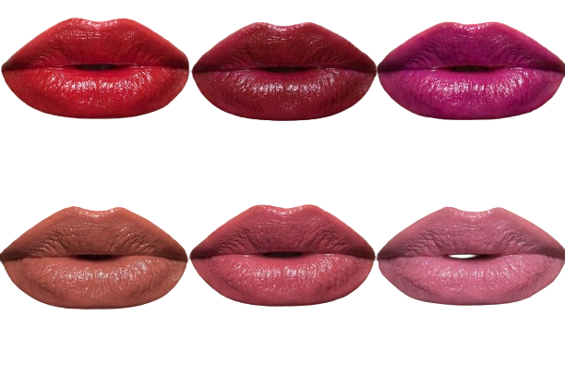

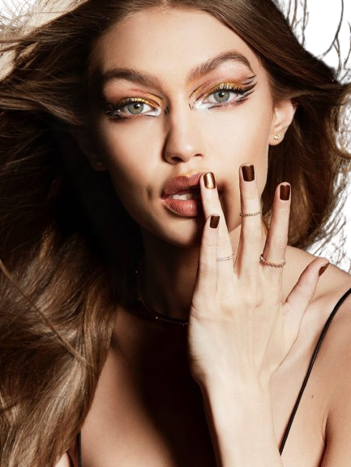MAYBE SHE’S BORN WITH IT.MAYBE IT’S MAYBELLINE