# 🌟SQL Query Documentation🌟

# SQL Queries Documentation for Food Giants Stock Data

This document provides 10 insightful SQL queries to analyze stock market data for various food companies. These queries cover key performance indicators (KPIs) such as average prices, volatility, trading volumes, trends, and comparisons.

## 1. Average Closing Price per Company

Purpose: Identifies companies with the highest and lowest average closing stock prices.

SQL Query:

SELECT Company, AVG(Close) AS Avg_Closing_Price  
 FROM food_giant  
 GROUP BY Company  
 ORDER BY Avg_Closing_Price DESC;

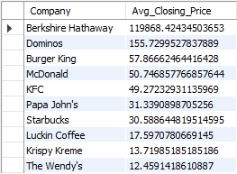

## 2. Top 5 Days with Highest Trading Volume

Purpose: Highlights the top 5 days with the highest stock trading volumes, indicating significant market activity.

SQL Query:

SELECT Date, Company, Volume  
 FROM food_giant  
 ORDER BY Volume DESC  
 LIMIT 5;

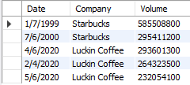

## 3. Monthly Average Closing Price Trend

Purpose: Tracks the monthly trend of average closing prices, helping identify seasonal patterns.

SQL Query:

SELECT DATE_FORMAT(Date, '%Y-%m') AS Month,

Company,

AVG(Close) AS Avg_Close

FROM food_giant

GROUP BY Month, Company

ORDER BY Month, Company;

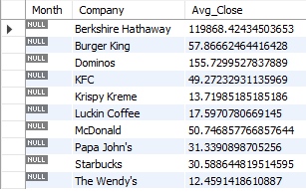

## 4. Highest and Lowest Prices for Each Company

Purpose: Provides historical price extremes for each company, useful for understanding price ranges.

SQL Query:

SELECT Company, MAX(High) AS Highest_Price, MIN(Low) AS Lowest_Price  
 FROM stock_data  
 GROUP BY Company;

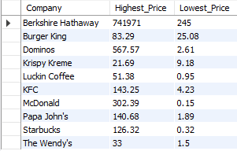

## 5. Yearly Trading Volume Summary

Purpose: Shows total yearly trading volume per company to analyze market activity trends.

SQL Query:

SELECT YEAR(Date) AS Year,

Company,

SUM(Volume) AS Total_Volume

FROM food_giant

GROUP BY Year, Company

ORDER BY Year DESC, Total_Volume DESC;

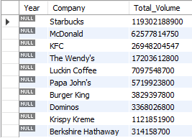

## 6. Identifying Most Volatile Companies

Purpose: Identifies the most volatile stocks by calculating the average daily price fluctuation.

SQL Query:

SELECT Company, AVG(High - Low) AS Avg_Daily_Volatility  
 FROM food_giant  
 GROUP BY Company  
 ORDER BY Avg_Daily_Volatility DESC;

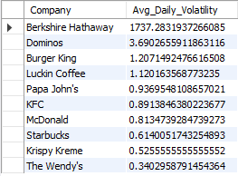

## 7. Days When Closing Price Was Lower Than Opening Price

Purpose: Lists days when stock prices closed lower than they opened, indicating bearish trends.

SQL Query:

SELECT Date, Company, Open, Close  
 FROM food_giant  
 WHERE Close < Open  
 ORDER BY Date DESC;

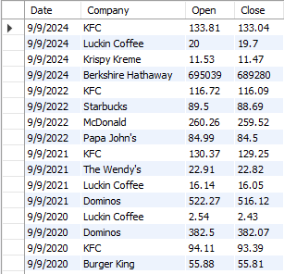

## 8. Moving Average of Closing Price (7-Day Window)

Purpose: Computes a 7-day moving average for stock closing prices to smooth short-term fluctuations.

SQL Query:

SELECT Date, Company, Close,   
 AVG(Close) OVER (PARTITION BY Company ORDER BY Date ROWS BETWEEN 6 PRECEDING AND CURRENT ROW) AS Moving_Avg  
 FROM food_giant;

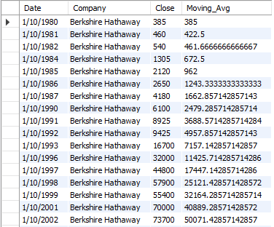

## 9. Companies with Highest Closing Price Growth (First Year vs Last Year)

Purpose: Determines stock price growth by comparing the earliest available year (1980) with the latest (2023).

SQL Query:

SELECT Company,

(MAX(CASE WHEN YEAR(Date) = 2023 THEN Close END) -

MIN(CASE WHEN YEAR(Date) = 1980 THEN Close END)) AS Price_Growth

FROM food_giant

GROUP BY Company

ORDER BY Price_Growth DESC;

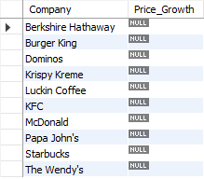

## 10. Top 3 Companies with Highest Average Adjusted Closing Price

Purpose: Identifies the top 3 companies with the highest historical average adjusted closing price.

SQL Query:

SELECT Company, AVG("Adj Close") AS Avg_Adjusted_Close  
 FROM food_giant  
 GROUP BY Company  
 ORDER BY Avg_Adjusted_Close DESC  
 LIMIT 3;

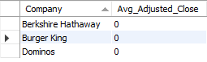

## Additional Notes

- **Date Format:** Ensure `Date` is stored in `YYYY-MM-DD` format for better query performance.

- **Indexes:** Indexing `Date` and `Company` columns can improve query execution speed.

- **Table Name:** The queries assume the table name is `stock_data`. Modify accordingly if needed.