Q1. Create Database.

Soln.

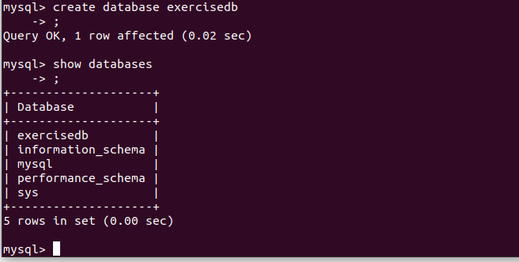

create database exercisedb

show databases

Q2. Design Schema.

Soln.

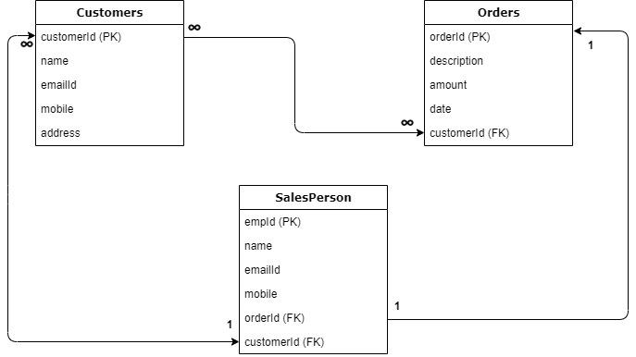

Q3.Create tables.

Soln

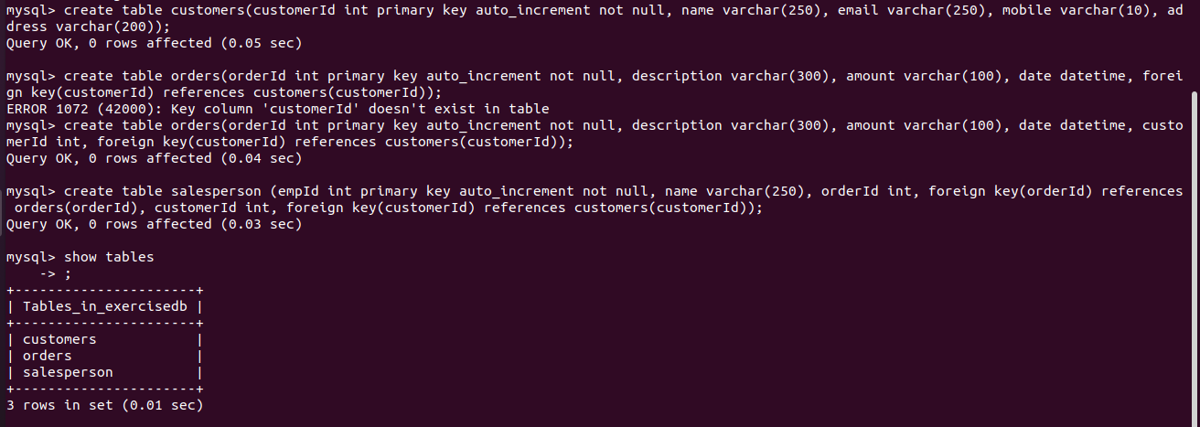

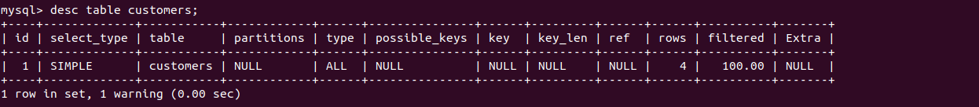

create table customers(customerId int primary key auto_increment not null, name varchar(250), email varchar(250), mobile varchar(10), address varchar(200));

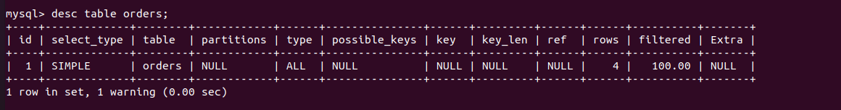

create table orders(orderId int primary key auto_increment not null, description varchar(300), amount varchar(100), date datetime, customerId int, foreign key(customerId) references customers(customerId));

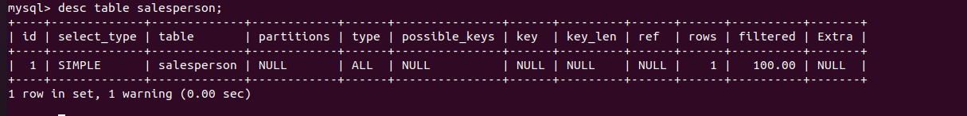

create table salesperson (empId int primary key auto_increment not null, name varchar(250), orderId int, foreign key(orderId) references orders(orderId), customerId int, foreign key(customerId) references customers(customerId));

Q4.Insert sample data.

Soln.



insert into customers(name,email,mobile,address) values('Prince','princeyadav@gmail.com','8130173739','Faridabad'),('Ashu','ashu@gmail.com','8448056564','delhi'),('Sunil','sunil@gmail.com','9818833816','dwarka'),('abhishek','abhi@gmail.com','9874561235','Faridabad');

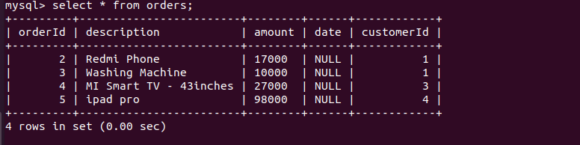

insert into orders(description, amount, customerId) values('Redmi Phone', '17000', 1), ('Washing Machine', '10000', 1), ('MI Smart TV - 43inches', '27000', 3),('ipad pro','98000',4);

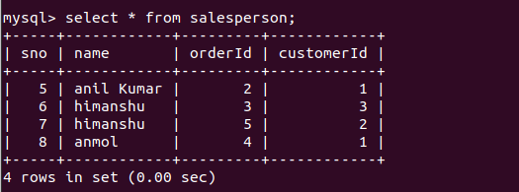

insert into salesperson(name, orderId, customerId) values('anil Kumar', 2, 1), ('himanshu', 3, 3), ('himanshu', 5, 2), ('anmol', 4, 1);

Q5.Find the sales person have multiple orders.

Soln.



select name from salesperson group by name having count(*)>1;

Q6.Find the all sales person details along with order details.

Soln.

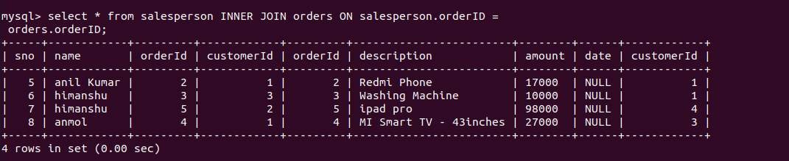

select * from salesperson INNER JOIN orders ON salesperson.orderID = orders.orderID;

Q7. Create index.

Soln.

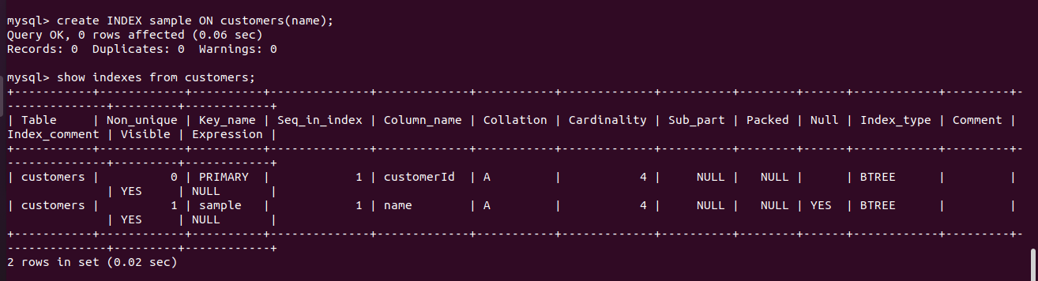

create INDEX sample ON customers(name);

show indexes from customers;

Q8.How to show index on a table.

Soln.

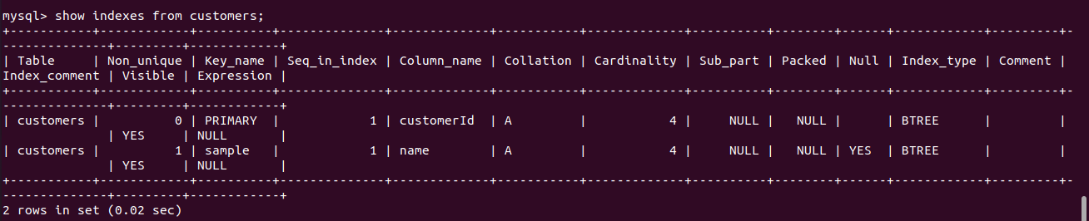

show indexes from customers;

We can simply use the command to index is below:

**show INDEXES from table_name;**

Q9.Find the order number, sale person name, along with the customer to whom that order belongs to.

Soln.

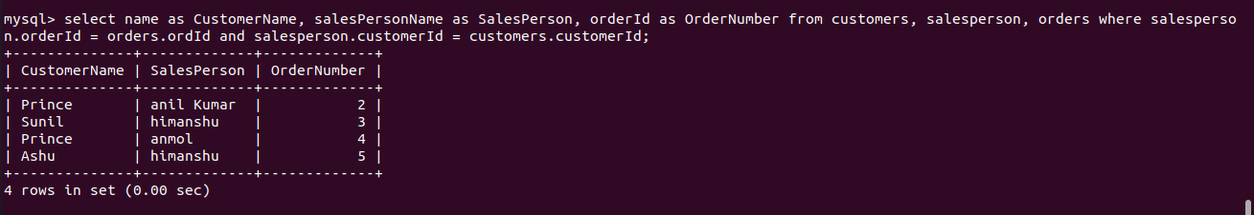

select name as CustomerName, salesPersonName as SalesPerson, orderId as OrderNumber from customers, salesperson, orders where salesperson.orderId = orders.ordId and salesperson.customerId = customers.customerId;