Q1. How are inline and block elements different from each other?

Soln.

A **block** element always starts on a new line and takes up the full width available (stretches out to the left and right as far as it can).

<div>, <heading tags>, <p> etc are example of block elements.

An **inline** element does not start on a new line and only takes up as much width as necessary.

<span> , <label>,<input> are example of block elements.

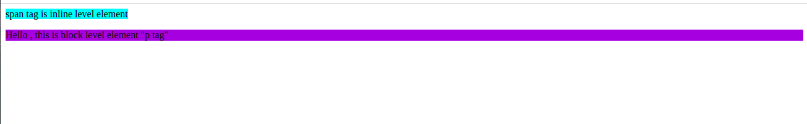

Q2.Explain the difference between visibility:hidden and display:none.

Soln.

**visibility: hidden** hides the element, but it still takes up space in the layout.

**display: none** removes the element completely from the document. It does not take up any space, even though the HTML for it is still in the source code.

Example of visibility:hidden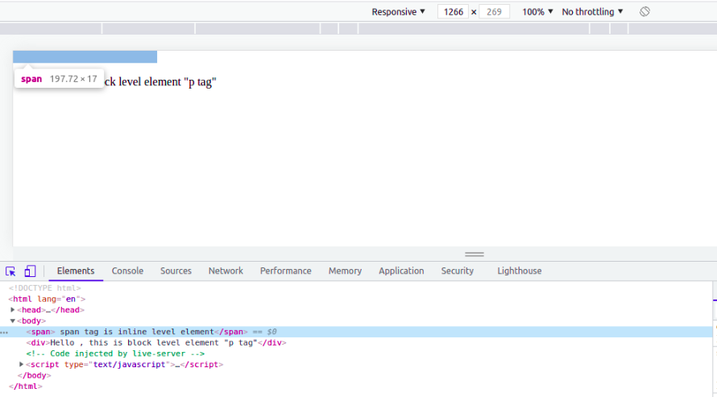

Example of visibility:hidden

Q3.Explain the clear and float properties.

Soln.

Example of display:none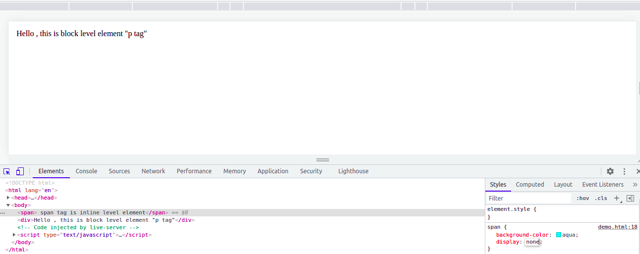

Q3.Explain the clear and float properties.

Soln.

The CSS **float property** specifies how an element should float.

**Left:** float:left is used to make an element float left to its container.

**Right:** float:right is used to make an element float right to its container.

**None:** When float:none is used, the related element does not float but is displayed where it is. It is default.

**Inherit:** When float:inherit is used, the element inherits the container’s float value.

The **clear property** specifies what should happen with the element that is next to a floating element.

**none** - The element is not pushed below left or right floated elements. This is default

**left** - The element is pushed below left floated elements

**right** - The element is pushed below right floated elements

**both** - The element is pushed below both left and right floated elements

**inherit** - The element inherits the clear value from its parent

Q4.Explain difference between absolute, relative,fixed and static.

Soln.

**Static** - this is the default value, all elements are in order as they appear in the document.

**Relative** - the element is positioned relative to its normal position.

**Absolute** - the element is positioned absolutely to its first positioned parent.

(to use absolute property first we have to make its parent to relative otherwise element start considering body as a parent.

**Fixed** - the element is positioned related to the browser window.

Q5.Write the HTML code to create a table in which there are 4 columns( ID , Employee Name, Designation, Department) and at least 6 rows. Also do some styling to it.

Soln

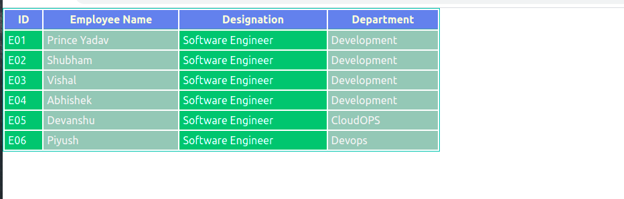

Code:

<!DOCTYPE html>

<html lang="en">

<head>

<meta charset="UTF-8">

<meta http-equiv="X-UA-Compatible" content="IE=edge">

<meta name="viewport" content="width=device-width, initial-scale=1.0">

<title>Table</title>

<style>

*{

margin: 0;

padding: 0;

box-sizing: border-box;

}

#employee {

width: 50%;

border: 1px solid rgb(31, 185, 173);

font-family: -apple-system, BlinkMacSystemFont, 'Segoe UI', Roboto, Oxygen, Ubuntu, Cantarell, 'Open Sans', 'Helvetica Neue', sans-serif;

}

#employee th{

border-bottom:1px solid cadetblue;

background-color: cornflowerblue;

color: cornsilk;

}

#employee th,#employee td{

padding: 5px;

}

#employee tbody tr :nth-child(even){

background-color: rgb(161, 194, 181);

color: whitesmoke;

}

#employee tbody tr :nth-child(odd){

background-color: rgb(0, 179, 107);

color: rgb(255, 255, 255);

}

</style>

</head>

<body>

<table id="employee">

<thead>

<tr>

<th>ID</th>

<th>Employee Name</th>

<th>Designation</th>

<th>Department</th>

</tr>

</thead>

<tbody>

<tr>

<td>E01</td>

<td>Prince Yadav</td>

<td>Software Engineer</td>

<td>Development</td>

</tr>

<tr>

<td>E02</td>

<td>Shubham</td>

<td>Software Engineer</td>

<td>Development</td>

</tr>

<tr>

<td>E03</td>

<td>Vishal</td>

<td>Software Engineer</td>

<td>Development</td>

</tr>

<tr>

<td>E04</td>

<td>Abhishek</td>

<td>Software Engineer</td>

<td>Development</td>

</tr>

<tr>

<td>E05</td>

<td>Devanshu</td>

<td>Software Engineer</td>

<td>CloudOPS</td>

</tr>

<tr>

<td>E06</td>

<td>Piyush</td>

<td>Software Engineer</td>

<td>Devops</td>

</tr>

</tbody>

</table>

</body>

</html>

Q6.Why do we use meta tags?

Soln.

The <meta> tag provides metadata about the HTML document.

Metadata will not be displayed on the page, but will be machine parsable.

Meta elements are typically used to specify page description, keywords, author of the document, last modified, and other metadata. Also, it helps to improve the SEO( Search Engine Optimization) of a web page by using certain keywords related to the web page.

**<meta name="keywords" content="HTML, CSS, XML, XHTML, JavaScript"> (For Search engines)**

**<meta name="description" content="Free Web tutorials on HTML and CSS"> ( Description of web page)**

**<meta name="author" content="John Doe"> (Author of web page)**

**<meta name="viewport" content="width=device-width, initial-scale=1.0"> (Responsiveness)**

Q7.Explain box model.

Soln.

The CSS box model is a box that wraps around every HTML element.

Box model consists of: margins, borders, padding, and the actual content.

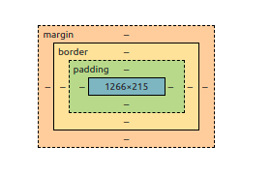

Q8.What are the different types of CSS Selectors.

Soln.

**1.Simple selectors eg: class_name{}, id_name{ }, tag_name{}**

**2.Combinator selectors**

descendant selector (space) **eg: div p{color: white}**

child selector (>) **eg: div > p{color:grey}**

adjacent sibling selector (+) **eg: div + p {color:blue}**

The general sibling selector (~) selects all elements that are next siblings of a specified element. Eg: **div ~p{color: smoke white}**

**3.Pseudo-class selectors**

a:visited {color: #999999;}

a:hover {color: #333333;}

a:focus {color: #333333;}

a:active {color: #009900;}

Q9.Define Doctype.

Soln.

It lets the browser know about the version of or standard of HTML or any other markup language that is being used in the document.

**Doctype Declaration: <!DOCTYPE html> - This is a doctype declaration for HTML5.**

Q10.Explain 5 HTML5 semantic tags.

Soln.

**<article>** - Defines an article in the document

**<footer>** - Defines a footer for the document or a section

**<header>** - Defines a header for the document or a section

**<nav>** - Defines navigation links in the document

**<section>** - Defines a section in the document

Q11.Create HTML for web-page.jpg.

Soln

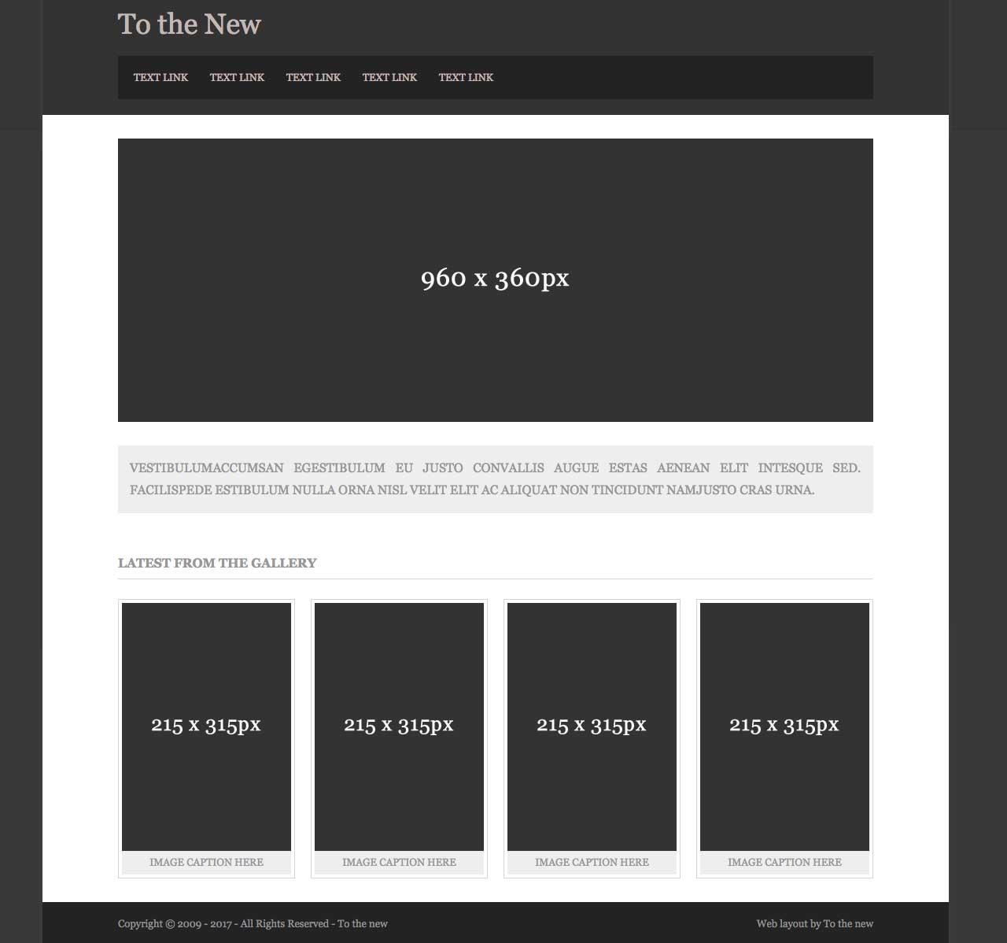

**Html code:**

<!DOCTYPE html>

<html lang="en">

<head>

<meta charset="UTF-8">

<meta http-equiv="X-UA-Compatible" content="IE=edge">

<meta name="viewport" content="width=device-width, initial-scale=1.0">

<title>To The New</title>

<link rel="stylesheet" href="style.css">

</head>

<body>

<header>

<div class="title">

<h2>To The New</h2>

</div>

<nav>

<ul>

<li><a href="#">TEXT LINK</a></li>

<li><a href="#">TEXT LINK</a></li>

<li><a href="#">TEXT LINK</a></li>

<li><a href="#">TEXT LINK</a></li>

<li><a href="#">TEXT LINK</a></li>

</ul>

</nav>

</header>

<section>

<div class="banner">

<h3>960 x 360px</h3>

</div>

<div class="content">

<p>Lorem ipsum dolor sit amet consectetur adipisicing elit. Sunt doloremque vitae, consectetur facere vel sequi modi provident consequuntur labore voluptates quisquam dolores magni repudiandae perferendis eum suscipit cumque laboriosam! Hic aliquid quisquam et facilis dolorum dolor sit, recusandae reiciendis, cum ab eum nesciunt eveniet ipsa adipisci fugit eaque explicabo ullam, corrupti deserunt voluptates ipsam fuga non! Consequatur

</p>

</div>

<div class="gallery">

<div class="gallery-title">

Latest From The Gallery

<hr>

</div>

<div class="cards">

<div class="card">

<div class="card-body">

215 x 315px

</div>

<div class="card-footer">

image caption here

</div>

</div>

<div class="card">

<div class="card-body">

215 x 315px

</div>

<div class="card-footer">

image caption here

</div>

</div>

<div class="card">

<div class="card-body">

215 x 315px

</div>

<div class="card-footer">

image caption here

</div>

</div>

<div class="card">

<div class="card-body">

215 x 315px

</div>

<div class="card-footer">

image caption here

</div>

</div>

</div>

</div>

</section>

<footer>

<div class="copyright">

Copyright &copy; 2009-2017 - All Rights Reserved - To the new

</div>

<div class="info">

web layout by To the new

</div>

</footer>

</body>

</html>

**CSS code:**

*{

margin: 0;

box-sizing: border-box;

padding: 0;

}

ul{

list-style: none;

}

a{

text-decoration: none;

color:rgb(146, 146, 146);

}

header{

padding:.5rem 5.5rem;

display:flex;

justify-content: center;

flex-direction:column;

background-color:rgb(39, 39, 39);

}

.title{

padding-bottom: .8rem;

color:rgb(146, 146, 146);

}

nav{

background-color:black;

padding: .5rem 0 .5rem .5rem;

margin-bottom:.5rem;

}

nav ul{

display: flex;

}

nav ul li{

margin-right:1rem;

}

section{

padding:1.5rem 5.5rem;

}

.banner{

width:auto;

height:360px;

background-color: rgb(39, 39, 39);

display:flex;

justify-content:center;

align-items:center;

color:seashell;

font-size: 2rem;

}

.content{

width:auto;

padding:.5rem .5rem;

background-color:rgb(153, 150, 150);

margin-top: 1rem;

}

.content p{

text-align: justify;

color: rgb(100, 91, 84);

text-transform: uppercase;

word-spacing: .2rem;

}

.gallery{

display:flex;

flex-direction:column;

margin-top: 2.5rem;

}

.gallery-title{

text-transform: uppercase;

line-height: 2rem;

font-weight: 600;

color:rgb(100, 91, 84);

}

.cards{

display:flex;

flex-direction:row;

justify-content:space-between;

margin-top: 1rem;

}

.card{

width:216px;

height:316px;

border: 5px ridge grey;

display:flex;

justify-content: center;

flex-direction: column;

}

.card-body{

width:auto;

height: 315px;

background-color:rgb(53, 53, 53);

display:flex;

justify-content:center;

align-items:center;

color:snow;

}

.card-footer{

text-align:center;

text-transform: uppercase;

background-color: silver;

font-weight: bold;

color: rgb(107, 96, 96);

}

footer{

padding:1.5rem 5.5rem;

background-color:rgb(39, 39, 39);

display: flex;

flex-direction: row;

justify-content: space-between;

color:rgb(221, 204, 204);

}

Q12.Create HTML for form.png.

Soln.

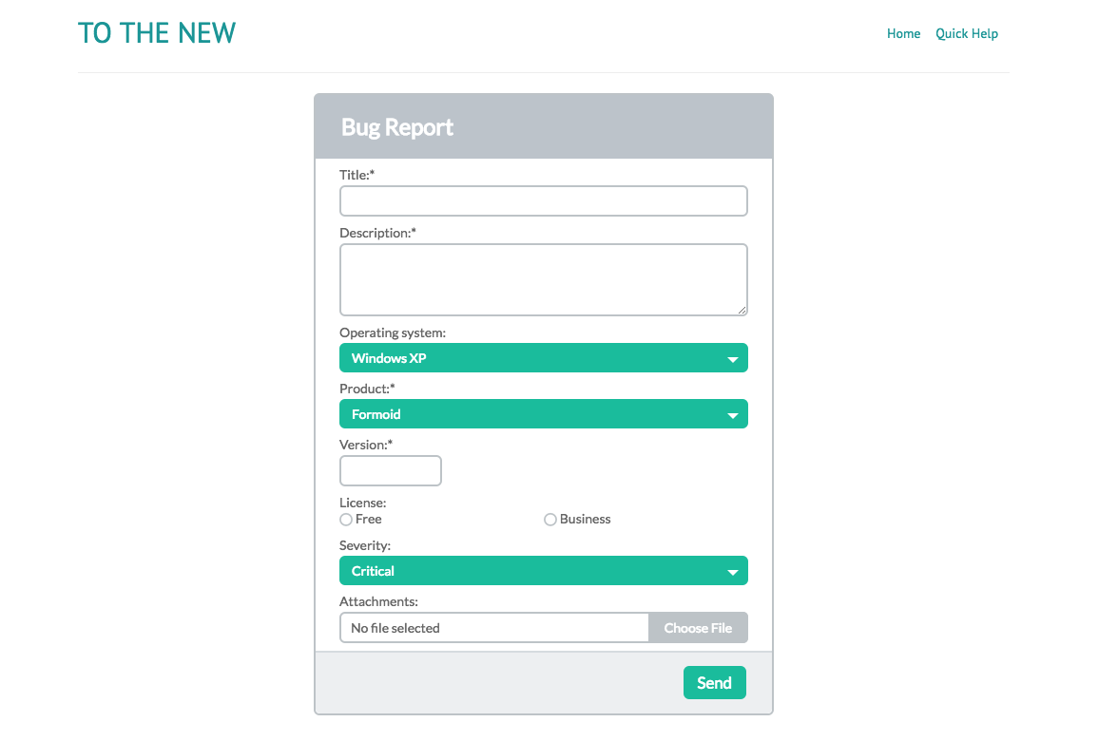

**HTML Code:**

<!DOCTYPE html>

<html lang="en">

<head>

<meta charset="UTF-8">

<meta http-equiv="X-UA-Compatible" content="IE=edge">

<meta name="viewport" content="width=device-width, initial-scale=1.0">

<title>Form</title>

<link href="style.css" rel="stylesheet">

</head>

<body>

<header>

<div class="title">

<h2>TO The New</h2>

</div>

<div class="header-menu">

<ul>

<li>Home</li>

<li> Quick Help</li>

</ul>

</div>

</header>

<section>

<div class="main-form">

<div class="form-header">

Bug Report

</div>

<div class="form-body">

<form>

<label for="title">Title:<sup>*</sup></label>

<input type="text" name="title" id="title"required>

<label for="description">Description:<sup>*</sup></label>

<textarea name="description" rows="5"></textarea>

<label for="Operating">Operating system:<sup>*</sup></label>

<select>

<option value="WindowsXP">WindowsXP</option>

<option value="Windows Vista">Windows Vista</option>

<option value="Windows 7">Windows 7</option>

<option value="Windows 10">Windows 10</option>

</select>

<label for="product">Product:<sup>*</sup></label>

<select>

<option value="formoid">Formoid</option>

<option value="office">Office</option>

</select>

<label for="version">

Version:<sup>*</sup>

</label>

<input type="text" name="version" class="version-field" required>

<label>License:</label>

<div class="radio-group">

<div class="radio-button">

<input type="radio" value="Free" name="license">

<label>Free</label>

</div>

<div class="radio-button">

<input type="radio" value="Free" name="license">

<label>Business</label>

</div>

</div>

<label>

Severity:

</label>

<select>

<option value="high">High</option>

<option value="medium">Medium</option>

<option value="low">Low</option>

</select>

<label>

Attachments:

</label>

<div class="file-field">

<input type="file" id="file">

<label for="file">Choose File</label>

</div>

</form>

</div>

<div class="form-footer">

<button>Send</button>

</div>

</div>

</section>

</body>

</html>

**Css Code:**

**\*{**

**margin: 0;**

**padding: 0;**

**box-sizing: border-box;**

**}**

**body{**

**padding: .5rem 5rem;**

**}**

**header{**

**display: flex;**

**flex-direction: row;**

**justify-content: space-between;**

**border-bottom: 1px solid gainsboro;**

**padding:.5rem 0 1rem 0;**

**}**

**header .title h2{**

**color:rgb(30, 155, 155);**

**text-transform: uppercase;**

**font-family: -apple-system, BlinkMacSystemFont, 'Segoe UI', Roboto, Oxygen, Ubuntu, Cantarell, 'Open Sans', 'Helvetica Neue', sans-serif;**

**font-weight: 400;**

**}**

**header .header-menu ul li{**

**list-style: none;**

**text-decoration: none;**

**display: inline-block;**

**padding-right: 1rem;**

**color:rgb(30, 155, 155);**

**font-size: small;**

**}**

**section{**

**display: flex;**

**justify-content: center;**

**align-items: center;**

**margin-top: 2rem;**

**}**

**.main-form{**

**border: 1px solid gainsboro;**

**width: 500px;**

**height: auto;**

**border-radius: 5px;**

**}**

**.form-header{**

**width: 100%;**

**padding: 1rem;**

**background-color: rgb(187, 187, 187);**

**color: white;**

**font-family: -apple-system, BlinkMacSystemFont, 'Segoe UI', Roboto, Oxygen, Ubuntu, Cantarell, 'Open Sans', 'Helvetica Neue', sans-serif;**

**font-weight: 700;**

**font-size: medium;**

**border-radius: 5px 5px 0 0;**

**}**

**.form-body{**

**width: 100%;**

**height: auto;**

**padding: .5rem 1rem;**

**}**

**.form-footer{**

**width: 100%;**

**height: 3rem;**

**padding: 1rem;**

**background-color: rgb(233, 232, 232);**

**border-radius:0 0 5px 5px;**

**display: flex;**

**justify-content: flex-end;**

**align-items: center;**

**flex-direction: row;**

**}**

**.form-footer button{**

**color: white;**

**display: flex;**

**justify-content: center;**

**align-items: center;**

**font-family: -apple-system, BlinkMacSystemFont, 'Segoe UI', Roboto, Oxygen, Ubuntu, Cantarell, 'Open Sans', 'Helvetica Neue', sans-serif;**

**background-color: rgb(9, 153, 146);**

**padding: .3rem .5rem;**

**border: none;**

**border-radius: 5px;**

**font-weight: 500;**

**}**

**label{**

**display: block;**

**}**

**.form-body input{**

**width: 100%;**

**height: 1.8rem;**

**border-radius: 5px;**

**border:2px solid grey;**

**margin: .5rem 0;**

**}**

**.form-body textarea{**

**width: 100%;**

**border:2px solid grey;**

**margin: .5rem 0;**

**border-radius: 5px;**

**max-width: 100%;**

**}**

**.form-body select{**

**width: 100%;**

**background-color: rgb(9, 153, 146);**

**border-color: rgb(9, 153, 146);**

**border-radius: 5px;**

**color: white;**

**font-weight: 600;**

**font-size: medium;**

**padding: 5px;**

**margin:.5rem 0;**

**}**

**.version-field{**

**width:25% !important;**

**}**

**.radio-group{**

**display: flex;**

**justify-content: flex-start;**

**align-items: center;**

**}**

**.radio-button{**

**display: flex;**

**justify-content: center;**

**align-items: center;**

**margin-right: 8rem;**

**}**

**.radio-button input{**

**width: auto;**

**}**

**.radio-button label{**

**display: inline;**

**}**

**.file-field{**

**display: flex;**

**width: 100%;**

**height: 1.8rem;**

**border: 2px solid grey;**

**border-radius: 5px;**

**}**

**input[type="file"] {**

**visibility: hidden;**

**}**

**.file-field label{**

**width: 120px;**

**height: auto;**

**background-color: grey;**

**float:right;**

**color: whitesmoke;**

**display: flex;**

**justify-content: center;**

**align-items: center;**

**}**