Q1.Create a directory "exercise" inside your home directory and create nested(dir1/dir2/dir3) directory structure inside "excerise" with single command.

Sol.

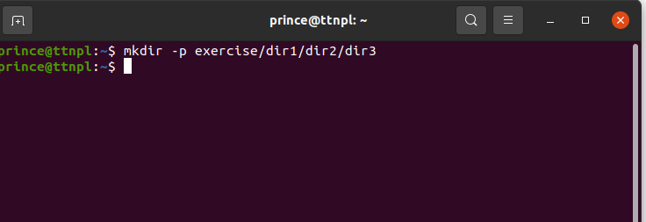

$mkdir -p exercise/dir1/dir2/dir3

Q2.Create two empty files inside dir2 directory: emptyFile1,emptyFile2 in single command.

Sol.

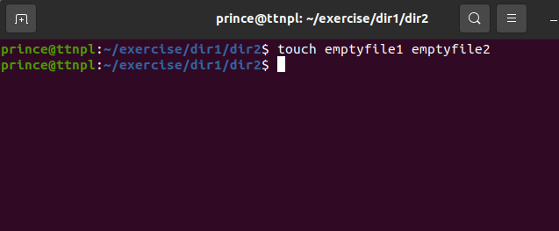

$touch emptyfile1 emptyfile2

Q3.Create one file file1.txt containing text "hello world" and save it.

Soln.

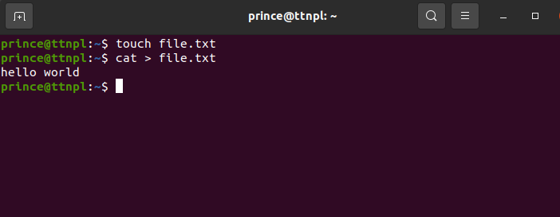

$touch file.txt

$cat > file.txt

Hello world

Ctrl +d (to exit)

Q4.Find a "passwd" file using find command inside /etc. copy this files as passwd_copy and then rename this file as passwd_backup.

Soln.

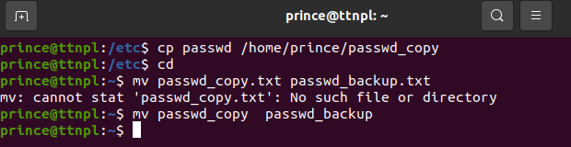

$ cd /etc/

$ find passwd

passwd

$ cp passwd /home/prince/passwd_copy

$ cd

$ mv passwd_copy passwd_backup

Q5.Try reading passwd_backup file in multiple tools: less,more,cat,strings etc and find the difference in their usage.

Soln.

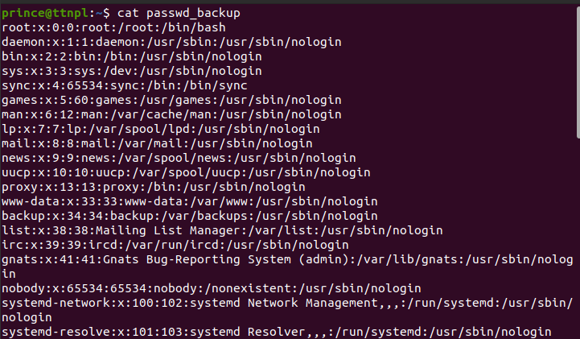

$cat passwd_backup -> Opens the file content

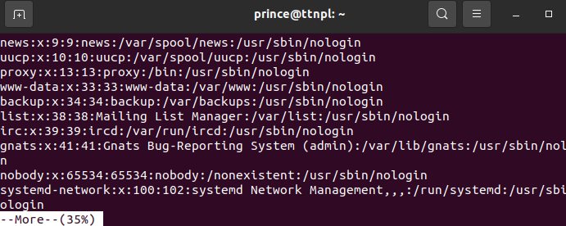

$more passwd_backup -> this command shows the file content and also shows the how much percentage of the file content is visible and we can scroll it line by line to reach the 100 percent visibility of the file.

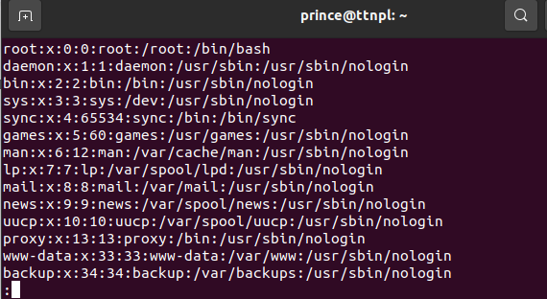

$less passwd_backup -> shows the contents of a file one page at a time. We can also use vim editor.

$strings passwd_backup -> prints all the strings present in the passwd_backup file.

Q6.Find out the number of line in password_backup containing "/bin/false".

Soln.

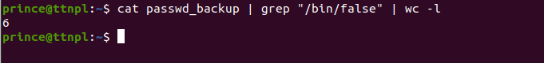

$ cat passwd_backup | grep “/bin/false” | wc -l

Q7.Get the first 5 lines of a file “password_backup” and Redirect the output of the above commands into file "output".

Soln.

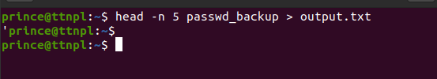

$ head -n 5 passwd_backup > output.txt

Q8.Create a "test" user,create its password and find out its uid and gid.

Soln.

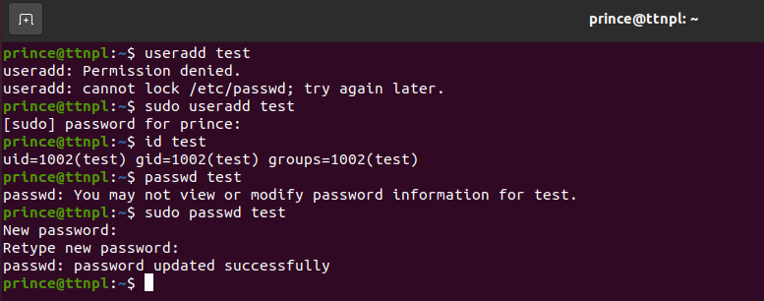

$sudo useradd test

$ id test

$ sudo passwd test

Q9.Change the timestamp of emptyFile1,emptyFile2 which are exist in dir2.

Soln.

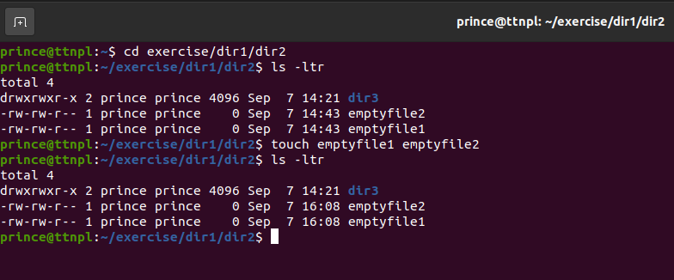

$cd exercise/dir1/dir2

$ls -ltr

$touch emptyfile1 emptyfile2

$ls -ltr

Q10.Login as test user and edit the "output" file created above. Since the permission wont allow you to save the changes. Configure such that test user can edit it.

1.Add group owner of the "output" file as the secondary group of testuser and check/change the "output" file permission if it is editable by group. Once done revert the changes.

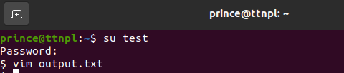

$ su test

$vim output.txt

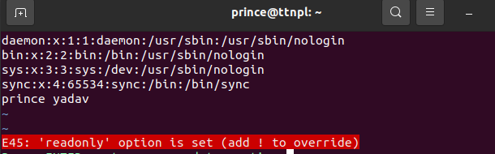

Try to edit the file it wont allowed me to override file was in read mode only

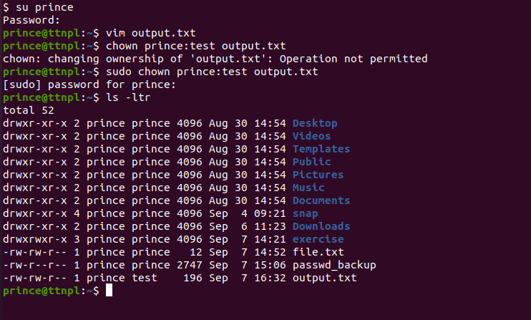

$ sudo chown prince:test output.txt

$ls - ltr



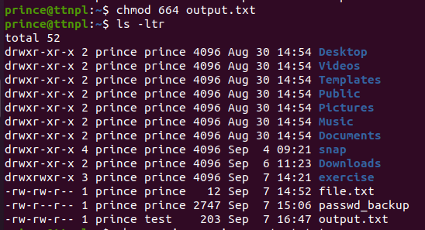

$chmod 664 output.txt

$ls -ltr

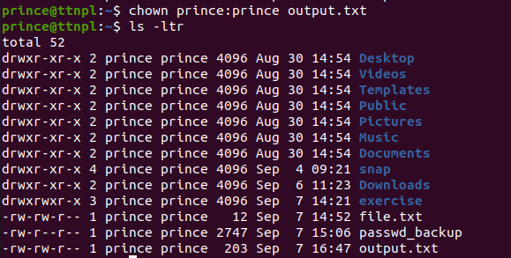

$chown prince:prince output.txt

$ls -ltr

2. Make the file editable to the world so that test user can access it. Revert the changes after verification

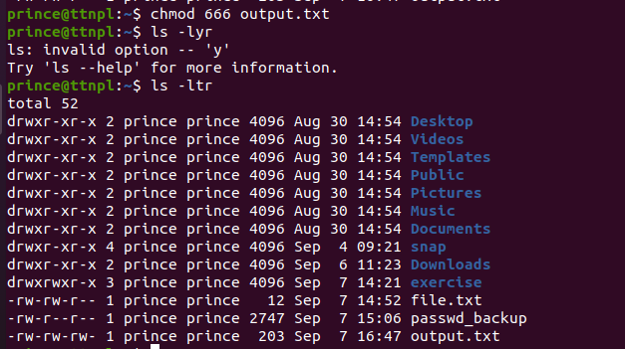$chmod 666 output.txt

$ls -ltr

3. Change the owner ship



$ chown prince:prince output.txt

Q11.Create alias with your name so that it creates a file as "/tmp/aliastesting".

Soln.

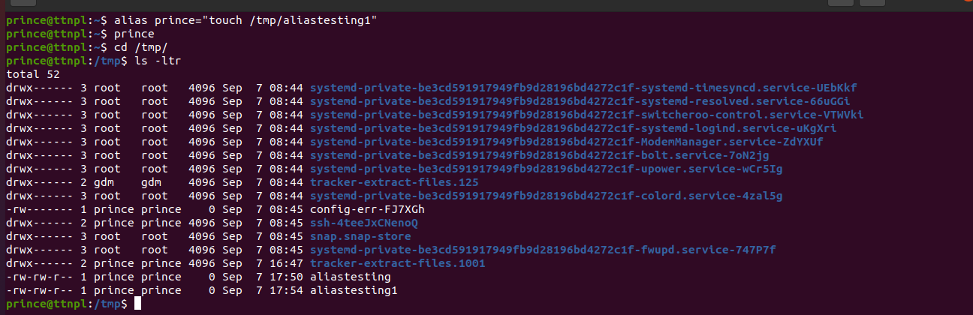

$alias prince=”touch /tmp/aliastesting1”.

$cd /tmp/

$ls -ltr

Q12.Edit ~/.bashrc file such that when you change to "test" user it should clear the screen and print "Welcome".

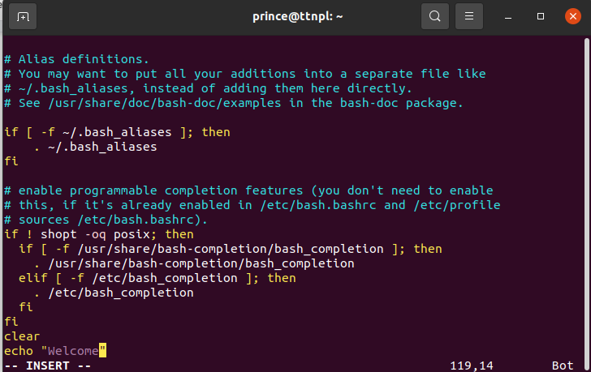

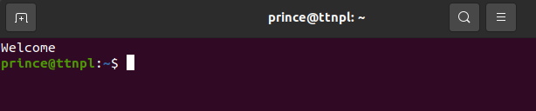

Edited in the .bashrc file

clear

echo “Welcome”

then save it

Q13. Install “zip” package.

Soln

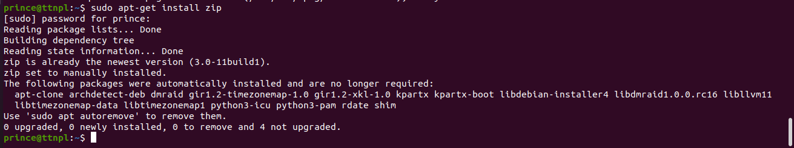

$sudo apt-get install zip

Q14.Compress "output" and "password_backup" files into a tar ball. List the files present inside the tar created.

Soln

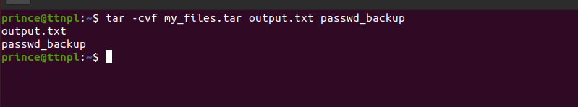

$ tar -cvf my_files.tar output.txt passwd_backup

Q15.scp this file to test user

Soln

‘

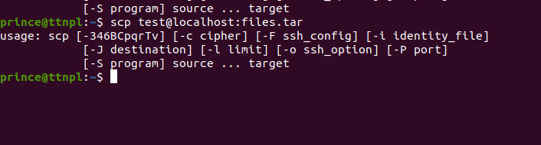

$scp test@localhost:files.tar

Q16.Unzip this tar file by logging into the remote server.

Soln.

Q17.Download any image from web and move to desktop.

Soln.

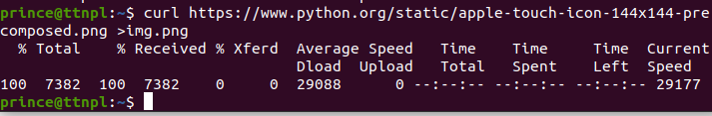

$ curl https://www.python.org/static/apple-touch-icon-144x144-precomposed.png > img.png

Q18.How to get help of commands usages.

Soln.

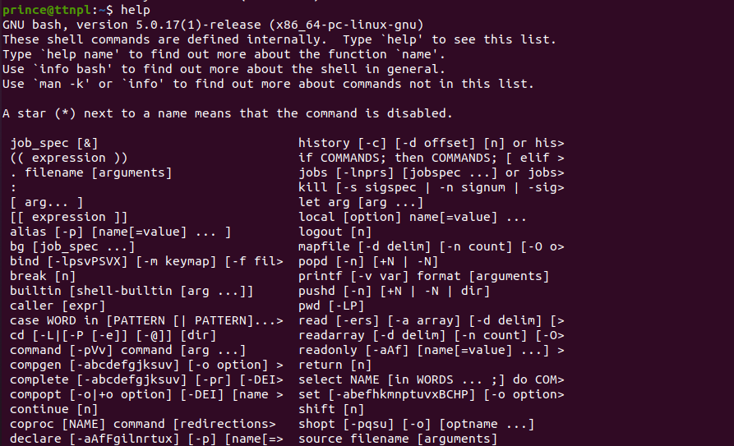

$help

Q19. Create a symlink of /etc/services into /tmp/ports-info

Soln



$ln -s /etc/services /tmp/ports-info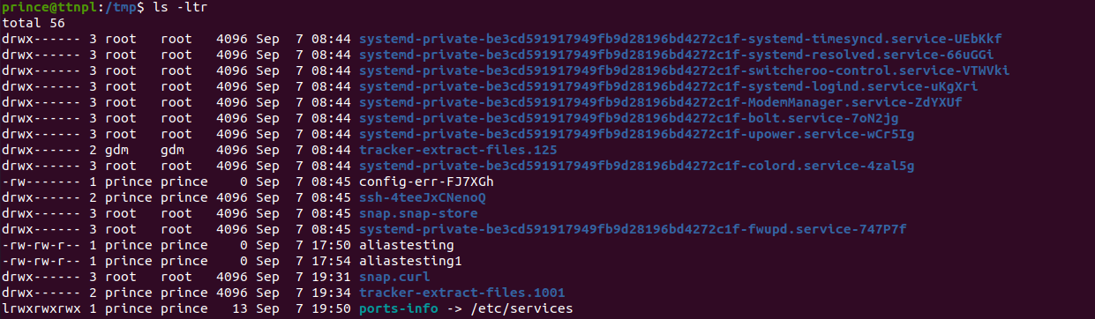

$ cd /tmp/

$ls -ltr

Q20.You are appointed as a Software/DevOps Engineer in ABC media services. On your first day you need to troubleshoot a problem. There is a command “xyz” somewhere installed in that linux system. But as a new joinee you do not have any idea about where is that Installed. How can you check that?

Soln

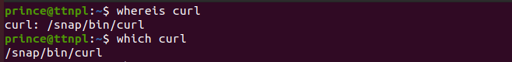

We can simply use **whereis** and **which** command to locate the path of the installed command in the system.