Q1.Write a function called cube() with one number parameter and returns the value of that number raised to the third power. Test the function by displaying the result of calling your cube() function on a few different numbers.

Soln.

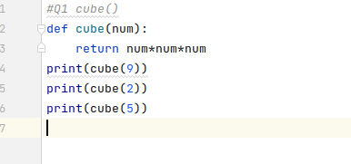

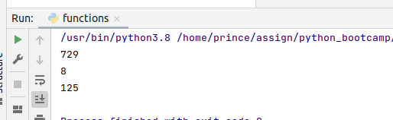

Q2.Write a script called temperature.py that defines two functions:

a. convert_cel_to_far(): which takes one float parameter representing degrees Celsius and returns a float representing the same temperature in degrees Fahrenheit using the following formula:

F = C * 9/5 + 32

b. convert_far_to_cel(): which take one float parameter representing degrees Fahrenheit and returns a float representing the same tem- perature in degrees Celsius using the following formula:

C = (F - 32) * 5/9

Soln.

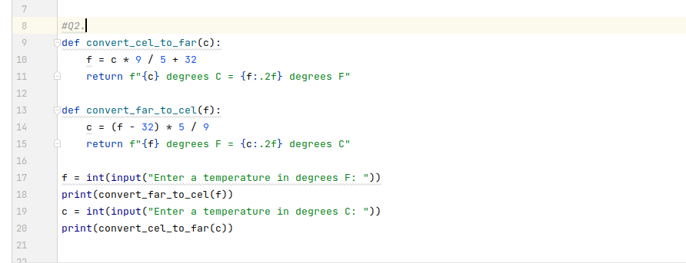

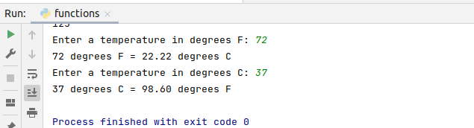

Q3.Write a program to create function func1() to accept a variable length of arguments and print their value.

Create a function in such a way that we can pass any number of arguments to this function and the function should process them and display each argument’s value.

Example Function call:

# call function with 3 arguments

func1(20, 40, 60)

# call function with 2 arguments

func1(80, 100)

Expected Output:

Printing values

20

40

60

Printing values

80

100

What is the data type that stores these arguments?

Soln.

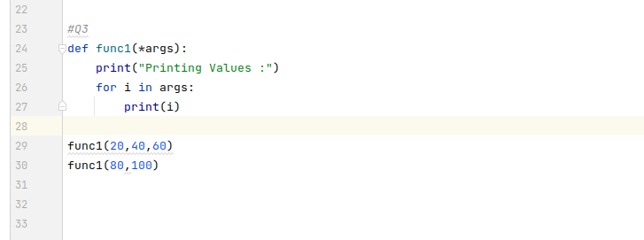

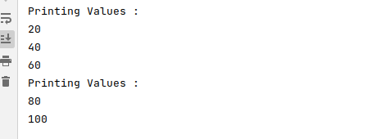

Tuple data type stores these arguments.

Q4.Write a program to create function perform_calculation() such that it can accept two variables and calculate addition and subtraction. Also, it must return both addition and subtraction in a single return call.

Given:

def calculation(a, b):

# Your Code

res = calculation(40, 10)

print(res)

Expected Output

50, 30

Soln.

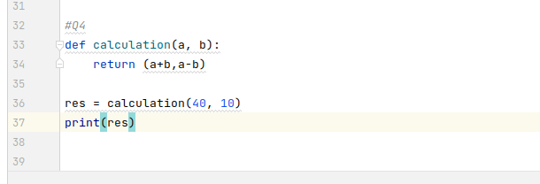

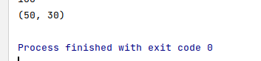

Q5. Write a program to create a function show_employee() using the following conditions.

It should accept the employee’s name and salary and display both.

If the salary is missing in the function call then assign default value 9000 to salary

Given:

showEmployee("Ben", 12000)

showEmployee("Jessa")

Expected output:

Name: Ben salary: 12000

Name: Jessa salary: 9000

Soln.

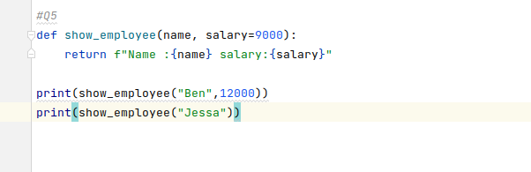

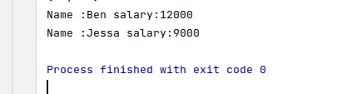

Q6.Write a function which expects variable length of keyword arguments. The function should print the following:

a. the number of keyword arguments passed

b. all the keys of the keyword arguments

c. all the values of keyword arguments

Soln.

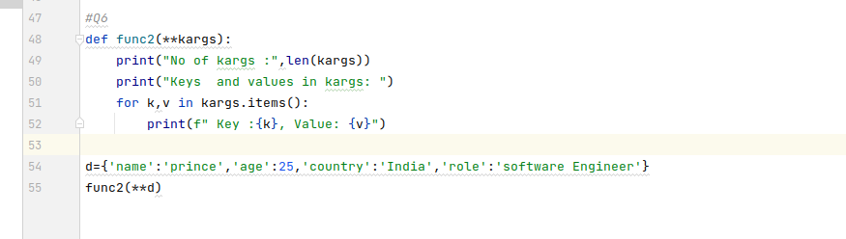

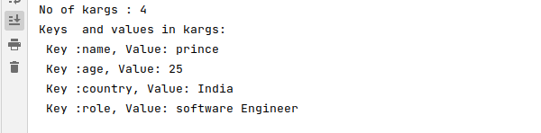

Q7.Create a function "catch" that expects any type of function as a argument. The job of catch function is to print the args and kwargs passed to the argument function and also result returned by the function.

Eg:

def add(a, b, c="sum of two numbers"):

print(c)

return a + b

catch(add, 1, 2, c="this is sum") # output: args: 1,2 kwargs: c="this is sum" result: this is sum 3

Soln.

