Q1.How can you get a list of all available modules on your computer?

Soln.

Command: help(‘modules’)

Will list all the modules names installed on your local computer

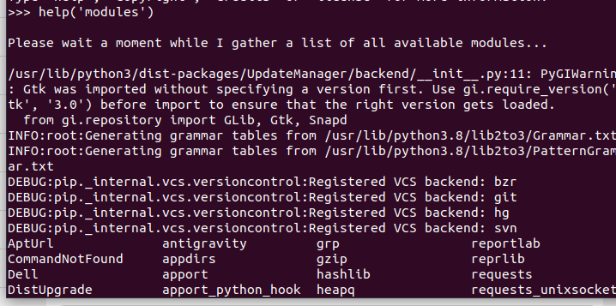

Q2.What is a namespace, and what does a module’s namespace contain?

Soln.

A **namespace** is a system that has a unique name for each and every object in Python.

**Local Namespace**: This namespace includes local names inside a function. This namespace is created when a function is called, and it only lasts until the function returns.

**Global Namespace**: This namespace includes names from various imported modules that you are using in a project. It is created when the module is included in the project, and it lasts until the script ends.

**Built-in Namespace:** This namespace includes built-in functions and built-in exception names.

Q3.What is the purpose of an __init__.py file in a module package directory and which directories require __init__.py files?

Soln.

**__init__.py** allows you to define any variable at the package level.

The **__init__.py** files are required to make Python treat directories containing the file as packages. This prevents directories with a common name, such as string, unintentionally hiding valid modules that occur later on the module search path.

The main folder is our Python directory that we want to treat as if it were a Python package. To be treated as such, we have to include an __init__.py file that relays this information to the Python interpreter.

Q4.How is changing sys.path different from setting PYTHONPATH to modify the module

search path?

Soln.

**SYS.PATH**

When we start a Python interpreter, one of the things it creates automatically is a list that contains all of directories it will use to search for modules when importing. This list is available in a variable named sys.path.

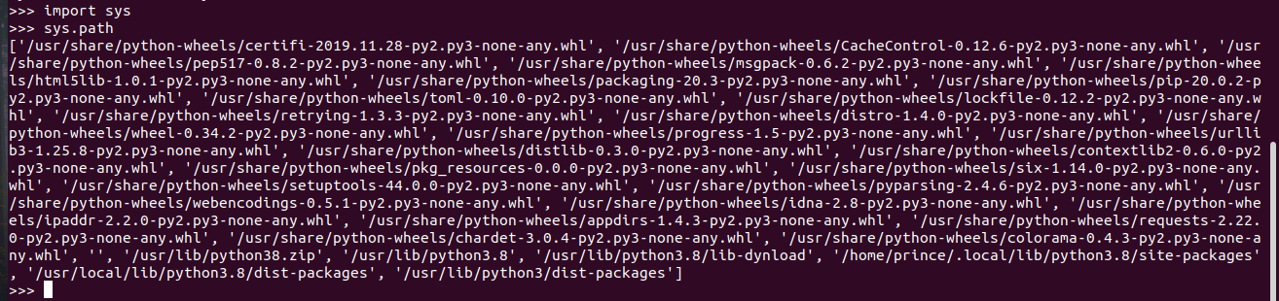

**PYTHONPATH**

PYTHONPATH is related to sys.path very closely. PYTHONPATH is an environment variable that you set before running the Python interpreter. PYTHONPATH, if it exists, should contain directories that should be searched for modules when using import. If PYTHONPATH is set, Python will include the directories in sys.path for searching. Use a semicolon to separate multiple directories.

Q5..What does it mean when a module’s __name__ variable is the string "__main__" ?

Soln.

Every Python module has it’s __name__ defined and if this is ‘__main__’, it implies that the module is being run standalone by the user and we can do corresponding appropriate actions.

If you import this script as a module in another script,

the __name__ is set to the name of the script/module.

Python files can act as either reusable modules, or as standalone programs.

if __name__ == “main”: is used to execute some code only if the file was run directly, and not imported.

Q6.What is the difference between from mypkg import spam and from . import spam ?

Soln.

1. import spam searches for module spam in the module search path defined as a list sys.path.

2. from . import spam searches for module spam in the current (same level) package.

Q7.What is significant about variables at the top level of a module whose names begin

with a single underscore?

Soln.

The underscore prefix is meant as a hint to another programmer that a variable or method starting with a single underscore is intended for internal use.( Private variable)

Q8.List down all the HTTP methods.Explain difference between PUT and PATCH?

Soln.

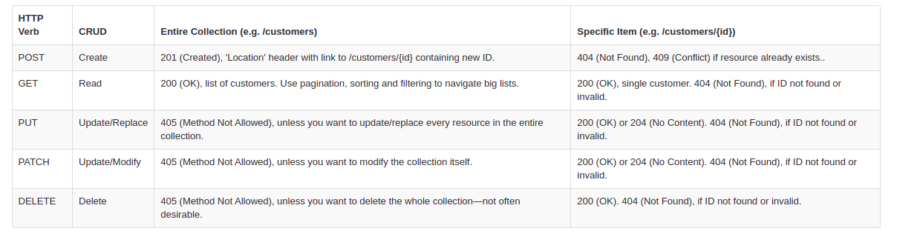

PUT:

It is used to Update record and each and every details of that particular record will get updated.

PATCH:

It is also used to update record and here important thing is whatever details will provide in payload , only those details will get updated and rest all will remain untouched.

Q9.What are query string parameters .Use github Search API('https://api.github.com/search/repositories') to look for "requests" library.Also print the total_count from the returned response.

Soln.

Query string parameters are a standard way of sending instructions to a backend processor. They are appended to URLs. You can add query string parameters to URLs on your site to set the values .

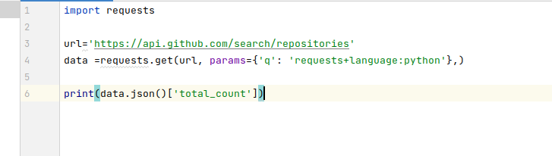

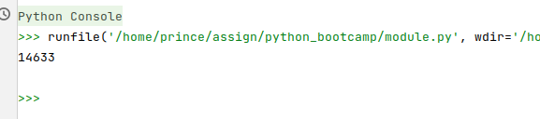

Q10.Write a function to send HTTP (GET, PUT,POST, DELETE) request to "httpbin" service .Inspect the response and print the headers.Use the url : <https://httpbin.org>.

Soln.

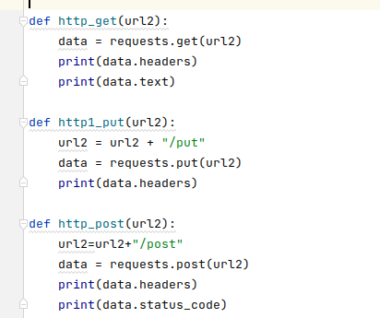

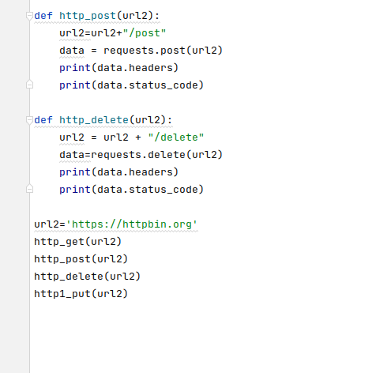

Output:

/usr/bin/python3.8 /snap/pycharm-community/252/plugins/python-ce/helpers/pydev/pydevconsole.py --mode=client --port=43645

import sys; print('Python %s on %s' % (sys.version, sys.platform))

sys.path.extend(['/home/prince/assign/python_bootcamp/module.py'])

PyDev console: starting.

Python 3.8.10 (default, Jun 2 2021, 10:49:15)

[GCC 9.4.0] on linux

runfile('/home/prince/assign/python_bootcamp/module.py', wdir='/home/prince/assign/python_bootcamp')

14633

{'Date': 'Sun, 03 Oct 2021 11:56:49 GMT', 'Content-Type': 'text/html; charset=utf-8', 'Content-Length': '9593', 'Connection': 'keep-alive', 'Server': 'gunicorn/19.9.0', 'Access-Control-Allow-Origin': '*', 'Access-Control-Allow-Credentials': 'true'}

<!DOCTYPE html>

<html lang="en">

<head>

<meta charset="UTF-8">

<title>httpbin.org</title>

<link href="https://fonts.googleapis.com/css?family=Open+Sans:400,700|Source+Code+Pro:300,600|Titillium+Web:400,600,700"

rel="stylesheet">

<link rel="stylesheet" type="text/css" href="/flasgger_static/swagger-ui.css">

<link rel="icon" type="image/png" href="/static/favicon.ico" sizes="64x64 32x32 16x16" />

<style>

html {

box-sizing: border-box;

overflow: -moz-scrollbars-vertical;

overflow-y: scroll;

}

*,

*:before,

*:after {

box-sizing: inherit;

}

body {

margin: 0;

background: #fafafa;

}

</style>

</head>

<body>

<a href="https://github.com/requests/httpbin" class="github-corner" aria-label="View source on Github">

<svg width="80" height="80" viewBox="0 0 250 250" style="fill:#151513; color:#fff; position: absolute; top: 0; border: 0; right: 0;"

aria-hidden="true">

<path d="M0,0 L115,115 L130,115 L142,142 L250,250 L250,0 Z"></path>

<path d="M128.3,109.0 C113.8,99.7 119.0,89.6 119.0,89.6 C122.0,82.7 120.5,78.6 120.5,78.6 C119.2,72.0 123.4,76.3 123.4,76.3 C127.3,80.9 125.5,87.3 125.5,87.3 C122.9,97.6 130.6,101.9 134.4,103.2"

fill="currentColor" style="transform-origin: 130px 106px;" class="octo-arm"></path>

<path d="M115.0,115.0 C114.9,115.1 118.7,116.5 119.8,115.4 L133.7,101.6 C136.9,99.2 139.9,98.4 142.2,98.6 C133.8,88.0 127.5,74.4 143.8,58.0 C148.5,53.4 154.0,51.2 159.7,51.0 C160.3,49.4 163.2,43.6 171.4,40.1 C171.4,40.1 176.1,42.5 178.8,56.2 C183.1,58.6 187.2,61.8 190.9,65.4 C194.5,69.0 197.7,73.2 200.1,77.6 C213.8,80.2 216.3,84.9 216.3,84.9 C212.7,93.1 206.9,96.0 205.4,96.6 C205.1,102.4 203.0,107.8 198.3,112.5 C181.9,128.9 168.3,122.5 157.7,114.1 C157.9,116.9 156.7,120.9 152.7,124.9 L141.0,136.5 C139.8,137.7 141.6,141.9 141.8,141.8 Z"

fill="currentColor" class="octo-body"></path>

</svg>

</a>

<svg xmlns="http://www.w3.org/2000/svg" xmlns:xlink="http://www.w3.org/1999/xlink" style="position:absolute;width:0;height:0">

<defs>

<symbol viewBox="0 0 20 20" id="unlocked">

<path d="M15.8 8H14V5.6C14 2.703 12.665 1 10 1 7.334 1 6 2.703 6 5.6V6h2v-.801C8 3.754 8.797 3 10 3c1.203 0 2 .754 2 2.199V8H4c-.553 0-1 .646-1 1.199V17c0 .549.428 1.139.951 1.307l1.197.387C5.672 18.861 6.55 19 7.1 19h5.8c.549 0 1.428-.139 1.951-.307l1.196-.387c.524-.167.953-.757.953-1.306V9.199C17 8.646 16.352 8 15.8 8z"></path>

</symbol>

<symbol viewBox="0 0 20 20" id="locked">

<path d="M15.8 8H14V5.6C14 2.703 12.665 1 10 1 7.334 1 6 2.703 6 5.6V8H4c-.553 0-1 .646-1 1.199V17c0 .549.428 1.139.951 1.307l1.197.387C5.672 18.861 6.55 19 7.1 19h5.8c.549 0 1.428-.139 1.951-.307l1.196-.387c.524-.167.953-.757.953-1.306V9.199C17 8.646 16.352 8 15.8 8zM12 8H8V5.199C8 3.754 8.797 3 10 3c1.203 0 2 .754 2 2.199V8z"

/>

</symbol>

<symbol viewBox="0 0 20 20" id="close">

<path d="M14.348 14.849c-.469.469-1.229.469-1.697 0L10 11.819l-2.651 3.029c-.469.469-1.229.469-1.697 0-.469-.469-.469-1.229 0-1.697l2.758-3.15-2.759-3.152c-.469-.469-.469-1.228 0-1.697.469-.469 1.228-.469 1.697 0L10 8.183l2.651-3.031c.469-.469 1.228-.469 1.697 0 .469.469.469 1.229 0 1.697l-2.758 3.152 2.758 3.15c.469.469.469 1.229 0 1.698z"

/>

</symbol>

<symbol viewBox="0 0 20 20" id="large-arrow">

<path d="M13.25 10L6.109 2.58c-.268-.27-.268-.707 0-.979.268-.27.701-.27.969 0l7.83 7.908c.268.271.268.709 0 .979l-7.83 7.908c-.268.271-.701.27-.969 0-.268-.269-.268-.707 0-.979L13.25 10z"

/>

</symbol>

<symbol viewBox="0 0 20 20" id="large-arrow-down">

<path d="M17.418 6.109c.272-.268.709-.268.979 0s.271.701 0 .969l-7.908 7.83c-.27.268-.707.268-.979 0l-7.908-7.83c-.27-.268-.27-.701 0-.969.271-.268.709-.268.979 0L10 13.25l7.418-7.141z"

/>

</symbol>

<symbol viewBox="0 0 24 24" id="jump-to">

<path d="M19 7v4H5.83l3.58-3.59L8 6l-6 6 6 6 1.41-1.41L5.83 13H21V7z" />

</symbol>

<symbol viewBox="0 0 24 24" id="expand">

<path d="M10 18h4v-2h-4v2zM3 6v2h18V6H3zm3 7h12v-2H6v2z" />

</symbol>

</defs>

</svg>

<div id="swagger-ui">

<div data-reactroot="" class="swagger-ui">

<div>

<div class="information-container wrapper">

<section class="block col-12">

<div class="info">

<hgroup class="main">

<h2 class="title">httpbin.org

<small>

<pre class="version">0.9.2</pre>

</small>

</h2>

<pre class="base-url">[ Base URL: httpbin.org/ ]</pre>

</hgroup>

<div class="description">

<div class="markdown">

<p>A simple HTTP Request &amp; Response Service.

<br>

<br>

<b>Run locally: </b>

<code>$ docker run -p 80:80 kennethreitz/httpbin</code>

</p>

</div>

</div>

<div>

<div>

<a href="https://kennethreitz.org" target="_blank">the developer - Website</a>

</div>

<a href="mailto:me@kennethreitz.org">Send email to the developer</a>

</div>

</div>

<!-- ADDS THE LOADER SPINNER -->

<div class="loading-container">

<div class="loading"></div>

</div>

</section>

</div>

</div>

</div>

</div>

<div class='swagger-ui'>

<div class="wrapper">

<section class="clear">

<span style="float: right;">

[Powered by

<a target="_blank" href="https://github.com/rochacbruno/flasgger">Flasgger</a>]

<br>

</span>

</section>

</div>

</div>

<script src="/flasgger_static/swagger-ui-bundle.js"> </script>

<script src="/flasgger_static/swagger-ui-standalone-preset.js"> </script>

<script src='/flasgger_static/lib/jquery.min.js' type='text/javascript'></script>

<script>

window.onload = function () {

fetch("/spec.json")

.then(function (response) {

response.json()

.then(function (json) {

var current_protocol = window.location.protocol.slice(0, -1);

if (json.schemes[0] != current_protocol) {

// Switches scheme to the current in use

var other_protocol = json.schemes[0];

json.schemes[0] = current_protocol;

json.schemes[1] = other_protocol;

}

json.host = window.location.host; // sets the current host

const ui = SwaggerUIBundle({

spec: json,

validatorUrl: null,

dom_id: '#swagger-ui',

deepLinking: true,

jsonEditor: true,

docExpansion: "none",

apisSorter: "alpha",

//operationsSorter: "alpha",

presets: [

SwaggerUIBundle.presets.apis,

// yay ES6 modules ↘

Array.isArray(SwaggerUIStandalonePreset) ? SwaggerUIStandalonePreset : SwaggerUIStandalonePreset.default

],

plugins: [

SwaggerUIBundle.plugins.DownloadUrl

],

// layout: "StandaloneLayout" // uncomment to enable the green top header

})

window.ui = ui

// uncomment to rename the top brand if layout is enabled

// $(".topbar-wrapper .link span").replaceWith("<span>httpbin</span>");

})

})

}

</script> <div class='swagger-ui'>

<div class="wrapper">

<section class="block col-12 block-desktop col-12-desktop">

<div>

<h2>Other Utilities</h2>

<ul>

<li>

<a href="/forms/post">HTML form</a> that posts to /post /forms/post</li>

</ul>

<br />

<br />

</div>

</section>

</div>

</div>

</body>

</html>

{'Date': 'Sun, 03 Oct 2021 11:56:50 GMT', 'Content-Type': 'application/json', 'Content-Length': '398', 'Connection': 'keep-alive', 'Server': 'gunicorn/19.9.0', 'Access-Control-Allow-Origin': '*', 'Access-Control-Allow-Credentials': 'true'}

200

{'Date': 'Sun, 03 Oct 2021 11:56:51 GMT', 'Content-Type': 'application/json', 'Content-Length': '400', 'Connection': 'keep-alive', 'Server': 'gunicorn/19.9.0', 'Access-Control-Allow-Origin': '*', 'Access-Control-Allow-Credentials': 'true'}

200

{'Date': 'Sun, 03 Oct 2021 11:56:53 GMT', 'Content-Type': 'application/json', 'Content-Length': '397', 'Connection': 'keep-alive', 'Server': 'gunicorn/19.9.0', 'Access-Control-Allow-Origin': '*', 'Access-Control-Allow-Credentials': 'true'}