Q1.What is PEP8 and why is it important?

Soln.

PEP 8 is a document that provides various guidelines to write the readable in Python.

It enhances the readability of the Python code.

Like proper naming convention,

Proper code layout,

Proper function or class name etc.

Q2.Create a python virutal environment, activate it, and install libraries like requests, beautifulsoup4.

Soln.

sudo apt install python3-venv

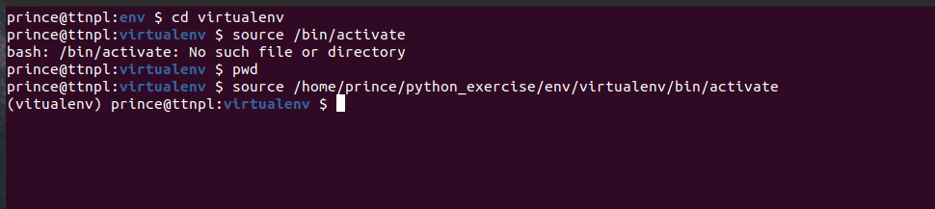

python3 -m venv virtualenv

Source /home/prince/pyton_exercise/env/virtualenv/bin/activate

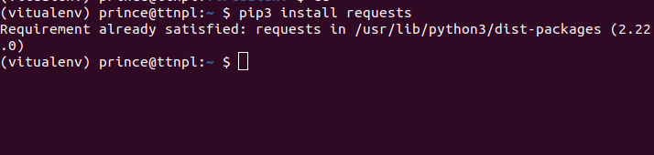

pip3 install requests

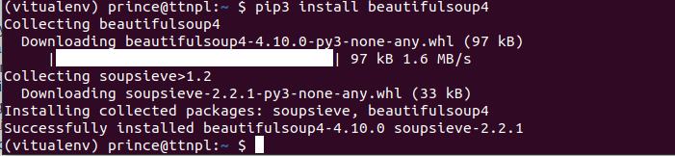

pip3 install beautifulsoup4

Q3.Write a Python program to get the Python version you are using.

Soln.

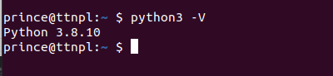

python3 -V

Q4.Write a program to implment floor and ceil function without using inbuilt functions.

Soln.

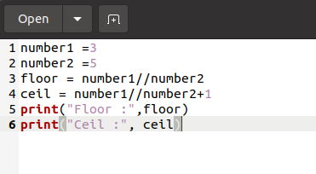

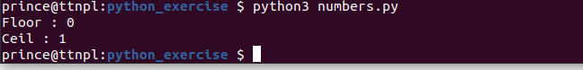

Q5.Given string my_string = ‘Hello Python!’, Reverse the string using slicing, print ’!’ using indexing.

Soln.

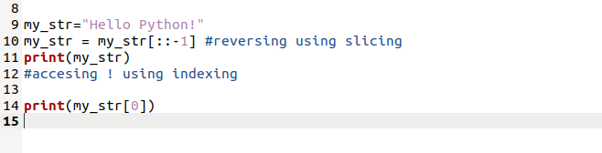



Q6.Using examples explain string.format and f-strings.

Soln.

String.format this .format method is used in python 2 to python 3.5 version

Example of .format()

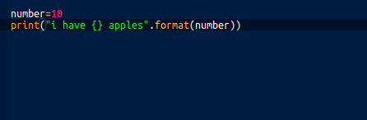

number=10

print("i have {} apples".format(number))

f-string is used in python 3.6 version and above , it is new way to use .format() which is used in python2 python 3.5 version.

Example of f-string.

Number = 10

print(f”i have {Number} apples”)

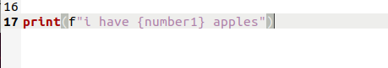

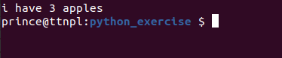

Q7.Write a program to find sum of digits of 3 digit number. Take input number from user. Example input = 123, result = 6.

Soln.

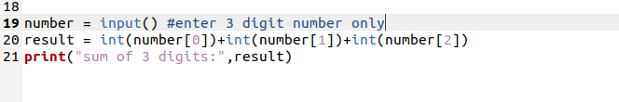



Q8.Replace all underscores(_) with + from a given string.

Example: hello_how_are__you => hello+how+are++you.

Soln.

